BMIH5005: Personnel Resourcing and Development

Analyse the impacts of socio-economic force on employees’ performance management and monitoring in different work modes: Hospitality HR’s perspective.
Research Project Proposal
Lecturer’s name: Scott James
Student Name: Mihaela Costache
Student ID: 2246360

Table of Contents
1.0 Introduction and Background 3
1.1 Company background 3
1.2 Employee Performance Management Issues 3
2.0 Socio-economic factors, a part of PESTLE Analysis 4
3.0 Description of the industry trend including but not limited to retention rates, turnover rate 6
4.0 Discussion on different work modes in the hospitality industry over these five years 7
5.0 An example of employee management that is initiated by the organisation Hyatt 8
6.0 Solutions to the problems 9
7.0 Evaluation and conclusion 9
Reference list 11

1.0 Introduction and Background

1.1 Company background
Hyatt Hotels Corporation, also known as Hyatt Hotels & Resorts is a hospitality and hotels company, based in Riverside Plaza, Chicago, the US. The company was founded in September 1957, and the product portfolio of the brand entails business and luxury vacation properties, resorts, and hotel properties across the globe (Hyatt, 2024). As of 203, the total employees of the firm across nations are 127,000, and these employees operate in the hotels, resorts and vacation properties that are under the brand portfolio of Hyatt Hotels and Resorts. Additionally, the revenue per employee ratio is $46,385, and the revenue as of 2023 Q3 was around $1.7 billion (Zippia, 2021).

1.2 Employee Performance Management Issues
Since the business environment is becoming more competitive, it has been observed that employees within the firm are among the ones to endure significant pressure. Thus, as a result, impacts the performance and hampers the long-term productivity of the firm (Awan et al., 2020, p 01). In the context of Hyatt Hotels and Resorts, the company has employee performance management issues such as lack of performance management consistency and lack of set standards within the performance management. Amid the COVID-19 pandemic, the company had to lay off a significant, approximately 1,300 employees to cope with the pandemic and deal with its impact ‌(Reuters, 2020). The layoff of employees also impacted the employee performance management prospects since the productivity of the firm plunged and faced economic hurdles to feasibly conduct operations across the globe. In the current terms, as the business situations have become feasible, the performance management issues as aforementioned can impact employee monitoring and management in work modes such as office-based work arrangements and flexible working modes. In career prospects, performance management becomes a tool to showcase the limits of productivity an individual has put forth in the company and the ways the efforts of the employee lead the firm to attain its goals (Marchington and Wilkinson, 2016). Lack of performance management consistencies and setting employee performance management standards could affect the morale and productivity terms of employees in the office-based working arrangement as well as in the hybrid mode of work. Rudman (2020) states that a lack of performance management and monitoring standards and consistencies not only affects the morale of employees but also impacts the productivity of firms in the long run because companies get a narrower picture of employee performance and their efforts upon achieving the organisational goals.

2.0 Socio-economic factors, a part of PESTLE Analysis
Socio economic-factors play a significant role in shaping the landscape of the hospitality industry. It also affects the consumer behaviour as well as the operational strategy.
Political factors, the hospital industry faces growing pressure in the UK for addressing the environmental impact and promotion of the sustainability practices. The companies are in the pressurised to make changes in their operational updates such as water usage and waste management (Chemmanur, 2024). It also influences the customer behaviour which binds the companies to make changes in their operational strategies.
Economic factors, it has been observed that most wealthier customers in the UK tend to spend their leisure time in an accommodated place. Whereas, half of the consumers having the lowest income try to spend their money on food and drinking activities (Deloitte, 2023).
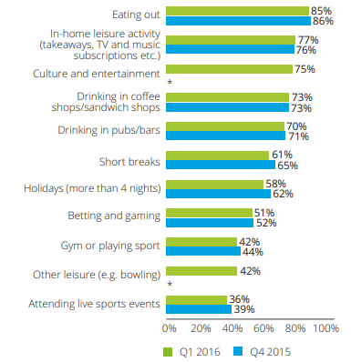
Figure 1: Consumers' leisure spending
(Source: Deloitte, 2023)
Sociocultural factors influence the hospitality industry which resulted in the demographic shifts. The increase in the millennial travelers and aging populations has raised the opportunities for the company. Millennials are often characterised by their tech-savvy nature and preferences which resulted in the experimental travel (GOV.UK, 2023). Changes in the cultural norms, lifestyle preferences, and societal values relating to sustainability and environmental consciousness have resulted in the adoption of eco-friendly practices by the hotel sectors (Medium, 2024).
Technological factorshave reshaped the hospitality landscape, it has changed the booking process and guest interaction procedure. The rise of online booking platforms and integration of technology within the hotel services has changed the way guests like to stay in the hotel (EHL, 2024).
Consumers are now focusing on the seasonal ingredients, and onsite gardens to get the best accommodation in the hospital sectors. Compliances are made to change the consumption of electricity in the hotel industry (Deloitte, 2023).

3.0 Description of the industry trend
Organisations tend to enjoy more sustained performance while their workers are motivated. New employees help to inject energy and fresh ideas within the companies. However, the increasing turnover rate and divert time might lead to loss of institutional knowledge and affect corporate culture.
The retention rate indicates the percentage of the employees who remain with the company. It is also known as the key indicator of workforce satisfaction. The turnover rate, which refers to the frequency at which employees leave a company, can signal underlying issues in recruitment, training, and workplace culture (Torrington et al., 2020). The retention rate is considered the converse of the turnover rate, as it helps to measure the percentage of the employees who continue with the organisation for a certain period of time (Luther, 2023).
Hyatt has the top position in retaining the quality employees within the hospital sectors. Most of the employees in Hyatt feel that the company is doing its best to retain employees. For maintaining these high retention rates, the hotel also offers low-cost lodging, increasing wages, and reduced peak-time working hours (Comparably, 2023).
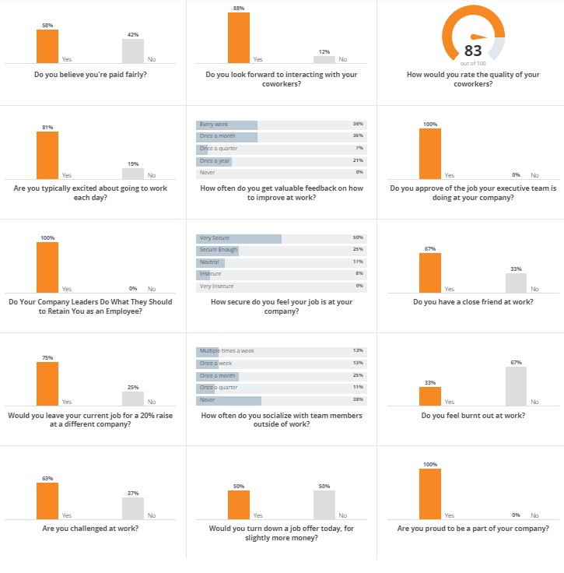
Figure 2: Hyatt retention rate
(Source: Comparably, 2023)
Hotel sectors are embracing contactless technologies to make simpler the process of guest journey by reducing waiting times and physical contact points. The use of augmented reality helps in staff onboarding training processes and also increases efficiency in back-of-house procedures such as F&B outlets and housekeeping (CIPD, 2024).

4.0 Discussion on different work modes in the hospitality industry over these five years
In the last five decades, the hospital industry has experienced a significant transformation in their working modes and employment structure. These modes are changed due to different factors such as changes in technological advancement and evolving consumer preferences and shifts in the labour market. It has also been observed that high performance working practices for internal and external workers have different outcomes for organisational performance (Murphy et al., 2018).
A significant change was noticed at the time of COVID-19, which resulted in the adoption of remote work for certain functions. The advancement in technology has made the process easier. The flexibility in the staffing presents the opportunities to reduce operational costs associated with maintaining the physical office spaces in Hyatt.
Industrialisation has played a important role in creating jobs. The concept of remote working, freelancing, work from home has gained popularity after the recession. Gig employment is lithe and temporary jobs at market and employers be disposed to hire freelancers and independent contractors as an alternative of full-time employees (Sahut and Lissillour, 2023).
It has been found that continuous change in the staff also disrupted the relationship between staff and guests. On the other hand, job security becomes a pressing issue. However, flexible scheduling has also emerged as a strategy for attracting and retaining talent. UK healthcare sectors make their position at the crossroads of tradition and innovation by adopting long-term employment and by replacing workers with flexible working modes (Medium, 2024).

5.0 An example of employee management that is initiated by the organisation Hyatt
It is to state that performance management is one of the important elements that is able to help in maintaining the productivity of the organisations (Armstrong and Taylor, 2020). In the case of different modes of work, whether it is the conventional work arrangement work, it is seen that organisations tend to use the performance appraisal method to manage the performance of their employees. It is to be said that the organisation had used the system named 'HRchitect' so that they are able to facilitate the human capital management in their business properly (Hrchitect, 2024). The system allows the organisation to facilitate their employee management as the data-driven monitoring of the employees can be carried out properly. The company also uses Cornerstone OnDemand's unified talent management solutions to do the performance management of its employees (Cornerstone, 2024).
On the other hand, for facilitating the management of their employees in the different work modes, it was seen that the organisation tends to listen to the opinions of their employees (PWC, 2024). This includes their employees on flexible working arrangements. Overall, it can be said that it is the feedback of the employees as well as the managers that helped the organisation in the monitoring of the employee management in the different work modes of the company.

6.0 Solutions to the problems
In the case of problems that have been identified, it can be seen that there are lack of consistency in the performance management of the organisations. A second-level manager review or a manager peer review helps in maintaining consistency in performance management (Cornerstone, 2024) In the different work modes that are applicable to the organisation Hyatt, it can be said that the consideration of such type of solution can be done as it will help in the maintenance of consistency in the performance management process.
On the other hand, it can be seen that the problem of lack of set standards is prevalent in the organisation. Although the usage of technological components is prevalent in the monitoring of the employees, the company is required to implement a set of standards and use assessments that will enable them to manage and monitor their employees working in different work modes. As per the report of Tsipursky (2022), regular weekly assessment needs to be included in work, and companies should reduce their dependence on software tracking programmes as 45% of the employees tend to be stressed in such cases. This is to be implemented in the Hyatt hotel as well.

7.0 Evaluation and conclusion
In reference to the information that has been obtained from the above section, it can be said that although Hyatt happens to be one of the leading hospitality industry companies, but, it can be seen that there is an issue related to lack of standardisation and lack of consistency. Apart from that, it can be said that it can be said that in remote modes of work as well as flexible work arrangements are prevalent in the hospitality sector. The employee retention rate in the company Hyatt happens to be less in nature. The work implies that it will be giving guidance about employee management strategies that companies such as Hyatt can implement in their operations and maintain their productivity. Apart from that it has also given a notion of the socio-economic factors that have been making an impact on the performance management of the companies.
Some solutions can be given to Hyatt. For example, the company can use manager peer review to maintain consistency in their performance management and they can use regular weekly assessments to facilitate their performance management. Based on the analysis that has been done in the previous sections, certain recommendations can be provided to the company. This has been highlighted in the following section
- In terms of the Hyatt, it can be seen that they are highly dependent on the technological system to do the employee management, however, it can create stress among the employees. 22% of the companies have used metrics to analyse the productivity of their employees (Tsipursky, 2022). The company can follow this to manage the performance of their flexible as well as the office work arrangement.
- On the other hand, as per the report of Gov (2024), in terms of the flexible working arrangement, the feedback of all the members of staff as well as the internal and the external clients needs to be done. It can be said that the organization will be required to follow such elements in their business process in an effective manner. The reason for this is that it will be able to help them to understand the performance of working in such a working arrangement in an effective manner.

Reference list

Armstrong, M. and Taylor, S. (2020) Armstrong’s handbook of human resource management practice. 15th edition. London, United Kingdom ;: KoganPage.
Awan, S.H., Habib, N., Shoaib Akhtar, C. and Naveed, S., (2020). Effectiveness of performance management system for employee performance through engagement. SAGE open, 10(4), p.2158244020969383.
Chemmanur, (2024). Sustainability in the hospitality industry [Online]. Available at: <https://www2.deloitte.com/uk/en/blog/consumer-business/2024/sustainability-in-the-hospitality-industry.html> [Accessed on: 14 May 2024]
CIPD, (2024). Employee turnover and retention [Online]. Available at: <https://www.cipd.org/en/knowledge/factsheets/turnover-retention-factsheet/> [Accessed on: 14 May 2024]
Comparably (2023). About Hyatt [Online]. Available at: <https://www.comparably.com/companies/hyatt/retention> [Accessed on: 14 May 2024]
Cornerstone. 2024. Hyatt: Reducing Sourcing Time and Increasing Review Frequency. Available at <https://www.pwc.com/us/en/library/case-studies/hyatt-talent-strategy-transformation.html > [Accessed 14 May 2024]
Cornerstone. 2024. INCLUDE A SECOND LEVEL MANAGER REVIEW OR A MANAGER PEER GROUP REVIEW. Available at <https://www.cornerstoneondemand.com/au/resources/article/how-to-ensure-consistency-in-employee-performance-appraisals/ > [Accessed 14 May 2024]
Deloitte, (2023). A view on the UK leisure consumer [Online]. Available at: <https://www2.deloitte.com/content/dam/Deloitte/uk/Documents/consumer-business/deloitte-uk-cip-leisureconsumer.pdf> [Accessed on: 14 May 2024]
EHL, (2024). Top 10 Trends in the Hospitality Industry in 2024 [Online]. Available at: <https://hospitalityinsights.ehl.edu/hospitality-industry-trends> [Accessed on: 14 May 2024]
Gov. 2024. Managing performance when working flexibly. Available at <https://www.psc.nsw.gov.au/assets/psc/documents/Managing-performance-when-working-flexibly.pdf > [Accessed 14 May 2024]
GOV.UK, (2023). Young people's travel – what's changed and why? [Online]. Available at: <https://assets.publishing.service.gov.uk/media/5a81dd5340f0b62305b9137e/young-peoples-travel-whats-changed-exec-summary.pdf> [Accessed on: 14 May 2024]
Hrchitect. (2024). HYATT HOTELS CORPORATION: EVALUATING AND SELECTING A LEARNING MANAGEMENT SYSTEM. Available at <https://hrchitect.com/wp-content/uploads/2017/11/Hyatt-Hotels-LMS-Evaluation-Selection.pdf > [Accessed 14 May 2024]
Hyatt (2024). About Us, Hyatt Hotels and Resorts . [online] Hyatt Hotels and Resorts. Available at: https://www.googleadservices.com/pagead/aclk?sa=L&ai=DChcSEwimgZuixIyGAxUzGYMDHclHBuQYABAAGgJzZg&ase=2&gclid=CjwKCAjw9IayBhBJEiwAVuc3fh7Wj8IGKcFQmNEw_hht66LPzmqyfQ_aF-3eCPKc7oPU9KrHRSm-LRoC9pEQAvD_BwE&ei=LQdDZrSuF5ST4-EP0IuxiAE&ohost=www.google.com&cid=CAESV-D239Bg1yIBCP3guPi5Fp-nK42TnWPbiP-uOTSeQUUF8aqB_jWxJ597pKhY3eE-yvQlR3Ql5XXg5H5iMsIOXb0Vewkbrk55S3dJLRk7mX0PLHfD6UJ7Vg&sig=AOD64_2iuiz2VINmDt-PwmaGudGes6JnzQ&q&sqi=2&nis=4&adurl&ved=2ahUKEwj0-JCixIyGAxWUyTgGHdBFDBEQ0Qx6BAgQEAE. [Accessed 14 May 2024].
Luther (2023). 12 Employee Turnover and Retention KPIs to Measure in 2024 [Online]. Available at: <https://www.netsuite.com/portal/resource/articles/human-resources/employee-turnover-kpis-metrics.shtml> [Accessed on: 14 May 2024]
Marchington, M. and Wilkinson, A. (2016) Human resource management at work. 6th ed. London: Chartered Institute of Personnel and Development.
Medium, (2024). Sustainable Travel, A Nomad’s Guide to Eco-Friendly Accommodation Choices [Online]. Available at: <https://medium.com/@jayrald.ado/sustainable-travel-a-nomads-guide-to-eco-friendly-accommodation-choices-06cf48b11a65> [Accessed on: 14 May 2024]
Medium, (2024). The Gig Economy and Care Work: A Flexible Future? [Online]. Available at: <https://medium.com/@care.connect.po/the-gig-economy-and-care-work-a-flexible-future-b5049c6ce74b > [Accessed on: 14 May 2024]
Murphy, K., Torres, E., Ingram, W. and Hutchinson, J., (2018). A review of high performance work practices (HPWPs) literature and recommendations for future research in the hospitality industry. International Journal of Contemporary Hospitality Management, 30(1), pp.365-388.
PWC. (2024). Hyatt’s talent strategy transformation. Available at <https://www.pwc.com/us/en/library/case-studies/hyatt-talent-strategy-transformation.html > [Accessed 14 May 2024]
‌Reuters (2020). CORRECTED-UPDATE 1-Hyatt to lay off 1,300 employees as pandemic cripples travel. [online] Available at: https://www.reuters.com/article/idUSL4N2CU0R1/.
Rudman, R. (2020). Performance planning and review: Making employee appraisals work. Routledge.
Sahut, J.M. and Lissillour, R., (2023). The adoption of remote work platforms after the Covid-19 lockdown: New approach, new evidence. Journal of business research, 154, p.113345.
Torrington, D, Hall, L, Atkinson, C, & Taylor, S (2020), Human Resource Management PDF EBook, Pearson Education, Limited, Harlow. Available from: ProQuest Ebook Central.
Tsipursky, D. (2022). How To Measure The Success Of Your Hybrid Work Model. Available at <https://www.cornerstoneondemand.com/au/resources/article/how-to-ensure-consistency-in-employee-performance-appraisals/ > [Accessed 14 May 2024]
Zippia. (2021). Hyatt Hotels Revenue: Annual, Quarterly, and Historic - Zippia. [online] Available at: https://www.zippia.com/hyatt-careers-5746/revenue/#:~:text=Hyatt%20Hotels[Accessed 14 May 2024].

