Learning in the Digital Era

Workshop Skills Logbook

(ACCA4025)

Louise Caygill; 2110765
Embedded Electronics Systems Degree Apprenticeship

Proteus Schematic
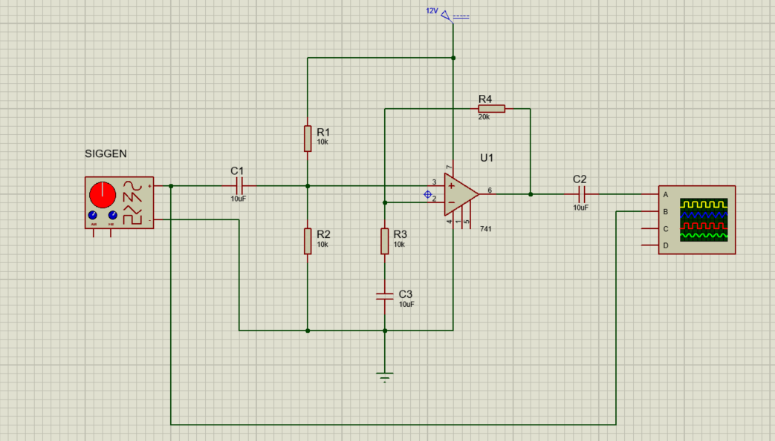
Below is the circuit I created in Proteus 8 Professional. It is a non-inverting amplifier circuit with a single supply, using the LM741 opamp, with a gain of 3 (the gain is found using the formula 1 + (R4/R2), in this case 1 + (20000/10000) = 3).
The below screenshot uses Proteus’ inbuilt simulation mode feature, to demonstrate that the gain of the amplifier is indeed 3. The signal generator is set to 1KHz centre frequency, with a 100mV sinewave input. As shown on the output of the oscilloscope attached to the circuit, we can see that the input from the signal generator is 100mV as stated, with the output of the circuit being 300mV, proving the gain of 3. This is how the test was conducted for the simulated circuits.
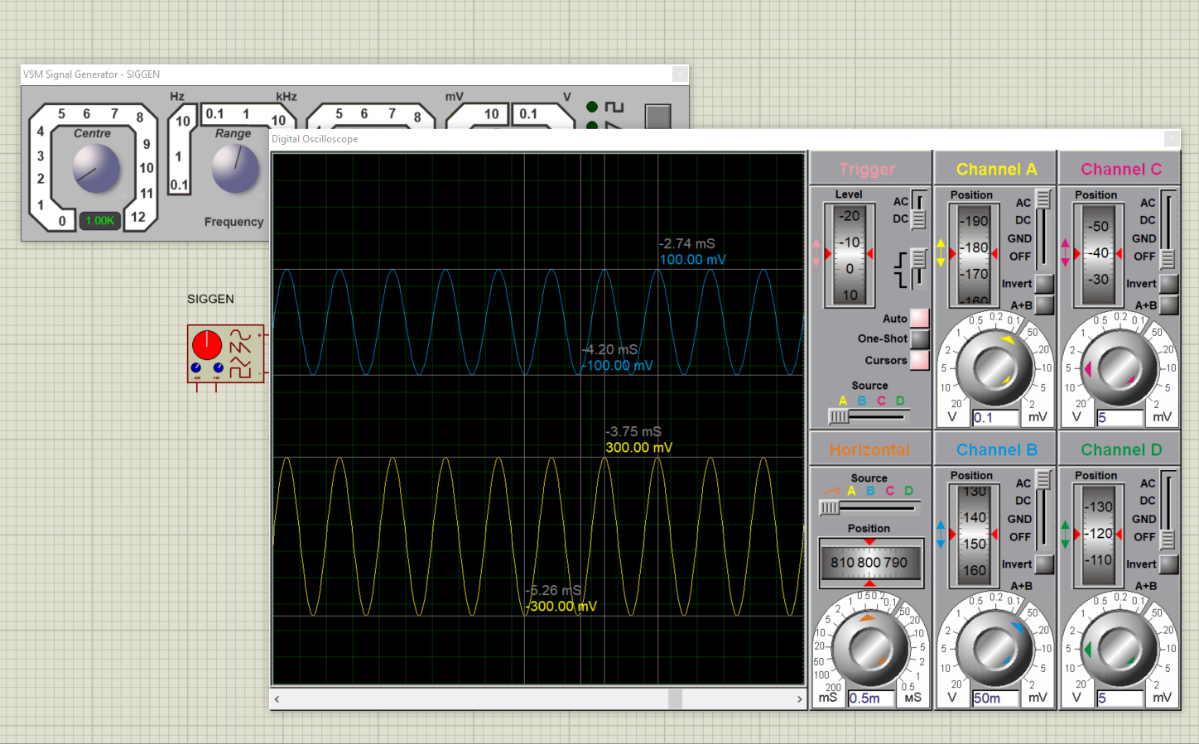

Proteus Simulation Table and Graph
Below is the gain response from the simulated circuit in Proteus (as demonstrated on the previous page), using the LM741 chip, with the gain plotted on a logarithmic graph. It shows a slight build up to 300mV, which is the gain of 3 that was expected and then a moderately steep roll off after 50KHz. The table and graph show that the best response happens across the 500Hz-20KHz range.
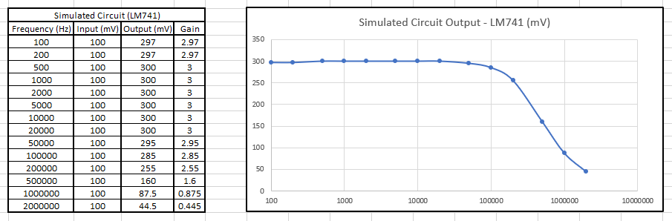
Below is the gain response from the simulated circuit in Proteus, using the TL071 chip, with the gain plotted on a logarithmic graph. This graph shows a more stable start at 300mV, with a less steep roll off after 100KHz, giving a much better gain response, from 100Hz up to 50KHz.
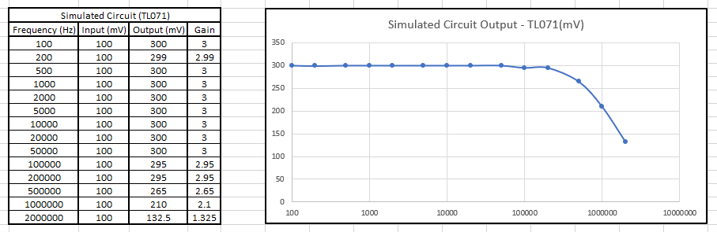

Breadboard Build and Test
After creating the circuit on Proteus, we then had made it on a breadboard using an LM741 opamp, with three 10KΩ resistors, one 20KΩ resistor and two electrolytic 10uF capacitors with wires for signal input and output and power. The same tests as carried out on the simulated circuit were then applied to the breadboard (as seen in the below graph), using the same frequencies as on the simulated circuit in order to get a comparison of results.
The opamp required 12V of external power in order to function and received a sine wave input through a potential divider of resistors, which is used to bias the opamp, so that the output signal is kept from being amplified beyond the limits set by the supply voltage, and to make sure that it has a large range. The output of the opamp then was connected through a second capacitor to the output header, with a feedback resistor going into a second potential divider for the negative input of the opamp. This is used to set the output voltage to the desired value, which will be a multiple of the input value because of this divider and feedback resistor. The input capacitor is a coupling capacitor used for DC blocking to allow the full sine wave from the input, limiting noise, with the output capacitor providing the same function, but to the output connection.
In order to test the circuit, probes were connected to the same points of the circuit as in the simulated one. On the output leg of the output capacitor and on the first leg of the input capacitor, to measure the difference in input and output to see the gain. The input probe provided the signal from the signal generator on the desk and the +12V power was provided from the same machine. The test started at 100MHz and increased on a logarithmic scale up to 2MHz. As in the simulated circuit, the chip worked well (albeit not quite as well as the simulation, but close) up until 100KHz, where it started to roll off, before a steep roll off starting at 500KHz. The same characteristics were observed in all the tests, with only the simulated circuit using the TL071 chip not having a steep roll off at the frequencies used. However, were it to be used with higher frequencies, it would more than likely exhibit the same characteristics (note: I attempted to test the TL071 chip at higher frequencies in order to test this theory, however, I was unable to due to the program crashing at anything higher than 3MHz. As expected, 3MHz did continue to lose gain, but not as much as the LM741).

Breadboard Table and Graph
Below is the gain response from the circuit recreated on a breadboard, with the gain plotted on a logarithmic graph. It shows a similar build up, but doesn’t quite reach 300mV, which can come from component/cabling/supply issues or interference from other systems. It also demonstrates the same steep roll off that the simulated LM741 chip produced, with the best response happening between 200Hz to 50KHz.
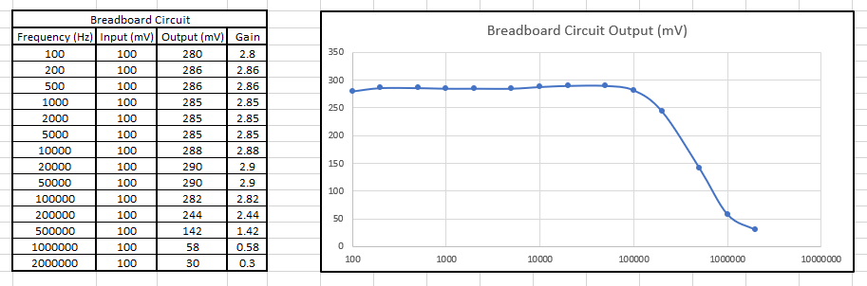

EasyPC Schematic
Below are two schematics, the first was made by myself. However, it didn’t get made, and I was given a fellow students PCB to solder and test. I felt it a good idea to include the design for the PCB I was given, so that any differences in the physical PCB were accounted for, as we used different designators, but also to show that I completed the work too.
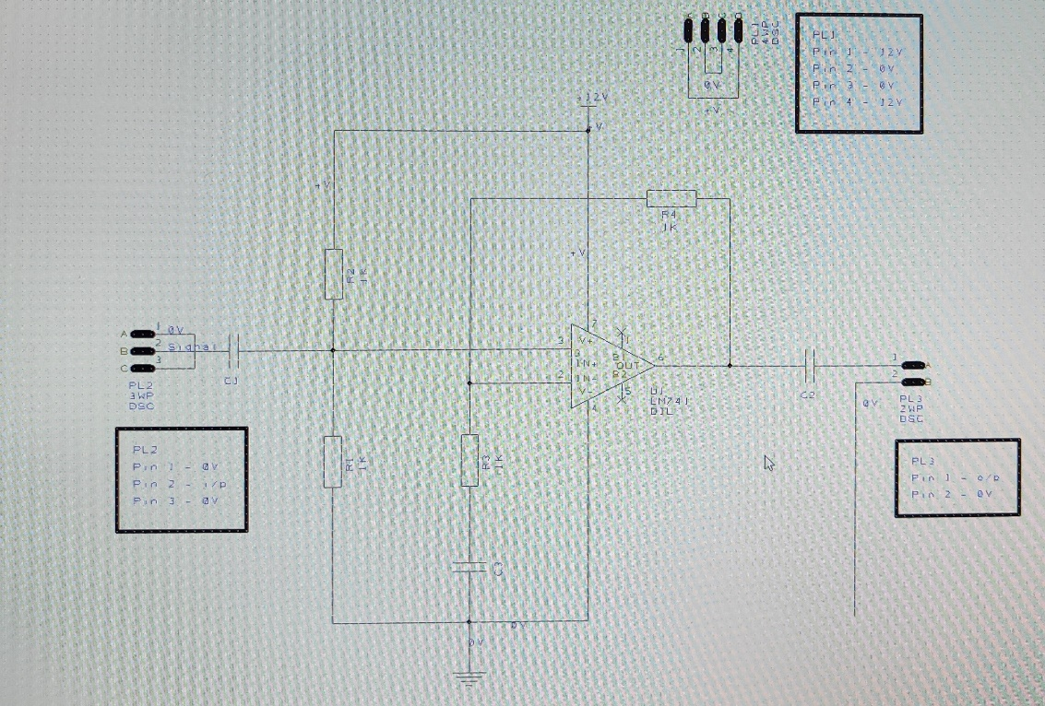
Directly below is the schematic made by myself. Following the circuit from the Proteus simulation, using generic components from the software library, with an LM741 chip

And below is the circuit of the PCB that I soldered and tested. Made by Rhys Higgins
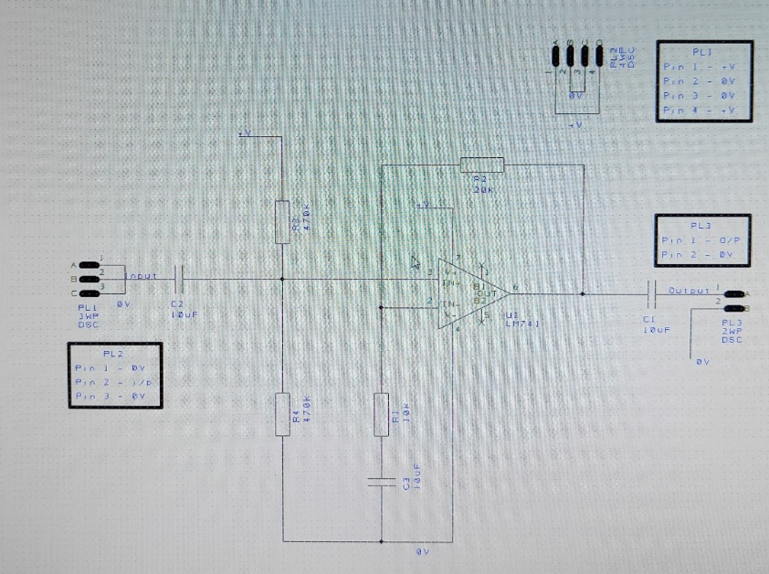

EasyPC PCB Design
As with the previous section, I have included my PCB design, made from my schematic, as well as the design of the PCB I ended up making from a fellow student. Again, both are included, in order to highlight any differences from the design to my handed in PCB, but also to show that I completed the work myself.
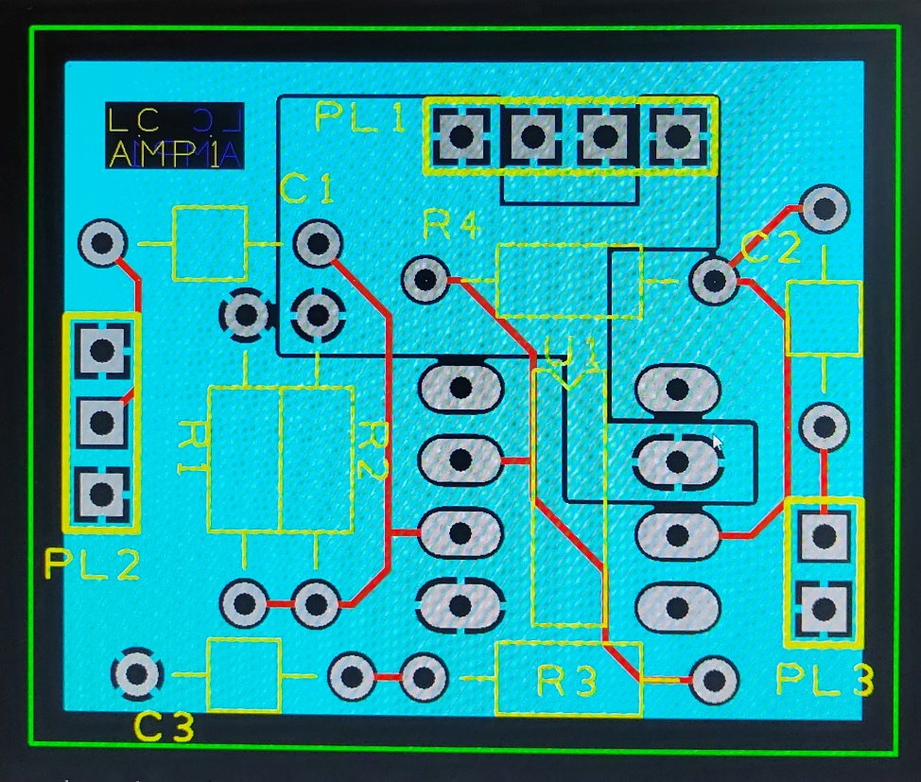
Directly below is my PCB design, created from my own schematic. It shows the tracks connecting as with the schematic, outlines for the components as well as designators, holes for the legs of the components, headers for cables to plug into and copper pours for the +12Vin and ground. For the IC the outline has a notch at the top, this will correspond to pin one on the chip and will match a similar notch cut into the chip itself in order to orientate it correctly. It was subject to a design rule check (DRC) in order to make sure that everything was connected correctly, none of the pours or masks were overlapping where they shouldn’t, and the tracks don’t come too close to each other. If a DRC isn’t run, then the PCB could be made as it is, mistakes and all, if the company used don’t pick up on any errors. So it is good practice.

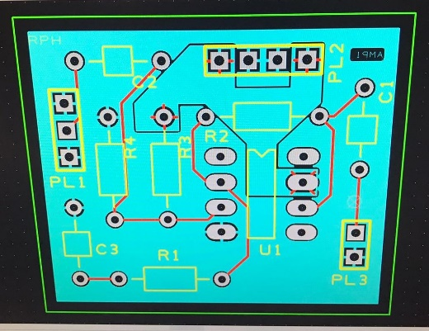
Second, is the PCB design from Rhys, which I ended up using. We had a very similar design and the only main difference is the way we have numbered components.

PCB Build and Test
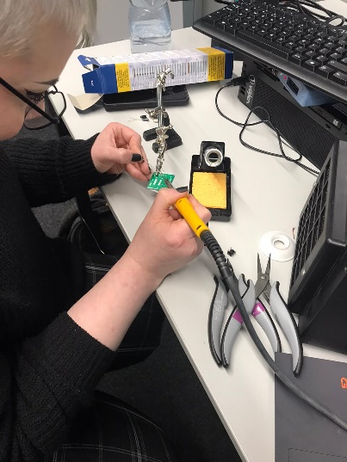
I collected my components from the supplies and set up my desk with the soldering iron, stand and extraction fan. I used tape to keep the components in place when I flipped the board over in order to solder them. I accidentally soldered two of the capacitors in the wrong position, as I was looking at my schematic, instead of the one belonging to the PCB I was soldering, which had different designators. So, I removed them using solder wick, which unfortunately left marks on the bottom of the board that I was unable to get rid of. The rest of the build went smoothly, and I then soldered wires for input, output and power straight into the board as headers were not available.
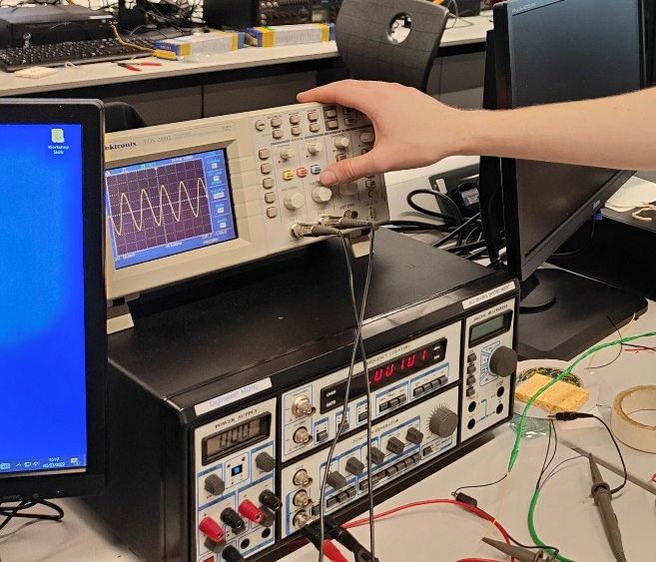
With the board built and myself happy with the quality, I then tested it in the same manner as the simulated and breadboard circuits, this time using the wires that I had soldered in. Using the signal generator and power supply (both provided from the same machine as shown in the picture to the right below) from the breadboard test, and an oscilloscope, with the first probe being connected to the input to provide the signal and measure it, and the second probe connected to the output of the circuit. I found that my results were not as I was expecting and after trying a couple of different frequencies, I noticed that two of the resistors were the wrong way round and I needed to change them, again, this is likely due to me looking at the wrong diagram. After doing this I got the results I was expecting and was able to complete the tests, as shown in the below graph. However, I did experience a large amount of noise from external sources on my circuit (this could also be from having the resistor values the wrong way round when first putting a signal into the board).

PCB Table and Graph
Below is the frequency gain response from the PCB that I built, with the gain plotted on a logarithmic scale. It shows a less uniform response to the simulated circuit, similar to the breadboard circuit, with the same build up and steep roll off as the other circuits, and the best response between 500Hz and 100KHz.

