

William Young
2113840
Word Count: 6 A4 Pages & 1520 Report

Risk Assessment & ALARP Justification

UWTSD
ACDA 5013 Safety & Hazard Assessment

BEng
Academic Year: 2023 - 2024

Supervisor: Austin Clarke
October 2024

Academic integrity declaration
I declare that:
- the thesis submitted has been written by me alone.
- the thesis submitted has not been previously submitted to this university or any other.
- that all content, including primary and/or secondary data, is true to the best of my knowledge.
- that all quotations and references have been duly acknowledged according to the requirements of academic research.
I understand that to knowingly submit work in violation of the above statement will be considered by examiners as academic misconduct.

Abstract
A group Risk Assessment (Section 1) has been conducted on the AK-47 system during the CADMID cycle’s In-Service phase, consisting of a Risk Class Matrix (RCM), Hazard Identification (HAZID) and Hazard and Operability (HAZOP) Study. An ALARP Justification (Section 2) was then created for a misfire hazard, with three initiators being selected due to word count limitations and their Severity similarity.

Table of Contents
Academic Integrity Declaration …………………………………………………………… 2
Abstract ...…………………………………………………………………………………… 3
List of Figures ………………………………………………………………………………. 5
1 Group Risk Assessment ..……………………………………………………………….. 6
1.1 AK-47 Introduction ….………………………………………………………..… 6
1.2 Group Work Introduction ….………………………………….……………..… 7
1.3 Risk Class Matrix (RCM) ..…..……………………………………….……..… 7
1.4 Hazard Identification (HAZID) …..…..………………………………...……… 9
1.5 Hazard and Operability (HAZOP) Study …….………………….……….…. 10
2 As Low as Reasonably Practicable (ALARP) Justification ……………………….… 12
2.1 Hazard ….………………………………………………………...………....… 12
2.2 Narrative ….………………………………………………………...……….… 12
2.3 Limits, Assumptions and Conditions (LACs) and Shortfalls …….……...… 14
2.4 Identified Controls ………….……………………………………………....… 14
2.5 ERICPD .…………………………………………………………………….… 15
2.6 Conclusion .………………………………………………………………....… 17
3 Bibliography …………………………………………………………………………..… 18

List of Figures
Figure 1 Kalashnikov Rifle ….……….......................................................……….……. 6
Figure 2 ALARP Demonstration .….….……………………………………………...….... 7
Figure 3 Risk Class Matrix (RCM) ……...……………….………………..…………….... 8
Figure 4 – Hazard Identification (HAZID) ….…….…………………….……………...… 9
Figure 5 – Hazard and Operability (HAZOP) Study ………….……………………..…. 11
Figure 6 – SPORTS Acronym ..…..…..………………………………………………..... 17

1 Group Risk Assessment
1.1 AK-47 Introduction
The AK-47, officially known as the Avtomat Kalashnikova, is an assault rifle developed in the Soviet Union by Mikhail Kalashnikov and is the original model of the Kalashnikov family of rifles. It has remained enduringly popular since its inception, with approximately 75 million in use worldwide. [1]
Work began on the creation of the AK-47 during the Second World War with submachine gun and light machine gun designs after a growing requirement to counter German automatic rifles. After the creation of the 7.62mm M43 cartridges, Kalashnikov designed a new rifle to accommodate them. Further early designs of the AK-47 were also produced, with the AK-1 and AK-2 being designed in 1946. A major redesign occurred in 1947 to improve reliability, giving rise to the Avtomat Kalashnikova 1947, or AK-47. Design improvements included a long-stroke gas piston above the barrel, a single receiver, a single control lever and dust cover, and a bolt handle attached to the bolt cover. [2]
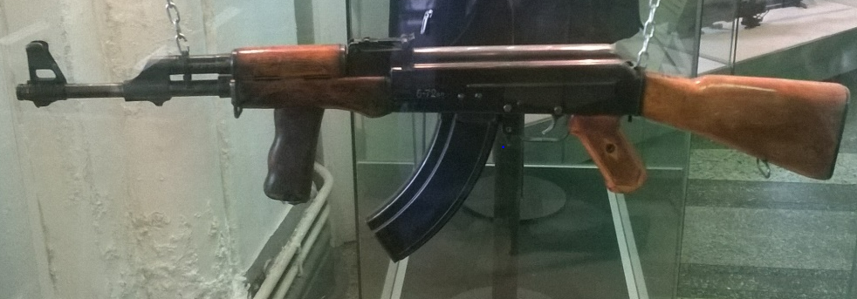
Figure 1 – Kalashnikov Rifle [2]
Designed by a former soldier, the AK-47 was a simple and reliable fully automatic rifle that could be manufactured through relatively fast and inexpensive mass production methods. [3] The long-stroke gas piston above the barrel significantly improved the rifle’s operability in a variety of weather conditions, leading to use in multiple international conflicts since its creation. Its inexpensive manufacturing methods have made the AK-47 cheaper to replace than to repair, and its service life ranges from approximately 6000 rounds to 15,000 rounds. [4]
  - Group Work Introduction
The initial tasking for this assessment was to conduct early-stage Safety Case assessments in a small group to simulate the process of Hazard Identification (HAZID) and the creation of Hazard Logs. A Risk Class Matrix (RCM) was produced, followed by a basic HAZID of the AK-47 system. Five hazards were taken forward from the HAZID into a HAZOP study, with Risk Classes (RC) being attributed from the RCM. Each member of the group chose a hazard on which to produce an As Low As Reasonably Practicable (ALARP) Justification to mirror the process of Hazard Analysis (HAZAN) and Fault Group (FG) creation.
  - Risk Class Matrix (RCM)
Figure 3 shows the RCM created by the group. Numbers and a traffic light system were used to illustrate the RC of the hazards and provide simple visual aids, ranging from Broadly Acceptable to Intolerable as per the ALARP justification diagram shown in Figure 2. Likelihood was estimated based on a reasonable Probability of Failure on Demand (PFD) for the AK-47, with Severity parameters based on qualitative data from the Health and Safety Executive (HSE).
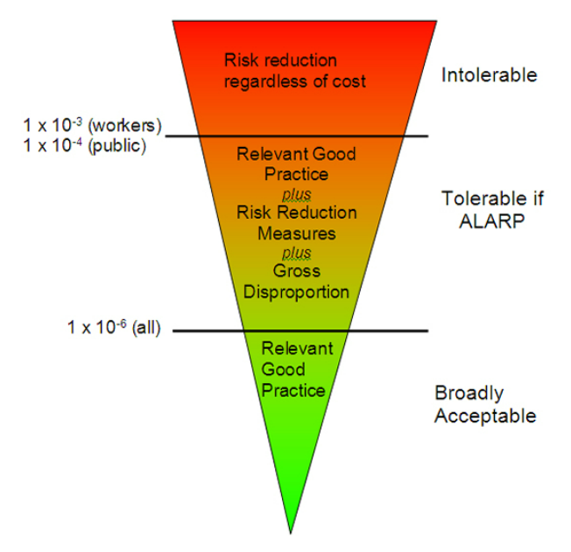

Figure 2 – ALARP Demonstration [5]

 | Insignificant (1) | Minor (2) | Significant (3) | Major (4) | Severe (5)
Frequent (5) | Medium (5) | High (10) | Very High (15) | Very High (20) | Very High (25)
Likely (4) | Medium (4) | Medium (8) | High (12) | Very High (16) | Very High (20)
Occasional (3) | Low (3) | Medium (6) | Medium (9) | High (12) | Very High (15)
Unlikely (2) | Low (2) | Low (4) | Medium (6) | Medium (8) | High (10)
Improbable (1) | Low (1) | Low (2) | Low (3) | Medium (4) | Medium (5)

 | Lower | Higher | Tolerability
Low | 1 | 3 | Broadly Acceptable
Medium | 4 | 9 | Tolerable if ALARP
High | 10 | 14 | Tolerable if ALARP
Very High | 15 | 25 | Intolerable

Likelihood
Frequent | 1-100
Likely | 100-1000
Occasional | 1000-10000
Unlikely | 10000-100000
Improbable | 100000-1000000

Severity
Negligible | No Injury
Minor | Minor Injury
Significant | Major Injury
Major | One Death
Severe | Multiple Deaths

Figure 3 – Risk Class Matrix (RCM)

1.4 Hazard Identification (HAZID)
Figure 4 shows the list of hazards considered during the group’s HAZID. A variety of hazards were briefly considered, with scope limited to the In-Service phase of the CADMID cycle.
Hazard | Description
Bandits | Terrorist attack
Recoil | Pushback from firing
Ejected casings | Casings from firing
Misfire | Failure to fire, ie lodged projectile/incomplete burn
Inadvertent Firing | Human
Hot Barrel | Heat from firing
Mis-Assembly | Puts magazine in wrong, etc
Slips Trips Falls | During use of gun
Drop & Impact | During use of gun
Water ingress | Ingress into gun/storage
Sand ingress | Ingress into gun/storage
Excessive Temperature | Leading to gun failure
Finger jam | Trigger getting jammed
Sun glaze on sight | Human error
Improper Electrical Input | Leading to other hazards
Bullet manufacture error | Leading to other hazards
Barrell manufacture error | Leading to other hazards
Improper storage | Leading to other hazards
Ricochet | Bullets rebounding, ie off walls
Lack of training | Human error
Grip | Poor grip leads to improper firing
Miss magazine hole | Human error
Attachment failure | Attachment breaking, ie sling/bayonet
Weight | Heavy gun
Explosive compound failure | Projectile failure
Wear and tear | Potential for other hazards
Sight/Scope | Potential to hit self/others
Human failure | Human error
Noise | Noise from firing

Figure 4 – Hazard Identification (HAZID)

1.5 Hazard and Operability Study (HAZOP)
From the HAZID, five hazards were selected to be discussed in greater detail. A table, shown in Figure 5, was produced to complete the HAZOP. ID numbers were attributed to each hazard, ranging from H1-H5, and a description and estimation of potential injuries was provided. [6] From this information, Likelihood and Severity was assessed and allocated a value, in turn providing a Risk Factor (RF) based on the equation below.
Equation 1: Risk = Likelihood x Severity [6]
Comparing the RF to the RCM provided an RC. Risk reduction methods were added to the table to create Residual Likelihoods and Severities, resulting in reduced RFs and RCs.
From this, each member of the group chose one hazard to proceed with an individual ALARP Justification. The hazard chosen for this report was misfire of the AK-47.

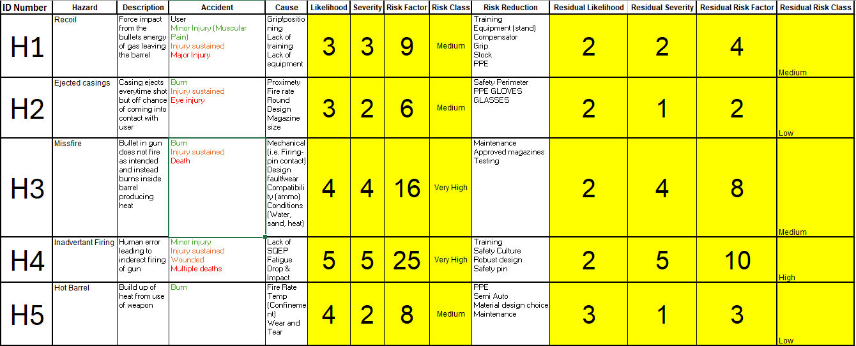
Figure 5 – Hazard and Operability (HAZOP) Study

2 As Low as Reasonably Practicable (ALARP) Justification
2.1 Hazard
This ALARP Justification is based on the misfire hazard identified during the group HAZID and HAZOP Study. The scope is limited to In-Service use of the AK-47. Three initiators have been selected due to the limited size of the report and their compatible Severities. The format for this Justification was selected from academic and professional sources in accordance with HAZAN best practice. [6] [7] [8]
2.2 Narrative
The AK47 uses the following cycle of operation in semi-automatic mode: [9]
- Feeding: A magazine is inserted into the receiver. The magazine follower forces the top cartridge into the path of the bolt. The magazine spring applies pressure to the magazine.
- Chambering: A cartridge is driven forward under pressure from the expanding action spring. The bolt carries the top cartridge and drives it into the chamber. The extractor snaps into the extracting groove on the cartridge.
- Locking: The bolt closes fully to prevent the loss of gas pressure until the bullet has left the muzzle. The cam pin rotates the bolt during the bolt carrier forward motion, locking it into the barrel extension.
- Firing: The firing pin strikes the primer in the rear of the cartridge. When the trigger is pulled, the trigger hooks disengage from the hammer and the hammer is released, moving it forward under pressure from the hammer spring to striker the firing pin. The firing pin is driven against the primer and ignites the propellant in the cartridge case to propel the bullet through the barrel.
- Unlocking: While expanding gases propel the bullet through the barrel, a small volume of gas enters the gas tube and pushes the gas piston, bolt carrier assembly and bolt assembly to the rear. Excess gas is vented through ports in the gas tube. As the bolt carrier moves, the bolt rotates in the bolt carrier and unlocks from the barrel extension. Remaining gas is expelled through the muzzle with the bullet.
- Extracting: The bolt extractor holds the base of the cartridge against the bolt face as the bolt moves to the rear until the front of the cartridge case clears the rear of the chamber.
- Ejecting: The empty cartridge case is held by the extractor. The base of the cartridge strikes the fixed ejector in the receiver. The cartridge is pivoted by the extractor and deflected out of the ejection of the receiver.
- Cocking: The bottom of the bolt carrier rides over the hammer, pushing the hammer down. While holding down the trigger, the hammer is pushed to the rear until it is caught by the disconnector. While not holding the trigger, the hammer is pushed to the rear until it is caught by the trigger hook.
The mechanism is almost identical during automatic firing, except for the addition of an auto sear that momentarily holds the hammer rearward until the bolt has fed, chambered and locked on the next round. [9]
INITIATOR 01 - Water ingress leading to misfire.
During In-Service use of the AK-47 it may be required to use the system in wet environments. Examples include the requirement to travel short distances or fire underwater, as well as operate during heavy rain. It is therefore reasonably foreseeable that water may enter the AK-47.
This may lead to misfire as a result of ingress into the magazine casing or primer, the barrel, or the gas propulsion systems. Failure to fire may result in the death of the operator from enemy combatants during conflict, or an increase in gas pressure due to higher resistance in the system while firing, resulting in a lethal barrel burst.
This has therefore been assessed as a Medium RF, with a Major Severity (one death) and Unlikely Likelihood (10,000-100,000 PFD).
INITIATOR 02 - Use of incompatible ammunition leading to misfire.
During In-Service use of the AK-47 situations may arise where the use of incompatible ammunition occurs. Misinformation suggesting AK-47 ammunition is interchangeable with other 7.62mm ammunition and may lead to incorrect usage in deployment. Combat situations may arise in which no compatible ammunition remains and alternatives may need to be used. Human error may also lead to the use of incompatible ammunition. It is therefore reasonably foreseeable that incompatible ammunition may be fed into the AK-47.
This may lead to misfire as a result of a round failing to leave the barrel and becoming lodged. Failure to fire may result in the death of the operator from enemy combatants during conflict. If another round is fired with a lodged round, a lethal barrel burst may occur.
This has therefore been assessed as a Medium RF, with a Major Severity (one death) and Unlikely Likelihood (10,000-100,000 PFD).
INITIATOR 03 – Firing pin fails to impact primer leading to misfire.
During In-Service use of the AK-47 the firing pin may fail to contact the primer. The trigger hooks may fail to disengage when the trigger is pulled, resulting in a failure to release the hammer and impact the firing pin, which in turn cannot impact the primer. The firing pin may also fail and break due to poor quality or age of the system. It is therefore reasonably foreseeable that firing pin failures may affect the AK-47.
Failure of the firing pin to impact the primer may lead to a failure to fire, resulting in the death of the operator from enemy combatants during conflict. Poor contact may lead to incomplete powder burn of the primer and a misfire of the round, leading to a potential cook-off and lethal unintended firing incident.
This has therefore been assessed as a Medium RF, with a Major Severity (one death) and Unlikely Likelihood (10,000-100,000 PFD).
2.3 Limits, Assumptions and Conditions (LACs) and Shortfalls
No Limits or conditions were found during this ALARP Justification. Two Assumptions were raised as follows:
ASSUMPTION 01: AK-47 rifles are fired no more than 15,000 rounds in their service lifetime.
ASSUMPTION 02: Prior to In-Service use of the AK-47, all system components are stored and transported in accordance with appropriate regulations.
2.4 Identified Controls
The following Safety Measures (SM) have been defined:
SM01 - Approved ammunition: Only approved NATO ammunition may be used In-Service.
SM02 - Operator training: All operators of the AK-47 shall be Suitably Qualified and Experience Personnel (SQEP).
SM03 - System maintenance: AK-47 shall be appropriately maintained before and after use.
SM04 - Component certification: All system components shall be tested and evaluated prior to receipt/use.
2.5 ERICPD
INITIATOR 01 - Water ingress leading to misfire.
ELIMINATE – Cannot eliminate the risk if deployment is necessary as it may require amphibious activities or use in wet climates. Consider the use of remote forces such as drones and missile strikes.
REDUCE – Minimise time spent with AK-47 underwater. Cover the AK-47 for as long possible during wet conditions. Drain water from the system, particularly the barrel, prior to firing. Maintain the system after water ingress to prevent rust and build-up of foreign material. Use approved military ammunition with lacquer seals. Use plastic magazines. Cease firing any weapon showing signs of misfire, such as a difference in sound or recoil, and point barrel away from personnel. Follow the SPORTS procedure (Figure 6).
ISOLATE – Remove wet systems from service after operations to ensure effective maintenance procedures prior to reuse. Remove any weapon that misfired from service until appropriate inspections can take place.
PPE – Consider the use of body armour, protective gloves, ear defenders and eye goggles.
DISCIPLINE – Follow all safety advice and protocol for inspection, maintenance and firing of the AK-47.
INITIATOR 02 - Use of incompatible ammunition leading to misfire.
ELIMINATE – Ensure all stored ammunition is NATO certified and compatible with the system.
REDUCE – Ensure personnel inspect supplied ammunition prior to deployment. Ensure personnel check ammunition prior to feeding.
ISOLATE – Control access to ammunition storage and supply to SQEP quartermasters.
PPE – Consider the use of body armour, protective gloves, ear defenders and eye goggles.
DISCIPLINE - Follow all safety advice and protocol for inspection of ammunition prior to and during operations.
INITIATOR 03 – Firing pin fails to impact primer leading to misfire.
ELIMINATE – Cannot eliminate the risk if deployment is necessary. Consider the use of remote forces such as drones and missile strikes.
REDUCE – Use AK-47 within its appropriate service life. Use approved AK-47 military ammunition. Use approved AK-47 suppliers. Maintain the system after use to prevent rust and build-up of foreign material. Cease firing any weapon showing signs of misfire, such as a difference in sound or recoil, and point barrel away from personnel. Follow the SPORTS procedure (Figure 6).
ISOLATE – Remove wet systems from service after operations to ensure effective maintenance procedures prior to reuse. Remove any weapon that misfired from service until appropriate inspections can take place.
PPE – Consider the use of body armour, protective gloves, ear defenders and eye goggles.
DISCIPLINE – Follow all safety advice and protocol for maintenance and firing of the AK-47.

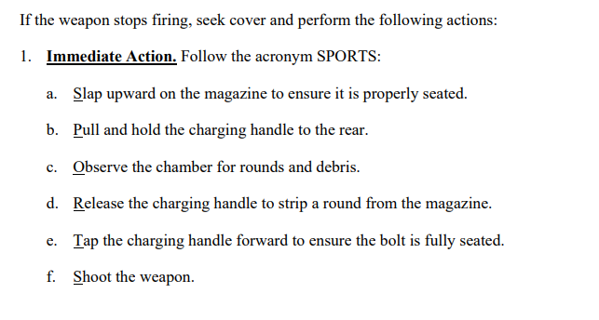
Figure 6 – SPORTS Acronym
2.6 Conclusion
Three initiators for the misfire hazard of an AK-47 have been analysed. Safety measures have been assessed and ERICPD has been used to justify their risk as ALARP.

3 Bibliography

[1] | P. Killicoat, “Weaponomics: The Global Market for Rifles,” University of Oxford, Oxford, 2007.
[2] | J. Poyer, The AK-47 and AK-74 Kalashnikov Rifles and Their Variations: A Shooter's and Collector's Guide, Tustin: North Cape Publications, 2006.
[3] | R. Tilstra, The Battle Rifle: Development and Use Since World War II, Jefferson: McFarland & Company , 2014.
[4] | Ruffle, “Arsenal Assault Rifle Advantages,” Ruffle, 2014. [Online]. Available: https://web.archive.org/web/20141006075455/http://www.arsenal-bg.com/defense_police/7%2C62ar-m1-m1f.htm. [Accessed 24 09 2024].
[5] | Health and Safety Executive, “Guidance on ALARP Decisions in COMAH,” HSE, 2024. [Online]. Available: https://www.hse.gov.uk/foi/internalops/hid_circs/permissioning/spc_perm_37/. [Accessed 24 09 2024].
[6] | B. a. T. F. Crawley, HAZOP Guide to Best Practice, Waltham: Elsevier Ltd., 2015.
[7] | T. Kletz, HAZOP & HAZAN, Rugby: Institution of Chemical Engineers, 1999.
[8] | V. &. V. R. Venkatasubramanian, “A knowledge-based framework for automating HAZOP analysis,” American Institute of Chemical Engineers Journal, vol. 40, no. 3, pp. 496-505, 1994.
[9] | Department of The Navy, Technical Manual 8370-50007-OR/1, Washington: Department of The Navy, 2009.

