ACCA5026Databases and Application Development
Part A Report: Database Design & Implementation

Scenario: MedAssist Clinic
Lecturer: Mohd Syafiq Bin Zolkeply
Student Name: Narcis Valentin Gorgos
Student ID 2407130
Submission Deadline: 31 July 2026

1. Introduction
MedAssist Clinic is an independent health care facility in the United Kingdom that provides outpatient care, such as basic consultations, diagnostic tests and specialist referrals. Paper-based records and disjointed appointment logs cause operational issues: When patient numbers grow, administrative staff can't see the customer's treatment history from one department to another without manually searching for files, and appointment conflicts are only noticed when they occur at the time of service. A centralized relational database addresses these issues by organizing patient information, appointments, treatment results, departmental organization and feedback into a uniform and structured data system accessible for queries. The clinic is currently limited in these ways, and the definition of a database management system by Silberschatz [1] focuses on these very points: it is a collection of related data and programs that makes information easily and efficiently accessible.
This report outlines the design and implementation of a relational database in MySQL 8.0 for MedAssist Clinic. It includes topics on entity identification, ER modelling, normalization to Third Normal Form (3NF), SQL schema design with integrity constraints, SQL stored procedures with transaction control, audit triggers and secondary indexing for query optimization. All design decisions are explained using known fundamental concepts of databases and existing literature. The full SQL implementation is provided separately in the file db.sql and this report concentrates on the rationale, structure and validation.

2. Database Design
2.1 Entity Identification and Attributes
The described processes of the clinic generate 6 entities. They are each a different real-world entity that has a well-defined purpose within the system. A seventh entity, AuditLog, is provided for trigger-based change tracking for governance.
Entity | Primary Key | Key Attributes
Department | department_id (PK) | department_name, location
Doctor | doctor_id (PK) | first_name, last_name, specialization, phone, email, department_id (FK)
Patient | patient_id (PK) | first_name, last_name, date_of_birth, gender, phone, email, address, registration_date
Appointment | appointment_id (PK) | patient_id (FK), doctor_id (FK), appointment_date, appointment_time, reason, status
Treatment | treatment_id (PK) | appointment_id (FK), diagnosis, prescription, notes, treatment_date
Feedback | feedback_id (PK) | patient_id (FK), appointment_id (FK), rating (1–5), comments, feedback_date
AuditLog | audit_id (PK) | table_name, operation, record_id, changed_at, changed_by

Wherever possible, AUTO_INCREMENT surrogate integer primary keys are used. Natural keys, like patient email addresses, may change, leading to update anomalies in all related tables. Coronel and Morris [2] suggest that in relational schemas where business data changes over time, but the schema must remain stable, surrogate keys should be implemented as a standard.
2.2 Entity Relationships and Cardinalities
The entities are related to each other as follows, based directly on the clinic's business processes:
- Department employs many Doctors (1:M). A dermatology department has multiple dermatologists each of whom is a member of exactly one department at any given time.
- A doctor makes many appointments (1:M). A GP visits several patients for several appointments and each appointment has one GP.
- Patient books many Appointments (1:M). A registered patient can visit multiple times, and each visit is an appointment of one registered patient.
- At least one Treatment (1:1, optional) is created from an appointment. Treatment record is only created for a consultation. Scheduled and cancelled appointments do not have a treatment record.
- Patient submits many Feedback entries (1:M), but each Appointment receives at most one Feedback entry (1:1). The one-per-appointment rule is enforced at the database level, by the UNIQUE constraint on Feedback.appointment_id.

2.3 Entity Relationship Diagram
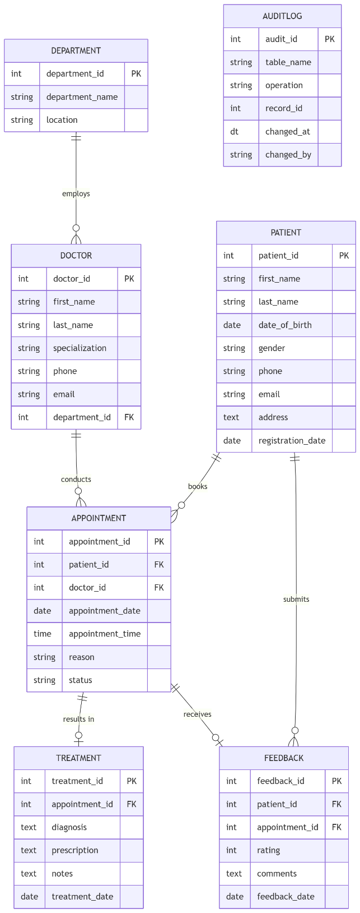
Figure 1 presents the ERD.
2.4 Normalization to Third Normal Form (3NF)
According to Coronel and Morris [2] the normalization process is an incremental process that involves restructuring a relational schema to remove data duplication and to avoid the update, insertion, and deletion anomalies. There are three normal forms satisfied by the design:
First Normal Form (1NF)
A relation is said to be in 1NF if it has no repeating groups and if each attribute is an atomic, indivisible attribute [1]. There is exactly one value in each table for each row for each attribute. Patient addresses are in one field called TEXT. Specializations of Doctor are single strings. There is no table containing multi-valued fields or array fields [10].
Second Normal Form (2NF)
In 2NF, all the non-key attributes are fully functional dependent on the complete primary key which means that there are no partial dependencies [1]. There are no partial dependencies by definition as each table is dependent on only one surrogate primary key (patient_id, appointment_id, etc.). There are no non-key attributes that are dependent on the subset of a composite key.
Third Normal Form (3NF)
Transitive dependencies are eliminated in 3NF, which is a dependency of a non-key attribute on another non-key attribute [2]. One of the most frequent errors is to have department_name directly in the Doctor table. This makes a transitive dependency between doctor_id and department_name, via department_id. The solution is to create a separate table for the department and connect to that table (department_id) through a foreign key. A change of a Department name now results in one change of one Department row, and all Doctor records 'roll up' due to the foreign key link between the two.
It is the same throughout. Treatment only stores the outcome of a consultation, not duplicate patient names, doctor names, nor appointment dates, but rather uses appointment_id. When a patient's phone number is changed, there are no cascading changes to the Appointment or Treatment records, only changes to one row of Patient. It's a completely 3NF design [7].
2.5 Normalization vs Performance
3NF involves joining the three tables Department, Doctor and Appointment for each query to the schedule. If department_name is denormalized as Doctor, you lose the join but you get an update anomaly: an update to the 'rename' column will affect every Doctor row, which may lead to partial updates without affecting the data, which can cause problems [2]. The join takes less than one millisecond at the scale of the clinic, with just six doctors and three departments. Denormalization is rejected. The Treatment, Prescription field is a known 1NF compromise, a future Prescription table would normalize multi-drug records, but adds complexity where there is no current requirement for such a query.
2.6 Alternative Design Choices
The choice of surrogate AUTO_INCREMENT keys over natural keys (NHS number, email) is due to the possibility of the natural key changing over time, and potentially exposing personal data in multiple tables, thus increasing the risk of GDPR breaches [5]. UUIDs were disallowed because they result in random B-tree insertions that cause fragmentation in the primary key index and AUTO_INCREMENT integers insert sequentially and maintain a compact primary key index [4]. The constraint on Appointment.status is enforced at the storage-engine level, with no join penalty, and an ALTER TABLE to add a fourth status value takes a few seconds at this scale.
3. Implementation Documentation
3.1 Table Creation and Constraints
The following SQL statement creates the full schema, using MySQL 8.0. Every table has primary keys, foreign keys, NOT NULL constraints, UNIQUE constraints, ENUM for controlled vocabulary, and CHECK for range constraints. On DELETE RESTRICT, foreign keys prevent any delete operations to remove child records if their parent record is deleted, and On UPDATE CASCADE ensures that primary key changes are propagated automatically [3].

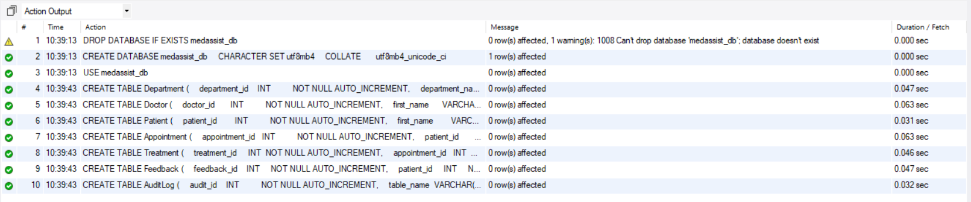
Screenshot: Screenshot 1- MySQL CLI or Workbench: SHOW TABLES confirming all seven tables created
Key constraint decisions and their justifications:
- ON DELETE RESTRICT on all foreign keys will not allow any doctor to be deleted from the department while they are still in the department, and will not allow any patient to be deleted from the system if there are any appointments that still exist for the patient. This sets referential integrity at the database engine level, without having to write any code.
- The ENUM('Scheduled','Completed','Cancelled') constraint on Appointment.status only allows the string to be either ‘Scheduled', ‘Completed' or ‘Cancelled', and will throw an error if it is attempted to be written to the table with any other string.
- CHECK (rating BETWEEN 1 AND 5) on Feedback.rating ensures that a rating is not provided outside of the range of 1 to 5, but does not involve application-layer validation (which is something that a user could prevent).
- UNIQUE on appointment_id is a business rule enforced at the schema level for both UNIQUE and Treatment.
- DEFAULT (CURRENT_DATE) on registration_date and feedback_date simplifies the process of filling in the date, as MySQL 8.0's default syntax for DATE types is an expression that automatically fills in the current date, thereby eliminating the need for the application code to write it [3].
3.2 Sample Data Population
There are three departments, six doctors, ten patients, 10 completed, 4 scheduled, and 1 cancelled appointment, 10 treatment records, and 8 feedback entries in the database. All status values, all departments and various clinical specializations are covered, offering a realistic basis for testing queries and for validating constraints.
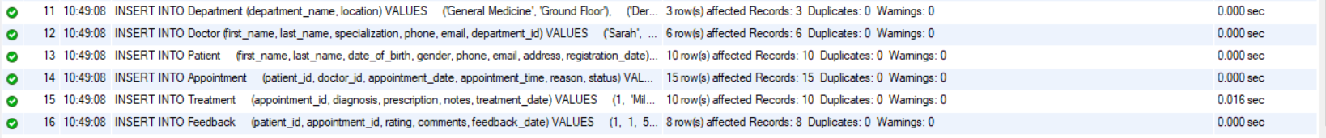
Screenshot: Screenshot 2 - Confirms data population for all the tables
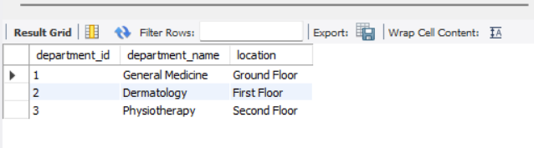
Screenshot: Screenshot 3 - SELECT * FROM Department showing inserted rows
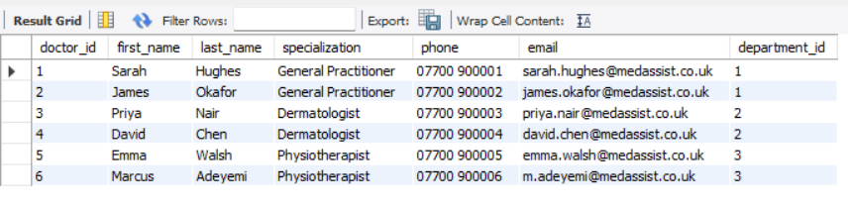
Screenshot: Screenshot 4 - SELECT * FROM Doctor showing inserted rows
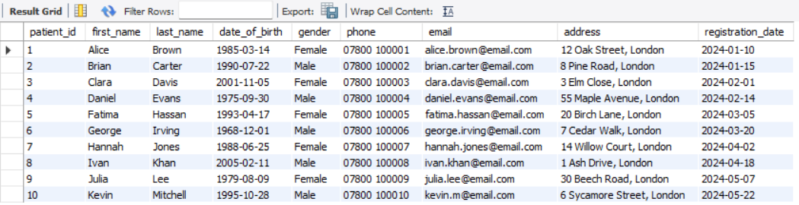
Screenshot: Screenshot 5 - SELECT * FROM Patient showing inserted rows
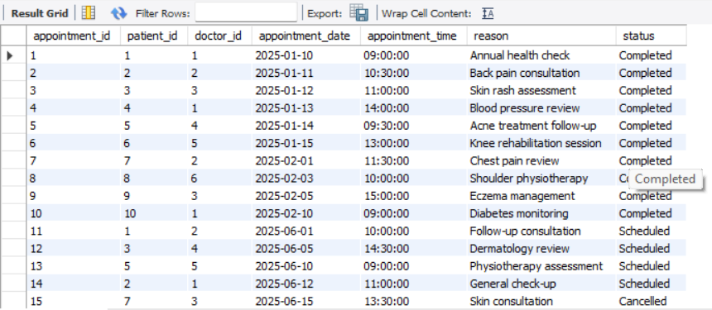
Screenshot: Screenshot 6 - SELECT * FROM Appointment showing inserted rows

Screenshot: Screenshot 7 - SELECT * FROM Treatment showing inserted rows
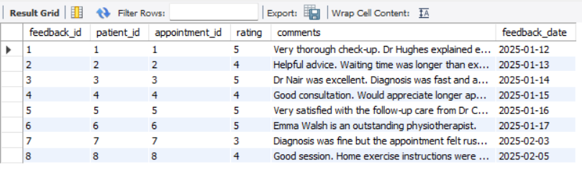
Screenshot: Screenshot 8 - SELECT * FROM Feedback showing inserted rows
3.3 Constraint Validation Tests
Screenshot: Screenshot 9 - Test 1: Rating out of range (Fails)
Screenshot: Screenshot 10 - Test 2: Duplicate feedback for same appointment (Fails)
Screenshot: Screenshot 11 - Test 3: Non-existent doctor FK (Fails)
Screenshot: Screenshot 12 - Test 4: Delete appointment with treatment (Fails)
Screenshot: Screenshot 13 - Test 5: ENUM constraint on Appointment.status (Fails)
Screenshot: Screenshot 14- Test 6: NOT NULL constraint on Patient.first_name (Fails)
Screenshot: Screenshot 15- Test 7: DEFAULT value verification (Succeds)
3.4 Triggers and Audit Functions
According to the MySQL 8.0 Reference Manual a trigger is a stored program that is automatically executed when certain events occur, such as a data modification event, on a specific table [3]. The auditing and integrity requirements are implemented by two triggers, which don't need to be modified in the application code.
Trigger 1: trg_log_appointment_update
This AFTER UPDATE trigger is fired on the Appointment table. If the value in the status column changes, it adds a row to the AuditLog table with the table name, operation type (STATUS_CHANGE), appointment_id, timestamp (NOW ()), and the current MySQL user (USER ()). This will provide a tamper-proof change trail, which will meet the clinical governance needs and UK GDPR accountability needs requirements outlined by the Information Commissioner's Office [5].
Trigger 2: trg_prevent_appt_delete
This BEFORE DELETE trigger counts rows in Treatment when an Appointment row is deleted. If the treatment record exists, it raises an SQLSTATE '45000' (with a descriptive message), preventing the deletion. It is not offered by foreign key constraints alone: While the fk_treatment_appt foreign key ensures that the parent appointment cannot be deleted, a BEFORE DELETE trigger is used to explicitly declare an explicit business-rule check, which has an appropriate error message exposed directly to the application.
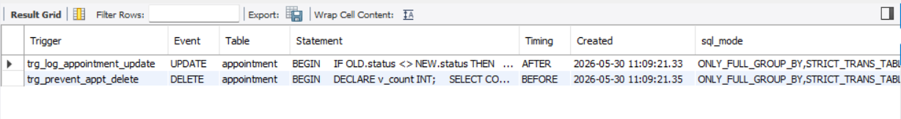
Screenshot: Screenshot 16 - SHOW TRIGGERS confirming both triggers registered
Screenshot: Screenshot 17 - DELETE FROM Appointment WHERE appointment_id = 1 returning the trigger error message.
3.5 Stored Procedures for CRUD Operations
Stored procedures are a collection of SQL statements run in the server as a single unit, which decreases the number of round trips to the network and keeps business logic in the database tier [3]. Every procedure below encloses its DML statement in a transaction and calls ROLLBACK and RESIGNAL whenever an error occurs:
- sp_book_appointment: Inserts a new Appointment row (CREATE). Rolls back when patient_id and/or doctor_id has failed the foreign key validation.
- sp_cancel_appointment: Sets status to Cancelled (will not remove the row, it's a "soft delete") only to leave the appointment in the audit trail.
- sp_get_patient_appointments: Joins Appointment, Doctor, and Department to return the full appointment history for a given patient (READ).
- sp_update_appointment_status: Updates the status field (UPDATE). Automatically triggers the audit trigger on all status changes.
- sp_delete_patient_if_no_history: This procedure Delete patient if no appointment history exists.
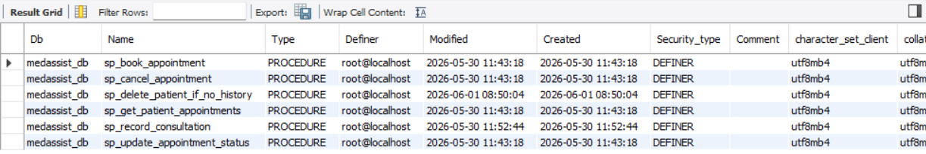
Screenshot: Screenshot 18 - Successful creation of stored procedures
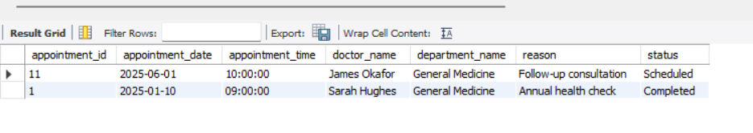
Screenshot: Screenshot 19 - CALL sp_get_patient_appointments(1) showing formatted result set with joined columns
3.6 User-Defined Function
The fn_patient_satisfaction_score function returns the average rating of feedback that a patient has received, based on their patient ID, from the Feedback table. It employs AVG () function to calculate the satisfaction score. If there is no feedback, it will return 0.00, using the COALESCE () function. It can be used to easily create patient satisfaction reports and ranking.
Screenshot: Screenshot 20 - Creation of fn_patient_satisfaction_score function

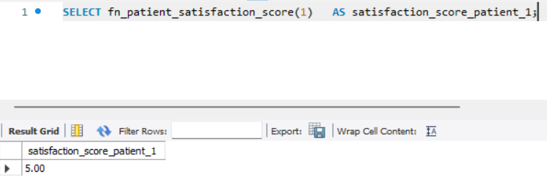
Screenshot: Screenshot 21 – Function demonstration 1
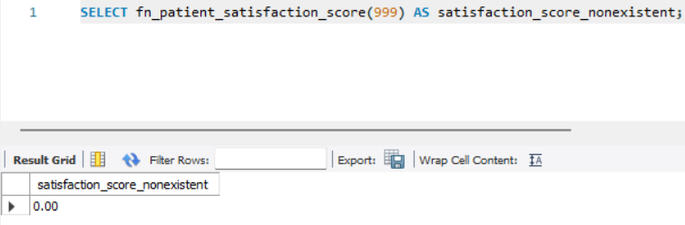
Screenshot: Screenshot 22 - Function demonstration 2

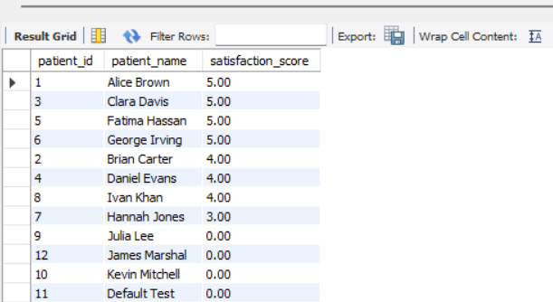
Screenshot: Screenshot 23 - Function demonstration 3
4. Stored Procedure and Transactional Scenario
4.1 The Multi-Step Scenario
When a consultation is completed, a Treatment record is added and the status of that Appointment is changed from ‘Open’ to ‘Completed' – which needs to be done simultaneously in two separate database writes. Once one of the writes succeeds, the database becomes inconsistent. If an appointment is recorded as Completed, but no treatment record is made, clinical staff will be misled that the consultation was fully documented. An appointment with a treatment record that was not removed from the appointment record would not be visible to worklist queries that were filtered by treatment record status. This is not good in a clinical setting [6].
Both writes are included in one stored procedure, sp_record_consultation. The DECLARE EXIT HANDLER will trap any SQLEXCEPTION that may occur before either write commits. If Step 1 (status update) is successful, but Step 2 (Treatment INSERT) is not successful — for example, if there is already a treatment record for the appointment, the UNIQUE constraint triggers — then the handler rolls back the status update with a call to ROLLBACK. The appointment is still Scheduled, and clinical personnel observe an accurate state when they try to do the recording again.
Screenshot: Screenshot 24 - Successful creation of sp_record_consultation procedures
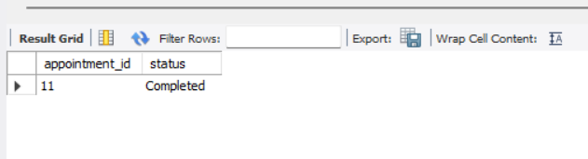
Screenshot: Screenshot 25 - Successful CALL sp_record_consultation(11, ...) followed by SELECT confirming appointment status = Completed and Treatment row inserted
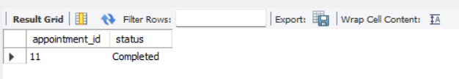
Screenshot: Screenshot 26 - Duplicate CALL on appointment_id = 11 triggering ROLLBACK; SELECT confirming Appointment status unchanged (already Completed), no duplicate Treatment row
4.2 Commit and Rollback Justification
According to Silberschatz et al [1] atomicity is one of the ACID properties that requires that a transaction be executed entirely or not at all. COMMIT also guarantees that all changes are persisted in the database when both steps are successfully completed without error, and that in the end the database is in one consistent state (appointment Scheduled, no treatment) to another consistent state (appointment Completed, treatment recorded). ROLLBACK will drop out any partial changes and restore the database to the state prior to the transaction. This behavior is not possible with stand-alone DML statements, which are automatically committed when executed in MySQL. If a Treatment INSERT fails because of a successful Appointment UPDATE, there is no recovery path and no transaction boundaries specified.
Screenshot: Screenshot 27 - Explicit Rollback Demonstration
The second call to sp_record_consultation(5) updates the appointment status to 'Completed', and then tries to insert a duplicate treatment record. The error is raised by the unique constraint uq_treatment_appt that invokes the EXIT HANDLER that will roll back the transaction. The status of the appointment is still 'Scheduled' which indicates atomicity – partial updates are not persisted.
4.3 Isolation Levels and Concurrency
MySQL's default REPEATABLE READ prevents non-repeatable reads within the transaction. Only UPDATE and INSERT have an intermediate state between them in sp_record_consultation; no other session does. SERIALIZABLE would introduce locks on all its reads, serialising writes — which would be an unnecessary overhead when the number of writes to the clinic is low. There is one issue yet – sp_record_consultation cannot update the status of sp_update_appointment_status of the same row. The victim transaction is rolled back, and the current EXIT HANDLER does not attempt to roll back the transaction. To remove the deadlock condition, any future batch procedure should ensure to get the row locks in ascending order of the appointment_id.
5. Performance Tuning Enhancement
5.1 Indexing Strategy
A B-tree index is automatically created for primary keys by MySQL. Secondary indexes are used to optimize the performance of columns used in the WHERE clause, JOIN condition, and ORDER BY part of the most likely clinic queries. According to the MySQL Optimization Reference MySQL goes through every row of the entire table to check every query predicate when there's no index [4]. If a clinic were to have thousands of appointments per year, it becomes slower and slower when the volume of data in the Appointment table increases [8].
Screenshot: Screenshot 28 - Successful creation of indexes
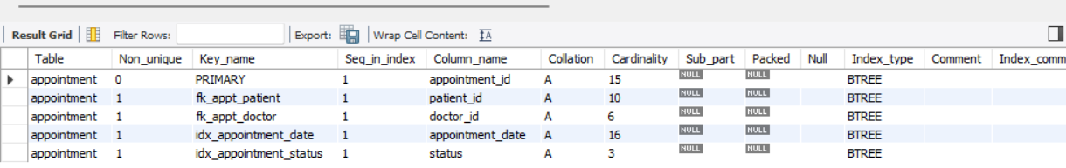
Screenshot: Screenshot 29 - SHOW INDEX FROM Appointment
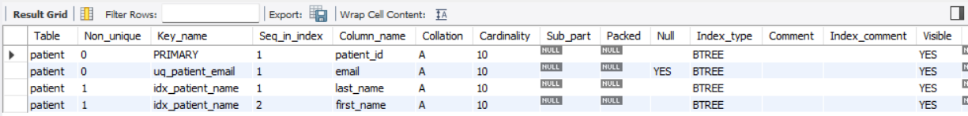
Screenshot: Screenshot 30 — SHOW INDEX FROM Patient
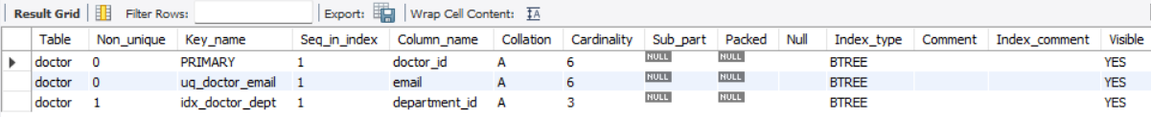
Screenshot: Screenshot 31 — SHOW INDEX FROM Doctor
5.2 Justification of Index Choices
idx_appointment_date — Appointment(appointment_date)
The following index, a B-tree index on appointment_date, makes this change from O(n) full table scan to O (log n) range scan [1]. This difference is noticeable in the EXPLAIN output and most noticeable in the scheduling response time at peak scheduling hours for 50,000 appointment rows.
idx_patient_name — Patient (last_name, first_name)
Reception staff search patients by surname. A composite index on (last_name, first_name) enables searching on the last name alone and on the full name using the leftmost prefix rule in MySQL [4]. The index is used for a search predicate on last_name, but not for a predicate on first_name. That is a fair compromise since most reception processes are first name-last name searches.
idx_doctor_dept — Doctor(department_id)
All types of queries that return all doctors per department will join Doctor to Department on department_id. If there is no secondary index, MySQL will have to read all rows in the Doctor table for each join. It uses an index lookup with the index on the foreign key column; Coronel and Morris [2] suggest this be the standard practice for frequently joined foreign key columns.
idx_appointment_status — Appointment(status)
A worklist query answers questions in the morning for appointments that have status = 'Scheduled'. In cases of a high cardinality, the index may not be used for large result sets because the query optimizer decides to use a full table scan. MySQL’s query optimizer can sometimes decide to use a full table scan instead of the index for large result sets, since there are only three distinct values [4]. The index benefits at normal clinic size – significantly below 200 appointments per day. When using the scheduling-dominated workload, the write overhead (a marginal b-tree update for every INSERT or status UPDATE) is insignificant compared to the number of reads [9].
5.3 Expected Performance Improvements
For date range queries on the appointment calendar, the best index is idx_appointment_date, which supports queries in logarithmic index scans as the number of records increases, as opposed to the linear scan needed without it.idx_appointment_date is best for date range queries on the appointment calendar, because it will use a logarithmic index search for growing volumes of records, rather than a linear search. The composite patient name index does away with a full-table scan for each reception look-up, which happens dozens of times every working day. The departmental doctor index is used for reducing the overhead for joining in reporting queries. The four indexes together cover the top four query patterns that the clinic uses most frequently, and have a low write cost because the number of INSERT and UPDATE operations is relatively small compared to the number of read operations in the outpatient scheduling system.
5.4 B+tree Internals and Write Overhead
InnoDB secondary indexes are sorted-leaf-page B+trees. A date range query on idx_appointment_date traverses only about 3-4 pages versus thousands of pages reads (with 50,000 rows) [4]. The composite idx_patient_name(last_name, first_name) implements MySQL's leftmost prefix rule: Predicates on the left-most component, that is, predicates on the last_name predicate use the index, whereas predicates on the right-most component, that is, predicates on the first_name predicate, do not. The three B+trees involved in the INSERTs on Appointment are the primary key B+tree, idx_appointment_date, and idx_appointment_status. At 50 writes/ day this is irrelevant; at least the change buffer of InnoDB delays secondary index writes even more, taking effect only when the index pages are not in the buffer pool [9].
6. Risk Assessment
Three risks apply. The first one is a server crash mid-transaction: InnoDB crash recovery automatically rolls back half-completed transactions, which the application should not have tried to continue. Secondly, index fragmentation: quarterly OPTIMIZE TABLE and archiving appointments more than 5 years old, maintains compact index pages. Thirdly, unlimited growth of AuditLog table: 36,500 rows per year with two status changes per appointment and 50 appointments per day. Archive rows older than 2 years, based on ICO retention guidance [5] or partition by YEAR (changed_at) and drop old partitions.
7. Conclusion and Reflection
The MedAssist Clinic database meets the functional and structural requirements in the brief. The 3NF consists of the seven-table relational schema that does not introduce data redundancy and uses foreign keys and check constraints to maintain referential integrity. Atomic and recoverable multi-step clinical operations are provided by stored procedures with transaction control. The audit trigger generates a tamper-proof change log to meet clinical governance needs, and four secondary indexes cater for the clinic's most performance-intensive query patterns.
A challenge in the design was to decide the cardinality of the relationship between Appointment and Feedback. The business rule that only one feedback entry be created per appointment was not self-enforced by the foreign key statements alone, it needed to be supported by a UNIQUE statement on Feedback.appointment_id. This is just another example of the concept that business rules should be explicit in the schema, not enforced in the application layer, where they can be circumvented.
A BEFORE INSERT trigger that counts the number of rows in the table could be used to implement the one-feedback-per-appointment rule. Alternatively, a UNIQUE constraint on Feedback.appointment_id is selected: it is atomic with the INSERT, which creates a race window where two sessions can execute the INSERT at the same time, both passing the count check before any of them commits. The constraint also prevents feedback on cancelled visits, which was a conscious clinical choice: feedback on a cancelled visit has no diagnostic value, and would bias quality scores.
Potential enhancements to the current functionality could be adding a new Prescription table, which would be normalized from the current unstructured text field in Treatment, allowing clinical staff to be able to query and analyze prescription patterns across the patient population. Row-level security, through the use of MySQL ROLE assignments and GRANT statements, would limit clinical users to accessing feedback data, and administrative users to accessing treatment details, ensuring the database is closer to meeting the UK GDPR data minimization requirements and the ICO guidance on access control for health data.

References
[1] A. Silberschatz, H. F. Korth, and S. Sudarshan, “Database System Concepts - 7th edition,” www.db-book.com, 2019. Available: https://www.db-book.com/
[2] C. Coronel and S. Morris, Database Systems: Design, Implementation, & Management. Cengage Learning, 2022. Available: https://books.google.co.ke/books/about/Database_Systems.html?id=6EbczgEACAAJ&redir_esc=y
[3] Oracle, “MySQL: MySQL 8.0 Reference Manual: 25.3 Using Triggers,” dev.mysql.com, 2024. Available: https://dev.mysql.com/doc/refman/8.0/en/triggers.html
[4] Oracle, “MySQL: MySQL 8.0 Reference Manual: 10.3 Optimization and Indexes,” Mysql.com, 2026. Available: https://dev.mysql.com/doc/refman//8.0/en/optimization-indexes.html. [Accessed: May 30, 2026]
[5] ICO, “UK GDPR guidance and resources,” ico.org.uk, Aug. 31, 2023. Available: https://ico.org.uk/for-organisations/uk-gdpr-guidance-and-resources
[6] Kousik Das Malakar, S. Roy, and M. Kumar, “Database Management System: Foundations and Practices,” Jul. 02, 2025. doi: https://doi.org/10.1007/978-3-031-92017-2_7. Available: https://www.researchgate.net/publication/393318307_Database_Management_System_Foundations_and_Practices
[7] L. Huddlestone, J. Turner, H. Eborall, N. Hudson, M. Davies, and G. Martin, “Application of normalisation process theory in understanding implementation processes in primary care settings in the UK: a systematic review,” BMC Family Practice, vol. 21, no. 1, Mar. 2020, doi: https://doi.org/10.1186/s12875-020-01107-y. Available: https://pmc.ncbi.nlm.nih.gov/articles/PMC7075013/
[8] M. Kvet, “Database Index Balancing Strategy,” May 2021, doi: https://doi.org/10.23919/fruct52173.2021.9435452
[9] A. Tezuysal, I. Ahmed, and P. Zaitsev, “Database Design and Modeling with PostgreSQL and MySQL: Build efficient and scalable databases for modern applications using open source databases,” Ieee.org, 2024. Available: https://ieeexplore.ieee.org/document/10769319
[10] A. F. Mohammad, P. Bearse, and I. R. I. Haque, “Healthcare Big Data Normalization Graph Theory Implementation,” IEEE Xplore, Dec. 01, 2020. doi: https://doi.org/10.1109/CSCI51800.2020.00153. Available: https://ieeexplore.ieee.org/document/9458087. [Accessed: Jul. 12, 2021]

Appendix
1.sql

