Qualification: CIPD Diploma in Applied Human Resources

Module Name: Contributing to Improving Organisational Performance

Word Count: 2708

Student Name: Darren Bonnell

Student Number: 1810223

CIPD Membership Number:

By signing below, I confirm that the work/evidence presented is my own, unaided work. I understand the regulations pertaining to candidate malpractice and the action that may be taken as a result.

Signed: Darren Bonnell

Date: 12/08/2019

Evidence Matrix
Candidate name: Darren Bonnell |  |  |  |  | CIPD Membership/registration No.: 53274287
Qualification title: Contributing to Improving Organisational Performance |  |  |  |  | Unique Learner No. (ULN): 5AIOP
Unit code | Unit title |  | Assessment criteria no. | Evidence description | Evidence reference number |  | Assessor  initials | I/V initials if sampled
5AIOP | Contributing to Improving Organisational Performance |  | 1.1 | Helping People Perform (HPP) appraisal form | EV1
 |  |  | 1.1 | Coaching & Mentoring available from the intranet | EV2
 |  |  | 1.1 | E-learning home page | EV3
 |  |  | 1.1 | Probation Policy and Forms | EV4
 |  |  | 1.1 | E-mail following probation review hearing | EV5
 |  |  | 1.2 | ACAS guide to performance management | EV6
 |  |  | 1.2 | Model performance management policy for schools | EV7
 |  |  | 1.2 | Equality & Diversity Policy | EV8
 |  |  | 1.3 | E-mail to manager regarding probation | EV9
 |  |  | 1.3 | Probation information on intranet | EV10
 |  |  | 2.1 | Capability Policy | EV11
 |  |  | 2.1 | Grievance Policy | EV12
 |  |  | 2.2 | E-mail sent to manager with draft capability letters attached | EV13
 |  |  | 2.2 | Copy of capability invite letter sent to employee | EV14
 |  |  | 2.2 | E-mail & final capability invite letter and related documents to line manager | EV15
 |  |  | 2.2 | Capability Stage 1/2 outcome template letter. | EV16
 |  |  | 2.2 | Grievance received | EV17
 |  |  | 2.2 | E-mail and related documents sent to Investigation Officer of grievance. | EV18
 |  |  | 2.3 | Witness testimony from line manager | EV19
 |  |  | 2.3 | E-mail requesting assistance with TUPE staff | EV20
 |  |  | 3.1 | Appraisal page on Intranet | EV21
 |  |  | 3.1 | Care Council for Wales Supervising and Appraisal | EV22
 |  |  | 3.2 | Recruitment & Selection Training Flyer | EV23
 |  |  | 3.2 | PIMS Report page | EV24
Candidate declaration:
- I confirm that the work/evidence presented for assessment is my own unaided work.
- I have read the assessment regulations and understand that if I am found to have ‘copied’ from published work without acknowledgement, or from other candidate’s work, this may be regarded as plagiarism which is an offence against the assessment regulations and leads to failure in the relevant unit and formal disciplinary action.
- I agree to this work being subjected to scrutiny by textual analysis software if required.
- I understand that my work may be used for future academic/quality assurance purposes in accordance with the provisions of the Data Protection Act 1998.
- I understand that the work/evidence submitted for assessment may not be returned to me and that I have retained a copy for my records.
- I understand that until such time as the assessment grade has been ratified through internal and external quality assurance processes it is not final.
Signature: |  | Darren Bonnell |  |  |  | Date: | 12/08/2019

1 - Be able to provide information on performance management activity within an organisation.
1.1 Explain performance management policies and processes in the organisation and the roles and responsibilities of those involved in them.
As a large public organisation employing over 9000 staff within several different departments Carmarthenshire County Council (CCC) has its own Organisational Development (OD) section which has the main dealing with performance management for the Authority. Within the OD section they are responsible for developing performance management procedures as well as having high involvement of filtering out appropriate training to line managers to ensure they are following them correctly. These processes are agreed following engagement with the trade unions and authorised by the council executive board. The main performance management processes implemented by CCC comes in the form of the appraisal system Helping People Perform (HPP) (Evidence 1). Line managers would use this process when conducting their regular appraisal which would need to be done at least once a year. Once appraisals have been completed, and objectives set, with areas that need to be development identified, the line managers will work with the OD section at ways to assist in helping meet the goals. This could be done through extra training provided both internally and externally, or by utilising the coaching facility available (Evidence 2) to help develop the required skills. Another function developed by the OD department is online aids such as e-learning (Evidence 3) programmes which again are there to help both managers and staff develop their skills. Other performance management processes designed by CCC is the Probation Policy (Evidence 4) where managers would have regular meetings with the staff who are new to the Authority and identify areas that need to improve in order to reach the required standard. These meetings would be done after one, three and five months. If performance was not up to the required standard following the probation period in my role as an Assistant HR Advisor I would assist in a probation review hearing (Evidence 5). This would result in the manager presenting the case as to why the employee has not reached the required standard, a senior manager chairing the hearing and HR on the panel to ensure that policy is followed correctly.
1.2 Explain key sources of information, including legislative information, which underpin performance management activities.
As a local Authority CCC follow best practices in their approach to all procedures put in place. This would be the same case within performance management. In order to do this the OD section will therefore look at external drivers such as ACAS (Evidence 6) and also the CIPD which would mean taking guidance such as that evident in a fact sheet by Gifford (2018) where he states the benefits of implementing a performance management strategy that is fit for purpose. Another area in which CCC need to follow in order to support performance management for teaching staff working for the Authority is The School Teacher Appraisal (Wales) Regulations 2011. This is written into Model performance management policy for schools (Evidence 7). This policy needs to be implemented by head teachers and line managers of all staff who fall under the teacher pay and conditions. It means that all these employees will need to have a set guidance on performance which is done through various assessments throughout different times of the year. In order for an employee to progress up a pay scale they would need to pass the assessment. One of the main pieces of legislation that CCC has to abide by when it comes to performance management is the Equalities Act 2010. This would mean that all staff should be treated fairly when it comes to performance management. CCC have designed their Equality and Diversity Policy (Evidence 8) which gives clear guidance on how through all areas of the employee life cycle staff who fall under the protected characteristic will not be discriminated against or treated less favourably.

1.3 Provide timely and accurate information to colleagues regarding performance management activities.
In my role in order to support line managers to perform appropriate performance management I would usually be a first point of contact when enquiring about the process. As previously stated the main performance management advice when it came to the actual process or documents used would come from the OD section. However, as an Assistant HR Advisor I regularly get managers who would contact me to ask for advice in areas such as probation. An example of this is when a manager had recently employed a member of staff and wanted to know information about the probation policy. I had a conversation with him and gave him an outline of the requirements that he needed to follow in line with policy. I then followed this up with an e-mail (Evidence 9) that signposted him to the probation section on the intranet (Evidence 10) which has all information and all documents relating to probation.

Evidence 1

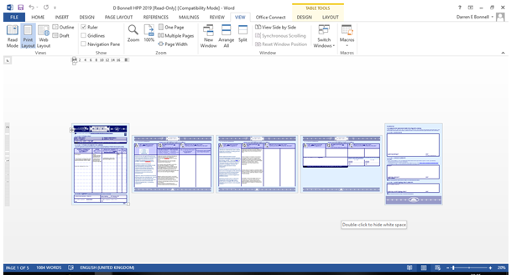

The Helping People to Perform Appraisal (HPP) Form is sent to all employees prior to their appraisal. This will list the duties they have from the job profile and look to give details of areas that need to be developed. A plan is then put in place in how to meet these objectives.

Evidence 2

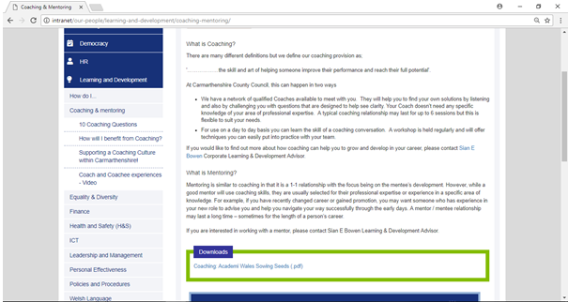

This information available on the intranet gives details of how managers can connect with the OD section to enhance their coaching skills in order to be able to help develop staff.

Evidence 3

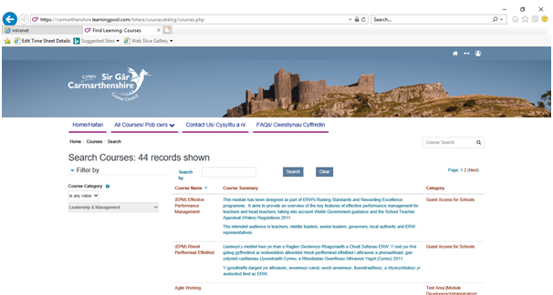

The online e-learning resource allows all staff take an online unit from a variety of different topics. Following completion of the course staff are often awarded a certificate and their learning record is updated to show they have completed the course.

Evidence 4

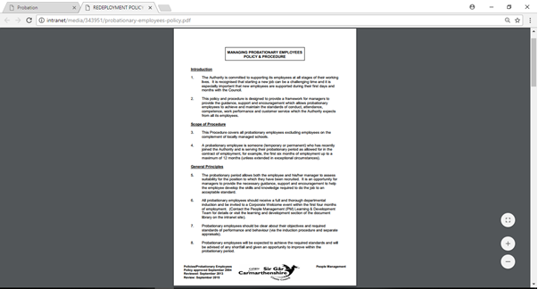
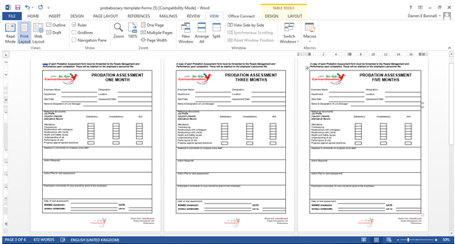

The probation policy would require a manger to meet up with a new member of staff after one, three and five months in employment. This would be extended to nine and eleven months for social workers. During these meeting performance would be evaluated and support put in place where required in order for the employee to meet the required standard.

Evidence 5

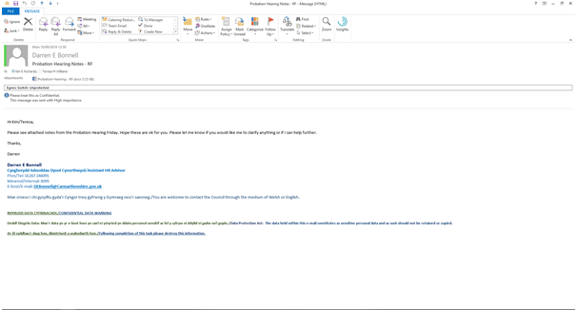

As part of the probation policy I took notes in a probation review for a member of staff who did not meet the required standard in his probationary period. The outcome of this meeting would either be dismiss, extend the probationary period or conclude that the employee has successfully passed the probation.

Evidence 6
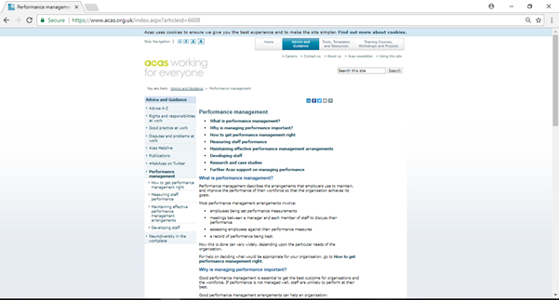

CCC will follow guidance set out by ACAS as best practice and a guide in which to follow to abide by required standards.

Evidence 7

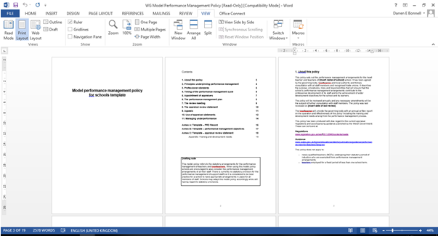

Model performance management policy for schools is a set out as guidance for head teachers and line managers to ensure they are following the correct procedure when it comes to staff who fall under teachers’ pay and conditions.

Evidence 8

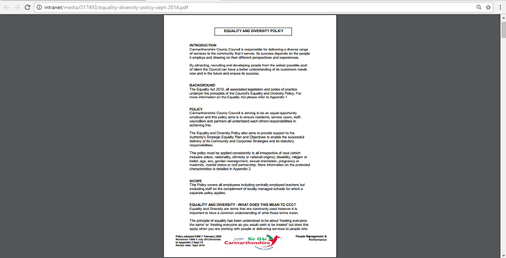

This policy gives an outline to all employees on the way all staff must be treated in line with the Equalities Act 2010.

Evidence 9

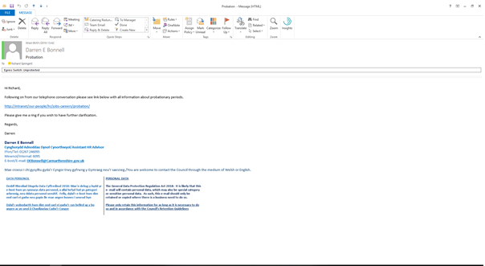

This e-mail was sent following a conversation with the line manager where I gave advice about the probation policy.

Evidence 10

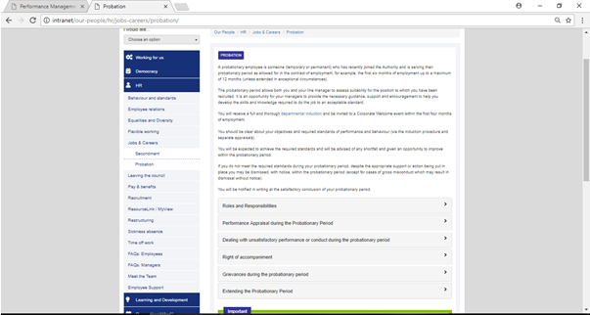

This evidence is the probation section of the intranet which gives all details if the policy as well as having access to all related documents.

2 - Be able to support line managers to deliver performance management activities within the organisation.

2.1 Analyse the types of support line managers in the organisation need from HR, in relation to performance management activities.

Within my role as an Assistant HR Advisor I don’t have any employees directly reporting to me so don’t have a role in performing appraisals or setting any performance management goals. In general both staff and managers wouldn’t really come to me for advice with the performance management process as this would generally come from the OD section. My role would be to advise managers/staff when performance isn’t satisfactory through the capability policy (Evidence 11). This policy would be used when an employee is not working to the required standard. It sets out a structure that would look at dealing with poor performance whether that’s informally or formally. Actions are put in place of what an employee needs to do in order to reach the required standard and if they do not then it could ultimately result in a demotion or even dismissal. HR would advise the managers and investigation officers as well as the chairperson if it got to a hearing or appeal. I would also assist when an employee doesn’t feel their performance needs are being met and as a result of this they submit a grievance (Evidence 12). This policy would be used if an employee didn’t feel happy about how their performance was being managed. They would then submit a grievance which as like the capability policy would be dealt with either informally or formally. HR would again assist at all stages of the process to ensure the procedure is followed correctly.

2.2 Support line managers’ capability to deliver performance management activities.
I have recently advised on a performance issue with one of the Cook’s at one of the local schools. Following a few brief informal meetings the line manager felt that the concerns regarding performance warranted the situation to be taken formally. In my role I talked through the situation and advised on policy in order to come to this decision which I followed up with an e-mail (Evidence 13). This also had a template letter for the manager to draft in order to send to the employee. Once the manager had attempted the draft she sent it on to me and I then assisted in finalising the letter (Evidence 14) and sent this back via e-mail as well as attaching appropriate correspondence (Evidence 15) which the manager then sent to arrange a meeting to go through the performance of the employee. Prior to the meeting I again met up with the managers and prepped them on the policy and processes and explained how they would need to follow them. At the meeting the manager gave examples of the performance concerns and an action plan was put in place with a time frame to review to see if the standard required has improved. This was then followed up in writing in the form of a letter sent from HR (Evidence 16). Another time in which I assisted with performance related issues was when a member of staff put in a grievance (Evidence 17) as she was not having a regular supervision as per the policy set out for care workers. Following the submission of the Grievance I again worked with the manager advised to investigate the matter. Again I advised on the policy side and gave instructions of what was expected as well as following this up with an e-mail (Evidence 18). I then supported in the meeting that was arranged in order to give any advice needed. In this particular case the grievance was upheld and there was a plan put in place to ensure in the future the employee was met on a regular basis.
2.3 Work in conjunction with line managers in the provision of employee performance and development reviews.
As stated I had previously supported a manager when a member of staff was not performing to the required standard and therefore was taken through the capability stage 1. As part of this process I advised in the meeting targets to be set to meet in a realistic time frame. A letter was then sent out to the employee of the areas she needed to address in order for her performance to be satisfactory and not progress to a further stage. The manager who I supported confirmed she was happy with the role I played in helping her through the procedure (Evidence 19). Another time I supported managers was when staff from outside the organisation joined the Authority via a TUPE transfer. As part of the process I was asked (Evidence 20) to go to an induction day which was being led by the director and head of service. My role was to give the new staff information about Carmarthenshire County Council and all the various things it has to offer as well as give information on policies and processes.

Evidence 11

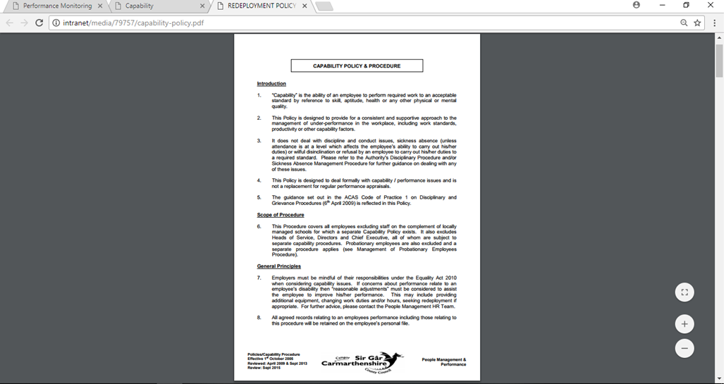

This policy would be used when staff are not performing to a satisfactory level. The guidance would show what to do which would be supported by HR.

Evidence 12

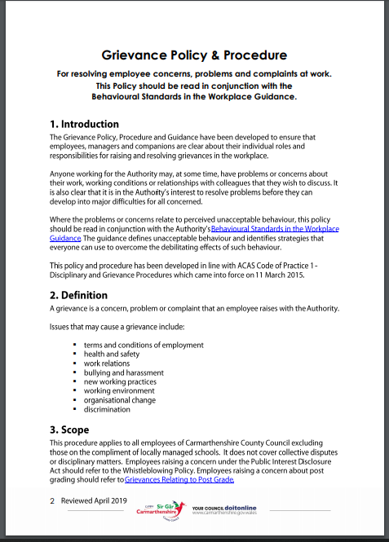

This policy would be used when an employee has a problem in the workplace. HR would again advise throughout the process.
Evidence 13

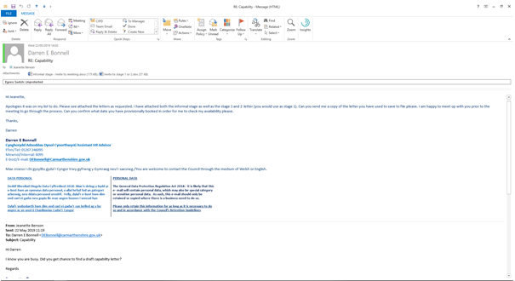

E-mail sent to manager with draft capability letters.

Evidence 14

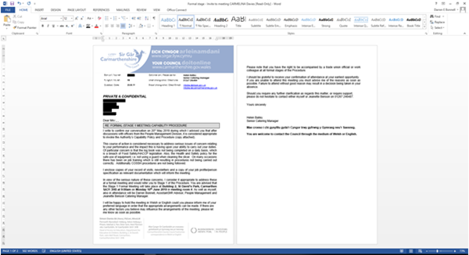

Letter sent to employee requesting she attend a capability stage 1 meeting.
Evidence 15

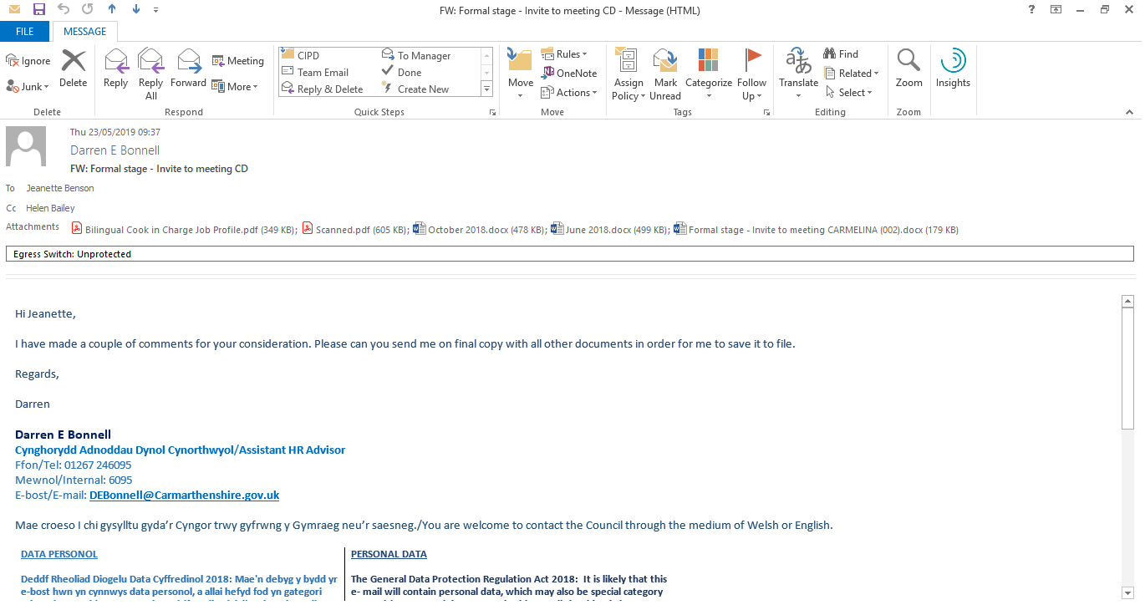

E-mail sent with amended letter and related documents for manager to send to the employee.

Evidence 16

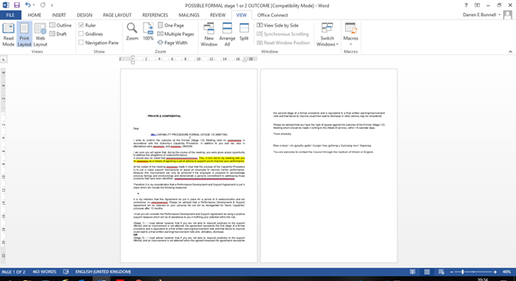

Example template letter sent to employee following capability stage 1/2 meeting.

Evidence 17

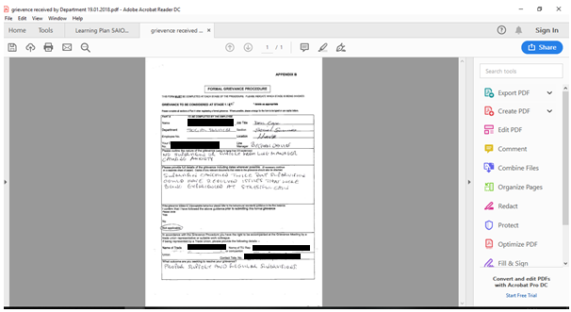

Grievance submitted by employee due to lack of supervision.

Evidence 18

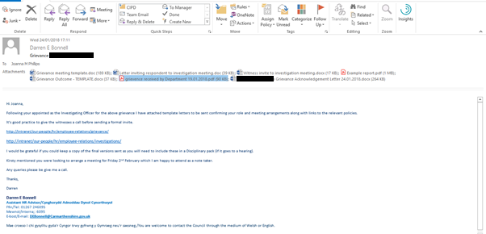

E-mail and related documents sent to the investigation officer in charge of a grievance.

Evidence 19

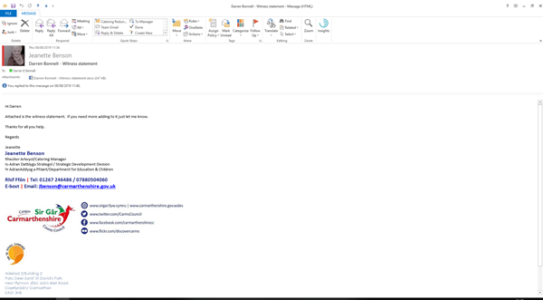
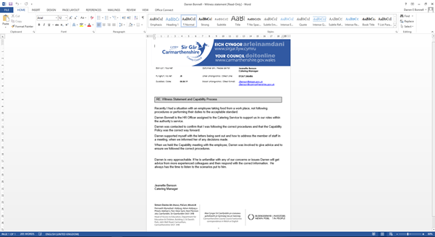

Witness statement from line manager who I supported during capability of a member of staff.

Evidence 20

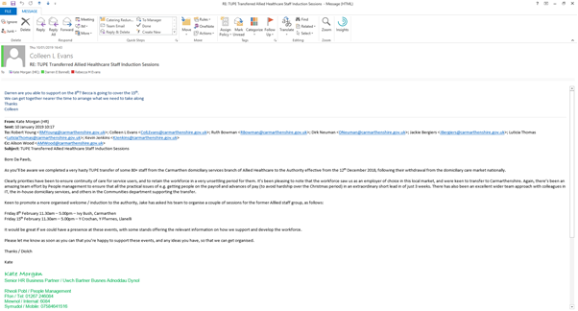

E-mail asking to support with the induction of staff coming to the Authority via TUPE.

3 Be able to assess the impact of performance management activities on organisational performance and make recommendations for enhancement.
3.1 Evaluate the organisation’s approach to performance management, including employee performance and development reviews.

The current Helping People Perform (HPP) appraisal scheme used by CCC works on a way that staff meet with a manager at least once a year and work to an ABC format (Evidence 21). This would be the approach to;
- Agree tasks to be achieved
- Backing/support that you need to perform
- Consider how things are going and if things need to be done differently
Having done some research into the current appraisal system used by the Authority I feel that it is somewhat outdated. From personal experience as well as discussions with my colleagues both inside and outside HR it is widely deemed as a tick box exercise which does not add much value to either the employer or the employee. As with a lot of companies these days new ways of working are being looked into which will help ensure that performance management assists the business in a positive way. This is evident in an article in the Harvard Business Review by Cappelli & Tavis (2016) where they suggest that rather than having the one big appraisal each year performance management should be an ongoing process which is flexible within its approach. They go on to say that many leading companies are now moving away from the traditional way of using performance management which is used in CCC. As well as this as CCC is such a big organisation with different departments I don’t feel it is feasible to have a one size fits all approach. Certain areas do have regular catch ups where performance and development is highlighted. However, these are usually enforced in areas that have to comply with the Care Council for Wales regulations (Evidence 22). These would not be the norm and many other areas of the business would only get an opportunity on their annual appraisal. My research has identified that poor performance is being dealt with through the capability policy which is highlighted in a growing number of cases each year. This would suggest that managers are starting to realise when performance is not to the required standard and then they are acting upon it.

3.2 Assess the extent to which performance management processes support high performance working (HPW) and contribute to sustained organisational performance.

As a large organisation it is important that CCC are continually evolving in order to keep up with the changing times. As evident by Taylor (2016) it is therefore important that High Performing Working is implemented with appropriate processes that add value to the company. A way in which CCC do this when it comes to performance management is by looking at the complete employee lifecycle. This is done by ensuring managers are appropriately trained when completing the recruitment of a new staff member and they are therefore given appropriate recruitment training (Evidence 23). This training course gives guidance of what managers need to do at every step of the recruitment process. This includes writing up the job profile and advert, to interviewing and conducting pre-employment checks. This gives the managers at CCC the best chance of appointing the right person to fulfil the role. Following the appointment CCC through guidance from the People Management department have put in High Performance Work Systems (HPWS) in the form of robust policies and procedures. These HPWS which include the HPP appraisal as well as the capability and grievance policies give managers the tools to fully support both good and bad performance. The Authority uses the Performance and Improvement Monitoring System (PIMS) (Evidence 24) in order to see how each department are meeting targets set. This system generates reports which are used by the chief executive and her team when making decisions and filtering down instructions on what is expected.
3.3 Recommend ways for developing performance management processes to enhance their impact on organisational performance.

In order to get the most out of performance management within CCC I think there are a few areas in which can be improved which would have a positive impact on the company. These include;

- Regular one to one meetings - With the current budget in local government being drastically cut it means that staff are pushed to their limit. This means that many managers feel they do not have time to meet staff more regularly. Whilst I appreciate not all areas have the resources for extra regular meetings I do feel however that this does need to be something that is implemented in all areas that it is possible. Through these meeting and extra engagement there could be new ways of working developed which allowed staff the chance to develop their skills, which will in turn help them gain positive results in an ever decreasing financial restricting organisation. By having more regular contact staff will feel like they are having their chance to develop in the company rather than the once a year tick box exercise of the current HPP appraisal process.
- New Appraisal Process – Whilst I do think more regular one to one meetings would benefit the company I appreciate that there would need to be a formal appraisal process developed. In order to do this I would advise the OD section look at new innovative ways that will get staff to change their perception of the appraisal process. I think this would be an ideal time to look at the different ways in which departments worked and look to adopt different appraisal systems to suit each area of the business.
- Reward good performance – This will be very difficult to implement within CCC as all jobs are evaluated by job evaluation specialists and then given a pay grade for that role. However, in order to intensify good performance I would suggest certain targets could be set where if staff hit them they would be rewarded with something non-financial such as extra annual leave or time off. I feel this would have a positive impact as although poor performance is managed quite well in CCC some staff will simply do the minimum amount required. By having an incentive this could boost their performance which again would help the organisation as whole.

Evidence 21

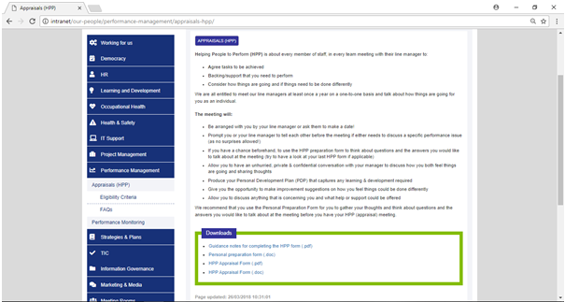

Appraisal page on the internal intranet gives details of how it works as well as includes related correspondence.

Evidence 22



These guides are instructed for social care workers in Wales which means that managers have to meet staff for supervision on a regular basis.

Evidence 23

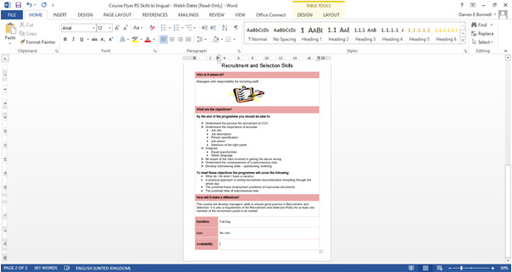

The flyer shows details of the Recruitment and Selection course run by OD and HR to give line managers all the required information to make the right appointment.

Evidence 24

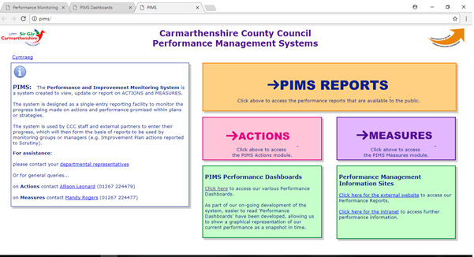

The PIMS Reports are used to evaluate how different areas in the Authority are performing.

Bibliography
Cappelli, P. & Tavis, A., 2016. The Performance Management Revolution. [Online]
Available at: https://hbr.org/2016/10/the-performance-management-revolution
[Accessed 10 7 2019].

Gifford, J., 2018. Performance management: an introduction. [Online]
Available at: https://www.cipd.co.uk/knowledge/fundamentals/people/performance/factsheet
[Accessed 10 7 2019].

Taylor, S., 2016. Improving Organisational Performance. In: Human Resource Management: People and Organisations. London: CIPD, pp. 197-218.

