Matthew Cowley (1700561) – Essay

Q. What does the artwork commissioned by the Normans tell us about how they wished to be perceived?
The Normans are famous for their various conquests and territorial gains all over Europe and the Near East, whether it be of Normandy and England, or Southern Italy and the Principality of Antioch. As the Normans originally came from Scandinavia, as pagan ‘Norsemen’, they were initially viewed as outsiders by the people of Christian Europe, resulting in the necessity to depict themselves as ‘Western’ as possible. As much as they conquered and assimilated into the local customs and cultures, they also commissioned various types of artwork, many of which can give modern historians a good indication of how the Normans viewed themselves and, more importantly, how they wished to be viewed by others. As such, pictorial evidence from Normandy, England, Southern Italy and Sicily, will all be analysed as these are the locations of the most illuminating and informative artworks, while the Principality of Antioch, due to its involvement with the Crusades, will be bypassed in this instance as the majority of its pictorial evidence portrays the Crusaders as a general group, so it is impossible to decipher who is Norman and who is not.
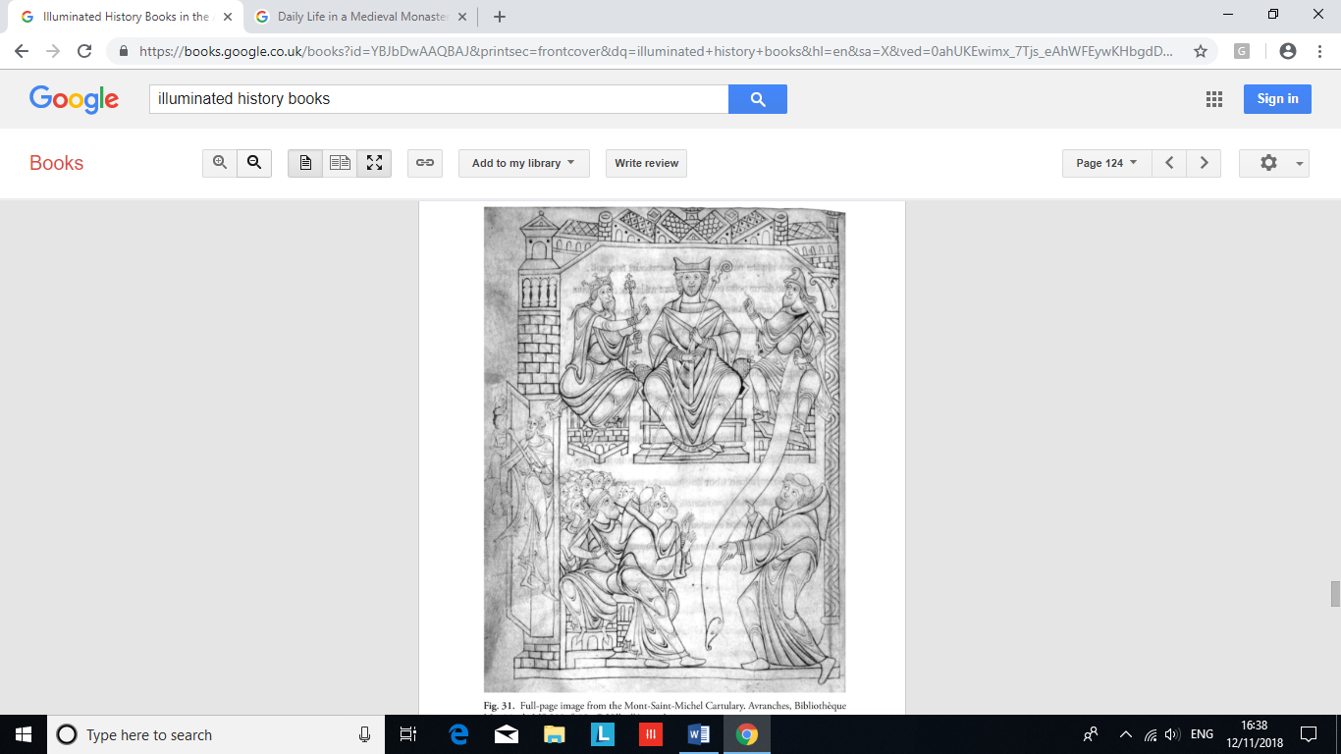

Figure 1: The King, the Duke, and the Bishop, from MS 210 in the Bibliothѐque Municipale. Accessed from Cleaver, Illuminated History Books in the Anglo-Norman World, p. 124.
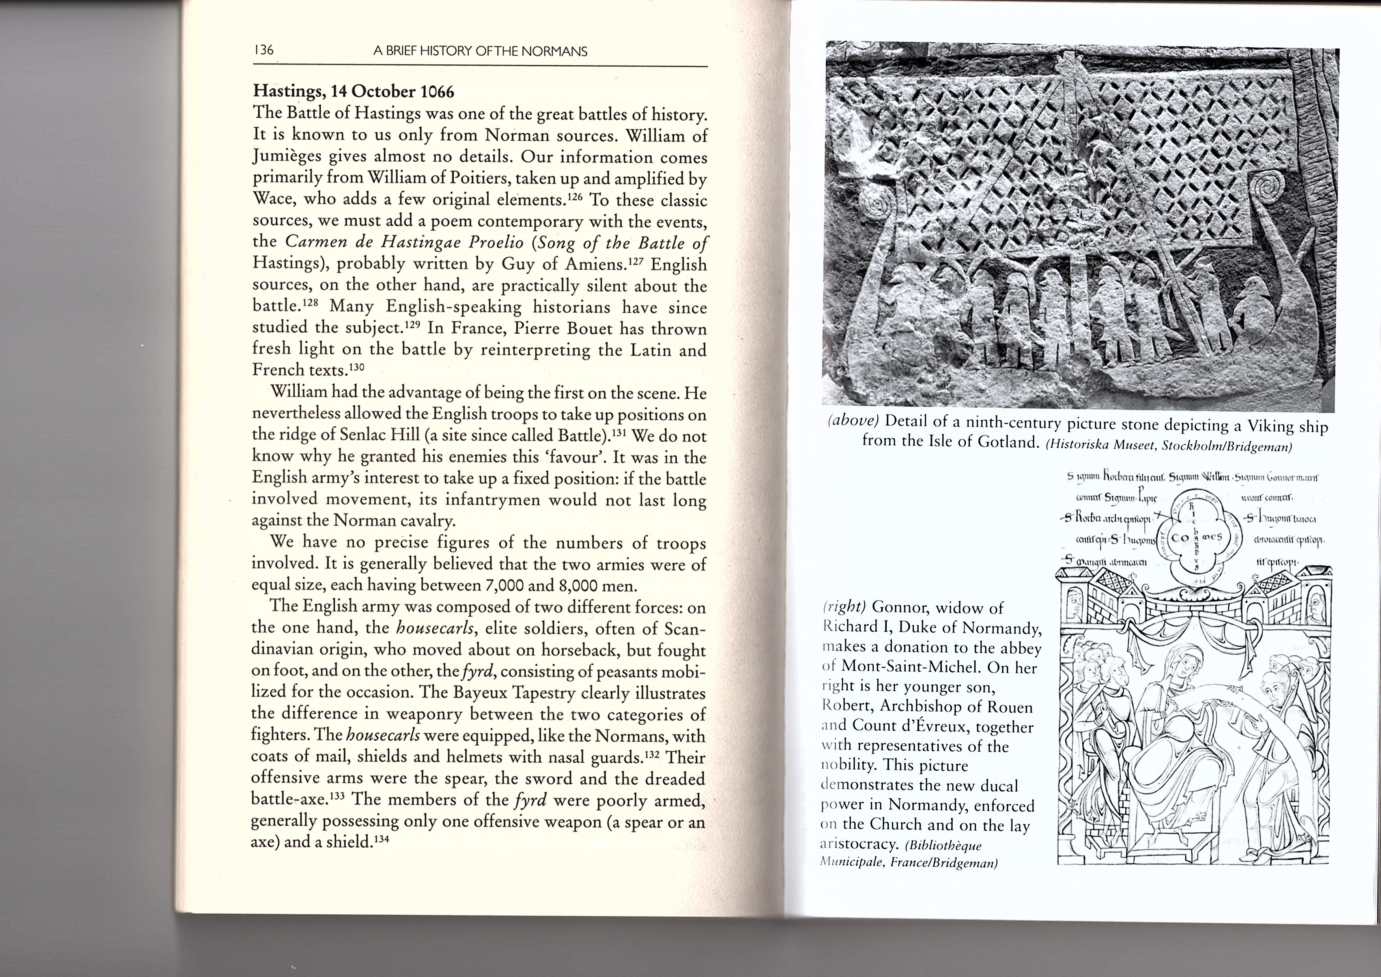
To start with, it is pivotal to analyse the artwork that some of the original Dukes of Normandy commissioned in order to discover how the first Normans wished to be perceived by their contemporaries. Discovered in the ‘Cartulary of the Abbey of Mont-Saint-Michel’, and now in the Bibliothѐque Municipale, France, Figure 1 depicts the three major powers in Normandy at the time, which are the Church, the King, and the Duke. The central figure on the top row is a bishop, who represents the Church, as is evident by his staff and clothing, while the King, who is depicted as wearing a crown, is to the Bishop’s left while the Duke of Normandy, who is portrayed with a strange hood, is positioned to the Bishop’s right. Due to these three figures, it could be claimed that this image portrays the events surrounding the foundation of Normandy in 911 with the signing of the ‘Treaty of Saint-Clair-Sur-Epte’. The King in the image could represent Charles the Simple, the King of West Francia who granted the lands of what would become Normandy to the Vikings, while the Bishop could depict the Archbishop of Rouen, who was sent as an ambassador by Charles. The Duke, on the other hand, most likely represents Rollo, the leader of the Seine Vikings who had been harassing the Franks for some time, as is evident by the strange hood that the Duke is wearing, possibly indicating that this Duke is a foreigner, which Rollo was. Furthermore, the scroll that the Duke is holding, and that has been blessed by the Church, could be in reference to the treaty that created Normandy, suggesting that these new Normans are the legitimate rulers of the land in the eyes of the Church. Continuing from this, the scroll transcends the tiers of this image and is received by what looks to be a monk on the lower levels. Subsequently, this monk seems to be presenting the content of the scroll to a crowd of other ecclesiastical figures and layman, which could further suggest the idea that this scroll represents the treaty as all are being informed of its content. As is evident here, the main way in which the Normans wished to be perceived at their dawn was as the rightful and legitimate rulers of their newly acquired land.

Figure 2: Gunnor, widow of Richard I of Normandy, donating to a local abbey, from MS 210 in the Bibliothѐque Municipale. Accessed from Neveux, A Brief History of the Normans, pp. 136 – 137.

Furthermore, the image to the right (Figure 2) depicts Duchess Gunnor, a woman who was Norman by marriage to Duke Richard I, donating funds and other supplies to the ecclesiastical centre of Mont-Saint-Michel following her husband’s death. Like Figure 1, Figure 2 was also discovered in the ‘Cartulary of the Abbey of Mont-Saint-Michel’, and this drawing seems to date from about the 1150’s. Firstly, it clearly depicts Gunnor reading a large scroll with an ecclesiastical man, most likely her son Robert, the Archbishop of Rouen and the Count of Evreux, which suggests the intertwined relationship of the Church and the state at the time. Behind the Archbishop, who wields a shepherds’ crook and who’s hand is interlocked with the Duchess’, lies a collection of other monastic figures, all of whom have a ring of hair around a bold patch at the very top of their head, a typical indicator of a clerical man as they are viewed as being closer to God when their hair is cut in this way. On the opposite side of Gunnor, a man sits enthroned with an entourage of various laymen, which can be inferred due to their hair styles. Laura Cleaver suggests that this man is Gunnor’s other son, Duke Richard II of Normandy, which can potentially lead to the accusation that the Duchess of Normandy has authority over both the Church and the state, as she is the mother of their leaders. Continuing from this, it is possible that Gunnor is also portrayed as being pregnant, due to what looks to be a large bump on her lower torso, but this could equally be an illusion made by her dress. If, however, Gunnor is pregnant, then it reinforces the views of medieval women, especially noblewomen, in that they were expected to produce children. This could potentially suggest the fertility and ability of Norman women to produce multiple heirs, portraying to others the Norman intention to stay where they are. As such, this image portrays the Normans as pious individuals, as they are donating to the Church, but also as wealthy rulers as they would not have been able to offer gifts if they did not have a stable economic base. Also, a stable base suggests that the Normans are strong leaders who have united the ecclesiastical and secular areas of Normandy, reinforcing the stability of the duchy. It seems that based on this image, the early Normans of Normandy wished to be perceived as wealthy and pious leaders who had a strong and stable grasp on their new territories that they planned to hold for generations.
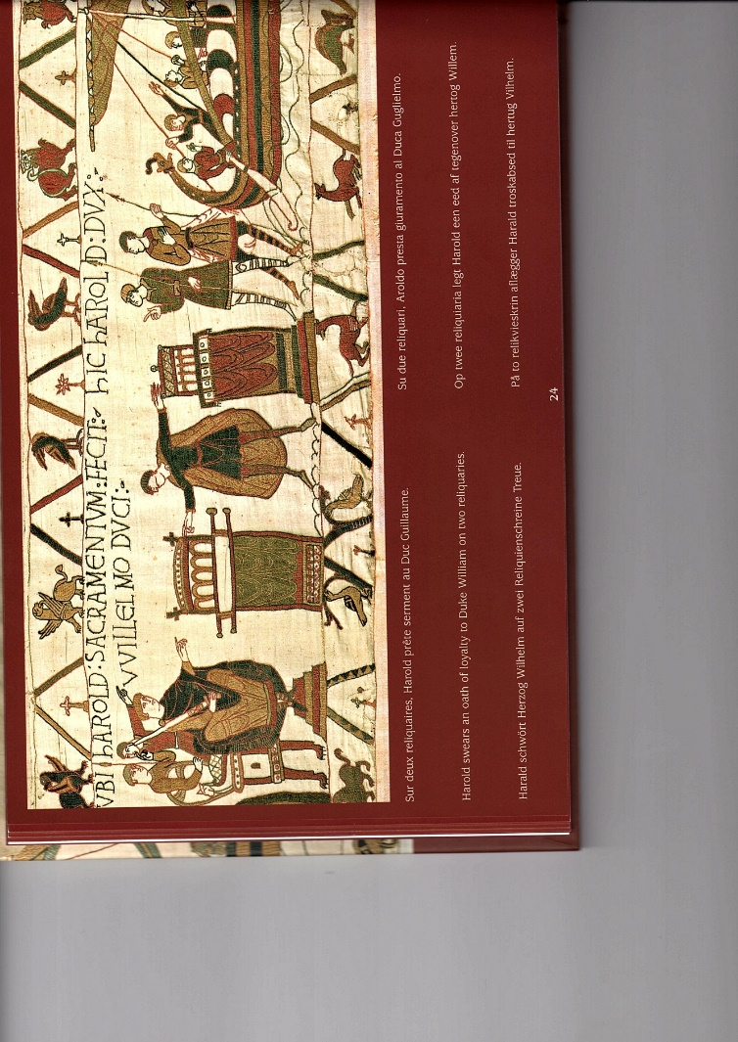

Figure 3: Harold swearing on Holy Relics, from the Bayeux Tapestry. Accessed from Collection Ville de Bayeux, Tapisserie de Bayeux, p. 24.

Furthermore, if we cross the Channel into England following the Norman Conquest of 1066, we can also see a variety of different artworks that indicate how the Normans wished to be viewed by contemporaries. One of the main sources for the conquest, and the best to demonstrate how the Normans wished to be viewed, is the Bayeux Tapestry, which was created sometime between 1070 and 1080. The 70-metre-long artwork, which is in fact embroidery despite its name, is believed to have been commissioned by William the Conqueror’s half-brother and the Bishop of Bayeux, Odon de Conteville, to celebrate the successes of the Norman invasion. However, the tapestry also provides various ways in which the Normans can be perceived. Firstly, the initial part of the tapestry presents Duke William of Normandy as a noble and just ruler, who agrees to pay Harold Godwinson’s ransom following his imprisonment at the hands of the Count Guy of Ponthieu, despite having no obligation too, and also granting Harold his knighthood following a campaigning season together in Brittany. Both these examples suggest that William, a Norman, is a wealthy and noble leader who, not only has enough income to pay for a stranger’s ransom, but also decides to free said stranger and grants them gifts of honour and wealth. As such, just from the initial part of the Bayeux Tapestry, it is clear that the Normans wish to be perceived as noble and just individuals who have the funds to support themselves and others. Continuing from this, Figure 3 demonstrates one of the most important parts, at least to a Norman, of the Tapestry in that Harold Godwinson is swearing an oath on holy relics to Duke William of Normandy that he will support the Duke’s claim on the Kingdom of England. However, following the death of Edward the Confessor, Harold Godwinson abandoned his oath and was crowned King of England. Some historians, such as Andrew Bridgeford, take the side of William of Normandy and claim that Harold wrongly usurped the throne from its rightful heir of William, while others, such as Peter Rex, suggest that William had no right to the throne so Harold was the rightful ruler. I personally agree with Rex in this instance in that Harold was the rightful ruler. Firstly, this is due to the fact that during the 1000’s, a man’s last will and testimony, usually referred to as their ‘verba novissima’, was binding and overruled any previous wishes that they had made, meaning that if Edward granted the kingdom to Harold as part of his last words, then Harold, and not William, was the rightful King. Furthermore, it must be remembered that the Bayeux Tapestry is a Norman artwork and as such, it will justify the Normans’ actions, meaning that it is not a useful source in terms of providing an impartial answer to who had the greater claim. However, it is a perfect source for how the Normans of England wished to be perceived by their peers. The Bayeux Tapestry suggests that the Normans are again pious, due to the swearing on holy relics and the acquisition of a Papal Banner from the Pope himself, but it also implies that the Normans are the rightful rulers of England, as they killed the usurper and the breaker of oaths. Finally, the Tapestry also implies that William and the Normans are skilled tacticians and commanders on and off the battlefield, with victory against the Anglo-Saxons at the Battle of Hastings as well as the construction of fortifications as soon as the Normans arrived in England. As is evident by the Bayeux Tapestry, the Normans of England wished to be perceived as, like before, pious and wealthy men, but also as militarily competent and the rightful rulers of the land they hold.

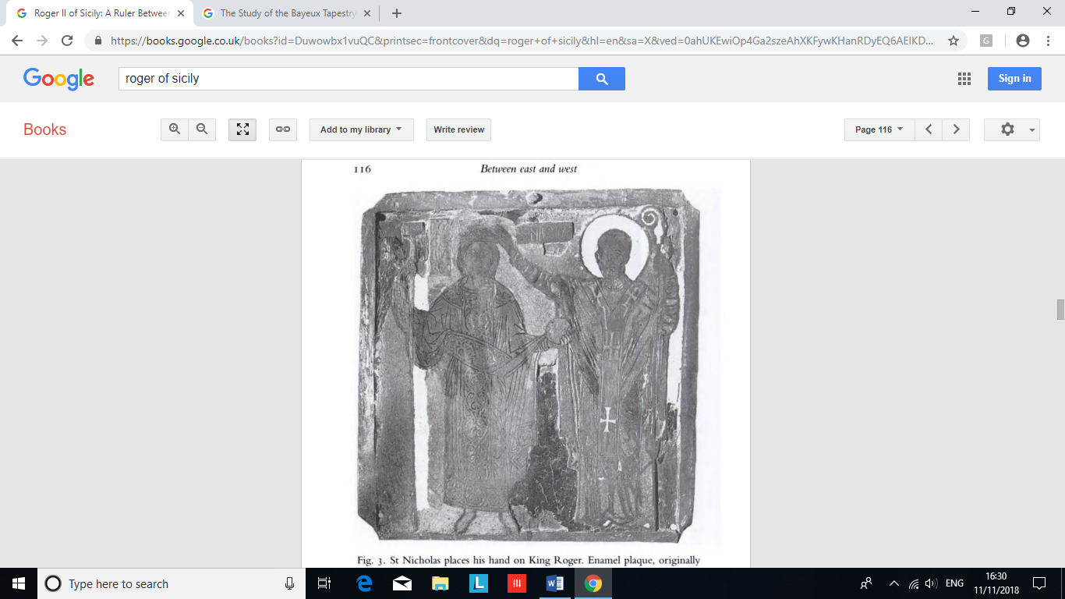
On the other side of Europe, the Normans also conquered many areas in Southern Italy and Sicily, under the leadership of the ‘De Hauteville’ family. Following multiple waves of Norman activity in the area, and the subsequent arrival of eleven of the twelve sons of Tancred De Hauteville, Southern Italy was subjected to various Norman rulers, most noticeably Robert De Hauteville, who was more commonly known as Robert ‘Guiscard’. Although these Southern Italian and Sicilian Normans were half way around the known world, they still commissioned many different artworks to communicate how they wished to be viewed by their contemporaries, as is evident in Figure 4. This plaque depicts a man, most likely King Roger II of Sicily, being crowned by St Nicholas, and is located in the Basilica of St Nicholas of Bari, in South-Eastern Italy. Positioned on the high alter of the Church, this image conveys the piety and legitimization of those involved as St Nicholas is using his divine power to crown this King, meaning that in the eyes of Christians, this Norman territory has been granted to them by God. Continuing from this, the fact that St Nicholas, and not Jesus Christ as is evident at the Martorana in Sicily, is crowning Roger is most likely an indicator to the Normans’ ability to assimilate into the local cultures of the areas they rule. For example, in the instance of Bari, St Nicholas is the patron saint of the area so his inclusion in the crowning of the King is the Normans’ way of adopting the customs of the local area as well as reinforcing the legitimacy of the King. Furthermore, Roger is also depicted here as having royal authority over his subjects, due to his possession of an orb, a symbol of kingship alongside the crown and the sceptre. Not only is Roger holding an item of authority, he is also dressed very much like an early Byzantine ruler, which demonstrates the connection between the Eastern and Western world’s. As such, Figure 4 suggests that the pious Normans were the rightful rulers of Southern Italy, who had the authority and ability to assimilate that would enable them to hold the Kingdom for generations.

Figure 4: Roger II being crowned by St Nicholas, from the Basilica of St Nicholas, Bari. Accessed from Houben, Roger II of Sicily, p. 116.

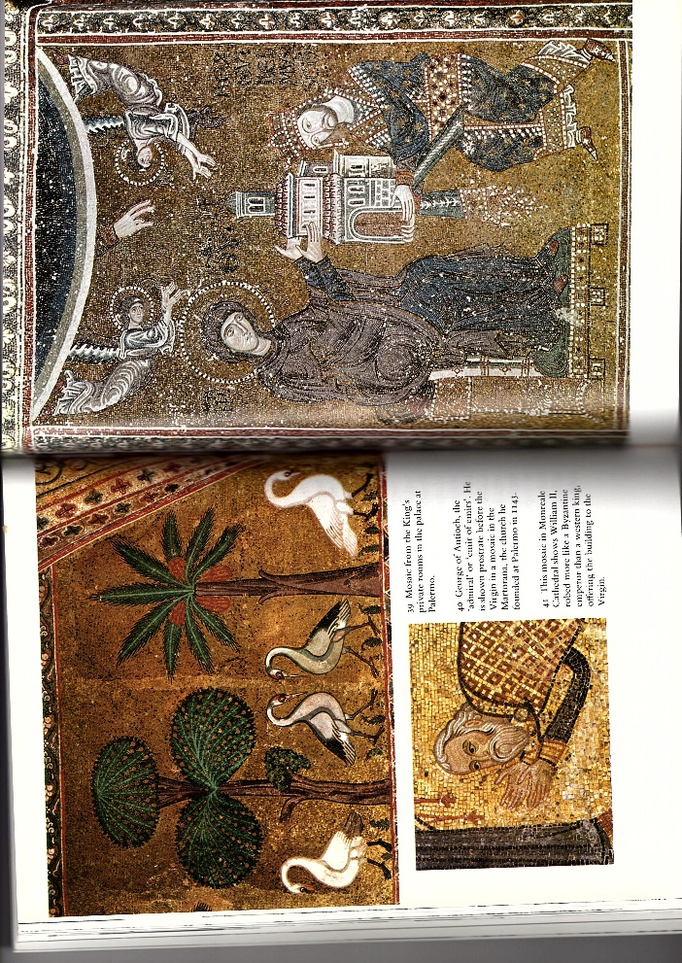
These concepts are further reinforced by a similar image from the Cathedral of Monreale in Sicily that depicts Roger II’s grandson, William II of Sicily, offering a gift to the Virgin Mary. The mosaic portrays William as a Byzantine Emperor instead of as a western king, as is evident by his robes and crown, in that he is dressed in a loros and a paludamentum. William’s crown is a tall, elaborately designed one that is identical to the closed crown design of the 1100’s Byzantine rulers, while, in terms of his clothing, the former is a leather scarf that was covered in a multitude of jewels and other ornately designed decorations, while the latter, which was originally an item of military apparel for the Romans, was a cloak worn exclusively by the Byzantine rulers during the Medieval period. As is evident here, William, in this mosaic, is clearly depicted as wearing Byzantine attire, which strongly suggests that he, along with his grandfather, wished to be perceived in a way similar to that of the Greek Emperors. The reasoning for this is not entirely certain, but it is possible that, as R.H.C. Davis suggests, the Sicilian-Normans wished to one day sit on the imperial throne of Constantinople as the rulers of the Byzantine Empire. I partially agree with Davis in that the Sicilian-Normans wished to be emperors, but it could also be claimed that this is their way of viewing themselves as the Mediterranean’s new dominant ‘empire’.
Figure 5: William II offering a gift to the Virgin Mary, from the Monreale Cathedral. Accessed from Davis, The Normans and their Myth, pp. 79 – 82.

Furthermore, this mosaic also portrays William as a very pious individual, due to his involvement with the Virgin Mary, who is receiving a gift from the King of Sicily. This gift, which is a model of a building, is most likely a monastic building, such as the Cathedral of Monreale where this mosaic is located, as is evident by the presence of the cross at the top of the building’s architecture. Continuing from this, the fact that William is gifting this building to Mary, the mother of Christ, further reinforces the religious connotations of this mosaic as it suggests that the building has the blessings and protection of the divine. Not only this, but it seems likely that William did in fact dedicate the Church of Monreale to the Virgin Mother, which would confirm the claim by Fred Kleiner that the model in the mosaic is a representation of the cathedral itself. As is evident here, this artwork clearly depicts the Normans as being incredibly pious as they are specifically commissioning buildings, as seen in the mosaic, and dedicating them to God. As such, Figure 5 depicts the Normans as having authority and influence within the Church and state, as well as implying the potential ambitions that the Normans of Sicily had.

In conclusion, these artworks, ranging from Normandy, England, Southern Italy, and Sicily, all suggest the different ways in which the Normans, who commissioned them, wished to be viewed by external eyes. Whether it be as strong and wealthy individuals, as is evident with the artwork from Normandy and England, or as the pious and righteous rulers of their conquered land, as seen in Southern Europe, the various artworks all imply an attribute of the Norman identity. Some of these characteristics, such as the focus on faith and legitimization, are unsurprising as the original Normans were pagan Vikings who acquired new land, while others, such as military prowess, are surprisingly absent in most of these artworks. Interestingly, it seems that the Normans did successfully convey their wishes as, even in the 13th Century, they were still being depicted as pious and authoritative individuals, as is evident with Matthew Paris’ ‘The Four Norman Kings of England’, which is now located in the British Museum. As such, the artwork commissioned by the Normans can tell modern historians a great deal about how the Normans wished to be perceived by their peers.

Words: 2651

Bibliography
- Bardsley, S., Women’s Roles in the Middle Ages (London, Greenwood Press, 2007), p. 82.
- Ed. by. Barnes, A., & Salerno, M., Symbols and Models in the Mediterranean: Perceiving through Cultures (Cambridge, Cambridge Scholarly Publishing, 2017), pp. 46 – 47.
- Benton, J. R., Materials, Methods, and Masterpieces of Medieval Art (Oxford, ABC-CLIO, 2009), pp. 91 – 92.
- Bridgeford, A., 1066: The Hidden History of the Bayeux Tapestry (London, Harper Perennial, 2004), pp. 6 – 7.
- Brooke, C., The Saxon and Norman Kings (London, B. T. Batsford Ltd., 1963), pp. 96 – 97.
- Cleaver, L., Illuminated History Books in the Anglo-Norman World: 1066 – 1272 (Oxford, Oxford University Press, 2018), pp. 122 – 128.
- Collection Ville de Bayeux, Tapisserie de Bayeux (Carquefou, Éditions Artaud Frѐres, 2013), pp. 2 – 23 & 43 - 63.
- Ed. by. Condra, J., The Greenwood Encyclopaedia of Clothing Through World History: Prehistory to 1500 CE, Vol. 1 (London, Greenwood Press, 2008), pp. 130 – 140.
- Davis, R. H. C., The Normans and their Myth (London, Themes & Hudson Ltd, 1980), pp. 7 – 20 & 79 – 87.
- Houben, H., Roger II of Sicily: A Ruler Between East and West (Cambridge, Cambridge University Press, 2002), pp. 114 – 118.
- Kleiner, F. S., Gardner’s Art Through the Ages: The Western Perspective, Ed. 13, Vol. 1 (Boston, Wadsworth Cengage Learning, 2009), pp. 250 – 253.
- Neveux, F., Trans. Curtis, H., A Brief History of the Normans: The Conquests that Changed the Face of Europe (Robinson, Great Britain, 2008), pp. 58 – 69 & 136 – 156.
- Olson, S., Daily Life in a Medieval Monastery (Oxford, Greenwood Press Daily Life Through History Series, 2013), pp. 42 – 51.
- Oxford University, Orb, Oxford English Dictionary 3rd Edition (Oxford University Press, Oxford, 2015 [2010]). Accessed from Oxford Referencing.
- Rex, P., 1066: A New History of the Norman Conquest (Stroud, Amberley Publishing, 2009), pp. 20 – 35.

R. H. C. Davis, The Normans and their Myth (London, Themes & Hudson Ltd, 1980), pp. 7 – 20.
Francois Neveux, Trans. Howard Curtis, A Brief History of the Normans: The Conquests that Changed the Face of Europe (Robinson, Great Britain, 2008), pp. 136 – 137.
Laura Cleaver, Illuminated History Books in the Anglo-Norman World: 1066 – 1272 (Oxford, Oxford University Press, 2018), pp. 122 – 124.
Neveux, A Brief History of the Normans, pp. 58 – 69.
Cleaver, Illuminated History Books in the Anglo-Norman World, pp. 122 – 124.
Neveux, A Brief History of the Normans, pp. 136 – 137.
Cleaver, Illuminated History Books in the Anglo-Norman World, pp. 122 – 128.
Neveux, A Brief History of the Normans, pp. 136 – 137.
Sherri Olson, Daily Life in a Medieval Monastery (Oxford, Greenwood Press Daily Life Through History Series, 2013), pp. 42 – 51.
Cleaver, Illuminated History Books in the Anglo-Norman World, pp. 125 – 128.
Sandy Bardsley, Women’s Roles in the Middle Ages (London, Greenwood Press, 2007), p. 82.
Collection Ville de Bayeux, Tapisserie de Bayeux (Carquefou, Éditions Artaud Frѐres, 2013), p.2.
Collection Ville de Bayeux, Tapisserie de Bayeux, pp. 8 – 23.
Collection Ville de Bayeux, Tapisserie de Bayeux, pp. 24 – 29.
Andrew Bridgeford, 1066: The Hidden History of the Bayeux Tapestry (London, Harper Perennial, 2004), pp. 6 – 7.
Peter Rex, 1066: A New History of the Norman Conquest (Stroud, Amberley Publishing, 2009), pp. 20 – 30.
Bridgeford, 1066, pp. 6 – 7.
Rex, 1066, pp. 25 – 35.
Collection Ville de Bayeux, Tapisserie de Bayeux, pp. 43 – 63.
Davis, The Normans and their Myth, p. 87.
Neveux, A Brief History of the Normans, pp. 152 – 156.
Hubert Houben, Roger II of Sicily: A Ruler Between East and West (Cambridge, Cambridge University Press, 2002), pp. 114 – 118.
Oxford University, Orb, Oxford English Dictionary 3rd Edition (Oxford University Press, Oxford, 2015 [2010]). Accessed from Oxford Referencing on 13/11/2018.
Houben, Roger II of Sicily, pp. 114 – 118.
Davis, The Normans and their Myth, pp. 80 – 81.
Ed. by. Aneilya Barnes & Mariarosaria Salerno, Symbols and Models in the Mediterranean: Perceiving through Cultures (Cambridge, Cambridge Scholarly Publishing, 2017), pp. 46 – 47.
Ed. by. Jill Condra, The Greenwood Encyclopaedia of Clothing Through World History: Prehistory to 1500 CE, Vol. 1 (London, Greenwood Press, 2008), pp. 130 – 140.
Davis, The Normans and their Myth, pp. 86 – 87.
Ibid, pp. 79 – 82.
Fred S. Kleiner, Gardner’s Art Through the Ages: The Western Perspective, Ed. 13, Vol. 1 (Boston, Wadsworth Cengage Learning, 2009), pp. 250 – 253.
Janetta Rebold Benton, Materials, Methods, and Masterpieces of Medieval Art (Oxford, ABC-CLIO, 2009), pp. 91 – 92.
Davis, The Normans and their Myth, pp. 7 – 10.
Christopher Brooke, The Saxon and Norman Kings (London, B. T. Batsford Ltd., 1963), pp. 96 – 97.

