Drama and Theatre in Education Process Workbook

Drama in Education Workshop and Performance
As part of the assessment for this module, our task is to work in groups of three or four to plan, prepare, deliver, and evaluate a Drama in Education workshop for a group of Year 6 children in Key Stage 2 in a school setting. The theme of our workshop is based on the Lady of the Lake, which is a famous Welsh folktale from Carmarthenshire, centred on a mystical woman who emerges from the Black Mountain lake to marry a local farmer. She agrees to marry him under the condition that he never strikes her three times, but she ultimately returns to the lake with their livestock after the condition is broken.
The workshop will last between 50 minutes and an hour, depending on the group size. Each of us will be responsible for leading about 10 minutes of the workshop and then supporting co-facilitators for the remainder of the workshop.
The workshop (see Appendix A) begins with an engaging icebreaker designed to encourage movement, imagination, and group awareness. Participants walk around the room freely while responding to a series of simple physical instructions such as walking, stopping, jumping, and touching the floor. These movements are then developed into more creative actions inspired by elements from Lady of the Lake, including the lake, mountains, wind and farm animals such as cows and sheep. This helps participants connect physical movement with imagery and themes from the story. Sensory prompts are also introduced, encouraging participants to think about what they could see (such as landscapes like mountains or lakes), hear (for example, animals or wind), and touch (such as bread), further deepening their imaginative engagement.
The main workshop activity focuses on “hot seating,” a drama technique in which participants take on the role of characters from Lady of the Lake, such as the Lady herself, the farmer, or the mother. Participants are divided into smaller groups and asked to develop three questions they could ask the characters. Guidance is provided to support them in creating thoughtful and relevant questions. These questions explore different aspects of the story, including the plot, character motivations, key events, moral lessons, and how the characters might have acted differently.
To model the activity, I will then explain and demonstrate how hot seating works, showing how to answer questions in character. Participants are then given the opportunity to take part themselves within their groups, with one round. This activity encourages empathy, critical thinking and a deeper understanding of the narrative, as participants consider characters’ feelings, decisions and perspectives.

Mantle of the Expert
One technique that has helped me throughout this module—and has also aided in developing my workshop—is Mantle of the Expert. Mantle of the Expert is an educational approach that uses imaginary contexts to generate purposeful and engaging activities for learning. Within this fictional framework, students are cast as a team of experts working for a client on a commission.
Mantle of the Expert was originated and developed by Dorothy Heathcote (1926-2011), an internationally renowned British drama educator and academic. She created this drama-based, inquiry-led approach in the 1980s at Newcastle University as a powerful teaching method to connect curriculum learning with student experience.
Key facts about the origin:
- Purpose: Heathcote designed the approach to empower students by placing them in roles of responsibility, using the “mantle of the expert” to work as professionals within a fictional context.
- Methodology: It involves using drama techniques, such as role-playing and improvisation, to explore subjects rather than simply instructing students.
- Development: It is often described as a “safe zone” for students to tackle complex decisions, focusing on learner-led values and community.
- Legacy: Heathcote is considered a pioneer in using drama for learning, and the approach is now used worldwide.
Heathcote’s work drew on her experience as a teacher and her belief in the power of drama to engage learners across the curriculum.
Key Examples of Mantle of the Expert Scenarios
- Archaeologists/Historians: Students excavate a “newly discovered” Egyptian tomb, researching ancient history, examining artefacts, and creating a museum exhibition.
- Environmental/Rescue Teams: Students act as a mountain rescue team (checking equipment, planning rescues) or as a team of re-wilders in Scotland or Canada studying ecology.
- Engineers and Designers: Students operate as engineers to build a land-speed record car or as design teams creating a new product (e.g., a chocolate bar for Willy Wonka).
- Conservationists/Medical Staff: A “Dinosaur Hospital” scenario where students design treatments, manage transport, and plan the rehabilitation of animals.
- Media and Marketing Agencies: Students work as a marketing firm designing ads, branding, and producing music for a festival.
- Event Organisers: The “Nelson Explorers Club” studying the Battle of Trafalgar.
These scenarios are often sustained over a whole term, allowing for deep curriculum integration (history, literacy, geography, science) and developing student empathy and responsibility.
Mantle is not a cloak by which a person is recognised. This is no garment to cover. I use it as a quality: of leadership, carrying standards of behaviour, morality, responsibility, ethics and the spiritual basis of all action. The mantle embodies the standards I ascribe to. It grows by usage, not garment stitching (Heathcote, 2009 cited in Aitken, 2013 p.35)
Conceptually – the mantle (cloak) ‘grows’ to envelop the user/learner/child.

Explanation
The quote distinguishes between a physical “garment” and a metaphorical “quality” of professional and personal character.
- A quality, not a Garment: Heathcote clarifies that the “mantle” is not a literal cloak or uniform one puts on to be recognised by others. Instead, it is an internal “vocation” or “calling” that represents a commitment to high standards.
- Core Pillars: She defines this quality through several key attributes:
  - Leadership and Responsibility: Carrying the weight of decision-making and accountability.
  - Morality and Ethics: Following a code of conduct that governs how one treats others (the “client” or the community).
  - Spiritual Basis: Grounding all actions in a deeper sense of purpose and human connection.
- Grows by Usage: The mantle is not “stitched” together or gifted by an outside authority; it develops through practice, experience, and the active fulfilment of one’s duties.
In the MoE classroom, students “wear the mantle” by adopting the persona of responsible experts (e.g., scientists, historians, or rescuers) to solve complex problems for a fictional client. This allows them to explore these serious qualities of leadership and ethics within a safe, imaginative framework.
Mantle of the Expert, as developed by Dorothy Heathcote, was particularly valuable to me within the Drama and Theatre in Education module because it shifted my role from a passive learner to an active participant with responsibility and purpose. By working as part of an “expert” team, I felt more invested in the creative process, which strengthened both my confidence and my engagement. This approach also helped me bridge the gap between theory and practice, allowing me to apply pedagogical ideas directly through drama rather than only writing about them abstractly. Personally, I found that I learn more effectively through doing, and Mantle of the Expert would enable me to develop practical skills such as collaboration, communication, and problem solving while simultaneously deepening my understanding of how theatre can be used as an educational tool. Additionally, taking on responsibility within a fictional but purposeful context encouraged me to think more critically about my creative choices and their impact on an audience, which is essential in Theatre in Education. Overall, this approach supported my development as both a performer and a reflective practitioner, helping me to produce more thoughtful, purposeful, and socially aware work.
In short, Mantle of the Expert has helped me immensely with this module and it is helpful to me because it makes learning active, meaningful, and collaborative and it bridges performance and pedagogy. It also helped me with my potential future career aspirations because I feel like real-world applied theatre work might be something I want to pursue in the future.

Personal evaluation
Delivering a Drama and Theatre in Education performance and workshop based on Lady of the Lake was a valuable and rewarding experience. Overall, I feel that the session was successful, as I was able to accomplish everything I had planned. The structure of the workshop allowed the children to stay engaged throughout, and they listened attentively, responding positively to both the performance and the activities. This demonstrated that my planning was effective and that the content was accessible and appropriate for the group.
One of the main strengths of my work was my ability to maintain control of the group while also encouraging participation. The children were enthusiastic and willing to contribute, which helped create an enjoyable and interactive learning environment.
However, there are areas I would like to improve. During the performance, my nerves became noticeable, which affected my confidence at times. This led to me forgetting one of my lines, briefly disrupting the flow of the piece. In future, I would aim to rehearse more thoroughly under performance conditions and develop techniques to manage nerves more effectively, ensuring a smoother and more confident delivery.

Appendix
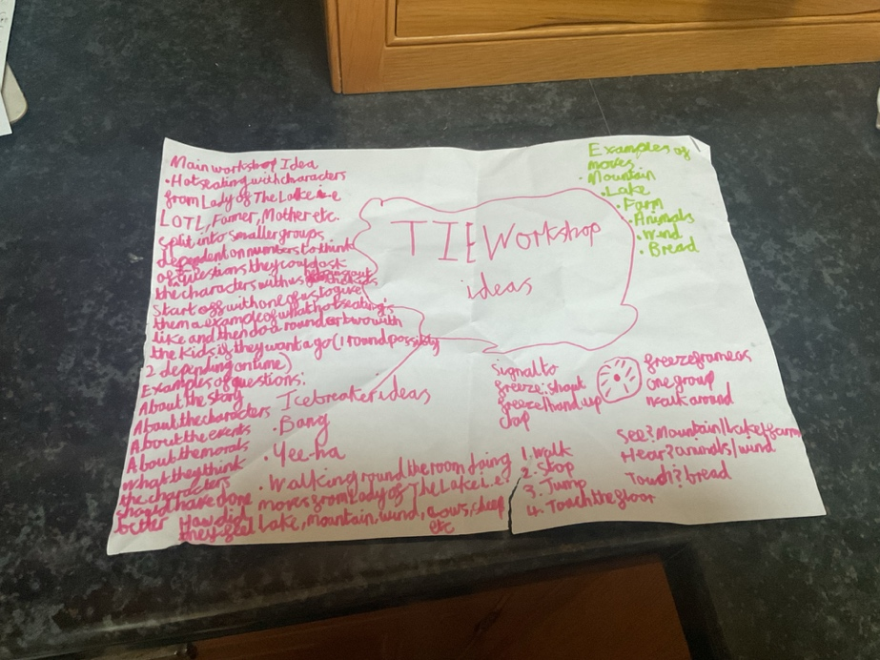
Appendix A

Reference List
- Aitken, V. (2013) Dorothy Heathcote’s Mantle of the Expert Approach to Teaching and Learning: A Brief Introduction. NCZER Press.

