Samra Mahroof 1816889
BSc Health and Social care
BMHP5003_BIRM
Introduction to Physiology
Mumtaz Goolam
Task 1 – Individual poster Presentation

Function of the bones are providing structural support for the body, mineral storage, particularly calcium phosphate, connection to muscles and tendons, mineral reservoir inside bones crucial for blood calcium levels that must be managed
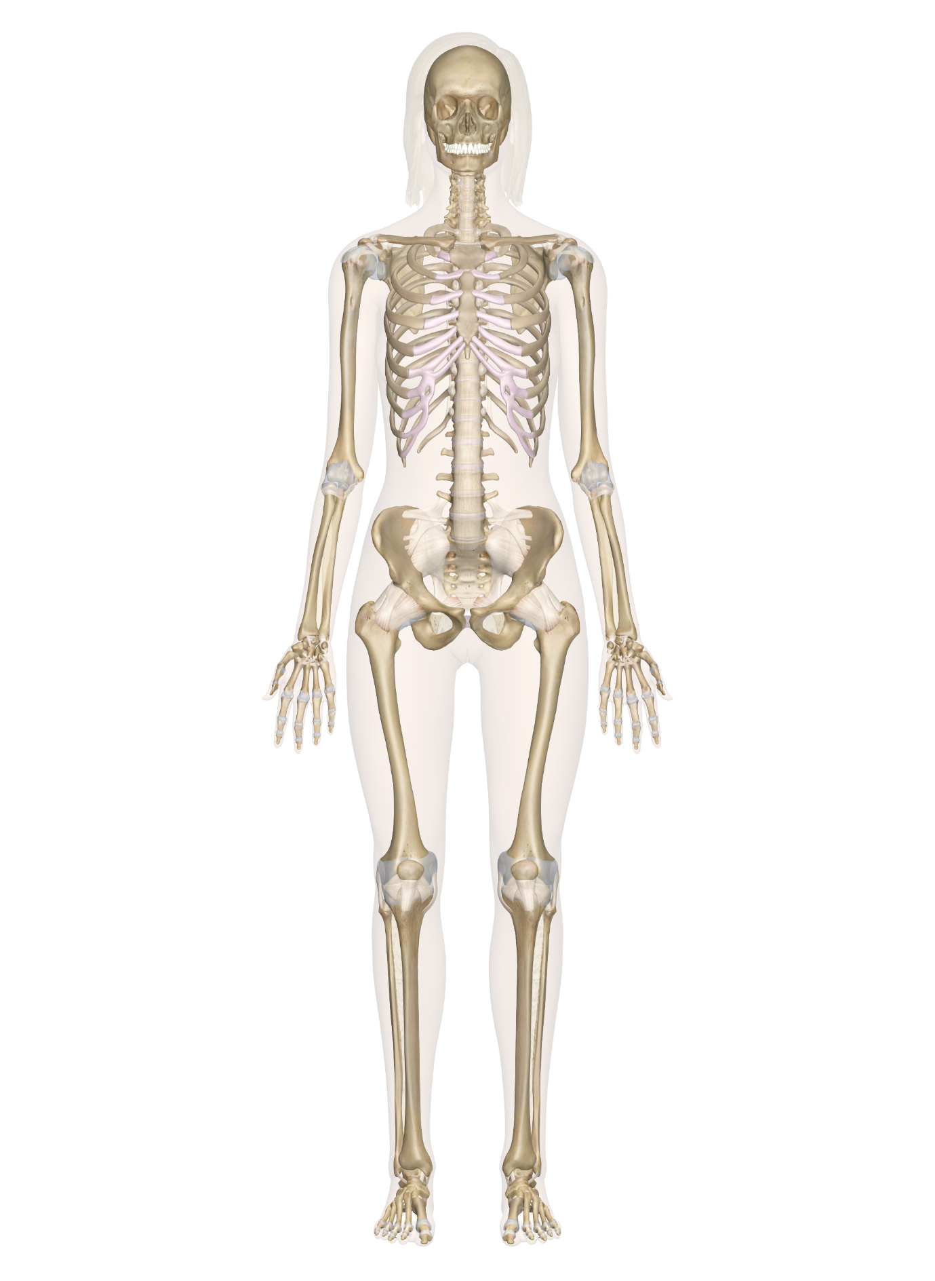
The skull is an essential bone in the body because it houses the brain, which is one of the body's most sensitive organs. It protects the brain and the facial skeleton, which is more delicate owing to the presence of thin-walled bones (Skull View & Bones, 2021).
Ulna
Bones of the skull
The purpose of the ribs is they safeguard your heart, lungs, and other upper-body organs and tissues, They also protect your liver and kidneys and offer structure and support to the bones and muscles in your chest, shoulders, and back. (How Many Ribs Does a Person Have? Anatomy and Rib Pain Causes, 2021)

According to (Dahlui, Wan and Koon, 2012) It provides structure and support to your body, It enables you to move freely and bend with flexibility and the spine is also intended to protect the spinal cord. The spinal cord is a network of nerves that links your brain to the rest of your body and allows you to regulate your motions.

Ribs
The bony structure of the thoracic cavity is comprised of the ribs, The ribs are the basic component of the thoracic cage that protects the thoracic organs, although its primary role is to help respiration. (Ribs, 2021)

Spine
The pelvis serves as a point of attachment for muscles that balance and support the trunk as well as move the legs, hips, and trunk. (Pelvis, 2021)
Radius

Bones of pelvis
Long bone
Phalanges / fingers
According to (Phalanges: Definition, Location, Anatomy, Functions, Diagram, 2021) the function of the fingers are to the phalanges are essential for the movement and flexibility of the digits as well as the entire hand, These bones allow us to flex and fold our fingers and thumbs to grip or pick something up, as well as carry out all of our daily tasks like as talking on the phone, typing, eating, and so on.
Long bones support the body's weight and enable for mobility. Long bones are generally found in the appendicular skeleton and include lower limb bones (tibia, fibula, femur, metatarsals, and phalanges) as well as upper limb bones (the humerus, radius, ulna, metacarpals, and phalanges) Body and bones (Body and Bones, 2021)

Four main bones
Short bones - A short bone is one that has a cube-like form that is roughly equal in length, diameter, and thickness.
Flat bones- Flat bones function as muscular attachment sites and frequently protect internal organs.
irregular bone- An irregular bone is one that has a clearly defined form and so does not fit into any other categorization.
Sesamoid bones- The quantity and location of sesamoid bones varies from person to person, although they are most commonly seen in tendons connected with the feet, hands, and knees.
The fibula, unlike the tibia, does not bear weight. Its major function is to connect with the tibia to stabilise the ankle joint, The distal end of the fibula has many grooves for ligament attachments, which provide support and leverage during ankle movements. 2020 (Body and Bones)
Knees
Fibula
Tibia

(skeletal system - Google Search, 2021)
Function of the skeletal system
According to (Skeletal System,2021), the major functions of the skeletal system are to form the body, enable mobility, generate blood cells, protect organs, and store minerals.
The soft, spongy tissue with many blood veins present in the middle of most bones, Bone marrow comes in two varieties: red and yellow. Blood stem cells in red bone marrow can develop into red blood cells, white blood cells, or platelets, Yellow bone marrow is primarily fat and contains stem cells that can differentiate into cartilage, fat, or bone cells. (NCI Dictionary of Cancer Terms, 2021)

(NCI Dictionary of Cancer Terms, 2021)
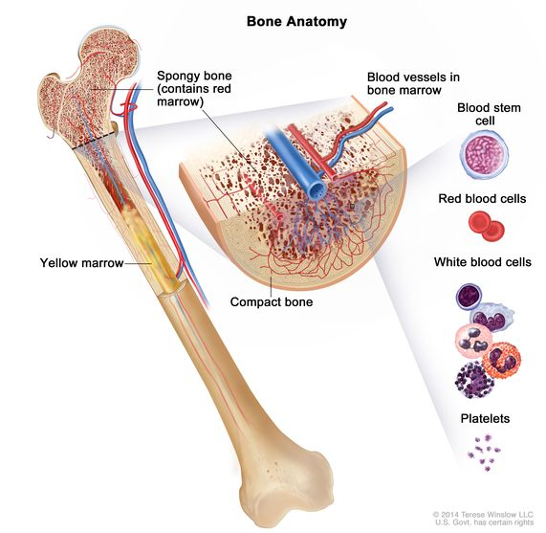
Function of the bones

According to (walker, 2014) there are many way to determine if you have Paget disease is to get blood test, x-ray, bone scans and bone biopsy to see if the thickness of the bone is tearing.
Paget's bone disease is a chronic disorder that impairs bone remodelling in certain parts of the skeleton, The condition can impact one or more locations and result in a number of consequences such as discomfort, bone deformity, osteoarthritis, fracture, or nerve compression. (Walker, 2014)

(Walker, 2014)
Disease of the bone
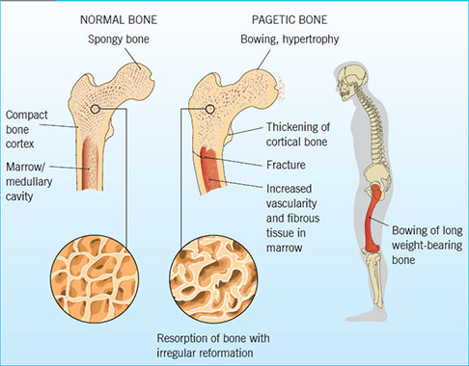
According to (Paget's disease of bone, 2021) the cause are when Something goes wrong with the osteoclast cells in Paget's disease of bone, and they begin to absorb bone at a much higher pace than usual, The osteoblasts then attempt to build new bone faster, but the resultant bone is bigger and weaker than normal.
The bone symptoms according to (Paget's disease of bone, 2021 NHS) Paget's disease causes bone discomfort that is dull or painful, deep inside the afflicted section of the body, and worst at night the afflicted region may also feel warm.

Some persons with Paget's disease benefit from supportive therapies such as physiotherapy or occupational therapy, which include exercises and procedures that can help reduce discomfort, improve mobility, and make daily chores simpler.

Reference list
The Human Memory. 2021. Skull | Functions, Facts, Fractures, Protection, View & Bones. [online] Available at: <https://human-memory.net/skull/> [Accessed 11 June 2021].

Healthline. 2021. How Many Ribs Does a Person Have? Anatomy and Rib Pain Causes. [online] Available at: <https://www.healthline.com/health/how-many-ribs-does-a-person-have#purpose> [Accessed 11 June 2021].

Dahlui, M., Wan, N. and Koon, T., 2012. Cost analysis of UMMC services: SPINE. BMC Health Services Research, 12(S1).

TheSkeletalSystem.net. 2021. Phalanges: Definition, Location, Anatomy, Functions, Diagram. [online] Available at: <https://www.theskeletalsystem.net/phalanges> [Accessed 11 June 2021].

Google.co.uk. 2021. skeletal system - Google Search. [online] Available at: <https://www.google.co.uk/search?q=skeletal+system&sxsrf=ALeKk02qKfIFpHHrtcZ1EuVLnondAI16TA:1623431499652&source=lnms&tbm=isch&sa=X&ved=2ahUKEwjJ9enOiZDxAhUR5uAKHTL0AwgQ_AUoAXoECAEQAw&biw=1366&bih=657#imgrc=shpvsryefBkcLM> [Accessed 11 June 2021].

Cleveland Clinic. 2021. Skeletal System. [online] Available at: <https://my.clevelandclinic.org/health/body/21048-skeletal-system#:~:text=The%20skeletal%20system%20works%20as,for%20organs%20and%20stores%20minerals.> [Accessed 11 June 2021].

National Cancer Institute. 2021. NCI Dictionary of Cancer Terms. [online] Available at: <https://www.cancer.gov/publications/dictionaries/cancer-terms/def/bone-marrow> [Accessed 12 June 2021].

Walker, J., 2014. Pathogenesis, diagnosis and management of Paget’s disease of the bone. Nursing Older People, 26(8), pp.32-38.

nhs.uk. 2021. Paget's disease of bone. [online] Available at: <https://www.nhs.uk/conditions/pagets-disease-bone/> [Accessed 12 June 2021].

