
MSc Public Health and Social Care in Practice
LCHS7006: Quality Assurance and Service Improvements
Lecturer: Dilhara Mampitiya and Christopher Mafuva
Internal Verifier: Dr Hamdi Hussain
Component 2: Service Improvement Report
Word count: 3064
(Title: From Special Measures to Sustained Improvement: A Comparative Review of Shrewsbury and Telford Hospital NHS Trust (UK) Maternity Scandal)

Executive Summary
This report has used the Donabedian model, SWOT analysis, fishbone diagram and 5 Whys technique to assess the maternity quality failures at Shrewsbury and Telford Hospital NHS Trust (SaTH). The findings revealed that structural and cultural weaknesses, rather than a single mistake, caused ongoing harm within the trust. The findings from the Benchmarking against East Kent Hospitals demonstrated that if there is a structured reform, it has a positive impact on safety outcomes. Furthermore, the three recommendations such as workforce capacity and clinical competencies, standardising maternity pathways, governance and psychological safety enhancement for SaTH.

Table of Contents
Introduction 3
Background 3
Shrewsbury and Telford maternity quality concern 3
Wider public health and equity implications 4
Purpose of the report 4
Main Body 4
1. Management of Quality & Theoretical Frameworks 4
2. Strategic Environmental Analysis 6
3. Root Cause Analysis (RCA) of the Quality Issue 7
4. Critical Synthesis & Evidence-Based Findings 9
Recommendation 12
Conclusion 16
Summary of the key findings 16
Implications for quality improvements 17
Concluding recommendations 17
References 18

Introduction

Background
Maternity care is one of the major components of public health which influenced directly with the quality of services and patient safety for maternal well-being, neonatal outcomes, family experiences and long-term population health. Based on the report of MNSI (2023), the effective maternity services need timely assessment, appropriate clinical intervention, accurate documentation, multidisciplinary communication and responsive governance. However, BBC News (2025) reported that persistent failures across NHS maternity services demonstrate that patient safety risks may develop when organizational systems do not identify, escalate or address concerns effectively. The Care Quality Commission (2024) reported around 47% have identified inadequate services continuing variation in the safety and quality of maternity services across England especially regarding workforce capacity, triage procedures, leadership and risk management.

Shrewsbury and Telford maternity quality concern
The maternity failures at Shrewsbury and Telford Hospital NHS Trust (SaTH) represent one of the most significant quality concerns in the history of NHS maternity care. The Independent Maternity Review investigated approximately 1592 family cases and identified avoidable baby deaths that occurred in the first 7 days of life, along with substantial maternal and neonatal harm (Ockenden Report, 2022). The findings described persistent weaknesses in clinical assessment, fetal monitoring, escalation, documentation, incident investigation and organisational learning. In addition, BBC News (2022) also reported that around 201 babies including 131 stillbirths and 70 neonatal deaths could have survived with better care. These failures were not isolated incidents instead they developed over an extended period because warning signs were insufficiently identified and acted upon. Therefore, the SaTH case enhances how weaknesses across the multiple organizational levels can combine by producing significant preventable patient harm.

Wider public health and equity implications
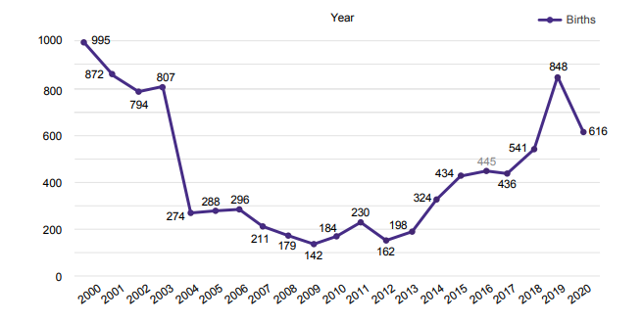
Figure 1: Number of records with incomplete ethnicity at the Trust from 2022-2020
(Source: Ockenden Report, 2022)
The significance of the SaTH case extends beyond one healthcare organization as similar concerns continue to affect maternity services in the UK. In this regard, Orovou et al. (2025) provided insights that the workforce shortages may improve pressure on midwives, reduce continuity of care and contribute to delays in triage, monitoring and escalation. Furthermore, maternity inequalities describing quality failures may affect population groups differently. The Ockenden Report (2022) explained that Black women experience substantially higher maternal mortality risks than White women in the UK by highlighting the importance of integrating equity into quality assurance and service improvement.

Purpose of the report
The purpose of this report is to evaluate the SaTH maternity quality concern by identifying the systemic factors contributing to unsafe care. The main discussion applies the Fishbone Diagram and the Donabedian Model to examine underlying causes relating to people, processes, organizational structures and governance. Furthermore, the SWOT analysis is subsequently used to consider internal capabilities and external factors influencing service improvements.

Main Body

1. Management of Quality & Theoretical Frameworks
1.1 Healthcare Quality Frameworks: Donabedian Model
Donabedian Model provides a defined process to assess the quality of care within the healthcare structure, process and outcome. The structure domain of the Donabedian Model influences the delivery of service, including staffing, equipment and governance systems (De Rosis et al., 2024). In the case of SaTH hospital, a number of structural weaknesses were present, such as chronic midwifery shortages and inadequate governance arrangements (Ockenden Report, 2022). This structural ambiguity impacted the trust’s ability to provide safe and reliable maternity services. Process indicators subsequently reflect clinical care delivery, coordination, and communication between practitioners and patients. The Ockenden Report indicated missed fetal monitoring and delayed escalation were critical process failures at SaTH. These breakdowns in operation highlight the direct clinical consequences of the structural weakness due to poor communication. Finally, clinical outcomes measure adverse events like child death, mortality and patient satisfaction due to inadequate care delivery within the organisation. It is found that 47% of all maternity services in the UK need to improve in respect to providing safety and quality of care (CQC, 2024). These outcomes validate that the SaTH’s structural and process failures are more indicative of national quality issues rather than an isolated event.
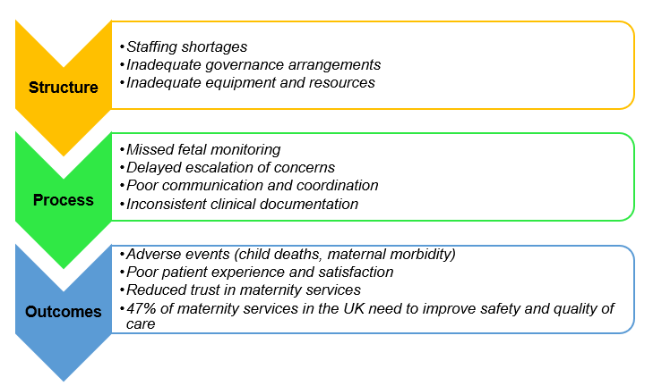
Figure 1: Donabedian Model
(Source: Self-developed)
1.2 System-Level Reform & Policy Context
SaTH Trust is facing a fatal quality failure within the organisation, which is influenced by the national policies encoded by NHS Trusts and the UK government. NHS has introduced the three-year delivery plan for maternity and neonatal services, which requires trusts to implement standardised safety tools and leadership training by 2024 (NHS England, 2023). This policy has indicated a move from a trust-based model to a more centrally-led approach to safety practice for the organisation. However, it was found that SaTH has policy gaps and an unsafe organisational culture remained after 24 years of repeated national warnings (The Guardian, 2026). This indicates that policy commitments are unable to convert into changes without an accountability and enforcement system within the structural healthcare system in the UK. The healthcare sector has a lack of financial sustainability, such as short-term budget planning, fragmented market mechanisms, and severe workforce shortages in terms of policy implementation. NHS organisations are facing issues in terms of savings in their running costs and boosting their productivity under continuous pressure (King's Fund, 2026). This pressure could reduce investments in the national workforce and training needed to integrate the national safety policy at the local level.

2. Strategic Environmental Analysis
2.1 Strategic Assessment: SWOT Analysis
Strengths | Weakness
- SaTH Trust has an experienced clinical workforce that is capable of delivering competent maternity care under strain.  - The point of difference (PoD) of SaTH Trust is its dual-site acute service model-split specialisation (Royal Shrewsbury Hospital-critical care, emergency departments and Princess Royal Hospital- surgical unit)  - The Trust has vast rural servicing areas (500,000 residents spanning across Shropshire, Telford and Wrekin, and mid-Wales)  - SaTH Trust has established a Maternity and Neonatal Safety Improvement Programme following the Ockenden Report (Ockenden Report, 2022). | - SaTH Trust has suffered chronic midwifery staffing shortages that compromised safe triage and monitoring (CQC, 2024).  - SaTH Trust exhibited weak governance and incident investigation processes that allowed harm to persist for almost two decades.
Opportunities | Threats
- The UK government has introduced the 10 Year Health Plan's national maternity taskforce reforms to strengthen safety oversight (GOV.UK, 2025). SaTH Trust can adopt this plan to strengthen its safety paradigm.  - Lean Six Sigma and PDSA methodologies are proven effective across comparable NHS trusts (Saha et al., 2024). SaTH Trust can implement this methodology to improve its quality of services. | - SaTH Trust faces continued NHS-wide financial deficits that could limit investment in future safety improvements (King's Fund, 2026).  - SaTH Trust risks further reputational damage amid the ongoing national investigation into similar maternity failures (BBC, 2025).
Table 1: SWOT Analysis for SaTH Trust
(Source: Self-developed)
Analysis
Table 1 SWOT Analysis helps to identify the internal and external conditions that will affect maternity service redesign after the failures of the SaTH. The strengths of this trust are a well-established and skilled clinical staff, while the weaknesses are associated with chronic staffing difficulties and weak governance. It is found that SaTH has issues with midwifery staffing levels as a national contributory factor to unsafe triage and monitoring (CQC, 2024). This deficiency illustrated that gaps in internal capacity had a direct impact on the provision of safe services at SaTH Trust in the UK. The use of digital infrastructure is another internal weakness of maternity services in the UK. Disconnected EHRs and disparate legacy systems create siloed data, which impacts safe data sharing in maternity care within the trust. These disparities in maternity care fragmented records prevent clinicians from accessing critical histories in real time, increasing the risk of medication error, duplicate tests and delays in emergency intervention with the trust.

3. Root Cause Analysis (RCA) of the Quality Issue
3.1 Diagnostic Problem Structuring: Ishikawa Fishbone Diagram
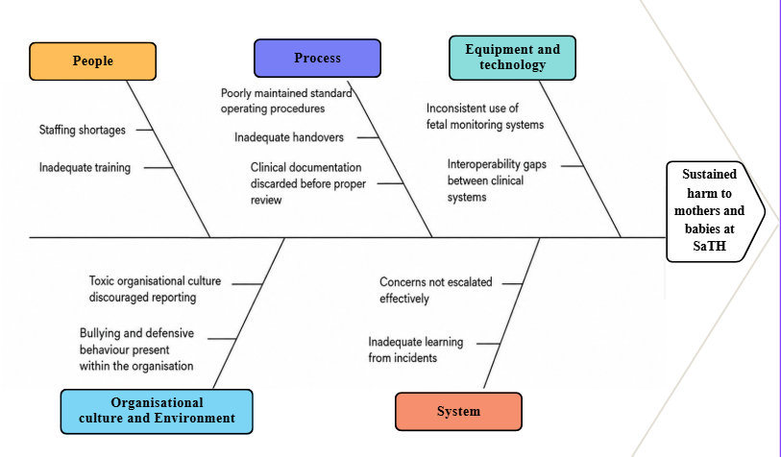
Figure 2: Ishikawa Fishbone Diagram
(Source: Self-developed)
Analysis
As per Figure 2, the Fishbone Diagram demonstrates the root causes of quality issues in SaTH Trust within its people, processes, equipment, and environments. Fishbone analysis is commonly used in the healthcare sector to systematically develop and categorise quality improvement ideas within the organisation (Kumah et al., 2024). Application of this tool in SaTH helps to explain how people, organisational culture and its environment contribute to the deaths of mothers and babies and the lack of quality in care. According to the report, there was a lack of staffing and poor training skills within the SaTH Trust, which caused these significant failures to result in fetal death of babies and mothers (Ockenden Report, 2022). Additionally, inadequate standard operating procedures and handovers were maintained, and clinical documentation was often thrown away before appropriate review, which compromised safety oversight within the trust. However, fetal monitoring systems were not used consistently, and interoperability issues between clinical monitoring systems still exist across the country (Digital Health, 2025). Moreover, the trust had expected that staff would not report concerns, while bullying and defensive behaviour caused the attitude of staff towards incidents within the SaTH’s environment and culture.
3.2 Deep-Dive Etiology: The 5 Whys
The 5 Whys analysis is a root cause problem-solving technique used in healthcare settings to find the underlying systemic causes of an issue rather than symptoms (Singh et al. 2024). In this case, delayed escalation of fetal distress was caused by the staff not being confident enough to challenge senior decisions in SaTH Trust. This was caused by a hierarchical culture that was unable to promote junior staff and raise safety concerns (The Guardian, 2026). Additionally, Governance mechanisms were unable to uphold the psychological safety principles, which led to this culture of quality failure. This validation shows that the surface-level staffing symptoms masked deeper governance and cultural failures. Finally, the lack of national regulation discloses that these local shortcomings could last nearly 20 years, and the same negligence has continued over the past 24 years despite numerous warnings to policymakers.
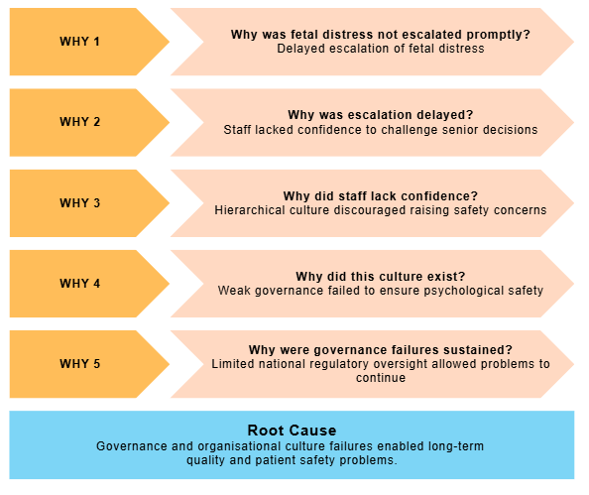
Figure 3: 5 ways Analysis
(Source: Self-developed)

4. Critical Synthesis & Evidence-Based Findings
4.1 Comparative Analysis with Real-World Benchmarks
Comparing SaTH with others investigated for trust, like Nottingham University Hospitals, reveals that there is a measurable gap with required safety in direct systemic shift instead of procedural updates.

Key improvements | Practice in SaTH | Practice in other Trusts | Improvements
Leadership and culture transformation | According to the Ockenden Report, SaTH has a hierarchical, defensive culture that discourages staff from rising concern. | East Kent Hospital has introduced a staff council and leadership training programs to embed openness (NHS East Kent Hospital, 2026) | SaTH need to improve transparency with their staffs
Listening to families | SaTH previously excluded families from investigations and dismissed their concerns (Ockenden Report, 2022). | East Kent Hospitals has embedded independent family representation within its governance panels (ITV News, 2025). | SaTH need to include independent family advocacy through its Ongoing Reassurance and Assurance Committee
Standardisation and risk assessments | SaTH allowed inconsistent fetal monitoring and missed escalation, contributing to avoidable harm (Ockenden Report, 2022). | Leeds Teaching Hospitals has standardised its staffing ratios through a skill-mix diagnostic planning process (Leeds Teaching Hospitals NHS Trust, 2025). | SaTH need to introduce standardised risk-assessment tools for complex and high-risk pregnancies
External Clinical oversights | SaTH lacked independent scrutiny within its internal incident review processes (Ockenden Report, 2022). | Hospitals in the UK use Local Maternity Systems to support regional peer-review of serious incidents (NHS England, 2023). | NHS England provided SaTH with external oversight through its Recovery Support Programme
Table 2: Comparison of SaTH Trust with other hospital Trusts in the UK
(Source: Self-developed)
4.2 Rationale for Implementation Strategies
SaTH need to develop stronger transparency with its staff and include independent family advocacy through its Ongoing Reassurance and Assurance Committee to improve its quality of care. Incorporating the outcomes of the Donabedian model, SWOT analysis, and root cause analysis helps to evaluate the best approach to improvement in SaTH’s failure in providing quality of care. Application of Lean Six Sigma in the hospital helps to enhance operational efficiency, which led to a reduction in errors and better consistency of workflow (Parthasarthy, 2025). This also supports the implementation of a structured methodology of continuous improvement of maternity workflows instead of individual policy measures within the trust. Additionally, the interactive and testable process of PDSA is applicable to enhance the iterative process of change that further enhances the psychological safety of the patients.

Recommendation
Recommendation 1: Enhancing workforce capacity and clinical competencies using PDSA
SaTH needs to implement a structured workforce improvements programme using the Plan-Do-Study-Act (PDSA) cycle to address persistent midwifery shortages, workload pressures and variations to enhance clinical competency. In this context, Ebert et al. (2023) found that inadequate staffing, insufficient training and failures in clinical escalation were important contributors to unsafe maternity care. Therefore, workforce improvement needs to extend beyond recruitment by involving workforce planning, retention, professional developments and appropriate skill-mix management.
SaTH needs to further undertake a maternity workforce review to find staffing gaps across antenatal, intrapartum, postnatal and triage services during the planning stage. Furthermore, the workforce data can be evaluated with the patient acuity, birth activity, staff sickness, overtime and incident patterns. In line with this, Hopkinson et al. (2023) suggested that an ethical leadership needs to be introduced across one maternity unit, combining with the target recruitments, protected training time, structured induction and mentoring for newly appointed and internationally educated midwives. The research stage needs to evaluate changes in staffing levels, missed training, staff confidence, response times and safety incidents. Hence, the successful intervention needs to be adapted and enhanced across the trust in future.
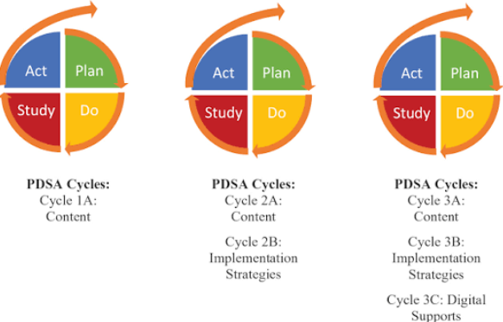
Figure 2: PDSA Cycle
(Source: Hobbs et al., 2023)
Moreover, sustainability could also be supported through quarterly workforce reviews and clear accountability for maternity leadership. The key performance indicators need to include midwife-to-woman staffing ratios, mandatory triage completion, staff turnover, sickness absence and the proportion of shifts meeting planned staffing requirements. However, recruitment may not improve safety during the high work pressures, limited career progression. This integrated PDSA approach would enable the trust to test interventions before wider implementation by reducing the risk of introducing unsustainable workforce changes.
Recommendation 2: Standardising maternity pathways through lean six sigma
The root-cause analysis found inconsistent documentation, inadequate fetal monitoring, delayed escalations and weak communication as interconnected process failures. The lean principles can identify unnecessary steps and workflow ineffectiveness; on the other hand, Lean Six Sigma is able to rescue variation by improving consistencies. Their combined application would support safer and more timely clinical decision-making.
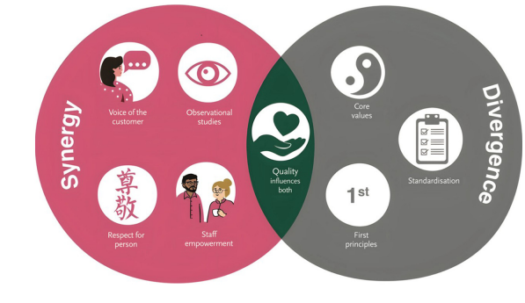
Figure 3: Lean Six Sigma model for improving services across the hospital sector
(Source: Teeling et al., 2025)
At first, a multidisciplinary improvement team needs to map the complete maternity pathways by focusing on triage, fetal monitoring, handovers, clinical escalation and incident documentations. The team needs to include midwives, obstetricians, neonatal staff, governance leads, data analysts and family representatives, As per the use of Define-Measure-Analyse-Improve-Control (DMAIC) approach, SaTH needs to identify their flaws such as delays, duplication, mission information and points where clinical concerns are not escalated properly. Therefore, the standardised electronic handover template and escalation checklist needs to be piloted. These models will be beneficial to identify a clear record of maternal and fetal observations, risk factors, clinical decisions, responsible professionals and required review times.
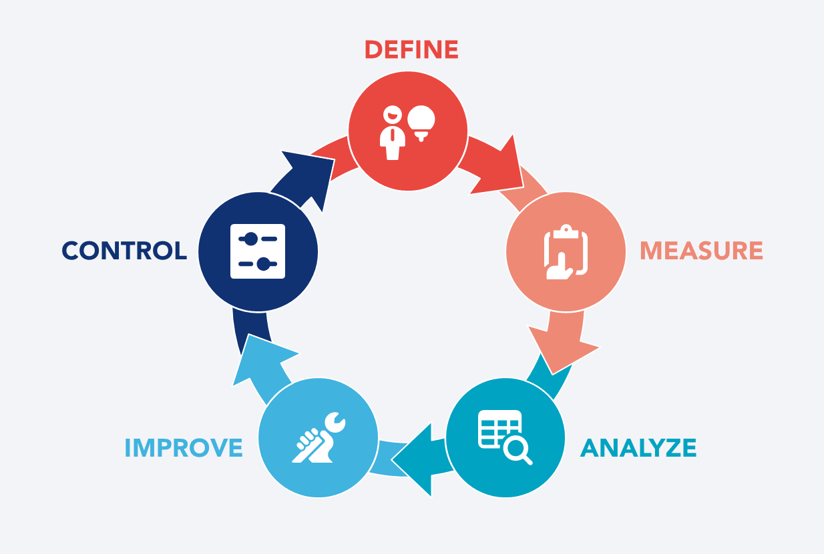
Figure 4: DMAIC approach
(Source: Kaizen, 2025)
Likewise, the interventions might be monitored through measures such as triage waiting times, completion of fetal monitoring documentations, compliance with escalation procedures, delayed interventions and incident-reporting rates. The regular audits may provide feedback to the clinical teams and visual performance dashboards also enable managers to recognise emerging risks (NHS England, 2025). However, standardisation needs not to make rigid procedures which prevent professional judgements. The clinical pathways need to include based on the escalation criteria while allowing staff to respond to individual patient needs. This Lean Six Sigma could improve reliability by reducing preventable variation to strengthen communication across the maternity services.
Recommendation 3: Improving governance and psychological safety by using PDCA
SaTH also can be recommended to strengthen their clinical governance by creating a psychologically safe organizational culture by Plan-Do-Check-Act (PDCA) cycle. According to the report of Atinga et al. (2024), identified weak oversight, inadequate investigations and a culture in which staff concerns were not effectively addressed. SaTH can build a maternity safety board involving senior leaders, frontline professionals and family representatives during the planning stage.
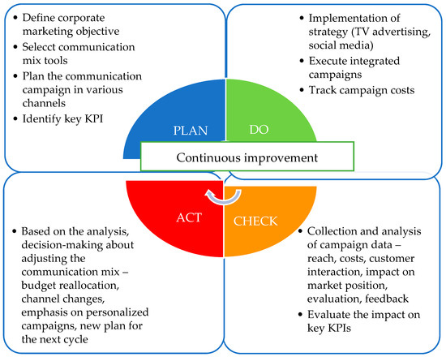
Figure 5: PDCA Cycle
(Source: Řepová et al., 2025)
In addition to this, NHS (2023) asserted that the leadership training should promote compassionate management, open communication and effective speaking-up practices during implementations. Furthermore, unresolved risks need to be assigned to accountable leaders with clear deadlines and regular progress reviews during the action stage. Lastly, the family participation should be implemented across the incident of investigations and service-design decisions. This approach would improve transparency, accountability and organizational learning. Repeating the PDCA cycle would ensure that governance improvements remain measurable, responsive and integrated into regular maternity practices at SaTH.

Conclusion

Summary of the key findings
In summary, this report evaluated the maternity quality failure at SaTH by demonstrating that the resulting harm was caused by interconnected organizational weaknesses rather than clinical errors. The Donabedian model has also described structural weaknesses including inadequate staffing and ineffective governance contributing to unreliable clinical processes and adverse maternal and neonatal outcomes. Furthermore, the Fishbone diagram has found in-depth associations with weak leadership, poor organizational learning and a culture. The SWOT analysis also highlighted the importance of using organizational strengths and external improvement opportunities by addressing workforce pressures and regulatory risks.

Implications for quality improvements
Only improvement of individual clinical performance would not be sufficient to address the structural, procedural and cultural factors which enabled unsafe care to persist. An effective quality assurance needs to integrate workforce planning, standardised clinical pathways, transparent governance, patient involvements and continuous performance monitoring. The report also described that quality improvement should promote equity because service failures may disproportionately affect women and families experiencing social, economic or ethnic inequalities. Thus, safety, accessibility, responsiveness and equitable outcomes need to be monitored together.

Concluding recommendations
The proposed recommendations provide an integrated approach to improving maternity by safety at SaTH. PDSA should enhance workforce capacity and clinical competence, one the other hand Lean Six Sigma needs to reduce process variation by improving documentation, communication and escalation. PDCA needs to enhance governance, accountability and psychological safety. The successful implementation also requires ethical leadership, adequate resources, multidisciplinary collaboration and measurable performance indicators. Combinedly, these actions can be beneficial for SaTH to deliver safer, equitable, accountable and responsive maternity care.

References
Atinga, R.A., Gmaligan, M.N., Ayawine, A. and Yambah, J.K. (2024). ‘“It’s the Patient That Suffers from Poor communication”: Analysing Communication Gaps and Associated Consequences in Handover Events from Nurses’ Experiences’. SSM - Qualitative Research in Health, 6(100482), p.100482. Available at: https://doi.org/10.1016/j.ssmqr.2024.100482
NHS England (2025) Clinical audit. Available at: https://www.england.nhs.uk/clinaudit/ (Accessed 3 Aug. 2026)
NHS (2023) Managing organisational change with compassion. Available at: https://www.nhsemployers.org/articles/managing-organisational-change-compassion (Accessed 3 Aug. 2026).
BBC (2025). Maternity care: 14 NHS trusts to be investigated over "failures." Available at: https://www.bbc.com/news/articles/ckg6xj1vz70o (Accessed: 3 August 2026)
BBC News (2022) Shrewsbury maternity deaths scandal will spark change - Javid. Available at: https://www.bbc.com/news/uk-england-shropshire-60933936 (Accessed: 3 August 2026).
BBC News (2025) NHS maternity care: what are the problems at the heart of its failures?. Available at: https://www.bbc.com/news/articles/clyn8n3nyrlo (Accessed: 3 August 2026).
Care Quality Commission (2024) Safety - Care Quality Commission. Available at: https://www.cqc.org.uk/publications/maternity-services-2022-2024/safety (Accessed: 3 August 2026).
CQC (2024). National review of maternity services in England 2022 to 2024. Available at: https://www.cqc.org.uk/publications/maternity-services-2022-2024 (Accessed: 3 August 2026)
Digital Health (2025). NHS 'must tackle maternity systems gaps' under 10 year plan. Available at: https://www.digitalhealth.net/2025/11/nhs-must-tackle-maternity-systems-gaps-under-10-year-health-plan/ (Accessed: 3 August 2026)
Ebert, L., Massey, D., Flenady, T., Nolan, S., Dwyer, T., Reid‐Searl, K., Ferguson, B. and Jefford, E. (2023). ‘Midwives’ recognition and response to maternal deterioration: A national cross‐sectional study’. Birth, 50(2), pp.438–448. Available at: https://doi.org/10.1111/birt.12665
GOV.UK (2025). Fit for the Future: 10 Year Health Plan for England – executive summary. Available at: https://www.gov.uk/government/publications/10-year-health-plan-for-england-fit-for-the-future (Accessed: 3 August 2026)
Hobbs, S., Bellows, L.L., Coatsworth, J.D. and Johnson, S.L. (2023). ‘Using plan, do, study, act cycles to improve a maternal self-care intervention with audience input’. Health Promotion Practice, 25(4), p.152483992311773. Available at: https://doi.org/10.1177/15248399231177305
Hopkinson, D., Gray, M., George, K. and Kearney, L. (2023). ‘Nurturing our new midwives: A qualitative enquiry of mentor’s experiences of supporting new graduate midwives working in continuity of care models’. Women and Birth, 36(4), pp.357–366. Available at: https://doi.org/10.1016/j.wombi.2022.12.003
ITV News (2025). Maternity services at East Kent Hospitals make 'significant improvements' following serious failures. Available at: https://www.itv.com/news/meridian/2025-05-15/maternity-services-make-significant-improvements-following-serious-failures (Accessed: 3 August 2026)
Kaizen (2025) DMAIC: The foundation of Six Sigma | KAIZENTM Article. Available at: https://kaizen.com/insights/continuous-improvement-dmaic-six-sigma/ (Accessed: 3 August 2026).
King's Fund (2026). NHS Funding Deficits. Available at: https://www.kingsfund.org.uk/insight-and-analysis/data-and-charts/nhs-trusts-deficit (Accessed: 3 August 2026)
Kumah, A., Nwogu, C.N., Issah, A.R., Obot, E., Kanamitie, D.T., Sifa, J.S. and Aidoo, L.A. (2024). 'Cause-and-effect (fishbone) diagram: a tool for generating and organizing quality improvement ideas.' Global Journal on Quality and Safety in Healthcare, 7(2), pp.85-87. Available at: https://pmc.ncbi.nlm.nih.gov/articles/PMC11077513/
Leeds Teaching Hospitals NHS Trust (2025). Maternity Improvement Advisor Diagnostic Report. Available at: https://www.leedsth.nhs.uk/wp-content/uploads/2025/07/MSSP-Diagnostic-report-FINAL.pdf (Accessed: 3 August 2026)
MNSI (2023) Safety factors surrounding effective communication throughout the pregnancy journey. Available at: https://www.mnsi.org.uk/news/safety-factors-and-effective-communications-in-pregnancy/ (Accessed: 3 August 2026).
NHS East Kent Hospital (2026). Board of Directors (BoD) Open meeting Available at: https://www.ekhuft.nhs.uk/s3/assets/files/board_of_directors_docs/bod-meeting-packs/board-of-directors-open-meeting-pack---28-july-2026-version-2.pdf (Accessed: 3 August 2026)
NHS England (2023). Three year delivery plan for maternity and neonatal services. Available at: https://www.england.nhs.uk/long-read/three-year-delivery-plan-for-maternity-and-neonatal-services/ (Accessed: 3 August 2026)
Ockenden Report (2022). Final Report of the Independent Review of Maternity Services at The Shrewsbury and Telford Hospital NHS Trust. Available at: https://www.gov.uk/government/publications/final-report-of-the-ockenden-review (Accessed: 3 August 2026)
Orovou, E., Liepinaitienė, A., Taskou, C., Gourounti, K., Papoutsis, D. and Sarantaki, A. (2026). ‘Determinants of midwifery workforce disaster preparedness and its impact on the continuity of maternal care: a systematic review’. Healthcare, 14(11), p.1499. Available at: https://doi.org/10.3390/healthcare14111499
Parthasarthy, R. (2025). Lean Six Sigma for Hospitals: Improving Patient Safety, Patient Flow and the Bottom Line. Quality Progress, 51(6), pp.61-61.
Řepová, M., Lendelová, L. and Lendel, V. (2025). ‘A PDCA-based decision-making framework for sustainable marketing communication strategies: A case study of a Slovak telecommunications company’. Systems, 13(8), p.721. Available at: https://doi.org/10.3390/systems13080721
Saha, K., Patel, B. and Paladini, S. (2024). 'Lean Six Sigma adoption in clinical pharmacy practice for reducing medicine waste in the NHS.' International Journal of Quality and Reliability Management. Available at: https://doi.org/10.1108/IJQRM-02-2024-0069
Singh, G., Patel, R.H. and Boster, J. (2024). Root cause analysis and medical error prevention. PubMed. Treasure Island (FL): StatPearls Publishing.
Tasca, L. (2024). ‘Normal accident theory and learning from major accidents at the National Aeronautics and Space Administration (NASA)’. Space Policy, 70, p.101653. Available at: https://doi.org/10.1016/j.spacepol.2024.101653 (Accessed: 3 August 2026).
Teeling, S.P., Baldie, D., Daly, A., Keown, A.M., Igoe, A., Dowling, C. and McNamara, M. (2025). ‘The contribution of a person-centred model of lean six sigma to the development of a healthful culture of health systems improvement’. Frontiers in Health Services, 5, p.1621233. Available at: https://doi.org/10.3389/frhs.2025.1621233
The Guardian (2026). NHS medical negligence persisting in England 'despite 24 years of warnings'. Available at:https://www.theguardian.com/society/2026/jan/30/nhs-medical-negligence-persisting-in-england-despite-24-years-of-warnings (Accessed: 3 August 2026)

