University Of Wales Trinity Saint David

Wales institute of science and arts



Development and application of manufacturing automation

Control and Automation (ACMA5001)

Jacob Christian Jones

2005053

March 2024
Table of Contents
1. Introduction 3
2. Brief History of Automation 4
2.1. Early machines 4
2.2. Automation in Industry 5
2.3. Modern Automation 6
3. The Three Key Types of Automation 7
3.1. Fixed Automation 7
3.2. Programmable Automation 9
3.3. Flexible Automation 10
4. Conclusion 12
References 13

Introduction

Automation in manufacturing production has revolutionized the way goods are produced, transforming traditional manual workflow into high-tech efficient processes. This method uses machinery and robotics to perform tasks that were once carried out by human operators. The change in manufacturing processes has drastically streamlined production, enhanced efficiency, and improved overall product quality. Automation encompasses the integration of control systems that manage aspects of the production line, such as material flow, quality control and equipment coordination.

The adoption of automation in manufacturing adds several benefits, including increased productivity and enhanced safety in the workplace. The hard labour-intensive tasks of the past are now carried out by large industrial machines, reducing the risk of physical injury. The large industrial machines mentioned above are able to complete the workload of a full team of human workers, resulting in the decrease of operators needed. From a business point of view, the integration of industrial machines has reduced the amount a company must pay in wages to their workload. Although machine maintenance is now a factor that must be considered.

In the manufacturing production industry, there are three key types of automation, which include: Fixed, Programmable and Flexible automation. These different types of automation are distinct approaches in manufacturing, each offering unique advantages and limitations.

Brief History of Automation

What defines automation and when did it become an integral technology used in manufacturing processes? Automation is the practise of using technology to carry out tasks with where human input is minimized, (IBM, 2024)Its aim is to improve efficiency and productivity while reducing costs and human errors by using various technologies, control systems and machinery.

Early machines
Automation or ‘self-operating machines’ have been used for thousands of years, primarily the use of water powered machinery. There is an example of this used by the Greeks recorded around 2000 years ago. Where they used these water powered machines to grind wheat to the then desirable flour product (Company, 2024)As seen if Figure 1 below, the waterwheel is attached with buckets that fill up from the river, causing the wheel to turn. The turning of the wheel then turns the pit wheel inside the mill by the connection of a steel axle. The pit wheels movement powers the other mechanical components in the system. The main component powered by the pit wheel is the damsel, which grinds the grains in the runner stone fed from the hopper above. This process requires little to no human input, making it an almost fully automated process.
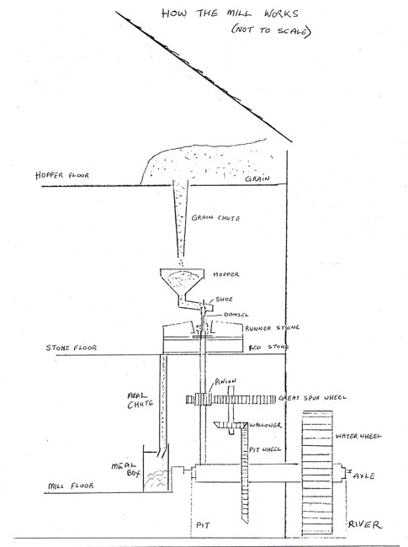
Figure 1. Watermill diagram (Frances Tallon)

Automation in Industry
The use of automation in manufacturing can be dated back as early as the 18th century to the industrial revolution. This period marked the initial phase of automation by using water and steam to mechanize the basic manual tasks usually carried out by a group of men/women. Steam engines gave companies the ability to transport, lift and produce goods freely. These new methods allowed certain aspects of the businesses to almost run themselves. The industrial revolution pathed way for the development of automation.

The introduction of electricity in the late 19th century gave manufactures a new, more efficient power source to essentially power their factories and workforces. Prior to the widespread use of electricity, industries relied on water and steam as mentioned above. This limited the locations factories could be built as they required a sustainable water source to be powered. During this transition phase from water and steam to electricity, manufacturing industries saw around a 30% increase in product output (Bong, 2022). This increase can be credited to the introduction of electrical motors. These motors had a much grater efficiency compared to the dated steam engines, requiring less maintenance. Prior to the 1930’s, colour coded lights were used as signals for factory workers to perform manual changes to the production lines, such as opening or closing valves. Commonly known as “on-off process control”. Sometime during the 1930’s, controllers were introduced to the industry to enable calculated changes in response to disturbances in the system. (Bong, 2022). As time went on and technology improved, the industry started to adopt PLC (Programmable Logic Controllers) that slowly replaced the dated electro-mechanical relay logic.

Another significant leap in automation was the implementation of the assembly line by Henry Ford. He changed the way factories operated using assembly line and conveyor belts. While Ford did not invent the assembly line, he revolutionized the way It was used. The original procedure used in automobile manufacturing required teams of trained individuals to manufacture a car from start to finish (Yue, 2016). Ford decided that an automated assembly line would be more efficient with individuals stationed at sections performing separate tasks along the assembly line. This manufacturing process has been and will be used in the manufacturing industry up until a new, more advanced system is invented.

Modern Automation
Modern automation, also known as industry 4.0 or the fourth industrial revolution is a concept that focuses on data exchanges and automation in manufacturing technologies (RVJ, 2022). The idea of modern automation consists of smart manufacturing where machines are connected to a large network that continuously exchange data to improve quality and reduce further costs down the line. Smart manufacturing has led to the development of the smart factory. A smart factory relies on its ability to instantaneously react to consumer demands and alter the assembly line dependant on the products specifications.

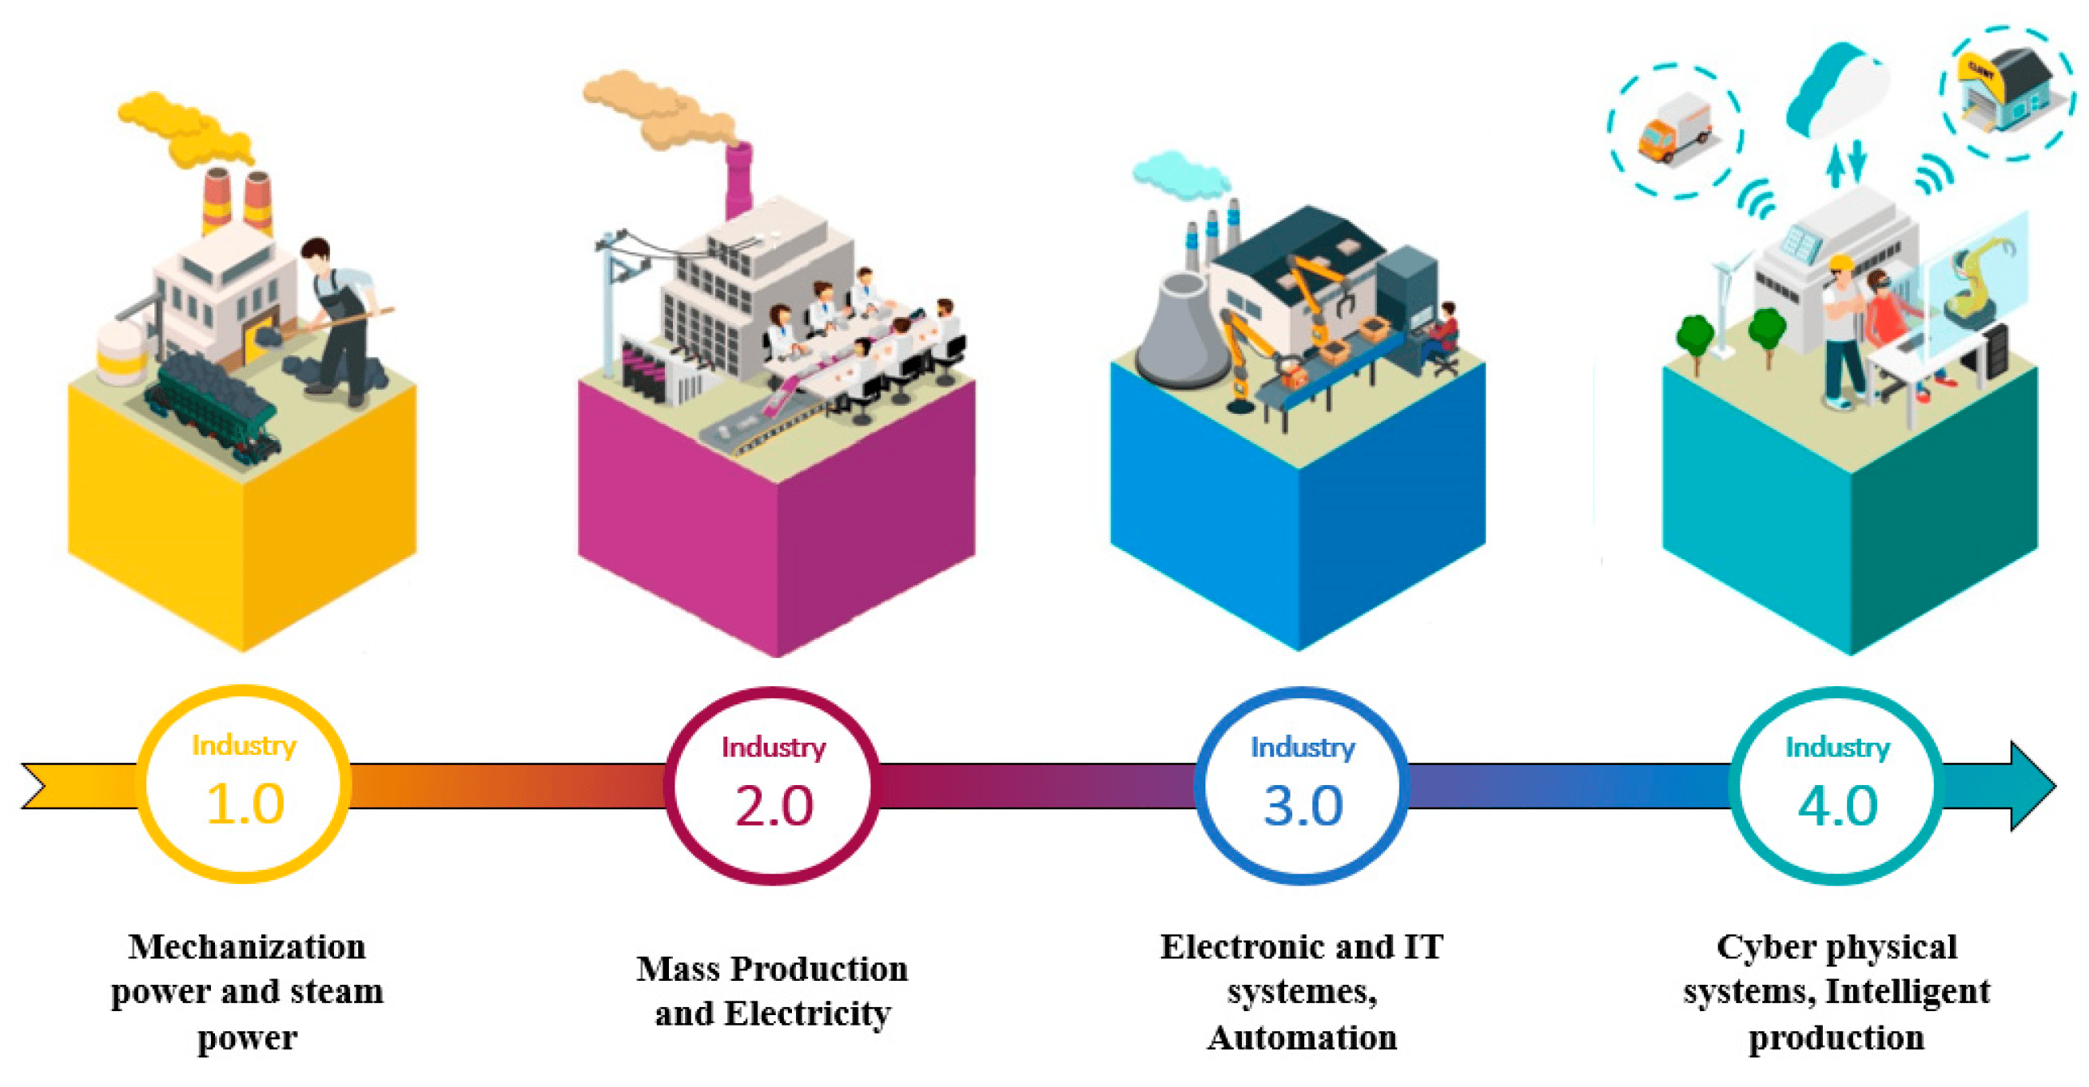
Figure 2. The Four Industrial Revolutions (Benotsmane et al,2019)

Figure 2 displays the four revolutions the manufacturing industry has undergone. As mentioned in the previous paragraph, we are now operating in the fourth industrial revolution, or industry 4.0.

The Three Key Types of Automation

In the manufacturing industry, the process of automation can be organised to three key types. These are as follows: Fixed, Programmable, and Flexible.

Fixed Automation

Fixed automation, commonly known as dedicated or hard automation, refers to the use of specialized machinery engineered to perform specific tasks with a high level of efficiency. These systems contain custom-built equipment specific to a range of products or production processes. Once the fixed automation system is set up for a certain task, the systems configuration cannot be easily altered, meaning this type of automation is usually best suited for high-volume production. As the name suggests, the automation process involves repetitive and or fixed sequences that are specific to the processing of a product. The aim of fixed automation is to carry out a sequence of automated processes that are fully integrated to produce a specific task from start to finish (Automation, 2022). This form of automation results in higher production speeds and volume rates than other methods.

Hard automation has been in used in the manufacturing industry for over a hundred years, with its first introduction in the early 20th century. The assembly line is one of the first examples of fixed automation used in the manufacturing industry. As mentioned in Automation in Industry, Henry Ford is credited with the implementation of the assembly line in the automotive industry. The original assembly line consisted of multiple workstations with human operatives carrying out specific jobs. The product, this example would be an automobile, would begin at the start of the conveyor belt and continuously move along the belt when the job would be completed. As technology improved, the human operators were gradually replaced by high-tech control systems and machinery. The new control systems incorporated technologies such as sensors and programmable logic controllers to monitor certain aspects of the assembly line (Ltd, 2024).These systems can detect faults in the system and make real-time adjustments to improve the lines efficiency.

Figure 3 shows a simple block diagram of a control system with its relevant process variables. In this example, the sensor module measures the output data of the plant and sends the data to the controller which acts as the brain of the control system. The controller compares the measured output with the desired output and decided whether a control action is necessary. The controller then sends the new signal to the plant as an input signal. The plant in turn, responds to the new input and the cycle continues (M. Chouikha, 1970).

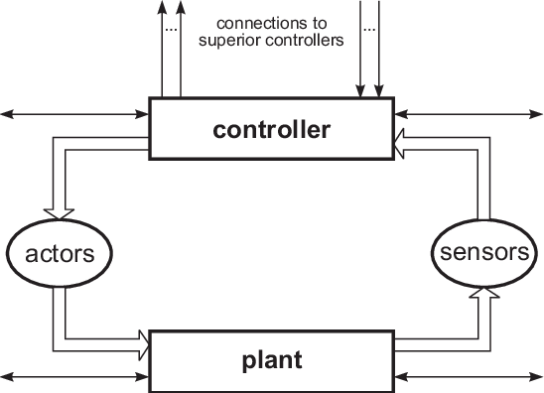
Figure 3. Fixed Automated Block Diagram

Fixed automation is clearly an advantageous form of automation when all the pros are considered. An example being the consistent precision and precise execution of tasks. Errors or variations in the product quality are very rare when fixed automation is used. The high-speed automated system can perform at higher speeds than other automated systems therefore, faster production cycles. These result in faster turnaround times.

Obviously, all manufacturing systems must have their negatives, one disadvantage of choosing fixed automation in the manufacturing process would be the initial upfront costs. The large investment associated with installing and programming etc. is clearly a negative for some businesses. Another factor to consider when selecting fixed automation is the limited task variety. The system is suited for a specific task and cannot be altered easily, hence the name ‘fixed’.

Programmable Automation

Programmable automation refers to automated systems and machinery used in manufacturing that can be reprogrammed and reconfigured to carry out different tasks in a production process. With a programmable automation system, a specific product can be produced in batches by the reprogramming of the machines operations (MWES, 2024). This type of automation is typically used in batch production as there are reduced set up times in comparison to other automation methods. Programmable automation systems can easily alter the control system to aid the manufacturers in transitioning from one product to the next. This contributes to a higher overall equipment effectiveness and reduces machine downtime. Programmable automation was first introduced in the 1960’s with the development of the programmable logic controller (PLC). The automobile industry was the first to deploy PLCs to their operations with General Motors being the initial user in 1968 (c3controls, 2024). Richard ‘Dick’ Morley, credited with the invention of the PLC, decided that the aim of a PLC was to replace the hardwired relays and timers with flexible and programmable controllers (c3controls, 2024).
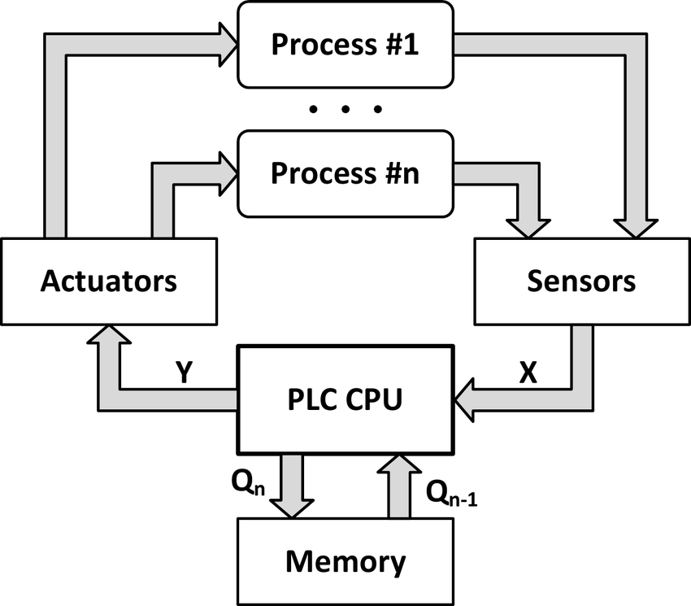
Figure 4 PLC Control System Block Diagram

Figure 4 (A.Milik, 2016) shows a Control system used in automation containing a PLC controller and other relevant process variables. In this system the sensors constantly monitor signals from the process variables and sends feedback signals to the PLC. The PLC interoperates the feedback signals to determine and alter the state of the system. Within the PLC, the systems control logic and decision-making algorithms are stored. The control logic analyses the feedback from the sensor and determines whether action must be carried out. If change is needed in the system, control signals are sent to the actuator which performs necessary adjustments. This cycle operates in a continuous feedback loop to maintain the desired results.

Programmable automation comes with many benefits like its flexibility and ability to adapt to changes in product specifications and requirements. The flexibility is especially beneficial to industries that use batch production and require frequent changeovers in products. Another positive of using programmable automation is the improved quality control that comes with it. The control systems can be programmed to quality check each batch individually, ensuring consistent quality and reaching standards.

Manufacturing processes like programmable automation come with individual disadvantages, as do all processes. The primary downside to programmable automation is the initial set-up costs. The investment that includes the purchasing of the PLCs and sensors etc can be high. For smaller businesses this could pose a problem. Other than the high set-up costs, the maintenance time can also put programmable automation at a disadvantage when it comes to deciding upon an automation system. Issues in programming and components of the system can be quite common, resulting in downtime in production. Regular maintenance is essential for the success of programmable automation.

Flexible Automation

Flexible automation refers to manufacturing systems that posses the capability to efficiently adapt to produce different products or carry out diverse tasks without having to reprogramme the whole system. The aim of flexible automation is to improve versatility in response to alterations in production requirements and product specifications. Like programmable automation, flexible automation also uses PLCs to swiftly adjust the control systems and switch between previous or future production set-ups. Technologies like PLCs allowed for reprogramming, providing the foundation for flexible automation. In the 1950’s, inventor Jerome H. Lemelson introduced flexible manufacturing systems to the manufacturing industry. His ideas were based on robotic systems that could perform usually manual operated tasks like welding and control inspections. (Resonance, 2023). Although Lamelson is credited with the development of flexible automation manufacturing, the ability to build the system was out of his reach. It was not until the late 1960’s the flexible manufacturing system was debuted on factory floors across the United States and Europe. (HAYES, 2023)

An industry that would benefit from using flexible automation would be the flat pack furniture manufacturing sector, due to its varied nature of production processes. Flat pack furniture usually come in a range of products with varying designs and dimensions. The variation in product specification requires frequent changes to the manufacturing process. Flexible automation allows for quick reconfiguration of the control systems to adapt to the required product. This minimizes downtime and increases productivity. Flat pack furniture is usually produced using a batch production method, where product models are produced in smaller quantities rather than a mass manufacturing process. Due to flexible automation’s ability to quickly changeover tooling for specific product variations, it is essential in the flat pack furniture industry. In summary, flexible automation in flat pack furniture manufacturing allows adaptability and freedom in relation to product variation.
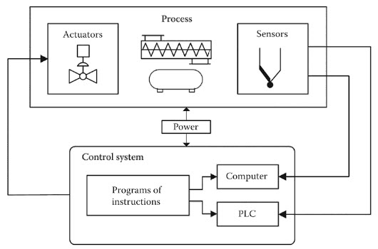
Figure 5 Flexible Automation system

Figure 5, like Figure 4, depicts a control system used in flexible manufacturing. The system contains the same process variables as Figure 4. These process variables have the same purpose, although this type of automation is easier to reprogramme and reconfigure. (Administrator, 2019).

Conclusion

Having examined the details, it is clear to see that the three automation processes analysed in this report have their own advantages and disadvantages, respectively. Fixed automation involves equipment dedicated to specific tasks that are suited to high volume production. This form of automation lacks freedom and changeability. Programmable automation uses control variables like PLCs to reprogramme the control system in relation to the desired product. Flexible automation, like programmable automation, can reprogram systems to alter the final products design or dimensions easily. Considering all these factors, all three automation systems are beneficial for the manufacturing industry but are dependant on the product type being manufactured.

References
A.Milik, M. E., 2016. On the systematic method of conditional control program executionby a PLC, Gliwice: Institute of Electronics, Silesian University of Technology of Gliwice.

Administrator, E. H., 2019. What is Industrial Automation? Types, Levels, Advantages. [Online]
Available at: https://www.electronicshub.org/introduction-to-industrial-automation/
[Accessed 7 March 2024].

Automation, C., 2022. FIXED AUTOMATION SYSTEM: WHAT IT IS AND ITS APPLICATION IN MANUFACTURING. [Online]
Available at: https://www.captechautomation.com/blog/fixed-automation-system-application-manufacturing/
[Accessed 1 March 2024].

Bong, N., 2022. The Evolution of Automation. [Online]
Available at: https://www.progressiveautomations.com/blogs/news/the-evolution-of-automation
[Accessed 27 February 2024].

c3controls, 2024. The History of Programmable Logic Controllers: From Then To Now. [Online]
Available at: https://www.c3controls.com/white-paper/history-of-programmable-logic-controllers/
[Accessed 7 March 2024].

Company, P. T., 2024. The History of Industrial Automation. [Online]
Available at: https://www.paramounttool.com/the-history-of-industrial-automation/
[Accessed 23 February 2024].

HAYES, A., 2023. Flexible Manufacturing System (FMS): Definition and How It Works. [Online]
Available at: https://www.investopedia.com/terms/f/flexible-manufacturing-system.asp
[Accessed 7 March 2024].

IBM, 2024. What is automation?. [Online]
Available at: https://www.ibm.com/topics/automation
[Accessed 23 February 2024].
Ltd, P. C. S., 2024. Automated Assembly Lines In Manufacturing. [Online]
Available at: https://phoenixcontrol.co.uk/automated-assembly-line/#:~:text=Automation%20control%20for%20automotive%20assembly,pressure%2C%20speed%2C%20and%20position
[Accessed 1 March 2024].

M. Chouikha, E. S. B. O., 1970. MODEL-BASED CONTROL SYNTHESIS FOR DISCRETE EVENT SYSTEMS, Braunschweig, Erlangen: s.n.
MWES, 2024. PROGRAMMABLE aUTOMATION SYSTEMS. [Online]
Available at: https://www.mwes.com/types-of-industrial-control-systems/programmable-automation-systems/
[Accessed 6 March 2024].

R.Benotsmane, G. L., 2019. Economic, Social Impacts and Operation of Smart Factories in Industry 4.0 Focusing on Simulation and Artificial Intelligence of Collaborating Robots. [Online]
Available at: https://www.mdpi.com/2076-0760/8/5/143
[Accessed 28 February 2024].

Resonance, F., 2023. Flexible Manufacturing Systems Explained. [Online]
Available at: https://www.firstresonance.io/blog/flexible-manufacturing-systems#:~:text=Flexible%20manufacturing%20systems%2C%20introduced%20by,stamping%2C%20or%20quality%20control%20inspections.
[Accessed 7 March 2024].

RVJ, 2022. Manufacturing Process Automation: All you need to know. [Online]
Available at: https://www.deskera.com/blog/manufacturing-process-automation/
[Accessed 2024 February 2024].
Tallon, F., N/A. Watermill Diagram,. [Online]
Available at: https://www.askaboutireland.ie/reading-room/history-heritage/traditionalcrafts/martry-mill/watermill-diagram/
[Accessed 23 february 2024].

Yue, F., 2016. Henry Ford was Right - Automation is the key. [Online]
Available at: https://www.radware.com/blog/applicationdelivery/2016/11/henry-ford-right-automation-key/#:~:text=Henry%20Ford%20changed%20the%20way,tasks%20along%20the%2%20assembly%20line.
[Accessed 27 February 2024].

