OME L6 Y1 Lab Report
Ballistics simulation
Kenneth Perry 2222109
UWTSD
Table of Contents
Introduction 2
Material properties 2
Simulation 3
Results 3
Definitions 4
Discussion 4
Conclusion 5
Appendices 5
References 19

Introduction

The report will demonstrate a level of knowledge gained through the module. As part of the coursework, an assignment was provided incorporating research on material properties and subsequently create a simulation based on the research gathered. The assignment itself was to show a projectile made of a material, penetrating a plate of a different material.
The simulation was to be run using Abaqus software. This software enabled the student to understand and analyse different material properties, the velocity of the projectile and the stress/strain values of the various materials under test.
Abaqus is a finite element analysis (FEA) software package used for analysing various engineering problems. It provides a wide range of features for analysis, visualisation and behaviour of materials under different loading conditions, it also allows the user to study mechanical stresses, thermal effects and fluid flow.
The student carried out two simulations, one of which, using the premade model supplied by the lecturer. The second simulation was created using different values which were attained through the research methods of the student.
For the second simulation, the material properties of the projectile and plate were not changed from those supplied from the lecturer, however, the velocity of the projectile was changed. This would allow the student to show on Abaqus the differences between projectiles moving at different speeds.

Material properties

In both the pre supplied model and the second simulations, the projectile was a steel bullet, and the plate was made from aluminium.
The material properties were attained from Johnson-Cook damage values, consisting of five damage values, melting temperature, transition temperature and strain rate. Density was also assigned to the projectile, using Young’s Modulus and Poisson’s Ratio, elasticity values were assigned. For the plastic section, melting temperature and transition temperature was entered.
For the armor plate, the material properties were used for aluminium. Properties entered were for density and elastic. For density, the mass density of aluminium was entered. Using Young’s Modulus and Poisson’s Ratio, the elastic properties were also inputted.

Simulation

The first simulation was run using the properties and values given by the lecturer. To show the most detailed stress and strain values, the sequence steps were increased from 20 to 200 steps.
In the second simulation, the student also increased the steps from 20 to 200.
For a simulation to run correctly, the student must create a job file on Abaqus. Once the job has been created, the job must be submitted. This starts the rendering, if during this rendering process the software detects an anomaly within the entered values, the job will be aborted.
Once the job has fully rendered, the full simulated job can be viewed and analysed thoroughly using the visualisation tab. At this point, the student will see a full 3d rendered image of the projectile and the plate. Using the steps slider, the projectile can be seen in motion striking the plate.

Results

In the first simulation, the steel bullet was shown penetrating the plate at a velocity of -2000 m/s which can be seen at different steps below. This velocity allowed the projectile to pass through the aluminium plate with relative ease. The stress/strain on the projectile and plate can also be seen in the images below.

The second simulation used the same material properties. The velocity of the projectile was changed from -2000 m/s to -200 m/s. This velocity demonstrated that although the projectile was able to penetrate the plate and cause some surface damage, the velocity was not high enough in order to pass through the plate such as in the first simulation. Shown below are the same properties, stress/strain.

Definitions

Tensile stress – a maximum load that a material can withstand without compromise while being stretched or divided by the materials original form and dimensions. When stresses less than the tensile strength are removed, a material returns either completely or partially to its original form, shape and size. [1]
Tensile Strain – A measure of the deformation of a material when it is subjected to tensile stress. It is defined as the change in length of a material divided by its original length. Normally displayed as a percentage. It can be used to predict behaviour of a material under stress and to ascertain its ultimate tensile strength. [2]
Stress – In physics, stress is a physical quantity that expresses the the internal forces that neighbouring particles of a continuous material exert on each other.
Strain – is the measure of the deformation of the material which is not a physical quantity. [3]
Johnson-Cook damage – a widely used model in material science and engineering, particularly applied to simulate the behaviour of materials under high strain rates, for example, those experienced under high impact or during explosive events. It predicts the materials plastic deformation and failure, combining the effects of strain rate, temperature and effects of damage on the material.
Youngs Modulus – describes the elasticity or stiffness of a material, it measures the stress/strain ratio in a material under tensile or compressive forces. A high Youngs Modulus shows a material is stiff and rigid, while a low Youngs Modulus indicates the material is more elastic and flexible.
Poisons Ratio – Influences the mechanical properties of a material, such as stiffness and elasticity, also how different load values impact the materials behaviour such as tension, compression or bending.

Discussion

As shown on the imagery, tensile stress and strain shows firstly on the top surface of the plate itself and travels through the material and eventually compromises the bottom of the plate. The ultimate tensile strength of aluminium is 310 MPa which in the case of the first simulation, is not stable enough to withstand or resist a steel projectile travelling at a velocity of -2000 metres per second, however in the second simulation of a projectile moving at a much less speed (200 metres per second), it can withstand more effectively.
In the images shown, it can be clearly seen that the weakest part of the aluminium plate is the bottom section.

Conclusion

In conclusion, both simulations demonstrated completely opposite results. In the case of the first simulation, a realistic simulation took place showing clearly what would happen to an aluminium plate being penetrated by a projectile travelling at -2000 metres per second. In the second simulation, no steel bullet would be travelling at such a low speed as -200 metres per second. The student entered those values in order to see how the plate would look at being struck at a far lower velocity.
For the simulation to be analysed more thoroughly, the student recognises that with more experience using Abaqus and damage modelling in general, this would allow the student to become more creative with the software and utilise it for studying different plate and projectile materials.
Using Abaqus allowed the student to gain a basic insight into damage modelling and the analysis of material properties and values.

Appendices

Simulation number 1:

Materials used:
Plate – Aluminium, Projectile – Steel
Projectile material properties
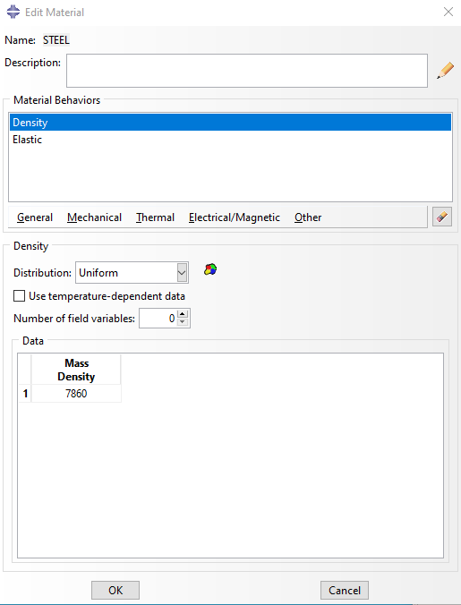

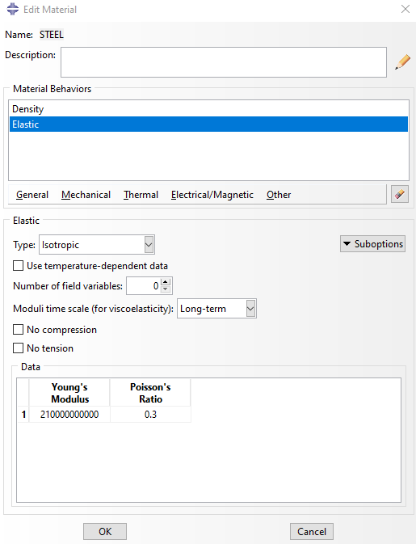

Plate material properties
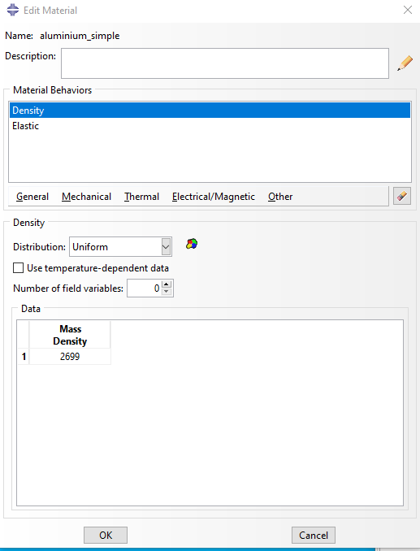

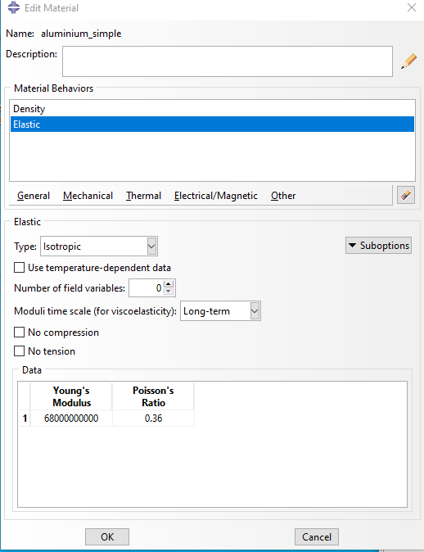
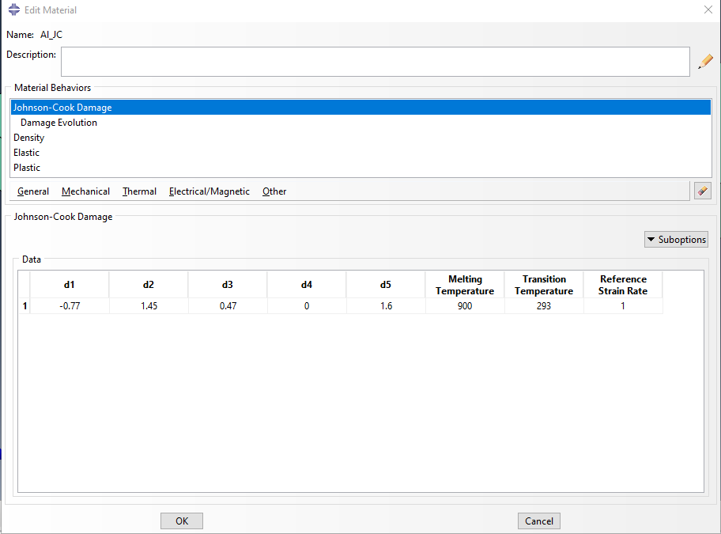
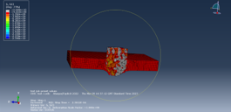

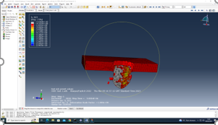

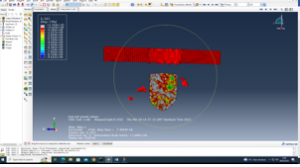

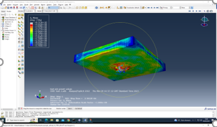
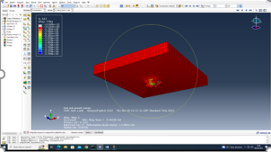
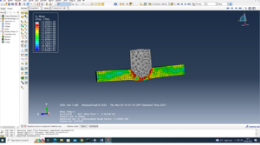

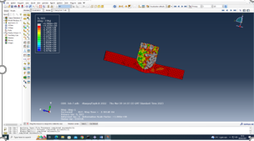

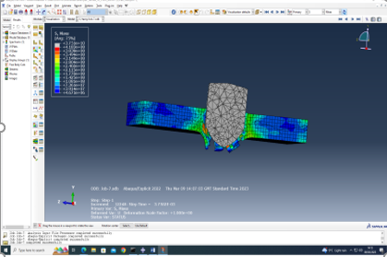
Simulation number 2 - Increase steps to 200 from 20 and velocity to -2000 m/s from -1200 m/s
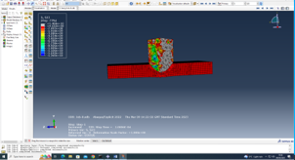
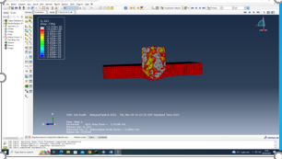

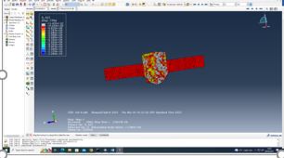
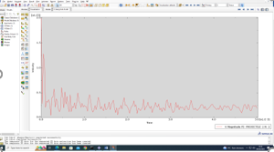

Decrease velocity to -200m/s
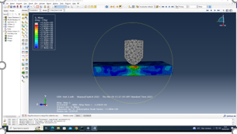
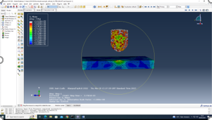
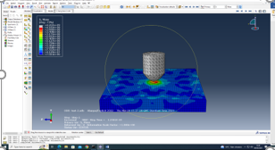

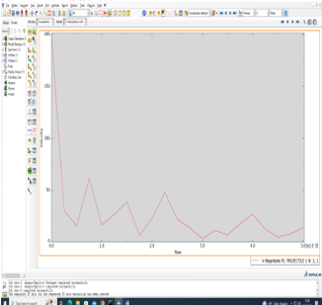

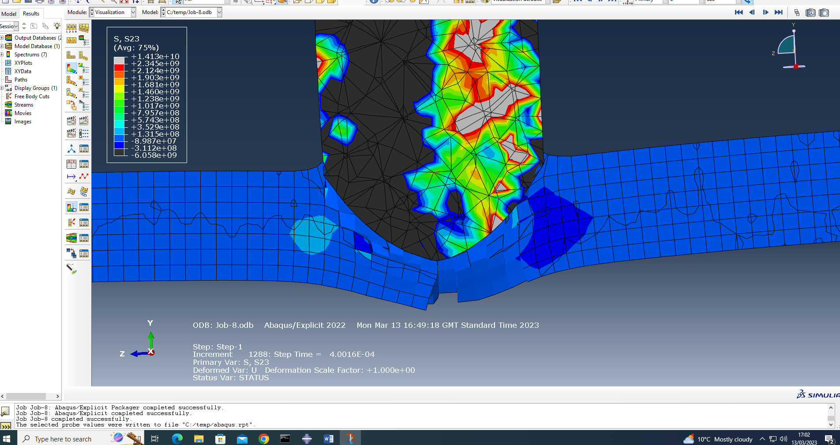
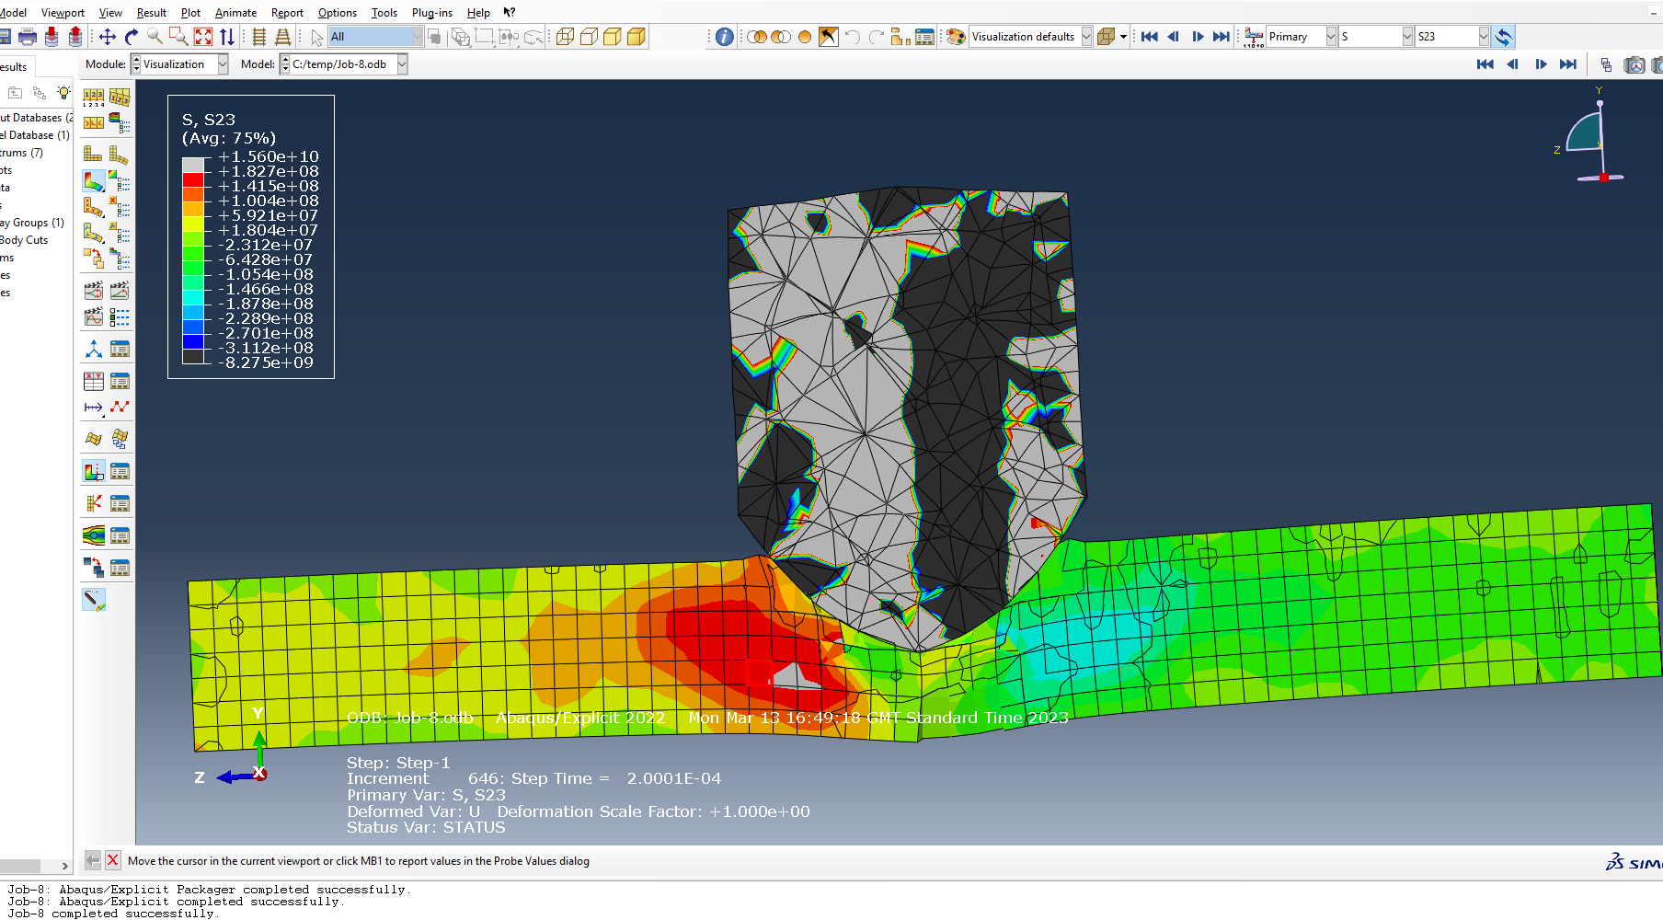
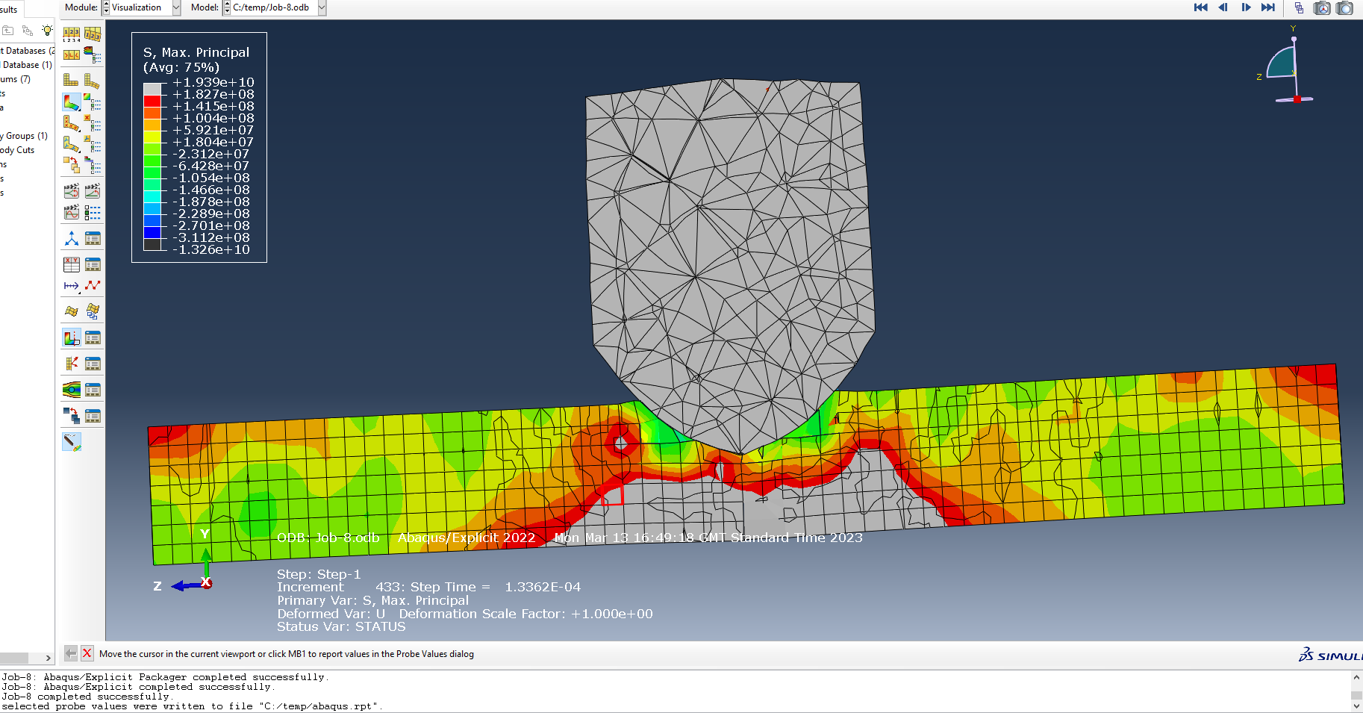

References

[1] | “Tensile Strength,” Britannica, [Online]. Available: https://www.britannica.com/science/tensile-strength. [Accessed 04 May 2023].
[2] | “Tensile Strain: Definition, Formula, Advantages, Disadvantages & Uses,” Mechanical Education, [Online]. Available: https://www.mechanicaleducation.com/tensile-strain-definition-formula-advantages-disadvantages-uses/#:~:text=Tensile%20strain%20is%20the%20measure,their%20behavior%20under%20tensile%20loads.. [Accessed 05 May 2023].
[3] | Nuclear-Power.com, [Online]. Available: https://www.nuclear-power.com/nuclear-engineering/materials-science/material-properties/strength/what-is-stress-in-materials-science/. [Accessed 20 May 2023].

