DIGITAL SKILLS AND RESEARCH METHODS

DSR ASSESSMENT 2

( BMSW4003_LON )

FARIDA AHMED

STUDENT ID: 2123556

LECTURER: SUNETH FERNANDO

TABLE OF CONTENTS

Introduction……………………………………………………………………………2

Virtual learning environment …………………………………………………………2,3
Student Learning experience ………………………………………………………….3,4
Literature review ……………………………………………………………………...4
Methodology ………………………………………………………………………….5
Population ………………………………………………………………………...5
Sample size ……………………………………………………………………….5
Data collection process ……………………………………………………………6
Research question …………………………………………………………………6
Analysis ……………………………………………………………………………6
Findings ……………………………………………………………………………7,8,9,10,
Limitation of the study …………………………………………………………………11
Conclusion ………………………………………………………………………………12
Reference ………………………………………………………………………………..13

Introduction:

In the twenty-first century, online learning is growing more popular among educational institutions and individuals. With diseases like Covid-19 on the rise, online education is becoming increasingly important for ensuring the quality of educational opportunities. This research module, which has been done on a regular and effective basis, has increased the overall quality of online lessons. One of the most appealing aspects of online education is the option to finish most courses from the comfort of your own home. The online learning experience module is insufficient to meet the needs of students who prefer traditional learning methods and are unable to devote enough time to educational efforts. Because of the worldwide epidemic of physical contact, traditional learners were apprehensive about internet learning. According to Hewson (2018), the rationale for this academic program's success is because, in the face of worldwide diseases or limits, online learning appears to have emerged as the safest option for learning and extending one's education. Students and learners who need to learn or study during a busy period might consider studying online, which is accessible from anywhere and provides an amazing learning experience. Online education is vital, in my opinion, in this time of epidemic. One disadvantage of this course is that it may not devote enough attention to how ordinary students might improve their educational experience. In this research, we will look at the impact of virtual learning environments in general and how it differs or is comparable among students that use Moodle as a virtual learning environment at the University of Wales and Trinity Saint David London campuses.

Learning in a Virtual Environment:

A Virtual Learning Environment (VLE) is a web-based system that the institution provides and controls to give all academic resources to students. Students can access the resources at any time and from any location, which encourages independent learning and boosts motivation.. Content management, curriculum and assessment, learner engagement, learner information administration, communication tools, collaboration tools, and real-time (live) teaching elements are all part of a VLE. The tools and elements that are available will be determined by the platform that is selected. Some larger organisations may create their own VLE from the ground up, including only the technologies they require. Others may elect to invest in a commercially available alternative. This requires investigation to ensure that they have the necessary instruments for the institution's requirements. VLEs often begin with a limited set of tools and gradually expand in terms of usage and capabilities. This is in keeping with the learners' and staff's confidence and involvement.

Learning Experience of Students:
Student learning experience is a description of what pupils are learning and how they are learning, as well as what they will know. When students have participated in or completed an educational program, they provide a statement that demonstrates their learning experience.

Review of the Literature:

Learning providers and institutions should make efficient use of technology, according to the UK Government's plan "Harnessing Technology - Transforming Learning and Children's Services," published in 2005. During the research, they discovered that half of the schools polled were enthusiastic about the VLE and that around half of the colleges (out of 58) had VLA at the time, and that one-quarter of them thought VLEs helped learners. (According to Becta, 2009). We may learn about the benefits and drawbacks of using a virtual learning environment by examining the literature:

Advantages-

• Anyone with a smartphone or personal computer can easily access it.

• If you have an active internet connection, you can join an online class from anywhere on the globe.

• The VLE allows students to be more flexible. They can finish the assignment whenever it is convenient for them.

• Because no physical presence is required and no travel expenses are incurred, VLE is usually cost-effective.

• Using a virtual learning environment (VLE) is more convenient than traditional learning because it can be done from anywhere and at any time.

Disadvantage-

• Without self-discipline, completing the task is difficult.

• Because there is no human interaction on the VLE, it can feel lonely.

• Because there is no physical interaction with other pupils, understanding is difficult through dialogue.

• In the vast majority of circumstances, immediate clarification is not feasible. Almost entirely self-taught.

• The smoothness of the technical environment affects VLE performance. The technology that supports a virtual classroom is only as good as the technology that supports it.

Experts weigh in on how the rapid, forced adoption of technology-delivered instruction would impair the well-being of professors and students alike, according to Lederman (2020). The face of education has altered as a result of the virtual learning environment. It provided adults and working professionals with the option to learn new skills or improve on existing ones. VLE's interactive and adaptable character makes it ideal for working in the digital age. It aids in the progression of one's profession and increases one's employability. Many experts believe that a virtual learning environment is superior to traditional classroom-based learning.

In a study conducted by Ryan, E. & Poole, C. (2019) with 40 students who participated in a virtual learning session, it was discovered that the student group taught utilizing the VLE had a higher mean score than the didactic group and had improved satisfaction, memory, and engagement. Even though it is yet unclear whether the VLE is superior to traditional teaching methods, the results are encouraging. According to the research, VLE has seven advantages:

• Involve pupils on a more personal level.

• Enhance your digital literacy

• Allow for scalability

• There is no requirement for physical classrooms.

• Get to know your pupils a little better

• Improve students' and faculty's job prospects

• Provide a variety of learning opportunities

Ryan, E., and Poole, C.'s findings were backed up by Diochon and Cameron (2001), who conducted a study in which they made learning materials available only on VLEs to a group of undergraduate students and discovered that the requirement to be active learners when using a VLE increased capacity and confidence, as well as the students' enthusiasm, allowing them to develop competencies and employability skills.

Students using an online platform to communicate with institutions and faculty considerably enhanced their analytical skills and increased their willingness to learn, according to a study conducted in West Virginia, USA.

Methodology:

Population:

All Trinity Saint David University of Wales London Campus students

Process of data collection: The primary data was obtained using a questionnaire constructed in MS Office Google Forms. I submitted the questionnaire form to 25 students via email and group chat to investigate their learning experiences, and I received responses from 19 of them.

Analysis:

The quantitative research was conducted using an e-questionnaire that could be analyzed using Excel. The questions were sorted and organized around the three research questions indicated above. My entire class of pupils was allowed to complete the survey on their own time. I received a total of 19 (76%) responses from my participants.

Findings:

I discovered some intriguing statistics after analyzing the data provided by my questioner:

19 responses

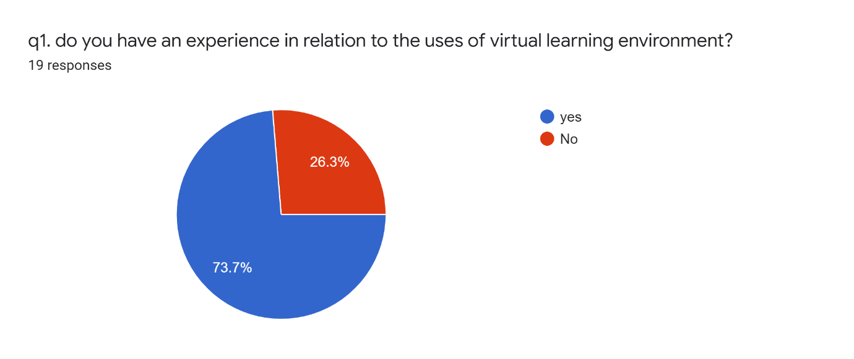
The majority of the student says they have experience with VLE.
yes | 14
No | 5
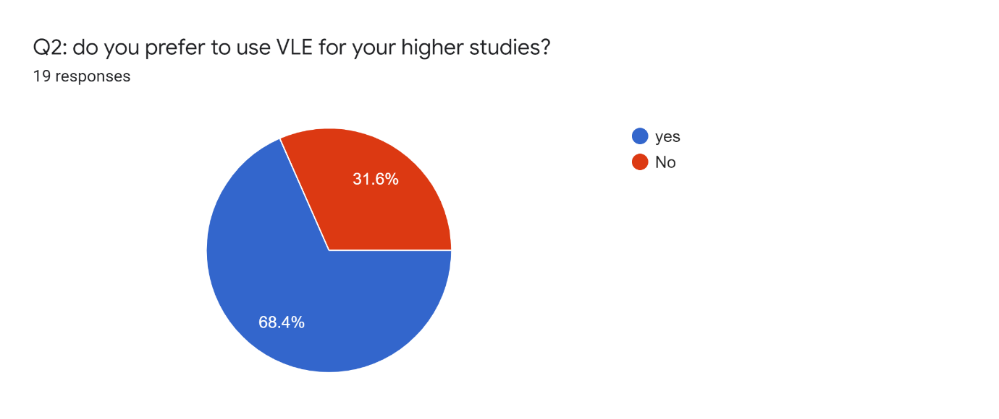
More than half of the students prefer VLE for their | Higher studies
Yes 13
No 6
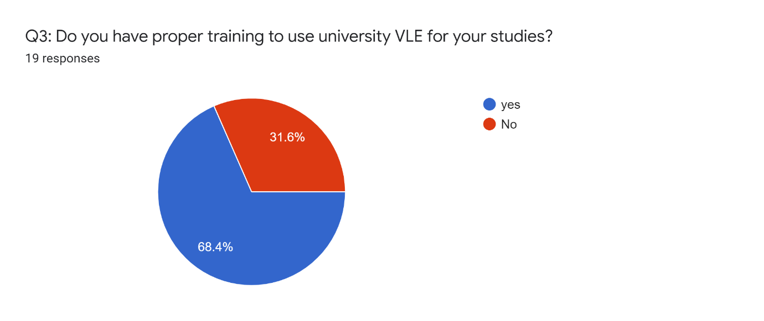
Yes 13
No 6
There are mixed results in relation | To proper training on VLE
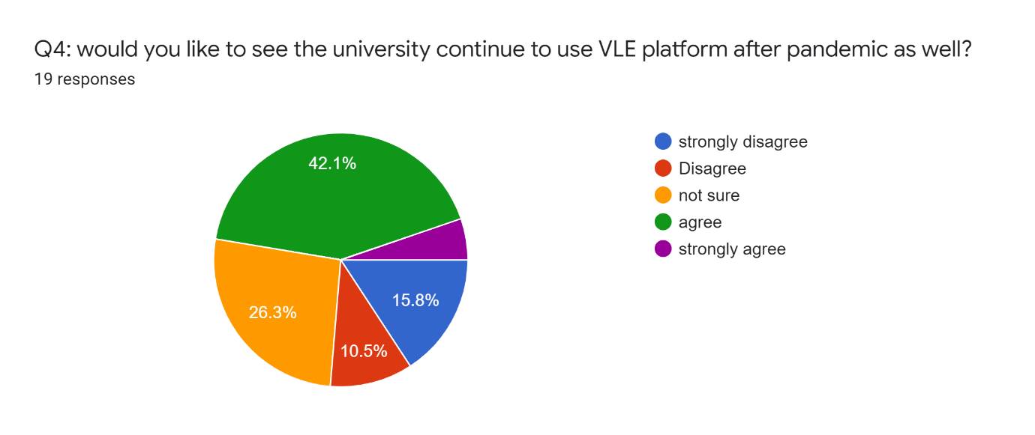
strongly disagree | 3
Disagree | 2
not sure | 5
agree | 8
strongly agree | 1
Again, it’s a mixed choice of opinion, almost less than a half of the students agrees to see VLE after the pandemic.
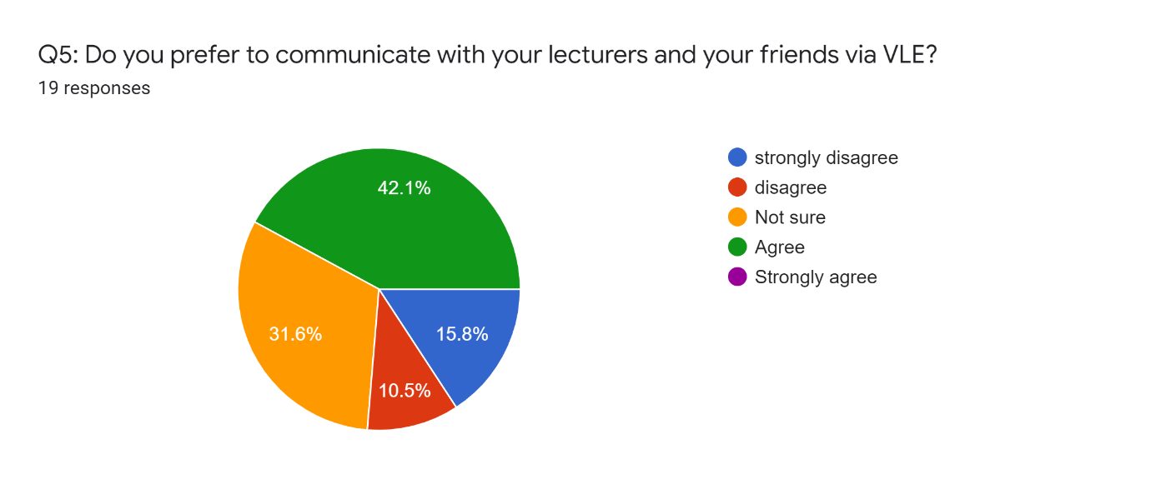
strongly disagree | 3
disagree | 2
Not sure | 6
Agree | 8
Strongly agree | 0
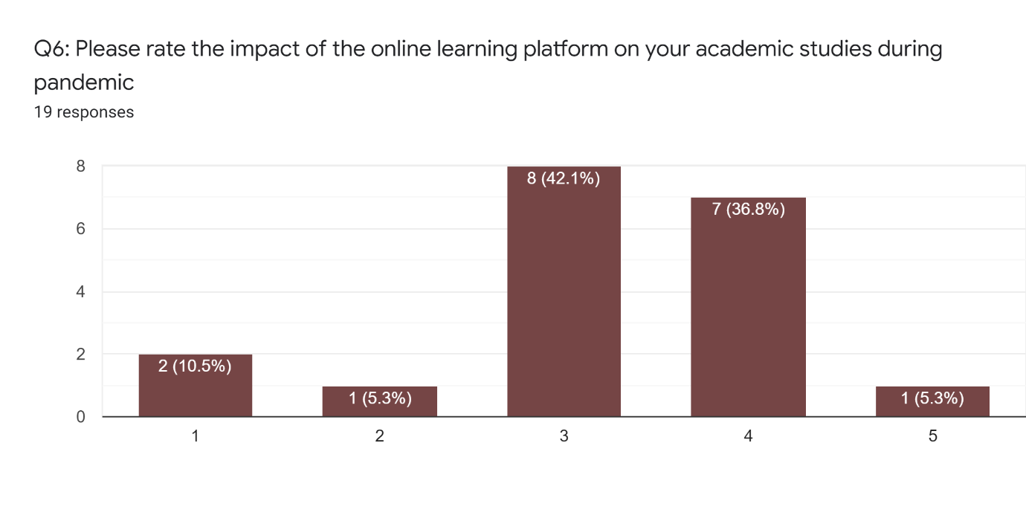
Value | Count
1 | 2
2 | 1
3 | 8
4 | 7
5 | 1
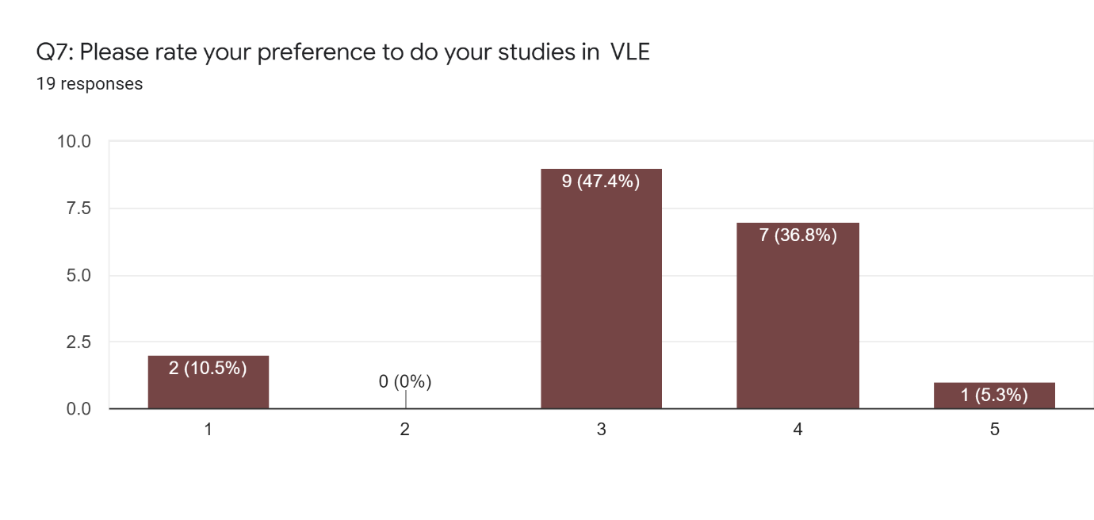
Value | Count
1 | 2
2 | 0
3 | 9
4 | 7
5 | 1
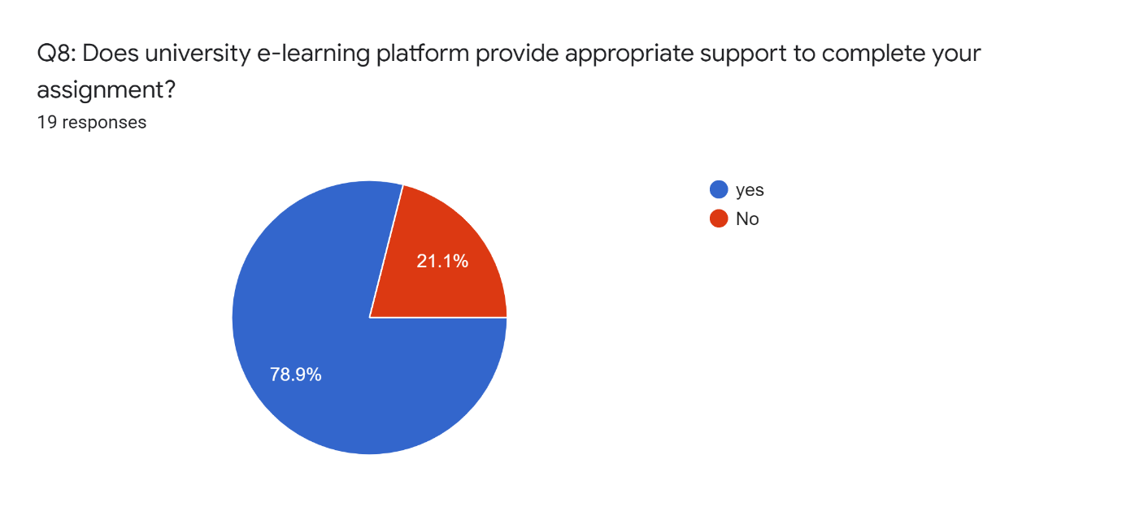
yes | 15
No | 4
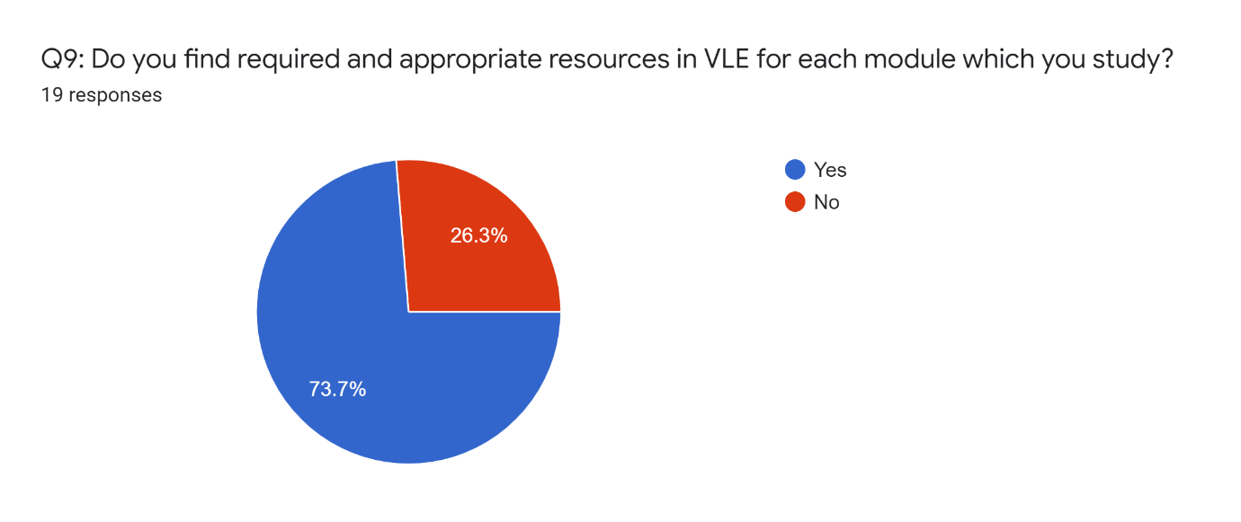
Yes | 14
No | 5
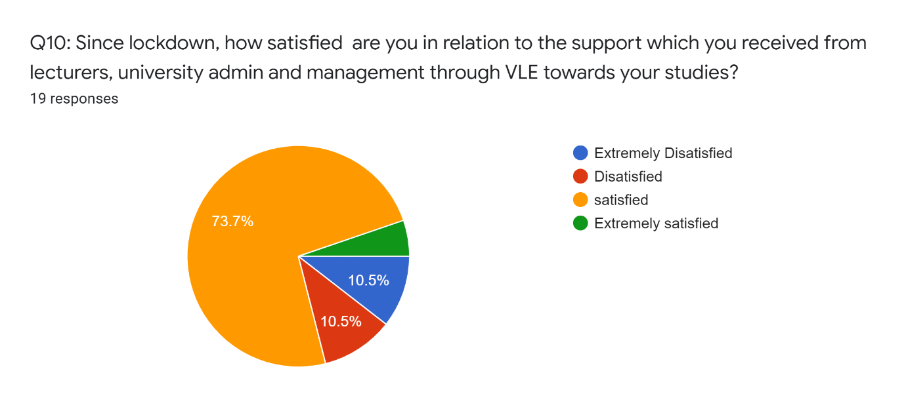

According to the pie chart, the majority of students claim to have used a VLE.

We can see from the statistics that the majority of the students agree that the Virtual Learning Environment has improved their proficiency, which is consistent with the preceding literature review. It's impossible to conclude whether students think VLE is better than face-to-face based on this survey. We can very certainly conclude from the responses that study resources are easily accessible in the MOODLE, as we received a large number of affirmative responses to this topic. We had a positive response to the recommendation of VLE from the respondent, which we may presume is because the students believe that VLE aids their autonomous learning and increases their motivation to learn.

Limitation of the study:

The following are some of the study's limitations:

• A small sample size

• Low response rate from questioners

• Using a survey questionnaire that isn't well-organized and elaborate.

• Failure to make use of modern statistical tools.

Conclusion:

According to a literature review, VLE improves student satisfaction, retention, and achievement in a variety of ways, and this improvement isn't just for students; it's also for teachers or their teaching process. These improvements aren't just for students; they're also for teachers or teaching processes. This study reveals that learning on a VLE provides an excellent opportunity for individual learners to access information at their leisure and in convenient locations. We should include a bigger and more diverse audience to acquire a more realistic picture of VLE and its impact on students' learning experiences. Ascertain that all students have remote access to the virtual learning environment.

Reference:

E. R. Hewson, E. R. Hewson, E. R. Hewson (2018). Reflections on two market research case studies on students' emotional engagement, motivation, and behavior during the duration of an online course. 1st International Journal of Interactive Media in Education (10). F. Defitrika and F. N. Mahmudah (2021). Character development through life skills education. 2(1), 116-135, International Journal of Educational Management and Innovation. 'The learning impact of a virtual learning environment: students' opinions,' Tean Journal 5 (2) July [Online], Barker, J., and Gossman, P. (2013). Visit http://bit.ly/AtMwtr for more information. (Accessed on September 1, 2021). https://ciftraining.ie/2018/01/advantages-disadvantages-virtual-learning/ (Accessed on September 1, 2021). D. Lederman (2020). The human factor in the shift to remote learning. https://www.insidehighered.com/digital-learning/article/2020/03/25/how-shift-remote-learningmight-affect-students-instructors- and (Accessed on September 1, 2021). How Online Learning Can Help You Achieve Better Academic Results [Online]. http://blog.digitalmarketinginstitute.com/how-online-learning-can-improve-academicperformance (Accessed on September 1, 2021). E. Ryan and C. Poole (2019). Students' Satisfaction, Engagement, Recall, and Retention in a Virtual Learning Environment, 50(3):408-415. Epub 2019 Jun 19. DOI: 10.1016/j.jmir.2019.04.005. M. C. Diochon and F. Cameron (2001). Interactive learning using technology. 114-127 in Active Learning in Higher Education, 2(2). Becta is a type of insect (2010) The 2009 Harnessing Technology Review The importance of technology in continuing education and skill development (Coventry, Becta)

