

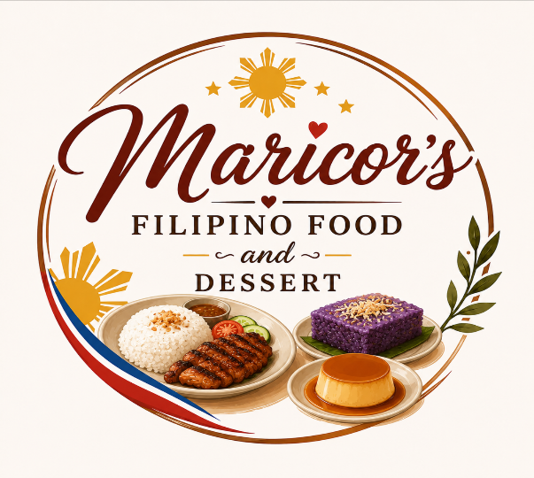

    - Assignment title: Business Plan
    - Module name: Enterprise and Entrepreneurship
    - module code: LCLM4005
    - Your name: Ma Corazon MacAspac
    - student number: 2509848
    - Lecturer’s name: Shengfeng Mai

Contents

Introduction 2

Section 1 - Overview of the Business Idea 3

Section 2 - Legal Format and Management Structure 3

Section 3 - PESTEL Analysis 4

Section 4 - Target Market and Marketing Strategies 5

Section 5 - Funding Requirements and Allocation 5

Reference List 8

Appendix 8

Introduction

The global Filipino restaurant market is experiencing substantial growth, valued at $28.4 billion and projected to reach $52.7 billion by 2034 with a compound annual growth rate (CAGR) of 7.1%. Europe accounts for an 11.4% revenue share, with the United Kingdom acting as a major hub driven by a well-established Filipino community that stands among the largest non-British nationalities owning registered businesses in the country. Traditional Filipino cuisine forms the largest market segment at 47.3%, supported by widespread appreciation for authentic comfort food and trending ingredients like purple ube. Furthermore, online delivery channels are expanding rapidly at an 11.3% CAGR, mirroring wider UK food and beverage trends where digital platforms provide critical scaling opportunities for independent operators.
• Name and Role: As the Founder and CEO, I am dedicated to bringing an authentic taste of home to our community.
• Background and Experience: With more than ten years of international experience working overseas as a nanny, cook, and housekeeper—including preparing meals for families from diverse cultures in London—I bring hands-on culinary expertise and operational discipline to this venture.
• Passion and Motivation: My driving motivation is to share the authentic, comforting Flavors of Filipino cuisine while delivering exceptional quality and customer service.
• Connection to the Industry: Years of missing the flavours of home abroad led me to start making and selling homemade Filipino desserts, such as biko, ube kalamay, leche flan, turon, and halo-halo. Seeing how much people enjoyed traditional sticky rice and coconut treats inspired my vision to open my own Filipino restaurant.

Section 1 - Overview of the Business Idea

My business idea is to make my own business like Filipino restaurant. To serve Filipino meals and dessert. The taste of cook with love, the authentic Filipino food, that brings the good taste of everyone. To become known as Filipino brand known for quality and affordable affordability and excellent customer service. In Filipino culture, I want to serve a lovely and tasty food for the customers. Like my specialty, Pork Adobo, Chicken Adobo, Beef Steak Tagalog and very good Filipino dessert like Biko, Ube Kalamay, Leche Flan, Turon and Halo-Halo.

Section 2 - Legal Format and Management Structure

- Specify the legal structure of your startup
Operating as a sole trader offers the distinct advantage of working independently without a traditional boss or manager. Running one's own enterprise allows an individual to hire familiar faces to assist with operations, including involving their children in the family business. Being self-employed provides personal ownership, freelance-style freedom, and a model where others adapt to how business functions. This setup delivers exceptional flexibility, higher earning potential, and the fulfillment of building a personal legacy.

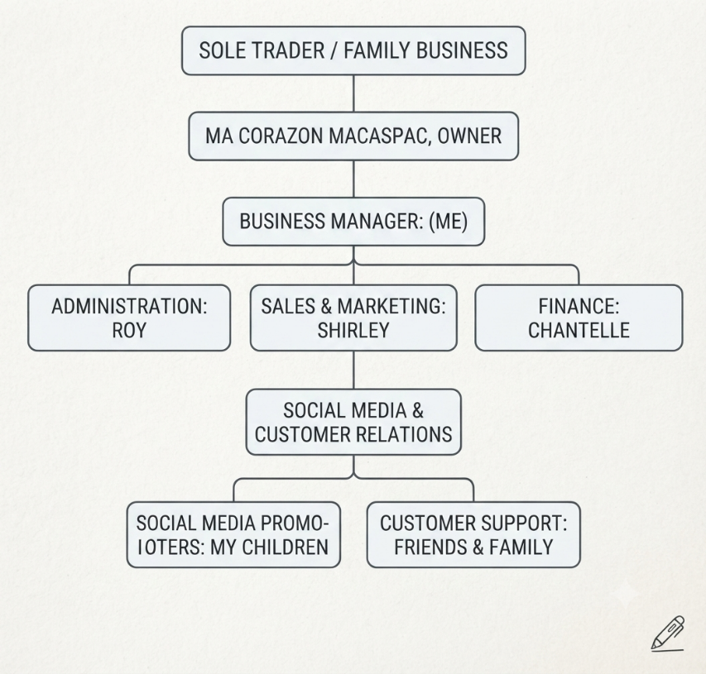
- State the management structure of your business by detailing the roles and responsibilities within your business. You could use an organizational chart to demonstrate this structure. As the example below.

Section 3 - PESTEL Analysis

Industry Identification:

Filipino Food and Dessert: Food and Beverage Industry. It is a Filipino Restaurant, Food Stall and Dessert Shop.

The Business operates in food and Beverage industry, specializing in authentic Filipino dishes and traditional desserts, it is offering a Filipino meal, snacks, and sweet treats that show Filipino culture and cuisine. The business serves customers who are looking for affordable, high-quality, and freshly prepared Filipino food for dine in, takeaway and delivery.

Target Market:
Student. Workers, Families, Tourists, Filipino food lovers and most specially Customers looking for traditional authentic and homemade desserts.

Main Product:
Filipino main dishes like (Pork Adobo, Chicken Adobo, Sinigang, Kare-Kare, Lechon, Beef Pares Beef Caldereta and sizzling Sisig. Every dish comes with Rice.

Filipino Snacks:
Turon, Lumpia, Halo-halo, Bananacue, and Coconut Macaroons

Traditional Desserts:
Leche Flan, Bibingka, Cassava Cake, Sapin-sapin and Ube Halaya

Industry Characteristics:
High quality in customer demand because food is essential requirement that cannot live without.
Increasing demand for online food delivery and convenient ordering.
Success depends on food quality, affordability, and customer service.
Highly competitive with many local restaurants and food stalls.

Step 2: Analyze Key PESTEL Factors

- Political: The restaurant must follow government regulations, including business permits, food and safety standards, and tax requirements.
- Economic: The success of the restaurant depends on customer spending. Rising food prices can increase the cost of ingredients, while a strong economy can lead to more customers dining out. Offering affordability attracts more customers.
- Social: People enjoy trying different cuisines. There is some interest in authentic Filipino food. Families and students are target regular customers.
- Technology: Technology improves the business through online ordering, food apps, and social media marketing.
- Environmental: The restaurant should practice proper waste management, use eco-friendly packaging for take-out orders, and buy fresh ingredients from local suppliers to support sustainability.
- Legal: Restaurant business must obey food and safety laws, labour laws and fire safety regulations. The employees should receive proper training in food handling and workplace safety.

Section 4 - Target Market and Marketing Strategies

Refer to week 5: Market Segmentation, Targeting and Positioning

Discuss the STP model (provide citations).

- Present a detailed analysis of your target market and its characteristics. Scope: Broad and high-level.

- Identify your primary customer segments. Scope: Specific and narrow

- Highlight the unique selling points

- Explain the marketing strategies you will adopt to reach and attract your customer segment(s).

Section 5 - Funding Requirements and Allocation

- Clearly specify the total amount of funding you are seeking.

- Break down the allocation of funds by categorizing them into:

  - Startup Costs:

  - Operating cost

    - Fixed Costs:

    - Variable Costs:

- Provide a monthly financial forecast for up to six months, detailing projected income and expenditure for each month.

- Include your breakeven analysis, indicating when your business is expected to cover all expenses and start generating profit.

Example:

Startup Cost


Startup Cost

 | Furniture |  | £8,000
 | Accessories |  | 4000
 | Toileteries |  | 1000
 | Renovation |  | 5000
 | Total |  | £18,000

Operational Cost
Fixed Cost
 | Fixed Costs |  | per month
 | Rent |  | £1,500
 | Bus. Rate |  | £300
 | Gas bill |  | £150
 | Two Emp Salary |  | £3,500
 | Accountant |  | £100
 | Total cost |  | £5,550

Variable Cost
Variable | Jan |  | Feb | Mar | Apr |  | May |  | June
Costs | Jan |  |  |  |  |  |  |  | June
Electricity | £300 |  | £400 | £500 | £700 |  | £700 |  | £750
Raw | £400 |  | £600 | £650 | £800 |  | £800 |  | £1000
materials |  |  |  |  |  |  |  |  | £1000
hourly paid | £0 |  | £500 | £500 | £600 |  | £600 |  | £700
Emp | £0 |  |  |  |  |  |  |  | £700
Total Var | £700 |  | £1,500 | £1,650 | £2,100 |  | £2,100 |  | £2,450
cost
Financial forecast for the first Six months
 |  | Jan |  | Feb |  | Mar |  | Apr |  | May | Jun
Fixed |  | £5,550 |  | £5,550 |  | £5,550 |  | £5,550 |  | £5,550 | £5,550
Variable cost |  | £700 |  | £1,500 |  | £1,650 |  | £2,100 |  | £2,100 | £2,450
Total cost |  | £6,250 |  | £7,050 |  | £7,200 |  | £7,650 |  | £7,650 | £8,000
Revenue |  | £3,000 |  | £4,500 |  | £6,000 |  | £8,000 |  | £8,600 | £9,500
Profit/loss |  | -£3,250 |  | -£2,550 |  | -£1,200 |  | £350 |  | £950 | £1,500

Investment needed = Total Startup Cost + Sum of Loss.. up to the breakeven point Investment needed = £18,000 + + £3,250 + £2,550 + £1,200

Investment needed = £25,000

Appendix A: Legal and Regulatory Framework

- Restaurant Businesses must follow the food and safety Laws, labor laws, and fire safety regulations all the time
- Employees must receive proper training in food handling and workplace safety.

Appendix B: Reference List

  - Burns, P. (2020) entrepreneurship and small business, 5th ed. London: Red Globe Press
  - Hisrich, R. Peters, M. and shepherd, D. (2020) Entrepreneurship. 11th ed. McGraw-Hill education.
  - Johnson, G. Scholes, K. and Whittington, R. (2020) Exploring Strategy: Text and Cases. 12th edn. Harlow: Pearson.
  - Kotler, P. and Keller, K.L. (2022) Marketing Management. 16th edn. Harlow: Pearson.
  - Mariotti, S. and Glackin, C. (2021) Entrepreneurship: Starting and Operating a Small Business. 5th ed. Pearson.

