STUDENT NAME: ANCUTA CHIRITA
STUDENT ID: 1605755
MODULE NAME: INTERNATIONAL BUSINESS
MODULE CODE: LCMB7014
LECTURER NAME: HOSSEIN SHOKRI
WORDS COUNT:5794 WORDS

Table of Contents
1. Introduction 3
2. Company Background 3
3. Country's Objective 3
4. Specifications of countries 3
5. External analysis 4
A) PESTEL analysis 4
B) Industry five forces 5
C) Market analysis 6
6. Country analysis 7
A) UK's national diamond 7
B) UK's business risks 9
7. Internal analysis 10
A) Global value chain- United Kingdom 10
B) SWOT analysis of Amazon 11
8. International strategy 15
9. Entry modes 16
10. Corporate social responsibility 16
11. Conclusion 17
References 17

Introduction
International business is stated as a trade of commodities, services, capital, and technology across international borders and transnational. It involves the transaction of commodities and services as well. It contains all commercial operations and distribution of commodities and services across national borders. In international business, all operations are taken place beyond the borders of nations. International trade boosts the economic growth of a nation and organizations of developing nations enhance their production ability to supply products in foreign nations. It is beneficial for currency fluctuations and increases the flow of cash in the market. It generates jobs and decreases the unemployment rate in the nations. The report will explain the business strategy of Amazon to enter the market of the United Kingdom. It will explain comparative PESTEL analysis and industry five forces of UK. It will evaluate business risks and analyse the host country market. It will also explain the internal analysis, international strategy, and entry modes of the international market.

Company Background
Amazon.com, Inc is a technology company based in Washington and Seattle. It is an American multinational company that focuses on digital streaming, e-commerce, artificial intelligence, and cloud computing. It is one of the top five companies in the information technology industry in the United State. It is also known as one of the biggest influential cultural and economic forces in the globe. It was established in 1994 by Jeff Bezos and one of the biggest online marketplace and AI assistant providers in the world. Jeff Bezos resumed in the best way, what was the Amazon growth from the beginning, until now. It operates a number of worldwide marketplaces as United Stated, which is the host country, United Kingdom, Australia, Brazil, Canada, China, France, Germany, India, Italy, Japan, Mexico, Netherlands and Spain.
“We’ve come a long way since then, and we are working harder than ever to serve and delight customers. Last year, we hired 500,000 employees and now directly employ 1.3 million people around the world. We have more than 200 million Prime members worldwide. More than 1.9 million small and medium-sized businesses sell in our store, and they make up close to 60% of our retail sales. Customers have connected more than 100 million smart home devices to Alexa. Amazon Web Services serves millions of customers and ended 2020 with a $50 billion annualized run rate. In 1997, we hadn’t invented Prime, Marketplace, Alexa, or AWS. They weren’t even ideas then, and none was preordained. We took great risk with each one and put sweat and ingenuity into each one.” (Anon., 2020)

Figure 1Amazon logo

Country's Objective
- To became market leader in the United Kingdom
- To increase revenue in the United Kingdom

Specifications of countries
Specifications of United Kingdom
When a global organisation are looking to expand in different country, there are many factors to consider it. There are a few key factors why United Kingdom is a great place, when you think to expand your business:
- Is one of the top ten manufacturers around the world. Also, has the largest industries in Europe for Life Sciences, IC (Anon., 2020)T and the Creative Industries; (Savage, 2014, 3rd of February)
- It is at the forefront of the International digital revolution. London has more software developers than any other city outside of Silicon Valley. (Savage, 2014, 3rd of February)
- Is the number one FDI destination in Europe. (Savage, 2014, 3rd of February) (Savage, 2014, 3rd of February)
- Has an open and internationally focused economy, which is one of the largest and most sophisticated in the world. UK it is also a proven gateway to either the EU( for non-European firms) or other English speaking markets. (Savage, 2014, 3rd of February)
- Has relatively low tax, less regulation and a talented workforce from all around the world. (Savage, 2014, 3rd of February)
Another factor to decide which country to choose for international expansion of your business, is how open is the market to new ideas.
Specifications of United State
It is the home country of Amazon. Amazon serves its services in United State and now operate in the United Kingdom as well.

External analysis

PESTEL analysis
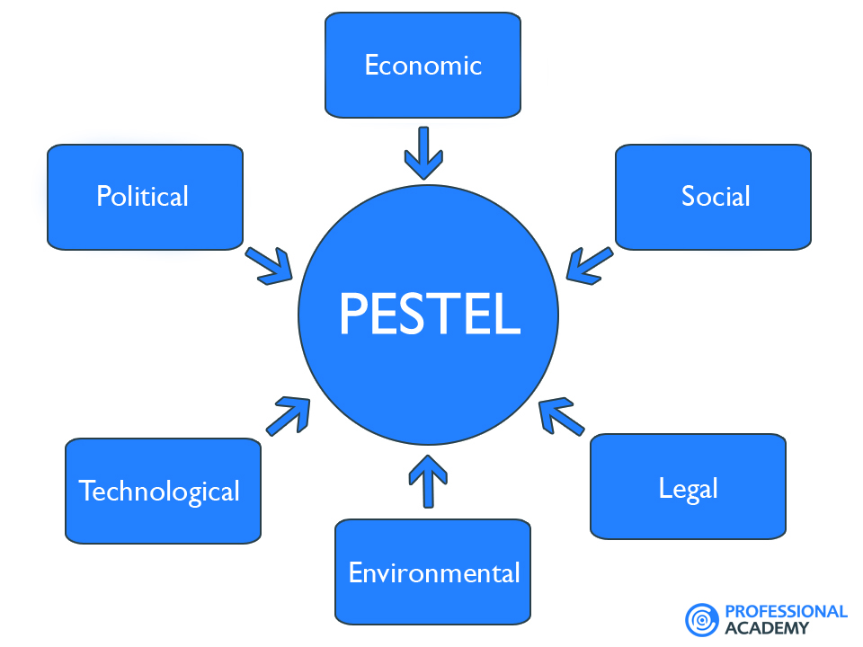
Figure 2
Amazon is the market leader in online shopping industry, in many countries. We could say that now a days, online shopping is very popular and significantly changed the customer behaviour, over the years. Like any other international company, Amazon’s strategy operational decisions has been influenced by some of the political, economic, social, technological and environmental legal factors.
Political factors- Amazon’s decision toincrease the minimum wages for its workers in the USA and UK, during the pandemic, is the result of both political and economic pressures, many analysts argued. Being criticised by Donald Trump, Bernie Sanders, the GMB union (UK) and Archbishop of Canterbury, has a big impact about the decision (Elliott, 2018).
Economic factors- During the pandemic, many companies around the globe, faced devastating year, economically speaking. In the same time, Amazon seems to be different and has had rather positive results. Customer needs of household essentials, groceries, streaming, gaming, crafts, news, entertainment, and many more, generated during pandemic, an increase for customer spending, which looks like the best environment for Amazon. Should be mentioned that high labour cost particularly in the UK, and the USA and changes in taxation jeopardize its profits with direct implications on the long term growth of the business.
Social factors- The impact of social factors can be positive or negative. Many simple people become financially solvent by trading on Amazon. Each person with a little bit of tech knowledge and patience, consider Amazon as an opportunity. By delivering everything at their door, during pandemic, when most of the people stay isolated inside of the house, scarred to go out, Amazon has been the hero company who saved the world, and changed the customers behaviour for long term, or even for goods.
Technological factors- New and innovative technologies are the backbone of Amazon. It is one of the profitable companies in the world due to technology. The company is focusing on cloud computing very system technology to satisfy its consumers. It launched a new delivery system Amazon Prime Air to deliver various packages to the consumers. This technology is also known as an Aerial Vehicle drone.
Environmental factor-reducing organizational emission is one of the challenges for Amazon. It is very difficult for the e-commerce industry to eliminate carbon emissions. The new drones will help Amazon to reduce carbon emissions. Amazon has targeted to reduce carbon emissions and another target is focusing on renewable energy (2021). It has also developed a strategy for renewable energy, waste reduction, and sustainable packaging to minimize pollution. The company has invested in CSR as well and is increasing its reputation in the market. The interest of the people in the environmental programs is increasing which is creating opportunity for Amazon.
Legal factor- It is significant to factor in the international market and more important for Amazon to stay compliant with the law (He and Harris, 2020). The company has its own legal team to oversee the challenges and issues associated with laws. Any kind of legal issues will negatively impact Amazon and any mistake can cause a big loss of reputation and fines. The laws of many counties differ from country to country which can create challenges for Amazon (Perchard et al., 2017)..

Industry five forces
The model of five forces is developed by Michael Porter to analyse the importance of the external environment. These external factors affect the activities of an organization. This framework will help Amazon to understand the important factors in the IT industry . It will be used by Amazon to analyse the competitiveness of the IT industry. All five forces are described below:
Bargaining power of buyers-The bargaining power of the buyers is high in the IT industry. The IT industry is controlled by consumers due to the larger number of consumers. Switching cost in the IT industry is minimal which has increased the bargaining power of the buyers . A large amount of IT sales comes from various firms that make larger purchases hence these companies have the power to influence the IT industry.
The bargaining power of the suppliers- There are a large number of suppliers in the Information Technology industry who supplier raw equipment. Suppliers' bargaining power is moderate in the IT industry due to the moderate cost of switching . Suppliers have the power to increase the prices of their raw materials in this industry. It causes expansive suppliers as well as unpredictable shifts in the price which impact the company's revenue. Amazon will develop a strong relationship with its suppliers to avoid this kind of situation (Perchard et al., 2017).

The threat of new entrants-The IT industry is very attractive but needs large invests which moderate the threat of new entrants. The threat of new entrants will influence the business of Amazon in the UK. This industry is not too attractive for newcomers due to large investments (Bruijl, 2018). There are many big and well-established organizations in the retail industry that give tough competition to new organizations. It de-motivates the new entrant in the IT industry. Moderate threat of new entrant is good for Amazon and help to gain competitive advantage.
The threat of substitutes- The threat of substitutes in the IT industry is low. There are very limited subtitles they do not have the quality to satisfy the needs of consumers due to lower quality. The lower threat of substitutes is beneficial for all organizations of the IT industry as it increases sales revenue. It is also beneficial for Amazon and helps to raise sales revenue in the UK. It will also assist to maintain demand in the market.
Competitive rivalry
Competitors in e-commerce – Being the leading online retailer in the USA, the UK, and many other countries, it is reported by Clement (2019) that the company’s e-commerce retail market share in the USA was 37 % in 2017, and significantly increased by now. Is reported as well, that 62% of Amazon’s customers in the USA, are Amazon Prime members. Butler (2019) reports that 90% of British shoppers use Amazon. In the same time, 40% are Amazon Prime subscribers. Dominating the UK e-commerce retailing with 30.1% market share as of 2019, Amazon’s biggest competitors both in the UK and USA is eBay, Alibaba.
Competitors in web services – Amazon is a cloud-based computing provider, competing in global markets with giants such as Google Cloud Platform(GCP), IBM Cloud, Alibaba Cloud, Oracle Cloud, etc.
Competitors in streaming service – Over the years, Amazon Prime Video has gained an huge popularity, competing with Netflix, YouTube, HBO Go. Netflix and Amazon Prime Video, looks like being the only two options for many people when they choose video streaming services.

Market analysis
Market analysis gives information regarding competitors, other markets, industries, and consumers. With the help of market analysis, companies can determine the relation between demand and supplies for particulars goods and services. There is some dimension of market analysis that helps to enhance the understanding of the market. Market size, competitors, key success factors, the growth rate of the market, and distribution channels are dimensions of market analysis.
Market size- Market size is a key factor for market analysis and if the size of the market is big, the number of competitors is high. If the market size is small, several competitors are fewer. The market size of the IT industry of the UK is very large so the number of competitors is high. The large size of market needs higher quality products to compete with other well-known companies. Amazon needs to ensure that their products stand out in the highly competitive market otherwise consumers can easily switch to the other product.
Key success factors- It refers to those components which assist the business to attain great success and higher growth in the market (He and Harris, 2020). The key success factors include technology programs, effective use of resources, and economies of scale. Amazon will use innovative technology in their business to achieve success. Effective use of resources will help to gain higher growth in the IT industry.
Competitors in the market- The market size of the IT industry of the UK is large hence several comept5itors are also high. Various companies provide higher quality IT products at reasonable prices which will create challenges for Amazon in the UK (He and Harris, 2020). Plaxonic Technologies, Cyber infrastructure Inc., Skelia, and Packetlabs are some top IT companies in the UK and these entire companies will provide tough competition to Amazon.

Country analysis

UK's national diamond
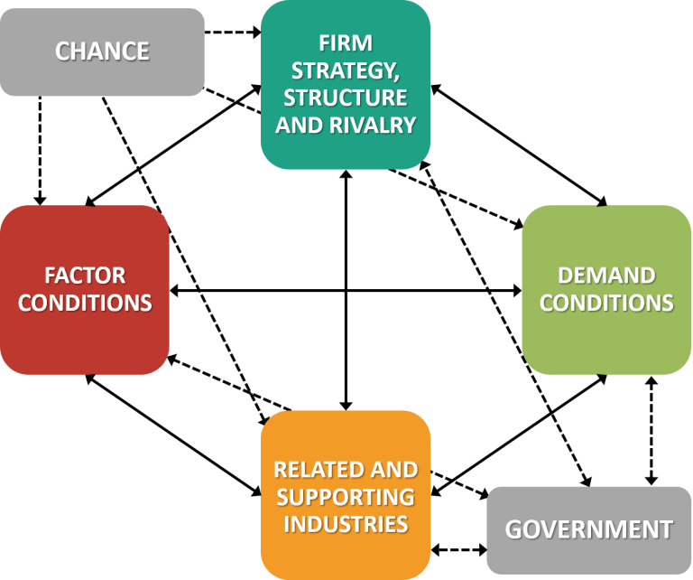
Figure 3
National diamond is defined as a theory and approach of competitive benefit developed by Professor Michael E. Porter who was a professor at Harvard Business School. Porter uses a diamond-shaped graphic to represent a theory (He and Harris, 2020). The diamond-shaped graphic is used to represent the factors that make up a competitive advantage in industrialized nations in the marketplace of the world. The national diamond is also defined as a Porter Diamond and it seeks to describe how the government of nations can act as catalysts to improve and enhance the position of nations in the competitive economic environment in the world. Porter was export in the economic competitiveness and categories competitive advantage factors into four categories- firm strategy, rivalry, structure; related and supporting industries; demand conditions and factor conditions. Firm strategy, rivalry, and structure indicate basic facts that competition leads to organizations finding different ways to enhance production as well as the creation of technological innovation.
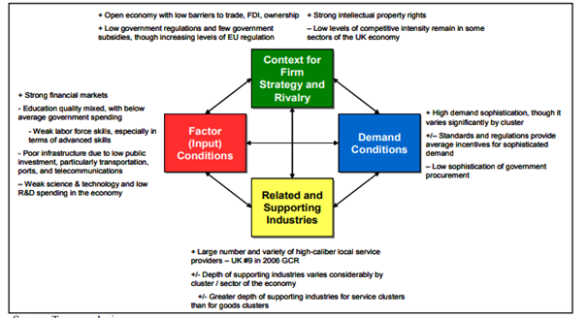
Figure 4national diamond of the UK

The national diamond of the UK is well developed and represents the high level of competitiveness in the country. The national diamond of the UK is characterized by the private- sector and strong context demand. One of the weaknesses of the UK national diamond is in factor conditions. The UK suffers from a lower level of innovations, poor infrastructure, and low labour skills. The strength of the economy of the UK is that it is a flexible and open economy with a high level of deception of demand and a larger number of premium quality service providers. The business of the UK is very concerned regarding the burden of the regulation of the EU (Nambisan, Zahra and Luo, 2019). The government of UK gas developed some approaches to reduce the burden of regulation on the organizations. The UK ranked poorly in the term of innovation in IT industry which is its weakness. The infrastructure of the UK is also not good and it has very crowded roads in the EU, which makes it complex to obtain the advantage of production technique just-in-time.

UK's business risks
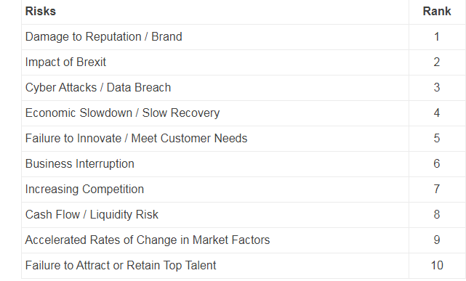
Figure 5

Business risk refers to the exposure an organization or company has to factors that will decrease its revenue and lead it to failure. In another world, anything that threatens the capability of an organization to obtain its financial goals is known as a business risk . Different types of business risks are- compliance risk, operational risk, reputational risk, and strategic risk. Strategic risk occurs when an organization does not operate its business as per its plan and model. If an organization does not operate its business as per the business plan and model, it becomes less efficient over time (Kurt and Kurt, 2020). Compliance risk is the second form of business risk and refers to compliance risk. This type of business risk occurs in sectors and industries that are extremely regulated. Operational risk is the third form of business risk and occurs when an organization failed to perform well in its day-to-day activity. For instance, HSBC international bank faced a higher degree of business risks due to ineffective performance of the business operations. Another form of business risk is reputational risk. Any time reputation of an organization can ruin and impact on the revenue. It includes the risk of losing loyal consumers and brand loyalty as well. Industries of the United Kingdom are also facing various business risks like cyber attacks, terrorist attracts, misuse of technology, change in technology data theft and fraud, failure in climate change adaptation, pandemic, and fiscal crises. The Covid-19 crisis is also business risk and negatively influences the business. According to risk assessment, the country risk rating of the UK is A4 which means acceptable risk. The rating of business climate is A1 which means very low risk. The risk assessment of the UK shows that country's risk rate is moderate and the business climate rate is very low in UK which is suitable for Amazon hence it can expand its business in the UK.

Internal analysis

Global value chain- United Kingdom
GVCs (Global Value Chain) refer to international production sharing where the production of organizations is broken into various tasks and activities carries out in different nations. Integrations of various nations in the international economy are currently associated with their participation in the global value chain. It is an indicator of the participation of the various nations in the global value chain. It represents what percent of the export of a nation is a part of the global value chain.
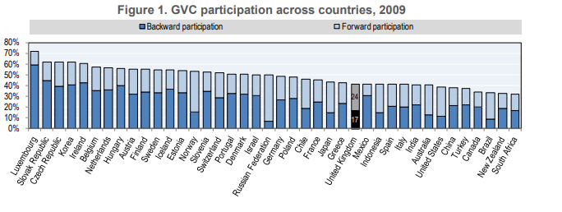
Figure 6 UK value chain

The above figure shows the downstream as well as upstream links that describe the participation of the UK in the global value chain. Utilize of United Kingdom intermediates in the nations' export is appreciably higher in utilize of the foreign intermediates involved in the exports of the UK.
Global production
Firm infrastrucure
Inbound logistics
Amazon consider that short time contracts with vendors, is a save mode to ensure the customers about the availability of items. They prefer do not store in the warehouses, items not ordered frequently, that means inventory management is often outsourced. The company is looking to its own renewable sources, even if they have energy sourced to run operations.
Operations
The three primary operating segments of Amazon are, North America, the largest one, International and AWS. For the regional website in the USA, Canada and Mexico, they use North American segment to manage it. For the global sales of computing, database, storage and other IT solutions, they use AWS, based in Romania, for European market.
Outbound logistics
Amazon fulfilment centers, designed by offering maximum efficiency, are coming to prove they use its own logistics to ensure that delivery time are met, all over the world, in countries that Amazon does not have warehouses, as well. Chritical pull time shipments (CPT) are the most priorities in every fulfilment, meaning that, prime customers, are ensure that, they will receive in the next day, everything will order during the previous day and night.
Marketing & Sales
Amazon used aggressive marketing strategy to grow. They increased the sales from 20% in 2020, to 38%, by regular advertise to the most high profile advertising event.
Service
As business model, Amazon own one of the most crucial customer service. They consider customer satisfaction, the most important factor, that is why, they found a balance between being profitable as business, and fidelize the customers, by ensure that, each one customer will receive what has been paying for, in the same time with the organisational profit. Amazon, is consistently ranked top of American Customer Satisfaction Index (ACSI) and UK Customer Satisfaction Index (UKCSI). (Anon., n.d.)

Global marketing
Global marketing refers to a procedure of applying the market strategies of an organization to implement to the conditions of the other nations (Amazon's global career site, 2021). It involves the process of planning, promoting, creating, and posting the product of an organization in the international or global market. Global marketing is very useful for Amazon as it will assist to improve the effectiveness of the products and services. Amazon will take advantage of strong competition in the global market. It will develop brand awareness among the audience of the UK which will aid to increase their revenue.
Global HRM
It is an umbrella term that contains all aspects of a company's human resources, talent management, and payroll on a global scale (Amazon's global career site, 2021). It makes sure that all workers remain active, engaged, and collaborative with the company. Different software of global human resource management will help Amazon to operate all human resources functions effectively. Global HRM is different from domestic HRM as global HRM is practiced by multinational companies and focuses on the management of the persons in a multi-nation context. Recruitment as well as on boarding process is functions of the global HRM. On boarding and recruitment process in the international market is more complex hence needs a strong HRM strategy.

SWOT analysis of Amazon
SWOT analysis is defined as a contextual review of the weaknesses, threats, strengths, and opportunities. This framework helps to increase the understanding regarding the business so that businesses can address their weakness and threats, and develop suitable strategies to minimize them.
Strengths
Internal Strategic Factors
Strong brand name – In the market, as a global e-commerce leader, Amazon has a strong position and successful brand image.
Brand valuation – After Apple, the leader, and before Google, the third position, Amazon is ranked at the second position , with a brand value of 200 billion dollars, according to Global Brand Ranking 2020.
Customer oriented – Amazon has a large number of customers for everyday needs.
Differentiation and Innovation – Amazon creates a differentiation from other companies, by bringing ambitious drone delivery service, and being able to deliver shipments to the customer’s door in less than 30 minutes.
Cost Leadership – By numerous strategic alliances with companies like Evi Technologies, Thalmic Labs, Shoefitr, The Orange Chef, etc, Amazon has a strong value chain system which helps to maintain a low cost structure.
Largest Merchandise Selection – In 2018 Amazon has sold 562.3 million products in its Amazon.com Marketplace, by offering variety and substitute to each product.
Large number of third-party sellers – Using Fulfillment by Amazon (FBA), there are more than 2 billion items available from third-party sellers, who sale their own merchandises.
Go Global and Act Local Strategy – Understanding the customer behavior and preferences, is one of the Amazon’s success. That is why develops partnerships with local suppliers, which helps to understand the local needs, and comped against rivals.
Large number of acquisitions – Aquisiting companies like Whole Foods, Zappos.com, IMDB.com, generated important revenue and profits for Amazon.
Involved into 3 key business- Amazon Marketplace, Amazon Web Services (AWS)and Amazon Prime – That three key businesses, work and support to each other, generating massive profits and advantages for company.
Market Leader – Amazon it is a market leader, by having over 1 trillion dollars market capitalization and above 386 billion dollars annual revenues.
Superior logistics and distribution systems – Using Chritical Pull Time delivery system (CPT) in less than 30 minutes, the Amazon prime members can receive the items at the door.

Amazon has over 310 million active users and 100 million subscribers, and its popularity is widespread around the globe, being the world’s leading online retailer.

Weaknesses
Easily imitable business model- The business model of Amazon is very simple hence any rival organization can adopt this business model. Nowadays online IT business is very common in the digital world. Some businesses are proving tough competition to Amazon. These organizations include eBay, Oyster, Barnes and Noble, Netflix, and Hulu 2021.
Free shipping- The Company offers the facility of free shipping to its consumers which decrease its revenue. Free shipping is a costly approach and influencing the profit margin of the company.
Tax Avoidance Controversy – Tax avoidance in UK, (Helen, 2010) (Bartlett Christopher A. and Beanish, 2011) (Buckley, n.d.) (Hill, 2006) (Daniels, 2011) (Kelly, 2009) Japan and US has sparked negative publicity for Amazon. Donald Trump criticized Amazon overtaxes on social media.
Massive product failure- Another weakness is massive product failure which reduces the profit of Amazon. The company has not able to maintain its success and achievement in other products. There are various products which failed in the market.
Opportunities
Diversify – Amazon is a leading brand of e-commerce and also performs well in cloud player which shows diversification (Kurt and Kurt, 2020). The company can diversify in another sector as well and use new technology to obtain a faster growth rate.
Purchasing other businesses- Amazon has the opportunity to purchase other businesses and expand the business. The financial position of this company is good and it has the ability to buy a new business.
Expansion is developing market- Amazon has the opportunity to expand business in developing market as it will aid to increase profit margin (Perchard et al., 2017). It will assist to gain a competitive advantage in developing markets. It will boost the revenue of Amazon.
Threats
Controversies- It has caused a dent in the brand image of Amazon. In 2020, people start boycotted and critically reacted on Amazon sites which negatively impacted the company. It caused lower sales of products and lower revenue.
Cybercrimes- Another threat is cybercrimes and nowadays rate of data theft and cybercrimes are increasing and creating threats for Amazon. It is creating problems for people who are using online platforms for shopping. People put their bank detail on the web page to make payments and cybercrimes have discouraged people to avoid shop online. People are avoiding use online platforms for shipping.
Aggressive competition- there is very high competition in the online IT industry which is a threat. Higher competition in the IT industry decreased the profit margin of Amazon. There are several competitors of Amazon-like Walmart, Costco, Apple, Microsoft, Wholesale, and Netflix.

International strategy
It is a business strategy or plan created by an organization to do business in the global market. It needs to define goals, develop the offering, evaluation of the international market, studying resources, and develop offering and understanding market dynamics. It is important for the organizations that are planning for expansion in the international market. It is a vital parameter for all international businesses. For example, an organization that is operating in India cannot use the same market strategy in other nations. The company needs to create an international strategy to operate in other nations. These are three types of international strategy which assist an organization to operate their business. - Multi-domestic strategy, global strategy, and transnational strategy are International strategies.
Multi- domestic strategy- This type of international strategy is utilized by MNCs. The aim of organizations with a multi-domestic strategy is to fulfill the needs and requirements of the local market globally by tailoring and customizing their services and goods extensively. This strategy needs higher responsiveness and a lower level of integration.
Global strategy- There is an opposite relationship between global strategy and multi-domestic strategy. The organization with a global strategy provides a standardized product globally and aims to increase efficiency and decrease the cost of goods . Their major role is to implement the decision of parent organizations and act as a pipeline of strategies and products. There are low responsiveness and higher integration.
Transnational strategy- This is a combination of global strategy and multi-domestic strategy. This strategy aims to increase the local responsiveness and also obtain the advantage of global integration. It is one of the intricate methods that organizations can use and implement when they expanding their business internationally.
Amazon will use a global strategy for the expansion of their business in the United Kingdom. It is an international strategy and it will help Amazon to expand and increase its consumer base in the UK market. Global strategy is an effort to sell goods in more foreign markets and provide the benefit of economies of scale. It will help Amazon to boost its revenue and reach as well. As per this strategy, Amazon will maintain its headquarters and central office, in their own nation of origin and establish other operations in the UK. This strategy will offer an advantage to overseas partnering and manufacturing with foreign organizations to market and develop foreign investment.

Entry modes
Licensing, joint venture, FDI, wholly-owned, franchising, and direct investment are some entry modes in the international market and some of them are explained below-
Licensing- It is an effective mode of entry in the international market and used by various companies for the expansion of business. In this entry mode, one company gives licenses to the other company to sell their goods in the global market. It is more suitable for small companies as they have fewer resources and licensing entry mode helps them in the expansion of business. It does not need large money hence preferred by many companies.
Franchising – It is a commonly used entry mode and mostly used by the firms of North American. It is also called the technique of distribution of goods and services. It includes three other entry methods named manufacturing franchising, product franchising, and format franchising. It is also appropriate for small companies as it minimizes the market risk of the international market. It increases the reorganization of the product and brand as well.
Foreign Direct Investment- FDI is also a mode of entry in the global market and offers benefits to both the foreign host and the organizations. It increased the economic growth as well as employment in the host nations. Amazon will use foreign direct investment entry mode to enter the market of the UK. Amazon is a very big organization hence FDI is the best entry mode. It will help Amazon to increase its consumer base and sales revenue in the UK. Amazon offers a variety of products which helps them to attract more consumers in a new market. Amazon will establish a new venture in the UK to operate its business. It will increase employment in the economy of the UK.

Corporate social responsibility
CSR is a concept in which firms integrate environmental and social concerns in their business operations. It is a way through which a firm obtain a balance of environmental, economic as well as social imperative and same time satisfying the need and expectation of stakeholders. Every firm needs to implement CSR in their business and meet their responsibility toward society. CSR contains social, environmental, economic, human rights, and philanthropic responsibility. It can be seen as an effort of public relations hence important for Amazon. Good CSR will help Amazon to stronger its brand image and reputation as well. It will add value to Amazon by maintaining and establishing a good corporate image . The loyalty of customers will also increase due to good CSR as consumers of an organization that practices good CSR feel that they are assisting the organization support good causes. The investment in operational efficiencies will help to decrease operational cost and decreased environmental impact as well. It will make easier access to funding as various investors are more interested to support the firm that practices CSR. Amazon will follow all rules and regulations related to human rights and provide a better working environment. It will also work to save the environment as it will reduce the burden of regulation.

Conclusion
International business is very beneficial for those organizations that want to expand their business in other nations to increase their profit. Organizations can sell products in other nations to increase their profit as well as the image of their business. It provides an opportunity for all sizes of the organization to expand their business and earn higher profits. It provides a world of opportunities to the organizations and also decreases the competition in the international market. Organizations can attain technical knowledge- how and modern technology from developed nations. It is useful for currency exchange and increases the currency rate. It is not only useful for organizations but also useful for consumers. It provides a variety of products and services in the market at reasonable prices due to higher competition in the international market. After external analysis, it was observed that the IT industry of the UK is suitable for the expansion of the business.

References (site, 2021)
Ali, W. J. a. M. Z., 2017. Determinants of corporate social responsability (CSR) disclosure in developed and developing countries. s.l.:s.n.
Anon., 2020. 2020 Letter to Shareholders, https://ir.aboutamazon.com/annual-reports-proxies-and-shareholder-letters/default.aspx: s.n.
Anon., 2020. https://ir.aboutamazon.com/annual-reports-proxies-and-shareholder-letters/default.aspx. [Online]
Available at: https://ir.aboutamazon.com/annual-reports-proxies-and-shareholder-letters/default.aspx
[Accessed 29 April 2021].
Anon., n.d. [Online]
Available at: https://s2.q4cdn.com/299287126/files/doc_financials/2021/ar/Amazon-2020-Annual-Report.pdf
[Accessed 29 April 2021].
Anon., n.d. [Online]
Available at: https://assets.publishing.service.gov.uk/government/uploads/system/uploads/attachment_data/file/555911/10-1252-technology-and-innovation-futures.pdf
[Accessed 29 April 2021].
Anon., n.d. Amazon.com, Inc.. [Online]
Available at: file:///C:/Users/Ancuta/Downloads/MarketLineIC_Amazon.comInc.ValueChainAnalysis_280421.pdf
[Accessed 29 April 2021].
Anon., n.d. MarketLine. [Online]
[Accessed 28 April 2021].
Bartlett Christopher A. and Beanish, P., 2011. Transnational. 6th ed. ed. s.l.:s.n.
Buckley, P., n.d. The Multinational Enterprise and the Globalisation of Knowledge. 2007: Palgrave Macmillian.
Daniels, R. a. S., 2011. International Business. s.l.:Pearson.
Helen, D., 2010. International Management: Managing Across Borders and Cultures. 7th ed. ed. s.l.:Pearson.
Hill, C., 2006. Global Business Today. s.l.:McGraw Hill.
Kelly, P., 2009. International Business and Management Cengage Learning. s.l.:s.n.
Savage, C., 2014, 3rd of February. WHY THE UK IS A GREAT PLACE TO EXPAND YOUR BUSINESS. Entering Foreign Markets, Industry News.
site, A. g. c., 2021. Amazon.jobs. [Online]
Available at: http://amazon.jobs/en/
[Accessed 29 April 2021].

