Analyse of the current challenges facing hotels in managing their employee turnover in the UK.

Denis Daniel Dinu
Personnel Resourcing & Development- BMIH5005
Lecturer: Kathryn Roberts
Words: 2130

One of the most important and successful industries in the UK is hospitality. This includes anything from pubs and restaurants to hotels. Despite the fact that working in hotels has been and continues to be one of the most sought-after careers for decades, the industry is struggling to keep its employees. It is common knowledge that the hospitality business is characterised by a high rate of employee turnover. (Francis Ch., 2020). The annual worker retention rate in the United Kingdom hospitality industry is now around 70 percent, as stated by a study conducted by the UK Hospitality Organisation (UKH, 2021). The managers in the hospitality industry need now to take several steps to reverse this trend and stop the various unfavourable repercussions that come with it, needing to continuously changing the staff on a regular basis. Although most hotels in the UK have already been reopened, many food and beverage establishments have closed permanently. (HospitalityNet, 2022). The current conditions of the labour market in the UK are being affected by Brexit as well. In fact, new limitations governing the capacity to work, visa requirements, and sponsorship licences have began to take effect in January 2021, making it substantially more difficult for EU citizens to enter the country and further worsening labour shortages. As a result, an increasing number of firms in the United Kingdom are having difficulty filling their open jobs. On average, 31% of hospitality organisations had trouble filling vacancies from July 2021 to January 2022, according to ONS figures released in January 2022. (ONS, 2022). Prior to the COVID-19 outbreak, the hospitality industry was one of the globe largest jobs recruiters, yet the epidemic and also the accompanying financial downturn have left the world in a position of disarray. The already challenging employment market has been further complicated by shifts in consumer demands for a variety of goods and services, as well as by a shift in the public response towards travelling , as well as making hotel reservations and planning holidays. (HospitalityNet, 2022).
The increase in the minimum wage, the closure of businesses permanently, and the provision of financial aid to formerly employed individuals by corporations in order for them to stay at home and not look for new employment have all contributed to a substantial shortage of skilled employees. Since a tight labour market may be witnessed all around the nation, it is most keenly felt in the hotel industry, which already had a tough time attracting employees before the pandemic. (Francis Churchill, 2020). According to a study made by YouGov (2022), during the course of their employment, 42 percent of UK workers have had experience working in the hotel industry and those who are now working in the hospitality business believe that it is feasible to have a long-term career in the industry at a rate of 62% of the total workforce. Increased pay and benefits are two essential factors that, if improved, would reduce the likelihood of a person quitting their job. (YouGov 2022). Employees who have mismatched preconceptions, in which they think the job they are performing is not what they were recruited for, are more likely to report feelings of dissatisfaction in their jobs, leading to employee turnover. Because of this disparity, people are motivated to look for work in other areas where they are better skilled. (Fleming, N., 2018). A significant amount of tension for many people may be attributed to the fact that they are unsure about what they will or should accomplish at work. In the event that work criteria are not well stated in advance, employees may come to the conclusion that it is time to seek a profession that provides greater fulfilment. It is not possible for everyone to have the traits and the skills needed to deal with the consumer service responsibilities that typically come along with working in the hotel industry, whether it would be in quick-service restaurants, upscale hotels, or restaurants. It is possible for an employee to become unhappy with their work and, as a result, leave their position if a new job function does not mesh well with their attitude or if they do not mesh well with the culture of the company. (Oates, D., 2021). The fact that employees in the hotel industry almost never manage to stick to a predetermined timetable is for the leaders a true and ongoing challenge. There are many people out there that want more free space in their schedules and are attracted by an employment flexibility. Additionally, because of this versatility, employers may not know what to expect from them on a weekly basis. On the other hand the employees do not like it when their schedules are handed to them at the very last minute. They also want some control over their vacation days, times when they are unable to operate, and whether or not they are required to put in long or excessive hours of work.
A significant number of students at universities and colleges choose to work in the sector on the side as they pursue their education. The majority of these employees will almost certainly always have the intention of quitting as soon as they have completed their education. It is possible that this is another factor contributing to poor worker retention rates in the hotel business. (Francis Churchill, 2020). As a high-pressure industry that often requires employees to put in long hours and do strenuous labour, the hospitality industry is a prime candidate for the development of burnout syndrome. Hospitality businesses, by their very nature, operate outside of the typical 9:00 to 17:00 time frame of most other types of businesses. This is because the busiest hours are also the times of day when the greatest number of people in the workforce are able have free time. As a consequence of this, those who work in the hospitality industry should be prepared to work on holidays, weekends, and late evenings. An employee's journey through the firm is broken down into several phases, each with its own set of unique challenges and opportunities, and the personnel life cycle model is utilized to describe and explain these phases. There are six phases involving attraction, onboarding, development, recruitment, retention and separation. The progression through each level is in chronological order for the employee. ( Personio, 2022). Leaders of high-volume recruitment efforts for service workers such as waiters, line workers at quick service restaurants, hotel staff, and other types of service employees need to be able to manage the various people and the systems involved. They need to be able to resolve conflicts, pass on duties to others, but the most important to communicate truthfully with their co-workers and with the clients. The team leaders must make the effort to fully inform their employees regarding the new procedures or policies, otherwise the employees interacting directly with the consumers could not provide their effort in full and the customer service would be poor, as a result the entire company could face a negative impact. (Armstrong, M. and Taylor, S. 2020). Communication is critical in the workplace, irrespective of the company line of business. Having said that, in the hospitality industry, it is of the utmost significance that senior management and the employees of the hotel properly express their needs and expectations to one another. Nevertheless, of the sector, efficient communication is vital in businesses and even more in the hotel sector, good communication involving the employees and the managers is enormously important. Employees might get disillusioned and demotivated if management and team leaders fail to bring them up to date on new policies and procedures. If these personnel are not doing their best for the company customers, it might reflect poorly on the whole company image. Regardless the position in the hospitality sector, employees will be expected to work long, unpredictable hours. Sadly, many workers do not however feel that their contributions to the company are appreciated by their superiors and management.
In hospitality sector the opportunities for progress are looking to be limited, resulting in employees leaving their jobs for better options. Progress is always a goal for new employees, and the hospitality sector is no different. In consequence many of the hospitality employees are treating the jobs as part-time or seasonal jobs and end up looking for new career paths that are more satisfying. (Griffeth, R.W. and Hom, P.W. 2001). In the hospitality sector, one of the primary contributors to high employee turnover is extreme stress in the job and the conditions of employment that are toxic or hazardous to employees. Even for employees who remain level-headed and composed under pressure, the working conditions in the hotel industry are typically fraught with anxiety. The high rate of turnover may be attributed to the fact that not everyone is cut out to work in an environment like this. In addition, this is not the only possible reason why the working environment might become poisonous or unpleasant. A number of workers have come forward to disclose incidents of sexual harassment that occurred on the job. Workers also report that they are increasingly subjected to harsh bullying in their places of employment. A series of steps should be taken in order to retain employees on a longer term. A very important factor in hotel industry represents the employees rewarding and acknowledging program as they need to feel appreciated and their efforts need to be seen and rewarded, otherwise the employees could feel neglected and unmotivated, and they will start to offer less rather than give more to the customers and to the business. Many employees are on the lookout for ways to grow in their current positions. They may seek elsewhere if they think their alternatives are restricted. In order to prevent employee’s turnover, the entire process of recruitment should be carefully looked at but also during the employment. (UK Hospitality, 2022). The duration and complexity of a company recruiting process will vary based on the size and resources of the organisation. There are a few phases, however that must be present, one of them represents defining the job responsibilities. A higher effort should be put in convincing people to apply and on reviewing applications and selection process management. In order to retain employees since the beginning the candidate expectations must be controlled and made clear, starting with something really basic. The initial few days and weeks of the new employee are essential in making a lasting impression. Just because a person has been a tremendous employee does not mean that he or she is capable of becoming a leader, as a result, clear expectations should be set also for the hotel management. (Beames C. 2014). The selection of candidates should also be optimised, even in a tight labour market, the selection of new candidates must find the best match possible. Using extra skills and judgement tests prior to making a hiring might help guarantee placing the proper individuals on the vacant jobs. Consistency is needed in releasing schedules and letting staff know what days they will be working and also the workers should receive notice in advance of their working hours plan and also a notice if they may be required to work longer or extra hours. (UK Hospitality, 2022). The staff should be constantly asked on how they feel regarding their work environment and also about the criticism or suggestions they may have on how to search and improve for practical methods to incorporate them into the daily work. It is important to prioritise communication in order to ensure that a clear line of communication is achieved at all levels. It is also critical to make sure that the line of communication is open both ways. Upper management should be able to hear suggestions from their employees and address any issues they have.
A good management should always look at new fresh ideas to keep the workplace a better place to work for their employees and should not stop when the staff looks happy and healthy but find new ideas at all times. (Armstrong, M. and Taylor, S. 2020). When roles become available, it is a good idea to first explore inside the organisation, even though a search for applicants outside of the company would be needed, it is also a good idea to let the current workers know that the hotel is looking for a new employee. (Oates, D. 2021).
As a conclusion on average, 31% of hospitality organisations had trouble filling vacancies from July 2021 to January 2022. Leaders of high-volume recruitment need to be able to manage the various people and systems involved. In order to retain employees since the beginning the candidate expectations must be controlled and made clear. Upper management should be able to hear suggestions from their employees and address any issues they have.

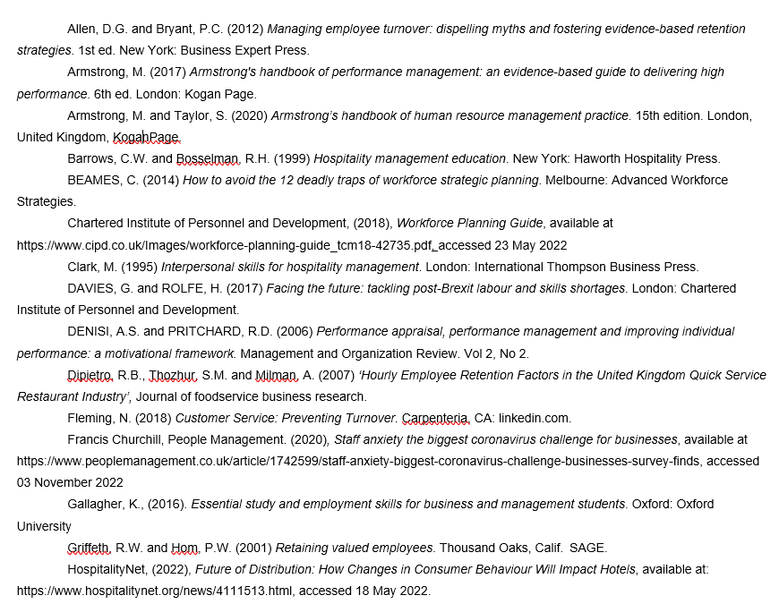
Reference list:



