Component 1:
Comprehensive Analyses of Knowledge Management in Airbus and British Airways

Kamil Lenczowski
Student ID: 2120445

BMSW5106 - KNOWLEDGE AND INFORMATION MANAGEMENT SKILLS FOR THE WORKPLACE
University of Wales Trinity Saint David

Contents
Introduction 2
Organisational overview 3
Airbus 3
British Airways 4
TOWS analysis 5
Application of Porter's Five Forces Model 8
Critical Evaluation of Knowledge Management System 10
Recommendations 19
Conclusion 20
References 21
Appendix 27

Introduction

Knowledge management involves systematically creating, sharing, using, and preserving information within an organisation. It is a vital tool that helps businesses streamline their processes, improve decision-making, encourage innovation, and maintain a competitive edge. Prieto R. Knowledge Management (2022).
This report focuses on evaluating the knowledge management strategies at Airbus and British Airways. These companies operate as two giants in their respective fields and offer valuable insights into how effective knowledge management contributes to their ongoing success.
In the contemporary business landscape, the effective management of knowledge assumes a pivotal role for companies as they navigate the abundance of available resources. This report delves into the realm of knowledge management and its essential role in modern organisations. The primary aim is to explore how industry leaders, Airbus and British Airways, handle knowledge management and provide suggestions for improvement
This study involves a comprehensive analysis of Knowledge Management components, including strengths, weaknesses, opportunities, and potential threats (TOWS analysis), all within the context of knowledge management. It also looks at the Knowledge Management (KM) value chain, explaining how knowledge is created, shared, and used within these organisations. The role of technology in supporting their Knowledge Management efforts will be explored. Additionally, Porter’s Five Forces are analysed as a framework for examining firms' value in the field of business strategy and analysis.
.

Organisational overview

Airbus
Airbus is a leading company that manufactures aeroplanes, helicopters, and equipment for defence and space. They have been in business for 50 years and have achieved many milestones. In the past, they made the first two-engine wide-body aeroplane and introduced new technology in the A320 model. They also produced numerous fighter jet models. In recent years, they made the A380, a giant passenger plane, and helped with space missions. They also developed planes that use less fuel. All of this happened because of good leaders like Tom Enders. Airbus website (2023).
Airbus works closely with thousands of partners and suppliers worldwide, who provide everything from aeroplane parts to office equipment. G.J.Wolf The Critical Communications Review (2023).
They value transparency, trust, and reliability in these relationships. Airbus spends a great amount of money on these suppliers, around €49.6 billion, which is a big part of their revenue. They aim to work together with suppliers who share their values, and they prefer creative and innovative solutions.
Airbus also insists on honesty and good business practices. They ask their suppliers to follow rules about ethics and sustainability in their supply chain. Airbus and its suppliers work together to make sure they do business with integrity.
“Airbus seeks partners and suppliers who share the company’s values. Transparency and trust are essential ingredients to work for the Airbus team. Partners and suppliers will need a proven track record of operational reliability and delivering on shared commitments. In particular, Airbus looks for partners who are ahead of the game, offering creative, innovative and digital solutions in a complex environment. This ensures Airbus provides first-class qualitative services to all of its customers.” Airbus Website (2023).

British Airways
British Airways, often called BA, is a famous British airline with a long history. In 1974, two national airlines, British Overseas Airways Corporation (BOAC) and British European Airways (BEA) joined forces to start the airline. On 11th of February 1987 British Airways changed from being owned by the government to becoming a privately-owned airline. This marked a major shift in how the company would operate moving forward.
The process of making British Airways private was announced in 1979, and it took eight years to happen. It was not easy because there were many challenges like making changes, dealing with legal issues, and sorting out schedules. During this time, the reasons for privatisation also changed as things went along. Cozmuta, Adrian Selling The World's Favourite Airline: British Airways privatisation and the motives behind it (2021).
British Airways embraces diversity, fair opportunities for everyone, and supports their employees' well-being. They aim to have a presence of women and people from various cultural backgrounds in leading roles. British Airways also cares about the planet, working to reduce pollution and waste. They are a company that values fairness and inclusivity, employee happiness, and a greener world. British Airlines website (2023).
The company emphasises the importance of a healthy environment. They started to offer their passengers eco-friendly choices in regard to materials used in their services. They also partnered to develop cleaner plane fuel, reducing their environmental impact and carbon footprint. Additionally, they reduced plastic usage and launched the BA Better World Community Fund to support both passengers and the environment. Sustainability Report (2022).

TOWS analysis

TOWS Analysis is a strategic tool that extends the concepts of SWOT Analysis. It combines internal strengths and weaknesses with external opportunities and threats to create specific strategies for an entity. TOWS Analysis enhances critical thinking and is valuable for individuals and businesses in making informed decisions and crafting effective strategies in a dynamic environment. Understanding how to conduct a TOWS Analysis can bring substantial benefits.
For employees, it enhances their ability to contribute effectively to their organisation, while business owners can significantly improve their operations.

This analysis also stimulates critical thinking, serving as an excellent mental exercise. Even if you are a student or not directly involved in the business field, having some familiarity with how businesses develop and execute strategies can be valuable. A.Monin ( Nov 2021).

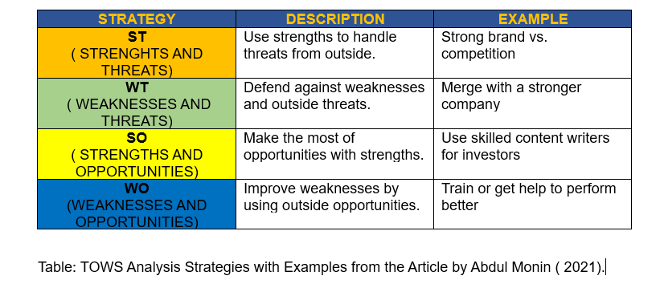
Table1 TOWS Analyses

This report applies the aforementioned TOWS analysis framework to the two companies being examined, Airbus and British Airways. The following table provides insight into how these organisations can utilise their strengths, address internal weaknesses, capitalise on opportunities, and safeguard against potential threats to their knowledge management efforts.
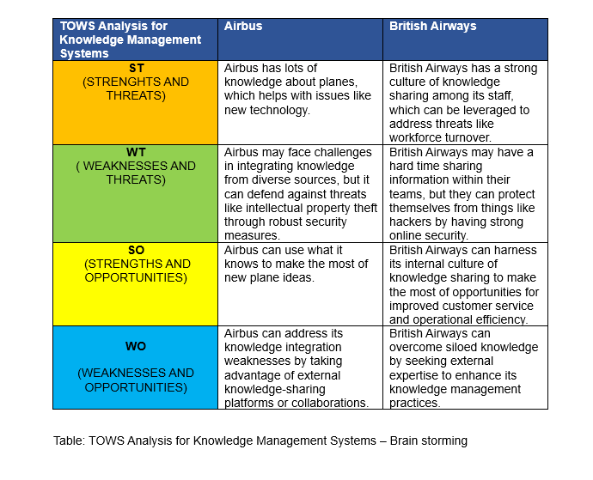
Table 2 TOWS ANALYSIS -BRAIN STORMING
This table shows how Airbus and British Airways use their strengths to tackle problems and protect themselves from threats. This allows them to excel in their fields and predict potential difficulties.
When examining the TOWS analyses of Airbus and British Airways, one can observe the similarities and differences in their approach to knowledge management within their operations Similarities:

Both Airbus and British Airways appear to value the importance of knowledge management and collaboration in problem-solving and addressing threats.
Both companies focus on safeguarding against threats, although in different ways: Airbus emphasises intellectual property protection, while British Airways focuses on online security.
Both companies see opportunities to leverage their strengths: Airbus in developing new ideas related to aircraft, and British Airways in improving customer service and operational efficiency.
Differences:

Airbus places emphasis on integrating knowledge from diverse sources and leverages external partners and knowledge-sharing platforms.
British Airways focuses on fostering an internal culture of knowledge sharing within teams to address threats related to employee turnover and enhance customer service.
In summary, both companies value knowledge management and threat mitigation but differ in their approaches to knowledge integration and utilising internal knowledge-sharing culture.

Application of Porter's Five Forces Model

Porter's Five Forces, a model developed by Harvard Business School professor Michael E. Porter, helps businesses understand their competitive environment. It identifies five key factors shaping every industry:
- New Entrants – refers to the likelihood of competition entering the market and threatening the business’ established position. An industry with high barrier of entry is ideal as it makes it less likely to happen.
- Suppliers’ Power – describes suppliers’ ability to affect the cost of inputs and how dependent the company is on their suppliers.
- Customers’ Power – how much power the customer base has to affect the nature of business, negotiate for lower prices and better buying conditions. It is affected by the size and significance of each customer.
- Substitute Products – how likely it is for a replacement product or service to appear from a competition. Companies operating on a market with little or no substitutes (monopoly) have more power to dictate higher prices and seek more favourable terms.
- Competitive Rivalry – presence of competing firms on the market. Customers seek out alternate sources of goods or services if they can get them somewhere else at lower prices or higher quality. Low level of competition allows the company to exert a higher level of control over their business. G. Scott (2023).

The following are examples of how these principles apply to Airbus.
New Entrants: Entering the aerospace industry is challenging due to high barriers like financial investment and regulatory obstacles. The threat from new entrants is minimal.
Suppliers power: Airbus relies on 7,700 global suppliers, including major companies like 3M, SIEMENS, Honeywell, and Rolls Royce. Their bargaining power is low, primarily due to Airbus's status as a major buyer.
Customer power: Airlines have moderate bargaining power in the aerospace industry. Airbus, along with a few competitors, provides high-quality, sought-after aircraft, which diminishes customer bargaining power.
Substitute products: The aerospace industry faces a low threat of substitute products, with Boeing and Bombardier as primary competitors offering similar quality. Airbus's strong performance, quality, technology, and timely delivery reduce this threat.
Competitive Rivalry: Intense competition exists among Airbus, Boeing, Bombardier, Embraer, and others, with quality and brand image as key competitive factors. A. Pratap (2017).
This template of these five principles can be applied to any company and used to asses its business environment, including the second firm being examined in this paper, British Airways.

Threat of New Entrants: British Airways encounters a limited threat from new entrants due to high capital requirements, regulatory barriers, customer loyalty, and restricted access to distribution channels. To address this, they can invest in customer relationship management and innovation.
Bargaining Power of Suppliers: British Airways can mitigate supplier power by diversifying suppliers, establishing long-term contracts, and considering alternative production methods.
Bargaining Power of Buyers: To reduce buyer power, British Airways can diversify their customer base, employ effective marketing strategies, foster customer loyalty, and prioritise customer needs
Threat of Substitute Products or Services: British Airways can reduce the threat of substitute products by highlighting their unique value, customer experience, and high switching costs.
Rivalry among Existing Firms: Low rivalry occurs when there are few competitors, market growth, and high switching costs. British Airways can strengthen customer relationships and explore new market segments. H. Zander (2018).

Critical Evaluation of Knowledge Management System
“People have always passed their accumulated knowledge and commercial wisdom on to future generations by telling stories about their thoughts, work and experiences. Now, as in the past, people use face-to-face and ’’hands-on’’ methods to convey their ’’know how’’ or tacit knowledge to others” E.A. Smith Journal of Knowledge Management (2004 ).
This human tradition of knowledge sharing remains a fundamental aspect of organisational learning and growth. However, in today's rapidly evolving and highly competitive business landscape, traditional knowledge-sharing methods are often insufficient to meet the demands of the modern enterprise. According to the Journal of Knowledge Management (2004), the knowledge that has been always passed to others creates a cycle. Repetitive movements from possessing information to decoding information to rely on outcomes have become crucial for organisations.
It has been proven that knowledge transfer (KT) actually helps organisations.
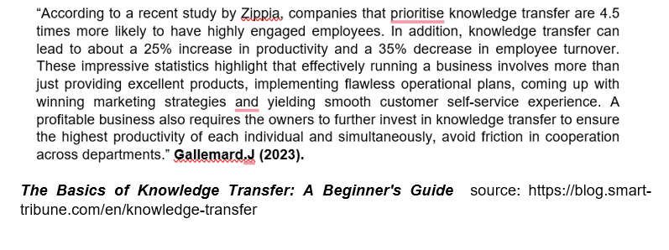 Sharing knowledge within a company is important. It makes employees happier, helps them work better, makes them more likely to stay long-term, and makes it easier for different parts of the company to cooperate. Therefore, investing in knowledge-sharing is a crucial move for any business.
In today's fast-paced business world, the most successful businesses are always on the lookout for ways to improve their operations and keep customers satisfied. Over the years, Airbus has employed multiple Knowledge Management tools to help them achieve this goal.
Some of the tools in use are:
- Einstein CRM by Salesforce
- Azure Cognitive Services by Microsoft AI and Research Team
- Anomaly Detector by AMS System

To do this, they decided to use a tool called CRM.
Airbus uses Salesforce's artificial intelligence solution, Einstein. This tool analyses past customer behaviours, such as purchase history and support interactions to make predictions and recommendations aimed at improving the user experience. This shift places a strong focus on customer satisfaction and engagement.
Customers now expect personalised and integrated experiences from the brands they interact with. They no longer tolerate disconnected or random interactions with businesses. In other words, companies need to provide cohesive and tailored interactions across all channels to meet these evolving customer expectations. Martin Kihn (2019)

Salesforce is a widely used cloud-based CRM platform known for its flexibility and scalability. It offers a range of features for managing customer relationships, sales, and marketing.
Airbus is committed to transparency and collaboration with its stakeholders. In line with its Knowledge Management (KM) strategy, the company has integrated Azure Cognitive Services as a transformative tool. This strategic decision aligns with Airbus's mission to deliver cutting-edge solutions to aerospace and defence customers, with a focus on pilot training and predictive maintenance for both civilian and military aircraft. Marcel Rummens Airbus (December 15, 2020 ).
They use this tool mainly for two things: training pilots and predicting maintenance issues for planes used by both regular and military customers.
For pilot training, they have made it easier with chatbots that use artificial intelligence. These chatbots help new pilots study and understand their materials. The best part is, that pilots can use them on their mobile devices, making learning more convenient. Airbus has also taken extra steps to keep this system secure.
On the other hand, for predicting maintenance needs, they have been using a service called Anomaly Detector. This tool helps Airbus analyse data from planes to find problems before they become serious. It also speeds up the process of creating solutions, saving time.
The people who benefit the most from these changes are pilots who can access their training materials easily and the teams responsible for plane maintenance. This makes flying safer and more efficient. Airbus is using these innovations to stay ahead in the aerospace industry and use the use of all the data collected wisely.
Airbus had a problem with employees not showing up for work (absenteeism) in their UK factories. This was causing issues because they could not meet their production demands. To fix this, they came up with a system called the Absence Management System (AMS). Airbus (2023).
The AMS is Airbus’ response to the problems they indicated in recent publications, this company revealed huge opportunities on how they can fill the gap in data, come up with a solution, and create a tool to manage that information efficiently.
This highlights Airbus's proactive approach to tackle the issue and how important is for this company to react to collected data and come up with solutions.
The Absence Management System is a computer-based solution that streamlines the management of employee absences. It consists of several key stages:

Step 1: Identifying the Challenge
Airbus noticed that many employees were missing work, causing production issues. This is the starting point, where Airbus identified a problem, a fundamental KM principle.

Step 2: Collecting Data
Airbus began collecting information about why employees were absent, including reasons, how long they were gone, and when they would return.

Step 3: Analysing the Data
Airbus carefully examined the collected data to discover patterns and reasons behind absenteeism.
This analysis is like studying the knowledge to find insights, aligning with KM practices.

Step 4: Using Data for Decision-Making
Using what they learned from the data, Airbus made informed decisions to tackle the absenteeism issue.
This step and others link to the DMAIC process and similarly works the same way as KM stands for. Sarah Laoyan (January 2023).

Step 5: Continuous Monitoring
Airbus did not stop there. They kept watching the data to see if their solutions were effective and made adjustments when needed.
Continuous monitoring and learning from data is a core part of KM for ongoing improvement. Emidio Amadebai (2023).
Collecting data is like gathering knowledge to understand a problem better, which is proven in Thematic analysis and align with KM. Swami Gurunand Jnanathapaswi (2021).

Managing process improvements is pivotal for all companies. This whole process matters because it helps Airbus understand why employees miss work and fix the problem.
It highlights the importance of using data for decision-making, which is a KM best practice.
Airbus's approach has led to fewer absent employees and smoother operations, proving that using data effectively can bring positive results.
This highlights the practical benefits of employing KM principles in solving real-world challenges.

This report also explores how British Airways uses clever knowledge to make flying safe and efficient. They focus on safety and training their pilots with smart ideas. British Airways is a great example of how to use Knowledge Management to strengthen the performance of employees.
British Airways is a well-known airline that has found success by using data about its customers in a smart way.
Some of the KM tools in use at British Airways are:

- TCRM by Teradata
- TABLEAU by Teradata

In the 1990s, British Airways set up a special team to focus on keeping good relationships with their customers. This team started using computer tools like SAS and Business Objects to understand who their customers were. A big change happened when they started using a tool called Teradata CRM (TCRM). This helped them understand their customers even better and made things faster and easier. This new way of operation was great for British Airways. It helped them send messages to customers in a more personal way, saved them money, made their work more efficient and helped more customers.
British Airways used this new system to deal with problems like strikes at the airport. They sent emails to customers quickly to apologise and help them stay informed. They also used it to run promotions and special offers for customers.
British Airways wants to use their smart data system, TCRM, not just for flights but also for vacations and holidays. They aim to send customers highly personalised messages. These messages will be tailored to what each customer likes and needs. They plan to check if this personalised approach works well by measuring things like customer satisfaction and how people respond to these messages. This way, they can see if their efforts are successful and if they should keep doing it. MyCustomer Newsdesk (2004).
British Airways has harnessed the power of customer data to achieve remarkable success. By leveraging this data intelligently, they have not only achieved cost savings but also enhanced operational efficiency. Furthermore, their customers have benefited from more personalised and tailored services. This strategic use of data has not only streamlined their operations but has also allowed them to provide a higher level of service and satisfaction to their passengers. In essence, British Airways has demonstrated how smart data utilisation can lead to a win-win situation for both the airline and its customers.
British Airways is strongly interested in using a tool called Tableau for data analysis. According to Jamie Whitehorn, an expert in Tableau working within the airline company, this software acts like a 'data detective' – it finds and cleans data, and then creates easy-to-understand charts and graphs that others can learn from.
According to the Spec India article Tableau Developer: Roles, Responsibilities, Skills, And Scope,( January 4, 2021), there are specific tasks to be done in regards to using the tableau.
Tableau is a leading data visualisation software company headquartered in Washington, United States. It offers a comprehensive suite of services and products that enable users to interact with data and create meaningful visual representations. With Tableau's user-friendly interface, both technical and non-technical users can leverage its capabilities. SPEC INDIA Tableau Developer: Roles, Responsibilities, Skills, And Scope,( January 4, 2021).

Nowadays, the world demands information and data flow to be easy to understand. The purpose of creating a tableau is to improve as many sectors as possible, sections or gaps to be filled. The report will focus on the elements which have been highlighted above.
Data Visualisation: Tableau is designed to make data visually comprehensible. It enables users to create interactive visualisations from their data, such as bar charts, line graphs, scatter plots, heat maps, and more. These visualisations help users understand complex data at a glance. Batt.S, Grealiss T, Harmon.O , Tomolonis. P. Learning Tableau: A data visualization tool (2020).
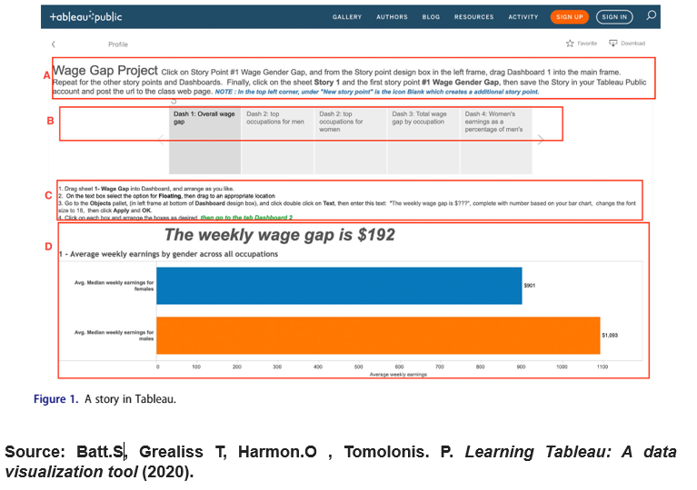
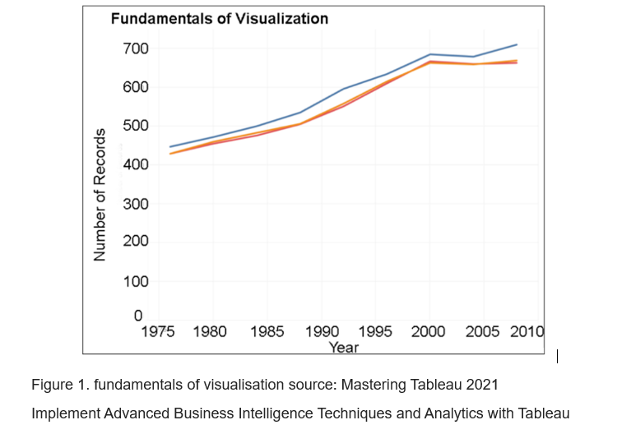
Data Analysis: Tableau provides powerful analytical capabilities, allowing users to explore data, identify trends, and make data-driven decisions. You can filter, sort, and drill down into data to discover valuable insights.
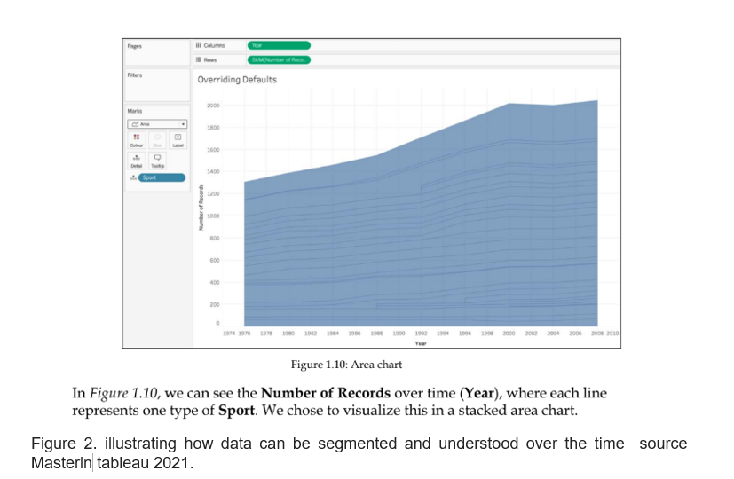Business Intelligence (BI): Tableau is widely used for business intelligence. It helps organisations analyse data to make informed decisions, track key performance indicators (KPIs), and monitor business performance in real-time. Dee Naidoo 5 Great Tableau Dashboard Examples to Try out Today (2022).
Reporting: Users can create reports and dashboards that display key data points and metrics. These reports can be customized and shared with others, making it easier to communicate data-driven insights. Vishal Agrawal Building Tableau Reports: A Comprehensive Guide (2023).
Data Connection: Tableau can connect to a wide range of data sources, including databases, spreadsheets, cloud services, and more. This enables users to work with data from various platforms. David Taylor Tableau Data Connections to Databases and Multiple Sources (2023).
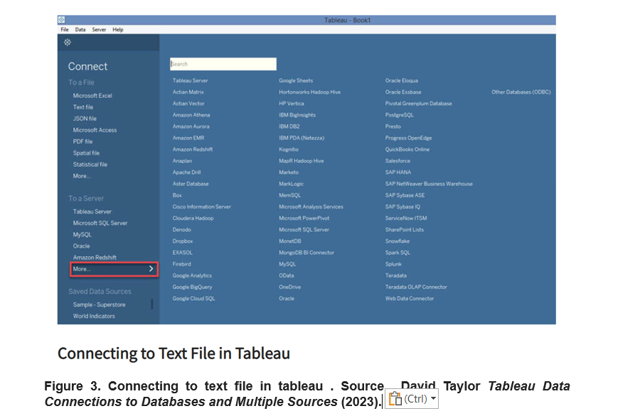

Interactive Dashboards: Tableau allows users to build interactive dashboards where they can explore data dynamically. Users can click on elements in the dashboard to see details and switch between different views.
Real-Time Data: It supports real-time data streaming and integration, making it suitable for monitoring and reacting to data changes as they happen.

Collaboration: Tableau offers collaboration features that allow teams to work on data projects together, share insights, and discuss findings. (Tableau community).
Decision Support: Tableau is a valuable tool for executives and decision-makers as it provides clear, concise, and visually appealing data presentations to guide strategic choices.
Data Storytelling: It enables users to create data stories by combining visualisations, explanations, and narratives to convey the meaning behind the data effectively.

In a world where information holds such significance, British Airways using Tableau shows that they want to get better at using and communicating data. By using Tableau, British Airways aims to make smarter decisions, runs their business smoother, and understand their customers better. This way, they can provide superior service, find new opportunities to grow, and keep up with what is happening in the airline industry.

Recommendations

Based on previously examined data and facts about these two firms, there are several recommendations to be made regarding there operations going forward.
For Airbus:
Use Data Wisely: Keep using smart computers and data to make flying safer and help train pilots. Stay updated on new technology.
Be Ready for Surprises: Make plans to handle unexpected challenges, like sudden problems or more competition. Be flexible and ready to change.
Work Well with Partners: Keep good relationships with suppliers who share your values and look for new and creative solutions together.
Take Care of the Earth: Keep their promise to use eco-friendly fuel and tell passengers about their efforts to protect the environment.
Understand Customers: Share important information with customers to make their experience better. Learn from other airlines to make their service even better.

For British Airways:
Focus on Passengers: Use data to understand what passengers like and give them a better experience. Keep checking if their efforts are working.
Protect the Planet: Keep using cleaner fuel and reduce plastic. Tell passengers about their efforts to help the environment.
Help Communities: Give back to local communities and show they care about the world around them.
Make Employees Happy: Fix employee issues quickly to keep them happy, which leads to better service.
Adapt with Data: Use real-time data tools to watch and quickly change how they work for better results.
Share What They Know: Encourage employees to share their knowledge to work better together and improve the services.

Conclusion

This report provides a comprehensive analysis of knowledge management and business strategies in two industry giants, Airbus and British Airways. Knowledge management plays a pivotal role in enhancing operational efficiency, fostering innovation, and ensuring customer satisfaction, all of which contribute to long-term success. It also explains the framework of Porters Five Forces and applies it to both firms.

Airbus, a key player in the aerospace sector, harness cutting-edge technologies such as Salesforce CRM, Azure Cognitive Services, and the Anomaly Detector to maintain safety, optimise maintenance, and streamline pilot training. Their Absence Management System exemplifies the power of data-driven problem-solving and continuous improvement.
British Airways, a renowned airline, leverages tools like Tableau and TCRM to deliver highly personalised services to passengers, underscoring the importance of data utilisation.

The recommendations for both companies underscore the significance of informed decision-making, adaptability, collaboration, and customer-centricity. Furthermore, they are encouraged to maintain their focus on sustainability, employee well-being, and continuous learning from data as it has been proven that these tactics increase growth potential and allow staying competitive.
In a dynamic business landscape, knowledge management remains a cornerstone for organisations striving to excel and lead in their respective industries. Airbus and British Airways epitomise how strategic knowledge management practices lead to competitive advantages, customer-centric service, and corporate responsibility. By consistently applying these principles, both companies can secure their positions as industry leaders and serve as role models for knowledge-driven excellence.

References

Agrawal, V. (2023) Building Tableau Reports: A Comprehensive Guide, Hevo, available at: https://hevodata.com/learn/tableau-report/
Amadebai, E. (2022) 13 Reasons Why Data Is Important in Decision Making, Analytics for Decision, available at: https://www.analyticsfordecisions.com/data-is-important-in-decision-making/
Anjum, Najam. (2017). Knowledge and Change Management Dilemma at Airbus. Abasyn Journal of Social Sciences. 10., available at: https://www.researchgate.net/publication/322273241_Knowledge_and_Change_Management_Dilemma_at_Airbus
Anonymous (2004) British Airways CRM Case Study, My Customer, available at: https://www.mycustomer.com/marketing/strategy/british-airways-crm-case-study
Anonymous (2017) Airbus Selects Salesforce to Put Customers at the Center of its Business, Market Screener, available at: https://www.marketscreener.com/quote/stock/SALESFORCE-COM-INC-12180/news/Airbus-Selects-Salesforce-to-Put-Customers-at-the-Center-of-its-Business-35053514/
Anonymous (2017) Salesforce Has Been Selected by Airbus to Put Customers at the Center of its Business, Salesforce, available at:https://www.salesforce.com/news/press-releases/2017/06/21/salesforce-has-been-selected-by-airbus-to-put-customers-at-the-center-of-its-business/
Anonymous (2018) Airbus consolidates its ecosystem thanks to digital technology, Rethink Work, available at: https://www.konicaminolta.eu/eu-en/rethink-work/business/airbus-consolidates-its-ecosystem-thanks-to-digital-technology
Anonymous (2018) Big Data: Airbus is mining the wealth of knowledge for aviation, Airbus, available at: https://www.airbus.com/en/who-we-are/our-worldwide-presence/airbus-in-europe/germany/welcome-to-airbus-hubberlin/public-affairs-berlin-digitalisation
Anonymous (2018) Website security, British Airways, available at: https://www.britishairways.com/en-gb/information/legal/website-security
Anonymous (2020) Airbus accelerates innovation with Azure Cognitive Services, Microsoft, available at: https://customers.microsoft.com/en-us/story/858578-airbus-defense-and-intelligence-azure
Anonymous (2020) British Airways reveals ambitious new target to remove a quarter of a billion items of single-use plastic from flights by the end of 2020, British Airways, available at: https://mediacentre.britishairways.com/pressrelease/details/12116
Anonymous (2020) Introducing our brand new Airbus Services Store, Airbus, available at: https://aircraft.airbus.com/en/introducing-our-brand-new-airbus-services-store
Anonymous (2020) New aircraft “e-Delivery” process assures health & safety for customers and Airbus employees, and enables business continuity, Airbus, available at: https://www.airbus.com/en/newsroom/press-releases/2020-04-quick-news-april-2020
Anonymous (2021) Airbus Annual Report, Airbus, available at: https://www.airbus.com/sites/g/files/jlcbta136/files/2022-04/Airbus%20Annual%20Report%20Overview%202021.pdf
Anonymous (2021) British Airways and Phillips 66 agree to first-ever UK-produced sustainable aviation fuel supply, British Airways, available at: https://mediacentre.britishairways.com/pressrelease/details/13592
Anonymous (2021) Tableau Developer: Roles, Responsibilities, Skills, And Scope, Spec India, available at: https://www.spec-india.com/blog/tableau-developer
Anonymous (2023) AI Anomaly Detector, Microsoft, available at: https://azure.microsoft.com/en-us/products/ai-services/ai-anomaly-detector/
Anonymous (2023) Airbus Competitors, Comparably, available at: https://www.comparably.com/companies/airbus/competitors
Anonymous (2023) Airbus, Black light software, available at: https://www.blacklightsoftware.com/industries/aerospace/airbus/
Anonymous (2023) British Airways takes B2B sales to a new high with smarter processes and richer insights, Salesforce, available at: https://www.salesforce.com/uk/customer-success-stories/british-airways-international/
Anonymous (2023) Supporting change that matters, British Airways Community Fund, available at: https://www.bacommunityfund.co.uk/about-us
Anonymous (2023) Sustainability Report, British Airways, available at: https://basustainabilityreport2022.co.uk/
Anonymous (2023) Who we are, Airbus, available at: https://www.airbus.com/en/who-we-are
Anonymous , (2020). BOAC (British Overseas Airways Corp.)Airline History. Available at: https://airlinehistory.co.uk/airline/boac-british-overseas-airways-corp/
Anonymous BA Better World 2022 sustainability report (2022), British Airways, available at:https://basustainabilityreport2022.co.uk/
Batt, Steven & Grealis, Tara & Harmon, Oskar & Tomolonis, Paul. (2020). Learning Tableau: A data visualization tool, The Journal of Economic Education. 51. 1-12. 10.1080/00220485.2020.1804503, available at: https://www.researchgate.net/publication/343780854_Learning_Tableau_A_data_visualization_tool
Bhargava, R. (2023) Revolutionizing Customer Experience: The AI Advantage, SAP, available at: https://news.sap.com/2023/10/ai-advantage-revolutionizing-customer-experience/
Cozmuta, A. (2021) Selling “The World's Favourite Airline”: British Airways’ privatisation and the motives behind it. Business History, (doi: 10.1080/00076791.2021.1926991), available at: https://eprints.gla.ac.uk/240788/1/240788.pdf
Eatery-Smith, M., & Lyles, M. A. (Eds.). (2011). Handbook of organizational learning and knowledge management. John Wiley & Sons, available at: https://nibmehub.com/opac-service/pdf/read/Handbook%20of%20Organizational%20Learning%20and%20Knowledge%20Management%20(2nd%20ed)%20by%20Mark%20Easterby-Smith.pdf
Ermine, Jean-Louis. (2013). A Knowledge Value Chain for Knowledge Management. Journal of Knowledge & Communication Management. 3. 85. 10.5958/j.2277-7946.3.2.008., available at: https://www.researchgate.net/publication/272731129_A_Knowledge_Value_Chain_for_Knowledge_Management
Ferreira, J., Mueller, J. and Papa, A. (2020), Strategic knowledge management: theory, practice and future challenges, Journal of Knowledge Management, Vol. 24 No. 2, pp. 121-126., available at: https://www.emerald.com/insight/content/doi/10.1108/JKM-07-2018-0461/full/html
Gallemard, J. (2023) The Basics of Knowledge Transfer: A Beginner's Guide, Smart Tribune, available at: https://blog.smart-tribune.com/en/knowledge-transfer
Hassan, M. (2022) History of CRM at British Airways, Course Hero, available at: https://www.coursehero.com/file/161095966/CRM-Group-Presentationpptx/
Jackson, S., Tozer, J. (2020) A vision for data science at British Airways, Taylor and Francis Online, available at: https://www.tandfonline.com/doi/full/10.1080/2058802X.2020.1720206
Jarvis, P. (2014). British Airways: An Illustrated History, Amberley Publishing, available at: https://www.google.co.uk/books/edition/British_Airways/wx38AwAAQBAJ?hl=en&gbpv=0
Jnanathapaswi, Swami. (2021). Thematic Analysis & Coding: An Overview of the Qualitative Paradigm. 10.6084/m9.figshare.17159249 available at: https://www.researchgate.net/publication/356924218_Thematic_Analysis_Coding_An_Overview_of_the_Qualitative_Paradigm
Kihn, M. (2019) Better Customer Data Management for Personalized Customer Engagement, Salesforce, available at: https://www.salesforce.com/blog/customer-360-data-personalization/
Laoyan, S. (2023) 7 types of process improvement methodologies you should know about, Asana, available at: https://asana.com/resources/process-improvement-methodologies
Malak, H. A. (2023). 11 key knowledge Management Challenges and Solutions The ECM Consultant Company. Available at: https://theecmconsultant.com/knowledge-management-challenges/
Meier, M., Baldwin, D., Strachnyi, K. (2021). Mastering Tableau 2021: Implement Advanced Business Intelligence Techniques and Analytics with Tableau, Packt Publishing, available at: https://www.google.co.uk/books/edition/Mastering_Tableau_2021/JhAxEAAAQBAJ?hl=en&gbpv=1
Miguens, P. (2022) “CO2llaborate”: British Airways unveils new carbon removal platform, Aviacionline, available at: https://www.aviacionline.com/2022/11/co2llaborate-british-airways-unveils-new-carbon-removal-platform/#:~:text=British%20Airways%20launched%20%E2%80%9CCO2llaborate%E2%80%9D%2C%20its%20new%20platform%20for,are%20issued%20for%20carbon%20capture%20and%20removal%20projects.
Momin, A. (2021) British Airways SWOT Analysis 2021, Pestle Analysis, available at: https://pestleanalysis.com/british-airways-swot-analysis/
Momin, A. (2021). TOWS Analysis: The Framework and How it Works in 4 Steps , Pestleanalysis.com. Available at: https://pestleanalysis.com/tows-analysis/
Naidoo, D. (2023) 5 Great Tableau Dashboard Examples to Try out Today, Udemy, available at: https://blog.udemy.com/tableau-dashboard-examples/
Oragui, D. (2023) Tacit Knowledge: Definition, Examples, and Importance, Helpjuice, available at: https://helpjuice.com/blog/tacit-knowledge
Pons, B., Rodriguez, JH., Reuzeau, F. (2022). Airbus Global Workforce Forecast (GWF). In: Laroche, H., Bieder, C., Villena-López, J. (eds) Managing Future Challenges for Safety. SpringerBriefs in Applied Sciences and Technology(). Springer, Cham., available at: https://link.springer.com/chapter/10.1007/978-3-031-07805-7_8
PRATAP,A Airbus Porter’s Five Forces Analysis (2017), CH Blog available at:https://cheshnotes.com/airbus-porters-five-forces-analysis/
Prieto, R. (2022) Knowledge Management, Research Gate, available at: https://www.researchgate.net/publication/363541812_Knowledge_Management
Schiff, A. (2020) SAP On Keeping The Customer Experience Smooth During A Time Of Chaos, Ad Exchanger, available at: https://www.adexchanger.com/strategy/sap-on-keeping-the-customer-experience-smooth-during-a-time-of-chaos/
Scott, G Porter's 5 Forces Explained and How to Use the Model (2023) ,Investopedia, available at:https://www.investopedia.com/terms/p/porter.asp
Shastri, A, (2021) Extensive SWOT Analysis of Airbus with Company Overview and Highlights, IIDE, available at: https://iide.co/case-studies/swot-analysis-of-airbus/
Staughton, J. (2023) What Are The Different Types Of Knowledge?, Science ABC, available at: https://www.scienceabc.com/eyeopeners/what-are-the-different-types-of-knowledge.html
Sullivan TM, Limaye RJ, Mitchell V, D'Adamo M, Baquet Z. (2015) Leveraging the Power of Knowledge Management to Transform Global Health and Development, Glob Health Sci Pract., available at: https://www.ncbi.nlm.nih.gov/pmc/articles/PMC4476855/
Sullivan, M. (2016) KM: definition, history, & current trends [Personality & TKMS series], Real KM, available at: https://realkm.com/2016/07/19/km-definition-history-current-trends-personality-tkms-series-part-2/
Taylor, D. (2023) Tableau Data Connections to Databases and Multiple Sources, Guru99, available at: https://www.guru99.com/tableau-data-connections.html
Tckhakaia, Ekaterina & Cabras, Ignazio & Rodrigues, Sergio. (2015). KNOWLEDGE MANAGEMENT IN AIRLINE INDUSTRY: CASE STUDY FROM THE BRITISH AIRWAYS, available at: https://www.researchgate.net/publication/274072963_KNOWLEDGE_MANAGEMENT_IN_AIRLINE_INDUSTRY_CASE_STUDY_FROM_THE_BRITISH_AIRWAYS
Tckhakaia, Ekaterina & Cabras, Ignazio & Rodrigues, Sergio. (2015). Knowledge Management in the Airline Industry: A Case Study from British Airways, available at: https://www.researchgate.net/publication/274072963_KNOWLEDGE_MANAGEMENT_IN_AIRLINE_INDUSTRY_CASE_STUDY_FROM_THE_BRITISH_AIRWAYS
Wolf, G. J. (2023, May 24). Airbus and Cellnex Strengthen Partnership for Mission-Critical Communications. The Critical Communications Review. Available at: https://www.criticalcommunicationsreview.com/ccr/news/110389/airbus-and-cellnex-strengthen-partnership-for-mission-critical-communications
Woodward, S. N. (2022) Business organization, Britannica, available at: https://www.britannica.com/money/topic/business-organization
Zander, H British Airways Porter Five Forces Analysis (2022),CASE 48 available at :https://www.case48.com/porter-analysis/13877-British-Airways

Appendix

Anonymous (2019) Global Workforce Forecast, Airbus, available at: https://www.airbus.com/sites/g/files/jlcbta136/files/2021-10/Global_Workforce_Forecast_Release2_2019-2029.pdf
Anonymous (2020) British Airways: Our Tableau Journey from Corporate Outlier to Corporate Mainstream, Tableau, available at: https://www.youtube.com/watch?v=PlKRiRTd72U
Anonymous (2020) Sales Cloud Einstein Demo | Salesforce, Salesforce, available at: https://www.youtube.com/watch?v=Ddj_-CPCsCM
Anonymous (2023) Airbus, Comparably, available at: https://www.comparably.com/companies/airbus
Anonymous (2023) Skywise Solutions, Airbus, available at: https://aircraft.airbus.com/en/services/enhance/skywise/skywise-solutions
Anonymous (2023) The life cycle of an aircraft, Airbus, available at: https://www.airbus.com/en/products-services/commercial-aircraft/the-life-cycle-of-an-aircraft
Whitehornm J. (2023) Jamie Whitehorn, Linked in, available at: https://www.linkedin.com/in/jwhitehorn/

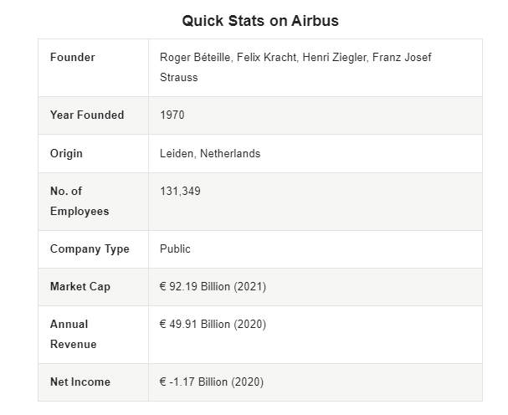
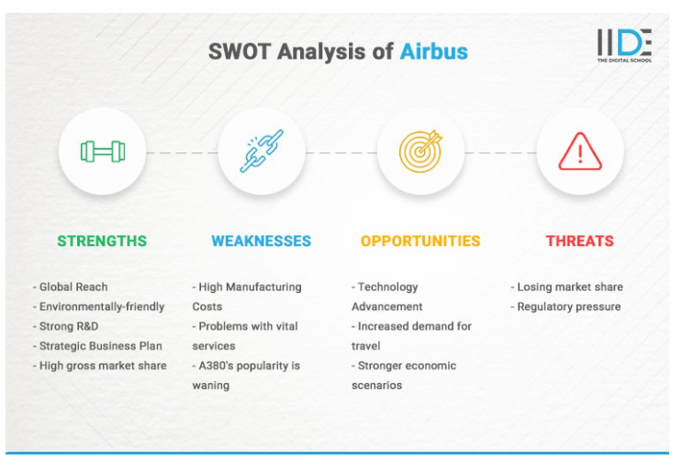
TOWS Analysis for Knowledge Management Systems | Airbus | British Airways
ST  (STRENGHTS AND THREATS) | Airbus has lots of knowledge about planes, which helps with issues like new technology. | British Airways has a strong culture of knowledge sharing among its staff, which can be leveraged to address threats like workforce turnover.
WT  ( WEAKNESSES AND THREATS) | Airbus may face challenges in integrating knowledge from diverse sources, but it can defend against threats like intellectual property theft through robust security measures. | British Airways may have a hard time sharing information within their teams, but they can protect themselves from things like hackers by having strong online security.
SO  (STRENGTHS AND OPPORTUNITIES) | Airbus can use what it knows to make the most of new plane ideas. | British Airways can harness its internal culture of knowledge sharing to make the most of opportunities for improved customer service and operational efficiency.
WO  (WEAKNESSES AND OPPORTUNITIES) | Airbus can address its knowledge integration weaknesses by taking advantage of external knowledge-sharing platforms or collaborations. | British Airways can overcome siloed knowledge by seeking external expertise to enhance its knowledge management practices.

Table: TOWS Analysis for Knowledge Management Systems – Brain storming
Strengths and Threats (ST):
Airbus: Uses its plane knowledge to deal with new technology challenges.
British Airways: Encourages staff knowledge sharing to combat workforce turnover.
Weaknesses and Threats (WT):

Airbus: Addresses challenges in knowledge integration and prevents theft with strong security.
British Airways: Manages team information sharing issues and defends against hackers with robust online security.
Strengths and Opportunities (SO):

Airbus: Maximizes knowledge for aerospace innovation.
British Airways: Enhances customer service and efficiency through internal knowledge sharing.

Weaknesses and Opportunities (WO):

Airbus: Collaborates with external platforms to overcome knowledge integration issues.
British Airways: Seeks external expertise to improve knowledge management and break down knowledge silos.

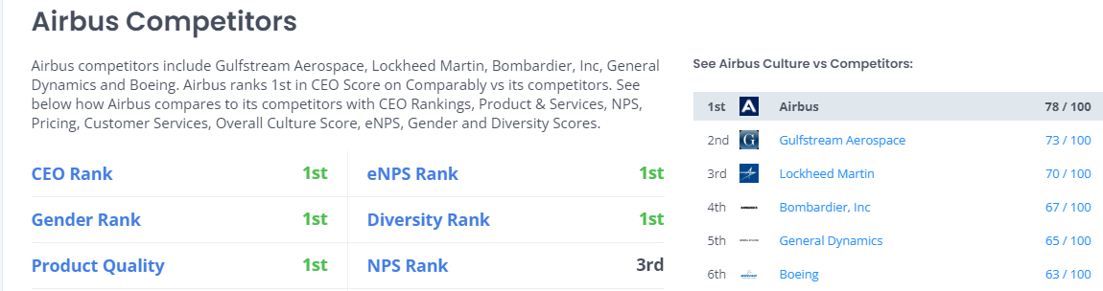
British Airways also launched the CO2llaborate platform. This is a tool that helps passengers make eco-friendly choices when they fly. Passengers can choose to use products that are better for the environment, like Sustainable Aviation Fuel or offsets. It is a form of giving passengers the power to make greener decisions while traveling. British Airways website (2023).
The airline did not stop there. They also made a deal with some of their partners to work on creating even better and cleaner fuel for their planes in the future. This shows their commitment to reducing the impact on the planet.
They also focused on using less plastic on their flights. They replaced plastic with eco-friendly alternatives for stirrers, packaging, and wrapping, while also using 50% recycled plastic for water bottles and eliminating plastic bags for onboard retail. This is great for the environment. But it is not just about the environment. British Airways cares about communities too. They started a fund called the BA Better World Community Fund. This fund raised a great amount of money and helped many groups in the UK that care about the environment and communities. So, they are not only thinking about their passengers but also about the world around them.

