
APPENDIX GA36a

LEVEL 4 ASSESSMENT SPECIFICATION

Student name: |  | Student ID number:
Programme: | BSc (Hons) Environmental Conservation
Module: | Environmental Biology
Module code: | M4X01940 | Contribution to Overall Module Assessment (%): | 50%
Lecturer: | Elanor Alun | Internal Verifier: | Prof Rhian Jenkins
Assignment Title: | Using models to design biological surveys | Word count (or equivalent): | 2000 words
Submission deadline: | 22/03/21 | Return date of provisional marks & written feedback: | 12/04/21
Submission method: | All written assessments, where practical and possible, must be submitted via Turnitin unless otherwise instructed by the Lecturer. (Please DO NOT put this assessment specification into Turnitin or it will match many similarities with other students’ submissions.)  Alternative submission method (if applicable):  Late submission of the assessment will result in a late penalty mark. Penalties for late submission: Up to one week late, maximum mark of 40%. Over one week late, 0%. Only the Extenuating Circumstances Panel may approve a change to submission dates.
Academic honesty / referencing: | Academic honesty is required. In the main body of your submission you must give credit to authors on whose research and ideas your work is based. Append to your submission a reference list that indicates the books, articles, etc. that you have used, cited or quoted in order to complete this assessment.

Module Learning Outcomes
(from module syllabus)
Upon the successful completion of this module, the student should be able to demonstrate the ability to:

- Appraise current knowledge of environment and the consequences of human intervention and natural change on the biosphere;

- Demonstrate a fundamental knowledge of the earth’s biodiversity and the earth’s ecosystems, including human distribution, population, and the effects on the natural environment.

- Convey and determine the variety and classification of organisms.

TASK DESCRIPTION

You are the new manager of Waun Tylluan, a ten-acre site in South Wales that used to be farmland but has recently been sold. The new owners have hired you to try and improve biodiversity, as the site is a rare green space in an increasingly urbanised area. A map is shown below, complete with field names included (please note this is a fictional site! Don’t waste your time trying to Google it.)
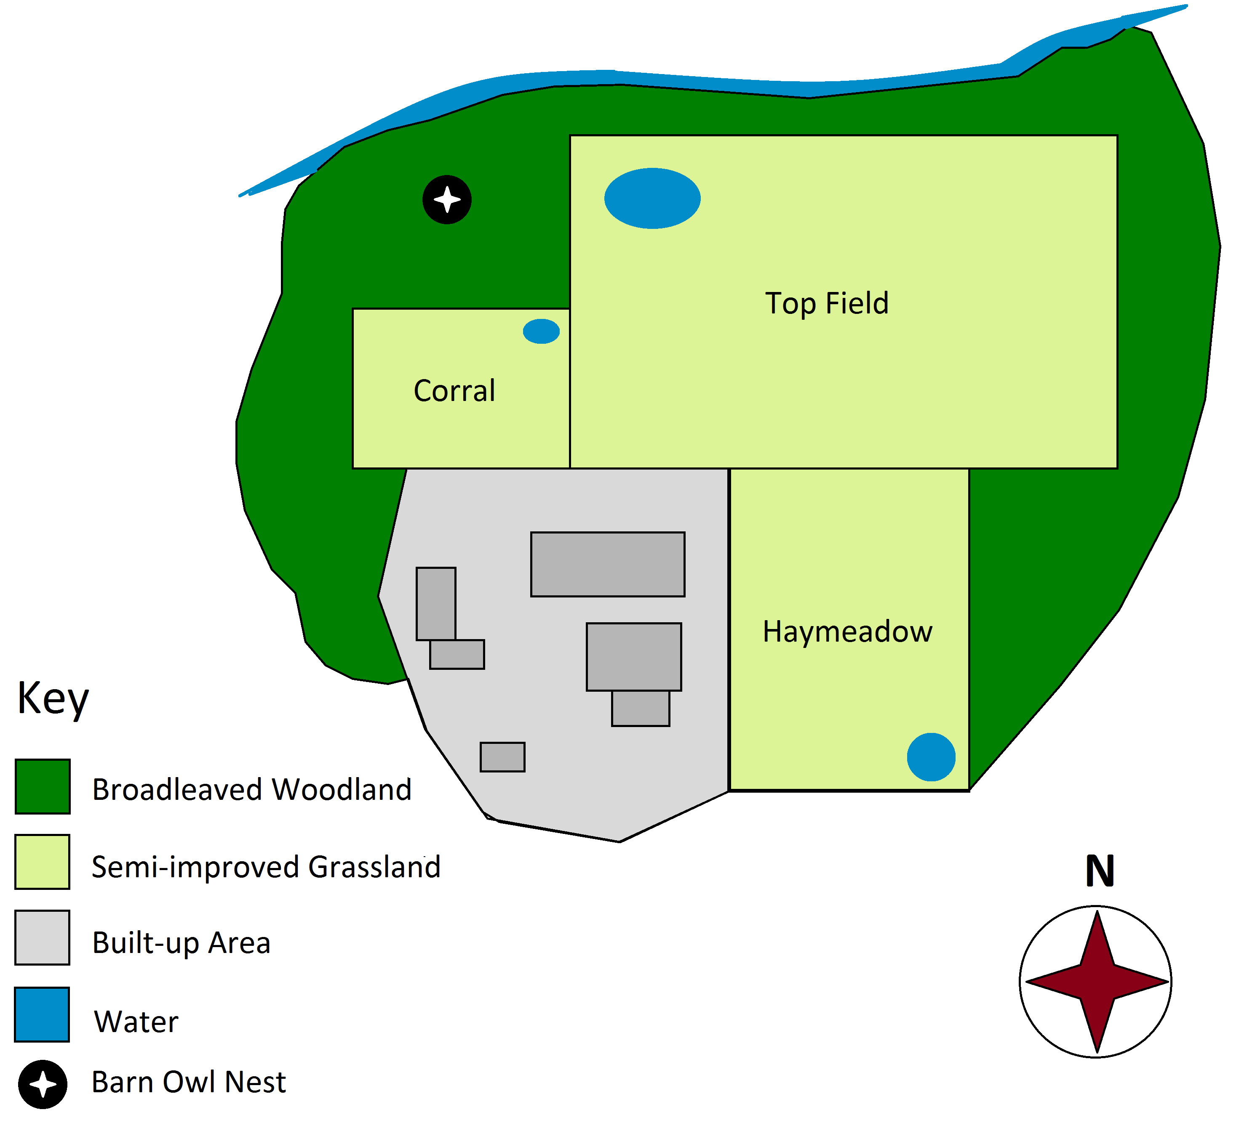
When managing a site for biodiversity, it is important to establish a baseline of data to know what organisms are present or absent from a site. You know that there is a pair of barn owls (Tyto alba) nesting in the woods, and otters (Lutra lutra) using the river that flows along the northern border. You therefore need to make certain you’re maintaining the right habitat for frogs (Rana temporaria) and field voles (Microtus agrestis) to flourish – prey species often taken by otters and barn owls respectively. You therefore decide to conduct surveys to find out your current populations. However, estimating animal populations is notoriously difficult thanks to them moving around. You therefore decide to use a model to help you design the best survey methodology.
To gather the data for this task, go to http://virtualbiologylab.org/population-ecology/ (link is available on Moodle also). For estimating tadpoles use Model 2, and for the voles use Model 3. You will be shown how to use the models in lectures, but if you need additional help, be sure to ask. You will need to explore the variables each offers (e.g. net size, trap experience, etc) and note down the results you get from each in order to choose your final methodology. You are welcome to include screenshots as you feel necessary.

Tadpoles
You have two possible methods with the tadpoles: sampling with removal, or mark/recapture. Each has advantages and disadvantages. The model will allow you to simulate both. When setting the model parameters for each of the three ponds, make sure to establish the correct pond size: the Corral pond should be small, the Top Field pond should be large, and the Haymeadow pond should be medium.
All other parameters are variables for you to explore as you wish.

Field Voles
The method you’re using is known as mark/recapture, to give an estimate of the population size.
You will need to conduct surveys in each of Waun Tylluan’s three fields: the Corral, the Top Field and the Haymeadow. For the surveys themselves, in addition to the other variables you need to choose the number and placement of the traps, and how long you’d like to set them for. Each field is a little different in terms of characteristics, however, so you will need to set the model parameters as follows:

The Corral
The smallest of the three, the Corral was formerly used – as its name suggests – to pen in cattle for the farmers to vaccinate or otherwise check them over. This means it was often subjected to heavy trampling and high manure rates. As such, it has highly varied ground cover, with some areas of bare ground and some patches of thick ruderal weeds.
Set the model to the following parameters:
- Set Pop_Size to Small
- Set Distribution to Clumped

The Top Field
The largest of the three, the Top Field saw the bulk of the grazing during the days of Waun Tylluan being a working farm. It’s got a fairly tussocky sward of varying height, although it is relatively species-poor.
Set the model to the following parameters:
- Set Pop_Size to Large
- Set Distribution to Random

The Haymeadow
As the name implies, the Haymeadow was used to grow long, herb-rich grasses and then be cut once a year to provide hay. As such, it has a species-rich mosaic, but the sward is of relatively even height throughout.
Set the model to the following parameters:
- Set Pop_Size to Medium
- Set Distribution to Random
All other parameters are variables for you to explore as you wish.

Once you have explored the possibilities on offer, construct your intended survey design. Remember to analyse your final design, and the use of the models themselves. You should be clear about the advantages and disadvantages of each. Crucially, this includes the practicalities of your final design. While surveying a field a thousand times might give you the most accurate data, it’s unlikely to be feasible for a land manager to do in practice!

Recommended structure:

Introduction: What is the aim of the experiment? Why is it important?
Methodology: Experimental description and justification of why this method is appropriate. Briefly discuss what you expect to see.
Results and Discussion: It is recommended that you tabulate your results, and then perform at least one statistical test (e.g. mean averages per variable – how close were they to the accurate number?) Your discussion should outline/explain your findings, interpret them, and then draw conclusions for your chosen survey design. Any shortcomings of the study should also be discussed here.
Conclusion: Sum up all important points.

GUIDANCE FOR Students IN THE COMPLETION OF TASKS

NOTE: The guidance offered below is linked to the five generic assessment criteria overleaf.

- Engagement with Literature Skills
Your work must be informed and supported by scholarly material that is relevant to and focused on the task(s) set. You should provide evidence that you have accessed an appropriate range of sources, which may be academic, governmental and industrial; these sources may include academic journal articles, textbooks, current news articles, organisational documents, and websites. You should consider the credibility of your sources; academic journals are normally highly credible sources while websites require careful consideration/selection and should be used sparingly. Any sources you use should be current and up-to-date, mostly published within the last five years or so, though seminal/important works in the field may be older. You must provide evidence of your research/own reading throughout your work, using a suitable referencing system, including in-text citations in the main body of your work and a reference list at the end of your work.

Guidance specific to this assessment:

You are advised to do some background research on the experimental techniques being used. How useful are models in the field? What are the advantages/disadvantages of mark/recapture, or capture with removal? Etc.

- Knowledge and Understanding Skills
At level 4, you should be able to demonstrate knowledge of the underlying concepts and principles associated with your area(s) of study. Knowledge relates to the facts, information and skills you have acquired through your learning. You demonstrate your understanding by interpreting the meaning of the facts and information (knowledge). This means that you need to select and include in your work the concepts, techniques, models, theories, etc. appropriate to the task(s) set. You should be able to explain the theories, concepts, etc. to show your understanding. Your mark/grade will also depend upon the extent to which you demonstrate your knowledge and understanding.

Guidance specific to this assessment:

You should be aware of why this particular technique is appropriate for this type of experiment, e.g. why use mark/recapture for voles?

- Cognitive and Intellectual Skills
You should be able to present, evaluate and interpret qualitative and quantitative data, in order to develop lines of argument and make sound judgements in accordance with basic theories and concepts of your subject(s) of study. You should be able to evaluate the appropriateness of different approaches to solving problems related to your area(s) of study and/or work. Your work must contain evidence of logical, analytical thinking. For example, to examine and break information down into parts, make inferences, compile, compare and contrast information. This means not just describing what! But also justifying: Why? How? When? Who? Where? At what cost? You should provide justification for your arguments and judgements using evidence that you have reflected upon the ideas of others within the subject area and that you are able to make sound judgements and arguments using data and concepts. Where relevant, alternative solutions and recommendations may be proposed.

Guidance specific to this assessment:

Some basic interpretation of the observations should be demonstrated together with the appropriate analysis.

- Practical Skills
At level 4, you should be able to apply the basic underlying concepts and principles to evaluate and interpret these within the context of your area of study. You should be able to demonstrate how the subject-related concepts and ideas relate to real world situations and/or a particular context. How do they work in practice? You will deploy models, methods, techniques, and/or theories, in that context, to assess current situations, perhaps to formulate plans or solutions to solve problems, or to create artefacts. This is likely to involve, for instance, the use of real world artefacts, examples and cases, the application of a model within an organisation and/or benchmarking one theory or organisation against others based on stated criteria.

Guidance specific to this assessment:

You will be conducting your own experiment and evaluating what you see and why. Often the results do not turn out exactly as predicted but then you must look for and articulate potential reasons why this is not the case.

- Transferable Skills for Life and Professional Practice
Your work must provide evidence of the qualities and transferable skills necessary for employment requiring the exercise of some personal responsibility. This includes demonstrating: that you can communicate the results of your study/work accurately and reliably, and with structured and coherent arguments; that you can initiate and complete tasks and procedures, whether individually and/or collaboratively; fluency of expression; clarity and effectiveness in presentation and organisation. Work should be coherent and well-structured in presentation and organisation.

Guidance specific to this assessment:

Report writing, data analysis, demonstration of model techniques all demonstrate academic skills which will be transferable to other taught modules and work outside the University.

Student FEEDBACK FORM

This section details the extent to which the assessment criteria are demonstrated by you, which in turn determines your mark. The marks available for each category of skill are shown. Lecturers will use the space provided to comment on the achievement of the task(s), including those areas in which you have performed well and areas that would benefit from development/improvement.

Generic Assessment Criteria | Marks available | Marks  awarded
1. Engagement with Literature Skills  . | 10
2. Knowledge and Understanding Skills | 15
3. Cognitive and Intellectual Skills | 30
4. Practical Application Skills | 25
5. Transferable Skills for Life and Professional Practice | 20

Assessment Mark (Assessment marks are subject to ratification at the Exam Board. These comments and marks are to give feedback on module work and are for guidance only until they are confirmed. ) | Late Submission Penalties (tick if appropriate) |  | %
 | Up to 1 week late (40% Max) |  | %
 | Over 1 week late (0%) |  | %

GENERIC ASSESSMENT CRITERIA

Level 4
In accordance with the Framework for Higher Education Qualifications, at the end of Level 4 students will be expected to have demonstrated knowledge of the basic underlying concepts and principles of a subject, and an ability to evaluate and interpret these within the context of that area of study. They should be able to present, evaluate and interpret qualitative and quantitative data in order to develop lines of argument and make sound judgements in accordance with basic theories and concepts of their subject(s) of study. They will have learned how to evaluate different approaches to solving problems, and will be able to communicate the results of their study/work accurately and reliably, and with structured and coherent arguments. They will be able to undertake further training and develop new skills within a structured and managed environment and will have the qualities and transferable skills necessary for employment requiring the exercise of some personal responsibility.

Level 4 | FAIL | MARGINAL FAIL | SATISFACTORY  (3rd / Pass) | GOOD  (2.2 / Pass) | VERY GOOD  (2.1 / Merit) | EXCELLENT  (1st / Distinction) | EXCEPTIONAL  (1st / Distinction)
Category | 0-29% | 30-39% | 40-49% | 50-59% | 60-69% | 70-84% | 85-100%
Engagement with literature (including reading, referencing,  academic conventions and  academic honesty) | Little or no evidence of reading and/or reliance on inappropriate sources.  Views and findings mostly unsupported and non-authoritative.  Referencing conventions used incoherently or largely absent. | Poor engagement with essential reading. No evidence of wider reading. Reliance on inappropriate sources, and/or indiscriminate use of sources. Heavily reliant on information gained through class contact. Inconsistent and weak use of referencing. | Engagement with a limited range of mostly relevant and credible sources but with some reliance on information gained through class contact. Some omissions and minor errors.  Referencing conventions evident though not always applied accurately or consistently. | Engagement with an appropriate range of literature, including sources retrieved independently. Some over-reliance on texts rather than other sources. Referencing may show minor inaccuracies or inconsistencies. | Engagement with a wide range of literature, including sources retrieved independently.  Selection of relevant and credible sources. Generally sound referencing, with no/very few inaccuracies or inconsistencies. | Engagement with an extensive range of relevant and credible literature. Consistently accurate application of referencing. | Exceptional engagement with an extensive range of relevant and credible literature. High-level referencing skills consistently applied.
Knowledge and understanding (Knowledge of the basic underlying concepts and principles of a subject.) | Major gaps in knowledge and understanding of the basic underlying concepts and principles of the subject matter. Inclusion of irrelevant material. Substantial inaccuracies. | Gaps in knowledge of the basic underlying concepts and principles, with flawed or superficial understanding. Some significant inaccuracies and/or irrelevant material. | Limited knowledge and understanding of the basic underlying concepts and principles within the subject area. Some elements may be missing. | Knowledge of the basic underlying concepts and principles is accurate with a good understanding of the field of study but lacks depth and/or breadth. | Competent knowledge of the basic underlying concepts and principles. Exhibits very good understanding. | Excellent knowledge and understanding of the basic underlying concepts and principles of the subject. | Exceptional, detailed knowledge and understanding of the basic underlying concepts and principles
Cognitive and intellectual skills  (Evaluate underlying concepts and principles of a subject and interpret qualitative and quantitative data in order to develop lines of argument and make sound judgements.) | Wholly or almost wholly descriptive work. Little or no evaluation of the underlying concepts and principles.  Failure to develop arguments, leading to illogical or invalid judgements. Minimal or no use of  evidence to back up views. | Largely descriptive work, with superficial evaluation of the underlying concepts and principles. Weak interpretation of data, flawed development of arguments and judgements. Information accepted uncritically, uses generalised statements made with scant evidence and unsubstantiated opinions. Ideas sometimes illogical and contradictory. | Limited attempt at evaluation of the underlying concepts and principles, tending towards description.  Can interpret qualitative and quantitative data but with some errors. Some evidence to support emerging arguments and judgements but these may be underdeveloped or with a little inconsistency / mis-interpretation. | Good evaluation of the underlying concepts and principles. Can interpret qualitative and quantitative data, with minor errors.  An emerging ability to use evidence to support the argument.  Mostly valid arguments and logical judgements. | Sound evaluation of the underlying concepts and principles. Can interpret qualitative and quantitative data accurately. Ability to devise arguments using evidence to make mostly appropriate and valid judgements. | Excellent evaluation of the underlying concepts and principles. Can interpret qualitative and quantitative data accurately and with some insight. Excellent ability to devise arguments using evidence and make appropriate and valid judgements. | Exceptional evaluation of the underlying concepts and principles based evidence. Outstanding interpretation of qualitative and quantitative data.  Exceptional ability to devise arguments using evidence and make wholly appropriate and valid judgements.
Practical skills  (Different approaches to solving problems in particular contexts.) | Limited or no use of taught, basic methods, materials, tools and/or techniques.  Little or no appreciation of the context of the application.  Very weak evidence of different approaches to problem-solving in particular contexts. | Rudimentary application of taught, basic methods, materials, tools and/or techniques but without consideration and competence. Flawed appreciation of the context of the application.  Weak evidence of different approaches to problem-solving in particular contexts. | An adequate awareness and mostly appropriate application of basic methods, materials, tools and/or techniques.  Basic appreciation of the context of the application.  Can identify problems in particular contexts and propose basic alternative approaches or solutions though there may be errors. | A good and appropriate application of basic methods, materials, tools and/or techniques.  Clear appreciation of the context of the application.  Good evidence of different approaches to problem-solving in particular contexts and proposes mostly appropriate solutions. | A very good application of a range of basic methods, materials, tools and/or techniques.  Very good consideration of the context of the application. Very good evidence of different approaches to problem-solving in particular contexts and proposes appropriate solutions. | An advanced application of a range of taught, basic methods, materials, tools and/or techniques.  The context of the application is well considered, and insightful.  Excellent evidence of different approaches to problem-solving in particular contexts and proposes appropriate solutions. | Exceptional levels of application and deployment skills in particular practical contexts. Outstanding identification of problems in particular contexts and formulation of wholly appropriate, thoughtful solutions / different approaches.
Transferable skills for life and professional practice  (Communicate the results of their study/work accurately and reliably, and with structured and coherent arguments; the qualities needed for employment requiring the exercise of some personal responsibility within a structured and managed environment.) | Work is poorly structured, disorganised, inaccurate and/or confusingly expressed. Very weak use of language and/or very inappropriate style. Failure to work effectively individual or as part of a group. Little or no evidence of the skills for employment requiring the exercise of some personal responsibility. | Work is poorly presented in a disjointed manner. It is loosely, and at times incoherently, structured, with information and ideas often poorly expressed. Weak use of language and/or inappropriate style. Flawed approach to individual or group work, meeting only partial obligations to others. Limited evidence of the skills for employment requiring the exercise of some personal responsibility. | Mostly ordered presentation and structure in which relevant ideas / concepts are reasonably expressed. Work may lack coherence and/or accuracy in places. Can work as part of a group, meeting most obligations to others but perhaps with limited involvement in group activities.  Demonstrates the basic skills for employment requiring the exercise of some personal responsibility, with some areas of minor weakness. | Mostly coherent, organised and accurate work, in a suitable structure and is for the most part clearly expressed. Can work effectively independently and/or as part of a team, with clear contribution to group activities.  Demonstrates the skills for employment requiring the exercise of some personal responsibility, with some areas of strength and some of minor weakness. | Work is accurate, coherent, fluent, well-structured and organised.  Can work effectively independently and/or as part of a team, with very good contribution to group activities. Demonstrates very good skills for employment requiring the exercise of some personal responsibility, with just occasional minor weakness. | Work is coherent, very fluent and is presented professionally. Can work effectively independently and/or as part of a team, with an excellent contribution to group activities. Demonstrates excellent skills for employment requiring the exercise of some personal responsibility with an appetite for further development. | Work is accurate, exceptionally coherent, very fluent and presented well. Can work effectively independently and/or as part of a team, with an exceptional contribution to group activities. Demonstrates exceptional skills for employment requiring the exercise of some personal responsibility with an appetite for further development.

THIS DOCUMENT IS ALSO AVAILABLE IN WELSH

