Hotel Handbook

Name: Adrian Grigore
Student id: 2127381
Lecturer's name: Rodrigo F. Aquilera
Module code: 5003
Module Title: Cultural Awareness

Executive summary
The assignment was constructed with the aim of developing an understanding of international hotel management. City Hotel Luxembourg was considered in the report that is based in a French-speaking country. Hofstede insights model was measured in the project based on the cross-culture theory. The cultural background was determined in the report for increasing United Kingdom and Luxembourg. The author’s opinions were discussed in the assignment regarding the culture, beliefs, and ideologies. Hotel personnel of City Hotel Luxembourg were recommended to adopt the UK culture for facilitating room booking operations.

Table of Content
Introduction 5
Introduction of Luxembourg (Hotel Location) 5
Luxembourg country analysis 5
United Kingdom (Guest’s home country) 7
United Kingdom analysis 7
Country Analysis 7
Comparison analysis 7
Critical evaluation 8
Hofsetede as tool 8
Hotel Handbook Recommendation 9
Conclusion 9
Reference 10

Table of figures
Figure 1: Visits from UK to Luxembourg 5
Figure 3: Hotels revenue in Luxembourg 6
Figure 2: Intercultural competence development 7
Figure 4: Hofstede insights of UK and Luxembourg 8

Introduction
Cultural awareness is the process of spreading knowledge and understanding about the ethics, behaviour, languages, and other aspects involved in culture (Lam, Cheung, and Lugosi, 2022). City Hotel is selected in the report that is based in Luxembourg (City Hotel, 2023). The report will discuss the importance of cultural understanding in the global marketplace. Reservation emails related operations are selected in the report for measuring the cultural norms adopted by the company.

Introduction of Luxembourg (Hotel Location)

Luxembourg country analysis
Intercultural competence for hotel companies in Luxembourg increases concern for spreading cultural awareness. Three types of official languages are used within country: Luxembourgish, French and German. The intercultural competence of Luxembourg attracts guests from the United Kingdom.
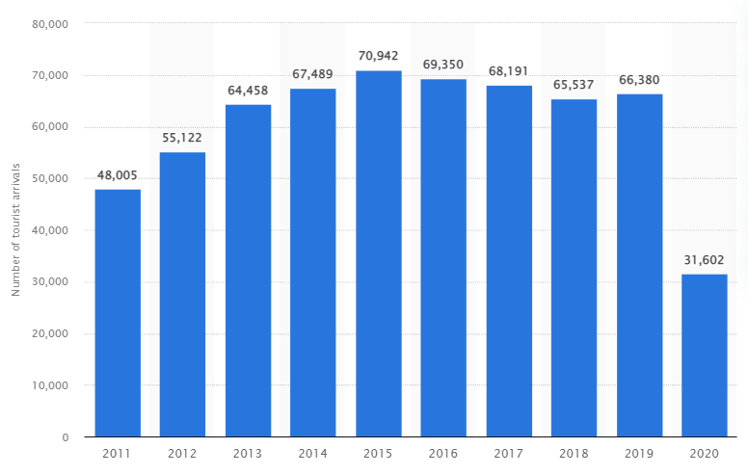
Figure 1: Visits from UK to Luxembourg
(Source: Statista, 2023)
It has been determined that 31.6 thousand people visited Luxembourg in 2020. This rate gets lower affected by Covid-19 (Statista, 2023). It is resolute that City Hotel Luxembourg focuses on international hotel management for staffing concerning intercultural competence. It is analysed that the organisation has adopted ethics and behaviour for attracting guests from the UK.

Importance of cultural understanding in global marketplace
Nowadays, cultural understanding in a global marketplace is required to be concerned an essential aspect of hotels. It has been analysed that cultural understanding attracts guests to hotels from other countries.
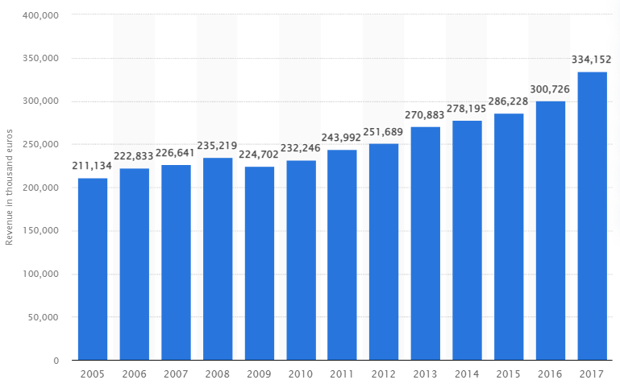
Figure 2: Hotels revenue in Luxembourg
(Source: Statista, 2023)
Hotels in Luxembourg have promoted the UK culture in their rooms through architecture, which helped generate revenue of £334 million in 2017 (Statista, 2023). It is analysed that hotel staff has developed ethics for culture to improve the relationship of employees with the international visitor’s experience. It increases the brand value and image of the company in the global marketplace. There are various considerations that are required to be adopted by the company for the development purpose. The global marketplace is full of various cultures that influence hotel companies' performance in Luxembourg. It is resolute that beliefs, ideas, customs, art, literature, and other aspects exchange in the global marketplace. It increases the attention of guests to visit a particular country based on their beliefs and concern. Thus, cultural competence is essential in the global marketplace. Various types of theories are required to be analysed by the countries and hotel companies to attract guests from other countries.

United Kingdom (Guest’s home country)

United Kingdom analysis
Mixed cultural background is measured for the United Kingdom. Gestures like handshake have been adopted by the employees and staff of the company to establish effective relationships with the guests and customers of the company.
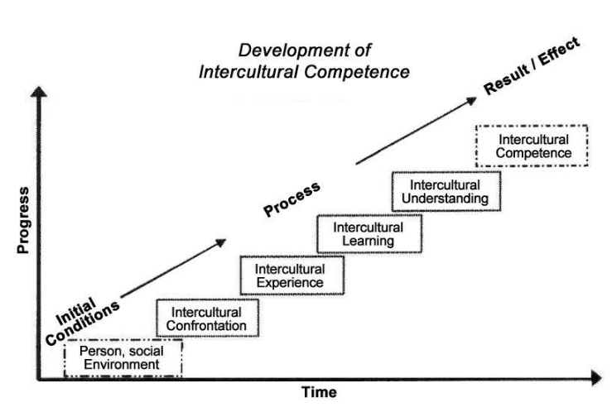
Figure 3: Intercultural competence development
(Source: Research Gate, 2023)
Intercultural competence can be developed by following the steps mentioned in the above image. Time and progress are required to be concerned with developing the cultural aspects. It includes initial conditions, process and result/effects. Environments based on personal and social are required to be created in a sound manner for increasing effectiveness.

Country Analysis

Comparison analysis
Cultural intelligence and sensitivity are required to be measured by the hotel personnel for developing cultural norms. Room bookings through email reservations are determined as a comparison of the culture in Luxembourg and the United Kingdom. Thus, it has been analysed that both countries have different attitudes towards each other culture that attracts guests. It is observed that individualism cross-culture theory, like Hofstede, increases understanding of the culture adopted in different countries. There are various concerns which have impacted the performance of hotel personnel for reservation emails. Room booking through online media increases the feasibility for personnel to adopt cross-cultural aspects of the United Kingdom in a Hotel Company that is based in Luxembourg. Beliefs and ideas provided by the guests are welcomed for developing their interest in the country.

Critical evaluation
According to Burke (2019), cultural differences, customs, and behaviour develop a positive impact on the hotel personnel to interact with the guest feasibly. It has been determined that hotel personnel can communicate with guests from another country effectively if they know about their culture, customs, and behaviour. It positively impacts the guest’s perspective by maintaining cultural norms. Requirements of cultural intelligence and sensitivity are fulfilled effectively by acknowledging cultural differences within countries. Therefore, it is helpful for maintaining increasing cultural awareness among hotel personnel. However, argued by Jawabreh et al. (2022), it has been determined that learning other countries’ cultures, customs, and behaviour increases challenges for hotel personnel. Thus, it also increases difficultness and complexities of providing guest services. Accommodating guests becomes difficult and quite complex for hotel personnel as per the cultural differences. Sometimes it increases challenges for the staff to fulfil the cultural norms and requirements. It has been determined difficult for an organisation to maintain sustainability through cultural intelligence and sensitivity. Service delivery in the hotel industry becomes difficult due to cultural barriers like communication gaps.

Hofstede as tool
Significant differences such as power distance, individualism, masculinity, indulgence, and others are misunderstood if the hotel employee gets these cultural values wrong.
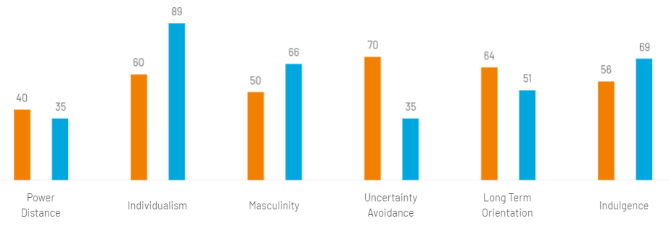
Figure 4: Hofstede insights of UK and Luxembourg
(Source: Hofstede insights, 2023)
In the above image, it has been analysed that both countries have similar insights, such as individualism for the United Kingdom stands at 89% and 60% for Luxembourg. Indulgence stands at 69% in the United Kingdom and 56% in Luxembourg. Long-term orientation is measured at 51% in the United Kingdom and 64% in Luxembourg (Hofstede insights, 2023).

Hotel Handbook Recommendation
Hotel handbook for employees
Do’s | Don’ts
- Welcoming the guest during their check-ins in hotels.  - A handshake gesture should be adopted for welcoming international visitors.  - Guest’s requirements and demands should be focused on maintaining customer relationships.  - Try to learn “Hello” and “Welcome sir/madam” in English and French language for increasing positive impression on the visitors as per their culture. | - Do not conduct informal communication with the guest during check-ins.  - Do not touch the luggage of international visitors without their consent.  - Do not avoid guests’ requirements in any case.  - Do not try to be over-friendly with the guest, as it can make them uncomfortable.

In the City Hotel Luxembourg handbook, it is recommended that the personnel enhance their knowledge of the culture of the United Kingdom. They should participate in training and development to learn new beliefs and develop ideas to remove cultural barriers. It would be helpful for attracting the guests and providing them with effective guest services. Cultural norms and requirements must be adopted by hotel personnel to develop cultural intelligence and sensitivity. It is measured that City Hotel Luxembourg personnel should not avoid the requests generated by the employees. Hotel staff should increase the practices for developing ethics to deal with the guests. It would be beneficial for interacting with international guests in the global marketplace. Therefore, it has been recommended to the hotel staff to increase the use of cross-culture theories in the business environment for developing cultural norms and requirements. Room booking must avail feasible for the guests to enable them access to related operations.

Conclusion
The report has summarised the concept of international hotel management for the City Hotel Luxembourg. Guests from the United Kingdom have been concerned about covering the concept. It has been determined that hotel personnel must develop individualism cross-culture theories to increase the positive effects. Hofstede insight model has been applied to the cross-culture theory in the report considering the global marketplace.

Reference
Burke, P., 2019. What is cultural history. John Wiley & Sons.
City Hotel, 2023. Home [Online] Available Through <https://cityhotel.lu/en/> [Accessed on 5 June 2023]
Hofstede insights, 2023. Comparison of UK and Luxembourg [Online] Available Through <http://surl.li/hqsfq> [Accessed on 5 June 2023]
Jawabreh, O., Jahmani, A., Maaiah, B. and Basel, A., 2022. Evaluation of the contents of the five stars hotel website and customer orientation. Information Sciences Letters, 11(4), pp.1077-1085.
Lam, R., Cheung, C. and Lugosi, P., 2022. The impacts of cultural intelligence and emotional labour on the job satisfaction of luxury hotel employees. International Journal of Hospitality Management, 100, p.103084.
Research Gate, 2023. Development of intercultural competence [Online] Available Through <http://surl.li/hqsfl> [Accessed on 5 June 2023]
Statista, 2023. Hotels revenue in Luxembourg [Online] Available Through <http://surl.li/hqsfn> [Accessed on 5 June 2023]
Statista, 2023. USA guests to United Kingdom [Online] Available Through <http://surl.li/hqsfh> [Accessed on 5 June 2023]

