

Name: Rizwana Ahmed
Student ID: 2525197
Module Code: LCHS4007
Module: Digital Skills and Research Methods
Lecturer: Markus Klingelfuss

1.1
This extract will be about diabetes type 2. Type 2 diabetes is a chronic condition characterised by insulin resistance and high blood sugar levels, often manageable through lifestyle changes and medication. This is a common issue in health and social care and has led to serious concerns on patient safety. I have researched about diabetes and found that this condition is most common within the Asian community. One factor could be due to cultural foods, as Asian households tend to have a lot of oil and fried foods which can contribute to type 2 diabetes at an early stage. A second factor could be due to a lack of awareness, many Asian may lack information about the health hazards that their food pose, this leads to regular overeating of unhealthy foods which can spike glucose. Glucose is the main source of energy that is retained from the foods you eat. Healthcare organisations like the NHS make be overburdened by the amount of patients who turn up with this illness as diabetes can make someone more prone to heart disease, Kidney disease and strokes as well as nerve damage. I have chosen this topic as coming from a south Asian background I would like to raise more awareness about diabetes and how this can be managed. I hope to bring change in the healthcare system to promote more healthy eating lifestyle choices.
1.2
On the NHS website there are lot of information on diabetes type 2 such as the definition of what this is and what can cause this, however I have noticed that that the website doesn’t really provide solutions. For example If the NHS website was to include healthy meal plan options as well as contact numbers on who to reach out for lifestyle changes, this may benefit service users especially those who are elderly or neurodivergent. Between 2005 and 2026, the global prevalence of diabetes increased steadily from about 7–8% of adults in 2005 to around 8.3% in 2010, about 9% by 2015, and roughly 10.5% by 2021. Recent estimates for 2024–2026 show about 11% of adults worldwide (around 1 in 9 people) living with diabetes, reflecting a gradual rise over the past two decades.
Another type of source I can use can be world health organisation. This is useful as it provides highly reliable information with global statistics and evidence based information, however some information can be quite general and less detailed which will not provide me the assurance that I need.
A third type of source I could use is Diabetes Uk, this provides clear explanations, UK focused data and more update information for patient experiences and prevention advice, however the content is simplified and may not include detailed scientific information, also I have noticed a lot of detailed reports may require downloads or be more technical to understand which places groups such as neurodivergent, people with language barriers and elderly at a risk of understanding a serious health condition they are suffering with.

1.3
Many research methods can be used to gather information on type 2 diabetes. This can be qualitative, quantitative and mixed methods. Qualitative methods involve collecting non-numerical data to understand people’s experiences, opinions, or behaviours. They often use interviews, focus groups, or observations. Example: interviewing people with Type 2 Diabetes about how the condition affects their daily actives involve collecting numerical data that can be measured and analysed statistically. Common tools include surveys, experiments, and health records. Example: measuring the percentage of adults diagnosed with Type 2 Diabetes in a population. Mixed methods combine both qualitative and quantitative approaches to give a fuller understanding. Example: using a survey to measure diabetes prevalence (quantitative) and interviews with patients about their lifestyle changes (qualitative).
My preferable choice of research methods would be mixed methods, this is because it Incorporates both qualitative and quantitative which can provide better, less biased results in the long term this provides me with more accuracy and completeness for researching about type 2 diabetes which tends to be a complicated area to discuss due to many different opinions.

1.4
There are two types of data collection, primary and secondary. Primary data collection is when researchers gather new, original data directly from sources for a specific study using methods like surveys, interviews, experiments, or observations. Example: surveying patients about their experience living with Type 2 Diabetes. Secondary data collection involves using existing data that was already collected by others, such as government reports, research articles, or health databases. Example: analysing published statistics on the global prevalence of Type 2 Diabetes. I would choose primary data collection. This is because information gathered by secondary data may be flawed, biased or include systematic errros from previous years. Collecting new information that I have gathered myself can provide me with more accurate, less out of date information. I believe this is the right method as times change, and so do people opinions and lifestyle choices, therefore collecting new statistics, and conducting new interviews will provide me with a more reliable, longer lasting and relevant information. For my future research I would also choose primary data as this can helps researchers and decision-makers understand real problems and create better solutions, policies, or treatments. For example, collecting new patient surveys about living with Type 2 Diabetes can help health professionals improve prevention programs and healthcare services.
Conclusion
Overall, online information about type 2 diabetes has many advantages, such as being widely accessible and providing a large amount of medical guidance and statistics. However, it also has disadvantages, as much of the information is not always easy to read or clearly updated for everyone. This can make it difficult for elderly people, neurodivergent individuals, and those with language barriers to fully understand the content. Providing information translated into multiple languages, clearer layouts, more contact numbers for support, and simple healthy meal plan options with pictures could make the information more accessible and useful for a wider range of people.

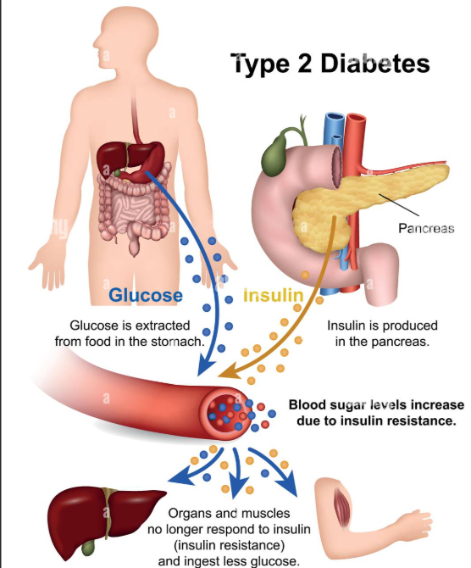

Reference list
Home | International Diabetes Federation
https://www.who.int/health-topics/diabetes
Diabetes - NHS
https://www.bing.com/ck/a?!&&p=342a727f0221d5743a789bc1c2998704a77f6d9de7b7b36275db98388593cb49JmltdHM9MTc3MjkyODAwMA&ptn=3&ver=2&hsh=4&fclid=0e358e0f-411a-6c31-2044-9b1d451a6897&psq=research+methods+qualitative+quantitative&u=a1aHR0cHM6Ly93d3cuc2ltcGx5cHN5Y2hvbG9neS5vcmcvcXVhbGl0YXRpdmUtcXVhbnRpdGF0aXZlLmh0bWw
https://www.bing.com/ck/a?!&&p=a8a007b6c59e7560574df69aaab9bc430b360bb7d38badfffd3556304caa457aJmltdHM9MTc3MjkyODAwMA&ptn=3&ver=2&hsh=4&fclid=0e358e0f-411a-6c31-2044-9b1d451a6897&psq=primary+and+secondary+research&u=a1aHR0cHM6Ly9yZXNlYXJjaC5jb20vcmVzZWFyY2gvcHJpbWFyeS1yZXNlYXJjaC12cy1zZWNvbmRhcnktcmVzZWFyY2g

Submitted on: 08/03/2026

Table of Contents
Research Report 4
Introduction 4
1.1 Selection of Research topic 4
1.2 Evaluating information sources 4
1.3 Research Methodologies 4
1.4 Data Collection 4
Conclusion 5
Reference List 5

Delete any and all instructions before you submit (including this one)!

Research Report
Use the information below to guide you, but DO NOT just write brief answers under each question. Use this structure to create paragraphs for your report. USE SPECIFIC DETAILS AND EXAMPLES FROM YOUR RESEARCH (CITATIONS) TO MAKE EACH SECTION STRONGER!

Introduction
(~100 words)
You should use 100 words here to explain what you will be reporting on. You need to state your aims and objectives, provide some background, and a roadmap for the reader to follow.

1.1 Selection of Research topic
(~300 words)
- What problem have you identified?
- Which health and social care sector have you decided to focus on?
- Who is affected by the problem and why does it matter for care organisations, staff, or service users?
- How have you justified your research? What reasons have you given for doing your research? Are the reasons personal or social, or both? Can you support your reasons with data / citations?
- Does it link to your personal / professional development?

1.2 Evaluating information sources
(~500 words)
- Which information sources have you chosen?
- Have you summarised the content?
- Have you justified why you have chosen them (use the CRAAP test to help).
- Can you show how they are related to your research question? This demonstrates your understanding of your sources.
- Can you identify any gaps in the research?

1.3 Research Methodologies
(~250 words)
Think of a good topic sentence to introduce this section / paragraph:
- Have you provided an overview of research methodologies – what are they?
- What you explained qualitative, quantitative and mixed-methods?
- Have you supported your definitions with good, relevant sources?
- Which research methodology have you chosen to answer your research question (Mixed methods)? Have you justified your decision? This demonstrates your understanding of research methodologies.
Look at the 3 information sources you explored in Part 1.2 to. What sort of research methodologies do they use?

1.4 Data Collection
(~250 words)
Think of a good topic sentence to introduce this section / paragraph:
- Have you provided an overview of data collection techniques – what are they?
- Have you explained the difference between primary and secondary data collection?
- Have you supported your definitions with good, relevant sources?
- Which form of data have you chosen to address your research question (and why)? Have you justified your decision? This demonstrates your understanding of data collection types.
- Have you discussed the advantages and disadvantages of your data?
Look at the sources you have found to help you. What sort of data collection do your sources use?

Conclusion
(~100 words)
Finish your report with a short summary:
- Restate your aims – what were they?
- Summarise your main findings – what were they?
- Do you have an answer to your question? If yes, have you provided it? If no, why not? What prevented you from finding answers to your research question?
- Provide a link to future research – does more need to be done? Is further research necessary to help provide answers to your question?

Reference List
Only include sources you actually used in your report (quoted or paraphrased).
List sources in alphabetical order by the author’s surname.
Separate each source clearly on a new line
Don’t number the list.
You need to provide a minimum of 6 relevant sources / references

