
The Business of Sport Template
Assignment 1

Chelsea Jenkins – 1910104
Business of Sport (M4X02084)

Table of Contents
1. Task A 2
1.1 Definition 1 2
1.2 Definition 2 3
1.3 Definition 3 4
1.4 Definition 4 5
1.5 Definition 5 6
2. Task B 7
2.1 Stakeholder Diagram 7
3. Task C 11
3.1 Gantt Chart 17
3.2 Eventbrite 18
3.3 Survey 19
3.4 Floor Plan 22
3.5 Poster 24
4. Reference List 25
5. Appendix 29

Task A – Definition 1

Physical Literacy is ….
Physical Skills + Confidence + Motivation + Knowledge + Understanding = Physical Literacy.
Sport Wales state that with all these elements a person is more likely to be physical literate. For example, be happy and confident and have the tools to enjoy being active. Sport Wales’ objective us to have every person in Wales physically literate. When looking at physical skill, you need to consider skills such as, jumping, running, throwing and balancing. These skills are the building blocks for children to be able to activities like swimming or riding a bike. Children learn the basic skills when they are younger to help achieve greater movements to form an activity or sport. The most important part of confidence and motivation is that children are exposed to fun, positive and safe experiences. In addition, capturing their natural motivation while they are young and when they have the confidence to try anything. Furthermore, knowledge and understanding is how to transfer skills and confidence into different and constantly changing environment in preparation for life. All of this will be resulted in a more rounded person who is able to participate and enjoy a vast range of activities and sports. (Sport Wales, 2020).
It is important to remember that physical literacy is something that children will explore in their early years with parents and other family members, but it is key that this continues throughout their life. For example, the skills they learn from a young age allows them to take part in sport and activities into adulthood and as a result pass those skills onto their children and skill continue to be active into retirement. This is supported by NGB, Sport Wales. (NGB, Sport Wales, 2020).

Task A – Definition 2

To achieve expertise, it is stated that you must train/practice for 10,000 hours over a period of 10 years. (Jayanthi, Pinkham et al, 2013). Sports specialisation is defined as “intense, year – rounded training, in a single sport.” (Jayanthi, Pinkham et al, 2013). This definition has been challenged due to whether people feel specialisation or generalisation is better for sport development in children from a young age. In the United States, participation of organised sports has increased 9% of children 6 years old and under in 1997 to 12% in 2008. (Malina RM,2010).
There are risks that come with single sport intense training, for example, psychological stress and premature withdrawal from competitive. Research suggests that intense training and specialisation may be an independent risk factor. (Jayanth, Dechert et al, 2011). Figure 1 shows the ratio between injury and hours training in high school athletes. It highlights the more hours you spend intensely exercising the greater risk you have in developing an injury.
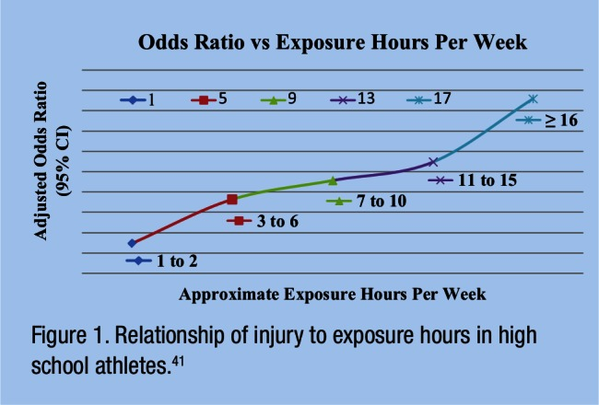
Figure 1 - (Rose, Emery, Meeuwisse,2008).
Children or young adults who are at the top of their sports do get financial support of colleges and universities via grants and bursaries. This as a result puts a lot of pressure on them to achieve, pushing them to their limits and therefore possibly causing injuries.
.

Task A – Definition 3

To be a captain you must have certain qualities that link to the responsible role of captain. For example, in the psychology of sport they state that there are 3 C’s to embodying a captain e.g. caring, courageous and consistent. (Larry Lauer and Kevin Blue, 2020). Caring includes how a captain should treat all teammates with respect and recognise the contributions made by all team members. When considering courageous the Association of Applied Sports Psychology highlighted that a captain should set example for the rest of the team and understand that your actions must embody the core values of the teams most importantly during times of adversity. Finally, being consistent is giving 100% effort in every practice, game or alternative. Also, a consistent captain will communicate effectively either by actions or words. (Larry Lauer and Kevin Blue, 2020).
The first example of someone who takes on the role of captain is a team manager in F1 such as, Christian Horner from Red Bull. They organise and communicate well with their drivers to ensure maximum effectiveness for each race. In addition, they value that their team is made up of many different teams that all come together to make the team a success and without one there would not be a team.
The second example is Welsh Rugby player and captain Alun Wyn Jones. He has 138 caps for Wales, this season has had 7 turnovers,173 tackles and 85 carriers. (WRU, 2020). Thus, he was crowned 2019 Guinness Six Nations Player of Champions along with winning a third Grand Slam for Wales. (Six Nations Rugby, 2019). He has also captained the British and Irish Lions to victory and made 20 appearances and 9 tests for them. (British and Irish lions Statistical Data, 2020). Along with all his achievements he leads his teams with positivity and good valves.

Task A – Definition 4

Women’s football has come a long way in the last decade. Despite this and new commercial deals such as Boots and Barclays and record number of attendances being set across the leagues, the Women’s Super League was struggling to be profit in 2019. (Guardian, 2019).
FIFPro have stated that “the current situation is likely to present an almost existential threat to the women’s game if no specific considerations are given to protect the women’s football industry”. In addition, that due to women’s football being less established as the Premier League for example there are low salaries, narrower operatories, uneven sponsorship deals and less corporate investment. They also highlight there are a lack of written contracts in the sport and short -term durations of employment contracts and there is a lack of health insurance has now left many female players at great risk of losing their livelihoods. (FIFPro, COVID-19: Implications for Women’s Football, p.2).
FIFPro continue saying that the growth in “professional women’s football and its journey to becoming a strong and viable industry is threatened by the implications of the current crisis.” (FIFPro, COVID-19: Implications for Women’s Football, p.4). This will continue to be difficult for the women’s professional after COVID-19 due to people not having a lot of extra money/income to spend on going to watch them because of a great number of the UK population either losing their jobs or being put on the Furlough Scheme.

Task A – Definition 5

There are many different processes that go on in a leisure centre front of house to behind the scenes that members and the public do not see that keep the organisation running. The staff at leisure centres have many jobs, these include identifying hazards, evaluating risks and regular risk assessments. When identifying a hazard staff have a process that involves checking manufactures instructions or data sheets for chemicals and equipment as some can be helpful in explaining the hazards and putting them into perspective. (A brief guide to controlling risks in the workplace, Health and Safety Executive, p.1). Also, considering non-routine operations such as, maintenance, cleaning operations or changes in productions cycles. (A brief guide to controlling risks in the workplace, Health and Safety Executive, p.2).
When evaluating risk staff must decide how likely that injury or harm will occur, for example, the level of risk and how to approach it. When working at a leisure centre you need to do everything ‘reasonably practicable’ to protect members from harm. This means weighing the level of risk against the measures needed to control the real risk like money, time or trouble. Whilst working at a leisure centre you should use a risk assessment that will highlight the general risk and anticipate unforeseen risks and put processes in place to deal with them. (A brief guide to controlling risks in the workplace, Health and Safety Executive, p.2).

Task B – Stakeholder Diagram (with appropriate communication channels selected for each stakeholder) and referenced material detailing role, emphasis, funding and performance of organisation (Internal and External)

Twickenham
Sponsorship
Sport England
Community
Game Management
Rugby Football Union
Rugby Development Director (Steve Grainger)
Chief Executive (Bill Sweeney)
World Rugby
Employees
Players
Suppliers
Unions
Activist Groups
Competitors
Government
Trade Association
Customers
Chief Financial Officer (Sue Day)
Rugby Players Association
Governance
Organisation
The Containing System
The System
The Wider Environment

- Owners:
Twickenham has a board made up of executive directors that help run and make key decisions regarding the present and future of the organisation. Bill Sweeney is Chief Executive Officer and was appointed in May 2019 after serving nearly six years as Chief Executive Officer at British Olympic Association. Angus Bujaski is the Legal and Governance Director, he is responsible for RFU’s game wide governance functions. This includes on and off the field discipline, safe-guarding and integrity. Moreover, he oversees corporate governance and the recent project to ensure that RFU follows the Code for Sport Governance published by Sport England and UK Sport. In addition, Sue Day became Chief Financial Officer and member of RFU in April 2018. She is responsible for the financial planning, management and reporting, legal and governance and technology reporting to the CEO, and is also a former England rugby captain. Furthermore, the Rugby Development Director is Steve Grainger. Lastly, Simon Massie-Taylor is the Chief Commercial Officer and is also a member of the RFU board. He is responsible for all RFU’s commercial operations and revenue generating activities. For example, commercial partnerships, broadcast, tickets, hospitality and licensing and rental of the stadium. (England Rugby, 2020).
- Sponsorship;
Twickenham has many sponsors such as, O2, British Airway, Canterbury, Dove Men Care and Sky Sports. The Rugby Football Union and Sky Sport have extended their partnership with a new five-year broadcast deal. This agreement has strengthened one of the longest running broadcast partnerships in sport, leading into third decade of partnership. Also, in their new deal in July 2015, the RFU stated in their contract that at least two live England’s Women’s matches a season, as well as additional England Under 20, Under 18 and England Saxon fixtures. This is aiding in getting more people to watch and support Women’s rugby. (England Rugby, 2020).

On 5th May 2020, England Rugby announced that Umbro will become the official England Rugby Kit partner from 1st September 2020 for the next four years. The Umbro logo will be worn by the England Men’s teams, Red Roses, Sevens and age grade teams. (England Rugby, 2020).
- Community:
RFU supports the ‘Injured Players Foundation’, which provides support and information to rugby players in England who sustain a catastrophic spinal cord injury playing in the game and aid in preventing future injuries through research and education. (Rugby Football Association, 2020).
In September 2012, RFU set in motion All Schools as a Rugby World Cup 2015 Legacy programme. The aim of the programme was to increase the number of secondary school children playing rugby union and to encourage new players to join their local clubs. This allowed one million children through rugby and its core values and as a result making school environment happier and healthier and reducing anti-social behaviour and enhancing learning and self-esteem. The Rugby Football Association helps schools and clubs by supplying kit and equipment for the children and thus Prince Harry is the patron of All Schools and therefore the foundation gains help via his generosity. (Rugby Football Association, 2020).
In March 2020, CEO Bill Sweeney stated that the RFU will be giving £7 million to provide support for community clubs in England during the COVID-19 outbreak. (Bill Sweeney, England Rugby, 2020).
- Customers:
Twickenham use their WIFI system to gain information off guest that are attending the facility to manage consumer and participant demand. This data helps the team to better target the public and find out what they like and dislike. Email and their website are the prime ways Twickenham get in touch with the public to inform them on upcoming events and what current deals they have. They are also active on social media which gives the organisation the opportunity to reach of variety of people.

Due to the COVID-19 pandemic the Rugby Football union has announced the end of the 2019/20 rugby season for all league, cup and county rugby in England. As a result, England Rugby have stated the tickets that were purchased for the postponed or cancelled matches have the option to keep the tickets and attend when a date is set in the future or they can have a refund. In addition, they are constantly keeping their customers updated has the situation is changing linking to the duty of care they have for their customers. They are also keeping them updated with that is happening in the world of Rugby and English Rugby via the website and email. (Rugby Football Union, 2020).

- Sport England:
Sport England invests in community sport in many ways such as, funding opportunities, and each year give more than £250 million of National Lottery and public money to invest into helping people participate in sport and physical activity across England. During the Coronavirus crisis they have set up ‘The Community Emergency Fund’. The fund aims to support community sport and physical activity organisations who are experiencing shirt term financial difficulties. They are working closely with England Rugby to achieve this. (Sport England, 2020).

Task C – Complete Operational Planning Document for your Event (Fill, 2006)

Title of Event | TRY AND STOP US !
Event Purpose Link to Case study and (Fill, 2006)  Think Why? | - To increase the participation of girls in rugby.  - To make Women’s rugby more equal on and off the pitch e.g. ethnicity.
Event Description  Think What?  What is your USP? | The event will a community event where families will have the opportunity to participate in a range of rugby-based games to show how fun the game is and what skills you can learn and develop has being a part of the sport.  In addition, we will not be charging people to attend the event making it accessible to all income groups and the purpose of the event is not to make a profit. However, there will be opportunity to buy food, drinks along with other stalls at the event. Any money raised will be going to the campaign to help community projects or help fund community event such as this.  Also attending will be female rugby players helping to promote Women’s Rugby and will be talking about how rugby is for all and as no barriers. (World Rugby, 2019, p.2).  Our unique selling point is that no one is specifically targeting girls/women to participate in rugby. There maybe trying to increase participation in sport or girls in sport but not specifically rugby.
Overall Funding Required (Financial Statement) | The Case study Organisation gives a Fixed grant of £10,000.  Forecasted Profit/ Loss = £16,000 + profit with 100% or £800 with 25% profit
Partners | - World Rugby  - Women in Rugby  - Sport Wales and England
Strategic Impacts (Government, Local Authority, NGB’s) | This event will act as another platform to get girls/women into sport and therefore aiding in other campaigns such as, This Girl Can and Us Girls, which has the same core values and objectives as TRY AND STOP US. For example, they aim to get girls and women moving regardless of shape, size, ability or ethnicity. (This Girl Can, Sport England, 2020).
Venue/ Facility (Justify) | Ysgol Bae Baglan:  I decided on Ysgol Bae Baglan for the venue because it has up to dated facilitates which includes, football pitch and three additional grass pitches. Along with two car parks to accommodate people attending, thus there are disable access into the facility and parking right outside the entrance. Also, there are bus stops along the road so people can easily get to the venue. (Ysgol Bae Baglan, 2020).  Furthermore, if on the day the weather is not the best, we can comfortably move the event inside due to Ysgol Bae Baglan having the facilities for the event to be held inside as well. For example, there is a large multiple purpose sports hall, gymnasium along with drama/dance studio and an activity studio. Also, they state on their website that community facilities are opening on Monday to Fridays 5pm-10pm and Saturday and Sunday 9am – 5pm, linking to have suitable the facility is. (Ysgol Bae Baglan, 2020).
Marketing Plan (Segmentation, Competition, Media, Sponsorship and Promotional Activities) | Competition:  The competition for this event is that there has been a spike by 50’% since 2016 in girls taking part in football across Wales according to Football Association of Wales (FAW) Trust. A record number of women and girls equalling 8,600 have now signed up to football clubs across Wales. The Trust has set their ambition by 2024 to have 20,000 female players registered. (BBC, 2020). This affects the TRY AND STOP US campaign because their ambition by 2025 is to double registered players globally. (World Rigby, 2019, p.3). Therefore, it is going to more difficult trying to get girls to chose rugby over football.  Promotion:    To promote the event, we will be going into local schools trying to gain interest by showing them the promotion videos called ‘start rugby, become unstoppable and TRY AND STOP US. (Links shown in appendix) Below, is the promotion one of photos for TRY AND STOP US from World Rugby. (See other examples in appendix). Thus, we will be giving out posters for the event for children to take home to their parents and guardian and we will send coaches into the schools to show girls especially what rugby is like. Along with this we will put up posters around the local community including Bae Baglan notice board.  Sponsorship:  Sponsorship will come from Wales Rugby sponsor Princes Gate water which will provide water for children throughout the day. Also, World Rugby by supplying equipment and coaches for the event along with £500 off Sport Wales.
Staffing Requirements (Duties, Technical Certificates etc.) | Staffing Requirements:  There will be around 50 members of staff which will include, volunteers on stalls such as, raffle and face paint. Also, coaches, staff for setting up and clearing event and security will be present at the event.  Certificates:  All volunteers will be DBS checked before event and there will be at least one first aider set up in each section of the event including by the entrance. Thus, all coaches will have at least a Level 2 – Developing Rugby Skill qualification via World Rugby.
Equipment Required | The equipment that I require for the event is:  - Flat disc markers  - Rugby balls x 65  - Colour bibs x60 (four different colours)  - First aid kit x6 (4 for each rugby group, 2 for stations)  - 4 stalls  - Seating and tables  - 2 food tents  - 6 portaloos (3 at each of the 2 stations)
Key Legislation | I will be following the guidelines set by the UK Cabinet Office “Organising a voluntary event a ‘can do’ guide”. Published on February 2019.
Health and Safety Risks | There is an emergency access point planned out as shown in the appendix. In addition, there will be a risk assessment performed before the event to ensure that pitches, equipment and venue is good quality and safe for use. Plus, we will be following the health and safety at events act in 1998.
Economic and Operational Considerations | I have managed my budget well and have tried to get the best deals available such as equipment because World Rugby has provided them for the event. Also, staff are all volunteers so there is no need to pay extra. Any profit from the event will go either back into the TRY AND STOP US campaign to aid in girls/women in rugby or help fund another event such as this.

Financial Statement / Profit and Loss Forecast Accounts
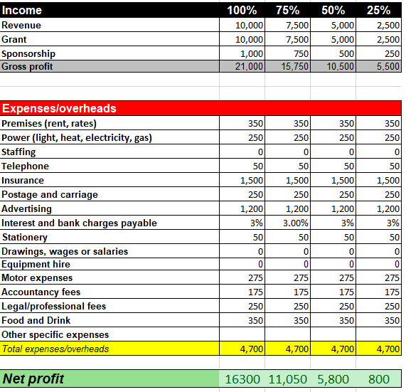
Gantt Chart

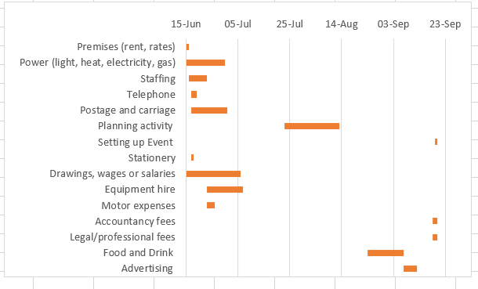

Eventbrite Page for your event

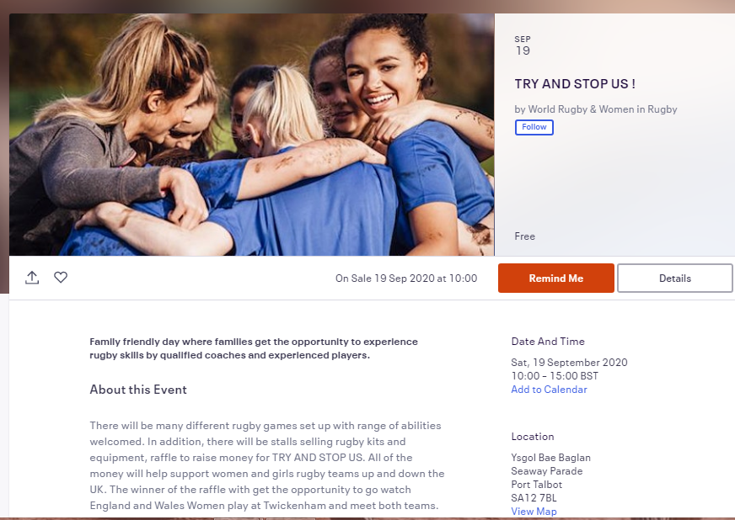

Survey Monkey Audit of relevant questions

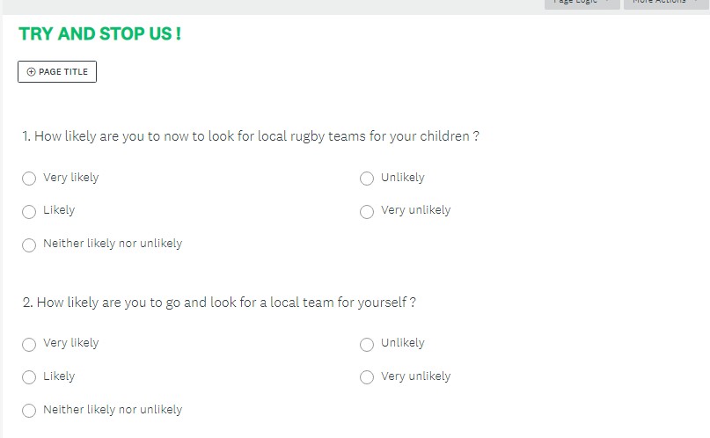

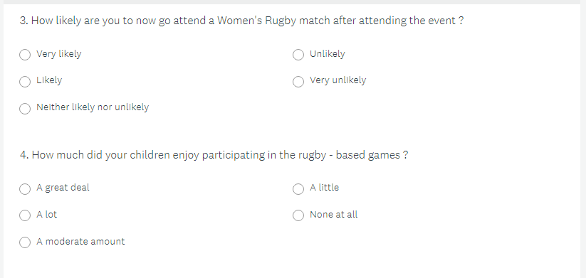

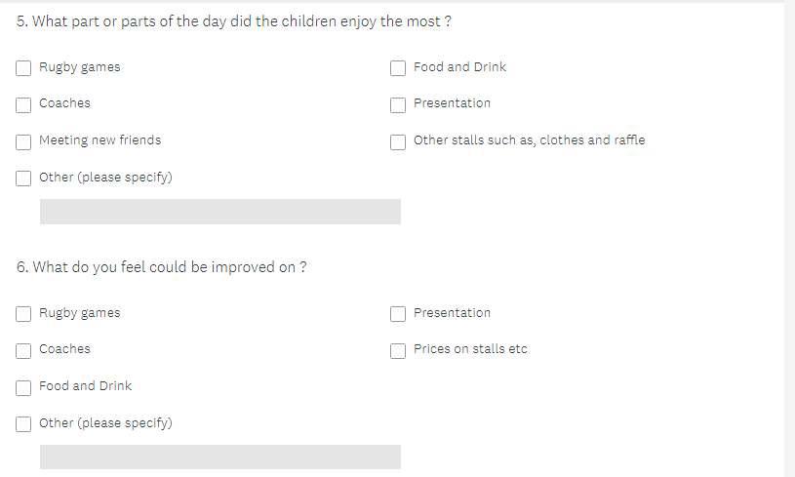

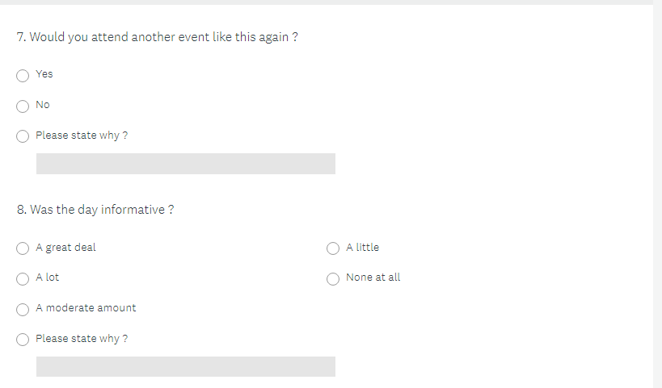

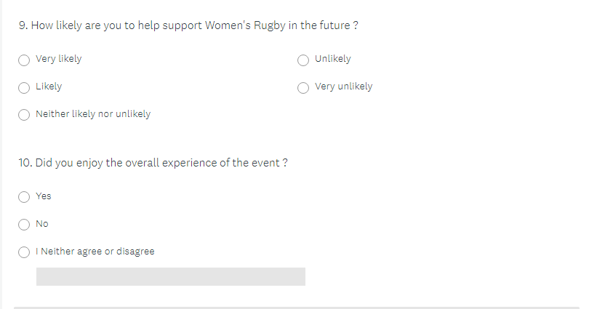

Event Floorplan

Key:

Rugby Games

Rugby Pitch



Stalls




Seating

Food & Drink



Toilets

Entrance/Exit


First Aid Stations



Event Poster

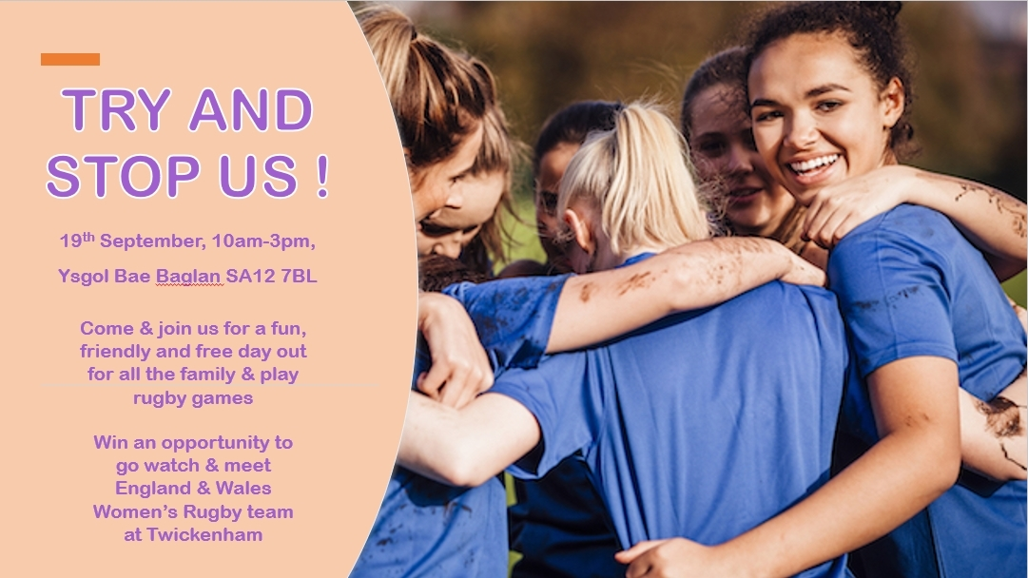

Reference List and Bibliography

Reference list:

- 2014. Risk Assessment - A Brief Guide To Controlling Risks In The Workplace. [ebook] HSE, pp.1,2. Available at: <https://www.hse.gov.uk/pubns/indg163.pd> [Accessed 3 May 2020].
- 2017. Accelerating The Global Development Of Women In Rugby 2017-25. [ebook] World Rugby, pp.2,3. Available at: <http://2019-WomeninRugby-Womens_Plan-1_Pager-DIGITAL-EN.pdf> [Accessed 6 May 2020].
- 2020. COVID-19 Implications For Professional Women's Football. [ebook] FIFPRO, pp.2,4. Available at: <https://www.fifpro.org/media/zp3izxhc/fifpro-wf-covid19-new.pdf> [Accessed 1 May 2020].
- BBC Sport. 2019. World Rugby Launches Campaign To Increase Participation In Women's Game. [online] Available at: <https://www.bbc.co.uk/sport/rugby-union/48348245> [Accessed 6 May 2020].
- BBC Sport. 2020. Women's Football Participation Growing In Wales. [online] Available at: <https://www.bbc.co.uk/sport/football/51710825> [Accessed 6 May 2020].
- British & Irish Lions. 2020. Alun Wyn Jones - British & Irish Lions. [online] Available at: <https://www.lionsrugby.com/players/alun-wyn-jones> [Accessed 11 May 2020].
- Coaching.worldrugby.org. 2020. World Rugby Coaching : The Home Of Rugby Coaching On The Web. [online] Available at: <https://coaching.worldrugby.org/index.php?> [Accessed 7 May 2020].
- Early sport specialization: roots, effectiveness, risks. Malina RM Curr Sports Med Rep. 2010 Nov-Dec; 9(6):364-71 = 01/05
- Englandrugby.com. 2020. RFU. [online] Available at: <https://www.englandrugby.com/about-rfu/structure-of-the-rfu> [Accessed 4 May 2020].
- Englandrugby.com. 2020. RFU. [online] Available at: <https://www.englandrugby.com/about-rfu/rfu-partners/sky-sports> [Accessed 5 May 2020].
- Englandrugby.com. 2020. RFU. [online] Available at: <https://www.englandrugby.com/news/article/umbro-to-become-official-england-rugby-kit-partner> [Accessed 5 May 2020].
- Englandrugby.com. 2020. RFU. [online] Available at: <https://www.englandrugby.com/about-rfu/rfu-charities/injured-players-foundation> [Accessed 5 May 2020].
- Formula 1® - The Official F1® Website. 2020. Red Bull – F1 Racing Team – Verstappen, Albon. [online] Available at: <https://www.formula1.com/en/teams/Red-Bull-Racing.html> [Accessed 11 May 2020].
- GOV.WALES. 2020. Curriculum For Wales | GOV.WALES. [online] Available at: <https://gov.wales/curriculum-for-wales> [Accessed 1 May 2020].
- Hse.gov.uk. 1998. Events Health And Safety. [online] Available at: <https://www.hse.gov.uk/event-safety/> [Accessed 14 May 2020].

- Jayanthi NA, Pinkham C, Durazo-Arivu R, Dugas L, Luke A. The risks of sports specialization and rapid growth in young athletes. Clin J Sports Med. 2011;21(2):157 [Google Scholar] 01/05
- Lauer phD, L. and Blue, K., 2020. The 3 C’S Of Being A Captain | Association For Applied Sport Psychology. [online] Appliedsportpsych.org. Available at: <https://appliedsportpsych.org/resources/resources-for-athletes/the-3-c-s-of-being-a-captain> [Accessed 4 May 2020].
- Network.streetgames.org. 2020. Us Girls | Streetgames. [online] Available at: <https://network.streetgames.org/our-work/us-girls> [Accessed 6 May 2020].
- Physicalliteracy.sportwales.org.uk. 2020. Sport Wales | Physical Literacy | Ngbs. [online] Available at: <http://physicalliteracy.sportwales.org.uk/en/ngbs> [Accessed 1 May 2020].
- Rose MS, Emery CA, Meeuwisse WH. Sociodemographic predictors of sport injury in adolescents. Med Sci Sports Exerc. 2008;40(3):444-450 [PubMed] [Google Scholar] 01/05
- Rugby Coach Weekly. 2020. Fast Feet. [online] Available at: <https://www.rugbycoachweekly.net/small-sided-games/fast-feet> [Accessed 7 May 2020].
- Rugby Football Union. 2020. Guinness Six Nations 2020: Italy V England - Important Information. [online] Available at: <https://help.englandrugby.com/hc/en-gb/articles/360006518097-Guinness-Six-Nations-2020-Italy-v-England-Important-Information> [Accessed 5 May 2020].
- Six Nations Rugby. 2020. Wales Captain Alun Wyn Jones Crowned 2019 Guinness Six Nations Player Of The Championship. [online] Available at: <https://www.sixnationsrugby.com/2019/03/22/wales-captain-alun-wyn-jones-crowned-2019-guinness-six-nations-player-of-the-championship> [Accessed 11 May 2020].
- Sportengland.org. 2020. Campaigns And Our Work | Sport England. [online] Available at: <https://www.sportengland.org/campaigns-and-our-work> [Accessed 6 May 2020].
- Sportengland.org. 2020. Our Funds | Sport England. [online] Available at: <https://www.sportengland.org/how-we-can-help/our-funds> [Accessed 5 May 2020].
- Sweeney, B., 2020. RFU. [online] Englandrugby.com. Available at: <https://www.englandrugby.com/news/article/an-update-on-covid-19-support-and-planning---bill-sweeney-ceo-rfu]> [Accessed 5 May 2020].
- The Guardian. 2019. [online] Available at: <https://www.theguardian.com/football/blog/2019/apr/16/womens-football-finances-womens-super-league-profitabl> [Accessed 1 May 2020].
- Welsh Rugby Union | Wales & Regions. 2020. Alun Wyn Jones - Welsh Rugby Union | Wales & Regions. [online] Available at: <https://www.wru.wales/player/alun-wyn-jones/> [Accessed 11 May 2020].
- Women.rugby. 2020. TRY And STOP US - Women In Rugby | Women.Rugby. [online] Available at: <https://www.women.rugby/#unionPicker> [Accessed 6 May 2020].
- Ysgolbaebaglan.j2bloggy.com. 2020. Community Facilities – Ysgol Bae Baglan. [online] Available at: <https://ysgolbaebaglan.j2bloggy.com/community-facilities/> [Accessed 6 May 2020]

Appendix


Promotion:
- https://youtu.be/WNaG2CM5Uss

- https://youtu.be/YQgM1qvxrGE




Mission statement:
Trawsnewid Addysg . . . Trawsnewid Bywydau
Transforming Education . . . Transforming Lives
Questions for Venue (Attach to Assignment Appendix)

DATE - 20/01/2020 FACILITY ADDRESS – The Oval Cricket Ground FACILITY CONTACT – Conferencing and Events Manager

- What type of events take place within the venue and how are they funded?

The prime event that takes place at The Oval is cricket games, from Test matches and World Cup in 2019 to 20/20 County Championships between Surrey and Middlesex. Plus, they also host conference meetings, team building events along with weddings and the chance to tour The Oval and see all the club has achieved. The main funder of The Oval is KIA, they have been the clubs sponsor since 2010.

- How do they market activities & manage consumer/ participant demand?

The Oval use their WIFI system to gain information off clients that are attending games or other activities to manage consumer and participant demand. This aids the company in organising their data and therefore can better target their audience. Thus, The Oval advertises through social media such as, Twitter, Facebook and Instagram. This helps expand the company’s information and as a result reaching a new fan base. Moreover, The Oval emails potential clients through email that they have obtained from the WIFI system to target their clients around their birthday and summer holidays, this increases sales.

- Observe the environment and list 3 key features?

- They are extending the stadium by building a new stand to increase the capacity.
- The club has an option of hospitality that includes foods and better seating that has cushioned seats.
- They have a memorial in the ground for all the past players that played for the club.

- Is the facility fit for purpose?

The Oval is fit for purpose. In 2017, the club announced that they would be expanding the capacity of the stadium from 25,500 to 28,000 by April 2021. This is apart of their re-development by KIA which will cost around £50 million. Furthermore, the facility is still being used for business meetings, weddings along with variety of more and the pitch itself is being maintained to a high standard.

- What key challenges do they currently face?

The main challenge the club has during the cricket season is having games being cancelled due to bad weather because The Oval does not have roof. This causes The Oval to lose potential profit and refund guests through insurance. However, the more games that are cancelled the higher the insurance.
Another challenge The Oval has currently is trying to get people into the stadium when the cricket season is not on. They try and decrease this problem by having tours, open their conference rooms to businesses and advertise their hospitability to attract more visitors.

- List three Health and Safety practices e.g. crowd control, alcohol, risk management, evacuation procedures, maintenance etc.

- The Oval explained in case of a fire they have a fire evacuation in place, this is supported by the clear fire exits throughout the facility.
- The Oval is a no smoking area since 2007.
- The ground state a long list of objects that you are not allowed to take into ground, for example, any banner/ signs that have anything offensive on it, flares and guest are not allowed to bring alcohol into the ground.

The three points above are in place due to The Oval highlighting throughout that the ground is a family environment and therefore they take any negative behaviour seriously.

Mission statement:
Trawsnewid Addysg . . . Trawsnewid Bywydau
Transforming Education . . . Transforming Lives
Questions for Venue (Attach to Assignment Appendix)

DATE – 21/01/2020 FACILITY ADDRESS – Twickenham FACILITY CONTACT – Head of Merchandise and Licencing

- What type of events take place within the venue and how are they funded?

The leading event that takes place at Twickenham is rugby. They host the 6 nations every year, along with HSBC London Sevens, the Army V Navy rugby game and the varsity match between Oxford V Cambridge. Twickenham also hosted some game in the 2015 World Cup such as, England V Australia.
Additionally, Twickenham have hosted a number of concerts like Beyoncé and The Rolling Stones over the previous years. The stadium has also hosted other sporting events such as, American Football in 2016/17.
Twickenham is partnered with British Airways so majority of their funds come from them, as well as they get grants off the Rugby Football Union (RFU) and Sports England.

- How do they market activities & manage consumer/ participant demand?

Twickenham use their WIFI system to gain information off guest that are attending the facility to manage consumer and participant demand. This data helps the team to better target the public and find out what they like and dislike. Email and their website are the prime ways Twickenham get in touch with the public to inform them on upcoming events and what current deals they have. They are also active on social media which gives the ground the opportunity to reach of variety of people.

- Observe the environment and list 3 key features?

- Three percent of the rugby pitch is artificial.
- They have all the flags of the countries that competed in the World Cup in 2015.
- The stadium capacity is 82,000, including the Royal Box.

- Is the facility fit for purpose?

Twickenham is fit for purpose due to them easily filling the 82,000 seats and all year around there is always some form of event being held there as shown in question one. Everything throughout the stadium is maintained to a high standard from the players dressing rooms, the seating areas and the building structure that has been there since 1907.

- What key challenges do they currently face?

The challenges that Twickenham is currently facing is trying to get more people to come and watch Women’s rugby events due to it being as popular as the men’s game. This is a realistic aim because in October 2019 a friendly game between England’s Women and Germany was sold out in Wembley. However, this challenge is not going to be fixed overnight.

- List three Health and Safety practices e.g. crowd control, alcohol, risk management, evacuation procedures, maintenance etc.

- Twickenham limit their guest to five units of alcohol due to majority of their events being family orientated.
- The ground has a fire evacuation plan in place to safety get all guests and staff out, this is aided by the clear fire exit signs around the stadium.
- The facility always has several stewards placed around the stadium when events are on to enforce safety when needed.

Appendix (Add Screenshot evidence here of any online costings etc.)

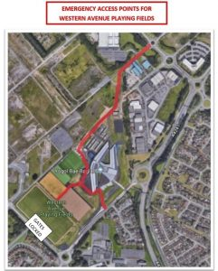
Health and Safety:



UWTSD SPORT

