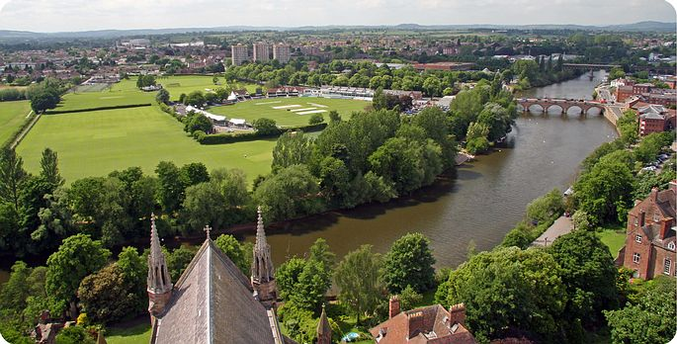

By

Nargas Ahmadzai 2106756
Vasilka Sarandalieva 2113113
Julia Mansell 2110746
Module Code: BMSW5104
Module: Managing Project in the Organisation
Lectures by: Abel Agoba

PROJECT MANAGEMENT PLAN
For Worcester Bridge construction

Contents
Introduction 2
Project description and management scope 3
The project management lifecycle 4
Quad Chart 6
Stakeholder Analysis 9
SWOT analysis 11
Work breakdown structure 12
Gantt Chart 14
Allocation of resources 14
Cost breakdown structure 15
Risk analysis 16
Conclusion 19
References 20

Figure 1 Phases of Project Management Life Cycle (Vitalii, 2022). 4
Figure 2 How are bridges built? A visual guide (BigRentz, 2023). 6
Figure 3 Quad chart (Agoba, 2023). 7
Figure 4 Stakeholder Analysis (Peachyessay, 2021). 10
Figure 5 Work Breakdown Structure ( Bridge Construction Planning, 2017), (Kurnia, Latief & Riantini, 2018). 12
Figure 6 Gantt Chart (Agoba, 2023). 14
Figure 7 Cost Breakdown Structure (Agoba, 2023). 15
Figure 8 Risks and Strategies (Munawar, H.S. et al., 2022). 17
Figure 9 Risk Assessment (Munawar, H.S. et al., 2022). 18

Introduction

Businesses always seek opportunities to develop, obtain their goals and maintain their position in the market. Therefore, they design unique projects to achieve objectives. However, projects require effective management to attain certain targets. Project management contains planning and organising projects and the essential tools to achieve goals. The process of management is to identify and manage the methods, required skills, and knowledge according to the agreed duration. The success margin of the projects depends on the effective plan. This report aims to outline the requirement of an effective plan for project management and the essential tools needed to implement a specific plan for project management.
An effective plan for project management is very important because it provides all information and guidance required to implement and control each phase of the project such as the aims of the project, objectives, scope of work to cover, time, estimation of budget, resources for execution and the risk assessment to avoid delays and misunderstanding among project management workers.
A constructive plan support managers to monitor and control the progress of all the tasks carried out in projects successfully.
This report attempts to explain that the success of projects depends on a convincing and productive plan. The main tools for successful project management are scope, cost, and duration. The report portrays a unique project management plan for building a new bridge in Worcester City to reduce congestion and traffic rush hours. It explains Effective planning for project management includes knowledge of project scope, activities for construction work, a well-designed QUAD and Gantt chart, an organised work breakdown structure, stakeholders ‘analysis and impacts of internal and external factors analysis and risk analysis and risk assessment to measure the opportunities of project success.

Project description and management scope

The introduction of the report outlines that effective plans are very important for successful projects. Therefore, to achieve successful outcomes for projects organisations require to make a practical and achievable plan to implement.
Worcester City has a huge population and busy routine life. The city has a bridge that connects the destinations for travellers with different vehicles and pedestrians. However, the rush hours create more congestion and travel delays due to an overload of travellers using the same bridge at the same time.
The ProAngel contractors’ company has a project to build another bridge over the river to reduce overcrowding, decrease noise and pollution, provide easy access to emergency services, and provide health and safety support, making travellers’ journeys more convenient.
To implement this project the ProAngel company has a constructive plan which includes different phases to complete.
The first phase of implementing this project is identifying the project scope that develops a detailed project plan, including timelines, milestones, and deliverables. Allocate human and material resources required for each phase of the project. Detailed work breakdown structure to operate by crew members. Conduct risk assessment and develop a risk management plan to define quality control measures and safety protocols. Establish a project budget and procurement strategy.
The design and Engineering stage engages architectural and engineering firms to design the bridge. They must develop detailed structural and technical specifications. Obtain necessary design approvals from relevant authorities and conduct geotechnical studies to assess soil conditions and foundation requirements.
The procurement and Logistics phase of management scope is to procure construction materials, equipment, and services following project specifications. Manage supplier relationships, ensure timely delivery of materials, and coordinate logistics, including transportation and storage.
The construction and Implementation section manages construction activities, including site preparation, foundation construction, and bridge erection. Monitor progress, ensuring adherence to design specifications, safety standards, and quality requirements. To manage subcontractors and construction crews. Implement a project control system to track progress, manage changes, and resolve issues promptly.
Post-construction is the final phase to conduct inspections and quality assurance checks upon completion. Address any deficiencies or required modifications. Obtain necessary certifications and clearances and document lessons learned for future reference.
Effective communication, stakeholder engagement, and continuous monitoring will be crucial for completing the bridge construction project within the projected scope, budget, and timeline (Robichaud & Anantatmula, 2011).

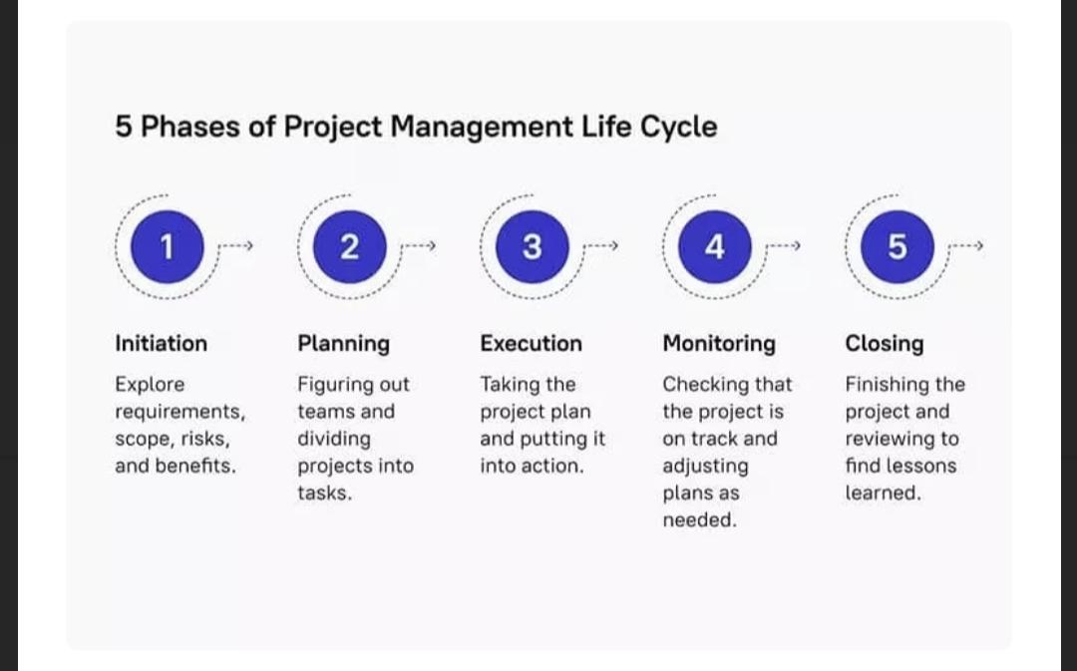
The project management lifecycle
Figure 1 Phases of Project Management Life Cycle (Vitalii, 2022).

Project management is the process that proceeds through certain phases to achieve its objective. Each phase and step are essential to attain successful project management plan results.
Initiation is the first phase of a project to identify the requirement of this proposal and to explore the scope, risks, and benefits of the project management possibility. This stage requires more research, discussions, and analysis. The knowledge of the vision behind the project, advantages, budget, risks, and most importantly the interest of stakeholders to measure the possibilities.
Once the project is approved the next phase is the planning. The project must be divided into small tasks and assigned roles and responsibilities to manage the project effectively. Leadership and team management are key sources of planning project management for better results (Vitalii, 2022).
The third phase is to start the practical involvement of each role according to the designed plan. The management requires more understanding of assigned teams’ clarification of their roles. Because any misunderstanding can delay the process of operation.
The other important stage is monitoring performances and controlling, resources and deadlines. Circumstances have an impact on the project, so changes are normal during the control stage. Because flexibility allows staff to effectively manage any issue or obstruction. More team communication and discussion lead to better solutions.
The final stage of the project management life cycle is closure and signing off. This phase allows team workers to know the result of the project either success or failure. The management team document the result for a future project (Vitalii, 2022).
According to the phases of the project management life cycle the Worcester Bridge construction required these five steps to build a bridge are explained in figure 2.

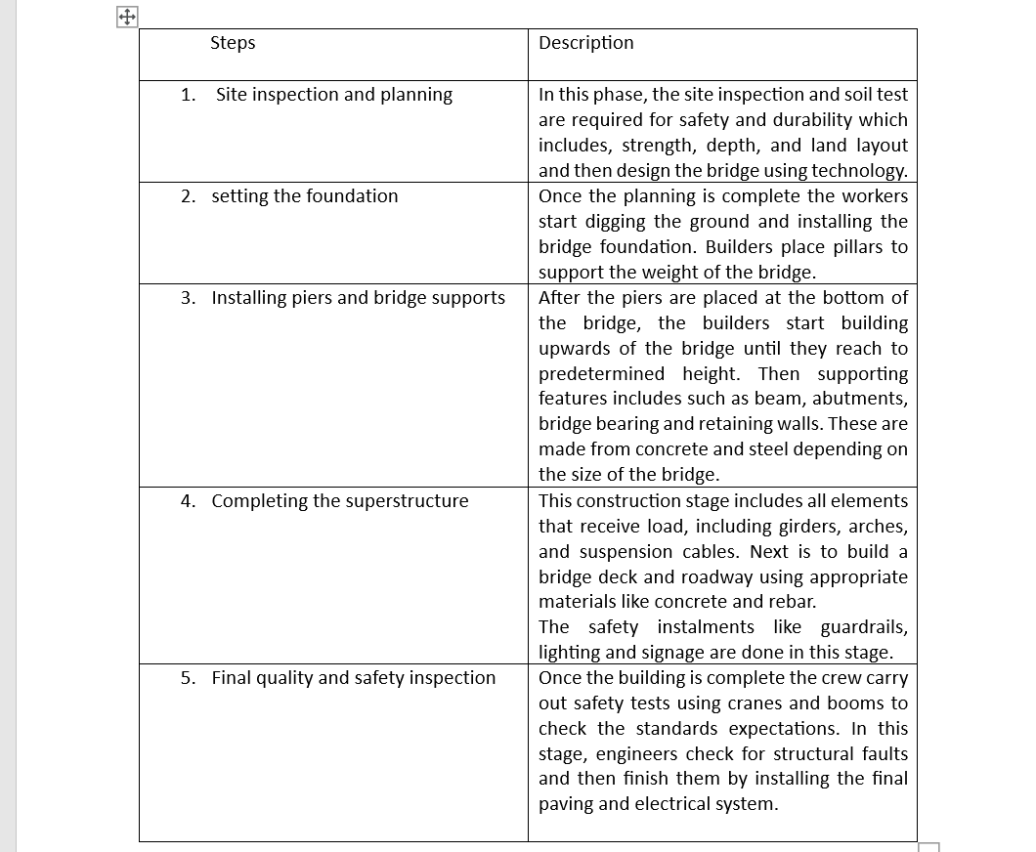
Figure 2 How are bridges built? A visual guide (BigRentz, 2023).

Quad Chart

A quad chart is displayed and explained below to create a clear framework and enable easy comparison and analysis of the project.
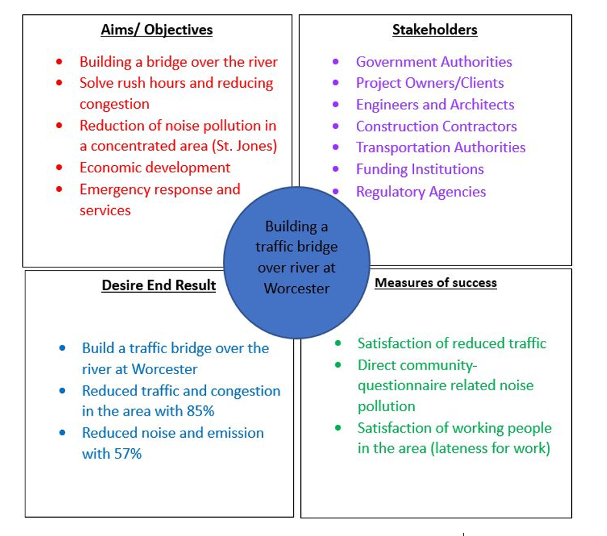
Figure 3 Quad chart (Agoba, 2023).

Aims / Objectives

Constructing a bridge aims to develop a structure that crosses a physical impediment while simultaneously serving numerous key functions.
- Transport: To provide a means for vehicles and pedestrians. Improve accessibility and reduce travel distances to facilitate community connections, trade facilitation, and transportation networks.
- Solve rush hours, and noise pollution and reduce congestion: Traffic congestion often leads to increased noise levels, especially in densely populated areas. By dispersing traffic across multiple bridges and routers, noise pollution can be minimized as vehicles are spread out rather than concentrated on a few roadways. The new bridge may also be designed with noise-reducing features such as sound barriers or low-noise road surfaces.
- Economic Development: Stimulate economic growth and development. Facilitate the movement of goods and services, attract investments, and open new areas for residential, commercial, and industrial expansion. Enhance regional prosperity, create jobs, and increase property values (Putnam et al., 2005).
- Emergency Response and Services: Provide critical access for emergency vehicles, such as ambulances and fire trucks, allowing for rapid response times during emergencies. Ensure that essential services, such as medical care, education, and utilities, are accessible to communities on both sides of the bridge (Munawar et al., 2022).
It is important to note that the effectiveness of a new bridge in achieving these benefits depends on various factors such as its location, design, and integration with the existing transportation network. Careful consideration and comprehensive planning are necessary to maximize the positive impacts and mitigate any potential negative consequences of building new infrastructure.

Stakeholder / Customers
- Government Authorities
- Project Owners/Clients
- Engineers and Architects
- Construction Contractors
- Transportation Authorities
- Funding Institutions
- Regulatory Agencies

Desire End Result

- Accessibility to essential services
- Reduced traffic and congestion in the area by 85%
- Reduced noise and emission by 57%
- Economic growth and development
Measures of success
- Satisfaction with reduced traffic
- Direct community questionnaire related to noise pollution.
- Satisfaction of working people in the area (no lateness for work)

Stakeholder analysis

Projects depend on the interest level of the stakeholders because the more interest involves the more success is possible to achieve. Therefore, project management must prioritise the stakeholder’s interest to implement their project. For this purpose, stakeholder analysis is a major key to starting the project management plan. The process of gathering information regarding every person that can affect the project or can be affected by the project is stakeholder analysis (Hoory, 2022).
The stakeholder analysis is the source that helps the project management process to identify each stakeholder’s interests, expectations, and requirements from the project and it has two stages. As the stakeholders for the Worcester bridge are outlined in the QUAD chart according to the analysis it is essential to create a stakeholder matrix to position each stakeholder into the right position. The interest and influence of each stakeholder have a huge effect on the project process. Therefore, effective communication and quick responses to each stakeholder are key to success.

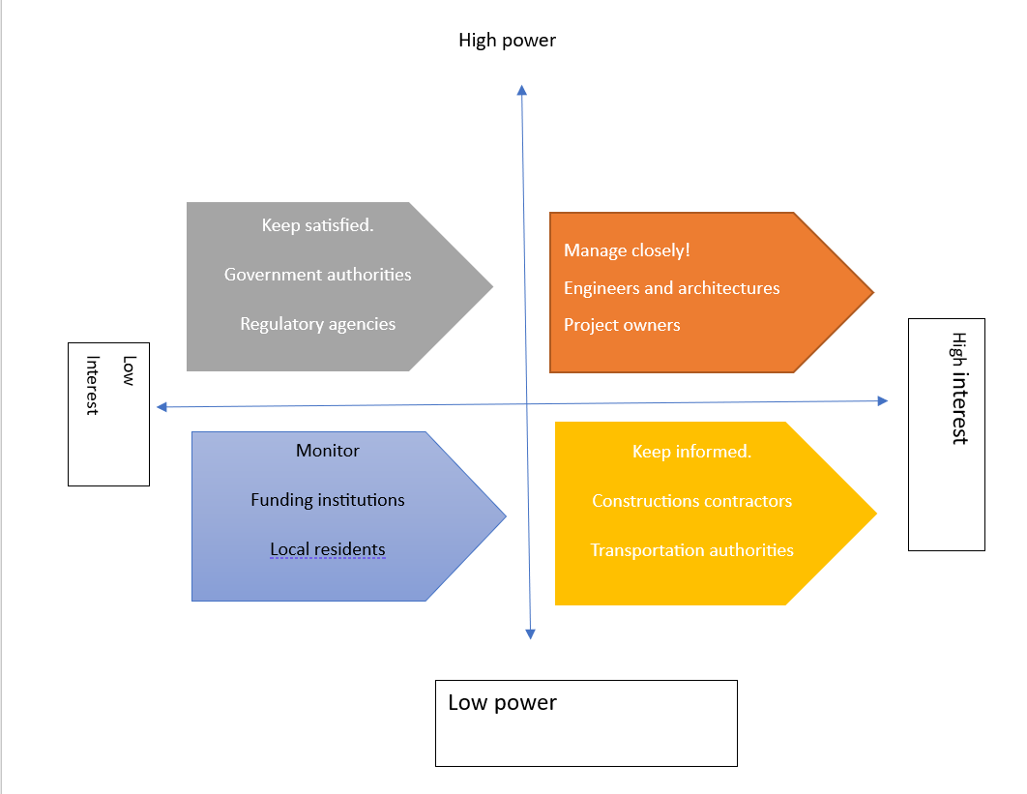
Figure 4 Stakeholders Analysis (Peachyessay, 2021).

The stakeholders are internal and external individuals with several project implementation roles. The government or municipality has a high impact because the approval of the project depends on their agreement. The second process of the construction plan requires the acceptance of board administrators to observe each phase and approve the project. The national government decision is the final approval that allows the project management team to start the operation (Peachyessay, 2021).
As the operation of construction creates loud noises and pollution which affects residents, the management must ensure health and safety and other precautions that lessen the disturbance in residents’ daily life.
A communication plan is vital for management to keep informed internal and external stakeholders regarding each activity taking place. This helps the workflow without any misunderstanding between workers and stakeholders (Peachyessay, 2021).
Furthermore, the important section of the stakeholder analysis is to categorise stakeholders with interest and influence measures. The project manager must provide more information and keep involving the stakeholders with high interest and high influence, for instance, project owners and engineers. On the other side, the manager must keep satisfied stakeholders with high power and low interest for example government.

SWOT analysis

The stakeholder analysis provides internal and external interests and involvement in the project, on the other hand, the SWOT analysis and PESTLE analysis support the project decision-making process more effectively. The strength, weaknesses, opportunities, and threats are internal and external factors that immensely impact any project management. Therefore, the report focuses on the SWOT analysis for the bridge construction application implementation. The process of SWOT requires an internal environment for recognizing strengths and weaknesses and an external environment for threats and opportunities (ARSLAN & Deha ER, 2007)
STRENGTH
The ProAngel company has previously successful projects for construction works because it has skilled managers, creative architectures with amazing design ideas, effective teamwork, and impressive communication during project implementation. The company has outstanding knowledge of managing projects and the ability to control every task and monitor every progress which makes it capable of building an amazing bridge.
WEAKNESS
The organisation has a successful history of construction work, however, a single misunderstanding leads to the failure of projects. Misconceptions in design and misunderstanding of information can affect the construction work. Lack of health and safety and protection measures may reduce or delay the construction work.
OPPORTUNITIES
The connections with stakeholders and investors are very important for identifying new opportunities and obtaining more projects. Building connections with reliable investors and financial arrangements. Cooperative team and management strategies for plans and projects in future.
THREATS
The challenges of construction work have an impact on the process, for instance, the manager leaving in the middle of work or miscommunication between workers and stakeholders, or lack of equipment can lead to threats and challenges. Government policies and regulations are the major threats to delay construction work. Weather and residents can be threats to construction work (Munroe, 2016).

Work breakdown structure
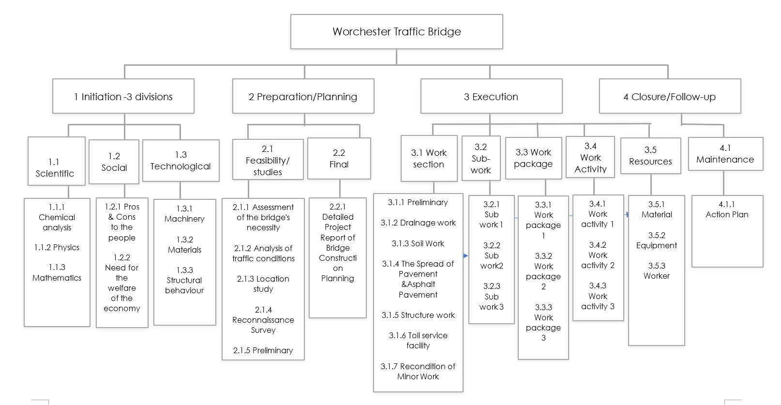
Figure 5 Work Breakdown Structure ( Bridge Construction Planning, 2017), (Kurnia, Latief & Riantini, 2018).

The Preparation for bridge construction consists of several key stages grouped into 2 main categories: feasibility & studies, and the final stage.
The most important steps to follow during the feasibility & studies stage:
- Assessment of the bridge's necessity through an examination of its socio-economic viability
- Analysis of traffic conditions considering the following aspects:
- Determining the number of lanes required for road or railway tracks.
- Defining geometric design parameters
- Assessing the societal benefits derived from the project.
- Location study is crucial to carefully consider the necessity and positioning of any cross-drainage structures if applicable. The river upstream should have a straight course. Additionally, any bends in the downstream section should be avoided. During flood events, measures must be implemented to safeguard the bridge’s approaches against potential flood damage or significant spills. It is advisable to minimize costs associated with constructing high-priced approaches. Ideally, the bridge route should pass through built-up areas, high hills, major basins, or religious structures.
- Reconnaissance Study, which includes exploring different options and evaluating feasible alternatives.
- Preliminary Engineering, involving creating plans, developing initial designs and cost estimates and lastly evaluating alternatives, conducting a risk analysis, and making the final selection.

Once the feasibility & studies are completed, the Final Stage is the Detailed Project Report. This phase marks the concluding stage of planning in bridge construction, preceding the initiation of actual construction. It involves conducting thorough investigations and documenting the findings in detail. The investigations carried out encompass ground survey, soil exploration, gathering hydrological data and performing model studies and analysis (Bridge Construction Planning, 2017).

The Execution phase encompasses Work Section, Sub-Work and Work Package detailed on Page 1 under section 3. The work methods alternatives are reflected in the breakdown of work activities and resources (Kurnia, Latief & Riantini, 2018).
Once the project is executed, the final step is Closure & Follow-up. This outlines the action plan for the continuous implementation of the bridge maintenance cycle. It further elaborates on the organizational structure, functions, and principles related to bridge maintenance. The action plan is to be completed by following procedures:
- Bridge Inspection
- Condition Assessment
- Planning and Budgeting
- Supervision of the work
- Recording the inspection results in the database
- Conducting Maintenance Operation Meetings
- Maintenance Expert Training
- Database Management
- Action Plan Implementation
(JICA,2018)

Gantt Chart

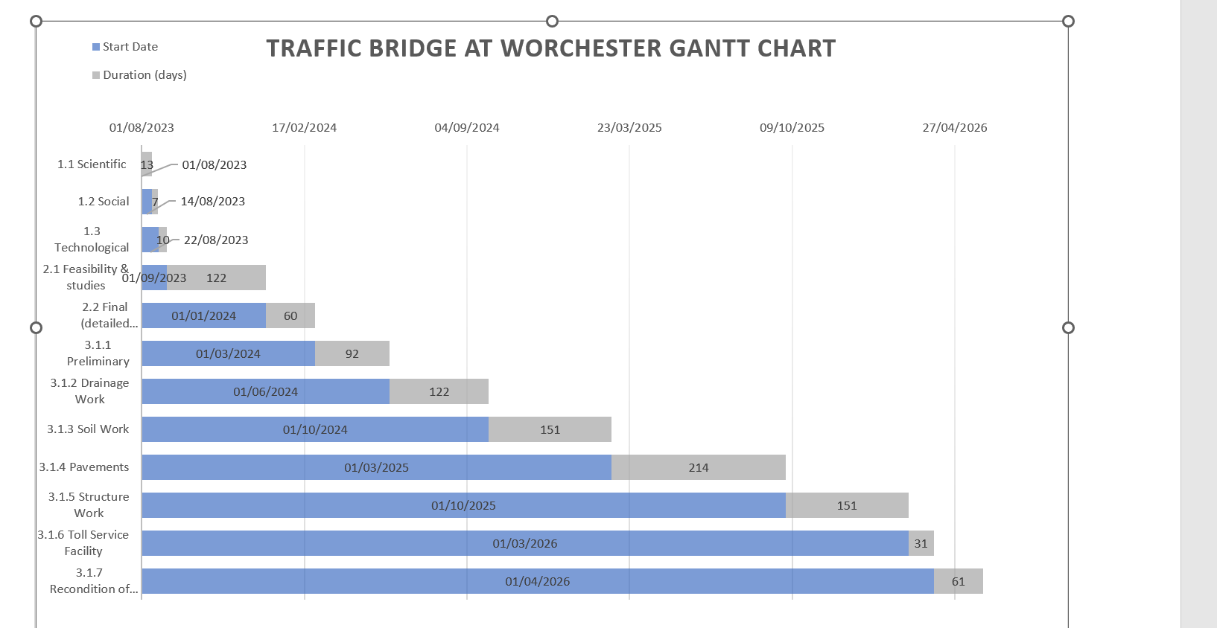
Figure 6 Gantt Chart (Agoba, 2023).

Allocation of resources

The work breakdown structure defines the activities and phases required to complete the bridge construction work. The next stage is to assign these tasks to the project team to start the operation. The assignment responsibility matrix is essential for the project team to recognise their roles and responsibility and avoid misunderstandings and delays. The responsibility matrix must have an accountable person to monitor tasks, materials, and labour hourly rate and estimate the total budget for the project of construction work. The cost breakdown structure is a mandatory resource to add labour rates, work, and cost estimates to the responsibility matrix.
On the other hand, it assists in the estimation of materials, expenses and consumables that is necessary to complete the tasks.

Cost breakdown structure

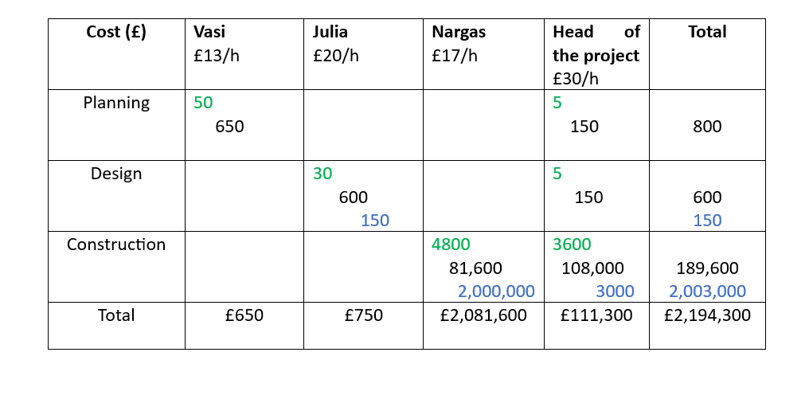
Figure 7 Cost Breakdown Structure (Agoba, 2023).

Risk analysis

Risk assessment is indeed an essential and integral part of the project management process. It involves identifying, analysing, and evaluating potential risks that may affect the project's objectives, outcomes, timeline, or resources. Risk assessment provides valuable insights that enable project managers and teams to develop appropriate risk management strategies and contingency plans (Nieto-Morote and Ruz-Vila, 2011).

Below, you will find a list of potential risks that could impact the project:
- Design and Engineering Risks
- Construction Risks
- Environmental Risks
- Cost and Budget Risks
- Stakeholder Risks
- Safety and Security Risks

After identifying the risks, it is important to analyse and prioritize them by considering their likelihood of occurring and the potential impact they may have on the project. This process will enable to develop strategies that effectively mitigate, avoid, or manage these risks throughout the project's duration.

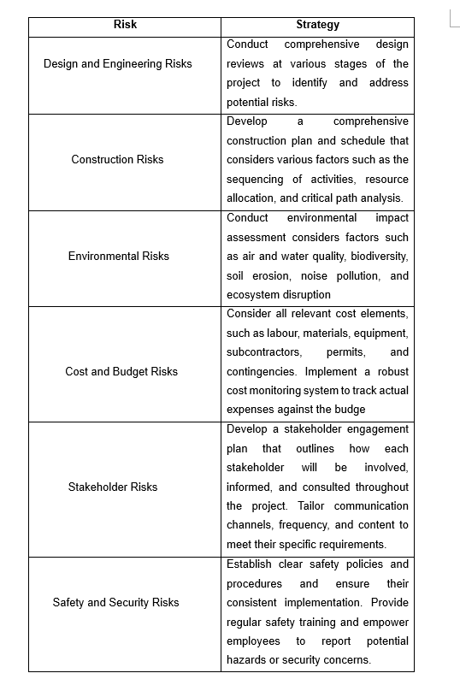
Figure 8 Risks and Strategies (Munawar, H.S. et al., 2022).

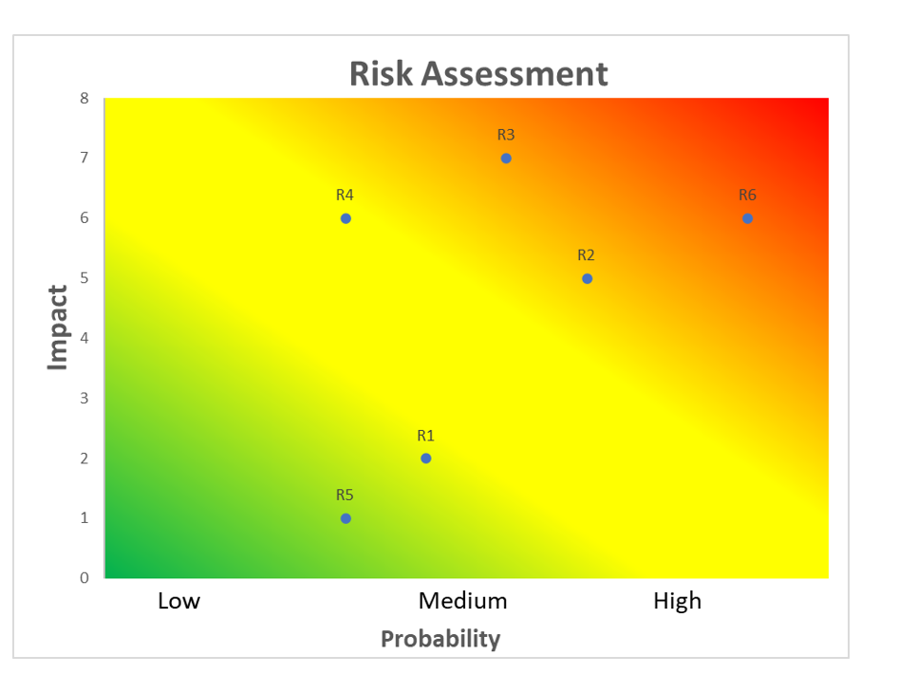
Figure 9 Risk Assessment (Munawar, H.S. et al., 2022).

Once the Risk Assessment has been completed, the identification of environmental and safety concerns with high impact and likelihood becomes a priority. The subsequent sections delve into a detailed discussion of risk mitigation and contingency plans for addressing these concerns.
Environmental Risk (R3) - Risk Mitigation
Engaging with environmental experts or consultants to ensure compliance with environmental standards and guidelines. Implementing measures to minimize environmental impacts, such as sediment control measures, erosion prevention techniques, and waste management practices. Developing and enforcing strict construction practices to prevent soil erosion, water pollution, or habitat destruction.

Contingency Plan
Establishing a contingency budget for unforeseen environmental risks or regulatory changes that may require additional resources. Maintain open lines of communication with regulatory authorities and environmental agencies to promptly address any emerging issues or changes in environmental requirements. Developing alternative construction methodologies or project schedules that can be implemented if specific environmental constraints arise.
Safety and Security Risks (R6) - Risk Mitigation
Developing a comprehensive safety plan that includes safety protocols, guidelines, and training for all project personnel. Conducting regular safety inspections and audits to identify potential hazards and ensure compliance with safety regulations.

Contingency Plan
Designating responsible individuals or teams for managing emergencies and ensuring their readiness through regular drills and training. Developing alternative project schedules or resource plans that can accommodate potential safety-related delays or disruptions.

Conclusion

Bridges are built to connect destinations and make journeys effortless. The project of building the Worcester city bridge impacts the whole environment. This project has many positive aspects that reduce congestion and provide more convenience in the area. However, proper planning is compulsory to achieve the desired goals. The scope of the project and risk assessment must measure every opportunity for success. The communication channels with stakeholders should be very effective and practical to avoid delays and distractions. The work breakdown structure and cost structure require operation in an understanding manner to conclude desirable achievement. Each activity prefers good monitoring and investigation to prevent failure of project management.
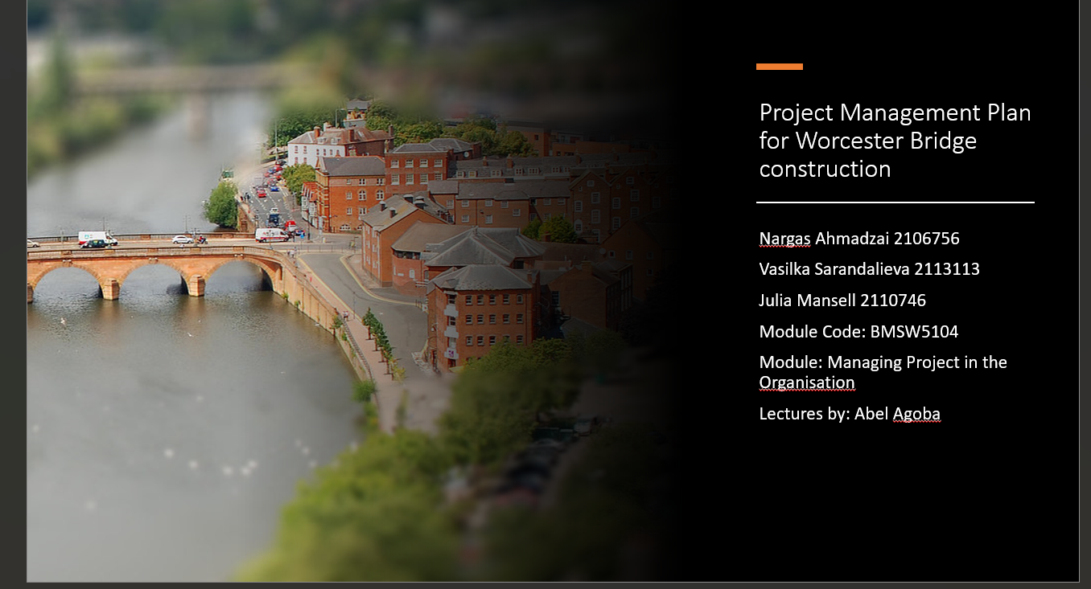

References

- Agoba, A. (2023)’ Week four project management scope, [ PowerPoint presentation]. BMSW5104: Managing projects in organisations. Available at: UWTSD (Accessed:2023)
- Agoba, A. (2023)’ Week three Quad chart and stakeholder analysis’ [ PowerPoint presentation]. BMSW5104: Managing projects in organizations. Available at: UWTSD (Accessed: 2023)
- ARSLAN, O. and Deha ER, I. (2007) A SWOT analysis for successful bridge team organization and safer ..., AIChE. Available at: https://aiche.onlinelibrary.wiley.com/doi/10.1002/prs.10209 (Accessed: 20 June 2023).
- Bridge Construction Planning (2017). Available at: https://theconstructor.org/structures/bridge-construction-planning/15656/ (Accessed: 23 June 2023)
- Globerson, S. and Zwikael, O., 2002. The impact of the project manager on project management planning processes. Project management journal, 33(3), pp.58-64.
- Hoory, L. (2022) What is a stakeholder analysis? everything you need to know, Forbes. Available at: https://www.forbes.com/advisor/business/what-is-stakeholder-analysis/ (Accessed: 20 June 2023).
- JICA. (2018). Bridge Maintenance Planning Manual. Available at: https://openjicareport.jica.go.jp/pdf/12304002.pdf (Accessed: 23 June 2023).
- Kurnia, RF, Latief, Y & Riantini, LS 2018, The development of risk-based standardized WBS (Work Breakdown Structure) for cost estimation of concrete Precast bridge construction. in Proceedings of the International Conference on Industrial Engineering and Operations Management, IEOM 2018. Proceedings of the International Conference on Industrial Engineering and Operations Management, vol. 2018-March, IEOM Society, pp. 731-739, 8th International Conference on Industrial Engineering and Operations Management, IEOM 2018, Bandung, Indonesia, 6/03/18.
- Munawar, H.S. et al. (2022) ‘Disruptive Technologies as a Solution for Disaster Risk Management: A Review’, Science of The Total Environment, 806, p. 151351. doi: 10.1016/j.scitotenv.2021.151351. Available from https://doi.org/10.1016/j.scitotenv.2021.151351 [Access: 20/06/2023]
- Munroe, S. (2016) SWOT analysis for building development, Small Business - Chron.com. Available at: https://smallbusiness.chron.com/swot-analysis-building-development-42456.html (Accessed: 20 June 2023).
- Nieto-Morote, A. and Ruz-Vila, F. (2011) ‘A fuzzy approach to construction project risk assessment’, International Journal of Project Management, 29(2), pp. 220–231. doi: 10.1016/j.ijproman.2010.02.002.
- Peachyessay (2021) Constructing a bridge: Development of a city, Peachy Essay. Available at: https://peachyessay.com/sample-essay/constructing-a-bridge-development-of-a-city/ (Accessed: 20 June 2023).
- Putnam, M. et al. (2005) ‘Building Financial Bridges to economic development and Community Integration’, Journal of Social Work in Disability &amp; Rehabilitation, 4(3), pp. 61–86. doi:10.1300/j198v04n03_06. Available from https://doi.org/10.1300/J198v04n03_ [Access: 19/06/2023]
- Robichaud, L.B. and Anantatmula, V.S. (2011) ‘Greening Project Management Practices for Sustainable Construction’, Journal of Management in Engineering, 27(1), pp. 48–57. doi:10.1061/(asce)me.1943-5479.0000030. Available from https://d1wqtxts1xzle7.cloudfront.net/31090393/11-libre.pdf?1392250501=&response-content- [Access: 20/06/2023]
- Three Dimensions of Planning for Bridge Construction (2017) Available at: https://theconstructor.org/structures/bridge-construction-planning/15656/ (Accessed: 22 June 2023).
- Vitalii (2022) 5 phases of Project Management Life Cycle You Need to Know, project. Available at: https://project-management.com/project-management-phases/ (Accessed: 19 June 2023).

