Student name and number: Nikolay Todorov Terziev 2028389
Module code: LCBB5000
Module leader: Zahra Mohammadnazari
Assignment Title: Data handling and Business Intelligence
Contents
Introduction 3
Mean median and mode for the reading score 3
Standard deviation and variables 9
Interpreting the outcomes 20
Pivot table 21
SPSS Correlation and Scatterplot 24
Advantages of different Data handling software 30
Excel 31
SPSS 31
Tableau 32
The Data mining cycle 32

Introduction
As a data analyst I will explore the Excel file ‘Student Performance’ and help present the data in different ways as well as analysing it to draw conclusions. I will use Excel and also SPSS for my analysis and different visualizations.
The assignment will be split into two sections, section 1 in which I wll use Excel and SPSS to analyse the dataset, here I will work out the mean median and mode for the reading score, the standard deviation for the writing score, the variances and which is the largest, the standard deviations and which is the largest, and I will interpret the outcomes and give some analysis on the situation.
I will then go on to use Pivot tables to show how we can easily show the data and look for different correlations.
After that a more in-depth analysis will be made with the use of SPSS to find correlations between writing and reading scores, and a scatterplot will be made to give a visual way to see the correlations easily.
In section 2 which comes after I will discuss about the different softwares commonly used for data analysis and visualization, these being Excel, SPSS and Tableau. I will talk about advantages and disadvantages while giving examples of it.
Finally I will explain what the data mining cycle is and why it is important, as the software discussed in this assignment all exists for the purpose of data mining.

Mean median and mode for the reading score
To calculate these we will start by choosing any cell and writing in our formula for the mean, which will be =AVERAGE(
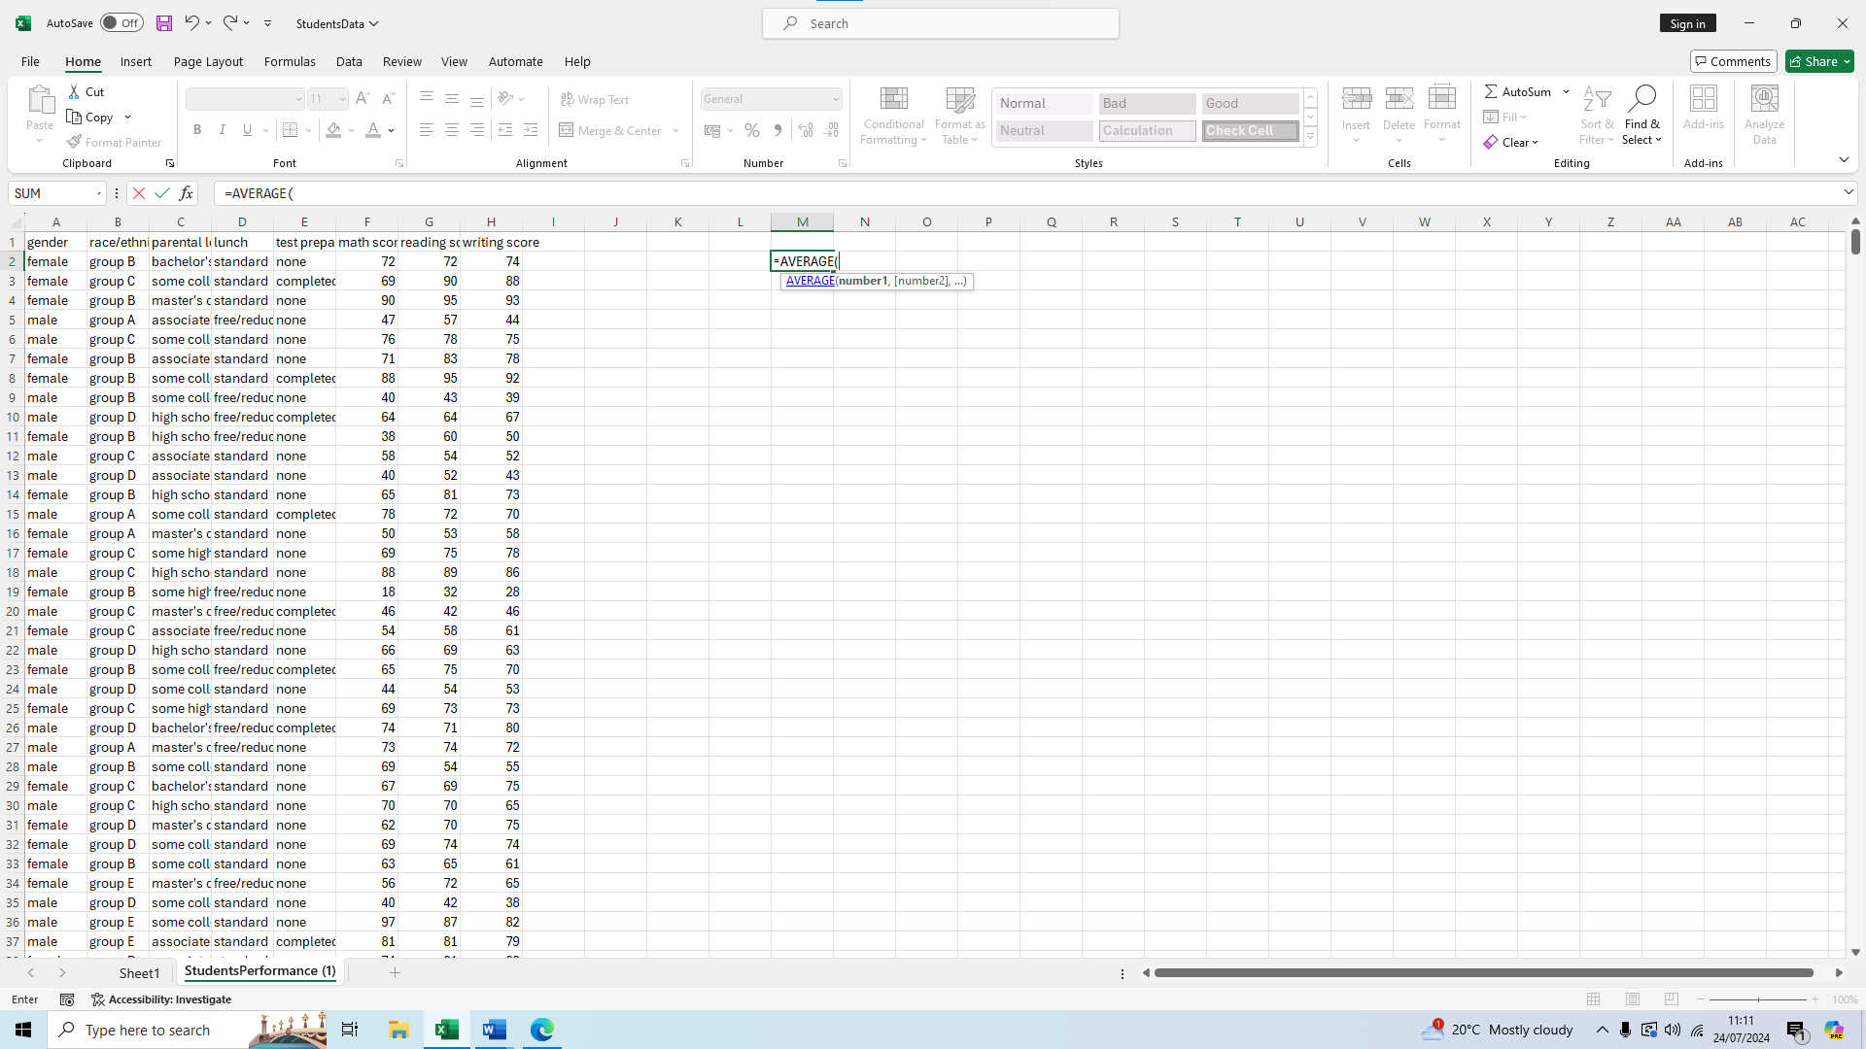
We then select the first value of the reading score which will be cell G2 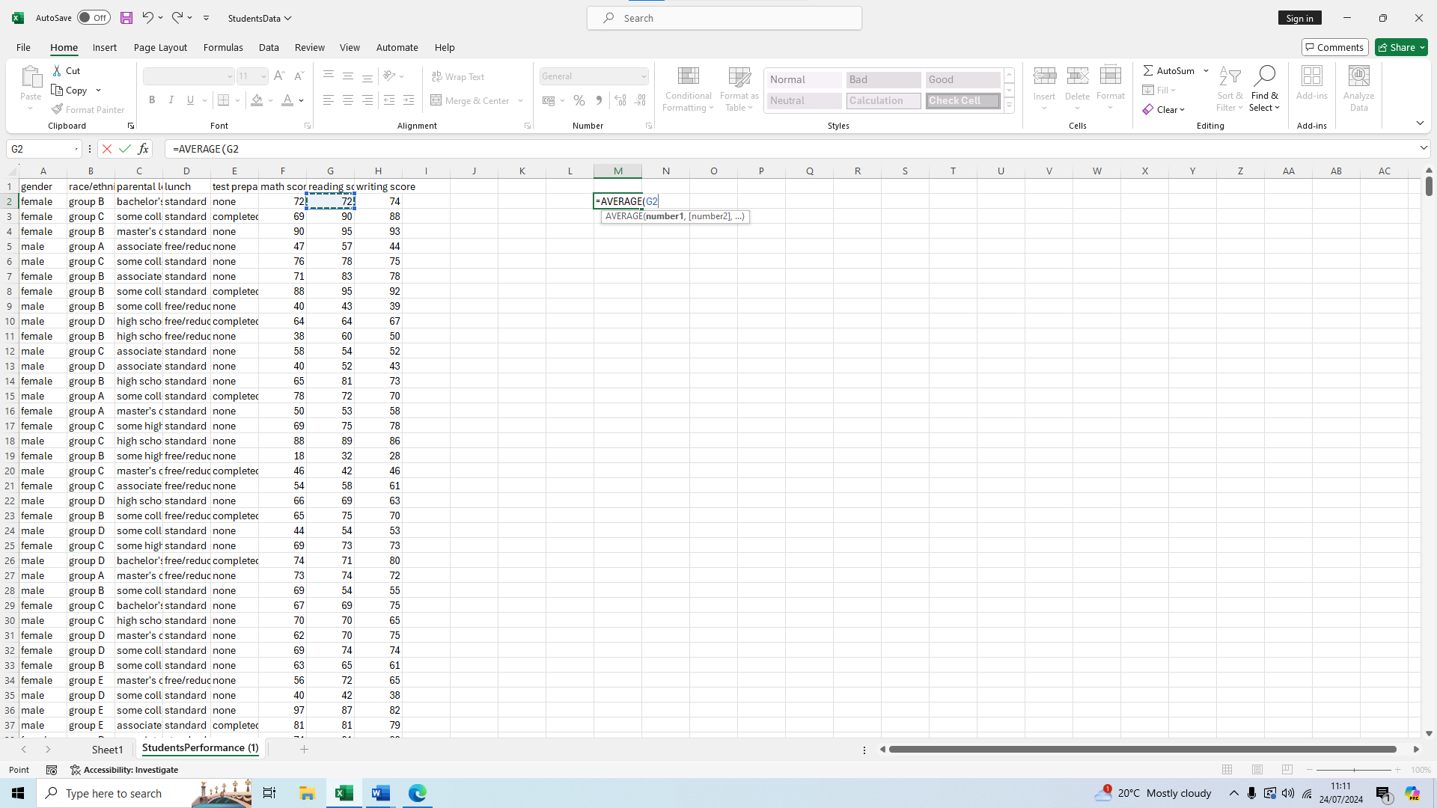
We then drag from G2 all the way down to G1001 to select our range of values
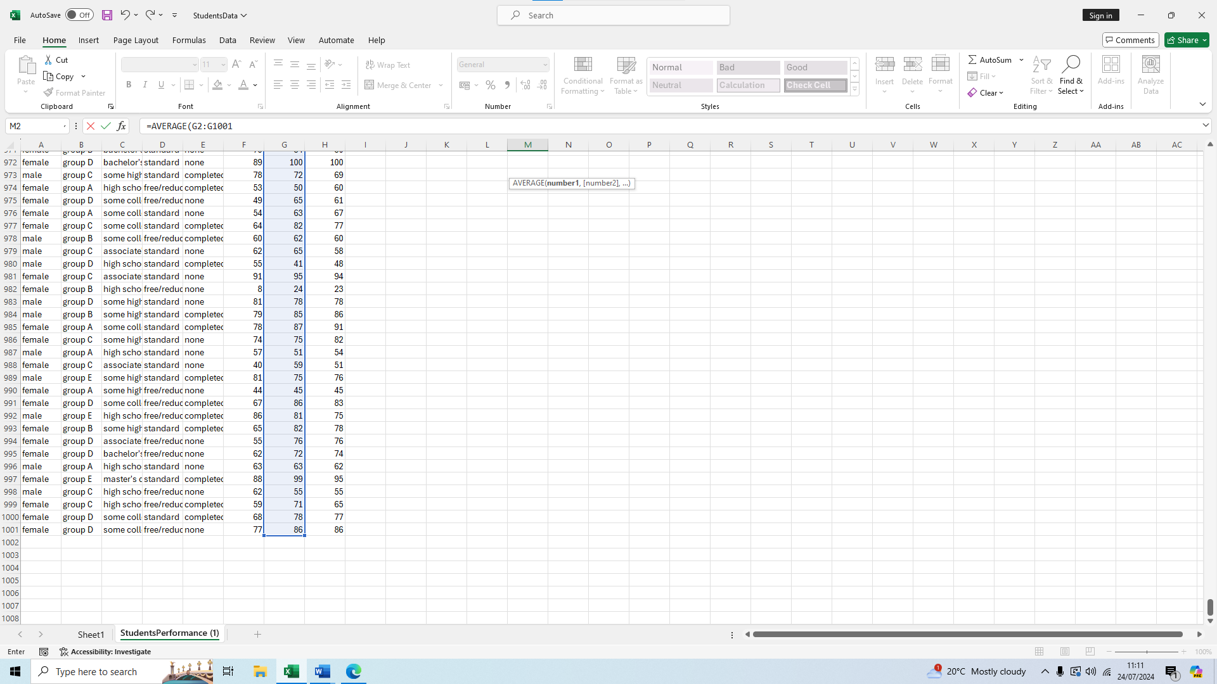
We press enter and we have our mean score of 69.169
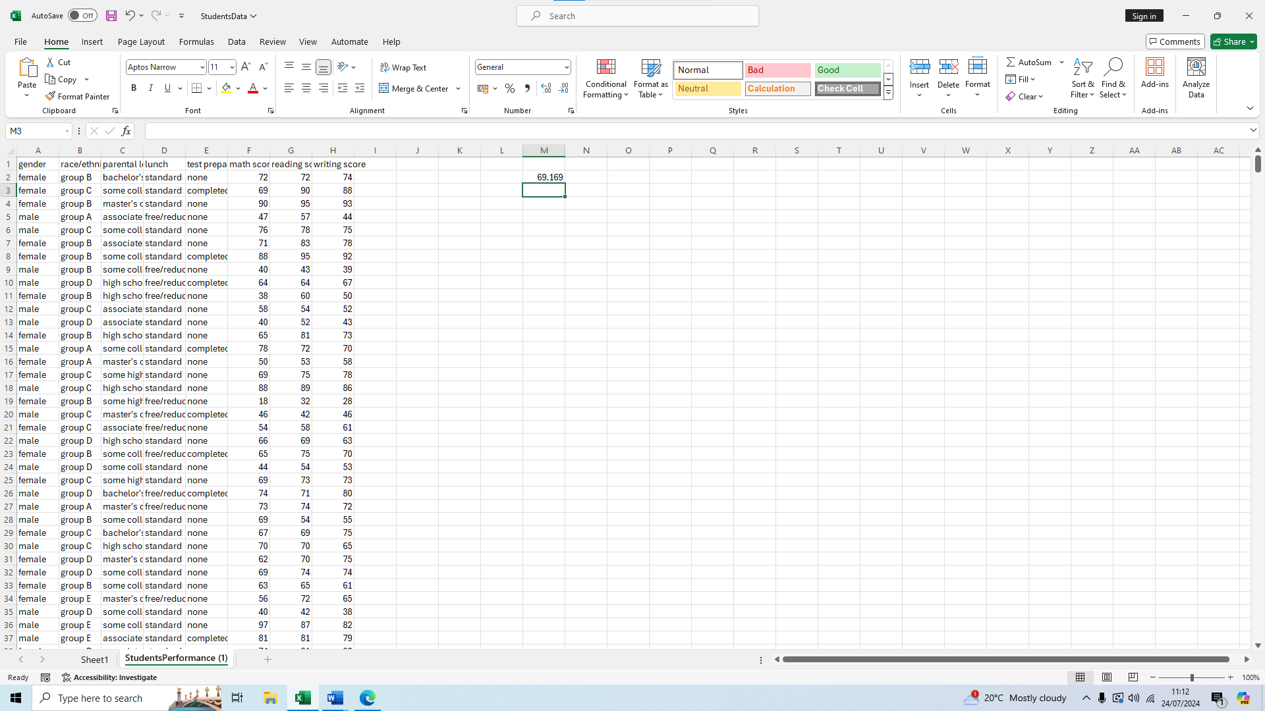
Now onto the median, we type our formula =MEDIAN(
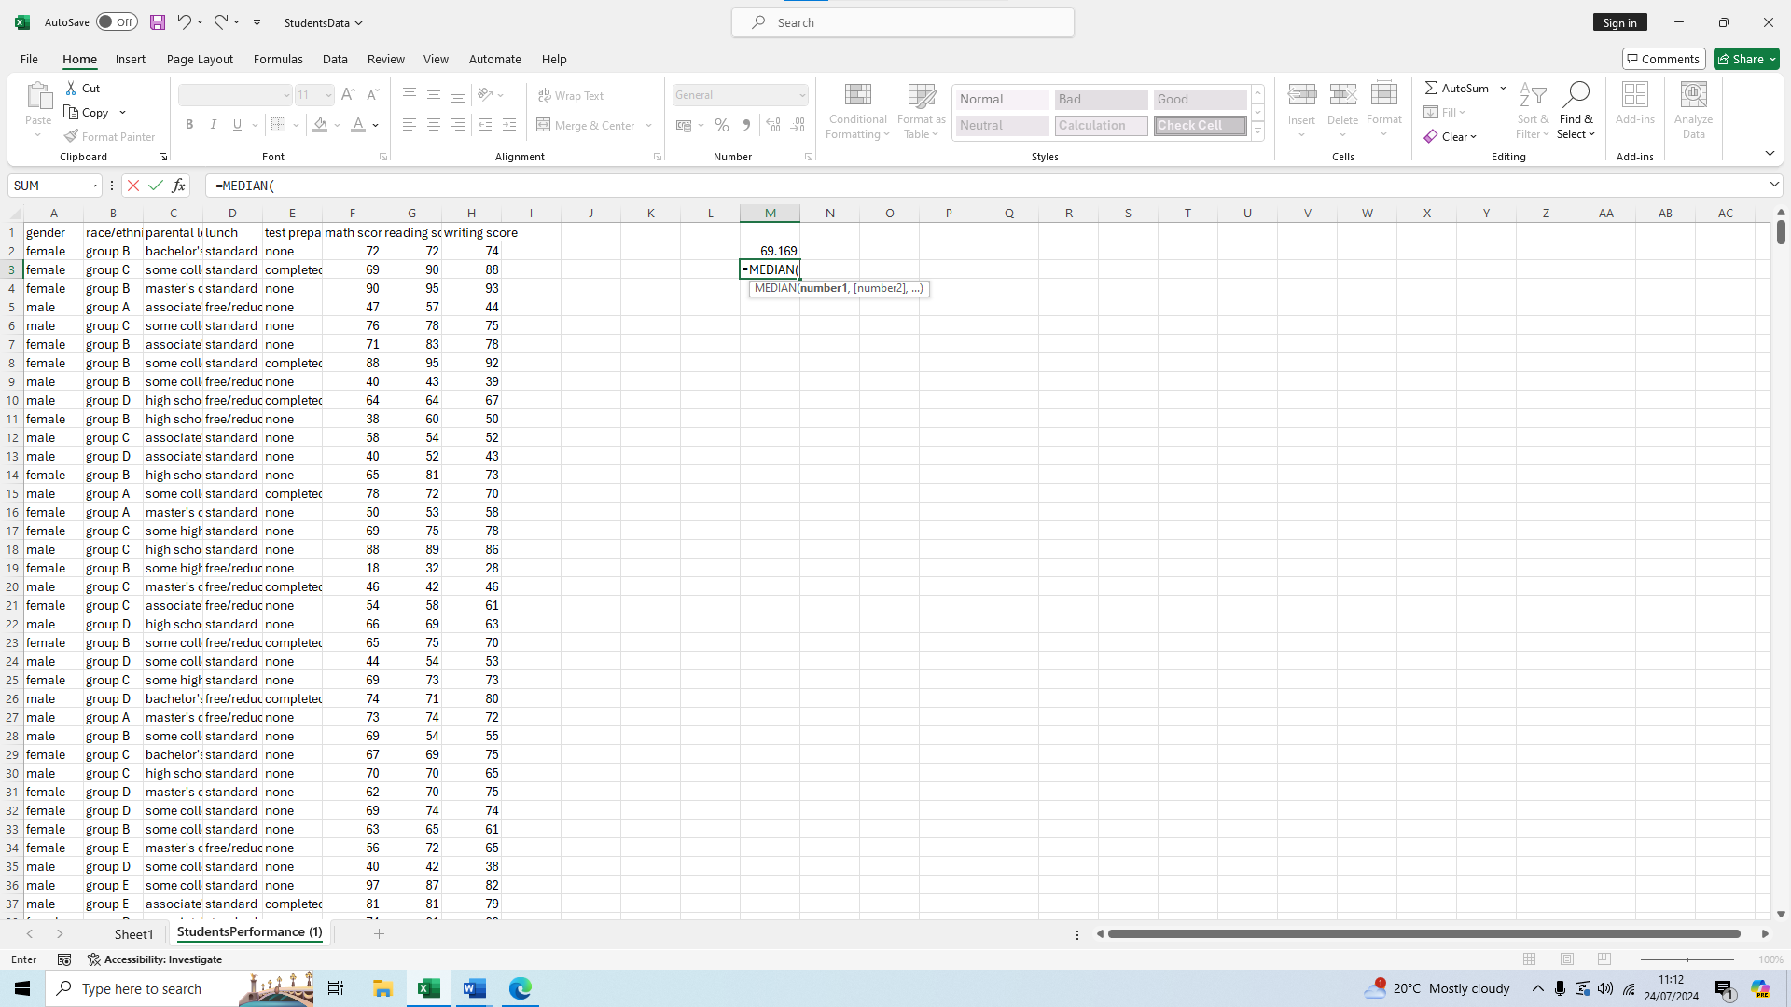
We select the G2 cell 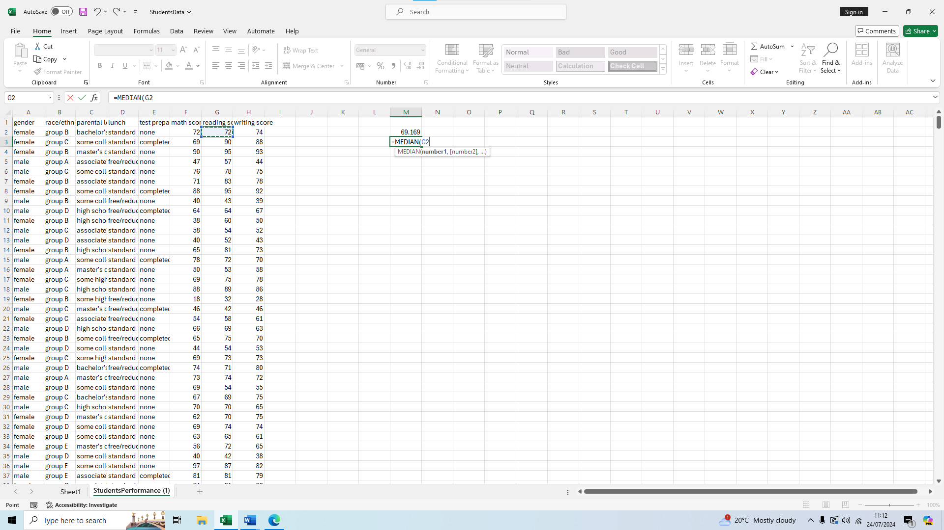
And we drag down to G1001 to finish our selection
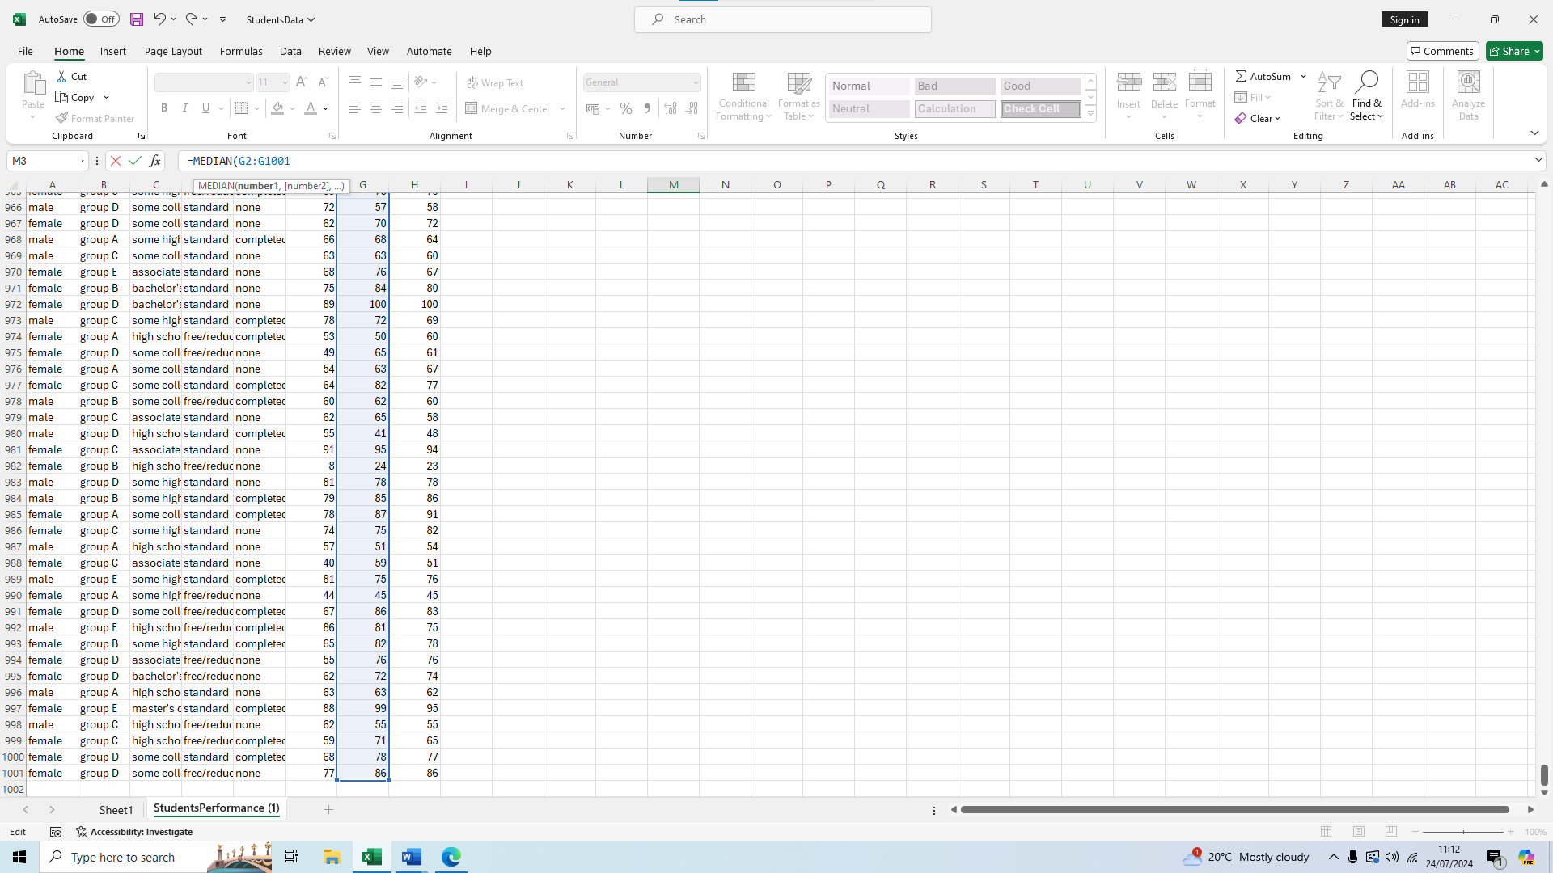
We press enter and we have our median score of 70
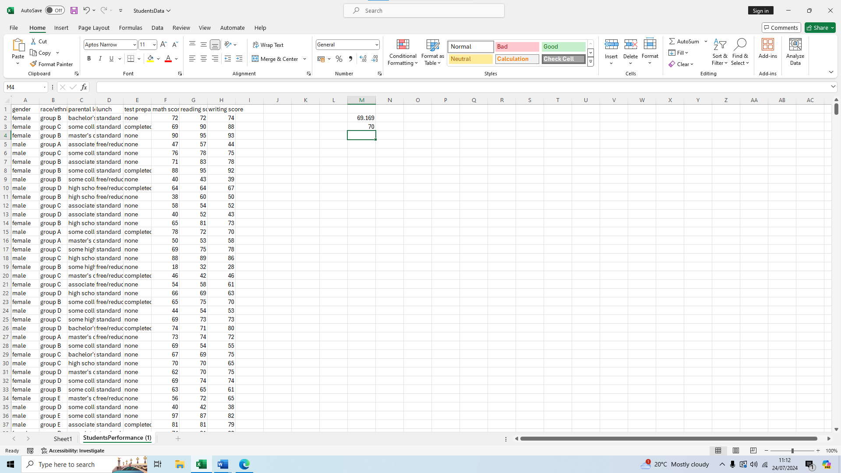
Finally for the mode, we write our formula =MODE(
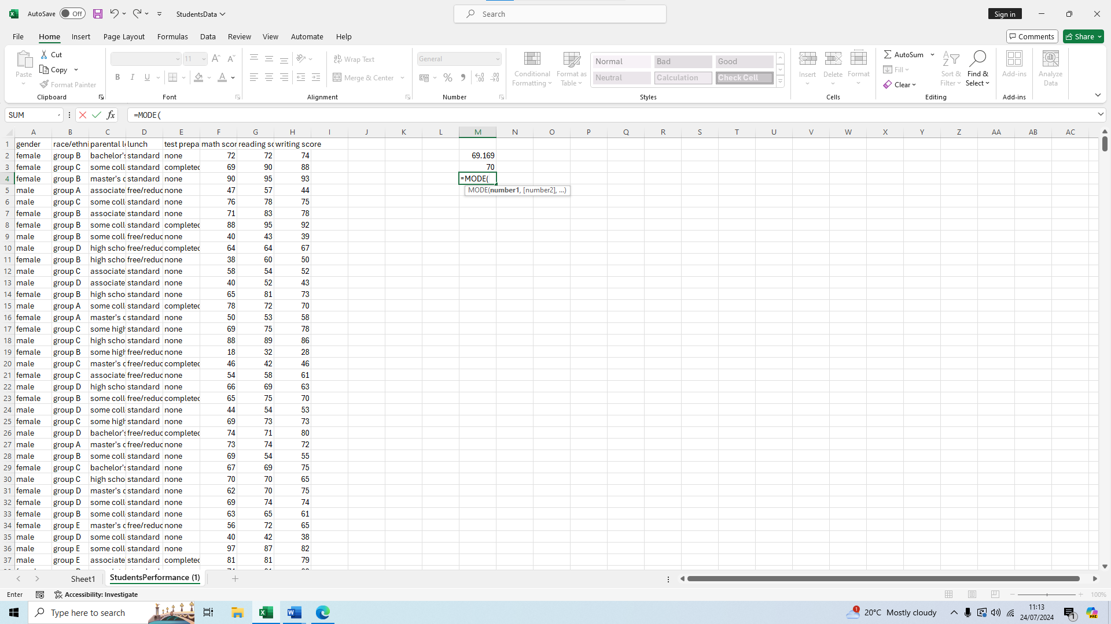We select the G2 cell
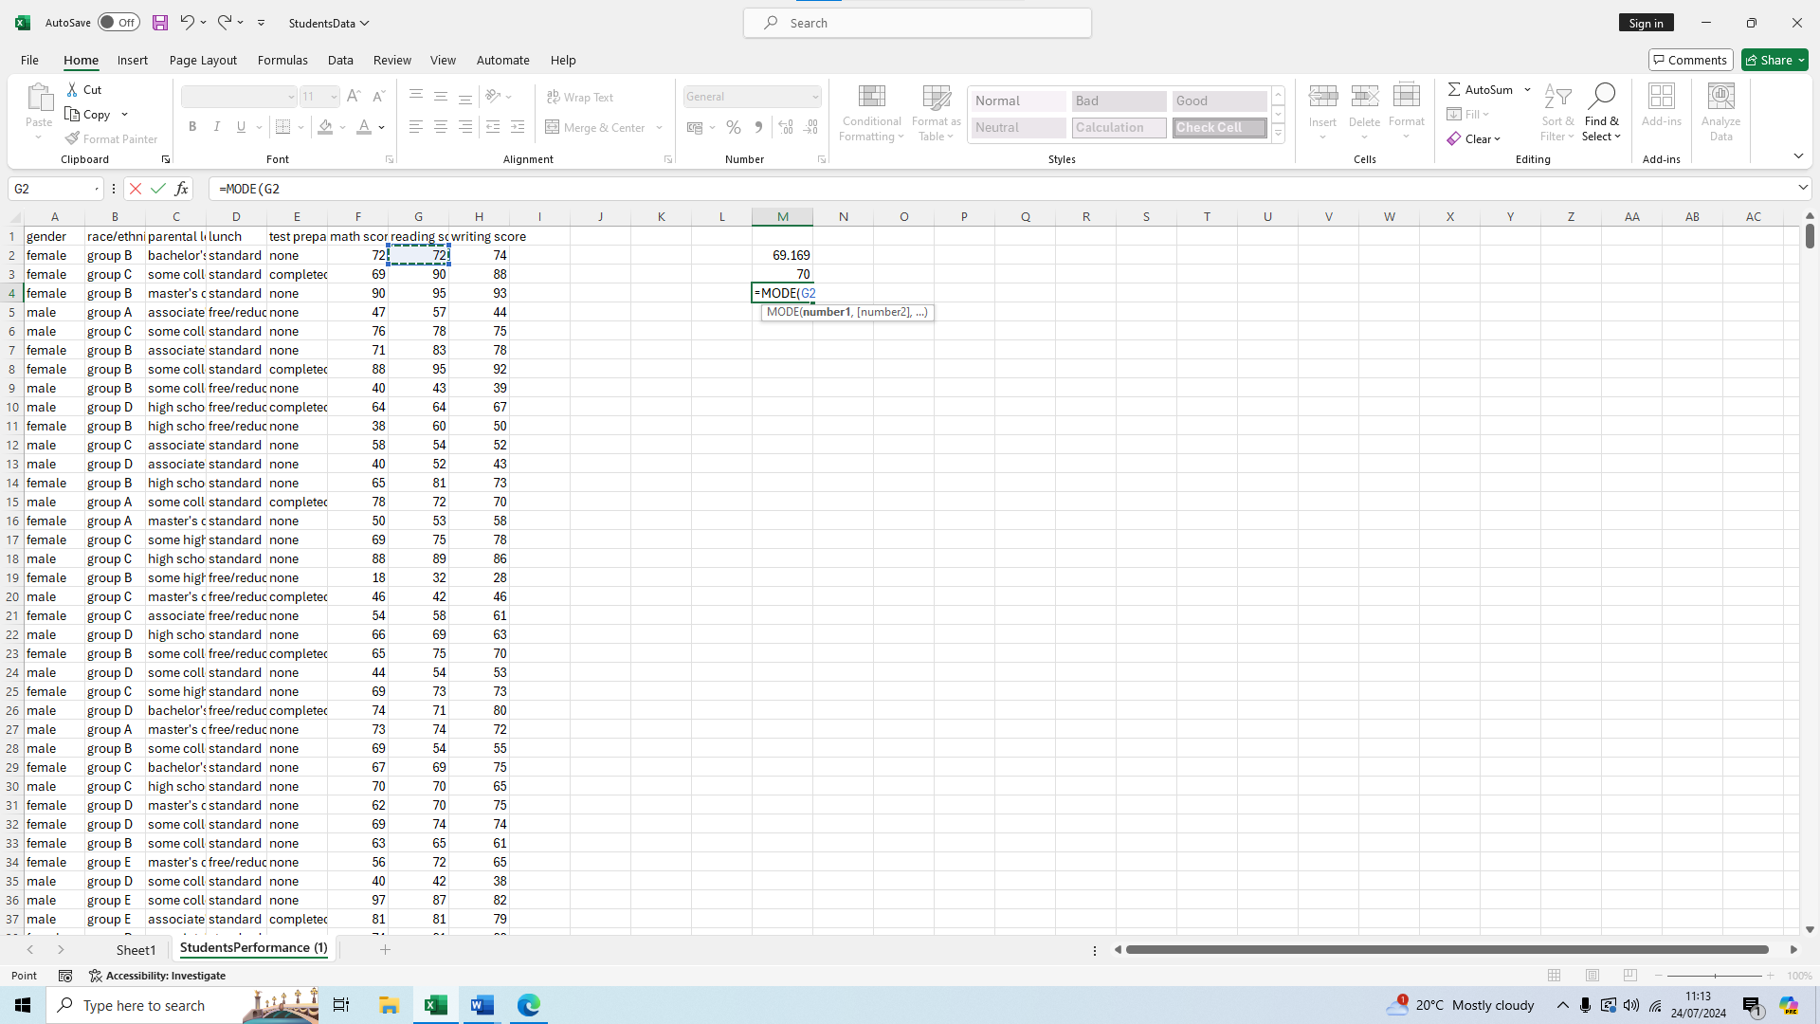
We then drag down to G1001 to finish our selection 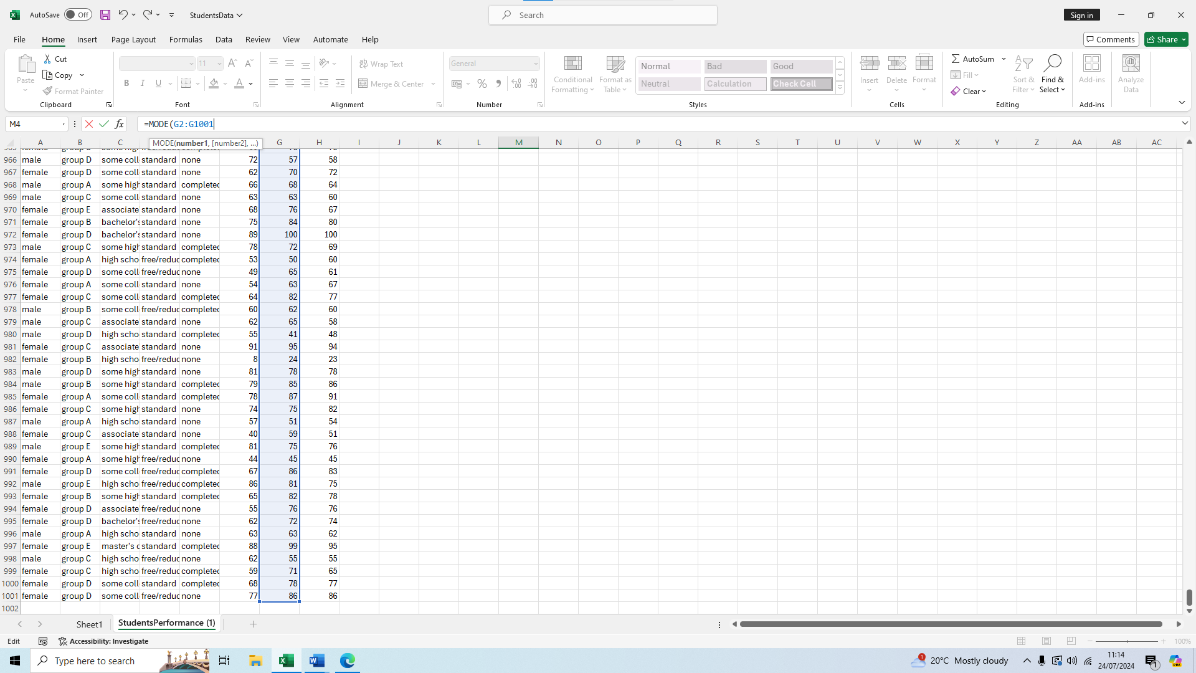We press enter and we have our mode score of 72
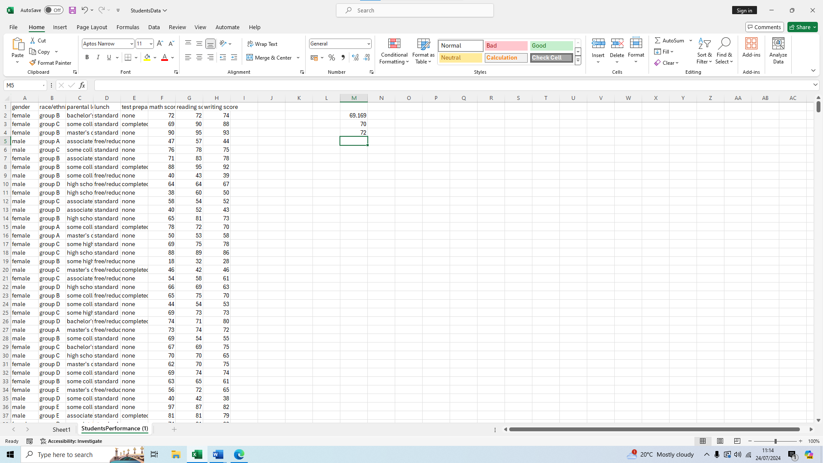

Standard deviation and variables
To calculate the standard deviation of the writing score we first type our formula, =STDEV.P(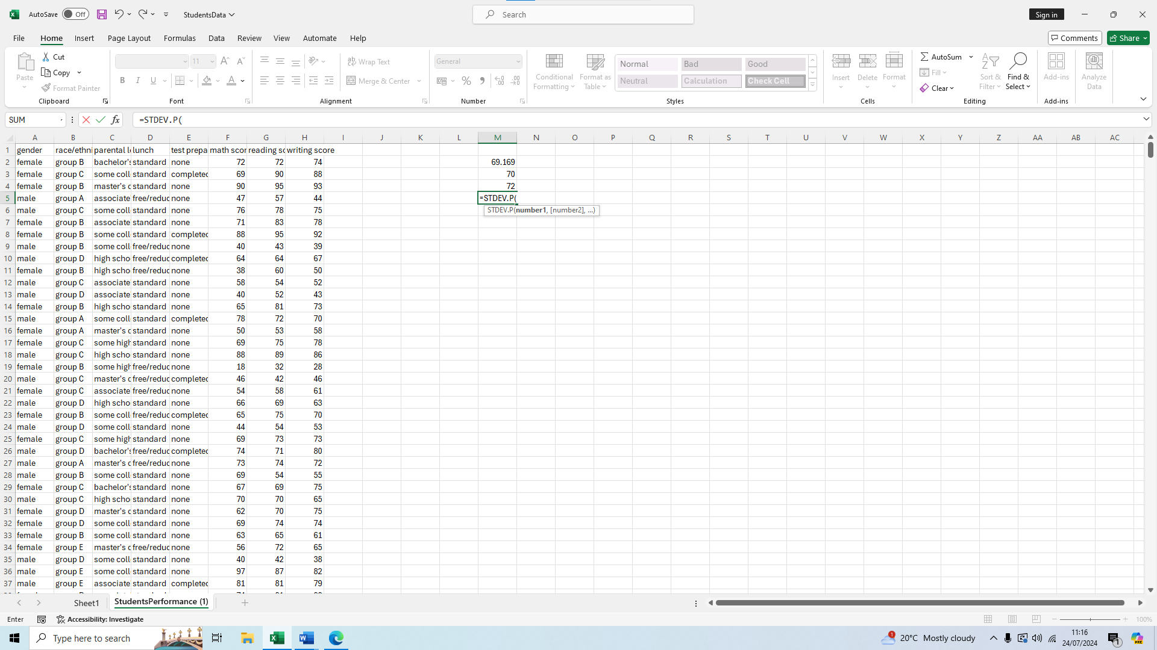We then select cell H2 as we are doing writing score this time
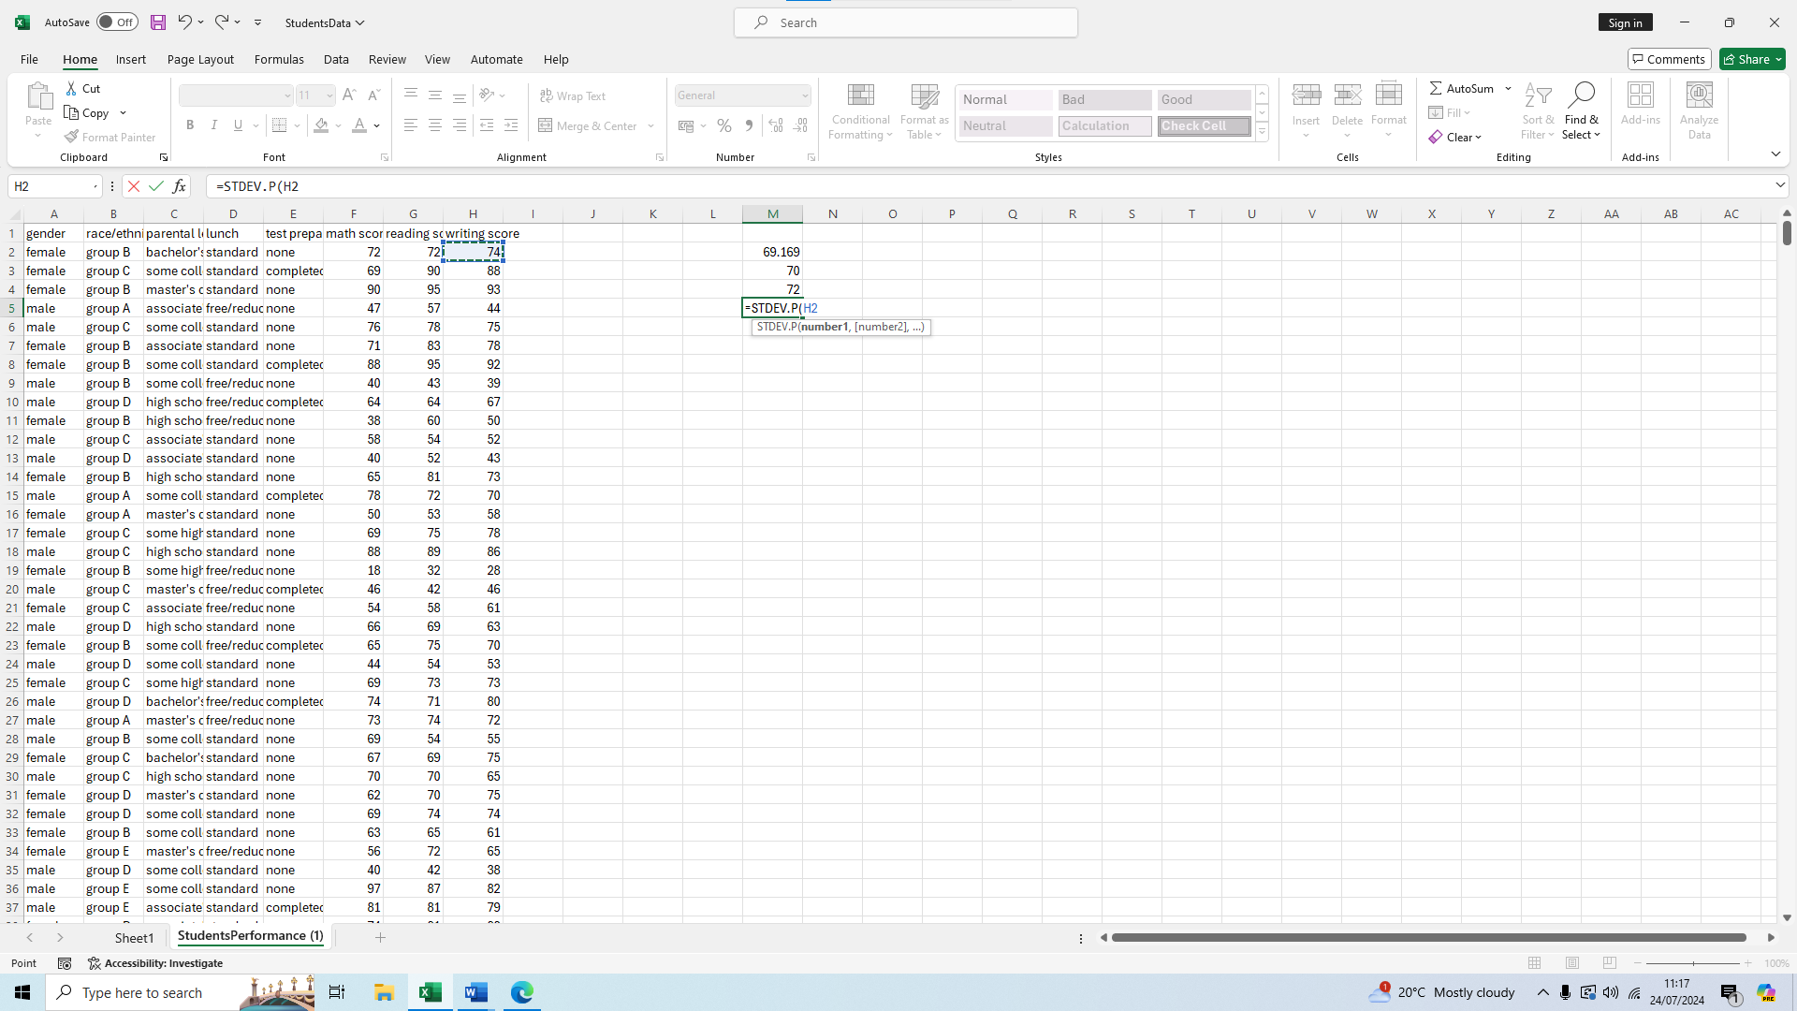 We then drag down all the way to H1001 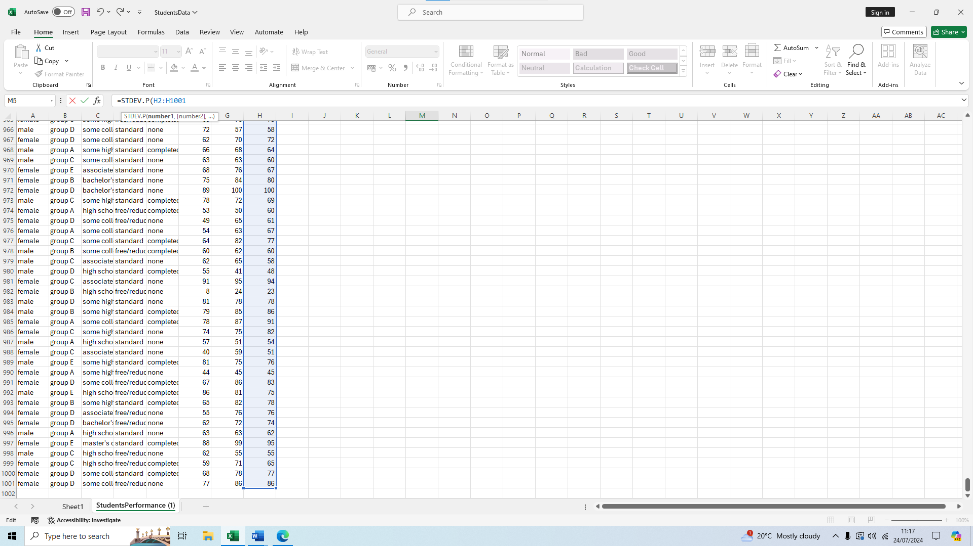Then we press enter and get our standard deviation for writing score of 15.18806 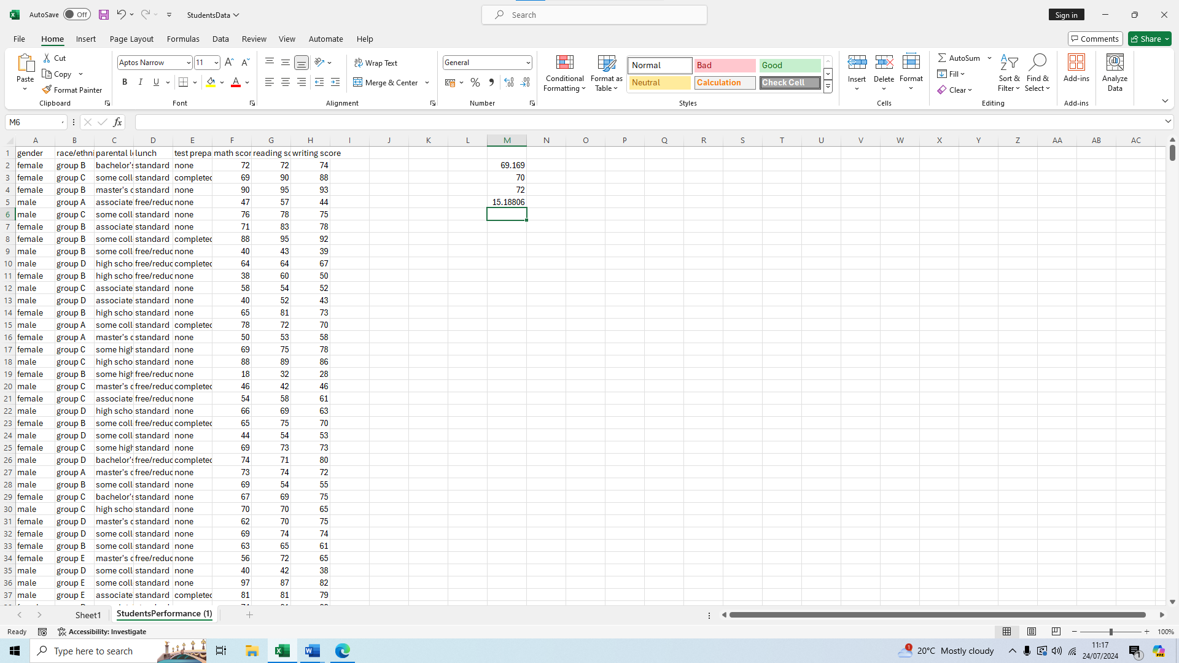
We are now going to calculate the variances of the three variables to see which one is largest
To do this we will use the formula =VAR.P(
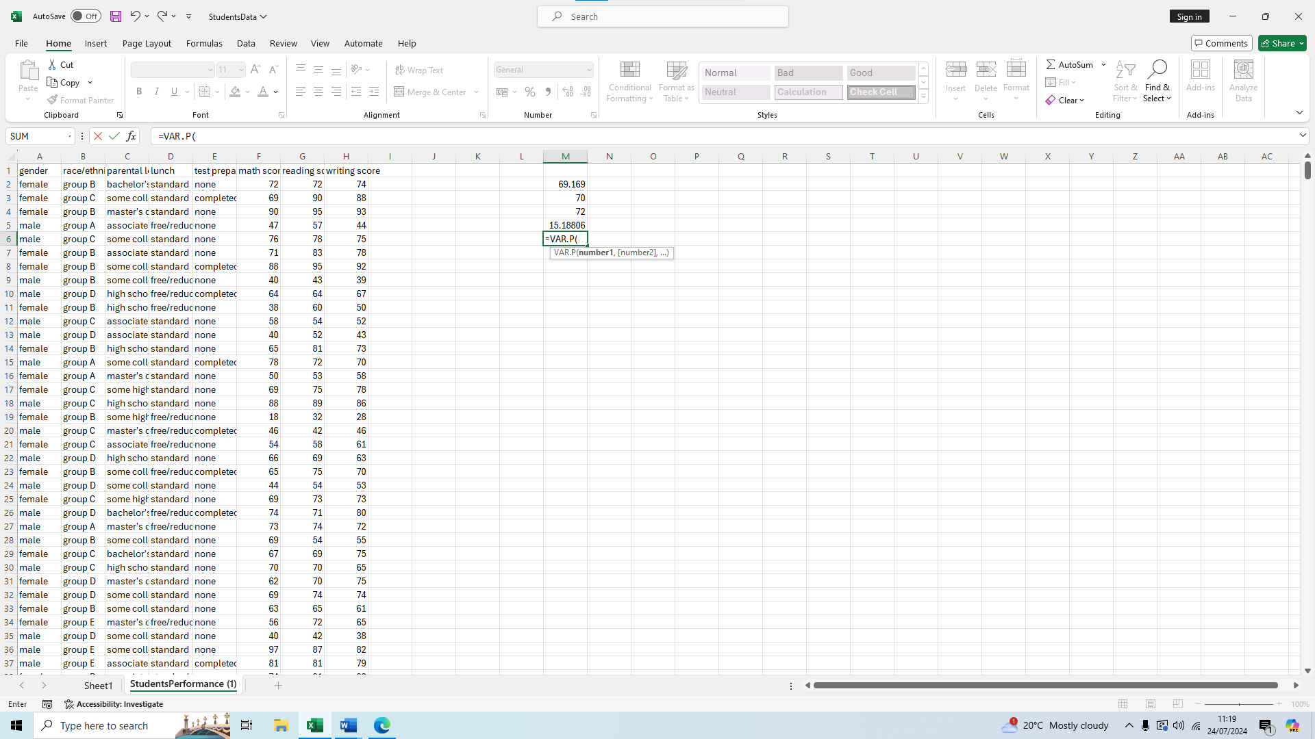We will start with math score so we select the F2 cell
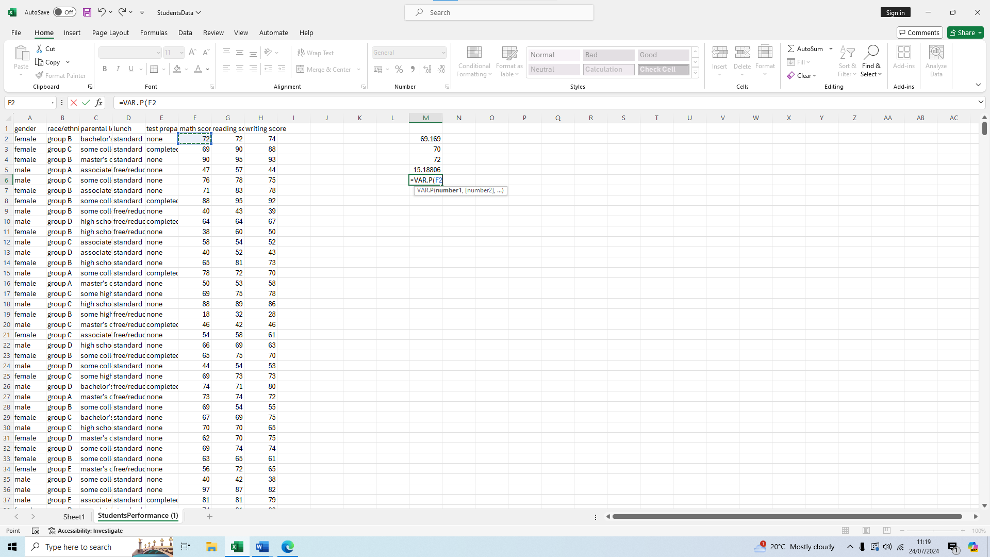 We then drag down all the way to F1001
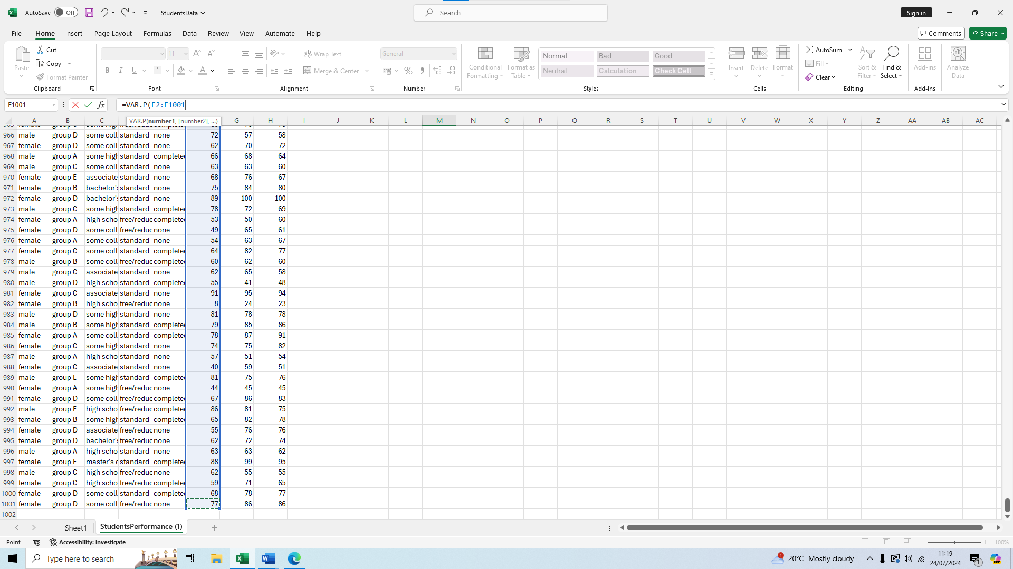Press enter to get our result of 229.6891
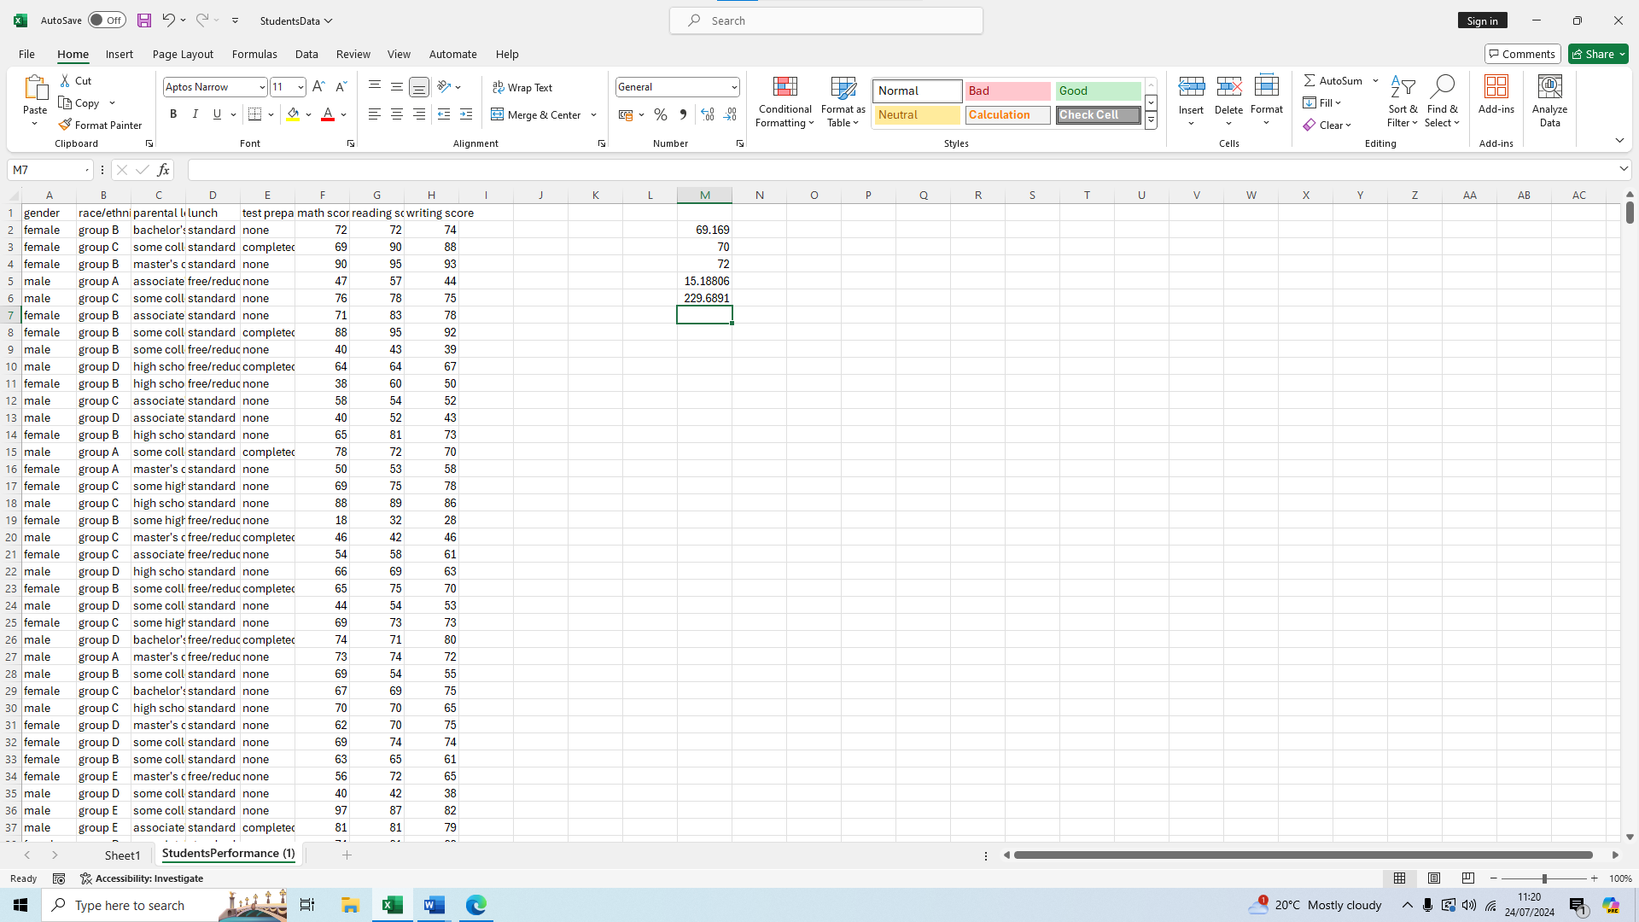
Do the same but for the reading score now, so we write our formula =VAR.P(
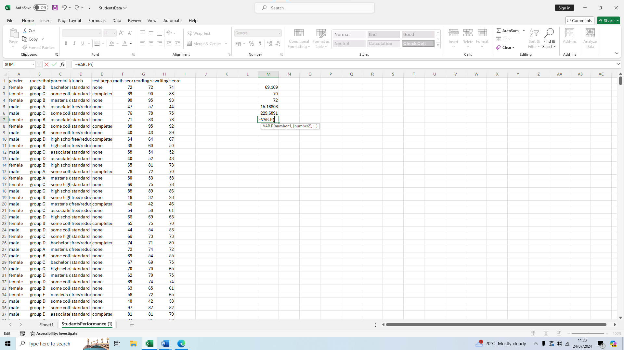Select the cell G2 as we are doing reading score 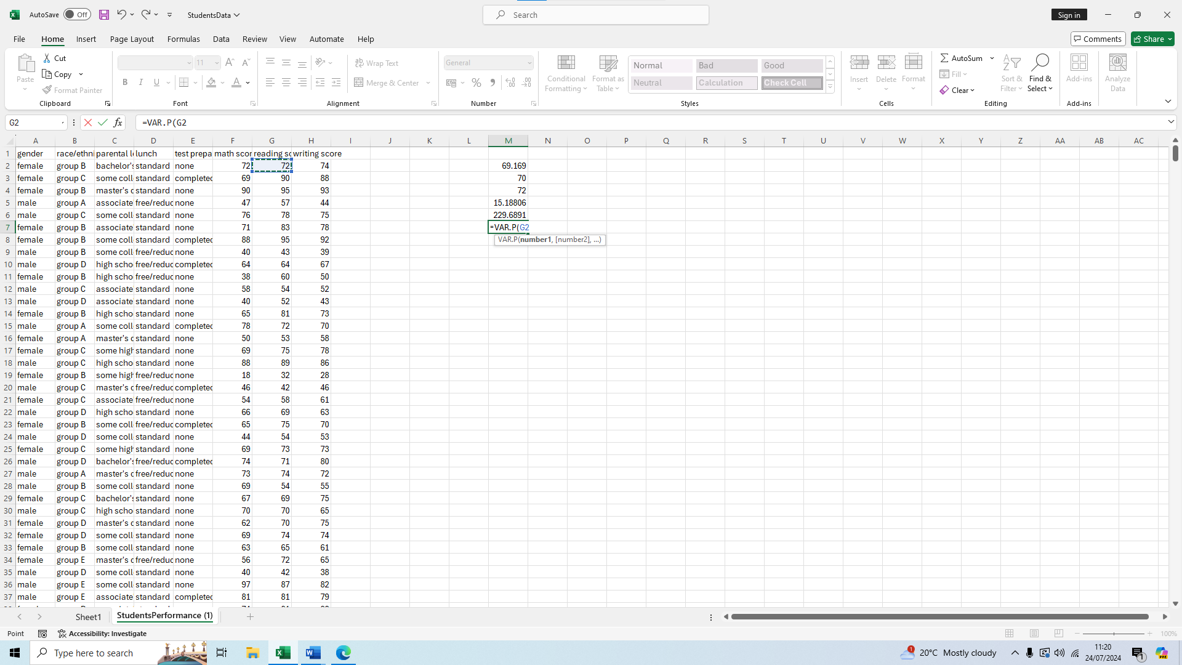
Then drag down to G1001 to finish our selection 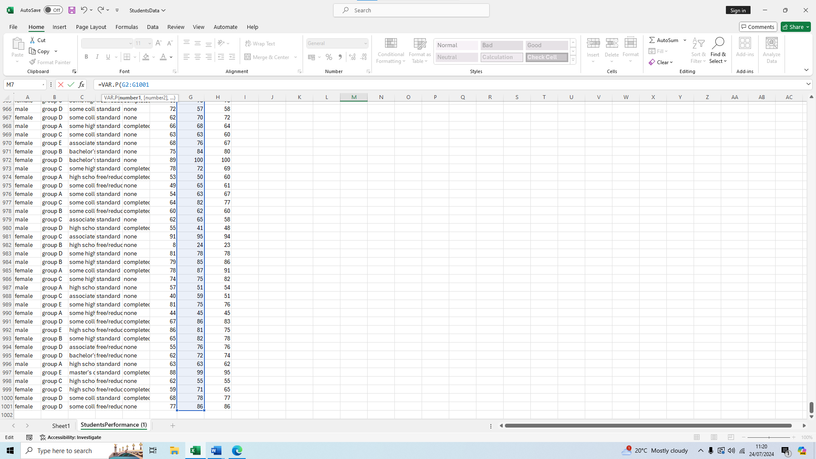Press enter and get our result of 212.9524
Finally do the same for the writing score, write our formula =VAR.P(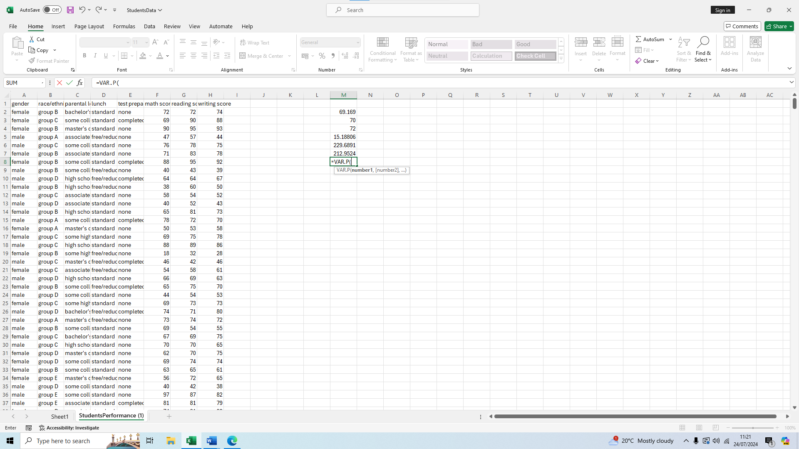 Then select the first cell H2
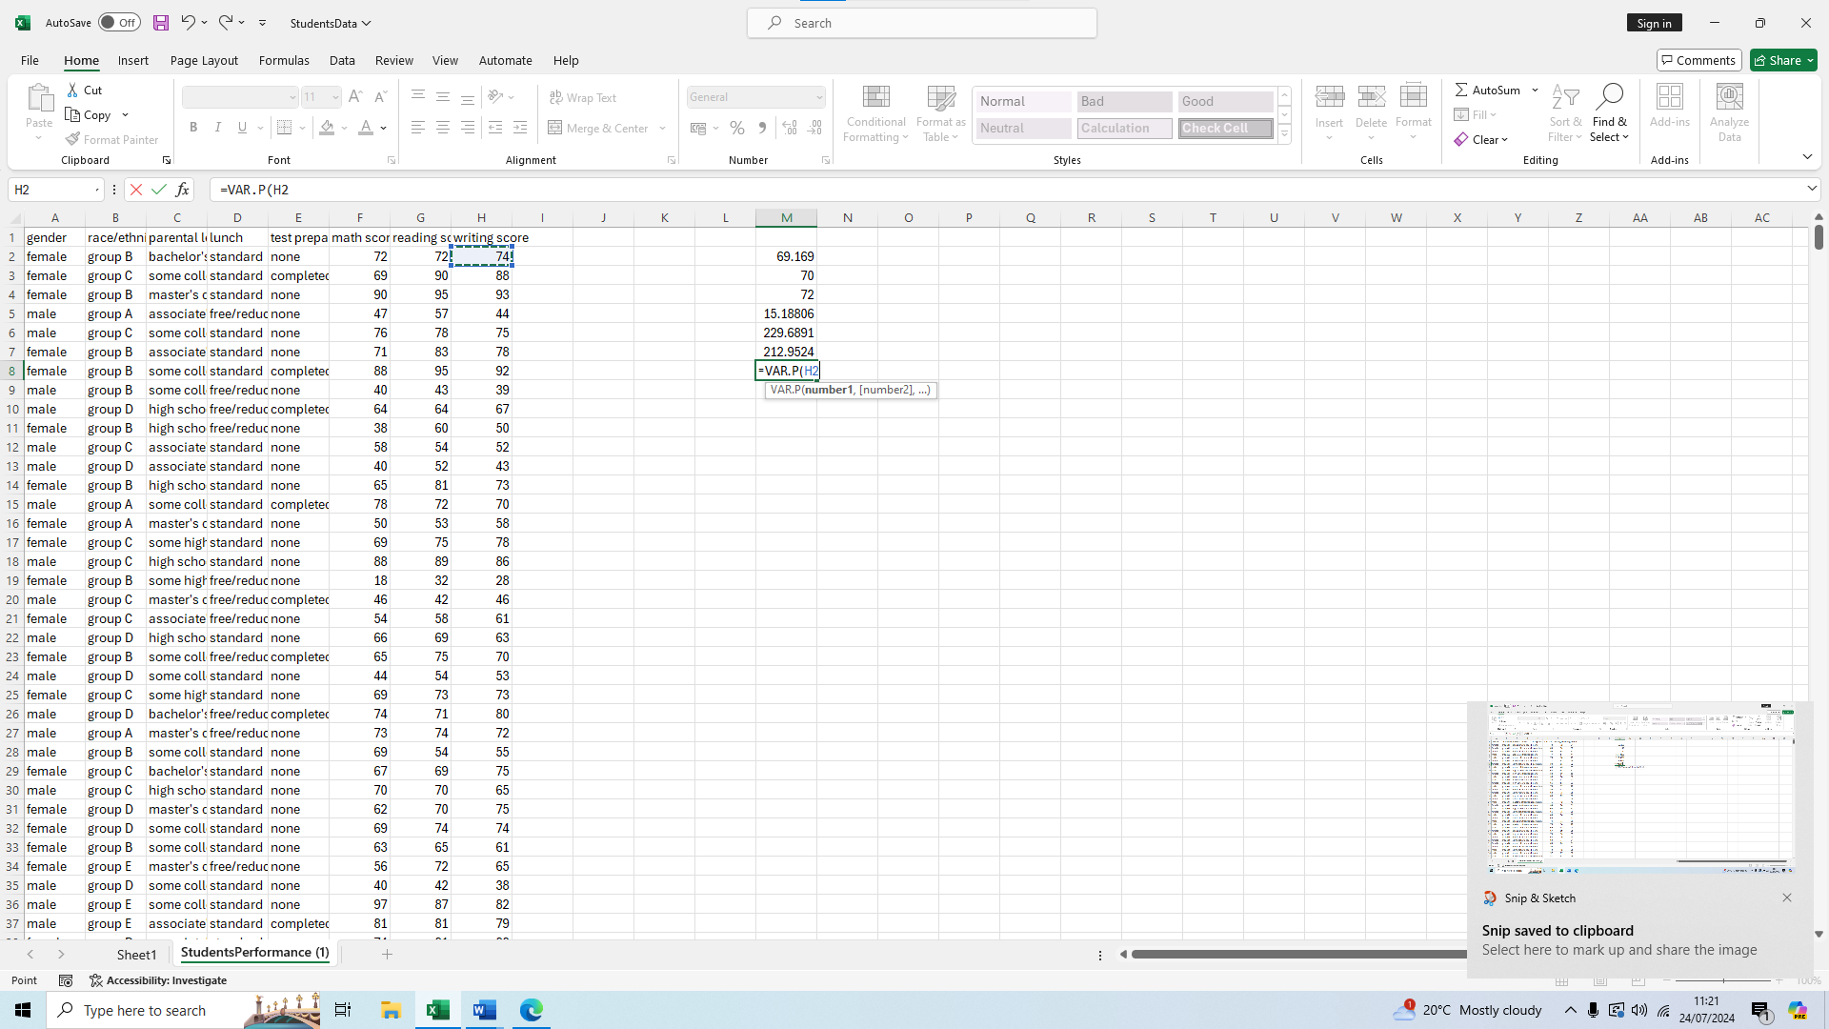Scroll down all the way to H1001
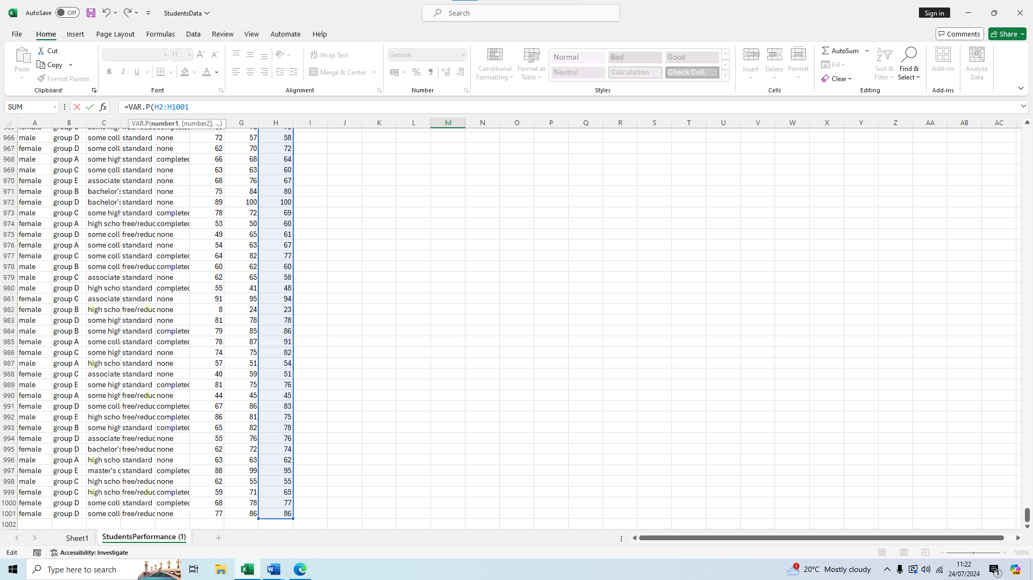Press enter for our result of 230.6771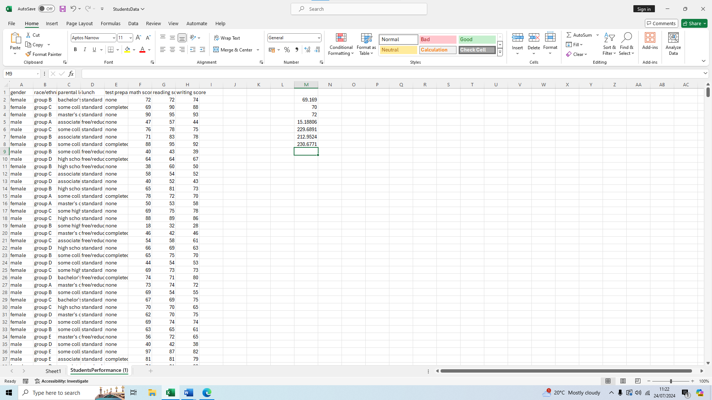
We can therefore see the largest variance is for writing score.
Now to calculate which one has the largest standard deviation, let’s start by math score
We type our formula =STDEV.P(
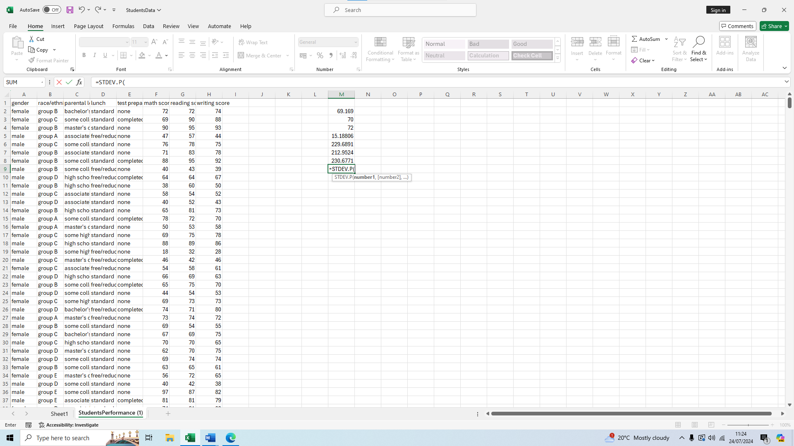We select the cell F2 as we are doing math score 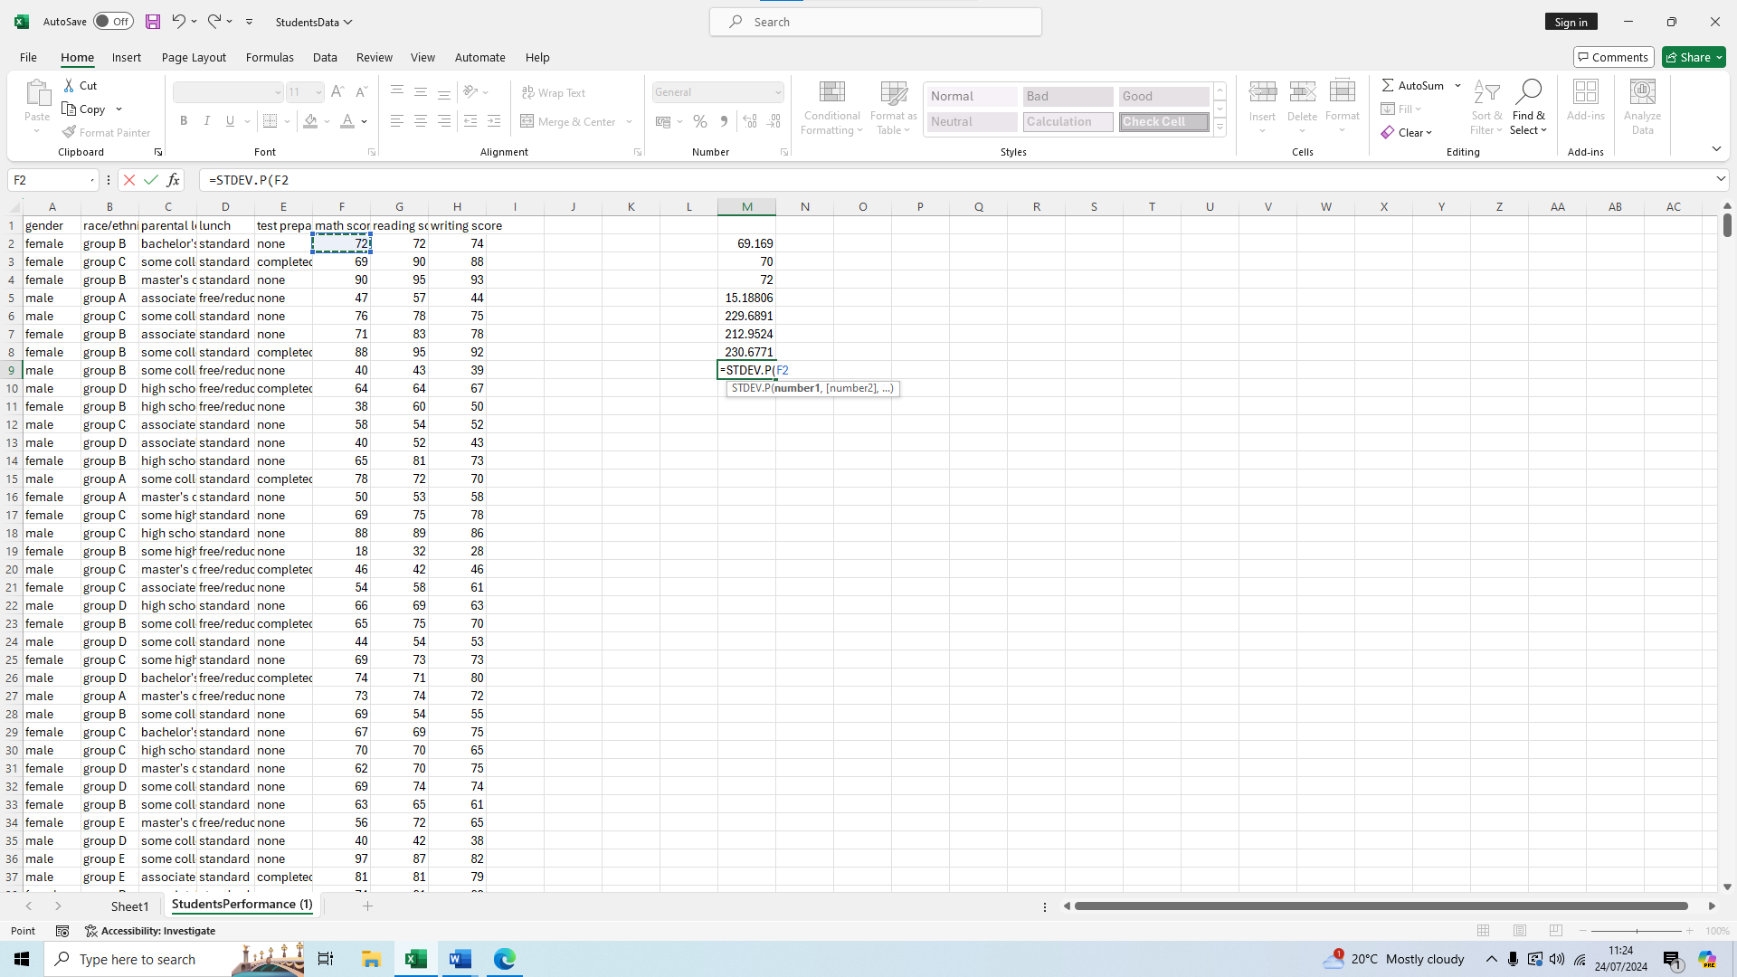We scroll down to F1001 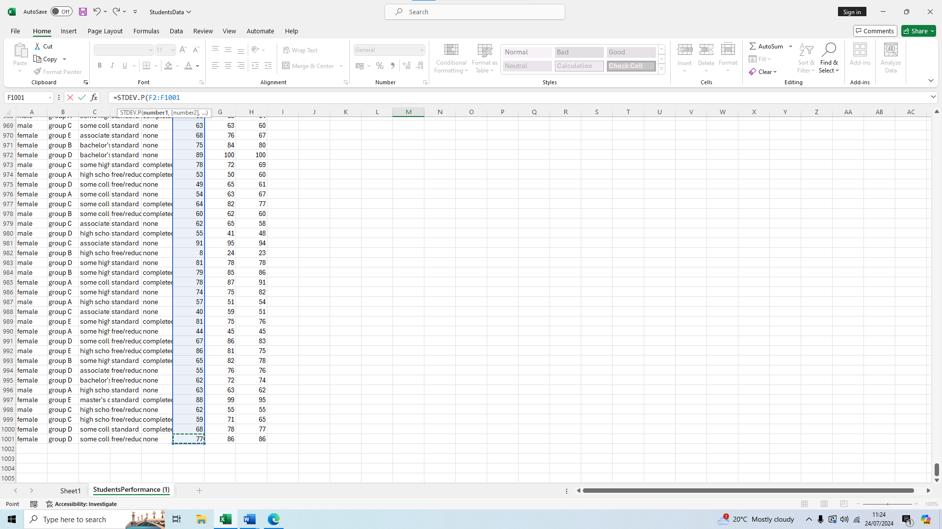We press enter for our result of 15.1555 for math score standard deviation
Now for the reading score standard deviation we type the formula again, =STDEV.P(
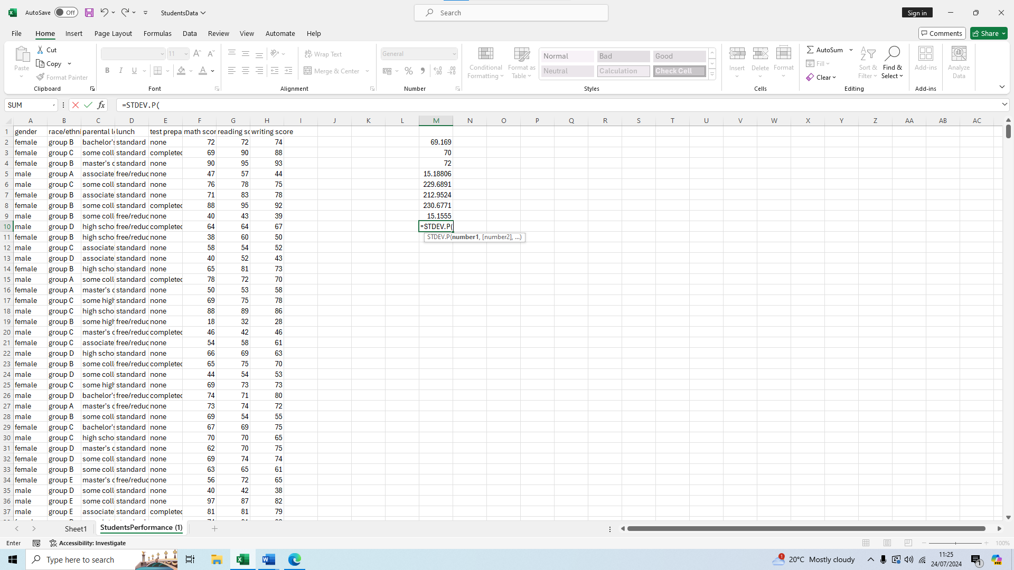
We select the G2 cell 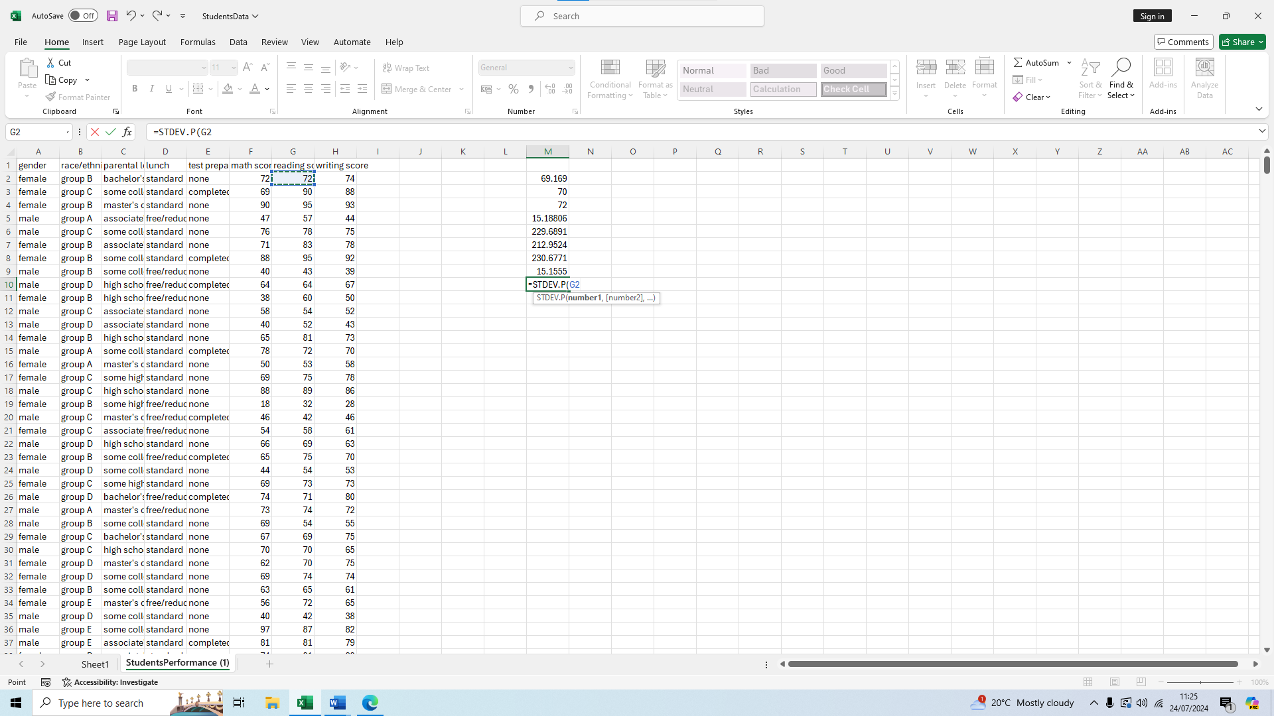We drag down to G1001
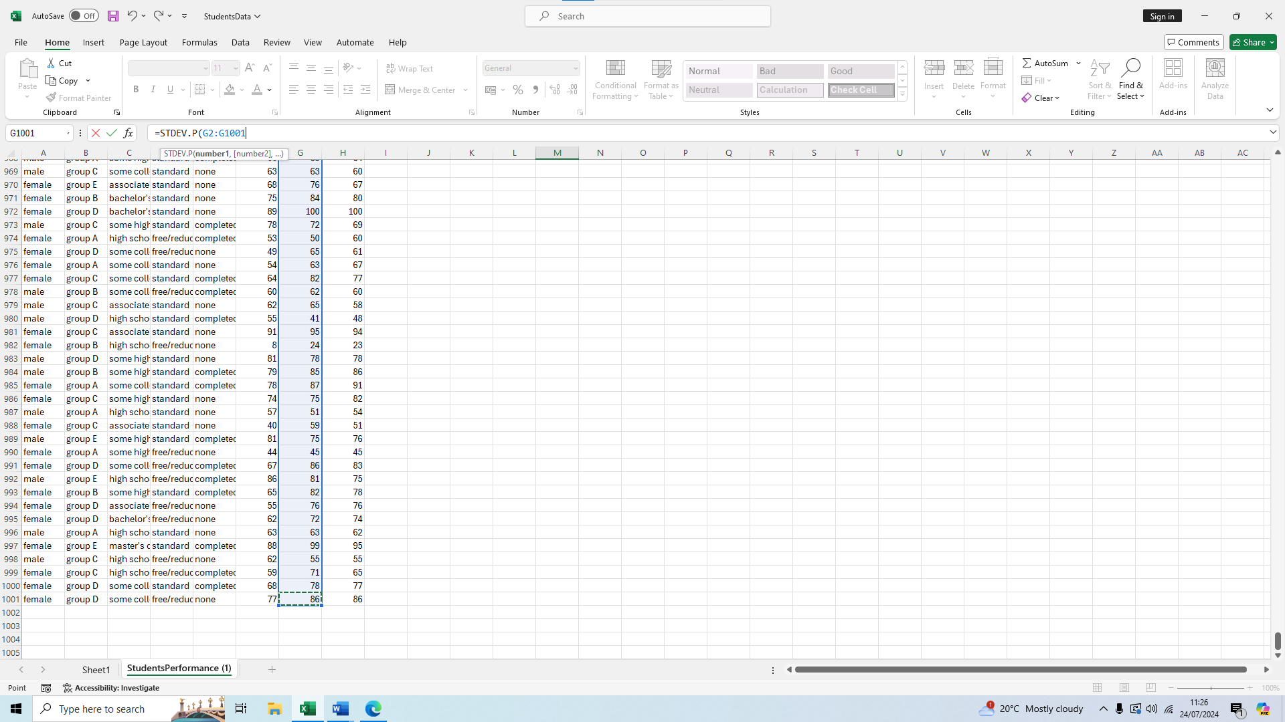
We press enter for our result of 14.59289
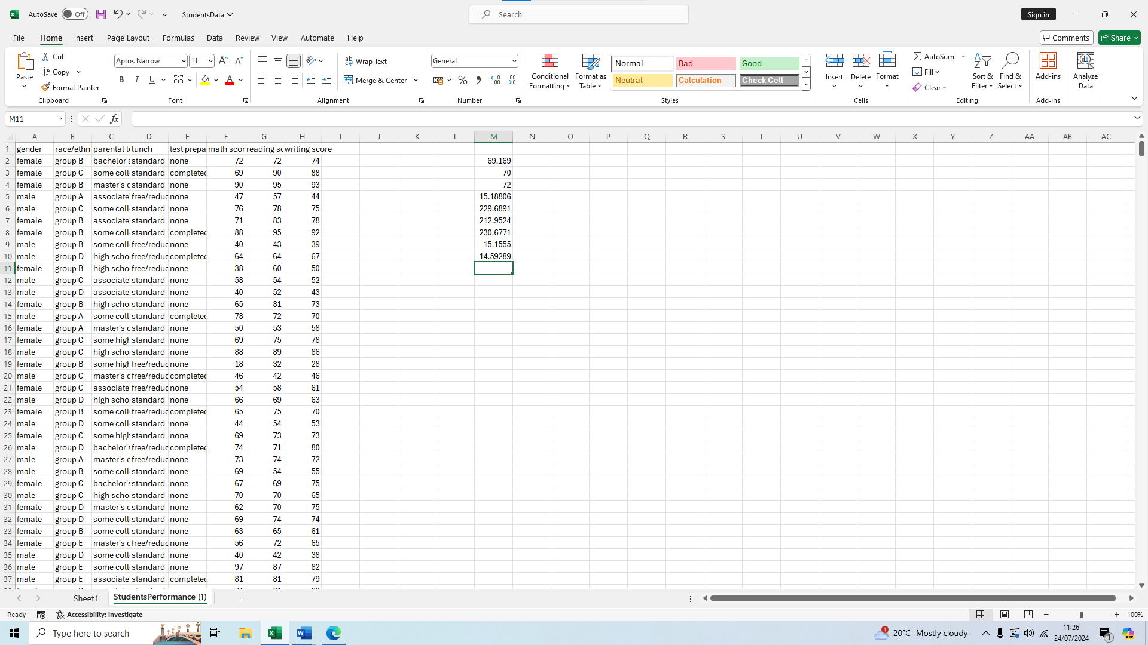
We will not do the writing score standard deviation again as we did it previously and got the result of 15.18806.
Now we can compare the three variances and see that writing score has the highest standard deviation, then math score with the second highest and close to the first, and then a lower standard deviation for reading score, but not by too much.

Interpreting the outcomes
What the standard deviations mean is that on average most scores are away from the mean on either side, negatively or positively by around 15~ points for each test.
Comparing the scores to each other we can conclude that the standard deviation for math and writing is slightly higher than that of reading, this means there is more variability in the scores of students who took the math and writing test as compared to when they took the reading test.
Math and writing are very close to each other so it is safe to say there is similar variability and standard deviation in these two scores.
Even though there is a small difference with the reading variability compared to the other two, they all fall within a very close range and it means that most students have similar performance in all three subjects. For teachers this can mean that no any particular subject needs more attention than others and that they can spread their efforts in improving knowledge equally among all three subjects.
What we can also understand from these deviations is that around 68% of the scores should fall within one standard deviation so we can do an educated guess and know that most scores for reading for example will fall between 54 and 84 as the mean is sitting at 69.

Pivot table
A pivot table is a tool of the softwarae Microsoft Excel that I am going to use to help analyze the data given. This tool will help us see data summarized by different categories very quickly and easily, we can filter through the aspects we want to see to see how much of our data is made up by a certain demographic which can help us in further analysis.
To create a pivot table first we have to select our whole data
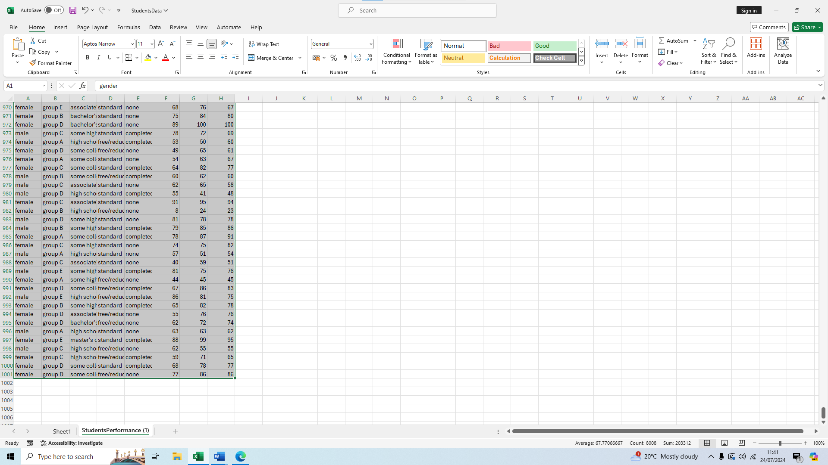We then go to the Insert tab on the top of Excel
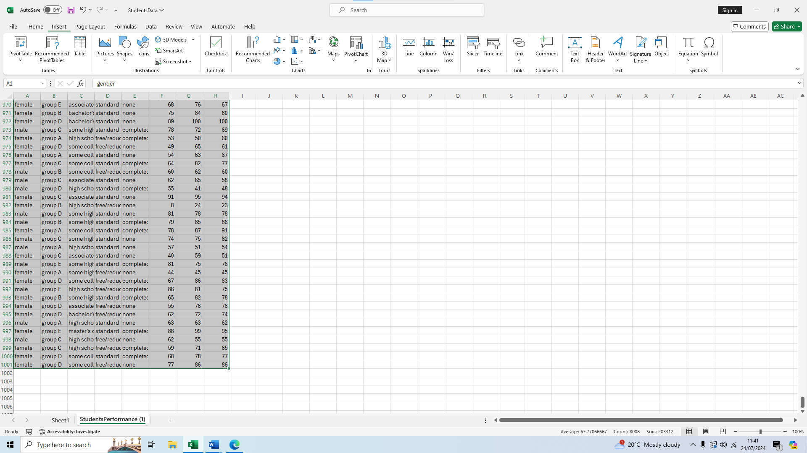We then click pivot table
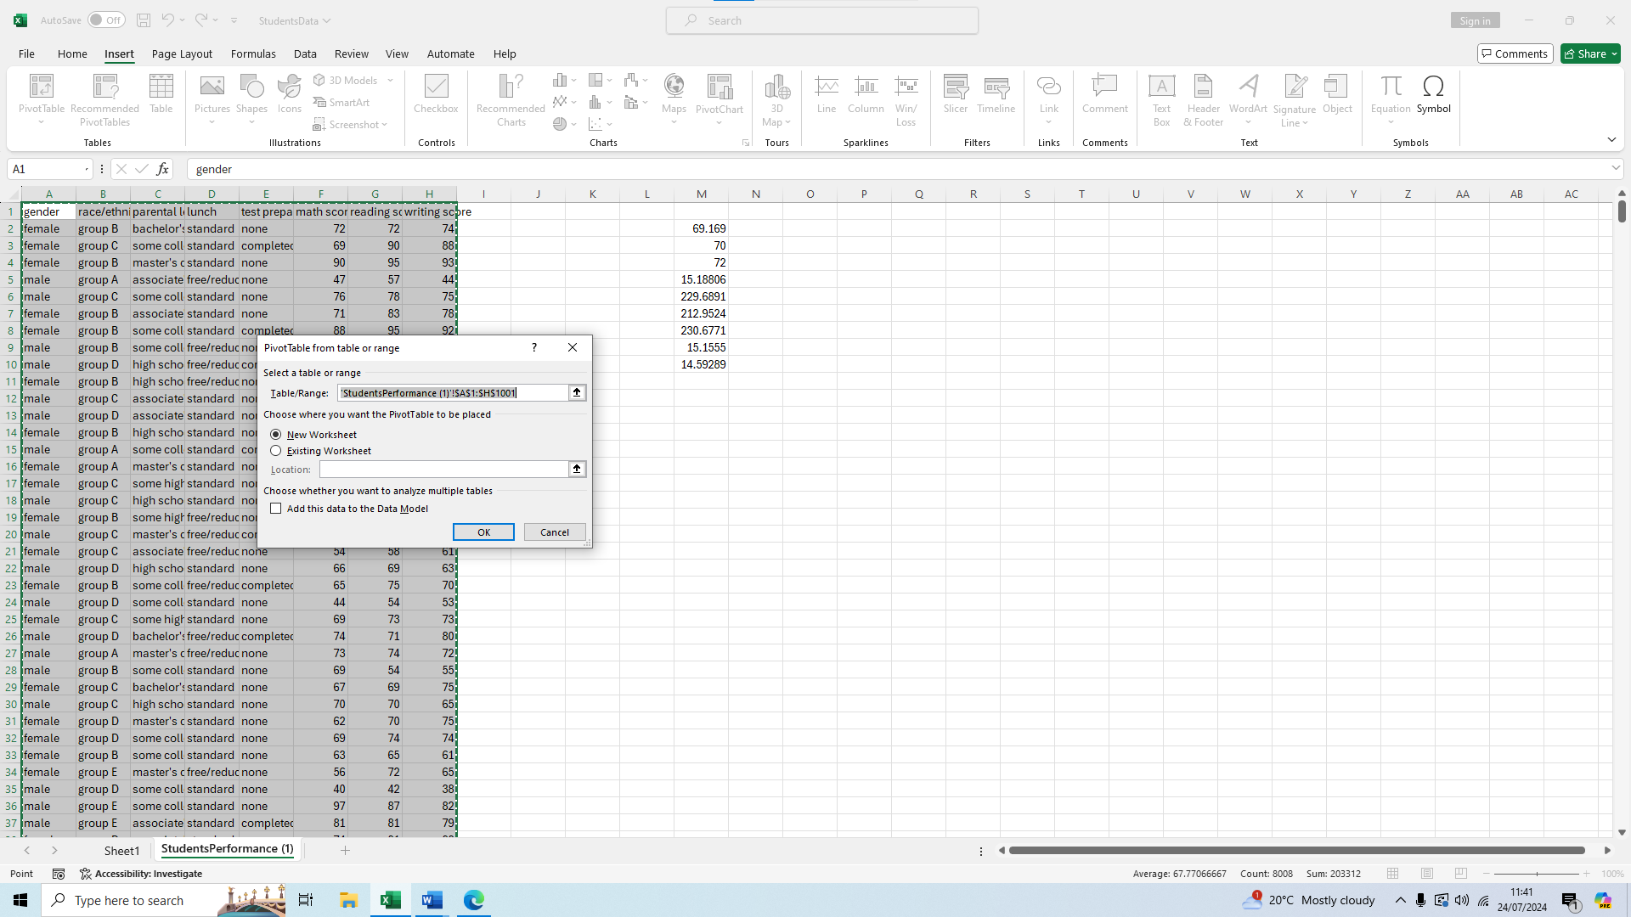
We press okay and check the first checkbox, new worksheet
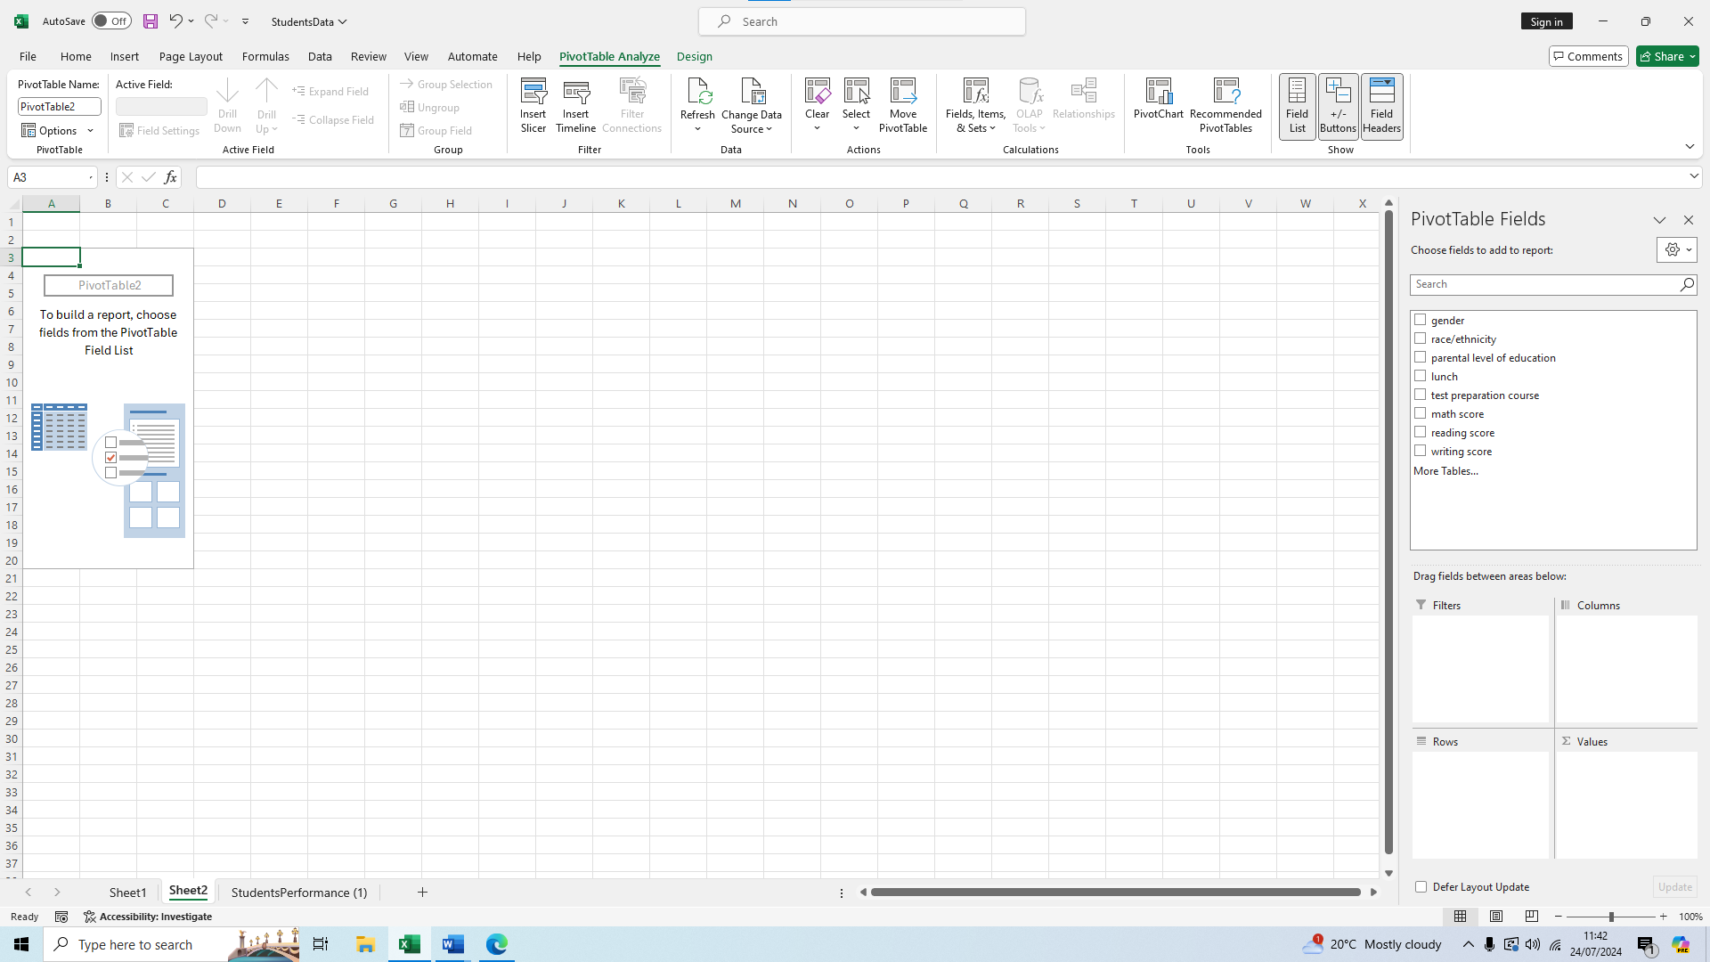We should now be in this page, on the right side we can see all our filters and start sorting out our data in whichever way we want to see it. For example let’s sort by gender and reading score
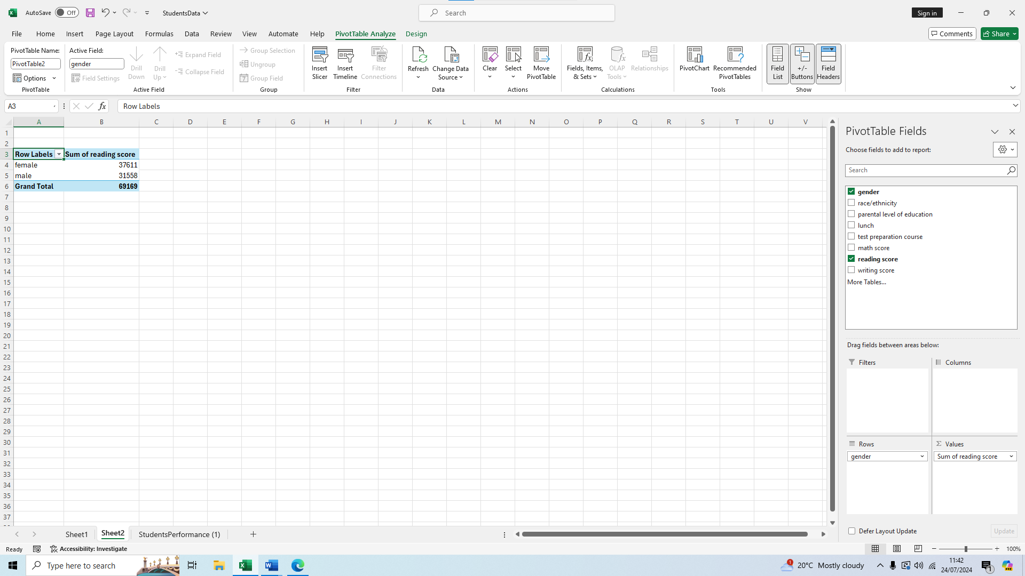So we can see on average females do better than males in reading tests.
We can see as well the total score of people who did the preparation course and the ones who did not, we select the appropriate filters on the right of test preparation course, math score, reading score, and writing score.
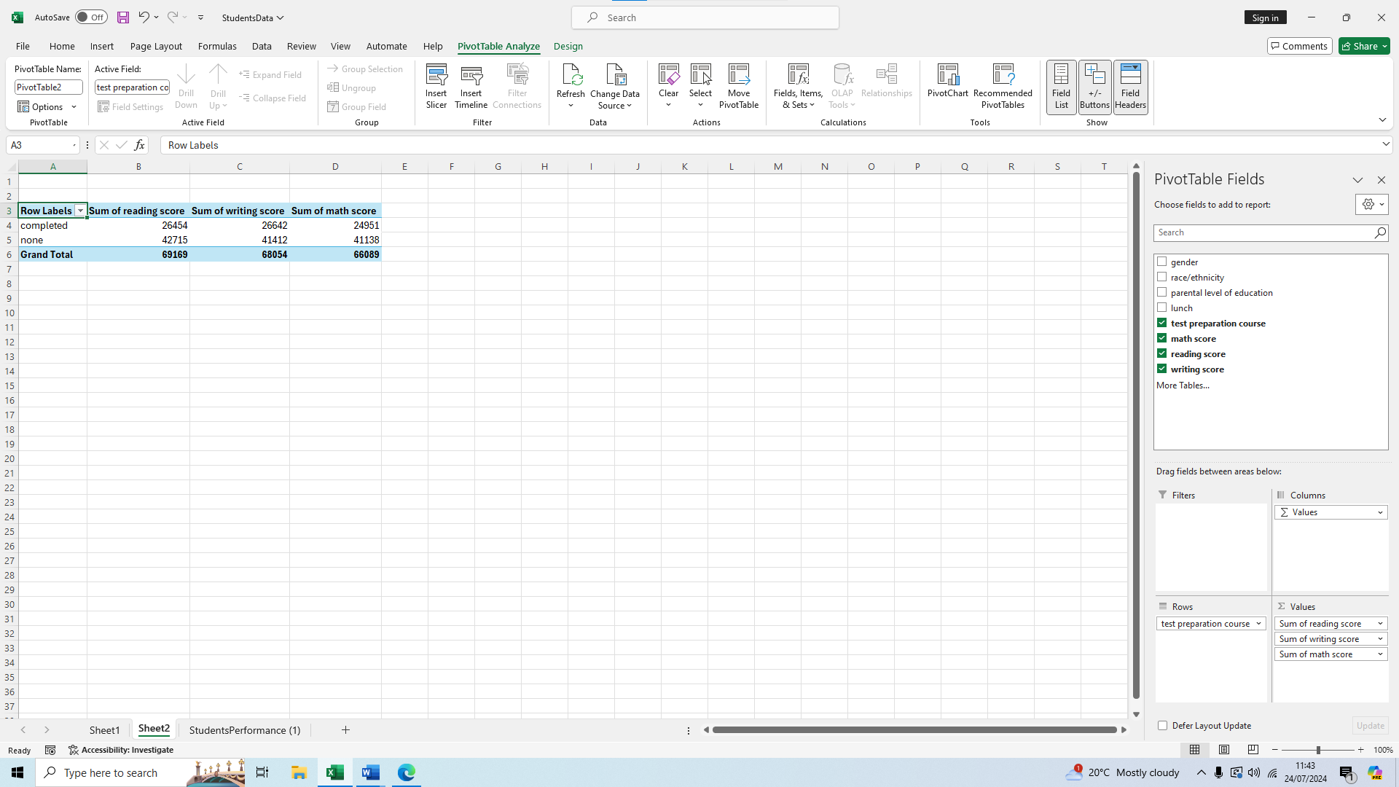We can see that there is a higher score of people who did not complete the course but this could just mean there was a higher amount of people who did not complete the course rather than people who did not complete it scoring higher.

SPSS Correlation and Scatterplot
We will use SPSS to find the correlation of the writing and reading scores in relation to each other, to do this first we open the file using SPSS
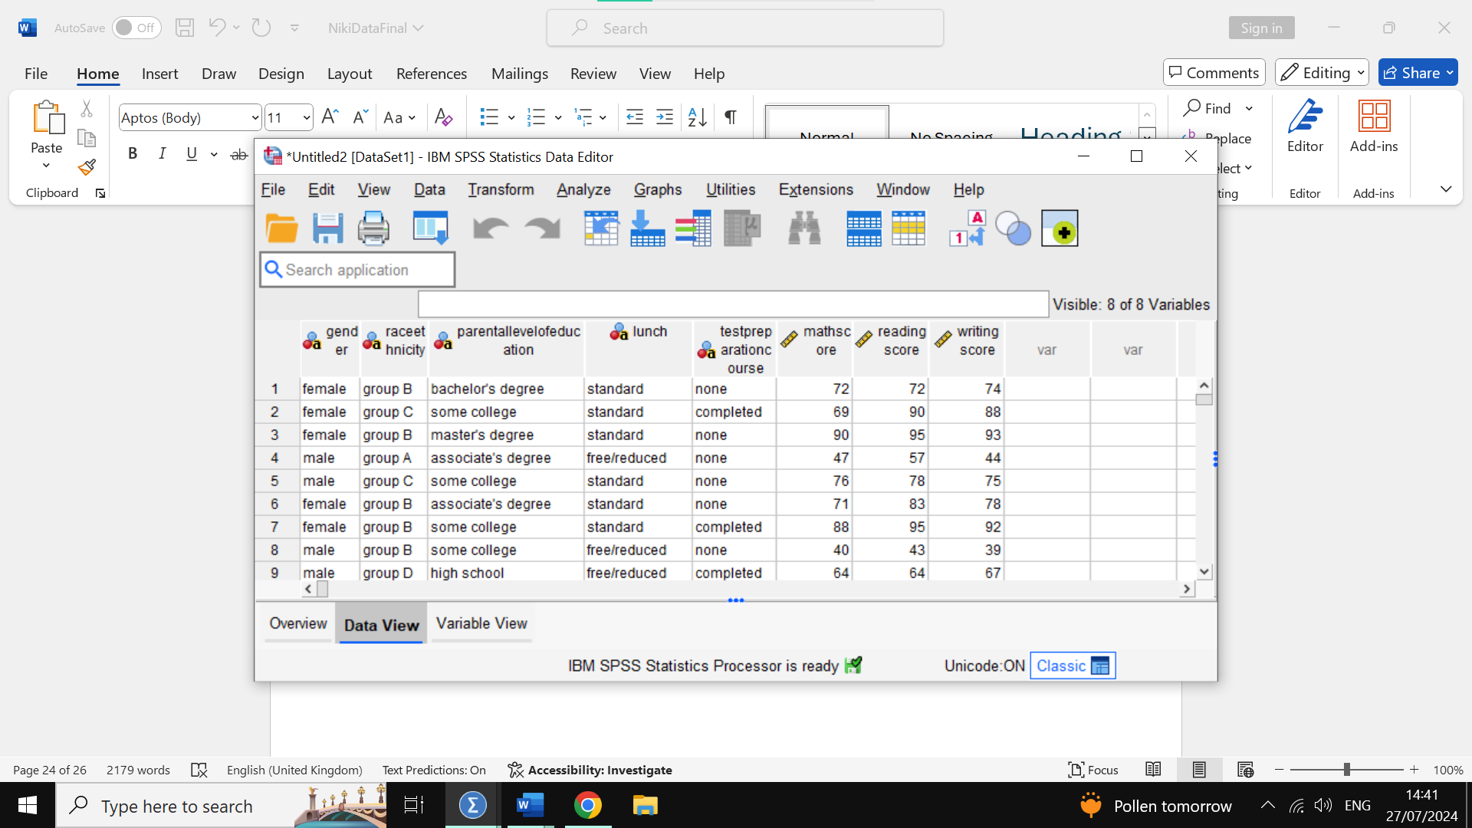
Then we click analyze on the top and select correlate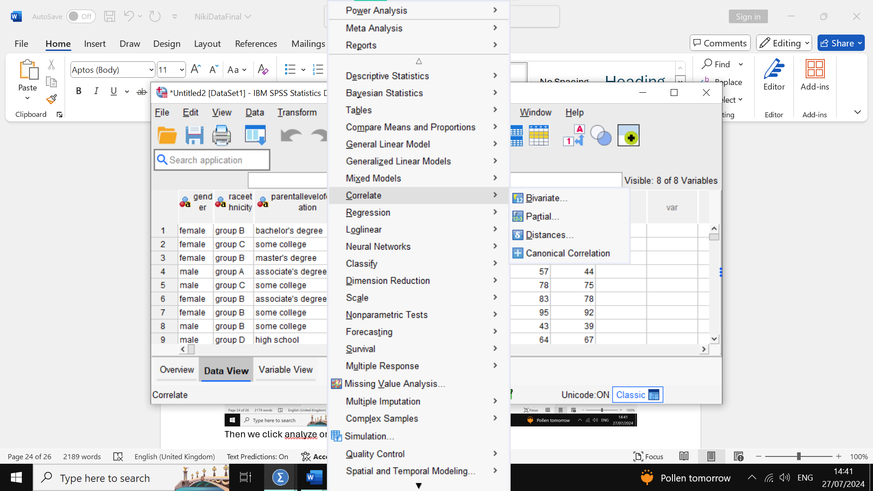
We then click on Bivariate 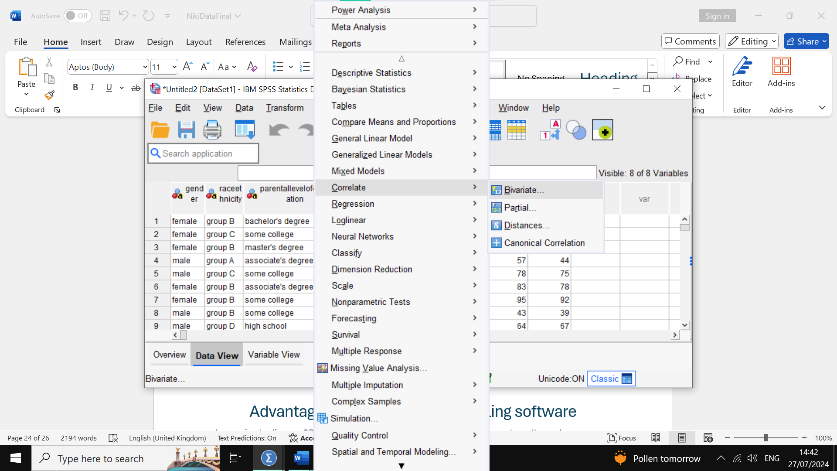
Once on this page we select the reading score and click on the arrow to change it to the list of variables we will use for the bivariate function. 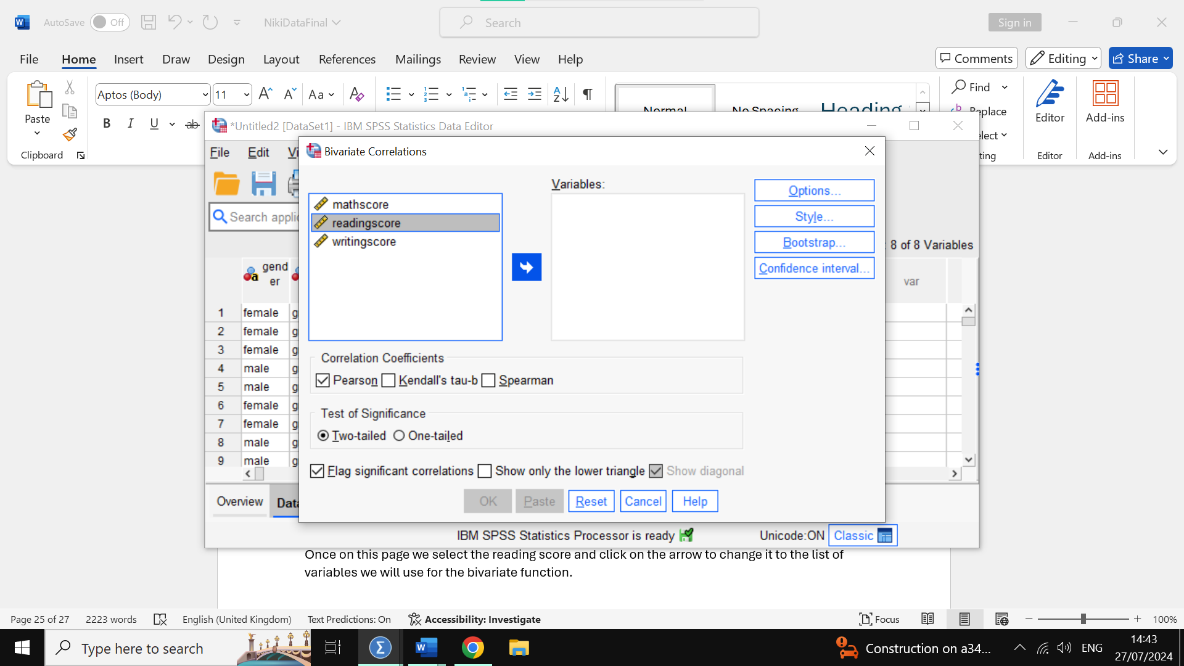 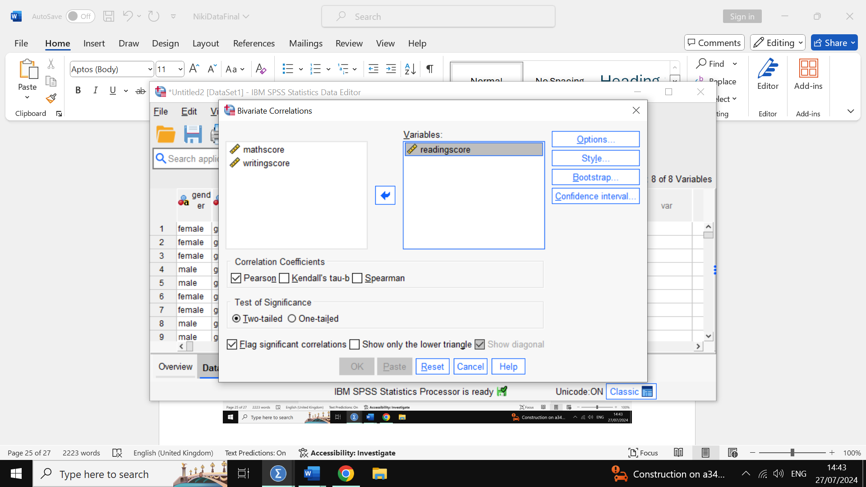We do the same for the writing score variable 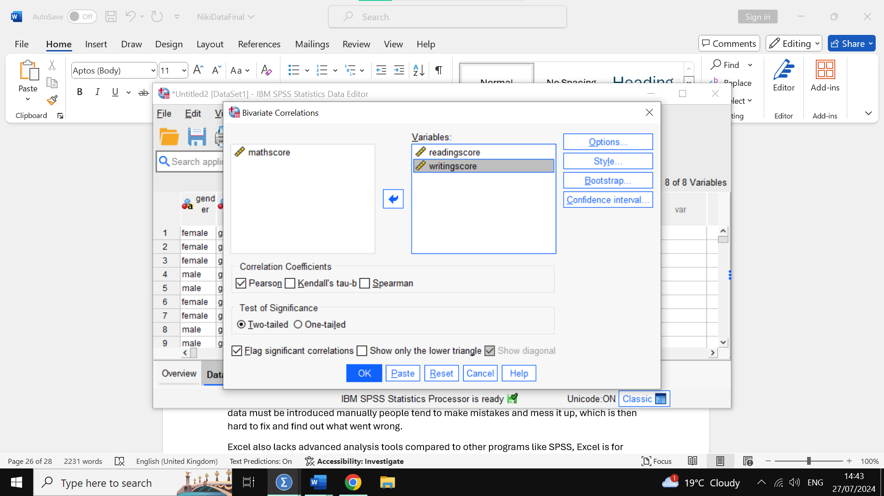Then we click on the blue OK on the bottom 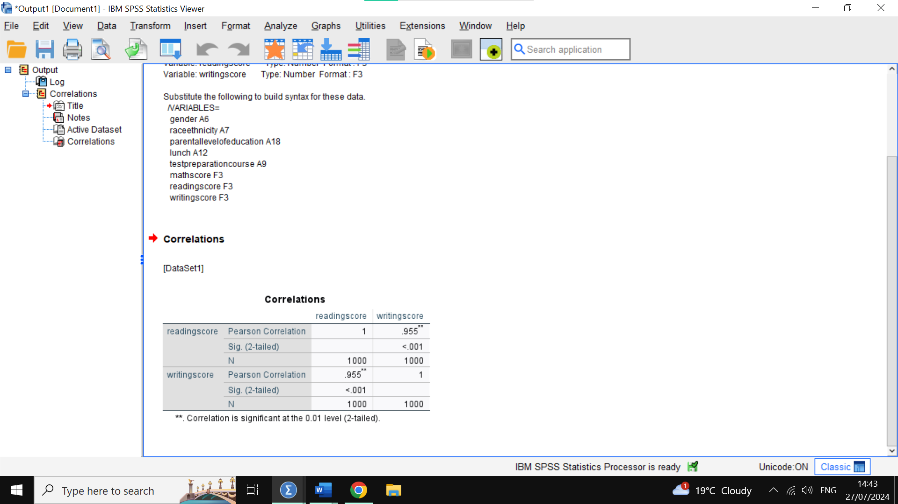We can see a high correlation of almost 1, sitting at 0.955 indicating a very strong direct correlation which is also positive. We will now produce a scatterplot diagram to better see this visually.
To do this we click on Graphs 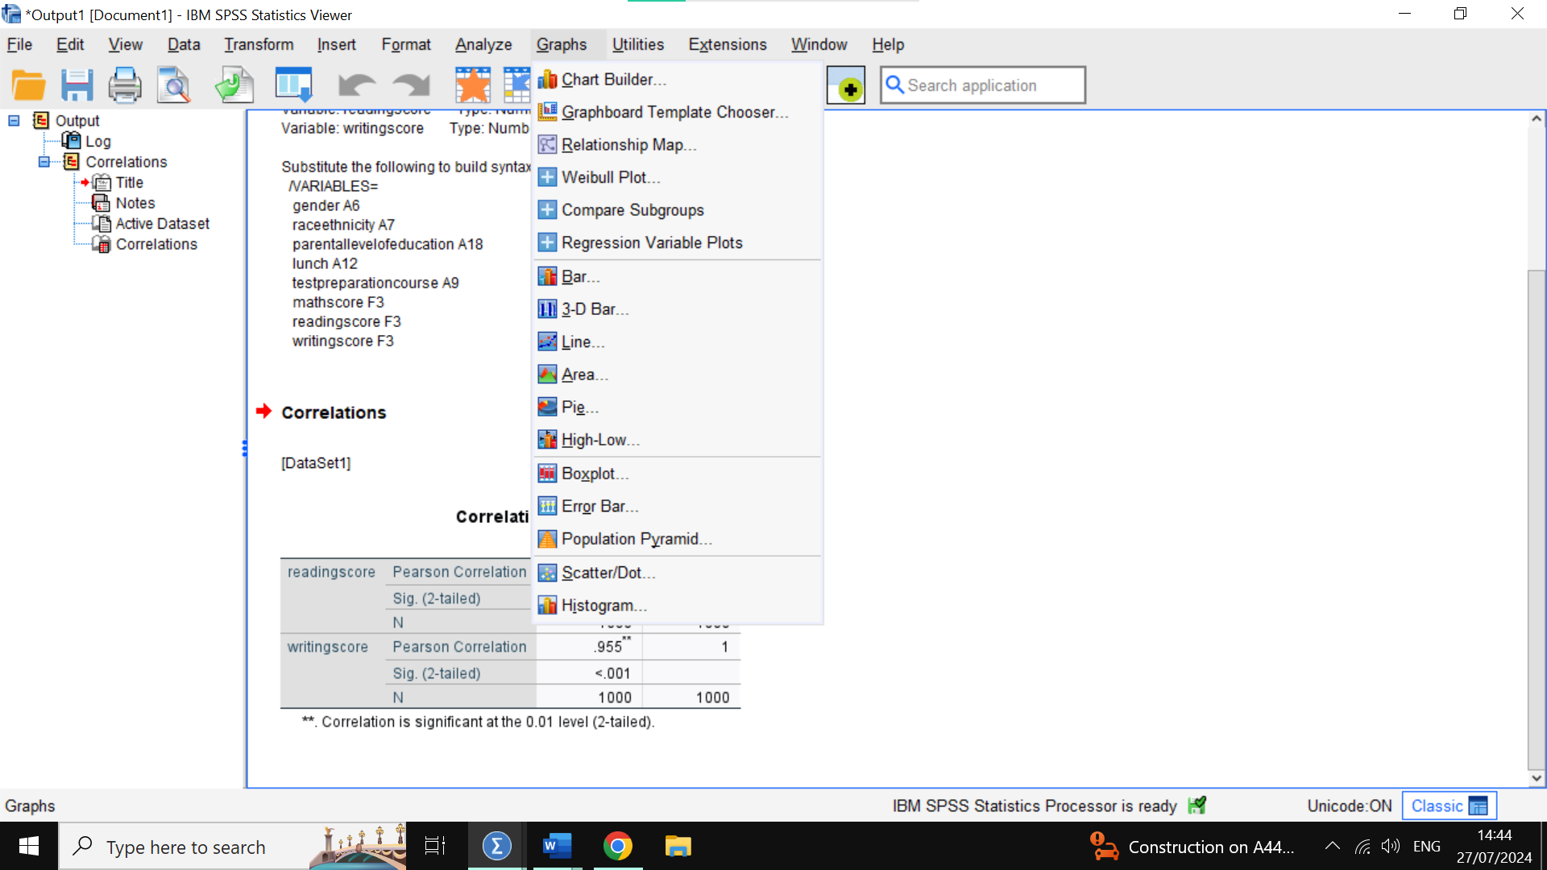Then we click on chart builder 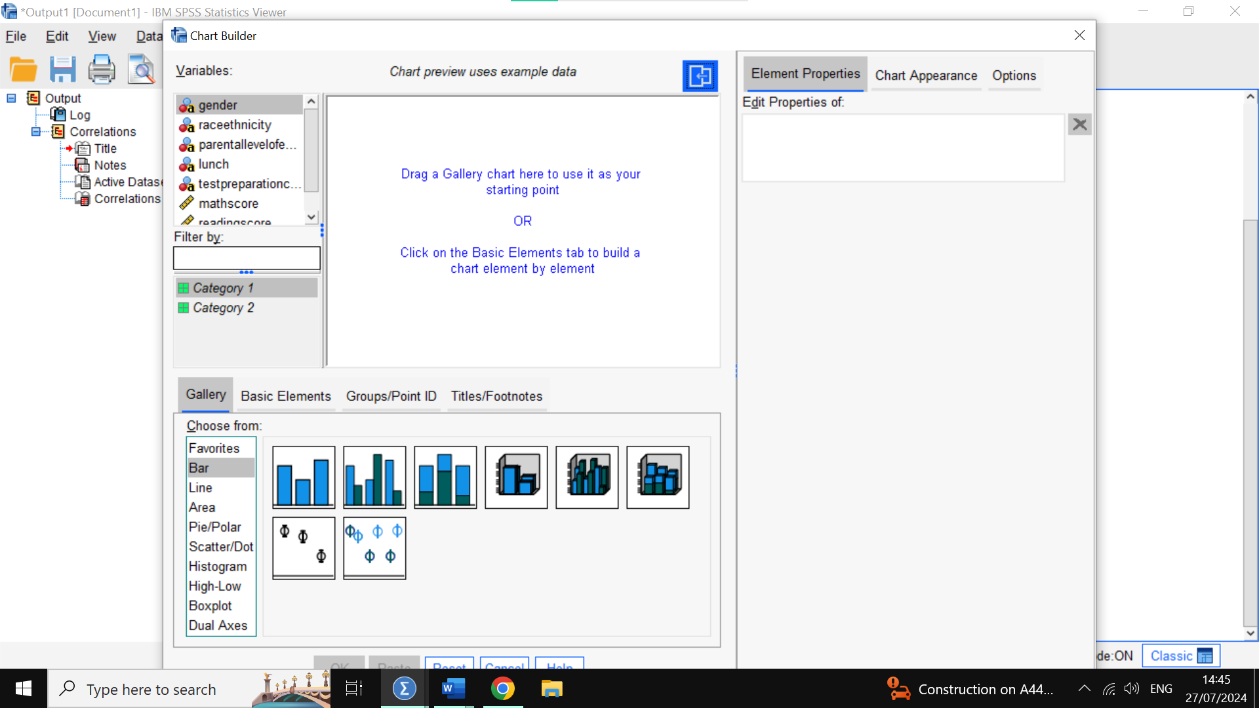Then we click on scatterplot on the list at the bottom left 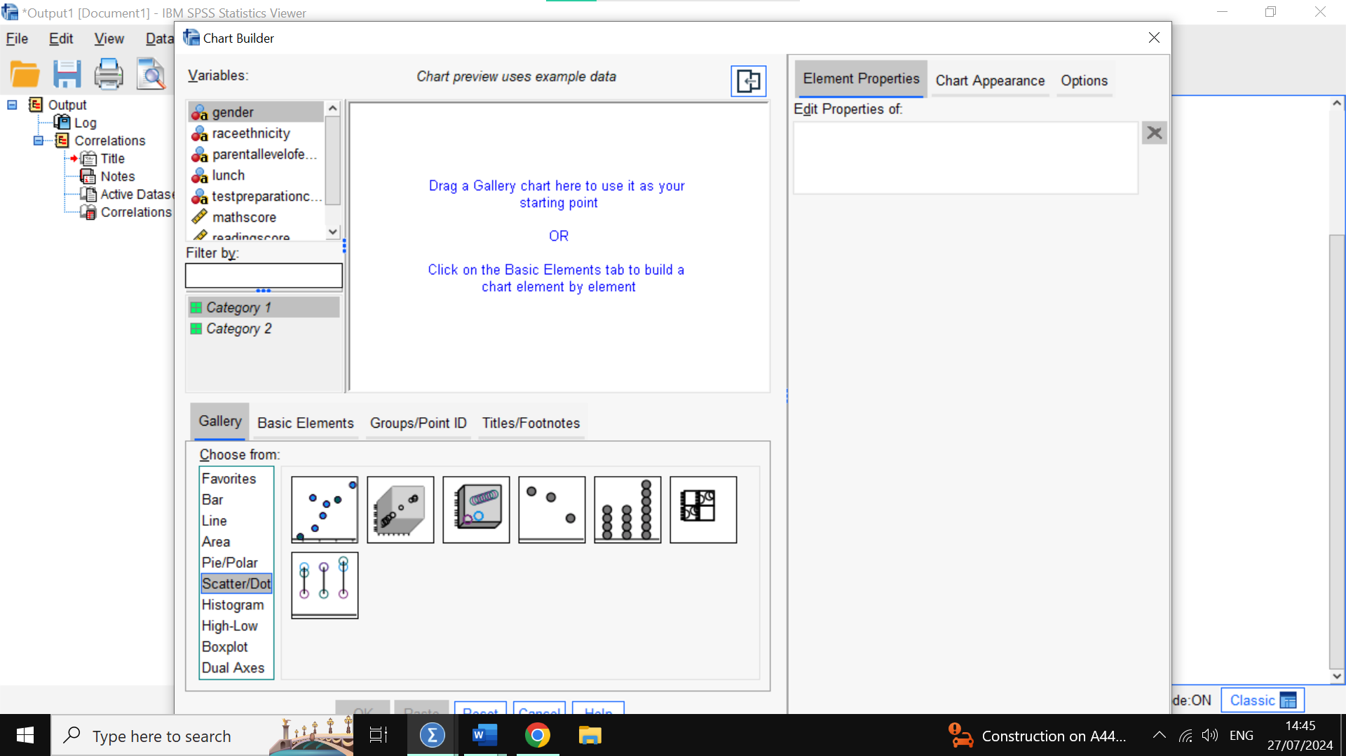Then we select the first scatter plot image and drag it above 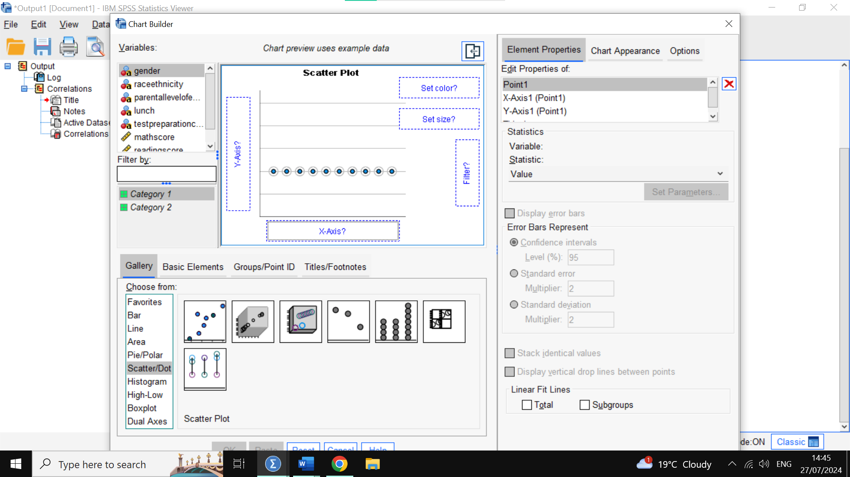Then we select our variables from the list on the top left, we are going to put writing score on the horizontal axis (x-axis) 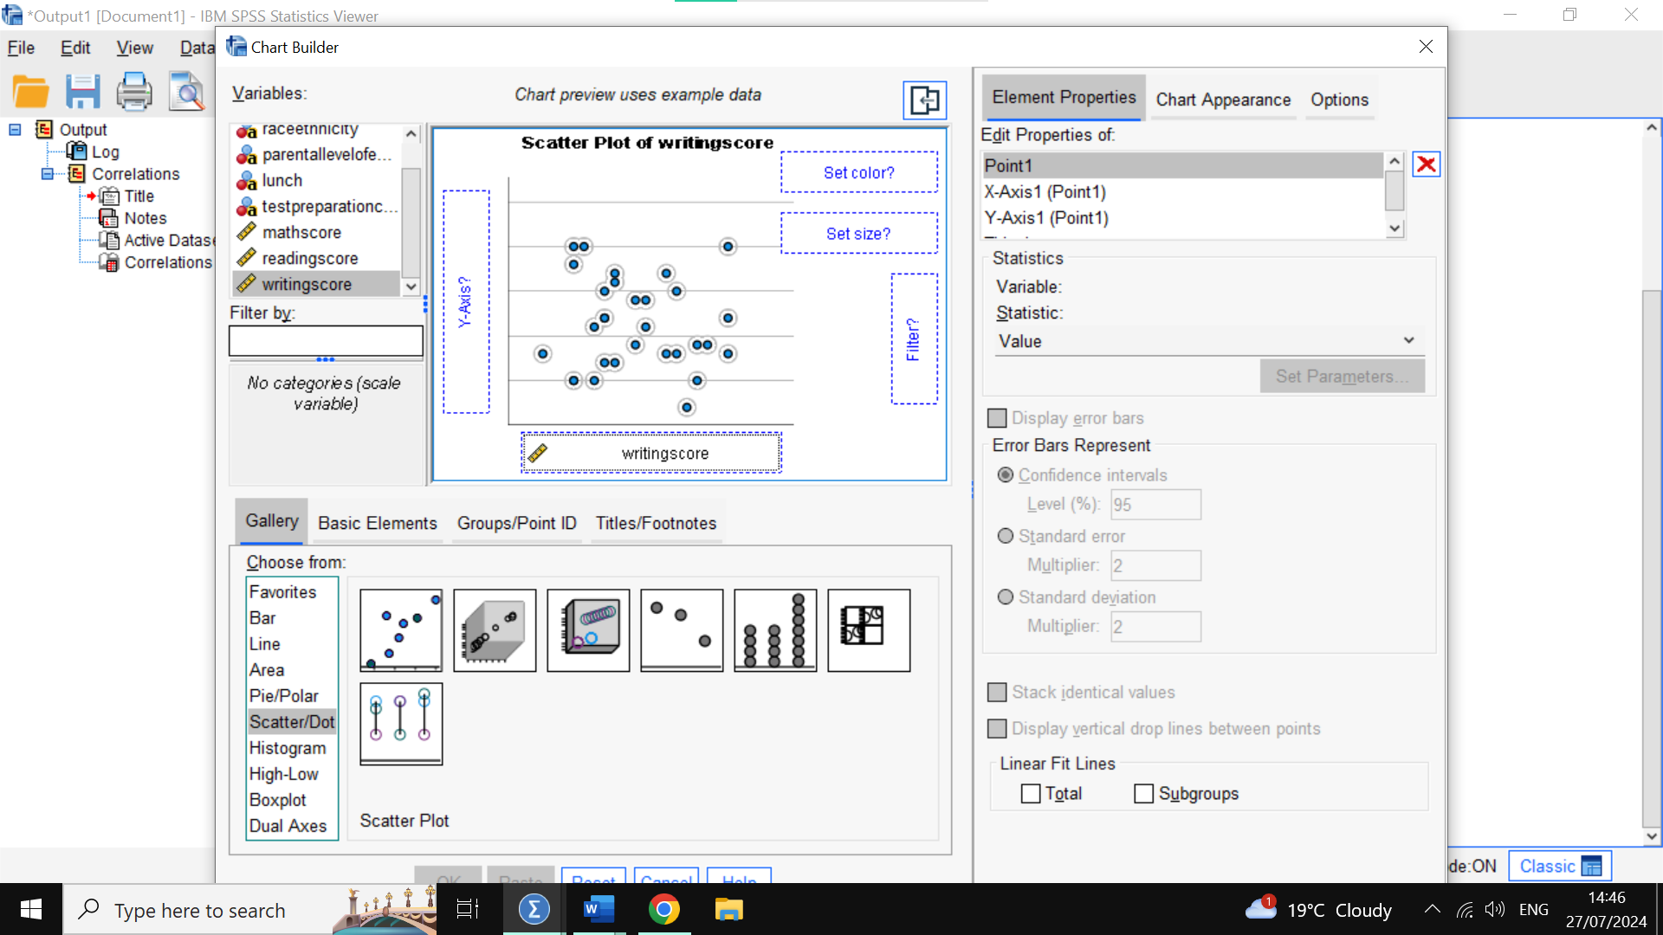We then put the reading score on the vertical axis (y-axis) 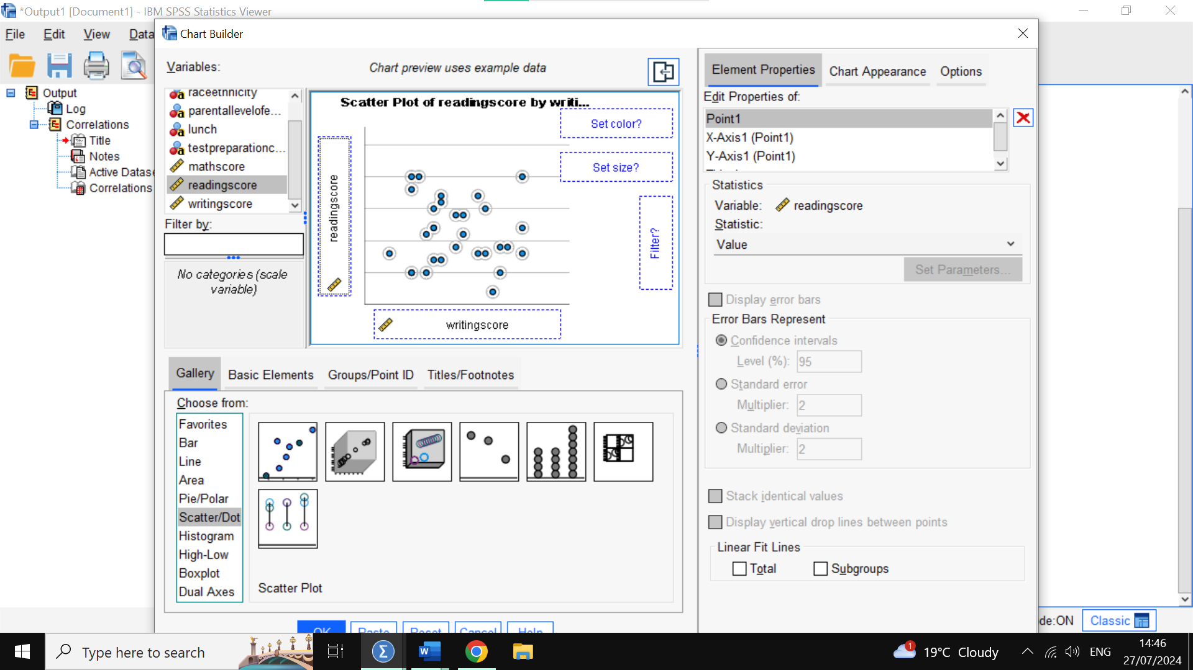We then press the blue OK on the bottom again 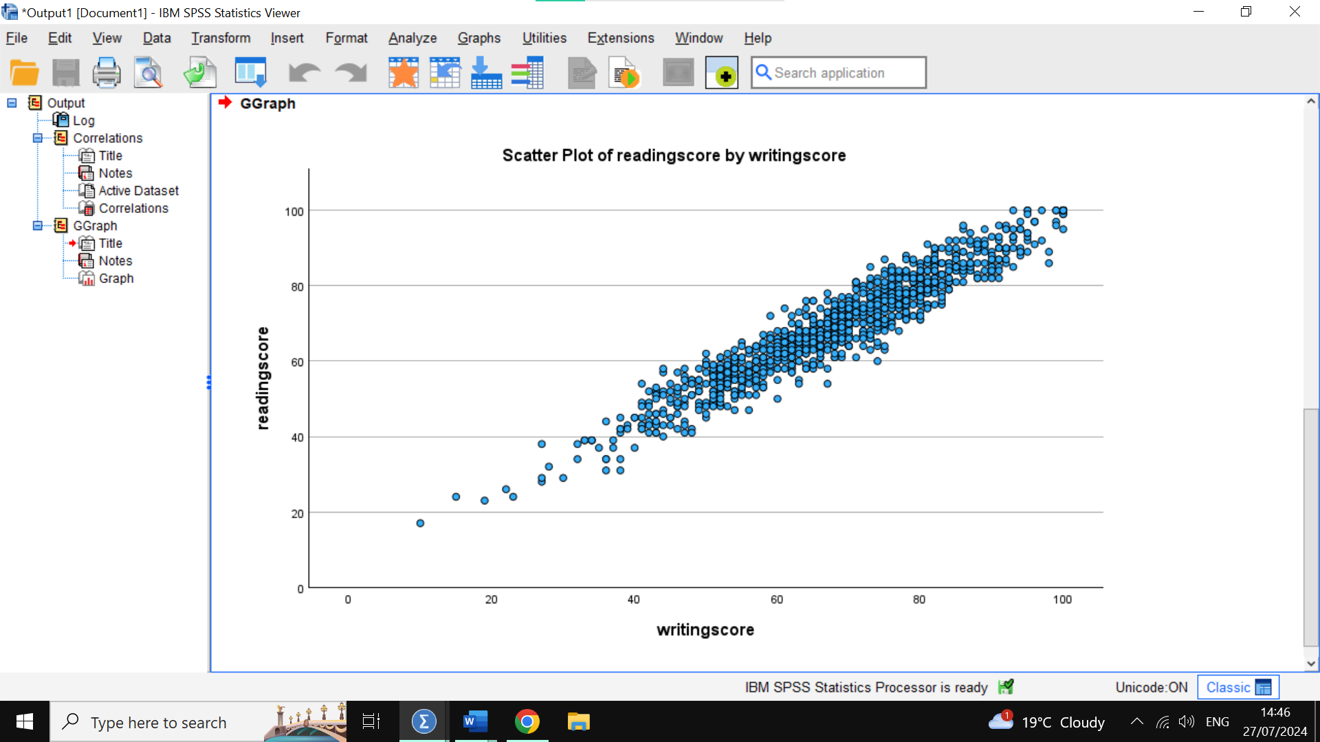And that’s our scatterplot confirming what the correlation Pearson ratio showed us earlier, that there is a huge positive correlation between writing score and reading score which means that as one goes up so does the other, and if one decreases so does the other. We can appreciate a few low scores around the 10-30 mark area, these are few but still show the beginning of the line that shows us the positive correlation.

Advantages of different Data handling software
I am going to discuss SPSS, Excel and Tableau and their different uses, strengths and weaknesses.

Excel
The uses of Excel are data entry and storage, basic analysis, basic charts and graphs, pivot tables to summarize data, and more complex automation using VBA to have macros to automate tasks.
The strengths of Excel range from being user-friendly and widely available throughout the world due to being part of Microsoft Suite, to pivot tables which are very commonly used in business and research and some basic data visualization with its charts and graphs that can help create good reports.
The weaknesses however are that it has scalability issues as Excel struggles to handle large datasets, leading to many problems such as formulas not working or values missing. Also as data must be introduced manually people tend to make mistakes and mess it up, which is then hard to fix and find out what went wrong.
Excel also lacks advanced analysis tools compared to other programs like SPSS, Excel is for basic statistical analysis and lacks in data mining capabilities.
Security is also a problem for Excel as sensitive data can be leaked if not careful and it happens more often than it should, this is also in part due to the strength of Excel being a collaborative tool allowing many people to work on the same file at once, but this is why its open to risk of being shared to the wrong party. Something to consider as well when collaborating is that there is many versions of Excel and this can lead to problems when working together with someone else if both parties are not in the same version.

SPSS
SPSS can be used for advanced statistical analysis, data collection and research, data management and manipulation through a wide range of high-end tools and functions, predictive analysis and modelling, and creating detailed reports with easy to understand graphs and charts.
The main strength of SPSS is how it is tailored and designed specifically for high-end work such as complex statistics analysis. This is what makes it so used amongst researchers and high-end businesses. Despite this complexity it is still a user-friendly program which makes the process of analysing data easier, while still including a lot of tests and functions.
The program is also strong in the sense of handling a lot of data, it can manipulate huge amounts of data efficiently without being slow or causing errors in contrast to Excel. Another difference from Excel is that it has more than simple graphical visualizations, it has complex and advanced graphic abilities to present data in detail while being clear.
Due to its many strengths SPSS has a clear weakness which is its pricing, it is a program not usually used by a common person as it is highly specialized and expensive making it a choice for businesses or other large organizations.
Also being a private software it lacks transparency and there is no community development on it unlike Excel which developed VBA coding to automate tasks (visual basic application).
And while it is a user friendly software, since it is so complex it does require quite a bit of time and training before mastering all the functions one may want to use, however its results and in-depth analysis is very good in exchange.

Tableau
Tableau is mostly used for data visualization as it is more focused on generating graphs and make the delivery of data more interactive. The good thing it has is that it can integrate with most other files that store data, such as cloud services or spreadsheets.
The strengths of Tableau is the ease and quality with which it shows graphs and dashboards. Making them visually appealing and easy to interpret for management or researchers.
Tableau is user-friendly and very fast in that it can handle big amounts of data, as well as itself being easily integrated in other programs too.
The weaknesses of Tableau are a bit like SPSS, as it is a specialized program for visualization it does its job very well but does come at a high cost because of it, and unlike SPSS it lacks the advanced data analysis tools and struggles transforming existing data.
This is also why it is dependent on the data inserted to be already good and clean as it lacks the capabilities to do it with its own functions, which could lead to wrong graphs and visualizations.
For this reason Tableau is best used after processing the data through another software like SPSS or Excel.
Overall Excel is very versatile and user friendly, doing a bit of everything such as data entry and basic analysis to basic graphs. Excel falls off when dealing with more complex functions or data.
SPSS is made for advanced analysis and research and has a high barrier of entry but good return for the effort, it is left for a niche group of people which require such advanced capabilities.
Tableau is not very good at analysis and data handling at all, as it is more focused on visualization of existing clean data. It comes at a high cost due to its specialty and integration with so many types of data handling software, but it does deliver great results in terms of graphs and easy to interpret data visuals. It works best with data that has already been processed by another software.

The Data mining cycle
The data mining cycle is a process used to get insights and conclusions from raw data, from this we can find patterns and achieve knowledge that we could not before. The process as a few steps and all are different from each other and play a crucial part.
The first one is to define the problem, as a business or a research institution we need to know what we are trying to understand, for a business this could mean define an objective such as finding out which demographic it resonates with the best and investigate the reasons why. This is useful because it can allow management in the future to do relevant decisions around the demographic they know works best with them, so they can cater to customer preferences and have an edge over competitors in retaining loyal customers.
The second step is to collect data around the question we are trying to find out about, the data can be gathered from many sources such as databases or surveys and must be then put together in a clean way.
Step 3 is the cleaning process where useful data is identified and sorted out, whereas the inconsistent data is removed. Missing values are handled here and the transformation of data into useful data is also handled at this step.
Step 4 is to explore data by analysing it with different software and drawing conclusions, visual tools can be used here.
Step 5 is to convert the data into a data that can be modelled and used. And lastly step 6 is to use these models in real life and see how well they predict outcomes. Like this businesses can ensure future success.

