Module Code: BMHP5014_BIRM

Change makers: Creativity and Value Creation

Assessment: E Portfolio

Module Lead: Robert Nartowski

Submitted By: Huma Shamas
Student ID: 2030024

Contents
Introduction 3
Artefact 1 3
Cancer Awareness Campaign 3
The Early Detection 3
The Early Detection Campaign 3
Stories of Women with Breast Cancer 4
Importance of Early Detection of Breast Cancer 5
Mortality Rate Due To Breast Cancer in Lower Income Countries 7
Conclusion 8
9
References 10

Introduction
To complete this assignment, a blog and flyer will be used. These two artefacts will be focused on breast cancer and its one of the most famous campaigns named as The Early Detection. They will contain all the fundamental information about breast cancer and its preventive strategies. The Blog will present the core and success of the Early Detection campaign. It will discuss how the Early Detection campaign is contributing towards reducing the prevalence of breast cancer. The Early Detection campaign is playing an essential role in raising awareness about breast cancer. The blog post will show how the campaign is helping to reduce breast cancer prevalence. Flyer will act as a great source of information about the risk factor and the significance of early detection of breast cancer. It will provide information about the steps that women can take to reduce the risk of breast cancer. The flyer will promote breast cancer prevention strategies and discuss the risk factors that can increase breast cancer. It will inform women to avoid risk factors that can increase the likelihood of breast cancer.

Artefact 1: Blog Post

Cancer Awareness Campaign
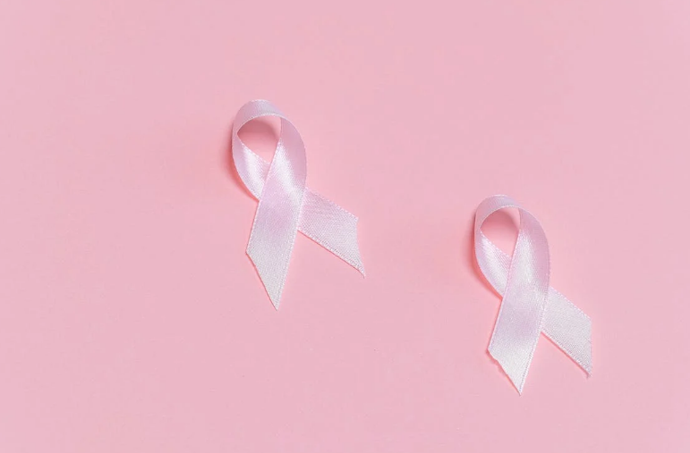

The Early Detection
There were around 375,000 new cancer cases in the United Kingdom every year from 2016 to 2018 (Cancer Research UK, 2022). The incidence of cancer is relatively higher among men compared among women. However, among those aged 25 to 54, the prevalence of cancer is higher among women. The most
common type of cancer in the UK falls into four categories: breast cancer, prostate cancer, lung cancer, and colorectal cancer. Around 137,234 died from cancer in 2020 in England (Cancer Research UK, 2022). The increasing prevalence of cancer requires cancer awareness campaigns in the UK.

The Early Detection Campaign

Breast cancer is the most communal type of cancer found in the UK and USA. Around one out of seven women in the UK are expected to be diagnosed with breast cancer during their life span (Breast Cancer Now, 2022). The end of October is considered the month for breast awareness. This blog highlights the breast cancer awareness campaign “The Early Detection.” The campaign aims to raise awareness about the early detection of breast cancer. It will provide steps and significant measures that women could take to save themselves from being diagnosed with breast cancer.
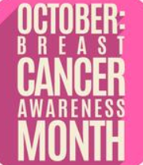

Stories of Women with Breast Cancer
In collaborating with different organizations, The Early Detection held several events in the UK to raise awareness. During these sessions, many women shared their stories about the screening and routine mammograms' role in their breast cancer diagnosis. One of the women, Lizzy, shared her story at The Early Detection campaign's event. She reported about her early detection and timely detection of breast cancer. Lizzy always attended an annual mammogram despite her family's absence of breast cancer history. In December 2019, Lizzy got to know about fast-growing breast cancer. The early detection due to annual screening and mammograms helped Lizzy start her treatment for the disease. She further said in conversation during the Early Detection event that she had no symptoms or history of cancer, and the only way she found out about her disease was through the annual screening and mammogram. After treatment, Lizzy became cancer free.
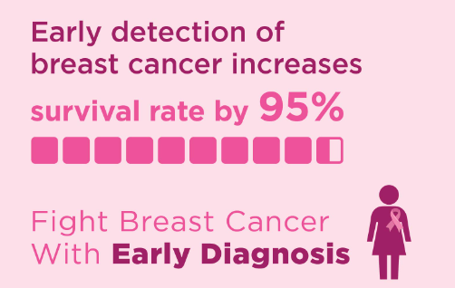
Figure 1: Survival Rate

Importance of Early Detection of Breast Cancer
In a blog post by Hillier, she shared nine breast cancer awareness campaigns that have used different ideas to raise awareness regarding breast cancer in the UK (Hillier, 2019). Early Detection helps British women to understand how important it is to get it checked before it’s too late. According to Milosevic and colleagues (2018), breast cancer is mainly characterized by a lack of early detection of symptoms and late detection of the disease, which leads to late treatment. Detection at the later stage of the disease leads to difficulties in treatment and makes the treatment uncertain. Early Detection aims to focus on the importance of being aware of any unusual changes developing in the breast. For example, women must be aware of any lumps or unusual changes in breast size.
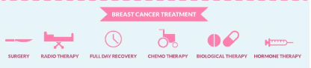

Centers for Disease Control and Prevention uploaded the following symptoms on its website. These unusual changes and symptoms include pain in the breast or armpits, a change in the skin texture, a difference in shape and size of the breast, swelling in the armpits or surrounding areas, a rash or redness around the skin, or a lump of thickening of the breast (Centers for Disease Control and Prevention, 2022). It is recommended to go straight to the GP when any women notice unusual breast changes.
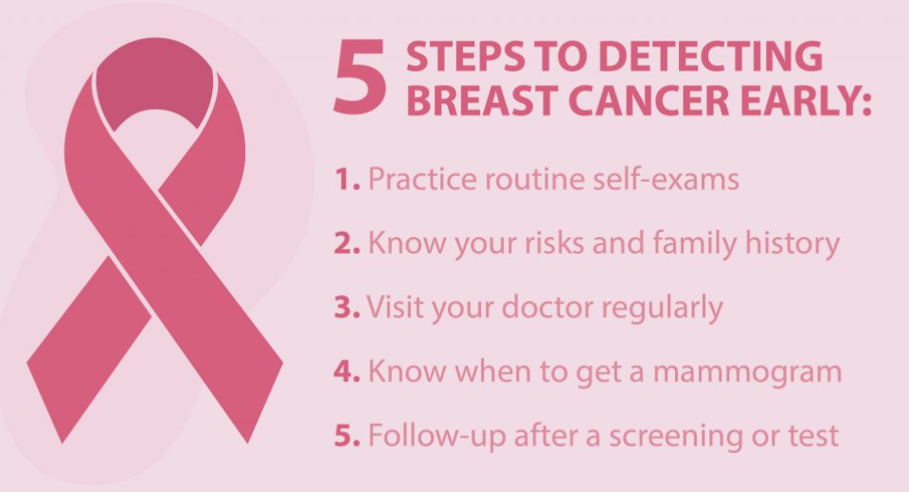
Figure 2: Steps towards Early detection of Breast Cancer (Northwest Primary Care, 2022)
The above signs and symptoms of breast cancer are enough to understand that it is not only the lump that characterizes breast cancer. However, unusual changes to breast size, changes in shape, rash, and skin irritation might be signs of breast cancer. Therefore, women must pay attention to their bodies and listen to them before it is too late. Nine out of ten women survive breast cancer when it is diagnosed or treated. Around 96% of women with breast cancer experience one-year survival after diagnosis, while 86% experience five years of survival after being diagnosed with breast cancer (Baker, 2021).
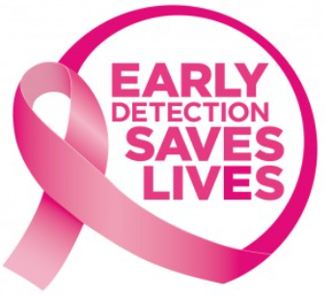

Figure 3: Early Detection of Breast Cancer (CDI Miami , 2017)

Mortality Rate Due To Breast Cancer in Lower Income Countries
Breast cancer is the most common reason of death among women. However, it is most widely detected in women in developed countries, although the number of deaths from breast cancer is higher among women in developing countries or lower-income countries (UNA-NCA, 2020). In developing and lower-income countries, it is most widely noticed that the early detection rate for breast cancer is relatively low, leading to the higher prevalence of breast cancer. In lower-income countries, the lack of medical care and stigma related to breast cancer makes the situation terrible for women living with breast cancer. However, the lack of early detection and knowledge in the lower income regions is the primary reason behind increasing mortality due to breast cancer. In the United States and the United Kingdom, women are alerted with breast cancer awareness campaigns and are accustomed to the early warning from the GPs and the campaigns to monitor their health (UNA-NCA, 2020).
Early detection of breast cancer ensure treatment with fewer risks and uncertainties compared to the late diagnosis of breast cancer. Several treatment options are present for breath cancer treatment. These treatment options include surgery, chemotherapy, hormonal, biological, and radiation therapy. Different organizations in the UK are offering free screening for cancer as well as providing awareness through sessions. For example, NHS provides free mammograms every three years to women registered with a general practitioner aged 50 to 70 years (NHS, 2011).
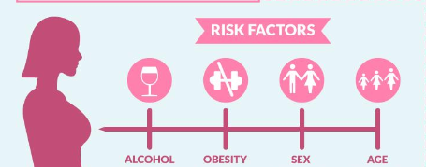

Conclusion
The Early Detection team is deciding to hold a breast cancer awareness session in the last week of October 2022 to educate women about the importance of early detection of breast cancer and how it could save the lives of millions of women around us. Women in the UK are requested to join the pink event that aims to be held in the upcoming week of October. During the awareness session, the free screening will be provided to women to detect breast cancer. The professional will also share some tips to recognize the signs and symptoms of detection at home. This informative session will help raise awareness about breast cancer detection, its treatment, and the need for a permanent cure.

Breast Prevention Strategies

Limiting Alcohol is Necessary: The more consumption women take, the higher the risk will be of getting breast cancer. The recommended amount of alcohol for women is one drink per day. Even a small amount of alcohol can elevate the risk of alcohol (Mayo Clinic, 2022).

Reduce calories: If the weight of the women is healthy, then they should maintain that weight. Females who are vulnerable to breast cancer should start reducing the number of calories and gradually increasing the amount of physical exercise. Having a balanced and healthy diet with regular physical exercise is suggested to every woman to prevent breast cancer.

Physical Exercise and Activity: Physical activity can assist in maintaining a healthy weight, which can help in preventing breast cancer in women. As a preventive strategy, women should take less saturated fat, not consume alcohol, and should maintain a balanced weight.

Breastfeeding: Breastfeeding can play a great role in the prevention of breast cancer. Women who breastfeed their children are less likely to have breast cancer.

Breast Prevention Strategies

Regular Exercise: Regular exercises are great preventative measures for breast cancer; being physically active can help women maintain a healthy weight, which further helps in preventing breast cancer. Most healthy adults should incorporate 150 minutes of physical activity or aerobic exercise into their daily routine. 75 minutes of weekly exercise are recommended, along with strength training for better management of cancer symptoms and other life-threatening diseases.

Do Not Smoke: Apart from another health risk, smoking can cause 15 different types of cancers that also includes breast cancer. Women who smoke should quit it as soon as possible. Cigarette smoke contains toxins that can cause cancer. Women who smoke are more likely to develop cancer compared to those who do not smoke.

Limiting Hormone Medications and Therapy: Women should think of reducing and limiting their intake of hormone medications. Combinations of hormone replacement therapies might increase the risk of developing breast cancer among women. It is recommended that individuals should ask their general practitioners or their doctors about the risk and benefits that are associated with hormone therapies.

Go for Mammograms: Another important preventative measure is the visit for screening. Screening with mammograms can save the lives of various people as it helps in the early detection of the disease. A mammogram cannot help in preventing cancer, but it can help in finding cancer at an early stage when it is more treatable and there are chances of successful treatment outcomes.

The increasing prevalence of breast cancer requires awareness about preventative measures for breast cancer. Breast cancer is the most commonly occurring type of cancer in the United Kingdom. Every woman can take steps to lower their chances of getting breast cancer by making small healthy changes. Effective treatments have been launched introduced the prevention of breast cancer easy. Some factors, like family history, cannot be changed, although small lifestyle changes can be made to reduce the risk of developing breast cancer. The different preventative strategies that could be used to prevent women from developing breast cancer are discussed below.
There were nearly 2.3 million females diagnosed with breast cancer in 2020, while 685,000 deaths have occurred worldwide (Siemens, 2022). Besides this, there were 7.8 million females alive in the past five years who were diagnosed with breast cancer at the end of 2020. Because of the fear of outcomes, women do not utilize the early detection tool for screening available for them. Early detection of breast cancer is a crucial factor. Early detection can certainly decrease the rate of death caused by breast cancer. It is considered a most important aspect in order to improve the prediction after the diagnosis of cancer (Siemens, 2022)
It will include nuts, fruits, whole grains, legumes and vegetables (Mayo Clinic, 2022).

Risk Factors of Breast Cancer

- Women having dense breasts have less fatty tissues. They have more connective tissue. Due to this, it is tough to see tumors on a mammogram. In such cases, the risk of breast cancer is high.

- The risk of breast cancer in females increases with increasing age. Most of the time, breast cancer is diagnosed in females after the age of 50 (CDC, 2022).

- Women who are less engaged in physical activities are at a high risk of having breast cancer.

- The risk of breast cancer is high in women whose any of the family members, such as sisters, mothers, and relatives either from the mother's or father's side, previously had ovarian or breast cancer.

- Women who consume alcohol in higher amounts are at great risk of having breast cancer (Komen, 2022)

- Women, who previously had radiation therapy for their treatment before the age of 30, are at a high risk of having breast cancer (CDC, 2022). Women having their first pregnancy after the age of 30 and not breastfeeding their kids can uplift the risk of breast cancer.


Female who take Mediterranean diet with nuts and extra virgin olive oil have less risk of breast cancer.

1 women in 8 will be diagnosed with breast cancer





References
Baker, C. (2021). Cancer statistics (England). [Online]
Available at: https://commonslibrary.parliament.uk/research-briefings/sn06887/
[Accessed 15 October 2022].
Breast Cancer Now (2022). Facts and statistics 2021. [Online]
Available at: https://breastcancernow.org/about-us/media/facts-statistics
[Accessed 15 October 2022].
Cancer Research UK (2022). Cancer Statistics for the UK. [Online]
Available at: https://www.cancerresearchuk.org/health-professional/cancer-statistics-for-the-uk#:~:text=There%20are%20around%20375%2C000%20new,year%20(2016%2D2018).
[Accessed 15 October 2022].

CDC (2022) What are the risk factors for breast cancer?
Available at: https://www.cdc.gov/cancer/breast/basic_info/risk_factors.htm
(Accessed:17 October 2022).
CDI Miami , (2017). Breast Cancer: The Importance of Early Detection and Screening. [Online]
Available at: https://www.cdimiami.com/breast-cancer-early-detection-and-screening/
[Accessed 15 October 2022].
Centers for Disease Control and Prevention (2022). What Are the Symptoms of Breast Cancer?. [Online]
Available at: https://www.cdc.gov/cancer/breast/basic_info/symptoms.htm
[Accessed 15 October 2022].
Hillier, L., (2019). Nine powerful breast cancer awareness campaigns. [Online]
Available at: https://econsultancy.com/nine-powerful-breast-cancer-awareness-campaigns-marketing/
[Accessed 15 October 2022].
Komen (2022) Breast cancer & your risk.
Available at: https://www.komen.org/breast-cancer/risk-factor/
(Accessed: 17 October 2022).
Mayo Clinic (2022) Breast cancer prevention: How to reduce your risk
Available at: https://www.mayoclinic.org/healthy-lifestyle/womens-health/in-depth/breast-cancer-prevention/art-20044676
(Accessed: 17 October 2022).
Milosevic, M., Jankovic, D., Milenkovic, A. & Stojanov, D. (2018). ‘Early diagnosis and detection of breast cancer’. Technology and Health Care, 26(4), pp. 729-759.
NHS, (2011). Breast screening, Stuttgart: Macmillan.
Northwest Primary Care (2022). Cancer awareness: Steps to detect breast cancer early. [Online]
Available at: https://www.nwpc.com/tips-for-detecting-breast-cancer/
[Accessed 15 October 2022].
Siemens (2022) A breast cancer patient is rarely fighting alone.
Available at: https://www.siemens-healthineers.com/company/breastcancer-care
(Accessed: 17 October 2022)
UNA-NCA, (2020). What it Means to Have Breast Cancer as a Woman in the Developing World. [Online]
Available at: https://medium.com/una-nca-snapshots/what-it-means-to-have-breast-cancer-as-a-woman-in-the-developing-world-b38c97e74b50
[Accessed 15 October 2022].

