Assignment 2 Global Contemporary Business Issues
University of Wales Trinity Saint David
Published December 12th, 2020
Author- Rhodri Stranaghan (1702678)
How the Tourism and Hospitality industries have been impacted by COVID-19- and is there a way forward?

Introduction
There has been a major challenge for the tourism, events, and hospitality industries during 2020 and the ongoing impacts of COVID 19 are yet to be fully established, however the pandemic has had a detrimental impact on businesses particularly in the tourism and hospitality industries. This journal article will discuss the impact of COVID-19 on the hospitality and tourism industries, with a specific look at the case study, Cardiff, and what impact the pandemic has had on the industries in Cardiff as well as a look at Wales as a whole, and the researcher will also provide strategic recommendations on how organisations can work towards reopening.

Research Methodology
Various methods of research have been used for this article to help the researcher gain a wide scope on the issues COVID-19 has brought to the tourism and hospitality industries. As the impact on COVID-19 on hospitality is very topical recent news articles will be used, with textbooks, e-books, and relevant theories as well also. For primary research an interview with a general manager of a hospitality organisation in Cardiff has been carried out to see their perspective.

- Findings
There has been various discussions on what industries have been most impacted, but the tourism, hospitality and events industries have seen forced closures and in many other parts have had to majorly adapt their services to provide customers with a safe experience and to make them feel confidence in the organisation to put their safety first. The largest increase in unemployment in July to September was in the hospitality sector in the UK (ONS, 2020) and the uncertainty around the industry means that this is likely to rise with the predicted nationwide lockdown after Christmas.

In accordance to Visit Britain, tourism has been the fastest growing sector in employment since 2010, and as shown below, Britain were forecast by Deloitte to have a tourism industry in excess of £257 billion by 2025 and so the mass loss of jobs forecast will be detrimental to the growth of the industry.
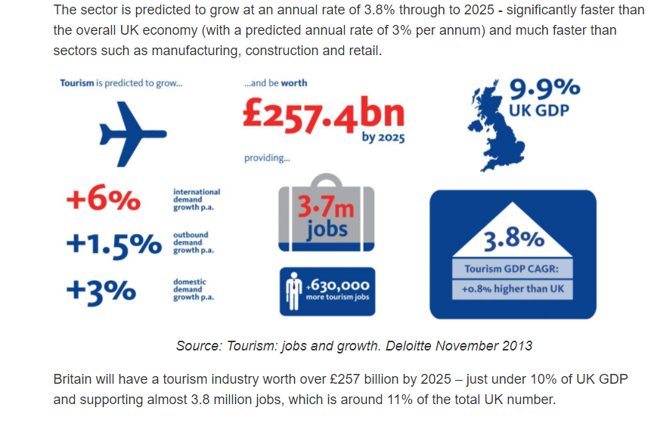

(Deloitte Figures Published by Visit Britain)

With news of several vaccines being approved and set to be rolled out in the UK this will play a major role in whether industries can pick back up to the vital role played in the GDP, however the distribution will take time and it could be years until things can be deemed as being back to normal.

Data published by UNWTO (2020) highlight that an estimated 100-120 million jobs in tourism are at risk worldwide as a direct result of COVID-19, and that there were 850 million to 1.1 billion fewer international tourists in 2020. Another worrying statistic is that the hospitality industry was forecast to generate one in six new jobs this year, however instead 20 percent of the sectors 3.2 million jobs have been lost BBC (2020). This is also supported by statistics from Fourth, published by The Caterer (2020) which state currently 650,000 jobs have been lost in the UK hospitality industry. The concern about these statistics is that with many on furlough, once this stops in March there will be more job losses as more businesses will close.

Pre-Covid, the hospitality sector was valued at £133.5bn, and data from UK hospitality found that £4.7bn turnover was lost in March and April, and around 80% of hospitality firms ceased trading in April, the highest of any other sector Guardian (2020). On a global scale, Europe will be the second hardest hit continent in the travel and tourism sector, with a forecasted employment drop of 13 million. Statista (2020).

The economic uncertainties regarding COVID 19 have also not been helped by the looming impacts from Brexit, which will mean inbound tourism will also be impacted. One identified issue in tourism since the referendum in 2016 is that the UK is seen less as a welcoming, hospitable country. (Andrews, 2019) and this may lead to a stage whereby post COVID-19 people will not want to visit the UK and instead go somewhere they deem more hospitable. Equally, staycations could be more prevalent and so this is important for hospitality organisations to consider, there could be a glimmer of hope if staycations are to be more common in the years to follow, although four in five hospitality industry leaders think Brexit will have negative impacts on their cost of goods McAllister (2020). It is vital for organisations to plan for the worst outcomes and have a Crisis Management strategy in place to tackle the issues.

- Crisis Management
“With prolonged social distancing policies, city lockdowns, stay-home ordinances and travel restrictions around the globe, the tourism-hospitality industry has been hit especially hard with empty rooms, tables, cancelled meetings and closure of properties” (Wong 2020). For organisations in Tourism and Hospitality, having a Crisis Management strategy is vital especially now with the constant changes in rules and regulations, so that the strategies can be met and implemented whilst also adhering to government rulings. “Crisis remain at the forefront of policy making and therefore exert an even higher demand on intelligence than routine decision-making processes” McCarthy (2019). It is very hard currently for strategies to be implemented without having to make slight changes due to the changing environment of the industry. Many are having to use Crisis Management and take big decisions such as whether to close or not until restrictions are lifted, or to adapt their services to provide a safer experience.

For organisations, it is vital that they begin to plan for a way forward so when it comes customers can get safely back to hospitality venues permanently.
One example of crisis management in the hospitality sector from the UK government was the introduction of the ‘Eat Out To Help Out’ scheme which was used more than 100 million times in August and although it cost the UK government £520 million Wales Online (2020) it helped businesses in the industry immensely, kept many workers in jobs and helped encourage some people to leave the house for the first time since the lockdown. This however has also been partly blamed for the rise of cases for the second wave, and so highlights the need for all outcomes to be considered, before implementing any big strategies.

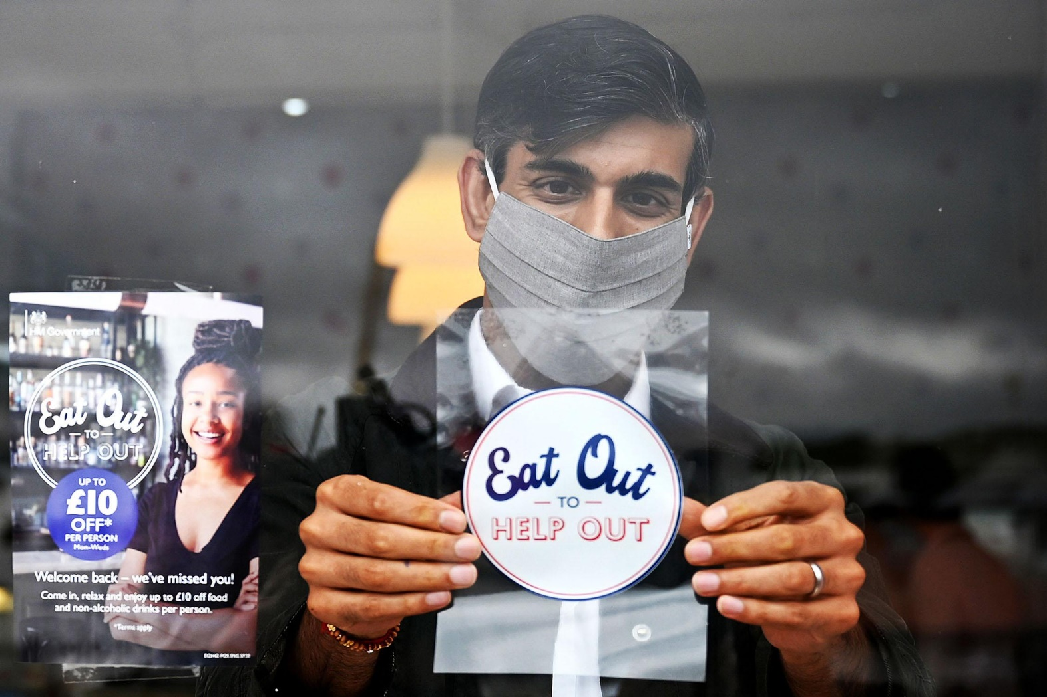

(Image courtesy of The Times)

- Case Study- Cardiff
Cardiff being the Capital City of Wales is at the forefront of events and tourism and has good transport links to Bristol, London, and Manchester as well as Birmingham and other transport hubs in the UK. The reliance on tourism and events in Cardiff to the economy is astronomical, and in 2016 the city saw an income of £1.2 billion from tourism (Financial Times) and with this is also a major demand for hospitality and accommodation. More recently, there was an increase in overnight visits in the first 6 months of 2019 compared with 2018 (Visit Wales) which shows that as a destination Cardiff in 2019 was attracting more visitors than prior, however the impact of COVID has not only been detrimental to inbound tourists, but also employment, and the latest figures show unemployment in Wales has risen to 4.6% BBC (2020) and 2.8 people per tourism business are currently furloughed in Wales, however this is down from the average of 7.5 in the summer. Wales Tourism Business Barometer (2020).

One major challenge that organisations in Cardiff face is the uncertainties over whether people will want to travel to the big cities that are likely to be overcrowded, whereas seaside and outdoor destinations such as Tenby, Swansea and many places in North Wales may cater to these needs instead. This has also been emphasised by the Wales Tourism Business Barometer (2020) published by the Welsh Government which states that tourism in South East Wales particularly was struggling. Cardiff is a major events city and as events are not allowed currently, more might likely travel to other parts of Wales instead.

This means that more work needs to be done in the city to provide safe spaces for tourists, with the Christmas at the Castle a perfect example of this which has currently proved to be a success with the alpine food and drinks area as well as a unique gift shop and festive activities, showing adaptation, collaboration and crisis management from hospitality and tourism organisations. With new harsher restrictions on the hospitality sector in Wales introduced on Friday 4th December meaning venues will be forced to shut at 6pm and unable to sell alcohol, this is another damaging blow to the industry that has had to overcome many challenges this year in what could have been the only real chance of trade this year.

These restrictions are identical to those introduced in Scotland, which were brandished by Stephen Montgomery of the Scottish Hospitality Group as “effectively signing a death sentence for hospitality businesses” whilst speaking to STV. Similar comments have also been reiterated by Tim Martin, owner of the Wetherspoons chain who brandished the restrictions in Wales as ludicrous, and noted Sweden as a best practice example to Wales Online (2020) “By sticking to the two proven measures and by keeping it simple, Sweden today has far better health and economic outcomes than Wales or the UK”. However, in Wales the constant changing of the rules means that people will struggle to keep up with latest advice and so long-term solutions need to be established by the Welsh Government for the hospitality industry to safely reopen.

The damage on hospitality by the recent restrictions has also been a major area for concern for bars in Cardiff. Urban pubs might still attract shoppers for lunch, but they are unlikely to spend as much and rural pubs are often a community’s main place to meet and are more dependent on the evening trade. The money businesses are getting from the government might pay overheads, but these are businesses that have already taken a huge hit this year. Dickins (2020).

David Dean, General Manager of Peppermint Bar in Cardiff stated to the Author that one of the biggest challenges for them was the moving of the goal posts every other week with regulations which mean that they spend a lot of money to adapt to new rulings, and feels that the hospitality industry is scapegoated. “As a venue that rely heavily on Christmas especially for parties and with Christmas shoppers who usually come in for a few glasses of wine or festive cocktails during or after their Christmas shop, the recent alcohol ban and 6pm curfew has forced us to close until this gets reversed, which is a devastating blow as we have not long opened back up from the fire break which clearly has not had the impact it was meant to have”.

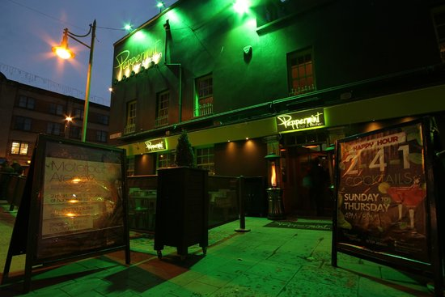

(Peppermint Cardiff- Image Courtesy of Trip Advisor)

Visit Cardiff have launched a campaign “The Same Diff Just Different” which aims to gain trust from visitors to be assured that Cardiff has adapted and can still be visited safely, however the potential city break to Cardiff at Christmas from other parts of the UK may have now been put off with the restrictions on hospitality meaning people from England may choose to go somewhere that is safely providing nightlife. Brains are an example of an organisation that has directly impacted from restrictions in Wales, and the firebreak during November cost them £1.6 million (BBC) and the latest alcohol ban has forced them to close more than 100 sites in Wales and they are not sure when they will be open again, and with a massive link to Cardiff this is a concern for one of the biggest hospitality providers in Wales.

- Maslows Hierarchy of Needs

“Post COVID-19 will change the expectations of the customer in relation to service both before and during service interactions” Girdhardi (2020). Maslows hierarchy of needs (1943) highlight the importance of the needs and wants of consumers, which are just as relevant this year than ever before. “As with any crisis, humans tend to move down Maslow’s Hierarchy of Needs towards the basics of food, security, and safety. Unfortunately, coronavirus has stifled the higher tier need of belongingness” Lewis (2020). It is important for governments to consider the needs and wants before making big decisions that will impact the different levels on Maslow’s needs and wants pyramid shown below.

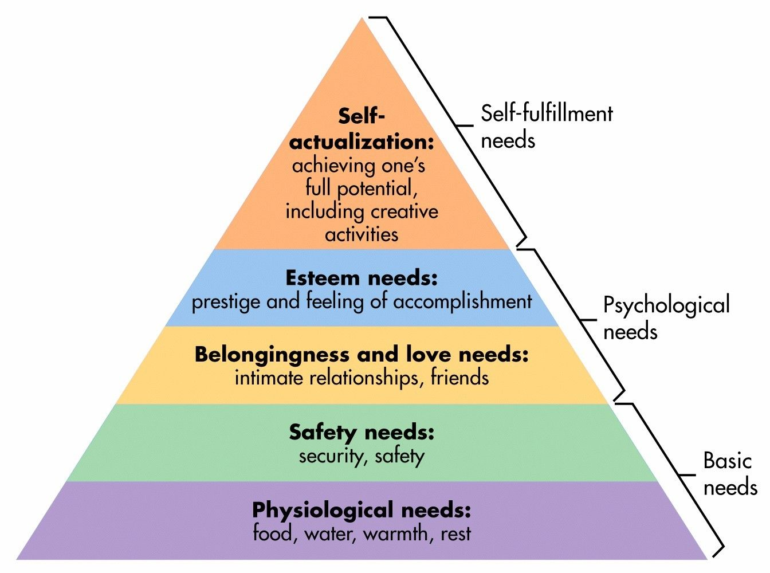

(McLeod 2020)

Many people have been left feeling lonely from not being able to meet with friends or family, and as hospitality organisations are often a safe place for people to socialise the forced closures means that many will be unable to see their friends or families and will subsequently have a negative impact on their wellbeing.

- Porters Five Forces
From an organizational perspective, the supply demands are uncertain, and many will be put off travelling to cities like Cardiff that are potentially overcrowded, however time will only tell if this is the case. Porters Five Forces (1979) shown below must be considered for organisations to understand the current state of the hospitality industry, with many hospitality businesses projected to close, now is a potential opportunity for bars such as Peppermint in Cardiff to implement new strategies to come out stronger, and to consider the competitive rivalry and buyer power considering many people are now without job stability, and many now not want to go out to hospitality organisations and so effective pricing strategies must be implemented, and in addition to Porters Five Forces, organisations must consider the Four P’s Marketing Mix also to ensure that they continue to appeal to the consumers.

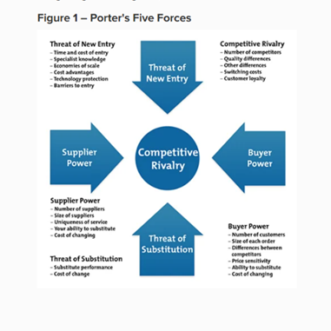

(Diagram Courtesy of Mind Tools)

- Sustainable Development Goals
It is also vital for organisations in Tourism and Hospitality to meet the Sustainable Development Goals as with COVID-19 and Brexit already big issues, this is another issue that still needs to be addressed to ensure the long term survival of the industry and the planet. “Policymakers must develop further initiatives to favour the voluntary adoption of new practices by tourism enterprises inspired by the need to actively contribute to the SDGS”. Rosato (2021).


(UNWTO Sustainable Development Goals, Diagram Courtesy of Exarc.net)

- Conclusion
The Tourism and Hospitality industries have faced major challenges over the last decade and the impact of COVID-19 has forced many organisations on the brink of closure and mass unemployment. It is challenging for research to be carried out in to the impacts of COVID-19 on the hospitality and tourism industries as the true impacts similarly with Brexit as these issues are still ongoing and will take years to fully recognise, as consumer needs and wants may now be changed forever. The closure in Wales of hospitality premises at 6pm with alcohol bans may be in the best interest of keeping the virus under control however it is at the cost of many businesses who may now never trade again, and with the Welsh Governments reluctance to publish the science behind these measures on the hospitality industry it means that many are left in the industry with unanswered questions, as tourism and hospitality are growing industries which many are employed in. It is also a challenge to predict a way forward with restrictions constantly being lifted then reinforced however with the vaccine beginning to roll out this could be a very significant moment as the hospitality industry aim to move forward to be able to provide a safe experience for customers, however what is evident is organisations are having to adapt their services and if failing to do so effectively are under serious threats of closures.

- Recommendations

- Due to certain limitations in terms of research on the impacts of COVID on the Hospitality industry, more research needs to be carried out to find working, actionable solutions.
- More clarity must be given to hospitality organisations from the government when bringing in potentially fatal restrictions on the industry, as 5 days is not enough time to prepare. Perhaps a few weeks’ notice and potentially updates on current ideas being discussed so that organisations can begin to plan and strategize instead of having to wait for press leaks and having to be left in the dark.

- A four nations approach for the United Kingdom that includes Tourism and Hospitality leaders input to work towards a strategy- Otherwise people will continue to travel to areas where pubs and bars are open and selling alcohol, or they may have house gatherings instead of safe environments.

- Hospitality businesses in Cardiff and other student cities to work closely with the Universities and Student Unions to ensure that students are socialising in controlled settings, as opposed to forcing them to have house gatherings.

- Ensure strategies are incorporating sustainable development goals for the industry to move forward more environmentally friendly.

- Bibliography

Andrews, H. (2020). With Brexit Uncertainty Heating Up is the tourism industry cooling down. Available: https://ukandeu.ac.uk/with-brexit-uncertainty-heating-up-is-the-tourism-industry-cooling-down/. Last accessed 10th Dec 2020.
Anon. (2013). Britain’s Visitor Economy Facts. Available: https://www.visitbritain.org/visitor-economy-facts. Last accessed 10th Dec 2020.
Anon. (2020). Covid: 'A fifth' of hospitality sector jobs lost in 2020. Available: https://www.bbc.co.uk/news/business-54972940. Last accessed 10th Dec 2020.
Anon. (2020). Covid: Alcohol ban for Welsh pubs and restaurants from Friday. Available: https://www.bbc.co.uk/news/uk-wales-55128305. Last accessed 10th Dec 2020.
Anon. (Unknown). Porters Five Forces. Available: https://www.mindtools.com/pages/article/newtmc_08.htm. Last accessed 10th Dec 2020.
Brown, M.J. (2017). https://www.ft.com/content/b8d732f2-4099-11e7-82b6-896b95f30f58. Available: https://www.ft.com/content/b8d732f2-4099-11e7-82b6-896b95f30f58. Last accessed 10th Dec 2020.
Deacon, T & Cooper, J. (2020). JD Wetherspoons Boss Tim Martin attacks Wales 'puritanical ...ludicrous' pub alcohol ban. Available: https://www.walesonline.co.uk/whats-on/whats-on-news/wetherspoons-boss-tim-martin-attacks-19370949. Last accessed 10th Dec 2020.
Dickins, S. (2020). COVID 'More Damaging' to Wales economy than pit closures. Available: https://www.bbc.co.uk/news/uk-wales-54934564. Last accessed 10th Dec 2020.
Image Used. (2020). Peppermint Cardiff Image. Available: https://www.tripadvisor.ie/LocationPhotoDirectLink-g186460-d5911283-i105358281-Peppermint_Bar_Cardiff-Cardiff_South_Wales_Wales.html. Last accessed 10th Dec 2020.
Image Used. (Unknown). Sustainable Development Goals Diagram. Available: https://exarc.net/sustainable-development-goals. Last accessed 10th Dec 2020.
Institute of Hospitality. (2020). How will hospitality service change post COVID-19. Available: https://www.instituteofhospitality.org/how-will-hospitality-service-change-post-covid-19/. Last accessed 10th Dec 2020.
Kale, S. (2020). How Lockdown Is leaving hospitality workers homeless. Available: https://www.theguardian.com/food/2020/nov/16/im-seeing-an-industry-disappear-how-lockdown-is-leaving-hospitality-workers-homeless. Last accessed 10th Dec 2020.
Lewis, K. (2020). COVID-19 changed consumer behaviour and marketing strategy. Available: https://www.smartbrief.com/original/2020/08/covid-19-changed-consumer-behavior-and-marketing-strategy. Last accessed 10th Dec 2020.
Lydall, A. (2020). Wales Tourism Business Barometer 2020. Available: https://gov.wales/sites/default/files/statistics-and-research/2020-10/tourism-barometer-coronavirus-covid-19-impact-survey-wave-5-2020.pdf. Last accessed 10th Dec 2020.
MacMath, J. (2020). Rishi Sunak's Eat out to Help Out scheme could make a comeback this winter. Available: https://www.walesonline.co.uk/news/uk-news/sunak-eat-out-help-out-19267201. Last accessed 10th Dec 2020.
Maslow, A.H. (1943). A theory of human motivation. Psychological Review, 50 (4), pp-370-396
McAllister, J. (2020). https://www.bighospitality.co.uk/Article/2020/12/04/Hospitality-s-confidence-shattered-as-sector-reels-from-impact-of-Covid#. Available: Hospitality's confidence shattered as sector continues to reel from impact of COVID. Last accessed 10th Dec 2020.
McCarthy, S.P. (2019). The Function of Intelligence in Crisis Management: Towards an Understanding of the Intelligence Producer-Consumer Dichotomy. [ebook] Taylor and Francis. Available at: https://www.perlego.com/book/1479609/the-function-of-intelligence-in-crisis-management-towards-an-understanding-of-the-intelligence-producerconsumer-dichotomy-pdf. pp8-14.
McLeod, S. (2020). Maslows Hierarchy of Needs Diagram. Available: https://www.simplypsychology.org/maslow.html. Last accessed 10th Dec 2020.
Office for National Statistics. (2020). Employment in the UK: November 2020. Available: https://www.ons.gov.uk/employmentandlabourmarket/peopleinwork/employmentandemployeetypes/bulletins/employmentintheuk/november2020. Last accessed 10th Dec 2020.
Pease, V. (2020). New restrictions 'Death Sentence' for hospitality industry. Available: https://news.stv.tv/scotland/new-restrictions-death-sentence-for-hospitality-industry?top. Last accessed 10th Dec 2020.
Porter, M.E. (1979) How Competitive Forces Shape Strategy. Harvard Business Review 57 (2) pp 137-145
Prayag, Girish, 2020. Time for Reset? Covid-19 and Tourism Resilience. Tourism Review International, 24(2), pp.179–185.
Price, K. (2020). Hospitality job losses hit 650,000. Available: https://www.thecaterer.com/news/hospitality-job-losses-650000-fourth. Last accessed 10th Dec 2020.
Rosato, Pier Felice et al., 2021. 2030 Agenda and sustainable business models in tourism: A bibliometric analysis. Ecological indicators, 121, pp. Ecological indicators, 2021–02, Vol.121.
Statista. (2020). COVID-19: job loss in travel and tourism sector worldwide 2020, by region Published by S. Lock, Aug 21, 2020 As a result of the coronavirus (COVID-19) pandemic, the global travel and tourism market. Available: https://www.statista.com/statistics/1104835/coronavirus-travel-tourism-employment-loss/. Last accessed 10th Dec 2020.
Statistics Wales. (2019). Wales Tourism Performance Report: January to June 2019. Available: https://gov.wales/sites/default/files/statistics-and-research/2019-11/wales-tourism-performance-january-june-2019-828.pdf. Last accessed 10th Dec 2020.
Swinford, S. (2020). Eat Out to Help Out scheme: taxpayers pick up £522m bill. Available: https://www.thetimes.co.uk/article/taxpayers-pick-up-522m-eat-out-bill-5xlpz3g9d. Last accessed 10th Dec 2020.
UNWTO. (2020). New Data Shows Impact of COVID-19 on Tourism as UNWTO calls for responsible restart of the sector. Available: https://www.unwto.org/news/new-data-shows-impact-of-covid-19-on-tourism. Last accessed 10th Dec 2020.
Wong, I. A, Ou, J & Wilson, A. 2021. Evolution of hoteliers’ organizational crisis communication in the time of mega disruption. Tourism management (1982), 84, pp. Tourism management (1982), 2021–06, Vol.84.

