Cert HE in Business skills for the Workplace

Digital Skills

Website evaluation

LCLM4002

Charles Oham

David Brown

2427443

Contents

- Introduction
- Usability
- Customer experience
- Perceived values
- Conclusion

List of References
James J. Cappel. (2016) A Comparative Study of Web Site Usability Practices of Fortune 500 Versus INC. 500 Companies. Information Systems Management 29:2, pages 112-122.
Foris, D., (2019). Relevance of the features regarding the performance of booking websites. Tourism Economics, 26(6), 1021-1041. Relevance of the features regarding the performance of booking websites - Diana Foris, Alina Simona Tecau, Madalina Hartescu, Tiberiu Foris, 2020 (Original work published 2020)

Introduction
Today I will be writing about a business called Eden spa Harborne and will show you the features of the company website. I will also show you what they offer to customers and how they present what they are offering on the website. Furthermore, I will also evaluate the different features the company website has and how good the features of the website are. As well as showing you what they could improve on to make its a website experience better for customers.

Usability
Eden spa Harborne, website is very quick and efficient when you load into the website its does run smooth, doesn’t require the user to refresh the page at all. The website doesn’t have a lot of subpages but does offer a home page, details about the spa, pricing and contact details for the user and contact information which is the companies telephone line. The sub-pages are easily accessible and easy to navigate but extremely difficult to see as there is map block the titles of two subpages as shown in figure 1 below. This causes a disruption for new or prospect customers which limits their view to the page and alters their navigation to the subpages. It can also cause more disruption because you are unable to get rid of the map which makes hard to use the website. It also doesn’t cause an unpleasant experience of wasting time trying to get rid of the map, this also delays the main use of the website. Meanwhile, although the company website does offer a subpage for a customer’s information, asking to provide name and email address and offering a box to write a message to the company. The company states in ‘the spa’ subpage that they take booking and provide availability via telephone; it does not offer customers to books a spa through the page. (Capple, 2016) Research show for usability for website realised if the website lacks any characteristic a customer can be enabled to become frustrated and go to a competing site that does offer bookings. Overall, this website usability isn’t great because of the map and unavailability to access information for availability for bookings on the website, as well as not being able make bookings. This will enable competing sites to have an advantage as their page may offer booking and availability on the websites. (Foris, 2019) It has been analysed that making booking accessible via websites ‘satisfies tourist needs’ and furthermore can enable a prospect customer into a visiting customer.
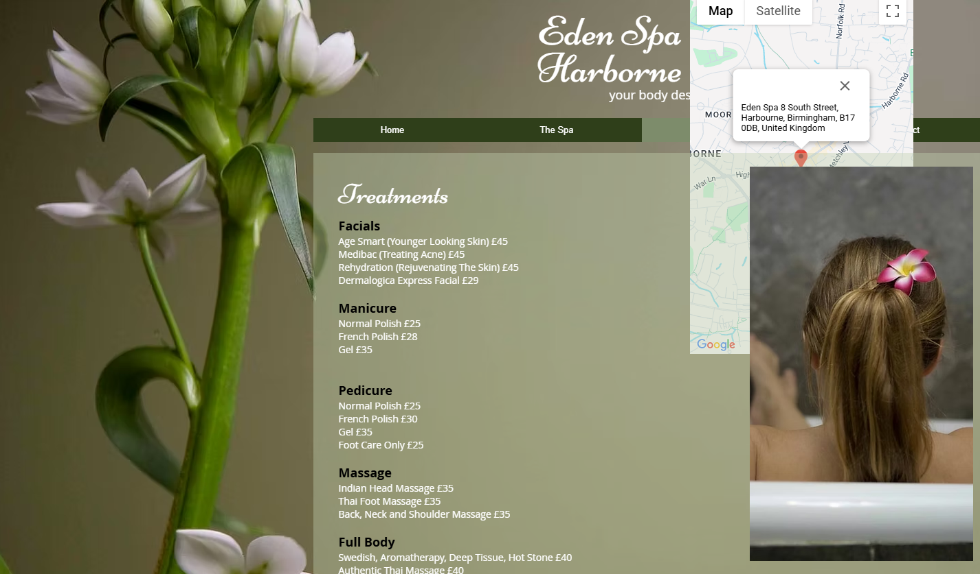Figure 1

Customer experience
The company website of Eden spa is basic and even though it uses images for the website the images are very simple and not relatable to the company’s place of business. They do not produce any pictures with employees offering services to actual customers. The company could add in more pictures of the place of business or present any type of service they produce for customers. However new customers are being presented with flowers which doesn’t support evidence for a good spa and especially if there are no customer reviews for the website. The website is also accessible on a phone and its appearance is better on the phone verses the computer. The website on the phone is not blocked by a map and information could be seen as more visible because of how big the text comes up on the phone. Another key point about the appearance is on the phone the website pages are not shown but are easily to navigate through with the category’s menu button. The website doesn’t use many images for the display and images don’t provide information about how the place looks or what they offer as well as not offering a video of the company or information for prospect customers. Furthermore, the company website could have added a chat tool to assist them and customers however there is no chat tool. This makes the website becomes non-interactive for customers and may leave them with unanswered questions. Equipping a chat tool to the website for assistance may help satisfy more customers instead the Eden spa website doesn’t have this tool which is a main characteristic for websites. The company does offer access to one form of social media on their website which is Twitter, the is an advantage in the Morden day because most people do have social media and are active on it. This can help attract customer as they can find your social media business account which help lead to the website of the company. Another positive thing is that the company was very active on their social media account for about two years however the last time they have posted was 2018 which may become a major problem for them as its been seven years and although twitter is one of the most used apps they should understand the age range of target audience and should have another link for a business account on a next platform so you can gain more attention to the business company that way.

Perceived value
Eden Spa Harborne makes it very clear for the services they can offer and produce they make clear by adding a sub page for the treatments they offer for customers attached with the pricing so that you are aware of much the service cost. Customer reviews are crucial to new viewers or for people that has never experienced any services that company offering. Reviews will help people understand how good services are and it builds trust because it provides proof which will make a new customer trust the business. However, Eden spa does not have any customer reviews on their website which makes it hard for new customers to trust them as they don’t provide any social proof. Pricing should always be clear to customer and should be provided so that anyone that establishes your website can see the price you offer for the services. Fortunately for Eden spa they do have a price list with all the different services they offer which makes it easier to know what you offer and for how much for any new customers. However, prices are not supported by any type of evidence as it doesn’t show any pictures/videos of services received by customer as well as no reviews for proof that the price should be equal to the service which might make customers question and not fully trust what the company is offering.

Conclusion
Overall, Eden spa Harborne is a company with potential, but website needs more work if they want to attract more customers and keep the business growing. They do show you what they can offer but on the other hand, I feel like they have rushed the website and have missed important features that a website would need to be classed as qualified. One recommendation I would make to the company is to add an advert video for customers so that they can see the place of business before the go there and so that customers can see how they offer their services.

