Name: Meheret Zeleke
Student number: 2426669
Module: Changemakers Creativity and Value Creation BMHP5014
Component 2: Written Assignment (Report)
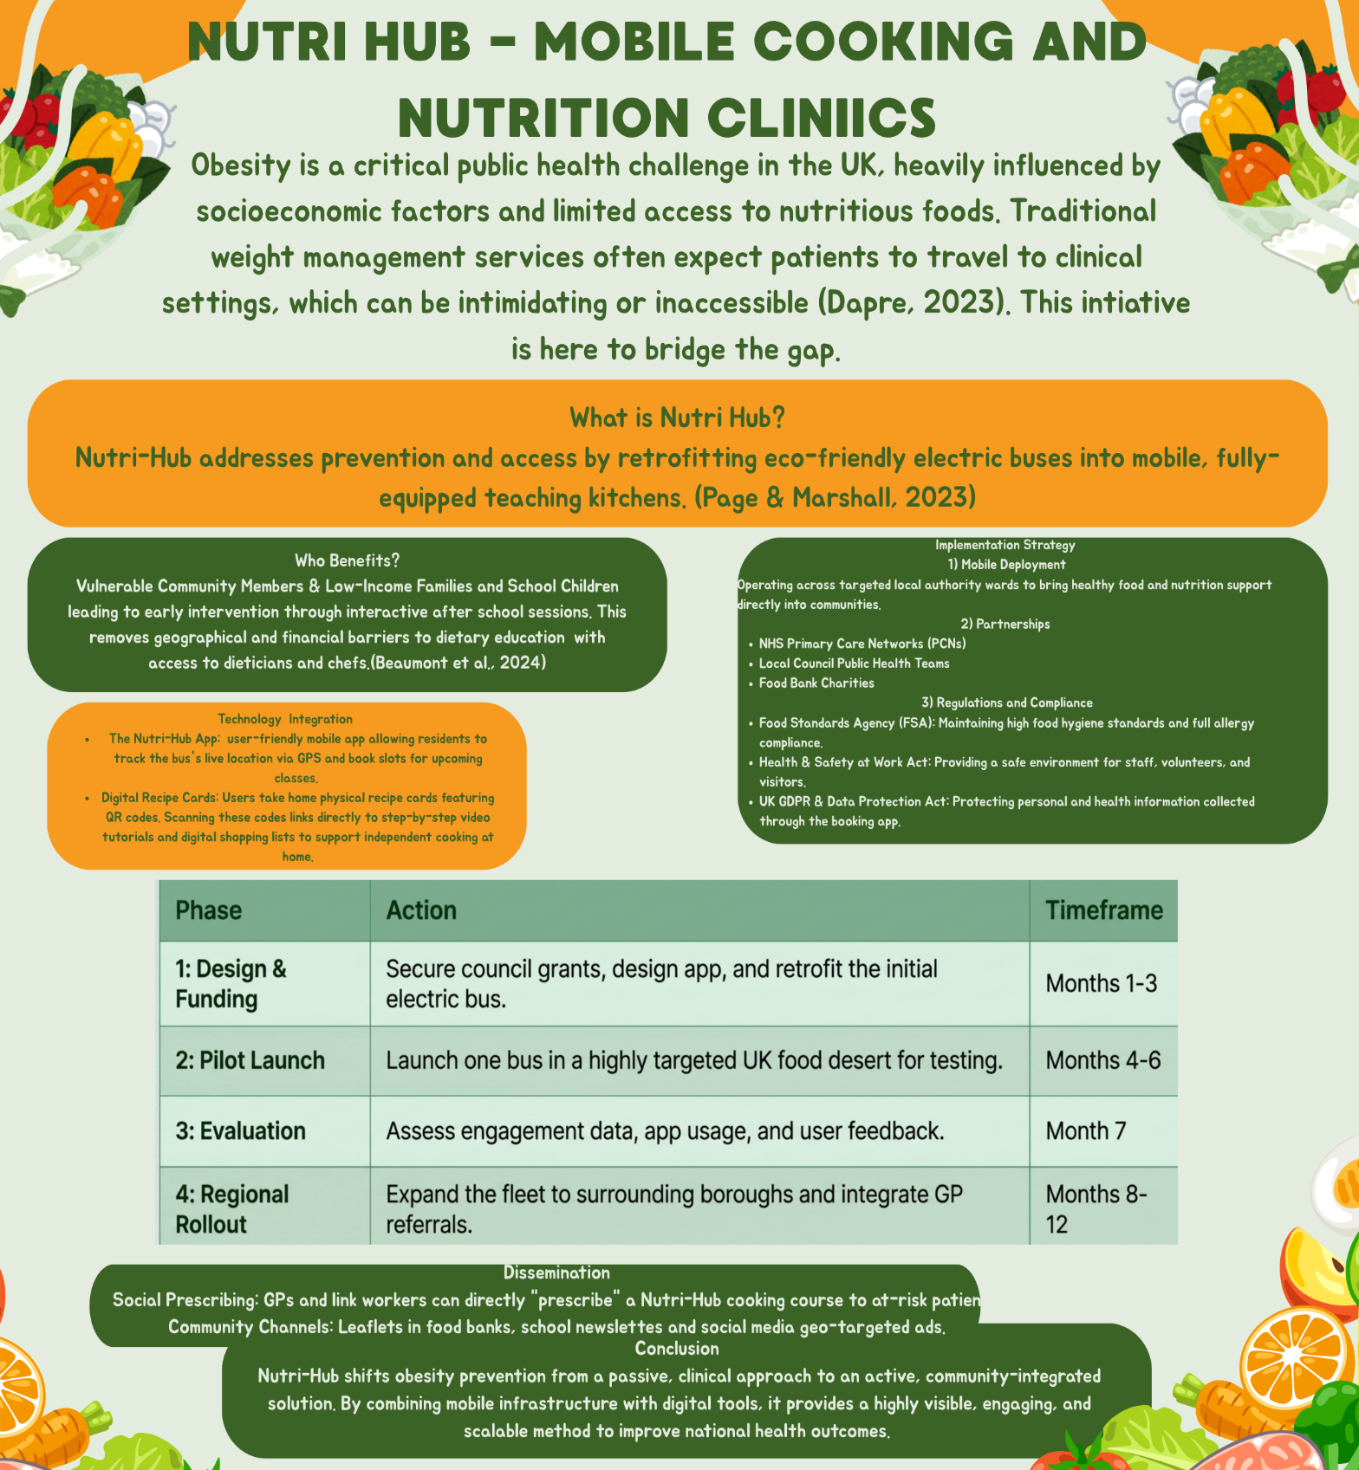
Nutri-Hub: Mobile Cooking & Nutrition Clinics Bringing the Kitchen Classroom to the UK's Food Deserts

The Challenge
Access to affordable, nutritious food is not evenly distributed across the United Kingdom. Areas with limited access to supermarkets or major grocery shops offering fresh produce, commonly termed "food deserts," are instead marked by a denser concentration of fast-food outlets and convenience stores, a pattern linked to poorer nutritional quality and a heightened risk of obesity, diabetes and cardiovascular disease (Beydoun et al., 2026; Titis, Procter and Walasek, 2021). Beydoun et al. (2026) mapped food desert risk against the Indices of Multiple Deprivation across 41,729 small areas in England, Wales and Scotland and found that, while the two measures were correlated, nearly a third of areas showed discordant classifications, with rural communities in Scotland particularly likely to combine low deprivation scores with high food desert risk. This means that deprivation indices alone will miss real pockets of food insecurity, a gap Titis, Procter and Walasek (2021) also identify in their systematic review of how physical food access is measured across the UK, noting that most methods rely on simple distance or density metrics that overlook the lived, day-to-day experience of accessing healthy food. Left unaddressed, this exposure compounds the broader burden of non-communicable disease, which behavioural risk factors such as poor diet and inactivity continue to drive globally (Kurniawan et al., 2025). Nutri-Hub is designed to close this specific, geographically uneven gap.

The Innovation
Nutri-Hub retrofits electric buses into mobile teaching kitchens that travel directly to community centres and schools located in identified UK food deserts. The underlying delivery model is not speculative: mobile health units already have a substantial track record of reaching populations that fixed-site services struggle to serve. Malone et al. (2020), analysing data from 811 US mobile clinics, found that more than half of clients served were women and 59% were racial or ethnic minorities, with clinics overcoming the transportation, time and trust barriers that keep vulnerable groups away from conventional facilities. Yu et al. (2017) similarly conclude that mobile health clinics succeed precisely because they deliver services at the curb side, in communities of need, and can flexibly adapt to a target population's changing requirements. Nutri-Hub applies this same physically embedded, trust-building logic to nutrition rather than clinical care, meeting people where the food access barrier actually exists rather than expecting them to travel toward a fixed centre.

How It Works
Aboard the bus, healthcare professionals and community dietitians deliver free, hands-on cooking classes centred on meals that are affordable, healthy and culturally appropriate. This format is grounded in the emerging field of culinary medicine and culinary nutrition, which blends practical food skills with nutrition science to support behaviour change (Asher et al., 2021). In their scoping review of 33 culinary medicine and nutrition programmes, Asher et al. (2021) found that over half were delivered directly to community members, including children, adolescents, adults and pregnant women, by health or education professionals trained in the approach, and that these programmes reported improvements in culinary skill, nutrition knowledge, dietary intake and cooking-related confidence. Nutri-Hub mirrors this facilitator-led, community-based structure, using qualified dietitians to ensure the same rigour that underpins the programmes Asher et al. (2021) reviewed, while keeping sessions short and accessible enough to fit around school hours and community centre schedules.

Impact and Target Demographic
Nutri-Hub is targeted at vulnerable community members and school-age children living in food deserts, groups who carry a disproportionate share of diet-related disease risk (Beydoun et al., 2026; Titis, Procter and Walasek, 2021). Beyond individual skill-building, the initiative supports the common good by strengthening the same "community-clinical linkage" that mobile health literature identifies as a mechanism for connecting disenfranchised groups back to wider health and social resources (Yu et al., 2017; Malone et al., 2020). This is not only a health argument but an economic one. Yu et al. (2017) report that mobile health delivery models have produced measurable cost savings and calculated returns on investment, including one programme returning $15 for every dollar invested in preventive screening and another producing $24.4 million in quality-adjusted life years saved over five years. If a comparable proportion of the value mobile clinics generate through prevention can be replicated through mobile nutrition education, the long-term case for local authority or NHS commissioning becomes considerably stronger.

Technology Integration
Service users book their place on the bus through a localised app, addressing the accessibility gap that digital nutrition tools are increasingly used to close. Kurniawan et al. (2025), reviewing 53 studies of digital nutrition and physical activity interventions in low- and middle-income countries, found that mobile apps, video and multicomponent platforms produced significant improvements in nutrition knowledge, attitudes and healthy food consumption among children, adolescents and youth, though effects on anthropometric outcomes were less consistent. Talens et al. (2025) reached a comparable conclusion in a systematic review focused specifically on children and adolescents in higher-income settings, reporting that game-based and web-based tools improved nutrition knowledge and fruit intake, even as evidence for sustained changes in body composition and physical activity remained limited. Both reviews therefore support the recipe cards with QR-linked video tutorials that Nutri-Hub sends home with participants: this extends the in-person lesson through a format with a demonstrated evidence base, while acknowledging that digital reinforcement works best as a supplement to, rather than a replacement for, direct facilitator contact.

Conclusion
Nutri-Hub combines three separately evidenced components into a single service: the geographically targeted, trust-building reach of mobile health delivery (Malone et al., 2020; Yu et al., 2017); the facilitator-led culinary skills education shown to improve dietary behaviour (Asher et al., 2021); and app- and video-based digital reinforcement shown to strengthen nutrition knowledge among children and families (Kurniawan et al., 2025; Talens et al., 2025). Layered onto precise UK food desert mapping (Beydoun et al., 2026; Titis, Procter and Walasek, 2021), this positions Nutri-Hub to reach the specific communities existing services overlook, converting a well-evidenced public health model into direct, practical action.

References
Asher, R.C., Shrewsbury, V.A., Bucher, T. and Collins, C.E. (2021) 'Culinary medicine and culinary nutrition education for individuals with the capacity to influence health related behaviour change: A scoping review', Journal of Human Nutrition and Dietetics, 35(2), pp. 388–395.
Beydoun, M.A., Georgescu, M.F., Banerjee, S., Beydoun, H.A., Noren Hooten, N., Khubchandani, J., Maldonado, A.I., Tsai, J., Weiss, J., Evans, M.K. and Zonderman, A.B. (2026) 'Mapping food access: how neighborhood deprivation shapes healthy food availability in the United Kingdom', BMC Public Health, 26, p. 1048.
Kurniawan, A.L., Theresia, T., Faradina, A., Paramastri, R., Haryana, N.R., Ginting, R.M.S., Nurrahma, B.A., Kinasih, L.S., Khan, A.F., Aji, A.S., Umami, Z., Putri, O.Q. and Mayasari, N.R. (2025) 'Digital intervention targeting nutrition and physical activity behaviours among healthy individuals in low- and middle-income countries: a scoping review', Journal of Health, Population and Nutrition, 44, p. 348.
Malone, N.C., Williams, M.M., Smith Fawzi, M.C., Bennet, J., Hill, C., Katz, J.N. and Oriol, N.E. (2020) 'Mobile health clinics in the United States', International Journal for Equity in Health, 19, p. 40.
Talens, C., da Quinta, N., Adebayo, F.A., Erkkola, M., Heikkilä, M., Bargiel-Matusiewicz, K., Ziółkowska, N., Rioja, P., Łyś, A.E., Santa Cruz, E. and Meinilä, J. (2025) 'Mobile- and web-based interventions for promoting healthy diets, preventing obesity, and improving health behaviors in children and adolescents: systematic review of randomized controlled trials', Journal of Medical Internet Research, 27, e60602.
Titis, E., Procter, R. and Walasek, L. (2021) 'Assessing physical access to healthy food across United Kingdom: A systematic review of measures and findings', Obesity Science & Practice, 8(2), pp. 233–246.
Yu, S.W.Y., Hill, C., Ricks, M.L., Bennet, J. and Oriol, N.E. (2017) 'The scope and impact of mobile health clinics in the United States: a literature review', International Journal for Equity in Health, 16, p. 178.
Beaumont, J.D., Ioannou, E., Harish, K., Elewendu, N., Corrigan, N. and Nield, L. (2024) '"We're one small piece of the puzzle": evaluating the impact of short-term funding for tier two weight management services', Frontiers in Public Health, 12.
Dapre, E. (2023) 'Are GLP-1 agonists the answer to our obesity epidemic?', British Journal of General Practice, 73, p. 365.
Page, B. and Marshall, L. (2023) Food insecurity – what can local government do? Available at: https://doi.org/10.37829/hf-2023-hl02.

