University of Wales Trinity Saint David
Wales Institute of Science and Art



BEng Motorsport – Contemporary Powertrain
Module Code: ACHA6006
Analytical Assessment of Engine Internal Components

Cameron Andrews
2300898
21/03/2026
Word Count - 2715

Contents
1 Introduction 2
2 Methodology 3
2.1 Piston Kinematics and Forces 3
2.2 Stress Analysis 3
2.3 Fatigue Analysis 4
2.4 Assumptions 4
3 Initial Analysis 5
3.1 Connecting Rod Midpoint 5
3.2 Gudgeon Pin 5
3.3 Connecting Rod Bolt 6
3.4 Extension to 9000 RPM 8
4 Bolt Redesign 9
4.1 Thread Diameter Optimisation 9
4.2 Shank Length Optimisation 10
4.3 Shank Thickness Optimisation 10
4.4 Surface Finish 11
4.5 Material Selection 13
5 Torque 15
5.1 Flat Plane Inertia Torque 15
5.2 Cross Plane Inertia Torque 16
5.3 Combined Crank Torque Comparison 16
6 Conclusion 17
7 Bibliography 18

Introduction
The structural integrity of internal combustion engine (ICE) components is critical to ensuring reliable and safe operation, particularly under high cyclic loading conditions experienced during normal engine operation. Fatigue failure in components can cause serious mechanical problems and harm to an ICE, so accurate fatigue assessment is an essential part of the design process.
The aim of this report is to analyse the mechanical behaviour of key components within a Ford EcoBoost 1.6L GDTi engine, specifically the connecting rod (conrod) midpoint, gudgeon pin, and conrod bolts. The forces acting on each component are derived from piston motion equations from in-cylinder pressure measurements across the full RPM range. These are then used to calculate stresses and fatigue safety factors (FSF) using the modified Goodman criterion, with results presented through Goodman diagrams.
The analysis is extended to 9000RPM through extrapolation of the pressure dataset, representing operating conditions relevant to high performance applications. A design optimisation of the conrod bolt is then performed, examining how changes to geometry and material influence the FSF. This includes an investigation into the influence of thread diameter, shank length, surface finish, and material selection on fatigue performance.
Finally, instantaneous torque is evaluated for both flat-plane and cross-plane crankshaft configurations, with a discussion on their suitability for automotive and motorsport applications.

Methodology
Component forces, stresses, and FSF are derived progressively, beginning with piston kinematics as the foundation of the analysis.

Piston Kinematics and Forces
Piston acceleration was modelled over a full 720° cycle using the geometric relationships governing piston motion within the cylinder, separated into first and second order components:
$$a = Rω²cos(θ) + (\frac{R²}{L})ω²cos(2θ)$$
Inertia force was calculated using Newton's Second Law, combined with gas force derived from experimental pressure data, giving net force:
$$F_{inertia} = m×a× F_{gas} = P × A {×F}_{net} = F_{gas} - F_{inertia}$$
This was resolved into axial rod force and lateral force using the conrod angle φ:
$$F_{rod}= \frac{F_{net}}{cos(φ) F_{lat}} = F_{net}× tan(φ)$$

Stress Analysis
Stresses were calculated based on the dominant loading mode for each component:
- Conrod midpoint (axial): $σ = \frac{F}{A}$
- Gudgeon pin (bending, 50% force each side): $σ = \frac{(M × y)}{I}$
- Conrod bolt (preload + external): $F_{bolt}= F_{preload} + \frac{k_{b}}{k_{b} + k_{c}} × F_{external}$
Bolt preload was set at 60% UTS. A thread stress concentration factor Kt was calculated from the M8×0.75 thread geometry (ISO, 1998) using the empirical U-notch and applied to the alternating stress component once the high mean stress from preloading causes local yielding at the thread root, which reduces the stress concentration effect on the component.
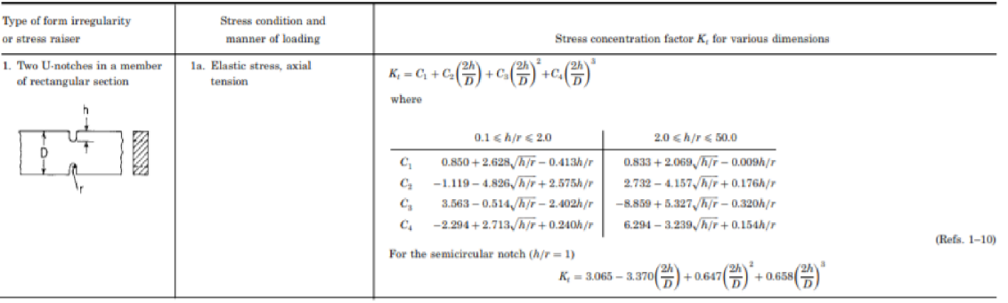
Figure 1. Roark’s empirical U-notch formula for stress concentration.

Fatigue Analysis
Fatigue performance was assessed using the modified Goodman criterion (Direct, 2025):
$$\frac{σ_{a}}{S_{e}} + \frac{σ_{m}}{S_{ut}} = \frac{1}{n}$$
where $σ_{a}$ and $σ_{m}$ are alternating and mean stress, $S_{e}$ is the endurance limit, $S_{ut}$ is the ultimate tensile strength, and $n$ is the FSF. Goodman diagrams were produced for each component at worst-case RPM.

Assumptions
A few key assumptions were made during the analysis, including purely axial loading affects the conrod midpoint, material properties were homogeneous isotropic, average lubricating conditions (μ = 0.1) at the piston-cylinder interface, and steady-state operation at each speed point.

Initial Analysis

Connecting Rod Midpoint
The conrod midpoint was analysed with stress calculated as $σ =\frac{F}{A}$ using a cross-sectional area of 210mm². A FSF of 3.61 was obtained at 6000RPM using the modified Goodman criterion (Direct, 2025) The Goodman diagram (Figure 2) confirms the actual stress range (purple) sits comfortably within the allowable range (yellow), with a mean stress of ~100MPa, well below the material UTS of 1000MPa. The mean stress remaining below the UTS is critical as it ensures the material retains enough strength reserve to prevent fatigue failure under unexpected loads.
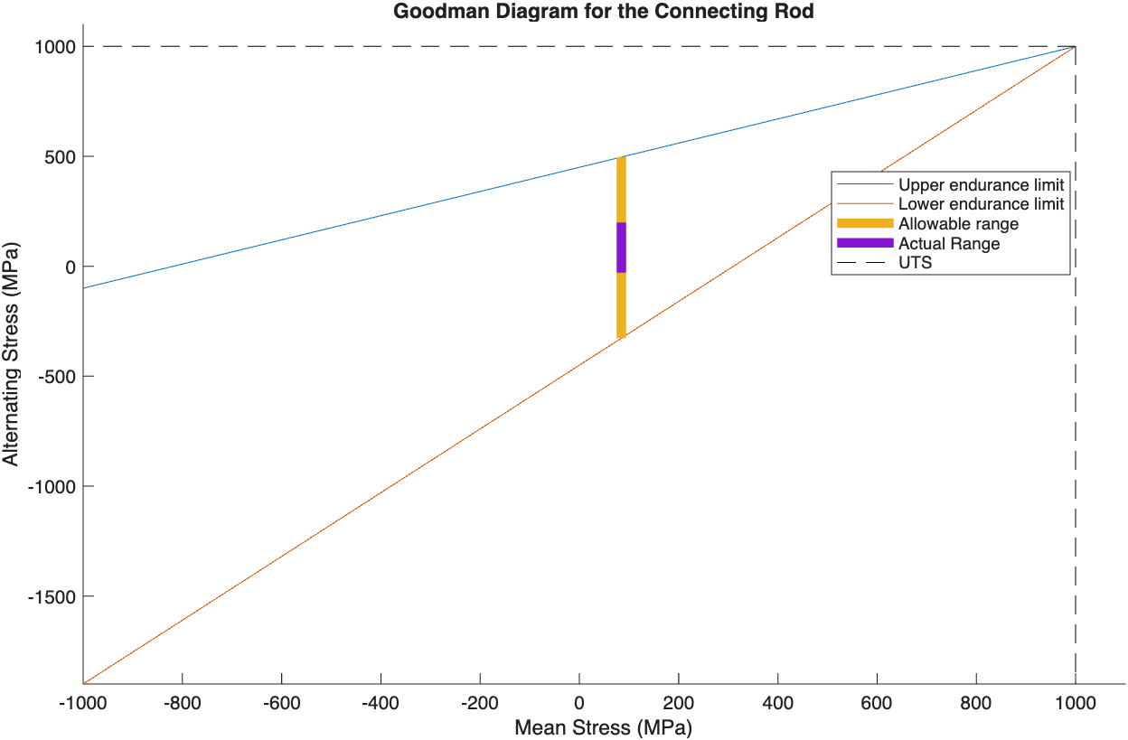
Figure 2. Goodman diagram of the connecting rod.

The large gap between the actual and allowable range reinforces the high FSF and indicates significant over-engineering relative to fatigue loading. This is consistent with literature, where production conrods typical FSF = 2-4 (Gao, 2022). The I-beam cross-section is smooth with minimal discontinuities and carries primarily axial load, so Kt = 1 was assumed.

Gudgeon Pin
The pin experiences bending as the combustion force compresses it whilst the conrod supports centrally. Net force was split equally between the ends of the pin, and the average of the bearing distances L1 and L2 was used to calculate the bending moment at the critical location where bending stress is highest. FSF = 3.90 was obtained at 6000RPM, the highest of the three components analysed. The Goodman diagram (Figure 3) confirms the actual stress sits within the allowable range, with mean stress remaining well below UTS, ensuring again that the component retains enough strength to withstand unexpected loading increases. The slightly higher FSF compared to the conrod suggests the pin is similarly over-engineered for fatigue, which is expected and designed for (G, 2011). Kt wasn’t applied as the bending stress equation captures the peak stress at the outer fibre.
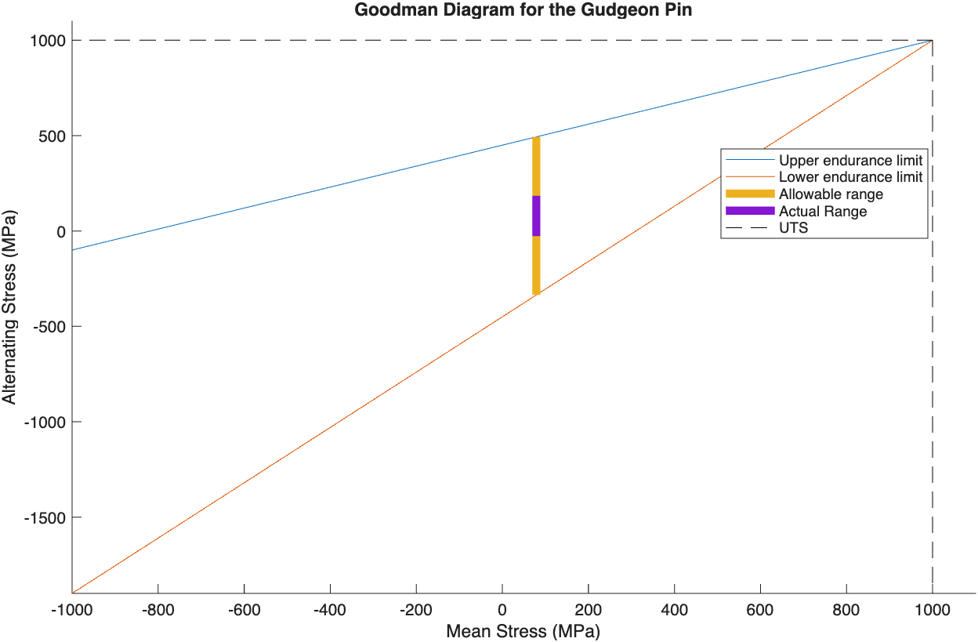
Figure 3. Goodman diagram of the gudgeon pin.

Connecting Rod Bolt
The conrod bolt was analysed using a stiffness-based model, which distributes the load between the bolt and cap based on their stiffness to better reflect real joint behaviour.
The bolt Goodman diagrams differ from the conrod and pin, as the mean stress sits at ~ 650MPa, significantly higher due to assembly preload dominating the stress state. This is expected for a preloaded fastener and leaves a reduced allowable alternating stress range, whilst the mean stress remaining below the UTS again ensures enough remaining strength.
Without including Kt, an FSF of 7.20 was obtained (Figure 4), suggesting the bolt is over-designed. However, without Kt the endurance limit is artificially high and using this as a basis for design would produce an unrealistic assessment.

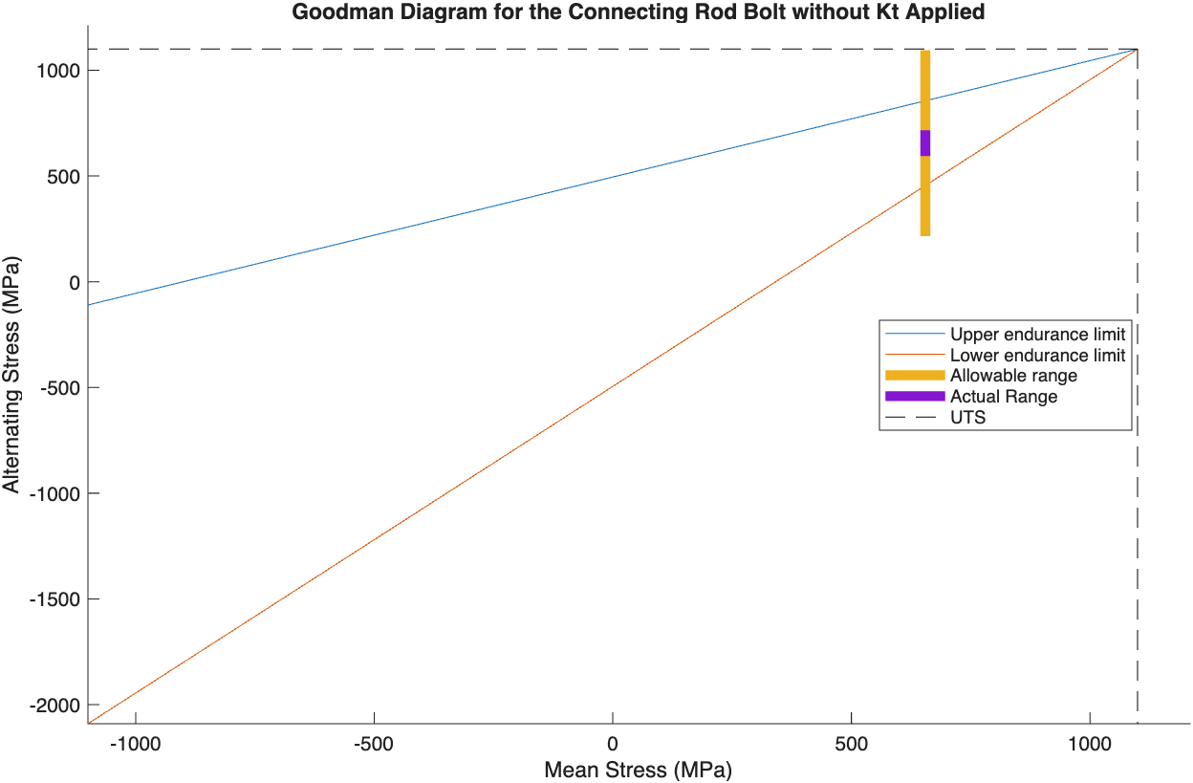
Figure 4. Goodman Diagram of Connecting Rod Bolt without Kt application.

Applying Kt = 4.49 reduces the FSF significantly to 1.30. The post-Kt Goodman diagram (Figure 5) shows the allowable range shrinking and the actual range now sitting very close to the boundary with minimal separation, contrasting the pre-Kt diagram.
An FSF of 1.30 is acceptable but provides little margin for loading increases, material property variations or manufacturing tolerances. Industry guidance typically recommends a minimum FSF of 1.2 for safety-critical fasteners (SafetyCulture, 2025), therefore the original bolt is borderline. The high mean stress from preloading leaves little capacity to absorb additional alternating stress, so as RPM increases and inertia loading grows, the remaining fatigue margin will decrease rapidly. Surface finish effects were also not applied at this stage, further skewing the results. These limitations confirm the bolt as the most fatigue-critical component in the assembly and motivate the extension of the analysis to 9000RPM.

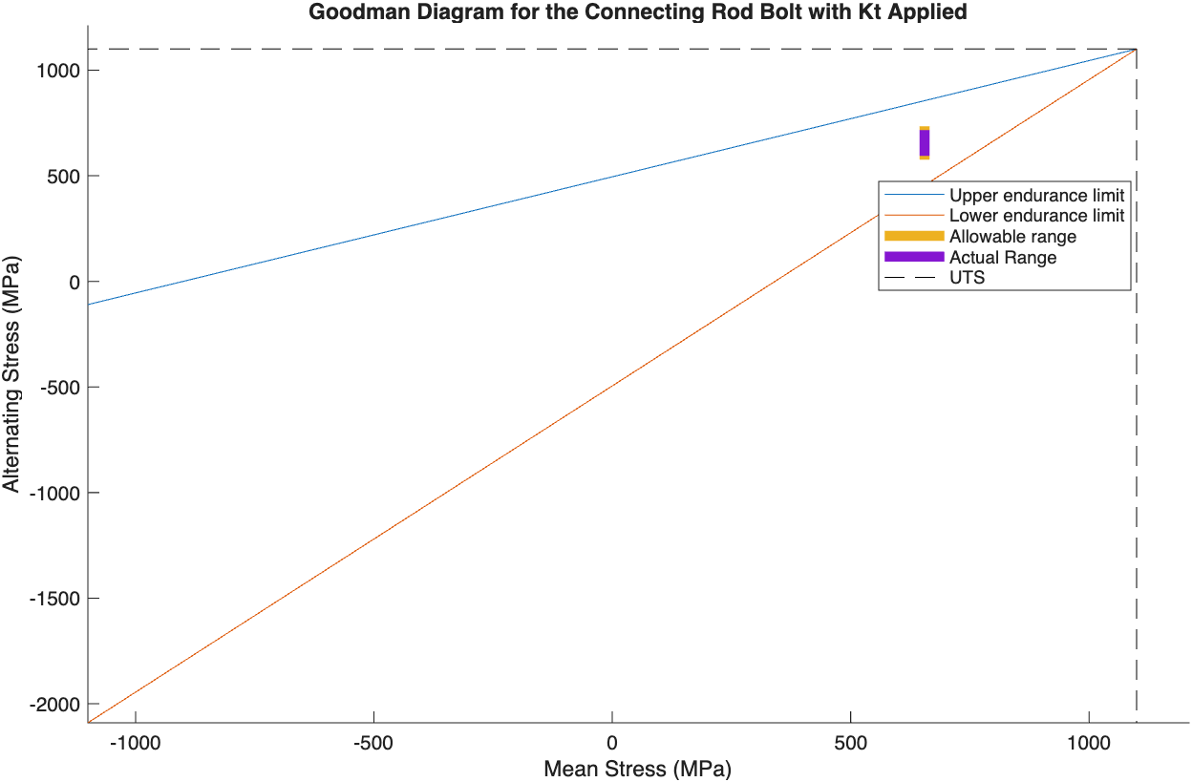
Figure 5. Goodman Diagram of Connecting Rod Bolt with Kt application.

Extension to 9000 RPM
Extension of the analysis is motivated by the demands of higher performance applications, and designing to this establishes confidence in the components by demonstrating their performance in a worst-case scenario.
As RPM increases, inertia forces scale with ω², rapidly increasing the separating load on the rod cap. At 9000RPM this is enough to push the bolt beyond its fatigue limit when Kt is accounted for, with FSF dropping to 0.82, predicting fatigue failure and motivating the redesign.
At 9000RPM the conrod and pin retained FSF values of 2.17 and 2.35 respectively, confirming both these components are not fatigue-critical even under the extended speed range.

Bolt Redesign

Thread Diameter Optimisation
The thread diameter is one main geometric consideration for redesign (Dewen Jia, 2025), as increasing the cross-sectional area reduces both the alternating and preload stresses from external inertia loading. The thread was scaled proportionally with diameter, allowing Kt to be recalculated at each to reflect the changing geometry, ensuring a physically consistent analysis.
FSF increases linearly with thread diameter (Figure 6), with the original bolt FSF of 0.823 within the failure zone. This relationship is expected, as increasing the area through diameter reduces both stresses whilst simultaneously reducing Kt through thread root radius scaling. The redesign study identified the minimum thread diameter required to achieve the target FSF as 8.936mm, 1.586mm more than the original. Cross-sectional area increases by an achievable 48% while recovering a safe fatigue margin.
A target FSF of 1.2 was selected by an achievable 48% while recovering a safe fatigue margin. As the analysis represents a motorsport-oriented worst-case scenario at a speed this engine would not sustain in normal operation. The selected diameter therefore balances fatigue safety against the weight and packaging constraints associated with increasing bolt size.

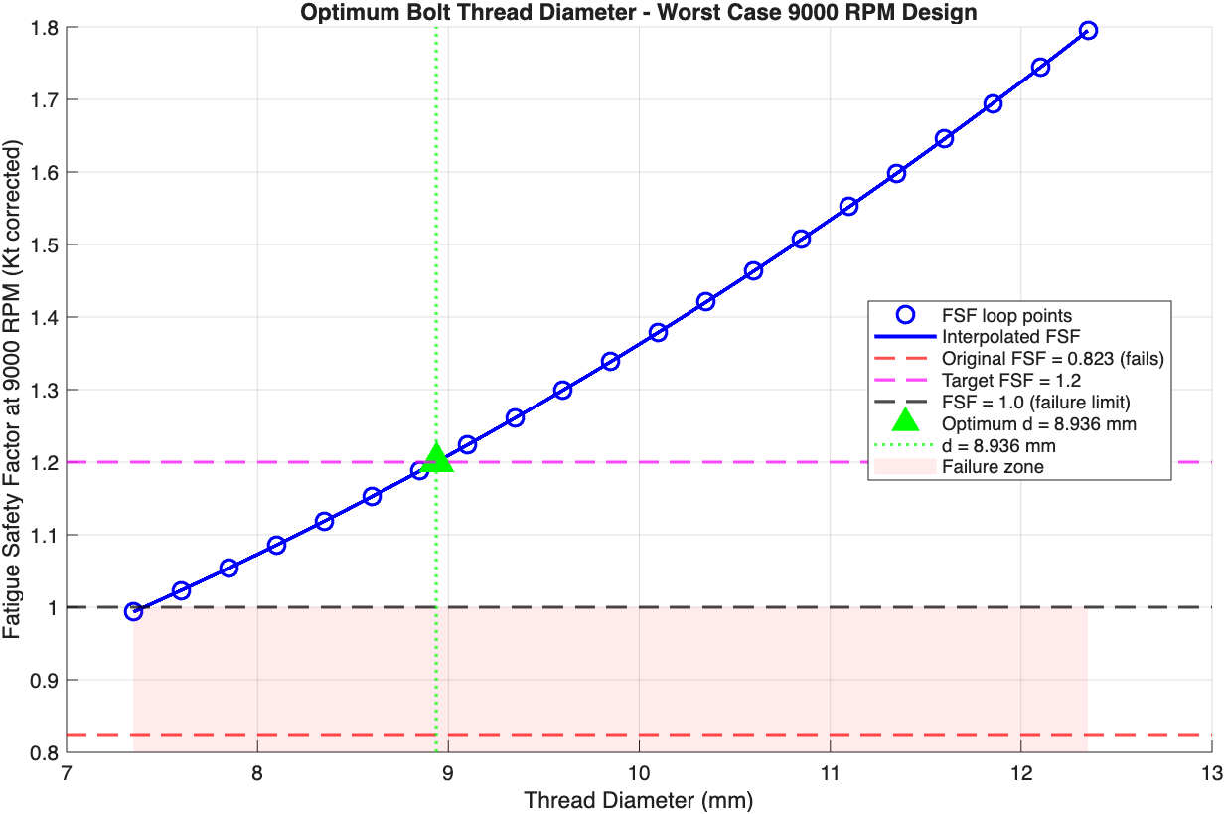
Figure 6. FSF vs Bolt Threat Diameter Comparison at 9000RPM

Shank Length Optimisation
Shank length was investigated as increasing length reduces bolt stiffness without changing the thread geometry or cross-sectional area. A longer bolt absorbs more of the external separating load rather than transmitting it as alternating stress, therefore reducing the fluctuating stress and improving FSF.
Figure 6 shows FSF increasing linearly with shank length, an expected trend as bolt stiffness is related to length. The minimum shank length required to achieve the target FSF was 32.199mm, 10.939mm longer than the original, identified by the green triangle on figure 7.
This is a practical option as it requires no change to thread geometry, Kt, or material, only a shank extension. However, increasing shank length has packaging implications as the rod cap geometry must accommodate it without interference, requiring verification against engine CAD before implementation. (Dewen Jia, 2025)

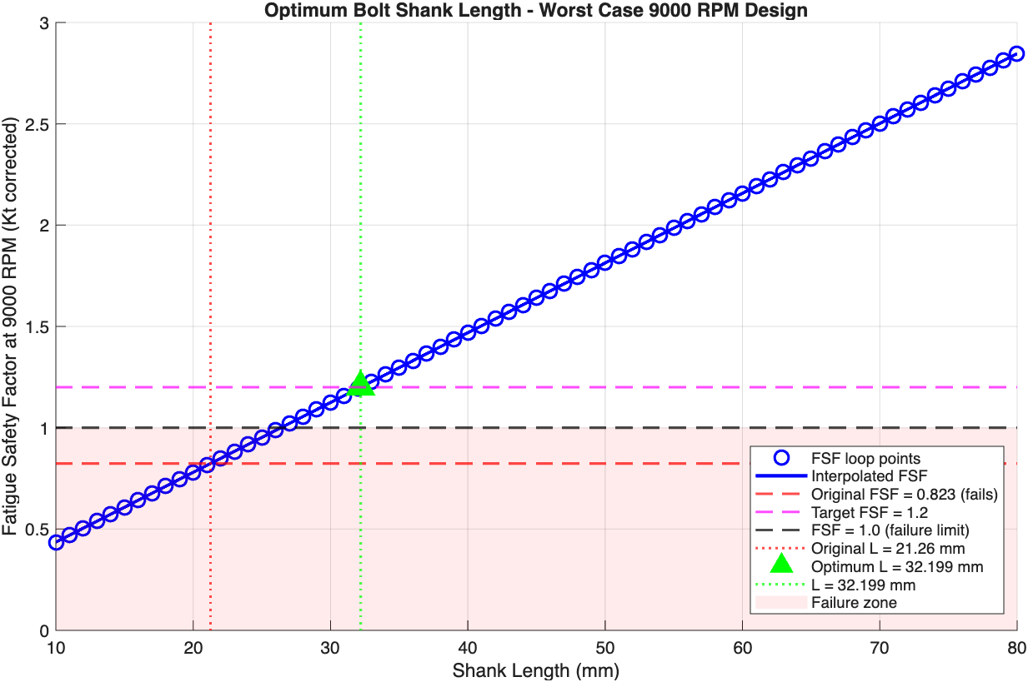
Figure 7. FSF vs Shank Length Comparison at 9000RPM

Shank Thickness Optimisation
Shank diameter was investigated also, with a limit on remaining below the thread diameter to ensure the root remains the critical cross-section under tensile loading. A 90% minimum diameter constraint was applied (Drew, 2025) reflecting standard practice to avoid introducing a weaker section.
The theoretical optimum shank diameter, being the lowest value that exceeds the target, was 4mm, shown by the green triangle (Figure 8). However, this represents only 45% of the thread diameter, falling well within the impractical zone and violating the 90% practical constraint. A shank diameter of 4mm would result in a cross-sectional area of 25% of the thread area, creating a significantly weaker section vulnerable to bending, lateral loads, and stress concentration, none of which are captured in this purely axial analysis.
Applying the 90% constraint gives a shank diameter of 8.04mm (red square in Figure 8) which gives an FSF of 1.588, comfortably above the target and even exceeding the recommended 1.2 minimum (Drew, 2025). This result demonstrates that whilst shank diameter theoretically influences FSF, the practical constraint means any diameter within the viable range already achieves the target. An FSF improvement is better achieved through thread diameter or shank length optimisation as demonstrated in Sections 4.1 and 4.2.
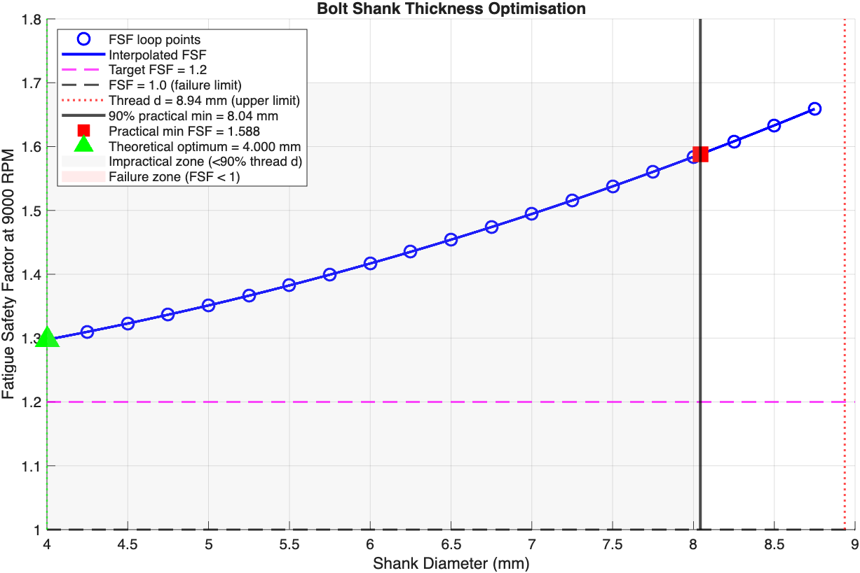
Figure 8. FSF vs Shank Diameter Comparison at 9000RPM.

Surface Finish
Surface finish was assessed using the standard Ka relationship, $K_{a}=a×{UTS}^{b}$, with constants defined by the manufacturing process and capped at 1. An additional multiplier, Km, was applied to represent process-specific effects beyond surface roughness. The effective surface factor = $K_{a}×K_{m}$.
Surface finish | Ka | Km | Ka_eff
Polished/ground | 0.8712 | 1.2 | 1.00
Nitrided | 0.8712 | 1.3 | 1.30
Machined/rolled | 0.7050 | 1.0 | 0.71
Coated/plated | 0.7050 | 0.9 | 0.63
Table 1. The four surface treatments selected and their surface factors, calculated with (Beardmore, 2025) (Perez, 2022) (Washington, 2022).

For the original bolt, only nitriding maintains the FSF above target across the lower RPM range, dropping to ~0.82 at 9000RPM (Figure 9), consistent with the geometric analysis. Machined/rolled drops below FSF = 1.0 from ~2000RPM, whilst coated/plated performs worst throughout, falling to ~0.55 at 9000RPM. These results confirm that surface finish alone can’t recover FSF on the original bolt at high engine speeds.
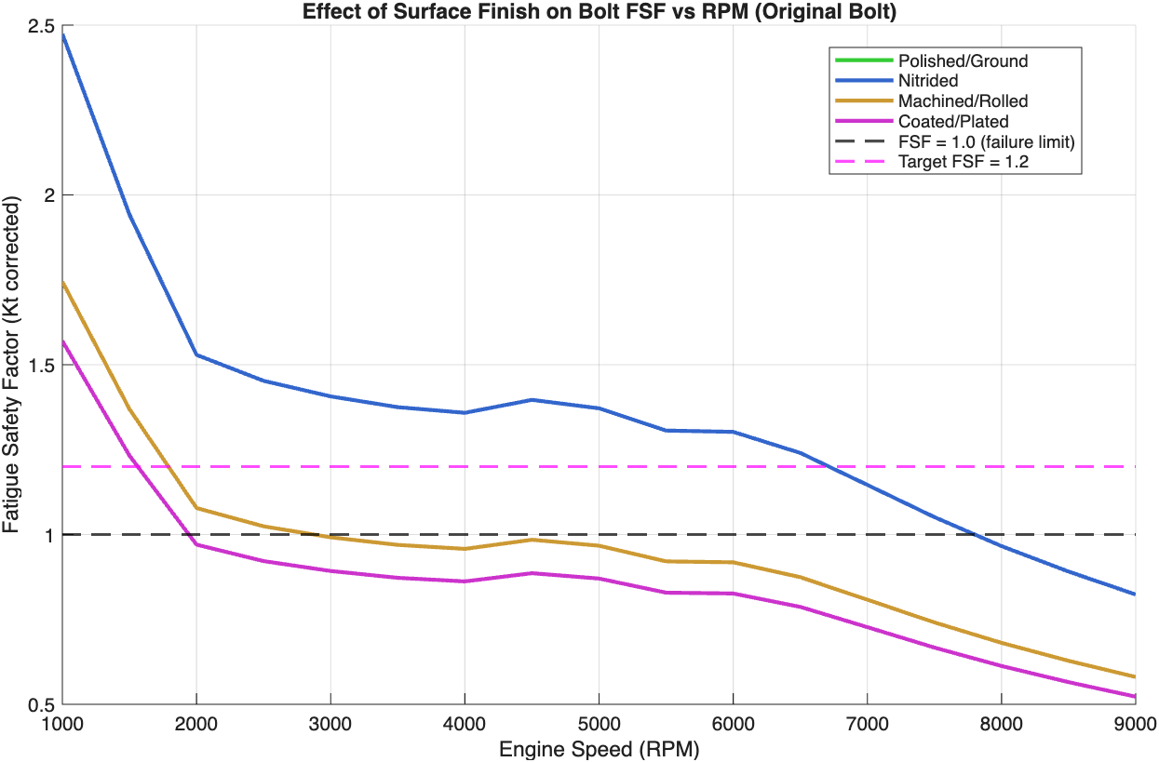
Figure 9. Original bolt FSF vs RPM at various surface finishes.
For the optimised thread diameter (Figure 10), nitriding maintains FSF comfortably above 1.2 across the full range, whilst machined/rolled sits just above at lower speeds before dropping just below at 9000RPM. Coated/plated again performs worst, dropping below FSF = 1.0 beyond 8000RPM, confirming its unsuitability for this application at the extended speed range regardless of geometric optimisation.
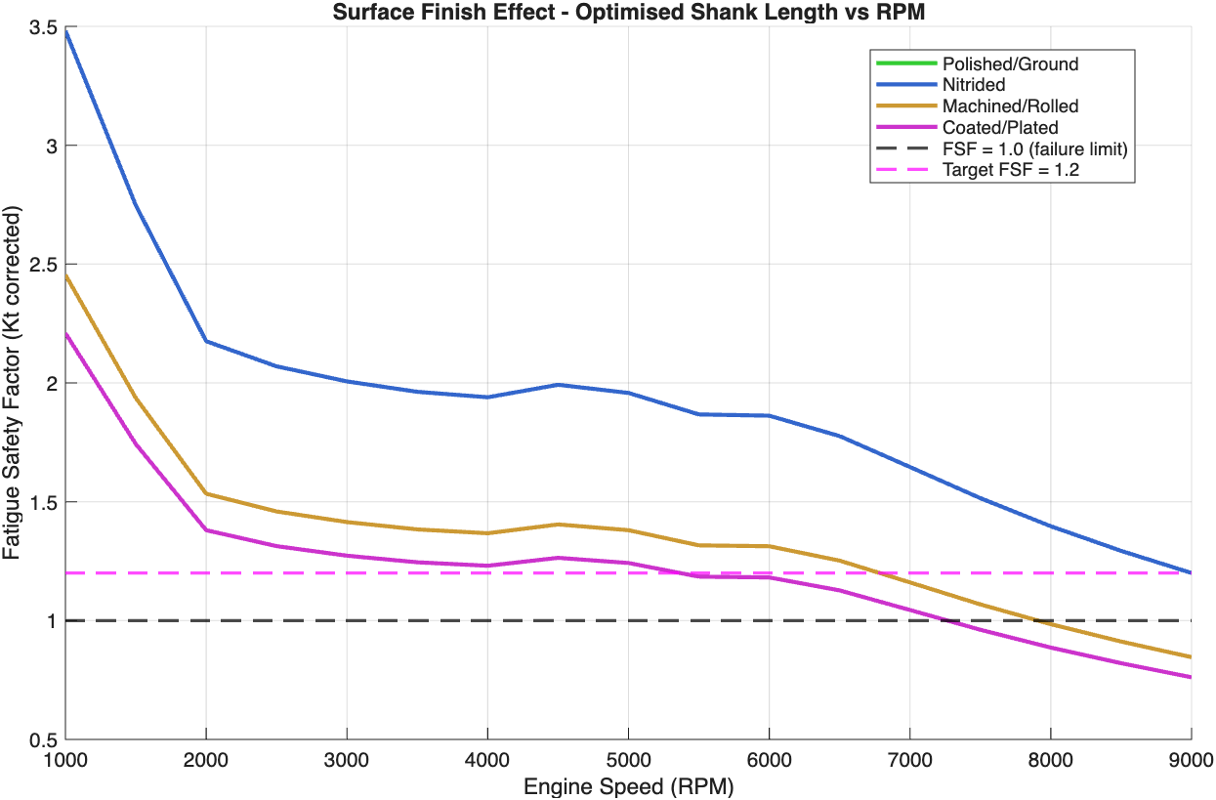
Figure 10. Optimised shank length FSF vs RPM at various surface finishes.
The optimised shank length results (Figure 11) are almost identical to the optimised diameter. This consistency across both optimisations confirms that each surface finish method’s FSF gain is independent of the geometric parameter chosen.
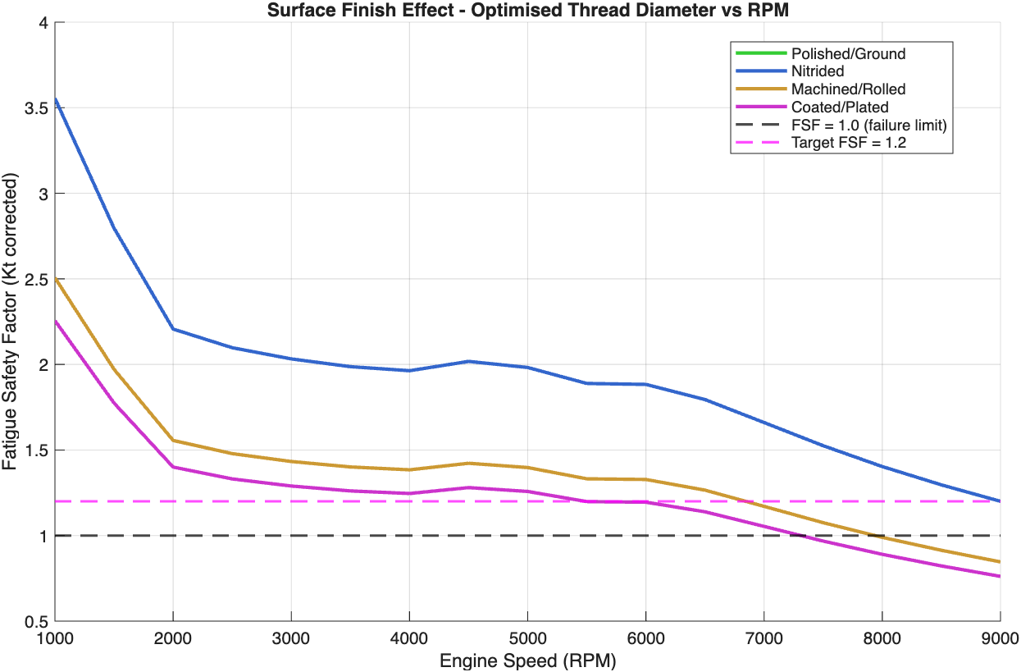
Figure 11. Optimised threat diameter FSF vs RPM at various surface finishes.
The key finding across all graphs is nitriding is the only treatment that maintains an acceptable FSF across the full operating range on the original and optimised geometries. This is due to the compressive residual stress layer introduced by the process, which opposes fatigue cracking at the thread root, identified earlier as the critical location.

Material Selection
Five materials were investigated across the original and optimised bolt geometry with a nitrided surface finish (Table 2).
Material | UTS (MPa)
Original steel | 1100
Grade 12.9 steel | 1220
Titanium Ti-6Al-4V | 950
Inconel 718 | 1380
Stainless Steel 316 | 620
Table 2. Materials assessed during the optimisation study (TCT, 2022) (Neway, n.d.).

For the original geometry (Figure 12), all materials except stainless steel maintain FSF above 1.0 across the lower RPM range, however all drop toward or below the 1.2 target at 9000RPM. Stainless steel fails immediately as its low UTS gives a correspondingly low endurance limit. Inconel and titanium perform best, with Inconel reaching ~1.1 and titanium ~1.0 at 9000RPM, but neither are sufficient to meet the target without geometric optimisation.
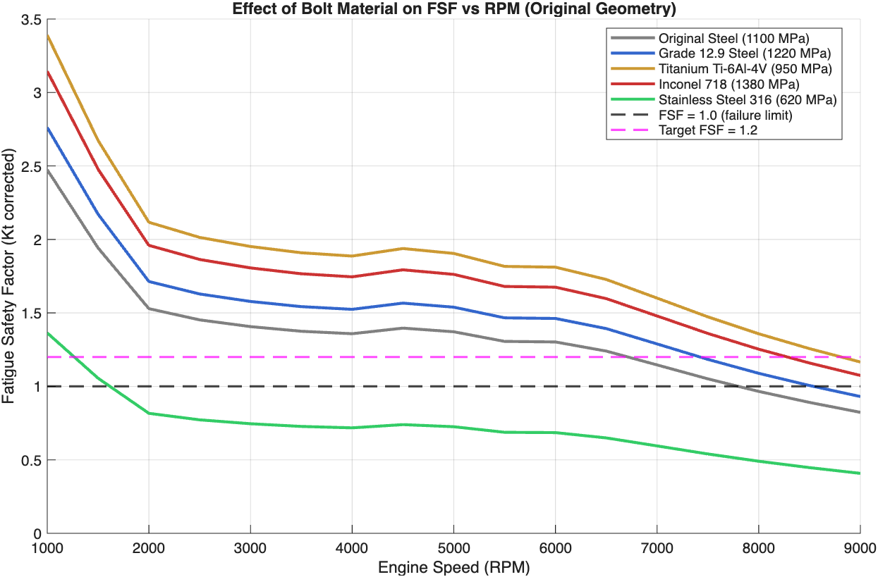
Figure 12. Effect of Bolt Material on FSF across RPMs on Original Bolt.
With the optimised geometry (Figure 13), titanium is the best performing material with an FSF of 2.34 at 9000RPM, outperforming Inconel (2.16) despite having a lower UTS. This counterintuitive result is due to titanium's lower Elastic Modulus (114GPa) compared to steel and Inconel (200GPa). This reduces the bolt's stiffness ratio relative to the clamped cap, meaning a smaller proportion of the external separating load is transferred to the bolt, reducing the alternating stress. This shows that material selection for preloaded fasteners under cyclic loading doesn’t only use UTS, but the ratio bolt and joint stiffness is also important in determining fatigue performance (Perez, 2022).
The clear recommendation from this analysis is Titanium Ti-6Al-4V with a nitrided surface finish on the optimised geometry, offering the highest FSF of 2.34 at 9000RPM.

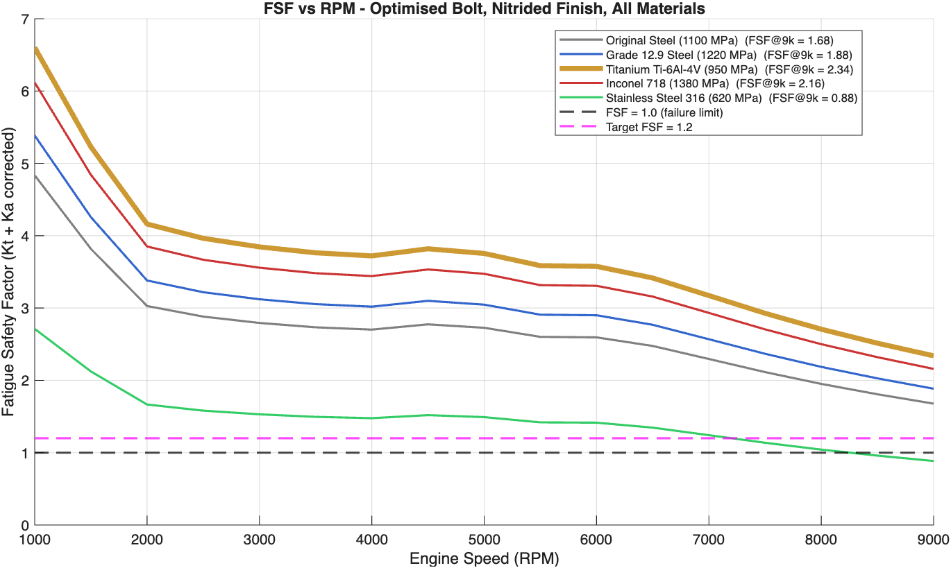
Figure 13. Effect of Bolt Material on FSF across RPMs on the Optimised Bolt.

Torque

Flat Plane Inertia Torque
The flat-plane configuration produces individual cylinder inertia torque curves of identical amplitude, phase shifted by 180° with the firing order 1-3-4-2 (Figure 14). Cylinder pairs that are in phase accelerate in the same direction simultaneously, causing the combined inertia torque to have ~3x the amplitude of a single cylinder, reaching peaks of ~±450Nm. The first-order inertia torque from each cylinder cancels across the four, meaning the combined torque is driven solely by the second-order, oscillating at twice crank speed. This large fluctuation is a key characteristic of the flat-plane configuration and has direct implications for engine vibration, requiring a heavier flywheel to smooth the output.
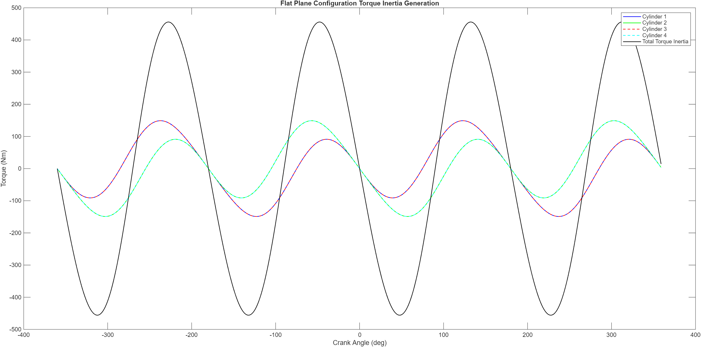
Figure 14. Torque inertia generation of a flat-plane configuration.

Cross Plane Inertia Torque
The cross-plane configuration (Figure 15) distributes the cylinders at 90° intervals, meaning each cylinder fires at a different phase. As a result, the individual cylinder inertia torque curves are evenly spread and partially cancel one another when summed. The combined torque’s amplitude of ±20Nm is much less than flat plane’s ±450Nm. This near-cancellation is the primary mechanical advantage of cross-plane, resulting in much lower torsional crankshaft vibration. The even acceleration spacing also reduces second-order vibration, allowing a lighter flywheel and improving throttle response, advantageous in road car and motorsport applications.
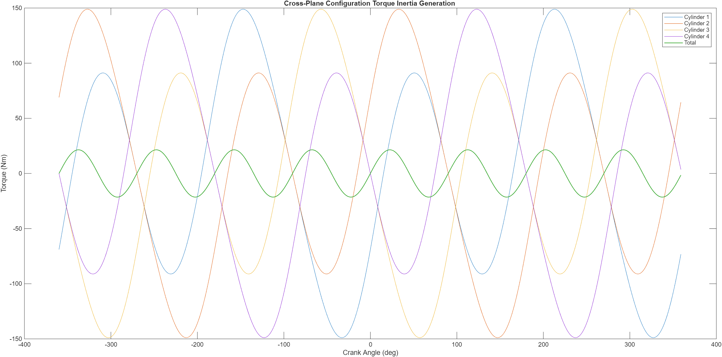
Figure 15. Torque inertia generation of a cross-plane configuration.

Combined Crank Torque Comparison
Figure 16 presents the combined crank torque (gas and inertia summed) for both configurations at 6000RPM. The flat-plane configuration produces a relatively consistent output, with a repeating range of near-zero to ~600Nm. The cross-plane configuration has a significantly wider torque range. This occurs because the uneven firing intervals of cross-plane cause combustion events to cluster, producing high instantaneous torque followed by extended gaps where inertia torque dominates and drives the crank negatively. The flat-plane produces smoother, more consistent torque better suited to road car applications where refinement and flywheel efficiency are priorities. The cross-plane produces higher torque but also fluctuation, more suited to motorsport applications where power is prioritised over smoothness.
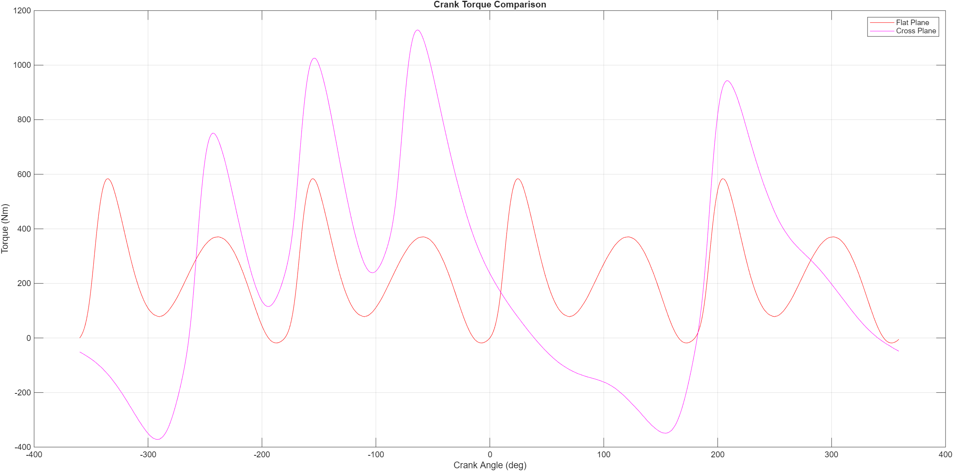
Figure 16. Crank torque comparison.

Conclusion
This report has presented a comprehensive mechanical analysis of the Ford EcoBoost 1.6L GDTi engine, evaluating the fatigue behaviour of the conrod midpoint, gudgeon pin, and conrod bolt across the standard and extended operating range.
The conrod midpoint and pin returned FSF of 3.61 and 3.90 respectively at 6000RPM, both well within the allowable range and consistent with published values. Both demonstrated some over-engineering relative to their fatigue loading, suggesting potential for mass reduction without compromising structure.
The conrod bolt was identified as the critical component. At 6000RPM an FSF of 1.30 was obtained with Kt included, confirming the bolt operates within an acceptable margin. Extending the analysis to 9000RPM reduced the FSF to 0.82, indicating fatigue failure would occur under sustained operation at this speed. This directly motivated the redesign study.
The redesign investigated several variables independently. Thread diameter optimisation identified a minimum viable diameter of 8.936mm, 1.586mm over the original. Shank length optimisation identified 32.199mm as the minimum required length. Shank thickness analysis showed the practical constraint of 90% minimum shank-to-thread diameter ratio means any viable diameter already exceeds target FSF. Nitriding was confirmed as the only treatment maintaining acceptable FSF across the full speed range on the original geometry. Material selection identified Titanium Ti-6Al-4V as the optimal material, yielding the highest FSF.
Torque analysis demonstrated that flat-plane configuration produces lower and more consistent crank torque fluctuation better suited to road car applications than cross-plane.
The overall recommendation for this application is a bolt with a thread diameter 8.936mm, shank length 32.199mm, nitrided surface finish, and manufactured from Titanium Ti-6Al-4V. This combination achieves a FSF of 2.34 at worst-case operating conditions whilst minimising mass, reducing the inertia loading that drives the fatigue problem identified in this analysis.

Bibliography
Beardmore, R. (2025). Fatigue Index. Swansea: Roymech.
Dewen Jia, X. S. (2025, 3 1). Scientific Reports. Retrieved from Analysis of the influence of : file:///C:/Users/2300898/Downloads/s41598-025-92013-9.pdf
Direct, S. (2025, 03 22). Goodman Diagram. Retrieved from Sceince Direct: https://www.sciencedirect.com/topics/engineering/goodman-diagram
Drew. (2025, 1 1). Thread Strength and Shear Failure Analysis. Retrieved from Scribd: https://www.scribd.com/document/628287739/Bolted-Joints-short?utm_source
G, R. (2011, 03 1). Internet Archive. Retrieved from Internet Archive: https://archive.org/details/shigleys-mechanical-engineering-design/page/61/mode/2up
Gao, W. (2022, 03 22). Machines. Retrieved from MDPI: https://www.mdpi.com/2075-1702/10/9/815
ISO. (1998). ISO general purpose . ISO general purpose, 14./
Neway. (n.d.). Neway. Retrieved from Inconel 718 vs Titanium TC4: Compare Strength for Your Custom 3D Printed Parts: https://www.neway3dp.com/de/blogs/inconel-718-vs-titanium-tc4-compare-strength-for-your-custom-3d-printed-parts
Perez, S. (2022, 1 1). Fatigue Strength and Endurance Limits. Retrieved from Scribd: https://www.scribd.com/document/309965153/12-Fatigue-Shigley?utm_source
Routledge, C. (2013). Chalmers. Retrieved from Chalmers: chrome-extension://efaidnbmnnnibpcajpcglclefindmkaj/https://odr.chalmers.se/server/api/core/bitstreams/da15e2f9-a56b-4a24-8901-edacbcdea924/content
SafetyCulture. (2025, aug 7). Factory of Safety. Retrieved from Safety Culture: https://safetyculture.com/topics/factor-of-safety?utm_source
TCT. (2022). Titanium Consulting & Trading. 22: 22.
Washington. (2022). Notes on Fatigue Design. s: Washington.

