Architecture in my Area

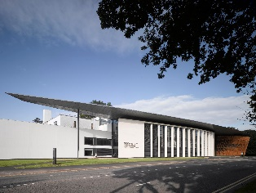
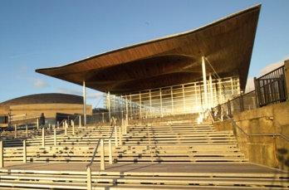
I have chosen two buildings of great significance in the city of Cardiff to evaluate their similarities and differences. The two buildings I have chosen are The Royal College of Music and Drama (Left) and the National Assembly for Wales (Right). Both buildings are on the edge of the city centre, and the buildings are set in two quite different landscapes. The National Assembly boasts extremely scenic surroundings. Located in Cardiff Bay, it sits on the waterline facing out into the huge tidal lagoon of Cardiff Bay. Glass extends from the ground to the roof on all four sides. The glass façade on the front of the building is intentionally taller in order to capture the views of the tranquil Cardiff Bay scenery.
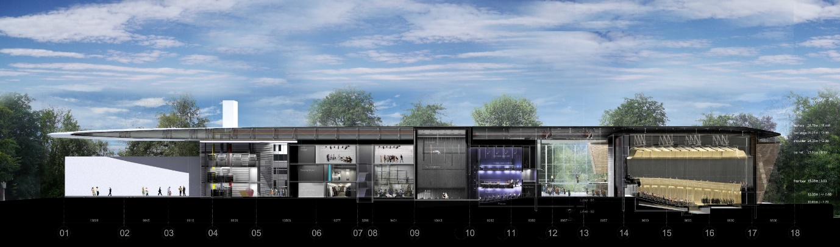
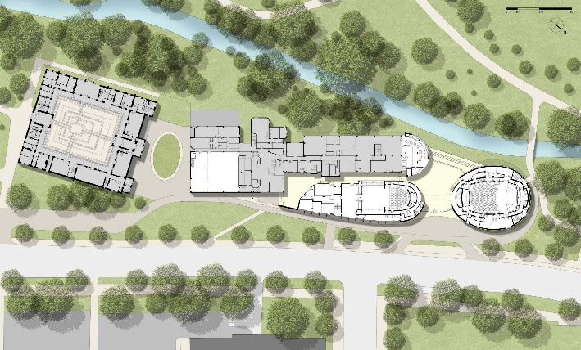
The Royal College is similar in that it also possesses a large amount of glass, though the shape of the building has a far more complex floor plan. It is comprised of four main structures, three of which are joined with one sleek, featureless, surfboard shaped roof and glass walls, one of which forms part of the front façade. The Royal College is situated on one of the main roads leaving the city centre towards north Cardiff. The building backs onto Bute Park and faces a very busy main road, beyond which is Cardiff Civic Centre which houses most of Cardiff University, the City Hall and the National Museum for Wales. This differs from the National Assembly building whereby the surrounding area is tranquil, quiet and pedestrianised. Below is a cross section of the Royal College. It is evident that the building is split into differently functioning parts. This is a college so this will be reflected in the layout of the building. The atrium section of the building is situated towards the left of this elevation. It is next to the main theatre. These two sections are likely to be put together because, they are the main functioning areas of the building. the atrium also separates the more public theatre from the rest of the building that is for students of the college.

The Royal College of Music and Drama commissioned Flanagan Lawrence who are an established London based Architectural practice. The building was completed in 2012. Flanagan Lawrence is a London based practice with an impressive portfolio.
The National Assembly for Wales commissioned Rogers Stirk Harbour and Partners which is an international architectural practice based in London. This build was completed in 2005. This practice has designed buildings all over the world including the rather prolific, Leadenhall Building in London, colloquially known as the ‘cheese grater’.
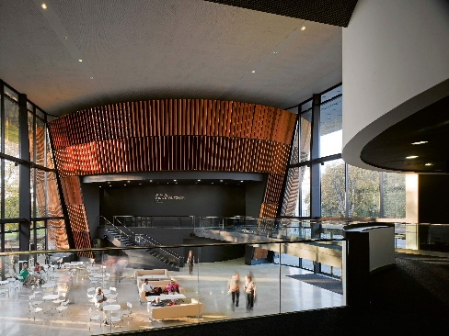
This image illustrates the full height atrium section of the royal college. The circular form at one end of the building is isolated from the other forms within the scheme. The glass walls joining the separate forms make the whole building one structure whilst clearly segregating the different parts of the building. The architect has used different cladding or surface finishes on different parts of the building which highlights the different areas. The architect clearly wanted the segregate parts of the building. The cladding is used on the circular end module, all the way around the outside of it. However, part of the outside is also inside because of the glass walls that join the three buildings together. The cladding used on the outside of the building has cleverly been continued on the inside of the building. This metaphorically brings the outside, in. The rest of the building shows some very modernist architecture and design like the stark white, smooth curved walls, and the large glass façades, also photographed in the above photo.
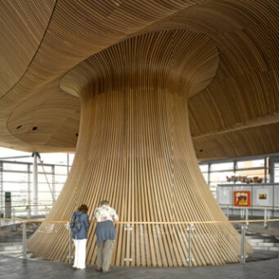
This image is taken from inside the National assembly for Wales, showing an extravagant sculptural form that sits inside the building. This organic form appears as if it bleeds down from the roof and seamlessly blends into the floors below. The entire underside of the roof structure is clad in Canadian cedar. This is very similar to the timber cladding used on the Royal College. The timber in the Royal college is very much a part of the building whereas the timber used in the National Assembly makes up most of the aesthetic of the whole building. The floor plan of this building is fairly simple. It is essentially based on a regular rectangle.
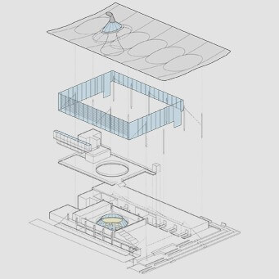
This image is an exploded drawing of the layout of the National Assembly. This building is a government building used for various governmental meetings and conferences. There is a central circular conference room situated underneath the timber form that is visible from the outside. This building features a large open communal area on the first floor and below, the main conference room. The main purpose of this building is to hold conferences. The large scale of the building is an extravagant way of showing its importance.
The roofs of both buildings are very similar in that each roof appears to be hovering above the rest of each structure. Both roofs are ornamental, however the roof structures differ. The sleek roof on the Royal College does not cover the whole building whereas the roof of the National Assembly spans over the whole building and is much more of a feature due to the its heavily sculpted organic form. This roof is also visible from all angles from the exterior and is visible from the majority of the space within the building also. This means that the roof feels very much more a part of the structure, unlike the Royal College where the roof appears to be sculptural decoration.
Both buildings allow large amounts of light into the open spaces within, however The National Assembly for Wales allows significantly more light in. The National Assembly’s steel frame is wrapped in glass around the perimeter, from the ground to the roof. Since the immediate scenery is not level or uniform, the glass walls are larger towards the front of the build. the atrium of The Royal College is partially used as a café and is well equipped. Light floods in through the North east and south west facing glass façades, though much less than the National Assembly. Both buildings receive ample natural lighting appropriate for the size of each space.
Both buildings that I have analysed have entirely different uses, however, are similar in parts, architecturally. I think I have written a comprehensive study, comparing both buildings. I have discovered many architectural techniques in the process of writing this report, such as the use of cladding on the exterior as well as the interior. I will be able to implement these techniques in future projects.

References
Rogers Stirk Harbour and Partners (2020) https://www.rsh-p.com/ accessed January 2020
Rogers Stirk Harbour and Partners (2020) https://www.rsh-p.com/projects/civic/ accessed January 2020
Flanagan Lawrence (2020) https://www.flanaganlawrence.com/ accessed January 2020
Flanagan Lawrence (2020) https://www.flanaganlawrence.com/royal-welsh-college-of-music-and-drama accessed January 2020
Architects Journal (2020) https://www.architectsjournal.co.uk/ accessed January 2020
Arch Daily (2020) https://www.archdaily.com/178785/royal-welsh-college-of-music-drama-bfls accessed January 2020
National Assembly for Wales (2020) https://www.assembly.wales/en/Pages/Home.aspx accessed January 2020

