

Clinical Coding Data Quality Checker and Dashboard

by
Karen Windsor

Supervisor: Dr Nik Whitehead

Project was submitted as part of the requirements for the award of
BSc (Hons) Computing Data and Information
Systems

July 2024

Declaration

I, Karen Anne Windsor declare that I am the sole author of this Project; that all references cited have been consulted; that I have conducted all work of which this is a record, and that the finished work lies within the prescribed word limits.

This work has not previously been accepted as part of any other degree submission.

Date : 26th July 2024

Abstract

This project aims to develop a clinical coding quality dashboard to ensure the accuracy and completeness of coded clinical data at the Royal United Hospitals NHS Foundation Trust (RUH). Clinical coding is the translation of medical terminology into standardized classification codes, which are used for various purposes such as monitoring patient outcomes, healthcare planning, and generating income through the Payment by Results (PbR) system. On average the RUH generates over 129,900 healthcare episodes, all of which must be processed by the clinical coding department.

The quality of clinical coded data is crucial, as it directly impacts healthcare statistics, patient safety, and financial reimbursement. However, ensuring data quality can be challenging, as clinical coders must adhere to national standards, local policies, and the four-step coding process. Traditional methods of evaluating coding quality, such as audits, only sample a small proportion of the total coded data, leaving the majority unvalidated.

The clinical coding quality dashboard will utilise a minimum of 100 SQL scripts to automatically check the coded clinical data against national standards, local policies, and the four-step coding process. The dashboard will provide real-time feedback to individual coders on potential errors, allowing them to investigate and correct issues. It will also offer management-level insights, such as the current coding backlog, error rates by specialty, and individual coder performance.

By implementing the dashboard, the RUH aims to reduce the number of coding errors from over 100 per week to under 20. This will improve the accuracy and completeness of its clinical coded data, leading to better-informed decision-making, improved patient outcomes, and increased financial reimbursement. The project has already highlighted cardiology as one of the specialties where the department needs to improve and as the number of queries increases it will enhance the clinical coding department's training program by identifying other areas where additional support is required.

Table of Contents

Declaration 2
Abstract 3
Table of Contents 4
1 Introduction 7
2 Literature Review 9
2.1 Definition of Clinical Coding 9
2.2 History of Clinical Coding 10
2.3 Uses of Clinical Coded Data in the UK 11
2.4 Data Quality 14
2.4.1 Clinical Coding Standards 16
2.4.2 Local Policies 18
2.4.3 Four-step coding process 18
2.4.4 National Clinical Coding Qualification 20
2.4.5 Charlson Index 21
2.4.6 Clinical Coding Audits 22
2.4.7 Training Requirements 23
2.5 Data Quality Solutions 23
2.6 Purpose of the Clinical Coding Data Quality Dashboard 24
2.7 Data Security 24
2.8 Project management 25
3 Research Methodology 26
4 Implementation/Development 29
4.1 Design 29
4.1.1 Defining the project goals 29
4.1.2 MoSCoW prioritisation method 29
4.1.3 Data set design 30
4.1.4 Categories of queries 32
4.1.5 Query Design 34
4.1.6 Planning outcomes 34
4.1.7 Wireframes 35
4.2 Implementation 37
4.2.1 Data set 37
4.2.2 Scripts 39
4.2.3 Validation 40
4.2.4 Measures in PowerBI 42
4.3 Results and Discussions 48
5 Evaluation 52
5.1 SUS Questionnaire 52
5.2 Errors by Specialty Evaluation 55
6 Conclusions/Future Work 58
7 Personal Reflection 60
8 References 62
9 Appendix 67
9.1 Timeline 67
9.2 Local Policy 69
9.3 Questionnaire 70
9.3.1 Questionnaire link 70
9.3.2 Questionnaire results 72
9.3.3 System usability scale form 74
9.3.4 Results of SUS 77
9.4 Charlson Comorbidity Index 83
9.5 Elixhauser Co-morbidity Scores 84
9.6 Example of TEMs 85
9.7 List of original checks 86
9.8 Data set 87
9.9 Index trail for calculus of kidney and ureter 88
9.10 Local Policy 27 89
9.11 Queries 90
9.12 Mind map 94

Figure 1 Example of ICD-10 classification codes [2] 9
Figure 2 Example of OPCS-4 Classification codes [2] 10
Figure 3 New tariff 13
Figure 4 Examples of codes that cannot be a primary diagnosis code [33] 16
Figure 5 Example of average coded FCE 18
Figure 6 Four-step coding process [38] 19
Figure 7 ICD-10 Index and Tabular [39] 20
Figure 8 Clinical Coding Checker 34
Figure 9 Timeline graph for backlog 36
Figure 10 Bar chart errors per specialty 36
Figure 11 Step 1 Check for I50.0 37
Figure 12 Step 2 Check for I50.1 38
Figure 13 DiagnosisConcat 38
Figure 14 Use of AS MS SQL command 39
Figure 15 Case and Else Statement 40
Figure 16 Views in the data warehouse 40
Figure 17 Validation process 41
Figure 18 PowerBI measure 42
Figure 19 Email from PowerBI 43
Figure 20 Error pages for the coder 43
Figure 21 Backlog dashboard 44
Figure 22 All ICD-10 errors 44
Figure 23 Individual coder's errors 45
Figure 24 OPCS-4 errors 45
Figure 25 Combined error type 46
Figure 26 Classification 46
Figure 27 Workspace 47
Figure 28CTPA query 48
Figure 29 Feedback 49
Figure 30 Error description 49
Figure 31 Non-working queries feedback 50
Figure 32Team meeting 50
Figure 33 Check for Sigmoidoscopies 51
Figure 34 SUS Calculator [65] 52
Figure 35 Frequency of use 53
Figure 36 Management assistance 53
Figure 37 Access 54
Figure 38 Inconsistencies 54
Figure 39 Neonatal query 55
Figure 40 Obstetrics error 56
Figure 41 Cardiology 56
Figure 42 Backlog 57
Figure 43 Timeline 67
Figure 44 Local policy anaemia 69
Figure 45 Questionnaire results 73
Figure 46 System usability scale form 76
Figure 47 Results from SUS 82
Figure 48 With Y76.3 85
Figure 49 With Y76.3 85
Figure 50 Original checks 86
Figure 51 Calculus of kidney and ureter index trail [69] 88
Figure 52 Local Policy 27 89
Figure 53 Mind map 94

Table 1 Extract from Tariff [22] 13
Table 2 DSTP Accuracy 22
Table 3 MoSCoW 29
Table 4 Data set Attributes 31
Table 5 Run times 39
Table 6 Countries using ICD-10 classification 68
Table 7 Charlson Comorbidity Index 83
Table 8 Elixhauser Index 84
Table 9 Data set 87
Table 10 Current ICD-10 queries 92
Table 11 OPCS-4 queries 92
Table 12 Combined queries 93

Introduction

The RUH in Bath generates 129,938 finished consultant episodes (FCEs) that must be coded annually. FCEs are made up of day cases and inpatient admissions, there is currently no government mandate to code outpatient admissions in the UK

Twenty whole-time equivalent clinical coders are employed by the RUH, and they each have a target of coding a minimum of 35 FCEs per day. The RUH also employs 2 clinical coding auditors and a trainee auditor who are tasked with performing individual audits for personal development reviews (PDRs), speciality audits for consultants and one Data Security and Protection Toolkit (DSPT) audit per financial year. A yearly DSPT audit is mandated by NHS England and is an important part of the department’s clinical coding audit program.

As well as ensuring that they accurately assign codes for all the diagnoses and procedures recorded by the clinical staff, clinical coders must ensure that they conform to the four-step coding process and the four hundred standards authorized by the World Health Organization and the classification service in NHS England formerly NHS Digital.

Data quality is not only important for statistics but in England, it also affects the funding for the Trust – when completed the clinical coding within the FCE creates a Health Resource Group. The tariff that governs the amount the trust receives is governed by the HRG generated.

There must be a balance between the clinical coder's accuracy and the speed of their coding. As with most tasks completed by humans the higher the speed the task is performed the less accuracy. Having an efficient way of monitoring the workload of the clinical coders is a paramount concern of the management team. The reason for the creation of the clinical coding quality dashboard is that with only 2 auditors it is impossible for the RUH to be certain that the clinical coding is valid and producing the correct HRG for the Trust as there is a limit to how many FCEs each auditor can review and then report back to the coder and the department’s management team and directors. It will also provide the management team with an up-to-date backlog tracking process, allowing them to make informed operational decisions.

The main aim of this project is to improve the standard and quality of the clinical coding in the RUH. With the objectives to:
- Write scripts to extract FCEs where the clinical coding has breached national standards, local policies or the four-step coding process, ensuring that the codes are valid and will generate the optimum tariff for the RUH.
- To create an automatic notification system to alert the clinical coders of their potential coding errors.
- To provide the management team with a dashboard page to monitor the backlog of uncoded FCE.

This report details the development of a clinical coding quality dashboard at the RUH. The literature review provides a comprehensive overview of clinical coding, including its definition, history, and uses within the UK healthcare system. It also examines the key dimensions of data quality and the standards and policies that govern clinical coding practices. The methodology section explains the research approach and design considerations for the dashboard, such as data security and project management.

The implementation and development chapter describes the process of creating the dashboard, including the design of the data set, the validation of the SQL scripts, and the integration with PowerBI. The evaluation section discusses the feedback from users, the impact on the coding backlog and training, and plans for future enhancements.

The report concludes with a personal reflection on the knowledge and skills gained through the project, as well as recommendations for future work.

Literature Review

Definition of Clinical Coding
NHS Digital describes clinical coding as:

“The translation of medical terminology that describes a patient’s complaint, problem, diagnosis, treatment or other reason for seeking medical attention into codes that can be easily tabulated, aggregated and sorted for statistical analysis efficiently and meaningfully.” [1]

This refers to how clinical coders translate clinicians’ medical terminology into internationally and nationally recognised classification codes. Clinical coders are not permitted to diagnose conditions and can only use the terminology documented in the patient’s medical record by clinical staff. Even when they know from experience that what the clinician has written is inaccurate, they cannot use their judgment to assign the correct code, they must either code exactly what the clinician has recorded or query the diagnosis/intervention with the responsible clinical staff.
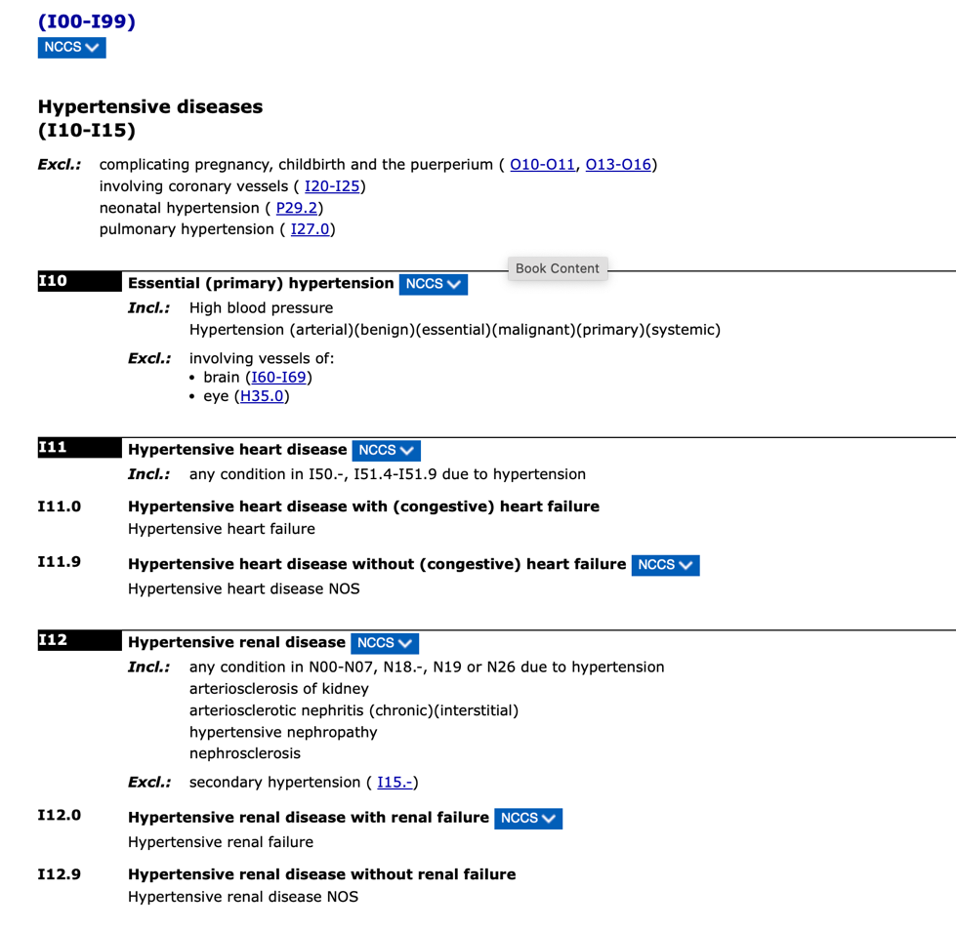
Figure 1 Example of ICD-10 classification codes [2]

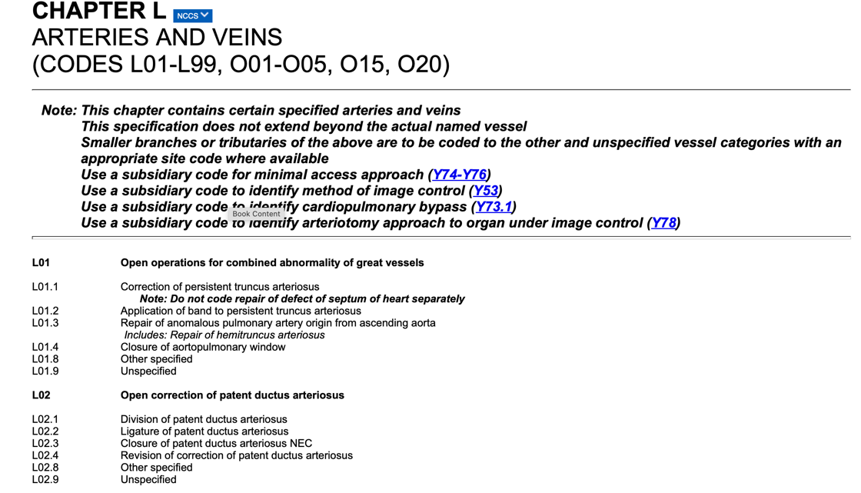
Figure 2 Example of OPCS-4 Classification codes [2]

History of Clinical Coding
The origins of clinical coding in the United Kingdom (UK) can be traced back to London’s Bills of Mortality [3], back in 1665, when London started tracking disease and mortality rates to inform the population of death rates due to the plague. Though the bills followed a very simplistic format they laid the paving stones for the more sophisticated classifications that succeeded them.

In the 1830s the renowned epidemiologist Dr William Farr [4] proposed a more refined and consistent methodology of classifying mortality, which was later expanded upon by the International Statistical Congress [5], leading to the publication of the International List of Causes of Death [6]. One of the most famous health statisticians to pioneer classifications during the Crimean War was Florence Nightingale [7] who collected data to try and understand the direct cause of death in the soldiers her team was caring for. The World Health Organisation (WHO) [8] would use the foundations of these classifications as the core for their classification of the International Classification of Diseases (ICD) [9].

The UK, similar to other countries (appendix) uses the ICD classification to record diagnoses, for day cases [10] and inpatient admissions [11], although outpatient admission can be coded using the ICD classification Trust and Health Boards (HBs) within the UK are not mandated to code these admissions. To code procedures/interventions/tests the UK uses the classification OPCS-4 (Office of Population Censuses and Surveys) [12], which has been created and developed exclusively for use by clinical coders in the UK by the Terminology and Classification Service in NHS England Digital [13]. Other countries use unique procedure code classifications created specifically to meet their country's reporting requirements. (e.g. America uses the Current Procedure Terminology, managed by the American Medical Association (AMA) ) [14].

With the creation of SNOMED-CT (Systematised Nomenclature of Medical Clinical Terms), there was a concern that this would replace or reduce the need for Clinical Coders, however, the two coding systems have very different use scenarios. SNOMED-CT is a terminology [15] used in input systems, such as the Electronic Patient Record during the patient’s admission, they are considered inadequate to perform the same statistical functions within secondary care as the ICD-10 classifications because they can be:
- Too granular
- Lacking rules and standards
- Consisting of complex poly-hierarchies
- Immense in size – consisting of more than 310,00 concepts
(Timeline)

Uses of Clinical Coded Data in the UK
Clinical Coded Data is used for several purposes within Healthcare in the UK:
- Monitoring of patient outcomes, using a combination of ICD10 and OPCS-4 codes it is possible to gauge the success of operations/procedures and interventions. A good example of how operations and outcomes can be tracked using the classifications is the recent report on the complications of vagina mesh. [16]
- Clinical coded data is grouped into Health Resource Groups (HRGs) [17] and in NHS England the HRGs are used as the basis for the Payment by Results (PbRs) tariff, which generates income for the hospital trust. PbR is a complex system and hospital trusts need to ensure that they are generating the optimum tariff for all hospital admissions, whilst complying with the rules and standards. PbR is not without its drawbacks, one of its major ones being that it can be open to fraud [18] [19] and relies on the accuracy of its clinical coders.

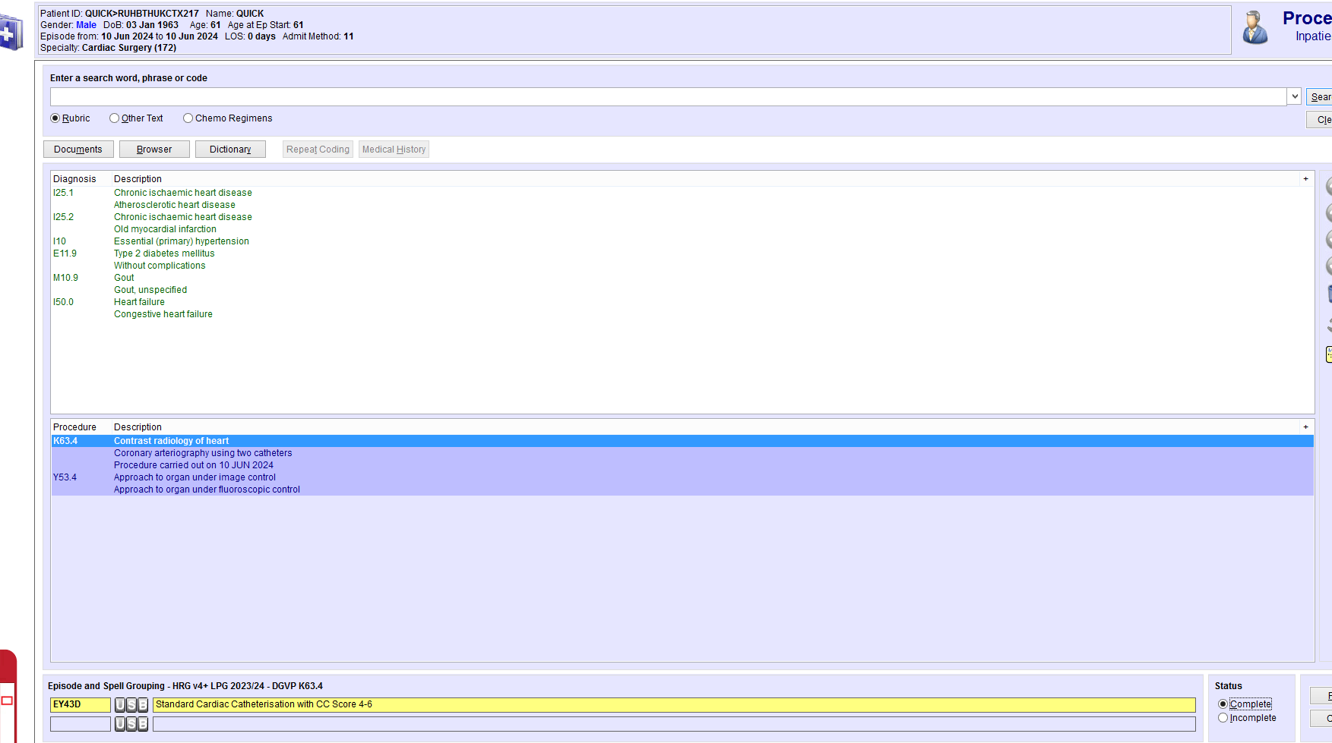
OPCS Procedure Codes
ICD10 Diagnosis Codes
HRG

Figure ICD10 and OPCS-4 - HRG
The HRG is a set of diagnoses (ICD-10 codes) and procedures(OPCS-4 codes) that are similar in terms of care delivered and the resource(s) used. The HRG consists of 5 characters, in the above example EY (cardiology standard cardiac catheterisation) and 43C is the complexity score. The lower the number the higher the complexity and the tariff. To generate the highest tariff for this FCE, the patient must have additional co-morbidities assigned, increasing the complication and co-morbidity score [20]. For example adding the codes for atrial fibrillation, obesity and the use of anticoagulants would increase the complication and comorbidity score for the patient. The new HRG is EY43C (see Figure 2). With the additional co-morbidities assigned, the financial payment rises from £1,183 to £1,485, showing the importance of capturing all the co-morbidities documented in the patient record.

The importance of generating the optimal HRG is proven in a paper by Mahbubani et al [21] who discovered that a North London Trust was annually under-claiming £1§8, 056 for orthopaedic procedures due to poorly coded FCEs.

HRG | HRG Name | Elective | Emergency
EY43A | Standard Cardiac Catheterisation with CC Score 13+ | 4,443 | 9,715
EY43B | Standard Cardiac catheterisation with CC Score 10 - 12 | 2,244 | 6,434
EY43C | Standard Cardiac catheterisation with CC Score 7 - 9 | 1,485 | 4,827
EY43D | Standard Cardiac catheterisation with CC Score 4 - 6 | 1,183 | 3,596
EY43E | Standard Cardiac catheterisation with CC Score 2 - 3 | 1,026 | 2,809
EY43F | Standard Cardiac catheterisation with CC Score 0 - 1 | 943 | 2,260
Table 1 Extract from Tariff [22]
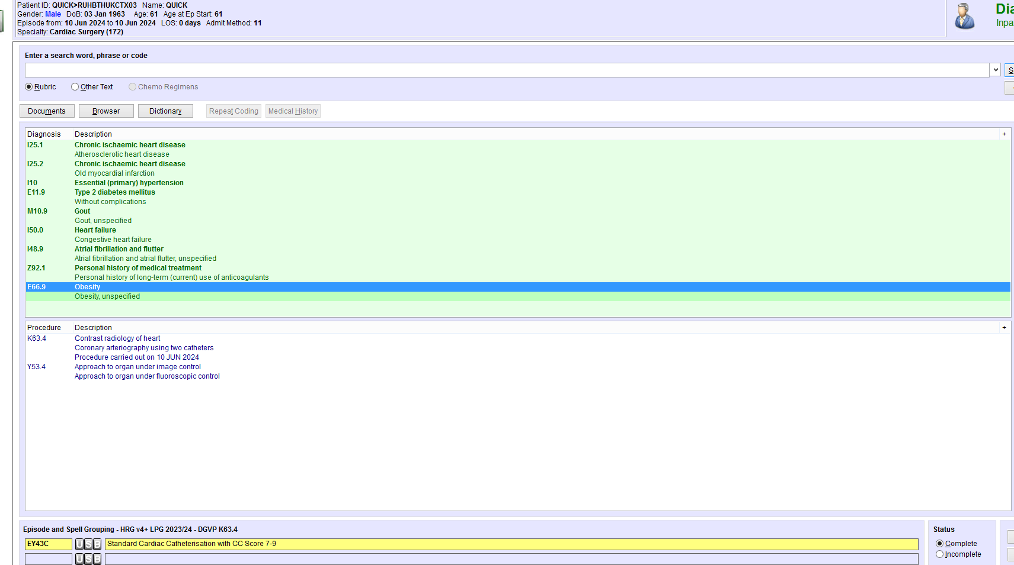
Figure 3 New tariff

- Epidemiologic tracking of disease incidence and prevalence, monitoring trends and emerging public health issues. Clinical coding was used to track the number of hospital-acquired COVID-19 cases during the COVID-19 pandemic. [23]
- Healthcare Planning as the clinical coded data provides valuable insights into the population's healthcare needs, enabling policymakers and healthcare leaders to make informed decisions concerning service planning, resource allocation, and development of new healthcare initiatives (e.g. planning for the care of patients with Chronic Obstructive Pulmonary Disease, which is prevalent in the South Wales Valleys [24]).

Data Quality
The UK Government [25] and Guah [26] refer to the six dimensions that have an impact on the quality of healthcare data:
- Accuracy
- Completeness
- Uniqueness
- Timeliness
- Consistency
- Validity
Each of these measures can be applied to clinical coding:
- Accuracy
This is a crucial dimension of clinical coding data quality. Clinical coding accuracy refers to assigning classification codes which correctly reflect the patient’s diagnosis and treatment based on what is documented in the patient’s medical record. Clinical coders must ensure that the codes assigned to the Finished Consultant Episode (FCE) reflect the diagnosis, symptoms, and interventions that have been recorded by the clinical staff, within the realms of known rules and standards. It is understood that speed can cause errors but there needs to be a balance between the speed and the accuracy of code assignments. Accuracy [27] is the most important factor but the Trusts in NHS England must also ensure that the episodes are coded promptly.
- Completeness
Have all the co-morbidities and interventions been coded? Missing co-morbidities and invention code assignments can impact healthcare statistics and financial income. The three dimensions of coding accuracy include the rationale that every diagnosis/intervention is assigned a code, but also the concept of ‘Totality of codes’, which mandates that all the necessary codes are assigned to give an accurate clinical picture of the reasons for the patient’s admission and what occurs during the encounter. The last step of the 3 dimensions is the sequencing of the codes, ensuring that the main diagnoses/procedures are assigned in the primary position and coding standards/rules are applied to the secondary diagnoses and procedures.
- Uniqueness
An admission can be made of multiple FCEs, each must uniquely reflect the diagnoses and procedures/interventions documented during the episode of care. Any conditions that have been resolved should not be carried forward into any subsequent FCEs, any new conditions should be coded to ensure that a complete depiction of the patient’s journey is coded. This is to ensure that each unique episode is not over or uncoded [28].
- Timeliness
All admissions should be coded on time, for two reasons. That the data is available for Freedom of Information (FOI) requests and to ensure that the analysts and stakeholders have the most up-to-date information to ensure that the Boards and Directors can make informed decisions. The other reason concerns finance: the Trust is mandated to ensure that all elective admissions are coded by the 10th of the consecutive month to enable the Trust to receive the appropriate payment from the government [29].
- Consistency
To guarantee clinical coding is fit to be used in statistical healthcare analysis patients’ diseases, conditions, symptoms and procedures performed during their admission are coded the same
nationally and internationally.
E.g. Covid 19 is coded to U07.1 Emergency use of U07.1
This enables analysts to track the disease emergency across the UK and worldwide.
Within ICD-10 some rules and standards mandate how diagnoses are coded, to permit data analysis nationally and worldwide. Even though the classification is limited to the available codes, international pandemics can be coded using the chapter ‘Provisional assignment of new diseases of uncertain aetiology or emergency use’, which holds codes U00 to U49. In 2020 WHO designated that COVID-19 should be coded to U071 in all the countries using the ICD-10 classification. By mandating this WHO ensured the consistent coding of COVID-19 worldwide, so that the pandemic could be mapped as it spread across countries, and appropriate health resources put in place to deliver care where and when it was most required.
- Validity
Data accuracy and data validity are two very different descriptions of data quality, that is clinical codes can be valid but inaccurately assigned to a specific FCE [30]. To ensure only valid ICD-10 and OPCS-4 codes are entered into the data warehouse, trusts and health boards in the UK purchase encoder software. Within the UK NHS, there are two suppliers of encoder systems:
- Solventum, part of the 3Ms consortium, is the market leader with its encoder Medicode [31].
- Woodward associates who supply the SimpleCode [32] encoder.
The purpose of the encoders is to speed up the rate of code assignment and prevent invalid codes from being entered into the FCE held on the Patient Admission System (PAS). Before encoder software clinical coders entered classification codes directly into the organisation’s PAS. This did result in invalid codes being assigned as there was no check to prevent this from happening. Encoder software also prevents invalid primary diagnosis/procedure codes from being assigned, as there are several chapters within both ICD-10 and OPCS-4 which contain codes which can NEVER be assigned in the primary positions.
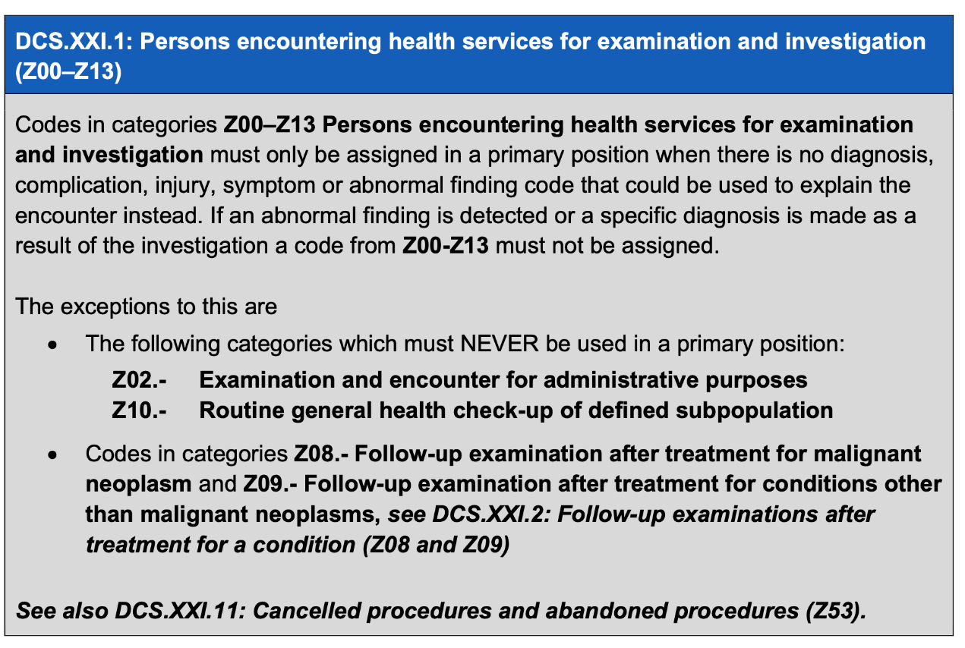
Figure 4 Examples of codes that cannot be a primary diagnosis code [33]

Clinical Coding Standards
When assigning codes from the ICD-10 or OPCS classifications clinical coders must ensure that the codes adhere to the Rules, Conventions, Standards and Guidance published in the National Clinical Coding Standards [34]. The standards are available on Delen [35] early each year to allow users to familiarise themselves with any changes to the standards that must be used between 1st April and 31st March each financial year. Publishing the standards early gives the clinical coding trainers in NHS or private organisations time to design training material ready to deliver to the coding staff before the implementation date.

What are the clinical coding standards?
WHO provides specific instructions and guidance on how the ICD-10 classification should be used, however, this can lead to slight differences in interpretation, reducing consistency and comparability at local and national levels. NHS England has written instructions on how and when specific codes should be assigned. A recent analysis conducted by the Classifications Manager in Digital Health and Care Wales (DHCW), counted the number of standards that a clinical coder would have to learn and transfer to their books as exceeding 400. Every individual standard plays an equal role in ensuring the validity of the clinical coded data. Still, some of the standards are particularly useful as they can be used to form the basis of a clinical coding quality dashboard. A good example of this is:
“Standard DCS.IX.10: Heart failure (I50) If both congestive cardiac failure (CCF) (I50.0) and left ventricular failure (LVF) (I50.1) are documented in the medical record only assign code I50.0 Congestive heart failure as this code includes both right and left ventricular failure.”. [36]
(Further examples and explanations can be found in the Methodology section)

Management of Clinical Coding Standards
In the UK, the management of standards is regulated by NHS England, which contributes to the development and maintenance of ICD-10 by WHO. They have been granted a licence by the WHO to design and revise the ICD-10 standards for use across the NHS in all the UK regions. NHS England developed OPCS classifications on behalf of the Department of Health and they have the remit to create and cancel any standards used in the NHS across the regions.

Standard Course
When they start, every clinical coder must attend and pass the Clinical Coding Standards Course [37](formerly the Clinical Coding Foundation Course) within 6 months of starting in the role. The course is 21 days (3 days for just mental health clinical coders) and guides the new clinical coders through all the National Standards. NHS England’s Classification Service owns the intellectual property rights of all course material, which cannot be altered and must be delivered only by their approved clinical coding trainers. To ensure that clinical coding staff at all levels stay abreast of current and new standards everyone must attend a refresher course, which like the standards course has been created by the Classification service and must be delivered by an approved trainer.

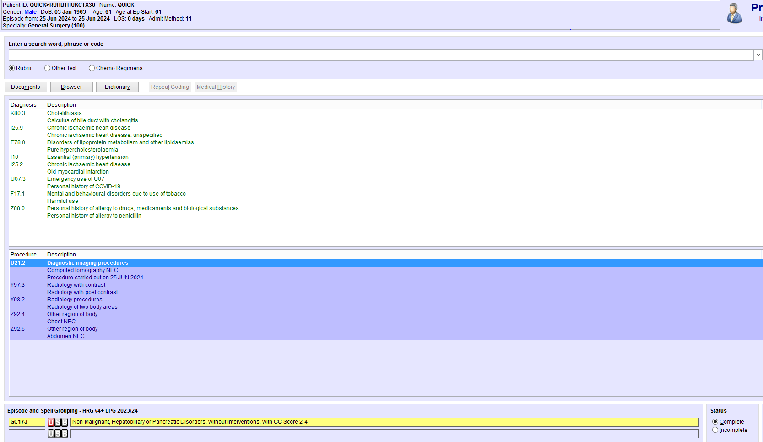
Figure 5 Example of average coded FCE
The above example would require the coder to be mindful of several standards:
- DGCS.1: Primary diagnosis
- DCS.IX.7: Chronic ischaemic heart disease (I25)
- DCS.XXII.9: History of COVID-19 (U07.3)
- DCS.V.7: Current smoker (F17.1)
- PSU1: Diagnostic imaging procedures (U01 – U21 and U34 – U37)

Local Policies
Local policies are an agreed clinical coding process and can be at a regional, health board or trust level. This is done when there is a need to code a diagnosis or procedure in a specific way, but there is no national guidance available. These cannot break a national standard and should be agreed upon and documented by the Clinical Coding Manager (or Audit Lead) and the clinical specialty lead. They should be annually reviewed to ensure that they are still required, are valid and do not contravene any national standard. (Appendix)

Four-step coding process
In addition to ensuring that they keep to national and local standards, clinical coders need to make sure that they use the four stages that make up the process of clinical coding, which is designed to ensure appropriate and consistent code assignments.
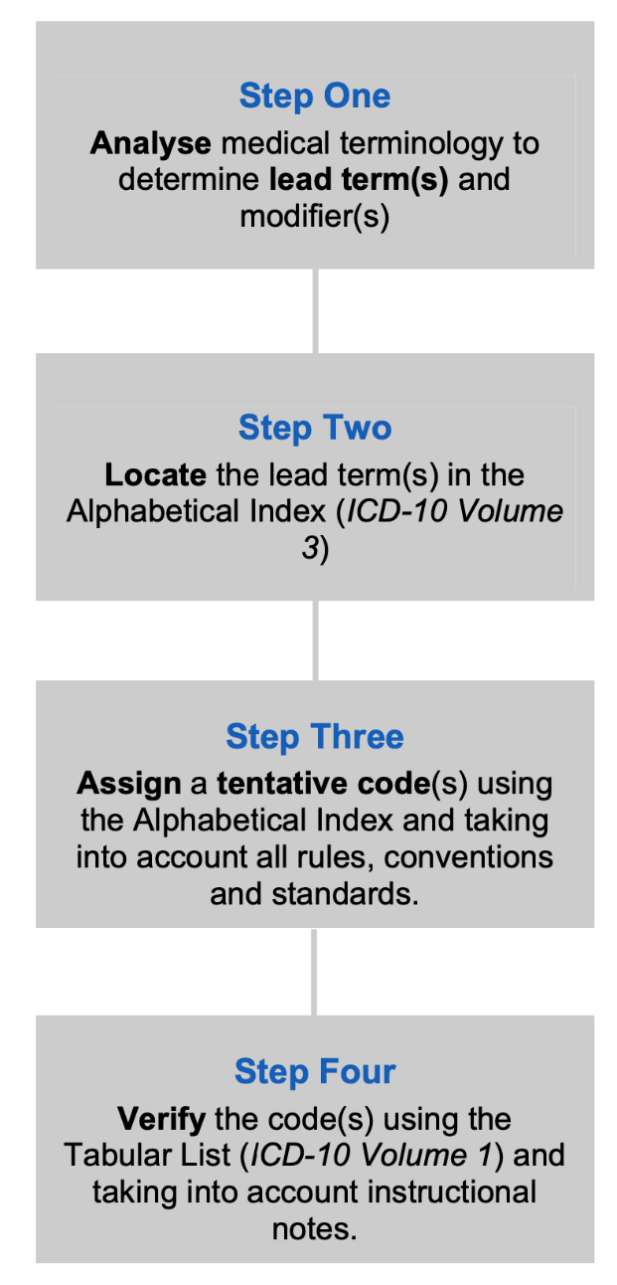
Figure 6 Four-step coding process [38]
For a clinical coder using the four-step coding process is a practice that should be used for every code assigned and one way of telling if a coder is carrying out this dictated is to look at their index and tabular books. One question that springs to mind is why the coder doesn’t replace their books when they get into the state shown below, the reasons are that it takes hours of hard work to update books with the national standards, and local policies and to highlight any difficult to index codes, and the ICD-10 classification books are no longer available to buy as WHO is preparing for release of the ICD-11 classification.
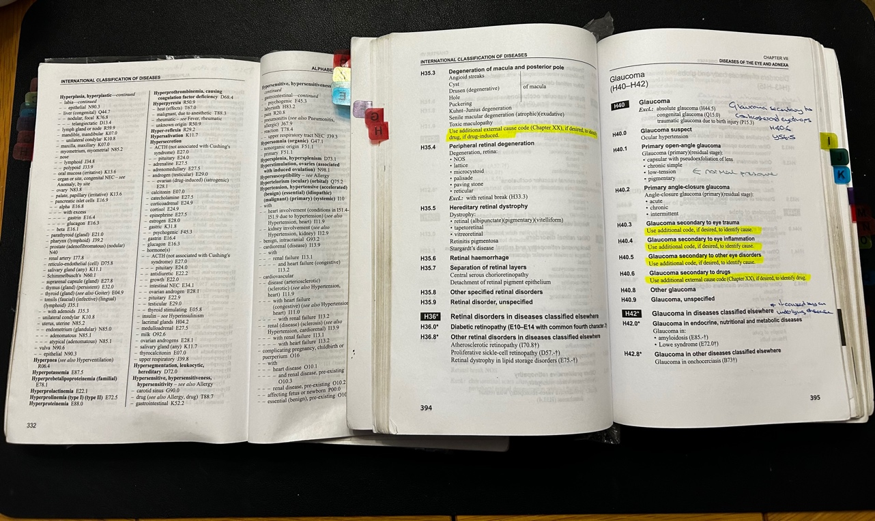
Figure 7 ICD-10 Index and Tabular [39]

National Clinical Coding Qualification
The National Clinical Coding Qualification (NCCQ) has two main aims: to ensure that clinical coders have the knowledge and capability to code to the highest standard and to provide clinical coding with a professional standing with a nationally recognised qualification. IHRIM has designed the NCCQ and has been running since May 1999 and has run bi-annually except for the years of the COVID-19 pandemic. Currently, the NCCQ is divided into two separate examination papers.
i. The practical paper allows the clinical coder to use their annotated ICD-10 and OPCS books (they are not allowed to use the National Clinical Coding Standards e-books) to answer 60 quick-fire questions and 4 case studies. The pass mark for this paper is 90% which might seem high but that is the accuracy target that coders are expected to achieve when coding for their organisations.
ii. The Theory paper, for this paper the clinical coders are not allowed to take in any of their books and have to rely totally on their knowledge to answer questions on standards, sequencing, anatomy and medical terminology. The pass rate for this exam is a mere 65%.
To achieve the NCCQ the clinical coding staff are required to pass both the practical and theory exams, and it takes an average of two years for a clinical coder to train and revise for the exams. Once they have passed the NCCQ they can add Accredited Clinical Coder to their name, an industry standard required for progression within clinical coding.

Charlson Index
The Charlson Comorbidity Index (CCI) is used in the NHS for measuring the burden of co-morbidities in clinical research and practice. CCI was originally devised by Mary Charlson and her colleagues in 1987 as a methodology for predicting one-year mortality for patients with multiple chronic conditions. The CCI measures the quantity and severity of 19 chronic medical conditions, and depending on the related mortality risk, each condition/disease receives a score of 1, 2,3 or 6. Then the overall score can range from 0 – 37 and is calculated by adding the points for each criterion. The CCI predicts patient outcomes such as mortality, length of hospital stays and healthcare costs. (Appendix)

The UK Government requires that English NHS trusts perform a monthly upload of all the patient care data sets to the Secondary Uses Service (SUS) [40]. SUS is England’s first all-inclusive healthcare data repository, which facilitates a reporting and analysis service, used to provide the population with the best healthcare service. One of the weaknesses of SUS for the clinical coding service is that it can only process the first 20 ICD-10 and OPCS-4 code assignments. All the comorbidities that can have a detrimental effect on patient care outcomes must be in the first 20 positions. When assigning clinical codes the clinical coders must ensure they comply with national and local standards and that all the codes referenced in the CCI are sequenced to be included in the SUS upload.

Since the advent of CCI in the late 1980s medical advances and research on co-morbidities that can affect recovery and outcomes, with the result that the codes included in the index are not sufficient to encapsulate the complex healthcare casemix and other conditions like HIV do not have the same impact on outcomes due to medical advances. To remedy this NHS England has mandated that from July 2024 the Elixhauser Co-morbidity Index Scores (ECIS), created by Anne Elixhauser in 1998 [41]. ECIS omits any co-morbidities that do not directly contribute to patient outcomes or mortality, includes more co-morbidities that are now relevant to patient outcomes and contains a new scoring methodology which accurately reflects the impact each co-morbidity has on patient outcomes. [42] ECIS was originally designed to work with ICD-9 but has been updated to reference the ICD-10 classifications using a list of 30 co-morbidities. Unlike the CCI the co-morbidities are not an index because each co-morbidity affected outcomes (i.e. length of stay, mortality, tariff) differently among different patient cohorts. The co-morbidities identified by ECIS are significantly associated with in-patient mortality and include both acute and chronic conditions. (Appendix). The use of ECIS will improve mortality risk and outcome analysis for healthcare statisticians, however, it will increase the sequencing complexity for the clinical coders, as they will be required to ensure that these codes are assigned in the first 20 diagnosis positions.

Clinical Coding Audits
Traditionally the only way to evaluate the accuracy of the coded clinical data was to perform a clinical coding audit. NHS England recommends that NHS trusts have a regular internal programme of clinical coding audits to ensure quality.

NHS regulatory bodies are increasingly using the outcomes of clinical coding audits as evidence that NHS trusts exemplify best practices and promote a culture of continuous improvement. To assert that the data is accurate clinical coding departments in acute NHS trusts must conduct an annual internal Data Security and Protection Toolkit (DSPT) audit [43]. The audit evaluates the accuracy of the assigned codes and the HRG tariffs generated, to ensure that the NHS trusts are correctly invoicing for their services. A typical DSPT audit should consist of 200 FCEs, and the NHS trust’s clinical coding department needs to obtain an accuracy of :
Description | Percentage
Primary Diagnosis | $≥$ 90
Secondary Diagnosis | $≥$ 80
Primary Procedure | $≥$ 90
Secondary Procedure | $≥80$
Table 2 DSTP Accuracy
The DSPT audit must be conducted by an auditor approved by NHS England and adhere to the audit methodology created by the NHS England classification service to be considered legitimate.

Clinical coding audits provide organisations with results for a small sample of clinical coded data. However, the finance and business intelligence departments within NHS trusts need assurance that all the clinical coded data is valid and accurate. To be able to audit all the coded clinical episodes generated by an acute NHS trust they would need to employ the same number of auditors as clinical coders, which is not just financially unsustainable it is also logistically impossible to apply to become an approved auditor a clinical coder needs to be 3 years post NCCQ and have extensive experience of coding multiple specialties. When accepted the coder needs to pass the assessment day with a score in all 3 tests of 95% or more [44]. There is also the financial cost to the organisation to pay for both the assessment day and the week-long workshop, which is usually held in Leeds and London. A typical NHS acute trust would have 130,000 coded FCEs every financial year, and a typical audit team would be hard-pressed to audit more than 2,000 of those FCEs, equating to less than 1.5% of a trust’s coded clinical data being validated.

Training Requirements
A clinical coding team is no different to any other team of professionals, Mossop [45] states that ensuring that the team has sufficient appropriate training is vital for achieving successful outcomes such as ensuring accuracy and reduction of the backlog.

Conventionally gauging clinical coding training requirements within a department has relied on DSPT, specialty or individual coders’ audit results to highlight any areas that need further development. This has been hampered by the small sample of FCEs audited, and it is easy to form bad habits the more confident you become in any subject. The expression ‘familiarity breeds contempt’ is as pertinent now as it was in Chaucer’s Tale of Malibee(c.1386), the challenge is to correct any coding errors by recognising patterns of bad coding before they impact the NHS trust’s information quality.

Data Quality Solutions
Solventum [46] (part of the 3M franchise) and IQVIA [47] both produce clinical coding quality solutions, these are commercial companies whose products have an underlying cost, which NHS Trusts cannot afford due to financial constraints and fixed budgets. Solventum’s quality package can be purchased as an add-on to its encoder package and works on looking at past coding for a patient and comparing that to the current code assignments. It does not assist with invalid code assignments of national standards or local policies. IQVIA will for a fee (estimates up to £1million) promise to ensure that all the trust’s codes generate the highest tariff within the HRG by implementing their Quality Income Performance methodology.

An example of the performance income and how it can uplift the HRG (appendix), is the addition of the OPCS code Y76.3 Endoscopic approach to other body cavity to enhance the OPCS code H41.2 Peranal excision of lesion of rectum, when a Transanal endoscopic microsurgical procedure has been performed. The methodology would highlight that the trust had performed X number of peranal excision of lesions of the rectum without the Y76.3 and by adding the Y76.3 they would generate £X’s extra income. (see appendix) The issue with this is that not every perianal excision of a lesion of the rectum is performed using TEMs.

Upgrading HRGs is a complicated process and trusts that use this service should be mindful of the possibility of fraudulent invoicing and noncompliance with NHS England’s best practice guidelines. Approved clinical coding auditors are instructed to report any fraudulent upscaling of HRG tariffs to NHS England’s Counter Fraud and Security Manager Service. [48] [49]

DHCW in NHS Wales provides the 7 health boards and Velindre University Trust with a free clinical coding quality and completeness dashboard. The dashboard was initiated in 2018 and consisted of 10 checks and the coding completeness of the health boards and trust. Since then it has grown to comprise over 300 validation checks.

Purpose of the Clinical Coding Data Quality Dashboard
The checks that make up a clinical coding dashboard can only certify that the assigned codes are valid, it cannot assert that the codes are correct or if any are missing, this can only be achieved by having a robust audit programme. The checks can complement the audit programme by highlighting specialties or chapters within the classifications that would benefit from an in-depth audit. The accuracy of the allocated codes and the yearly DSPT audit will be enhanced by integrating the automatic quality checker with an audit programme. The training team can use the data produced by the check to determine any training needs, which should guarantee the trust’s continuous growth in accuracy providing BI, finance, and other stakeholders with the assurance that the data they are using is reliable and valid.

Data Security
To be able to interrogate the data warehouse the repository for the Admitted Patient Care (APC) dataset there will be a requirement for the analysts to have SQL Server Management Studio and read-only permissions to the server. Kimball [50] states that protecting the information collected and stored in the data warehouse is one of the tenets of first-class data warehouse design. Security and access underpin all standards used in the NHS, but even with all precautions taken NHS organisations are under constant attack as a recent potentially damaging incident in June 2024 proved [51].

The General Data Protection Regulation (GDPR) [52] and the Caldicott Principles [53] maintain that only authorised staff members have access to patients’ data and even they should only access data when required. Administrators of the data warehouse ensure that the analysts, developers, stakeholders and users only have access to the data they need to perform their tasks and only the minimum access level.
Understanding CRUD (CREATE, READ, UPDATE and DELETE ) functions is imperative to ensure the data warehouse’s security and accuracy. [54] To get around giving analysts permission to create, update and delete tables within the data warehouse, administrators allow them to create, update and delete views, without impacting the tables in the warehouse.

Project management
When planning any project Lamb [55] emphasises the importance of setting achievable targets, which can be difficult due to difficulties in measuring technology aspects and human-based motivation factors. Establishing a framework and setting limitation boundaries is crucial for a project to achieve its aims and goals.

Not all projects need a project manager, however, it is worth researching project methodologies to discover which suits the project best. The NHS’s preferred methodology for project management is Agile as it allows for changes to be made throughout the lifecycle of a project as required, allowing adaptability to any evolving requisites and priorities. Baweja [56] maintains that agile project management methodologies have a high emphasis on teamwork and regular communication among the project team, stakeholders and users, this leads to improved collaboration and goal orientation.

Research Methodology
The research methodology best suited for this project is Positivist, as the project emphasises objective measurement criteria such as accuracy, consistency, validity, timeliness, and completeness of the coded clinical data. This Positivist approach promotes ethical data practices by ensuring the integrity and quality of the coded clinical data that forms the information used for clinical and strategic decision-making in the NHS.

Ensuring the ethical integrity of the research is of paramount importance. The Positive approach upholds ethical principles by prioritising the accuracy, reliability and validity of the clinical data. This is crucial as the coded data directly informs clinical and strategic decision-making, which can have a significant impact on patient care. Additionally, the research methodology emphasises transparency and adherence to established national standards, rules, and conventions, further strengthening the ethical foundations of the project.

It is Deductive as the testing of the data extracted from the warehouse is against pre-established national standards, rules, and conventions established in the ICD-10 and OPCS-4 clinical coding standards reference books. The standardised methodology enhances the reliability and generalisability of the findings, as the results are applied to other organisations’ clinical coding departments which also adhere to the national standards. The clinical coding department in the RUH has numerous local policies that dictate the assignment and sequencing of classification codes, and the results of the checks have been thoroughly tested.

The validity of the research is established through the use of surveys, a valuable qualitative research method to understand the users’ perspectives, preferences, and expectations for the clinical coding quality dashboard. The approach establishes the validity of the dashboard by ensuring it meets the needs and requirements of the intended users, further strengthening the validity of the project. The dashboard will have 2 different groups of users:
- Errors in code assignments will be forwarded to the clinical coders, and it will be up to them to see that the code assignments are corrected.
- The leadership team, consisting of the operational, audit and training sub-teams, will use the dashboard to supervise errors and productivity of each coder. They will also use the dashboard to monitor the backlog and to gauge what training is necessary to improve the accuracy and validity of the coded clinical data in the RUH.
Surveys (see Appendix) have been sent to the team to discover what they think of the checks, whether they are accurate, and valid, and are extracting FCEs that contain code assignment errors. The project has significantly impacted the clinical coding department's work practices, and the team must be engaged, this has been achieved by valuing their opinions and suggestions throughout the design process. Surveys are reinforced with regular 1:2:1 and team meetings to determine if the dashboard continues to have a positive effect and what further checks can be implemented to improve the project. The responses collected in the surveys and meetings have been collated and suggestions for new checks are being considered for future implementation. Using surveys and engagement as an approach replicates the Scandinavian approach to design, Gregory [57] illustrates the importance of democracy and empowering users through participation in the design phase of a project, which leads to a more user-centred solution.

A case study approach will provide an in-depth understanding of real-world context and processes surrounding clinical coding, which is crucial for designing an effective data quality dashboard. This method can contribute to the reliability of the findings, as it allows for a more comprehensive and contextual analysis of coding practices and challenges.

Feature-Driven Development (FDD) is a framework in the Agile methodology and focuses on developing a working dashboard that meets the needs of the clinical coding department. FDD aims to ensure that the project is completed in the given timeframe, which aligns with the ethical principles of efficiency and timeliness in project delivery. The development of the project adheres to strict information governance protocols, as the RUH has mandated the use of authorised software, and no external software can be downloaded or used. The software mandated for this project:
- SQL Server Management Studio, to extract the data from RUH’s data warehouse.
- Outlook to email the potential coding errors to the team.
- PowerBI to display the extracted data in a visual format.
This ensures the security and confidentiality of sensitive clinical data. The developer required elevated access levels on the data warehouse to create scripts and extract the necessary data, further emphasising the importance of information research in this project. The development of the project uses software authorised by the Trust and due to data protection no external software can be downloaded and used to build the checks and dashboard.

The combination of positive, deductive and qualitative research methods, along with a strong focus on ethical considerations, reliability, generalisability, validity, and information governance provides a robust and comprehensive research methodology for this project. This approach ensures the integrity, quality, and practical relevance of the coded clinical data, which is crucial for informing effective clinical and strategic decision-making within the NHS.

Implementation/Development

Design

Defining the project goals
The SMART system [58] defined the project goals ensuring that they aligned with the long-term goals of the RUH. The setting of the goals and measures is just one part of the design and consideration needs to be given to the minimum viable project and what outcomes the project must deliver. One project restriction is that only data from the current financial year as the data upload for previous financial years has already been sent.

MoSCoW prioritisation method

The MoSCoW prioritisation method [59] was used to define the projects objectives and measures.
MoSCoW
Must Have | Access to the data warehouse
Must Have | Design of data set to generate the table in the data warehouse
Must Have | Creation of data table by the data warehouse team
Must Have | Duplicate all checks that are currently on the checker
Must Have | Run automatically at a set time - weekly
Must Have | Includes process to track error rates – per coder, type and specialty
Must Have | Automatically notify coders weekly
Must Have | Coders to have access to their errors in PowerBI
Must Have | Send errors only to the appropriate coder
Must Have | Contain a minimum of 100 SQL scripts
Must Have | Combine the SQL scripts into views to power the dashboard
Must Have | Management team to have access to the coding backlog page
Should Have | Highlight in different colours those codes that have been assigned in error
Should Have | Checks written for all possible national standards
Should Have | Coders to have access to their own productivity page on the dashboard
Should Have | Management team to have access to combined coders' errors
Should Have | Management team to have access to the coder productivity page
Should Have | Coders to have access to the backlog page
Could Have | Links to National Standards
Could Have | Links to appropriate local policies
Could Have | Check written for all possible four-step coding process
Could Have | Method for coders to add FCE to exception list once it has been checked
Could Have | Forecasting on the backlog page of the dashboard
Could Have | Dashboard page to show error rates before and post specific specialty training
Could Have | Links to online browsers to show the correct four-step coding process
Won't Have | Checks to identify omitted codes
Won't Have | Published externally
Won't Have | Published outside of the clinical coding and BIU department
Won't Have | Will not be a replacement for the audit programme
Won't Have | Will not contain checks that could fraudulently uplift HRG tariffs
Table 3 MoSCoW

Data set design
To replicate the original checks using SQL queries the data warehouse team created a table to power the dashboard using a data set developed using the camel case convention for naming the attributes for readability.
Attribute Name | Attribute Type | Example | Data type
ProviderSpellNo | Nominal | 2004861894 | VARCHAR
MRN | Nominal | 1371289 | VARCHAR
DateCoded | Interval | 2024-06-14 00:00:00.000 | DATETIME
CodedBy | Nominal | Simpson, Bart | VARCHAR
AdmissionDtTm | Interval | 2024-04-05 01:19:00.000 | DATETIME
DischargeDtTm | Interval | 2024-04-15 16:32:00.000 | DATETIME
DiagnosisConCat | Nominal | J22X,S3501,J849 | VARCHAR
ProcedureConCat | Nominal | U051, Y981 | VARCHAR
BirthDate | Interval | 1941-08-14 00:00:00.000 | DATETIME
AgeOnAdmission | Numeric | 81 | INT
EpisodeNo | Numeric | 2 | INT
AdmissionMethod | Nominal | Emergency | VARCHAR
Specialty | Nominal | 300 | VARCHAR
TreatmentFunction | Nominal | 300 | VARCHAR
ConsultantCode | Nominal | C6029999 | VARCHAR
StartWard | Nominal | ED | VARCHAR
DischargeWard | Nominal | Respiratory | VARCHAR
DischargeDestination | Nominal | Usual place of residence | VARCHAR
EpisodeStartDtTm | Interval | 2024-04-05 01:19:00.000 | DATETIME
EpisodeEndDtTm | Interval | 2024-04-06 10:25:00.000 | DATETIME
HRGAcrossSpell | Nominal | DZ22N | VARCHAR
HRGAcrossEpisode | Nominal | DZ20N | VARCHAR
Diagnosis1 – Diagnosis51 | Nominal | J22X | VARCHAR
Procedure1 – Procedure51 | Nominal | U051 | VARCHAR
Table 4 Data set Attributes

RUH policy mandates that all dashboards driven by data from the data warehouse must use tables that are located in the ‘Presentations’ database, this ensures patient systems have the resources needed to run effectively. This is achieved by implementing effective resource allocation strategies and regularly monitoring system performance to identify and address potential issues. By doing so, the RUH maintains the reliability and availability of critical systems and continues to deliver high-quality care to its patients. When designing a table to power the dashboard, the first consideration is determining the minimum data elements required for the coder to identify the FCE, and whether there is a need to include Patient Identifiable Information (PII). PII is confidential information that identifies who the patient is, information about their medical condition and any treatment that they are receiving. NHS Digital [58] states it is important to consider the use of PII in any project, including any patient demographical and administrative information, such as their name and address. Attention should be given to the handling and management of PII to ensure privacy and compliance with regulations. By taking a thoughtful and responsible approach to how and when PII is used, the RUH can build trust with their patients and maintain the integrity of their systems and processes.

The first hurdle to manage is ensuring that the dataset includes enough unique information to identify the FCE but contains the least amount of PII data, per the guidance in the Caldicott principles.
“Sharing of no more information than is necessary for the purpose, i.e., information sharing does not equate to total disclosure” [53]

. For this reason, the dataset does NOT contain the patient’s:
- Name
- NHS number
- Address
It does contain the patient’s date of birth as some of the coding checks are specific to an age range. The data elements that will be used to identify the FCE that needs to be examined by the clinical coder are:
- ProviderSpellNo – unique PAS-generated number which identifies an admission.
- Medical record number (MRN)- the patient’s unique number within the RUH.

The reasons for including each data element in the dataset are provided in the appendix.

Categories of queries

When designing queries for the dashboard it was important to understand the constraints which prevent all national standards and local policies from being transformed into SQL queries. It is not feasible to verify code assignments that are valid but incorrect, for example, when it is documented in the patient record that they were admitted with NSTEMI and hypertension and the coder assigns:
I21.4 Acute subendocardial myocardial infarction
I95.9 Hypotension, unspecified
The checker will be unable to detect when irrelevant codes have been added, or when a clinical coder has failed to assign a code.

The checker will be able to evaluate the clinical coded data when the national standard, local policy or four-step coding process states:
- Specific codes should not be assigned within the same FCE
“DCS.IX.10 Heart Failure
If both congestive cardiac failure (CCF) I50.0 and left ventricular failure (LVF) I50.1 are documented in the medical record only assign code I50.0 Congestive heart failure as this includes both right and left ventricular failure.” [33]
- Specific codes are mandated to be sequenced after a code.
“DCS.XIX.7 Postprocedural complications of medical and surgical care
A code from categories Y40 – Y84 must always be assigned for complications of medical or surgical care T80 – T88 to allow for accurate reporting of external causes.” [33]
- An essential modifier directs the clinical coder to assign a specific code.
If the patient has calculi in both the kidney and ureter N20.2 Calculus of kidney with calculus of ureter. (see appendix)
- Specific codes should not be assigned.
RUH local policy 27 states that K02.9 Caries, unspecified should not be assigned and if ‘Caries’ is documented in the medical record K02.1 Caries of dentine should be assigned. (see appendix)
- 5th character has been assigned incorrectly.
“DChS.XIII.1 Fifth character in Chapter XIII
Fifth characters must only be used where doing so adds more specific information about the site.” [33]
The fifth character 9 unspecified site does not add any information therefore it should not be assigned.
- Omitted fifth character in code assignment
“DChS.XIX.2 Fifth characters in Chapter XIX
Supplementary fifth characters are used in this chapter to identify open or closed fractures, intracranial injuries with or without open intracranial wounds, and internal injuries with or without open wounds into the cavity. They must be assigned when instructed by the note at code, category or block level.” [33]
A fracture of the neck of the femur should have a fifth character of ‘0’ for close or ‘1’ for open, the default if it is not documented in the medical record is closed.
S72.001 Fracture of neck of femur, open
- Incorrect sequencing of codes.
“PCSU2 Radiological contrast and body areas (Y97-Y98)
Codes from Y97 Radiology with contrast must always be assigned after the codes for the specific scan and before codes from Y98 Radiology procedures.” [61]
CT of head with contrast
U05.1 Computed tomography of head
Y97.3 Radiology with post-contrast (default)
Y98.1 Radiology of one body area (or < 20 minutes)
- Require codes from both classifications
“PCSM5 Catheterisation of the bladder (M47)
M47.9 Unspecified urethral catheterisation of bladder must only be coded if medical record documents that the patient is in retention.” [61]
To be valid M47.9 must be coded with the ICD10 code R33X Retention of urine

Query Design

The first requirement before the new checker could go live was it must replicate all the checks in the current system.

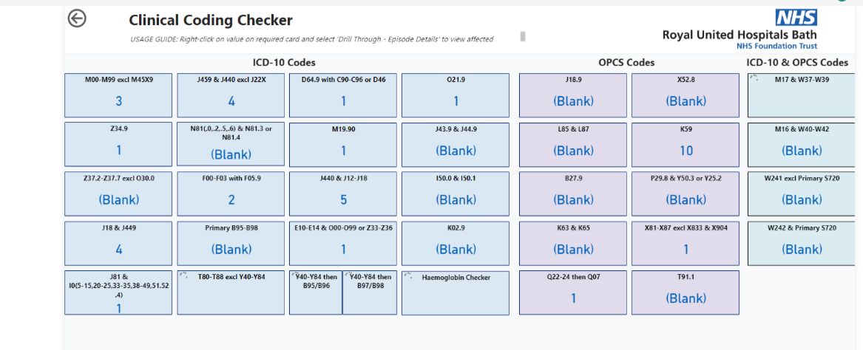
Figure 8 Clinical Coding Checker
The major disadvantage of the current checker is that each check had to be run manually and the results were amalgamated into one Excel file that would be posted on a TEAMs channel. This resulted in no confidentiality, meaning the whole team had access to all the errors. (see appendix list of errors). Additionally, the queries in the current checker have not been updated since pre-COVID (2020) and a few were no longer valid checks.
e.g. O21.9 Vomiting in pregnancy, unspecified
This query was still on the archetype checker however, after discussion during the design phase, it was agreed that this check was no longer valid and would not be replicated in the new checker, as it is a valid code assignment when the clinical staff have not stated what stage of pregnancy the patient is.

Planning outcomes

How the results are shared with the team needs to be considered, what would be the most appropriate and effective method of notifying the coders which FCEs they need to re-evaluate? Previously the output from the checker was posted on the department’s TEAMs channel, after a discussion with the coding team it was decided that a more confidential process should be designed and implemented. PowerBI has a function that can limit individual coders' views of a report while providing the management team with the option to view the entire report.

How the frequency of the report could affect the workload of the coding staff was discussed by the management team, the table created in the data warehouse updates overnight but it was decided that a daily update would be too disruptive. Results from the current checker are published weekly, and it was agreed that this frequency would put the least demand on the coding service.

The structure of the error report needs to be planned, what would be the optimum method of displaying the FCEs with coding validation errors to ensure user satisfaction? Usability of any software is a vital part of the design process, as even if the report and dashboard pages contain all the errors if the report is not easily accessible and legible the coders will not be engaged and willing to use the new checker. The queries can be split into diagnostic(ICD10), procedural(OPCS-4) and ones that examine both code assignments from both classifications, therefore it would be logical to have a separate page for each of these categories.

A wireframe depicting what charts will be used in the management pages of the dashboard, displaying the current backlog and what high-level view of the errors by specialty, classification and coder should be completed so that the correct granularity can be generated in the dashboard.

Wireframes
The minimum viable product will need to contain PowerBI pages for access only by the management team that will display:
- The current backlog – with a future objective of including forecasting to predict the backlog at the end of the financial year. (see figure 9)
- Specialty errors – displaying the number of errors generated for each specialty (see Figure 10)
- Coder errors – displaying the number of errors generated by each coder – with plans to use this page to track the coder’s errors over a quarter or year. This will only be feasible once all the queries have been added to the checker
The dashboard has 2 distinct parts, backlog and error monitoring, so the dashboard has been split into those sections. Within the error monitoring dashboard, there will be pages for each type of error, ICD-10, OPCS-4 and combined.
Figure 9 Timeline graph for backlog

Figure 10 Bar chart errors per specialty

Implementation

Data set
The RUH data is structured to permit 51 diagnosis and 51 procedure codes, this is a challenge when writing SQL scripts to check for codes that should not be assigned together. The first script written as a test for the data was to integrate the table for the ICD-10 codes I50.0 and I501 coded together in an FCE. Initially, this was written using the SQL codes to move all the FCEs with the ICD-10 I50.0 into a temp table and then check that temp table for the ICD-10 code I50.1.

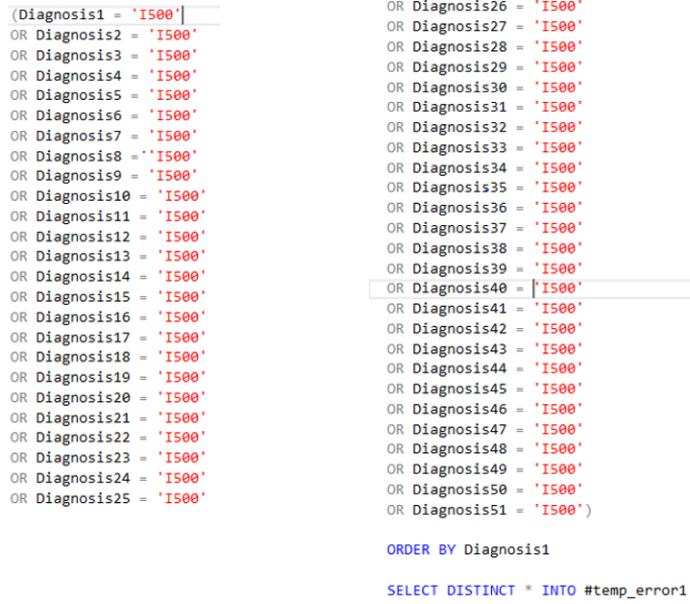
Figure 11 Step 1 Check for I50.0

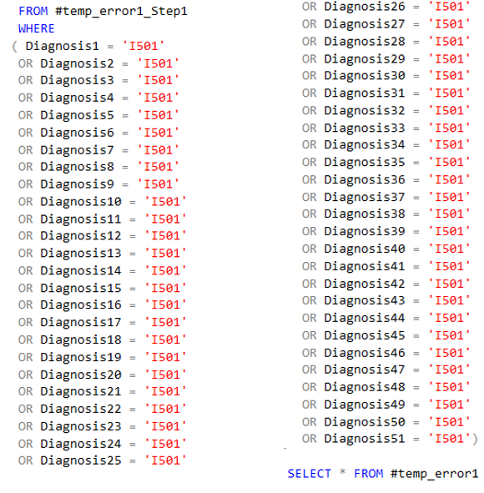
Figure 12 Step 2 Check for I50.1
Replicating this code was time-consuming and laborious, it was only when trying to write a script which interrogated the table for a code from ICD-10 E66 Obesity without O99.2 Endocrine, nutritional and metabolic diseases complicating pregnancy, childbirth and the puerperium or O99.8 Other specified diseases and conditions complicating pregnancy, childbirth and the puerperium in admissions with specialty 501 (obstetrics) that a more efficient method of coding was determined. Using the above 2-step process was not working for the obstetrics query as it took the NULL values in the diagnosis fields as a code assignment and did not regard it as an empty field, which did not extract the expected results. The data warehouse team suggested using the DiagnosisConcat field, which when used for the I50.0/I50.1 query reduced the 100 lines of script to just 2 lines:
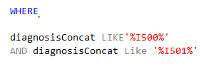
Figure 13 DiagnosisConcat
The new script does mean using the % % wildcard is not recommended as it can according to StackOverflow [62] cause an increase in CPU usage. Sometimes, using it with the ‘LIKE’ statement and the DiagnosisConcat data element allows for more compact and efficient scripts. To test whether the change to the code affected the CPU usage the script was run – looking for errors from the current financial year.
 | 2 step process | Amended script
Run Time | 00:00:06 | 00:00:00
Table 5 Run times
Proving that amending the scripts would reduce the run time for creating the views to power the reports and dashboard pages.

Scripts
There is a requirement to create additional columns in the scripts to :
- Provide coders with sufficient background information to recognise what national standard, local policy or four-step coding process they have broken to generate the error.
- what speciality has generated the error, allowing the quality and training team to evaluate the coding team’s training requirements.
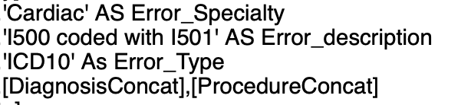
Figure 14 Use of AS MS SQL command
Another column needed to be created for the generated PowerBI report to be sent to the appropriate coder, this needs to be populated with the email address of the coder, using the CASE function, combined with an ELSE statement. The AS function is suitable to populate a column with one statement (e.g. Cardiology) but when the column needs to be populated with an email address, with a dependency on who coded the FCE, the CASE and ELSE statements are required. The ELSE statement has been included to capture any bank staff or contractors temporarily working for the RUH on an ad-hoc basis.

The data warehouse team combined all the separate SQL scripts to create 3 views in the data warehouse, ICD-10, OPCS-4 and combined classification queries. The major change the data warehouse team made was to convert the code that created temporary tables to ones that created Common Table Expression tables (CTEs), they are considered more efficient when dealing with small data sets. [63]
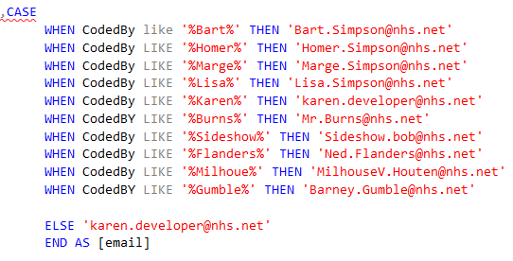
Figure 15 Case and Else Statement
The names in the above script have been anonymised in accordance with the RUH information governance methodology.

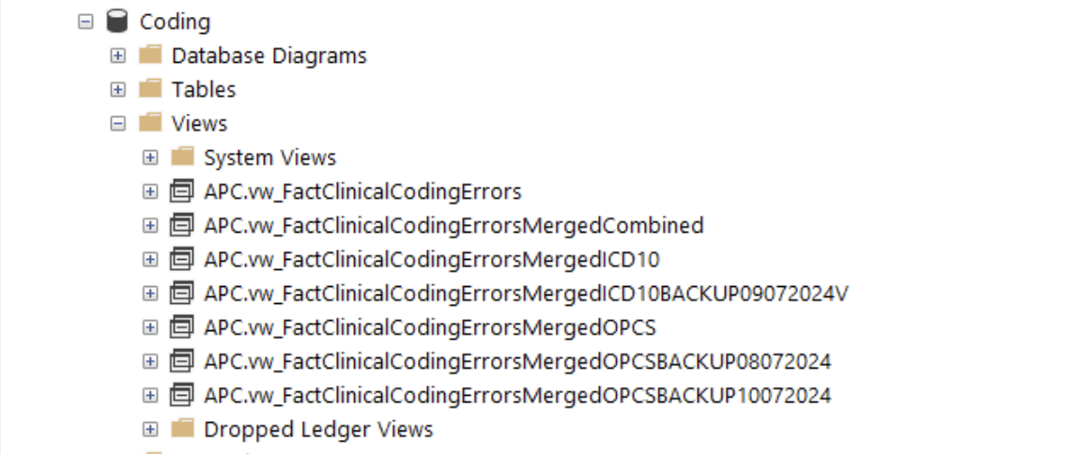

Figure 16 Views in the data warehouse

The data warehouse team handed over the maintenance of the views, but to do this increased access to the data warehouse was required to be able to amend the views when queries need to be updated or when new queries are added.

Validation
A validation process has been generated which covers the stages from conception of an idea for a new check to the SQL script being added to one of the views.
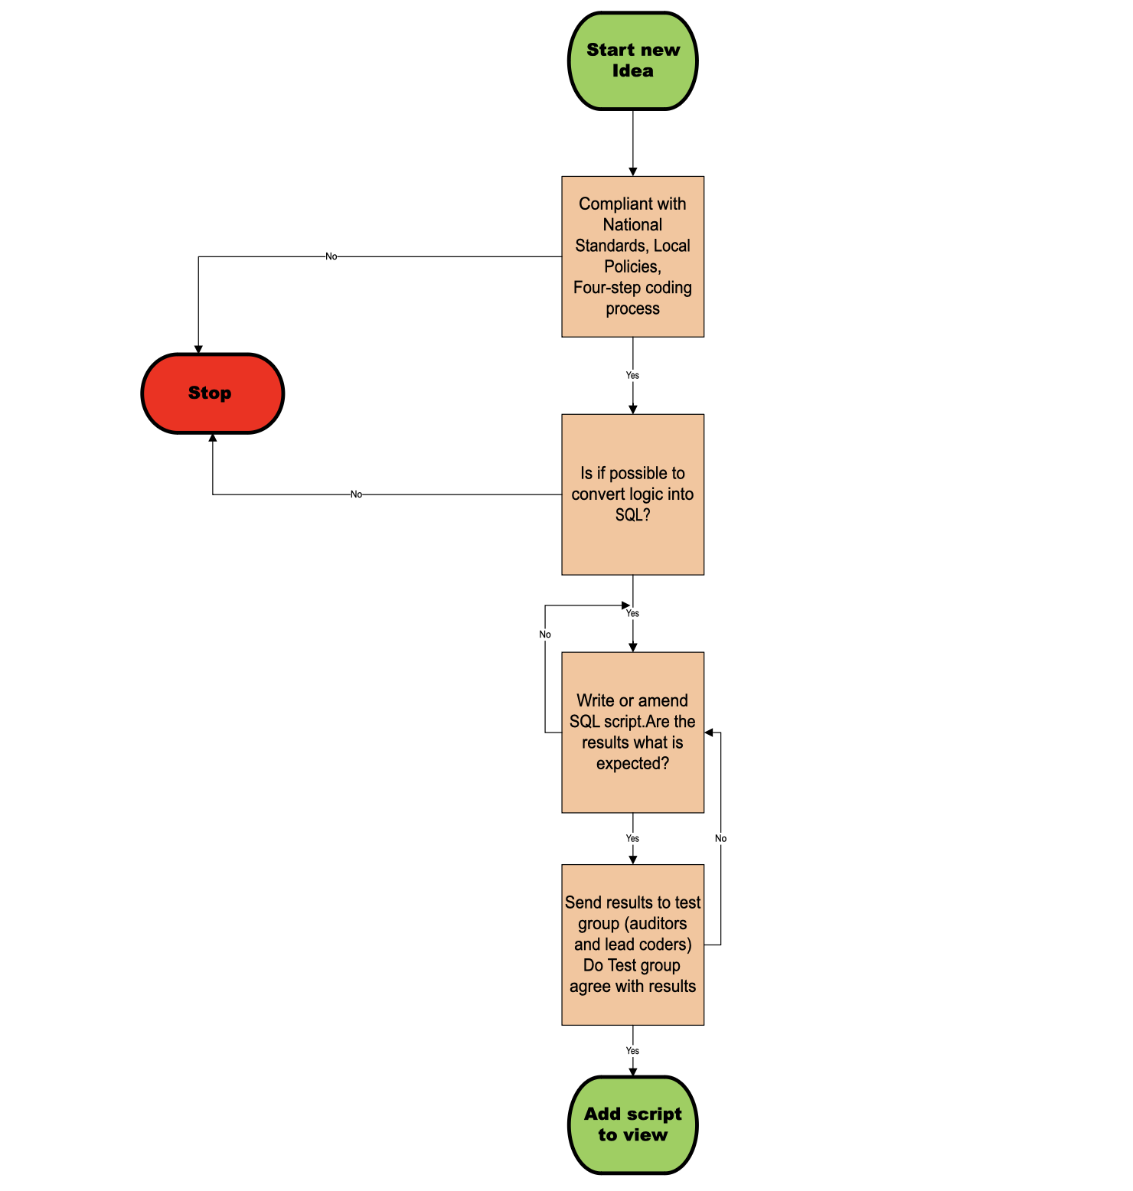
Figure 17 Validation process
For a script to be included in the views, it must first undergo a rigorous validation process, during which the results are validated by both Approved Auditors and lead coders within the department.
To ensure there is no single point of failure for the project, all the checks that will be included in the quality dashboard must be fully documented. The documentation categorises the type of check and rationale to explain why it is a valid query. A full list of the checks can be found in the appendix.

Measures in PowerBI
A basic PowerBI package is part of Microsoft Office 365, however, a publishing license with access to a dedicated workspace is required to send reports and to share dashboard pages with the other members of the leadership group.
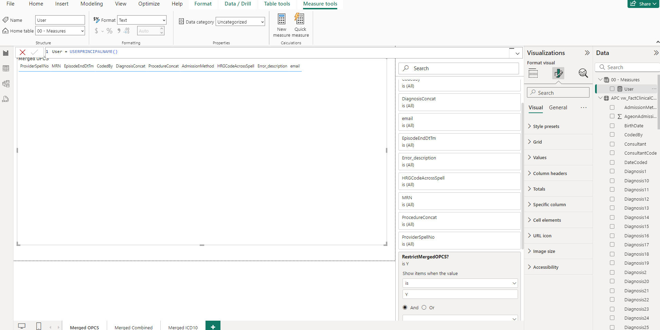
Figure 18 PowerBI measure
The BIU in the RUH assisted with setting up measures that prevent the coders from seeing any dashboard errors other than their own.
The report generation in PowerBI is set to run every Monday at 9:15 am, the time and weekday of the report were discussed with the data warehouse team, and this was the time they agreed would cause the least disruption to the business as the usual running of the data warehouse. By 9:30 am the coding team should receive an automatically generated email with a link to their view of the dashboard. Errors generated by the coders will be displayed on three sub-pages, and it is the coder's responsibility to investigate and correct any shown on their page. The example shown below in Figure 20 shows how the ELSE statement sends any errors generated by temporary staff members.


Figure 19 Email from PowerBI
Figure 20 Error pages for the coder

The backlog dashboard page will be expanded to show the coding rate for the team and individual coders for the current financial year. Currently, it does show a point in time when the backlog starts to grow at an average of 800 FCEs per week. The line represents the week when a clinical coder left the department and shows how the department is struggling to keep the backlog steady and under control.

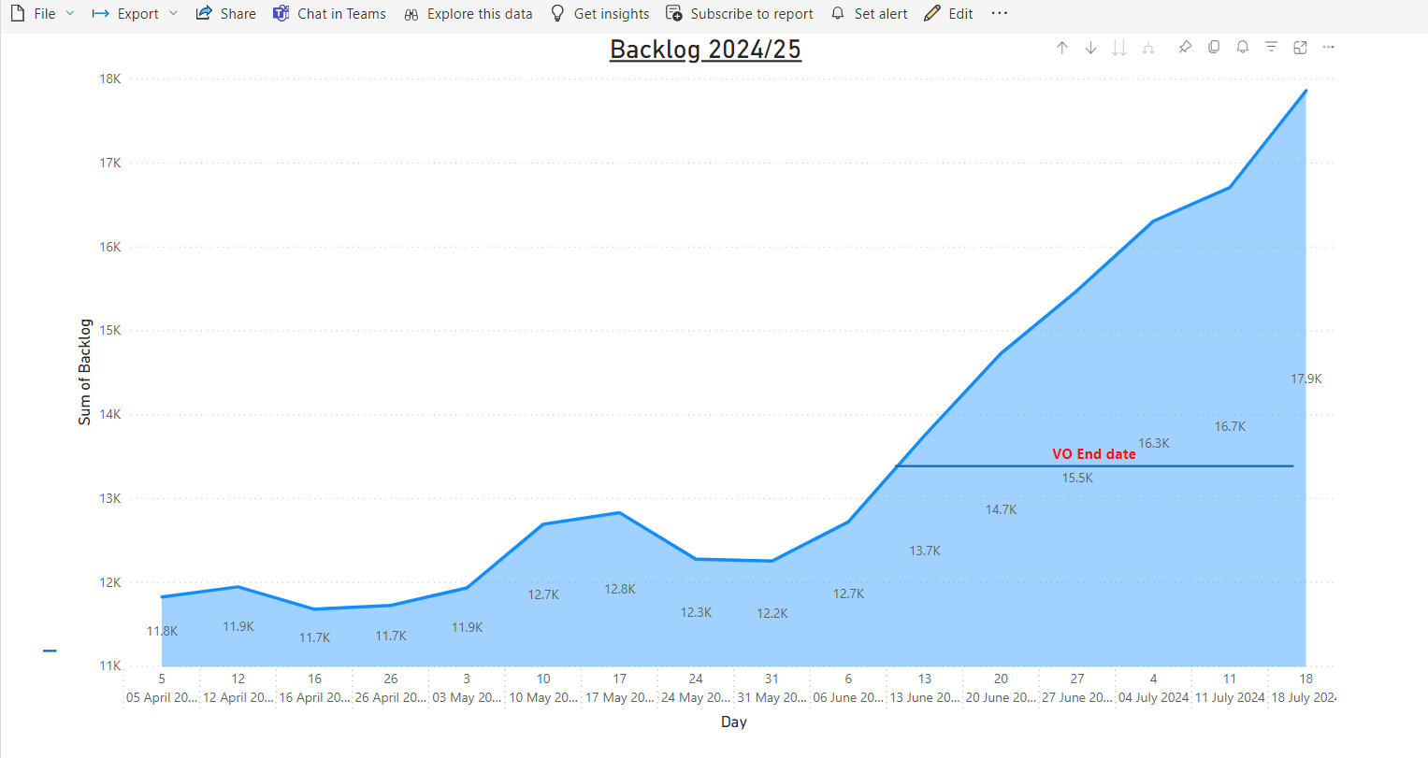
Figure 21 Backlog dashboard
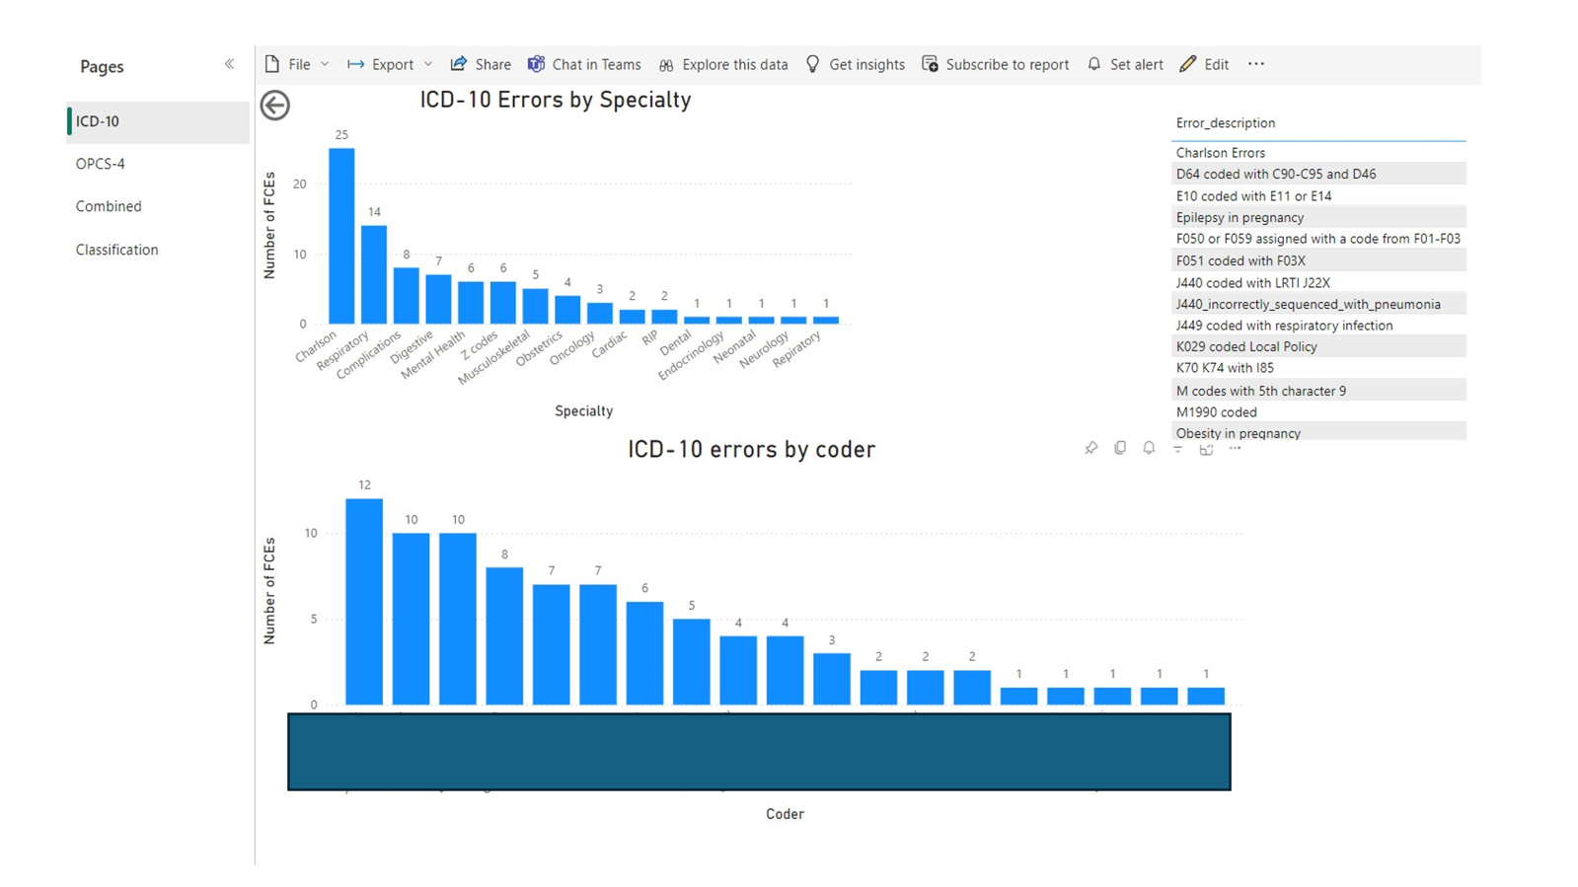
Figure 22 All ICD-10 errors
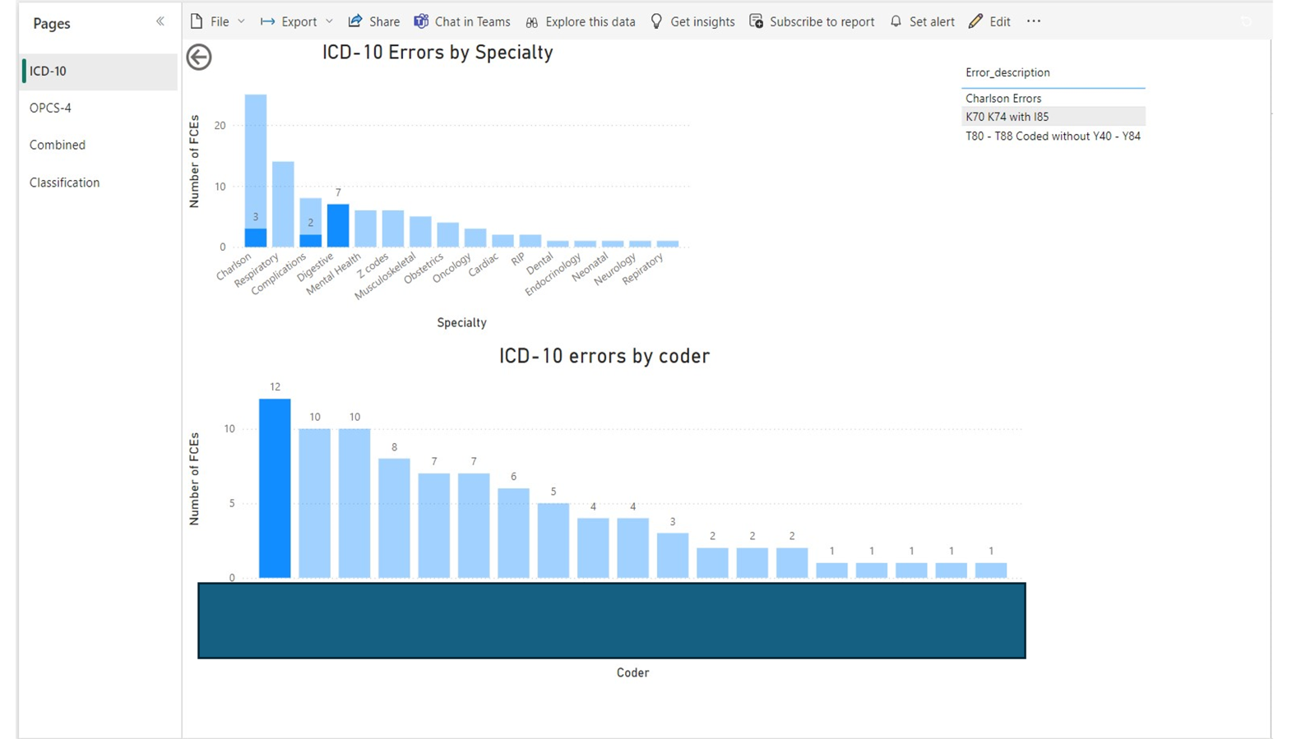
Figure 23 Individual coder's errors
The functionality was added to each of the error type pages on the error monitoring dashboard to be able to filter each individual coder’s errors. The specialty is highlighted as well as a description of the error.
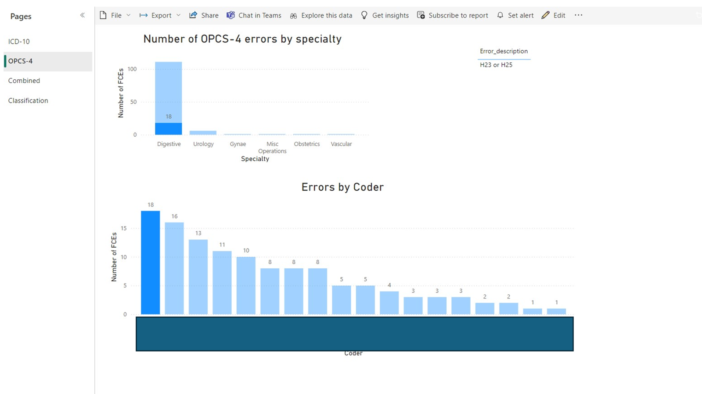
Figure 24 OPCS-4 errors

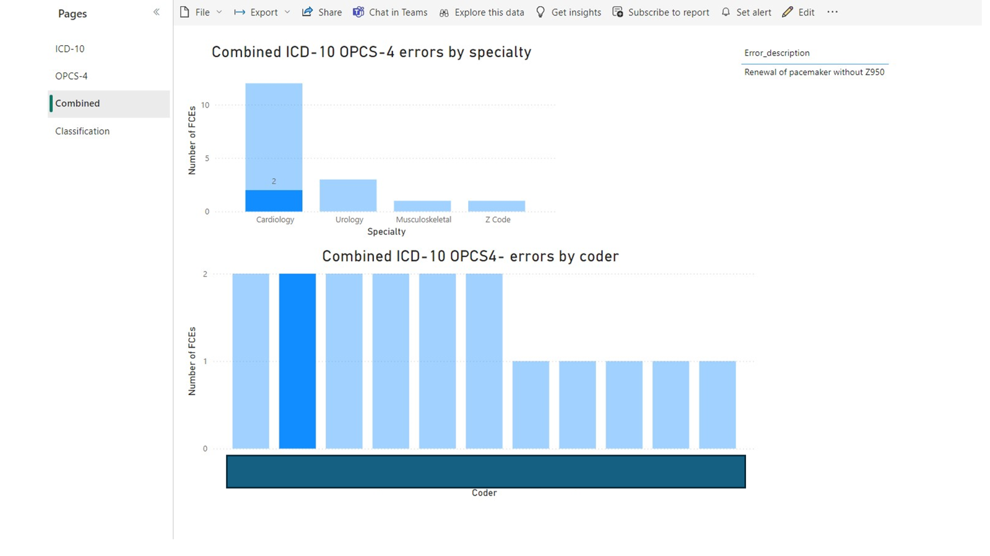
Figure 25 Combined error type

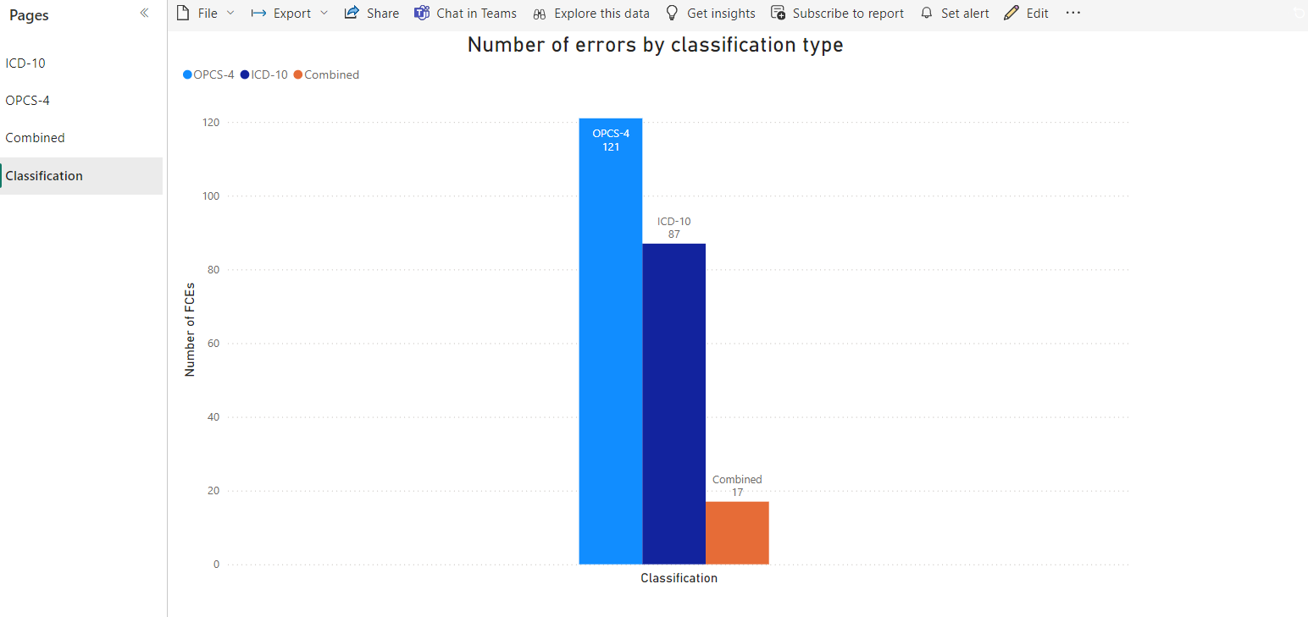
Figure 26 Classification

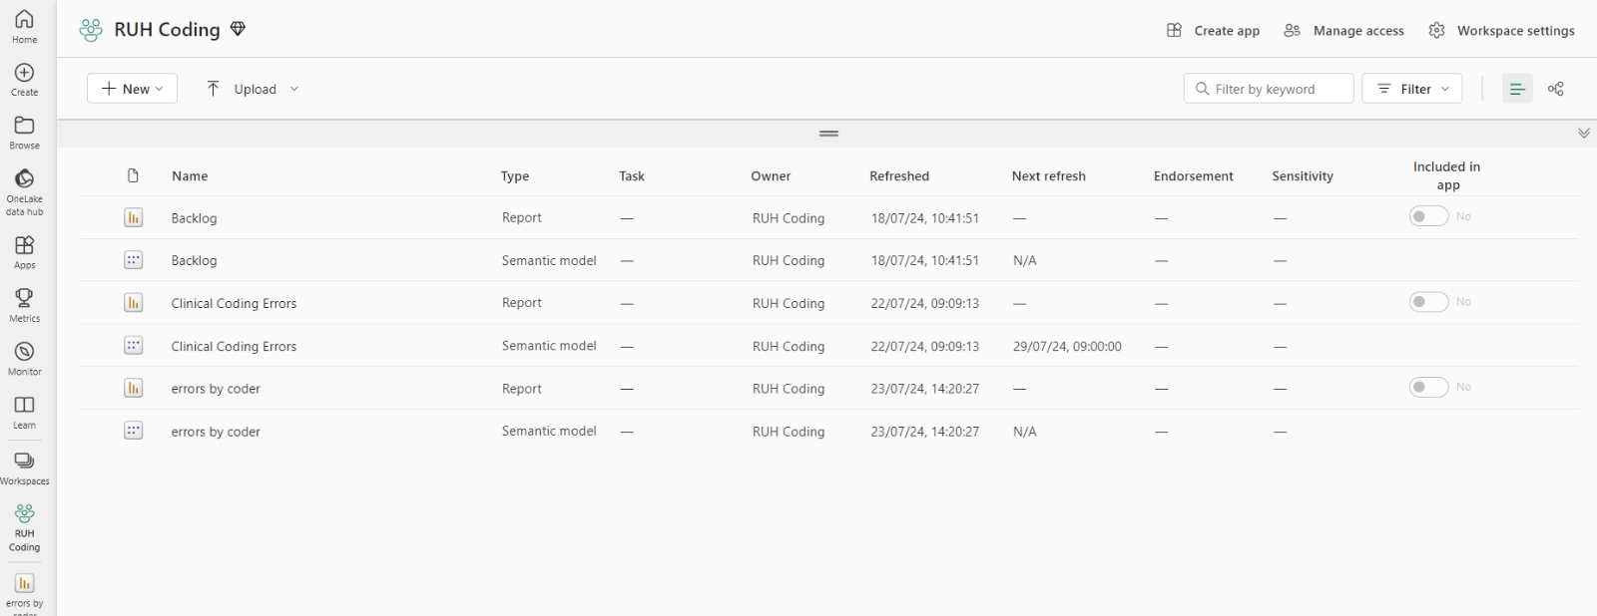
Figure 27 Workspace
All the reports and dashboard models are stored on the dedicated RUH Coding workspace. The management team have access to the backlog and error by coder models, and these are updated weekly on a Monday morning when the new views are generated by the data warehouse team. The error monitoring views provide the quality manager with invaluable insights into the training requirements of the team and individuals. In the above figures, all the coders’ names have been blanked out in accordance with information governance methodology.

Results and Discussions

Even though each of the queries had been checked it was only once the coders started to use the report to investigate their potential errors it was realised that some of the SQL queries needed to be tweaked or re-written entirely.

One example that demonstrates this is the OPCS-4 query that searches for a contrast code Y97 sequenced directly after the U35.4 Computed tomography of pulmonary arteries. The coder correctly queries that one of their episodes had flagged as an error, which was an error in the original SQL script as it was just checking for Y97.3 Radiology with post contrast when it should have been checking that Y97.1 Radiology with pre and post contrast and Y97.2 Radiology with pre contrast was also included in the check.
Figure 28CTPA query
The results from the first survey sent out 2 weeks after the dashboard error reports went live were encouraging :
- 100% of respondents found that the frequency of the error reports was ‘just right’
- 100% of respondents stated that there was sufficient information for them to locate the episode that needed to be evaluated.

Less encouraging was that further work would be needed to describe to the coders what checks were already in place and a forum has been scheduled to go over all the checks and discover what checks they would like in place, once all the OPCS-4 national standard checks have been written. The point made that the Charlson checks need to be highlighted in a different colour, has been flagged as a high priority, especially with the Elixhauser Index being introduced later this year.

It was also important that the coders felt the error reports were more beneficial than the old system. Senior coders were asked their opinions, and the results were that they felt confidentiality was a very important consideration for them.
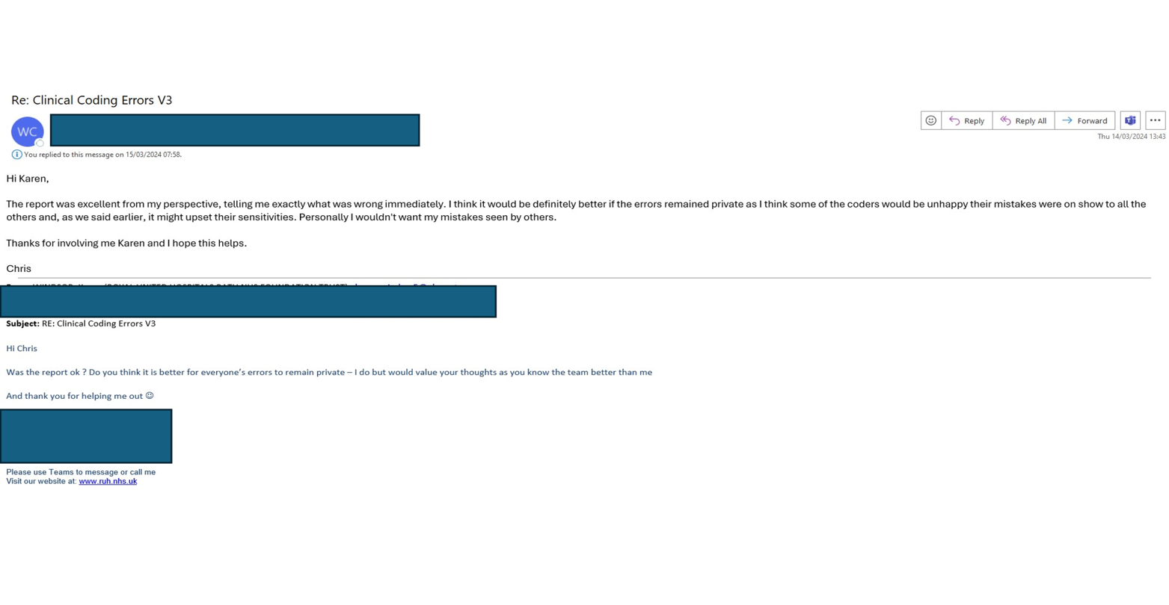
Figure 29 Feedback
Feedback also emphasised the requirement to ensure that the error description that was included in the error report was unambiguous. This corresponds to the survey where only one respondent stated the error report was easy to use, with the majority (71%) stating it was ‘Somewhat easy’ to use. More work needs to be completed to ensure that the error report is clear and easy for the coders to use.
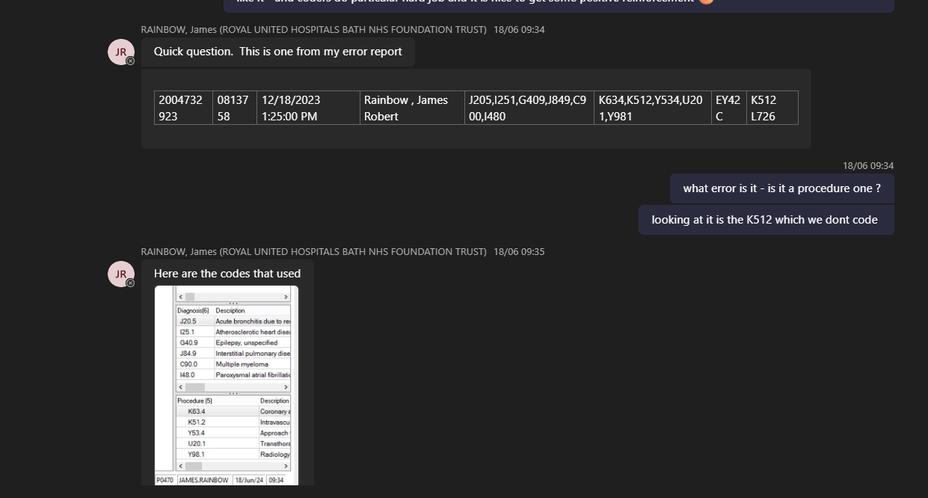
Figure 30 Error description
Feedback from the coders evidenced that a few of the scripts where the query was looking for code assignments with specific codes were not working and that more work had to be done to get the script to generate the correct results. One example was obesity in pregnancy check, which was not working, due to NULL values within the data, this feedback led to the realisation that there was a more efficient method of extracting the data, using the concatenated varibables.

Figure 31 Non-working queries feedback
The dashboard allows the management team to add new checks when an idea emerges, in a team meeting held on the 4^{th of} July it was confirmed that a new local policy would be created to mandate that the coders should not be assigning OPCS-4 codes H23 or H25.
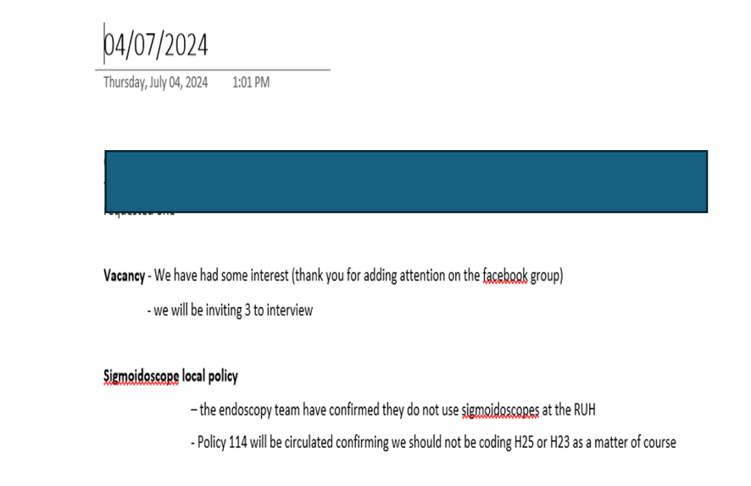
Figure 32Team meeting

The RUH no longer performs sigmoidoscopies but due to a software restraint, they are sometimes documented on the endoscopy report. This check shows the coders who are not coding to the new guidance and how many incidences the department has, as the colonoscopies have higher tariffs than sigmoidoscopy and the page shows the impact this can have on the RUH’s finance. (Figure 33 illustrates how this is still impacting the RUH)
Figure 33 Check for Sigmoidoscopies

Evaluation

The feedback from the first questionnaire was evaluated and it was apparent that the clinical coders preferred how the errors were feedback in individual reports rather than the old method of uploading a spreadsheet containing all the errors into a TEAMs channel. With 100% of respondents stating they found the new checker useful (see appendix).

SUS Questionnaire
The second questionnaire sent after the checker reports had been running for a month used the template questions recommended when administering the System Usability Scale (SUS) using the Likert Scale recommended by Thomas [64]. This might be considered an overloaded system to put in place for such a minor project, but it was deemed suitable as for this project to succeed it needs all members of the department to be engaged and happy to use the new error reporting system. The SUS form sent out to the clinical coders can be found in the appendix. An advantage of using Microsoft Forms to create surveys is, that it correlates all the responses into an Excel spreadsheet that can be fed straight into a SUS calculator. At the time of writing this report, there were 17 responses, however, due to a design error in the form only 16 were recorded.
Figure 34 SUS Calculator [65]

Looking at the responses for the individual questions, showed that 82% of respondents stated that they would like to use the report frequently.
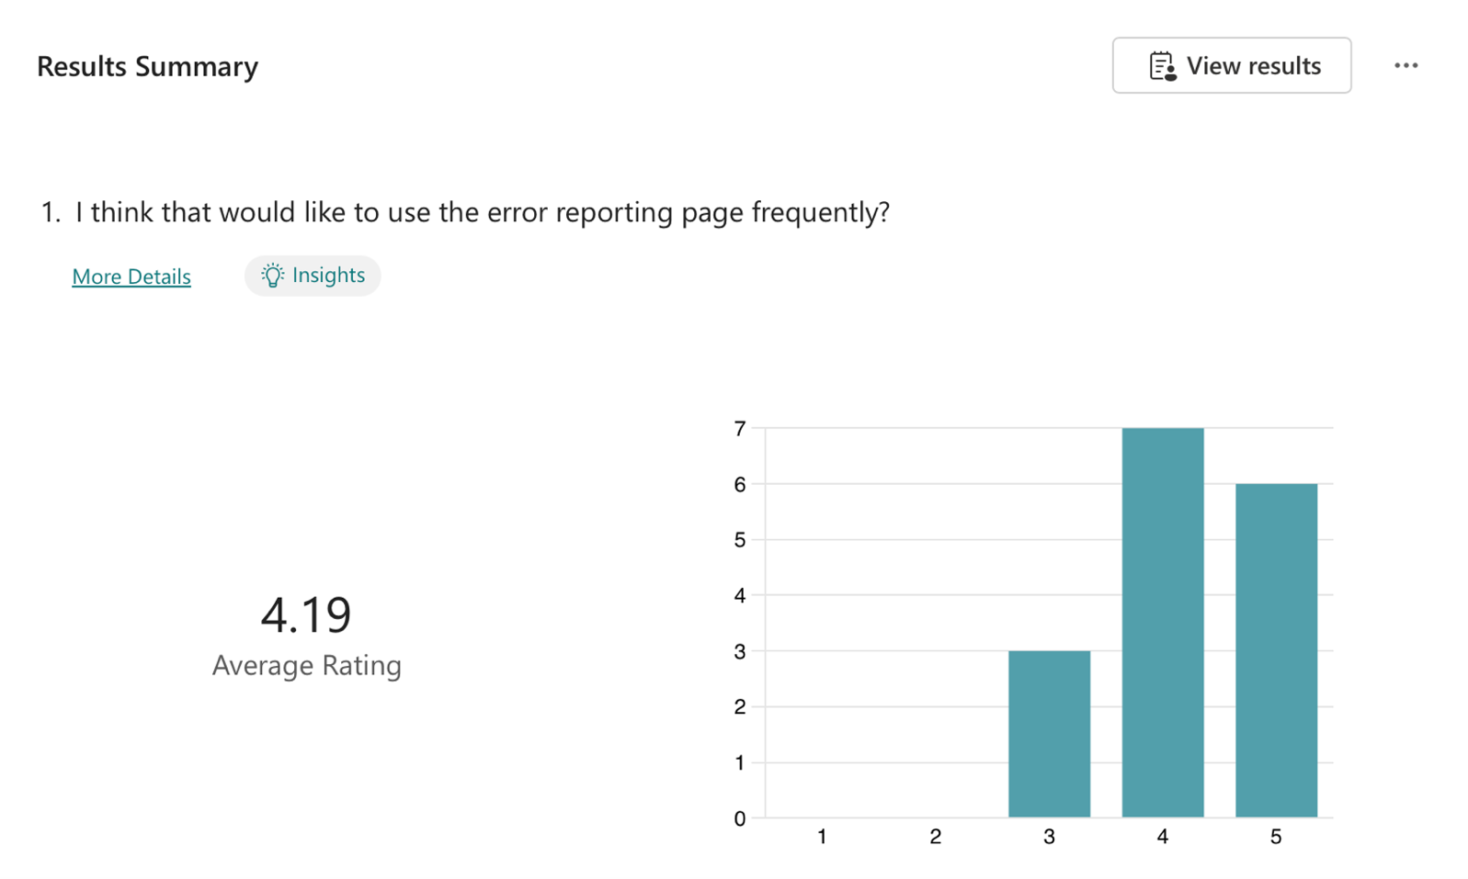
Figure 35 Frequency of use

With 87% stating they would need very little management assistance to use the error report.
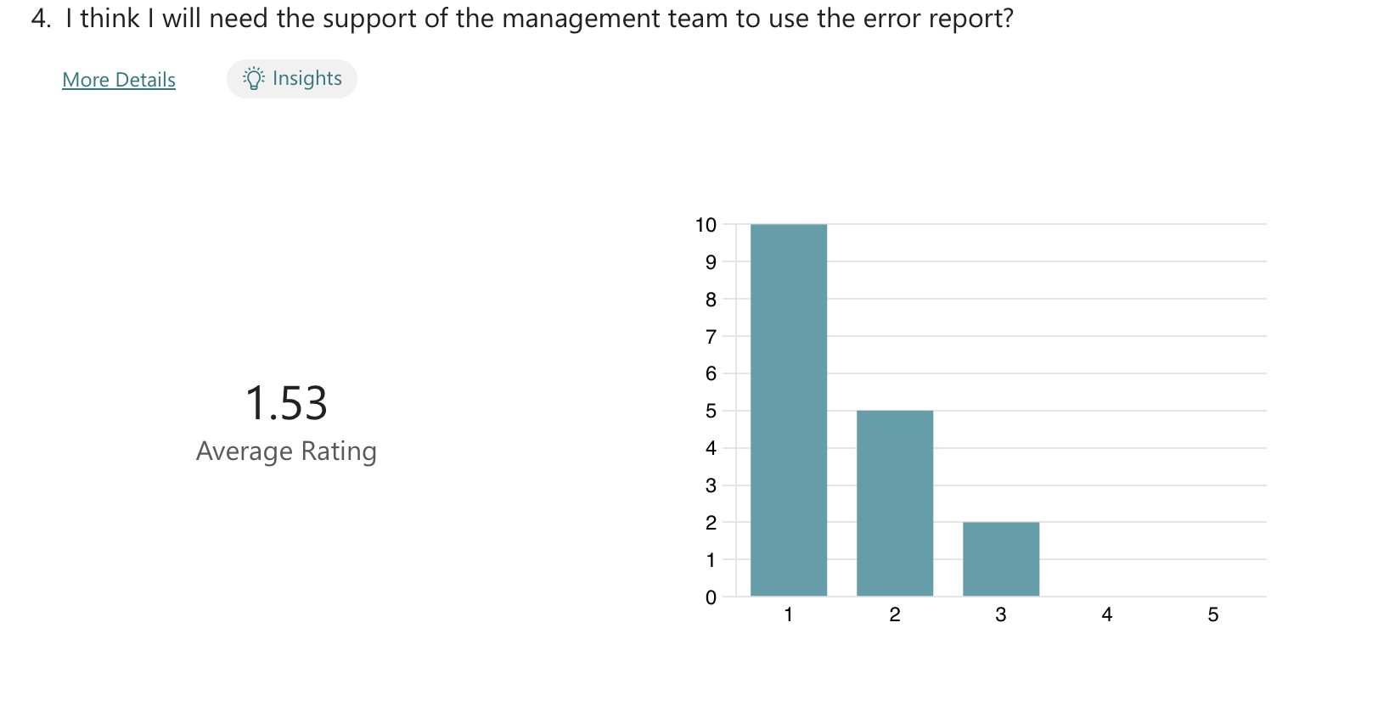
Figure 36 Management assistance

It was also encouraging that the majority (81%) of the coders found accessing the page easy and when they were using it 87% found that there were very few inconsistencies on the page.
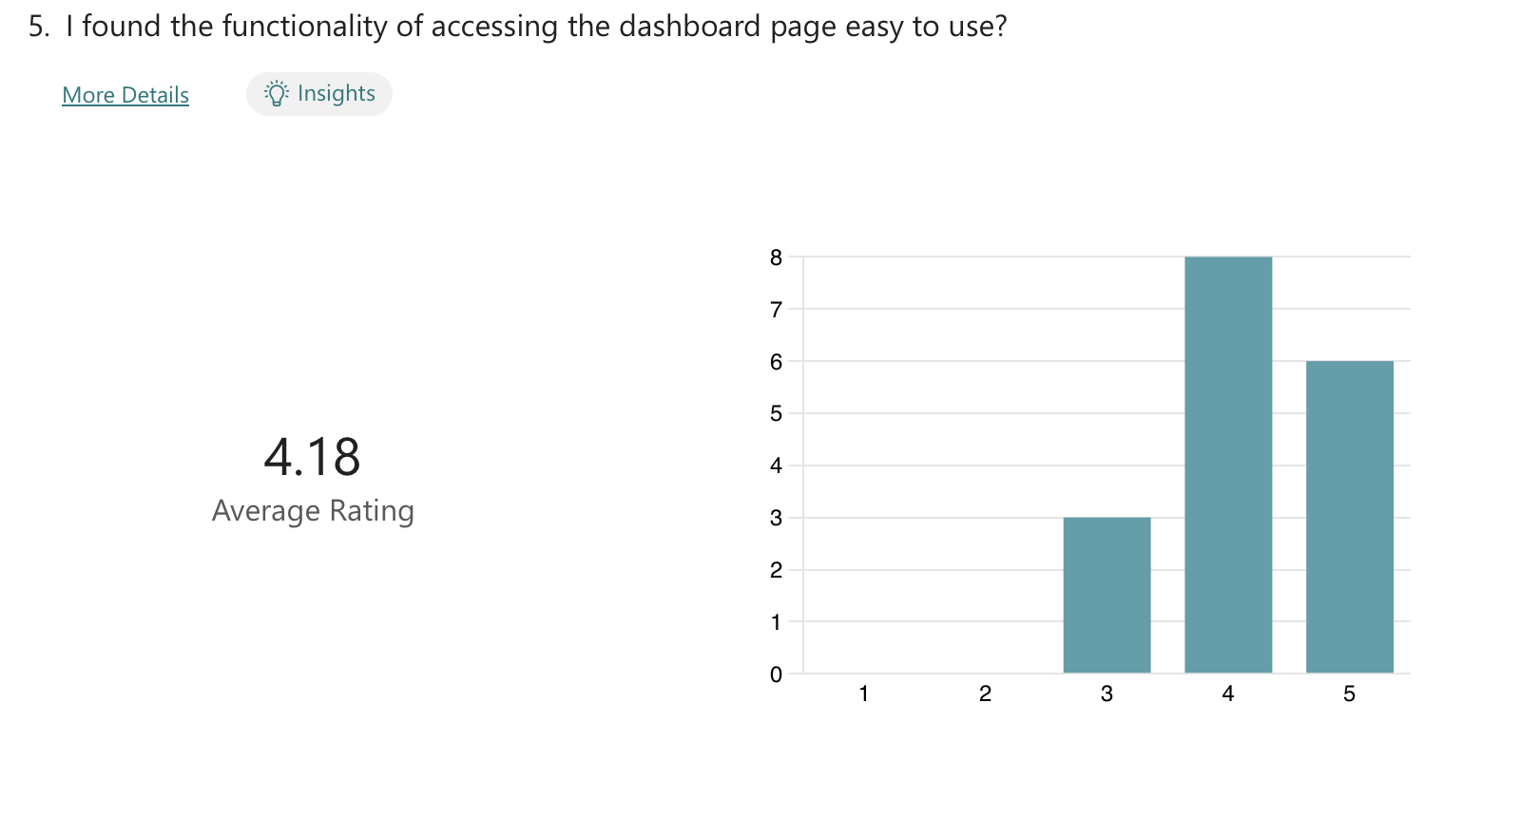
Figure 37 Access
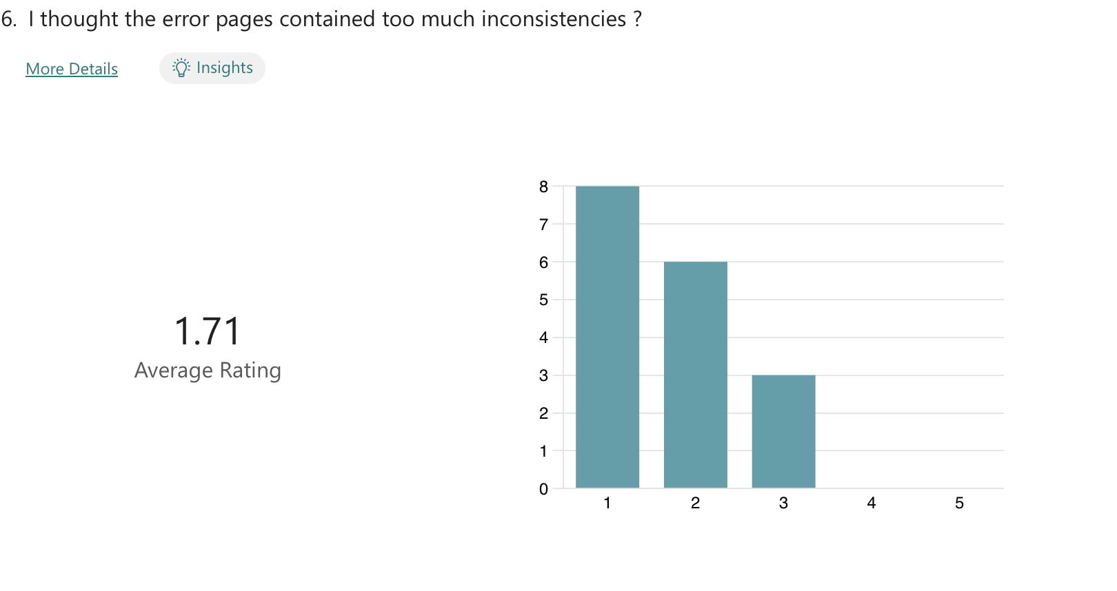
Figure 38 Inconsistencies

The results prove that the changes that have been made after the first survey and before the SUS questionnaire have had a positive effect on how the report is viewed by the coders. The average score is usually around 68 so the results gained from this survey are very constructive. The entire analysis can be found in the appendix.

Errors by Specialty Evaluation
The error reports have drawn attention to areas where understanding of the national standards is deficient and where training sessions are needed to ensure that the department is coding to the latest national standards.
The below email trail established that there was confusion around the coding of jaundice due to prematurity. This is not a national standard but is a rule that is communicated in both the standards and the refresher courses. The correct code assignment is also located using the four-step coding process.
Figure 39 Neonatal query

Since the introduction of the neonatal prematurity with jaundice check has been explained to the coders, no further incidents of this error have been reported.
Figure 40 Obstetrics error
After analysing the results from the combined page it became apparent that cardiology was still an issue and new training sessions have been set up to manage this issue.
Figure 41 Cardiology
One unexpected finding was how severe the clinical coding backlog looked when displayed in a plain line graph rather than just reported weekly in figures. The benefit of showing how the backlog has been steadily climbing in a visual has more impact than just reeling off figures. The backlog dashboard also has the benefit of being updated weekly (for the departmental briefing) and it can be shared with other executives and staff members in the RUH. This visual is going to be used as part of a business case to secure a retention and recruitment payment of 15% for the clinical coding department, allowing the RUH to retain the staff it has as well as being able to recruit new staff to fill current vacancies. At the moment the RUH is having difficulties recruiting as the package on offer is not as attractive as others available on the NHS jobs website. [66] It can be seen in the figure below how the backlog was stable but then started to rise sharply in June when a member of the department left the RUH.

Figure 42 Backlog
An objective was to improve the quality of the clinical coding in the RUH, this is being carried out and it is assisting the quality and training team to evaluate the department's training requirements. The dashboard page displaying the specialty errors allows the trainer to prioritise the department's training requirements and this will help the department and individual coders to improve their specialist knowledge and improve the clinical coding quality for the RUH. The rate of errors can be visualised on the page, and this graph will become more useful as the new number of queries increases.

Conclusions/Future Work

The project aimed to improve the standard and quality of clinical coding in the RUH, this financial year the clinical coding team have coded 22,524 FCEs, and they have been reviewed by the error checker, out of which just under 500 errors have been identified. So far there are 102 queries on the error checker, which contains scripts that check for breaches of national standards, local policies and the four-step coding process. The checker runs automatically at 9:15 am every Monday and the coders usually receive their email notifying them of potential errors within 20 minutes. So far since its conception it has not failed to run. The minimum viable product created for this project is a good starting point, but there a 100s more queries that can be added to the checker to make the project more substantive.

The OPCS-4 queries in particular need to be expanded there are so many four-step coding process queries can that be added, for instance checking for Y95 Gestational age after codes describing procedures performed on the uterus that contains products of conception :
- Q09.1 Open removal of products of conception from uterus
- Q10.1 Dilatation of cervix uteri and curettage of products of conception from uterus
- Q11._ Other evacuation of contents of uterus

Now that the error checks have proved to work and are having a positive impact on the coding department it will be possible to dedicate more time to the creation and validation of more SQL scripts.
The appearance of the error report is satisfactory, but it can be improved, in the future it will be imperative that a method is found to highlight in a different colour the particular codes that have been assigned in error. The coders have feedback that it is taking them time to locate the codes that have been flagged as being invalid, especially those that have been sequenced incorrectly in the first 20 positions as required by the Charlson index. Unless a fix can be found for this it will cause more of an issue when the new Elixhauser index is adopted later this year.

In the future, the department is going to use SQL extraction skills to expand its engagement with the clinical staff building on the success of the OPCS-4 check looking for the code assignments of H23 – H25 sigmoidoscopy procedures. A previous meeting with the endoscopist had highlighted a system constraint with their reports, although they no longer performed any sigmoidoscopies this was showing as the procedure performed. Adding this query to check enabled the coders to identify the FCEs holding the codes and amend the codes to colonoscopy H20 – H23. This increases the HRG and should provide the RUH with an extra £100,000 this financial year.

The checker is already providing the training department with valuable insights into the training requirements of the department, and this will improve when more queries are added to the checker. It will also allow the training department to evaluate the success of any training sessions by analysing the errors before and after training sessions.

The final objective was to create a way of tracking the backlog, the new backlog dashboard allows the management team to evaluate the backlog and provides the management team with valuable insights at a glance to see the current state of the coding backlog (at the time of this report it stands at just under 18,000 FCEs) but it would be advantageous to also be able to predict where the department would be in by the end of the financial year in March 2025 if the staff situation remains static. PowerBI does contain a forecasting function, and this will be investigated and added to the backlog page.

The next DSPT audit is scheduled for September this year, and the department is optimistic that the dashboard will have a positive effect on the coding quality and that we will improve on the level 1 (did not meet the target in any areas) result from last year and achieve at the very minimum a level 2 ( meet but did not exceed the targets in all areas). The recommendations and conclusions from the DSPT report will be vital to assess the value of the dashboard to the RUH and the areas in which it can be improved.

One final piece of work that the department will commence once more OPCS-4 queries have been added to the checker is to share the work with the other clinical coding departments within the Interrogated Care Board (ICB), which also includes the Great Western Hospital Trust in Swindon and Sainsbury Hospital Trust. At the moment only the RUH coding department has access to their data warehouse or has the knowledge and skills to create SQL views to power a dashboard. The purpose of the ICB is to share knowledge and best practice and the RUH will be sharing its clinical coding quality dashboard with its partners and giving them the help they require to build their own, with the aspiration of having one dashboard for the whole ICB.

Personal Reflection
My journey throughout the 4 years of BSc in Data and Information Systems has provided me with the knowledge and confidence to build the dashboard. The Database Application Development module demonstrated how the MS SQL command AS (alias) can add extra columns to a temporary table.

The Usability module gave me an awareness of the end user and how it is imperative to think of them when designing a project. Without this module, I would not have thought it important to use qualitative methods like surveys to find out what the end user thought of the project, and without the input of the coding staff the project would not be the success it is. I was frustrated that I had not thought when designing the SUS questionnaire, which resulted in a design flaw that allowed the respondents to skip answering questions. With hind sight I should have made answering all the questions mandatory so that the respondent could not skip questions.

The degree has bestowed on me the knowledge I needed to create the dashboard, and it also endowed me with the confidence to build it. Before when I came across a problem or issue with a piece of work, my first thought was to ask someone how to solve it. Now I have the self-reliance and self-assurance to try and solve the problem myself whether that is by researching on Google or using one of the many artificial intelligence bots that are available.

The experience gained in the degree gave me the confidence to try different online learning courses when trying to overcome the SQL scripting difficulties I had trying to make scripts work with ‘NULL’ data elements. I enrolled with the Codeacademy [67] and used W3Schools [68] to try and find a solution to the NULL data elements. It wasn't very comfortable to realise that the data set contained a data element that made writing the script easier and more efficient. This experience has taught me the importance of not being complacent, even when I am the one who created the data set. In the future, I will ensure that I thoroughly understand every aspect of the data elements before writing SQL scripts. Understanding how data elements interact was a crucial part of the Data Mining module; without this knowledge, including how data elements, tables, and databases connect, I would not have been able to effectively design the dataset or communicate my data requirements to the data warehouse team.

I have also gained an increased knowledge of clinical coding, and I have had to revisit some standards that I thought I knew. Clinical coding can be compared to learning to drive, at the beginning you follow all the rules and regulations but as you get more confident in your abilities your adherence to the rules slips. I found that I had fallen into that scenario, and I wasn’t looking at the entire picture, and that is why so many of the original scripts had to be rewritten and tweaked to correct my errors. Working on this project has increased my clinical coding knowledge and skills and continuing it will ensure that I keep on improving my skills.

I also discovered I enjoy writing SQL as much as I love clinical coding, which has been my career for over 20 years. The head of information said I am a very rare coder, as I have an in-depth knowledge of clinical coding, but I also have a technical knowledge that clinical coders do not usually possess and the only reason I have this talent is due to what I have learned in the 4 years of this degree.

Modules completed during the degree have inspired and empowered me to create this dashboard and not to fear learning new skills, without the technical knowledge gained the data warehouse team would not have given me the access to the warehouse I need to create views or obtain the publishing license in PowerBI, and I would not have had the confidence to use them if they had. I have tried to use everything I have learnt in all the modules in this project to show what can be done by someone who started this degree with very little technical knowledge.

References

[1] | NHS England, National Clinical Coding Standards ICD-10 5th Edition, London: Health & Social Care Information Centre, 2023.
[2] | Classification and Terminology Service, “Classification Browser,” NHS England, 2024. [Online]. Available: http://classbrowser.nhs.uk/#/book/ICD-10-5TH-Edition. [Accessed 25th June 2024].
[3] | “London's Bill of Mortality,” WorldHistoryCommons.org, [Online]. Available: https://worldhistorycommons.org/londons-bill-mortality. [Accessed 25th March 2024].
[4] | J. Beyersmann and C. Schrade, “Florence Nightingale, William Farr and competing risks,” Journal of the Royal Statistical Society: Series A (Statistics in Society), vol. 180, 2017.
[5] | S. Brown, “Report of the Proceedings at the Statistical Congress, held at Brussels, 19th - 22nd September, 1853,” The Assurance Magazine and Journal of the Institue of Actuaries, vol. 5, no. 1, pp. 25-45, 1855.
[6] | “International Iist of causes of death,” ajph alpha publications, [Online]. Available: https://ajph.aphapublications.org/doi/pdf/10.2105/AJPH.17.9.887-a. [Accessed 25h March 2024].
[7] | “Florence Nightingale: The Pioneer Statistician,” Science Museum, 10th December 2018. [Online]. Available: https://www.datadictionary.nhs.uk/supporting_information/international_classification_of_diseases__icd_.html. [Accessed 25th March 2024].
[8] | W. H. Organization, “World Health Organisation,” World Health Organization, 2024. [Online]. Available: https://www.who.int. [Accessed 25th March 2024].
[9] | N. England, “International Classification of Disease,” NHS England, 25th March 2024. [Online]. Available: https://www.datadictionary.nhs.uk/supporting_information/international_classification_of_diseases__icd_.html. [Accessed 25th March 2024].
[10] | “Day Case,” Digital Health and Care Wales, 2024. [Online]. Available: https://www.datadictionary.wales.nhs.uk/index.html#!WordDocuments/daycase.htm. [Accessed 29th March 2024].
[11] | “Staying as an inpatient,” NHS UK, 2024. [Online]. Available: https://www.nhs.uk/nhs-services/hospitals/going-into-hospital/staying-in-hospital-as-an-inpatient/#:~:text=If%20you%20have%20been%20referred,being%20treated%20as%20an%20inpatient.. [Accessed 29th March 2024].
[12] | GOV.UK, “Office of Population Censuses and Surveys OPCS,” November 2019. [Online]. Available: https://assets.publishing.service.gov.uk/media/625ecd67e90e072a04c065ee/OPCS_codes_supplement_UKHSA.pdf. [Accessed 29th March 2024].
[13] | “Terminology and Classifications,” NHS England Digital, 4th March 2024. [Online]. Available: https://digital.nhs.uk/services/terminology-and-classifications. [Accessed 1sr April 2024].
[14] | “CPT overview and Code Approval,” AMA, 2024. [Online]. Available: https://www.ama-assn.org/practice-management/cpt/cpt-overview-and-code-approval. [Accessed 1st April 2024].
[15] | C. Chute, “Clinical Classifications and Terminology Some history and observations,” J AM Med Inform Assoc, vol. 7, no. 3, pp. 298-303, 2000.
[16] | B. Dibb, F. Woodgate and L. Taylor, “When things go wrong: experiences of vagina mesh complications,” International Urogynecology Journal, vol. 34, pp. 1575 - 1581, 2023.
[17] | H. Sanderson, “Healthcare Resource Group (HRGs) : a casemix study,” British Journal of General Practice, vol. 46, pp. 623 - 623, 1996.
[18] | N. Hawkes, “NHS payment system in England is "completely illogical" says national director,” British Medical Journal, vol. 349, 2014.
[19] | NHS Counter Fraud Authority, “Financial Reporting,” CFA.NHS.UK, 2024. [Online]. Available: https://cfa.nhs.uk/fraud-prevention/reference-guide/types-of-fraud-within-the-NHS/NHS-systems/financial-reporting. [Accessed 1st April 2024].
[20] | Digital NHS UK, “Casemix Design Framework,” Digital NHS UK, 6th December 2023. [Online]. Available: https://digital.nhs.uk/services/national-casemix-office/the-why-what-and-how-of-casemix/the-casemix-companion/hrg-design-concepts#:~:text=CC%20splits%20are%20used%20in,one%20aspect%20of%20patient%20complexity.. [Accessed 10th June 2024].
[21] | K. Mahbubani, F. Georgiades, E. L. Goh, S. Chidambaram, P. Sivakumaran, T. Rawson, S. Ray, A. Hudovsky and D. Gill, “Clinican-directed improvement in the accuracy of hospital clinical coding,” Future Healthcare Journal , vol. 5, no. 1, pp. 47 - 51, 2018.
[22] | N. England, “2023/25 NHS Payment Scheme 20234/24 Prices Workbook,” NHS England, London, 2024.
[23] | A. Walker, B. Mackenna, P. Inglesby, c. Rentsch, H. Curtis, G. Hickman, C. Bates, R. Croker, D. Evans, T. Ward, J. Cockburn, S. Davy, K. S. A. Bhaskaran, E. Williamson, W. Hulme, H. Mcdonald, L. Tomlinson, R. Mathur, R. Eggo, K. Wing, A. Wong and Forbe, “Clinical Coding of long COVID in English primary care: a federated analysis of 58 million patients records in situ using Open SAFELY,” The British Journal of General Practice, vol. 71, pp. 806 - 814, 2021.
[24] | M. Klein, J. Peters, J. Vercoulen, B. Wma and T. Schermer, “Comparing health status between patients with COPD in primary, secondary and tertiary care,” NPJ Primary Care Respiratory Medicine, vol. 30 , 2020.
[25] | GOV UK, “Meet the data quality dimensions,” Gov.UK, 21st June 2021. [Online]. Available: https://www.gov.uk/government/news/meet-the-data-quality-dimensions. [Accessed 8th April 2024].
[26] | M. Guah, “NHS information quality and integrity: issues arising from primary service provision,” International Journal of Healthcare, vol. 6, no. 2, pp. 173 - 188, 2004.
[27] | Y. Kiberu, F. Ara, Y. Gue and J. Szygula, “Clinical coding errors in elective device implantation costing,” Cardiac Rhythm Management, 2020.
[28] | A. Medford, “Aberrant Clinical Coding: An under appreciated entity for NHS Trust Clinicians and coders,” Journal of the Royal College of Physicians Edinburgh, vol. 43, pp. 101 - 102, 2013.
[29] | NHS England, “Payment by results guidance,” NHS England, 11th March 2024. [Online]. Available: https://digital.nhs.uk/services/secondary-uses-service-sus/payment-by-results-guidance. [Accessed 8th April 2024].
[30] | B. Jansen, J. Salminen, S. Jung and H. Almerekhi, “The illusion of data validity: Why numbers about people are likely wrong,” Data and information management, vol. 6, no. 4, 2022.
[31] | “Improving Clinical Coding Accuracy and driving appropriate financial reimbursements,” 3Ms, 2024. [Online]. Available: https://www.3m.co.uk/3M/en_GB/health-information-systems-uk/providers-and-payers/coding-and-reimbursement/. [Accessed 8th April 2024].
[32] | “Simple Code,” Woodward Associates, [Online]. Available: https://www.woodwardassoc.co.uk/#/product/SimpleCode. [Accessed 8th April 2024].
[33] | Classification and Terminology Service, National Clinical Coding Standards ICD-10 5th Edition for Morbidity Coding, Leeds: NHS England, 2024.
[34] | “Clinical Classifications,” NHS England, 1st April 2024. [Online]. Available: https://nhsengland.kahootz.com/t_c_home/viewDatastore?dsid=356868&adv=s&showAllColumns=N&datViewMode=list&showSingleItem=N&cardColNo=&search=&search_0=9&sortCol1=Col%5F11&sortDir1=ASC&shownum=10&sort=Col_11&dir=desc. [Accessed 2nd June 2024].
[35] | “Delen Home,” NHS England, [Online]. Available: https://nhsengland.kahootz.com/t_c_home/groupHome. [Accessed 5th June 2024].
[36] | NHS England, “National Clinical Coding Standards ICD-10 5th Edition for Morbidity Coding 2024,” 1st April 2024. [Online]. Available: https://nhsengland.kahootz.com/t_c_home/viewDatastore?dsid=356868&adv=S&showAllColumns=N&datViewMode=list&showSingleItem=N&cardColNo=&search=2024&sortCol1=Col%5F11&sortDir1=desc&sortCol2=0&sortDir2=asc&showNum=10&dir=desc&sort=Col_11&startrow=11. [Accessed 8th June 2024].
[37] | NHS England, “Annex - Training for Clinical Coding (only),” NHS England, 18th September 2023. [Online]. Available: https://digital.nhs.uk/cyber-and-data-security/guidance-and-assurance/data-security-and-protection-toolkit-assessment-guides/guide-3---staff-training/annex---training-for-clinical-coding-only. [Accessed 15th June 2024].
[38] | “ICD10,” Wikipedia.org, 12th March 2024. [Online]. Available: https://en.wikipedia.org/wiki/ICD-10#Chapters. [Accessed 29th March 2024].
[39] | World Health Organisation, International Statistical Classification of diseases and related problems, Geneva: World Health Organisation, 2016.
[40] | NHS England, “Secondary Uses Service (SUS),” NHS England, 28th February 2024. [Online]. Available: https://digital.nhs.uk/services/secondary-uses-service-sus. [Accessed 15th June 2024].
[41] | A. Elixhauser, H. D. Steiner C and R. Coffey, “Comorbidity measures for use with administrative data,” Med Care, vol. 36, no. 1, pp. 8 - 27, 1998.
[42] | K. Tsai, K. Hsieh, S. Ou and F. Chow, “Comparison of Elixhauser and Charlson Methods for Discriminative Performance in Mortality Risk in Patients with Schizophrenci Disorders.,” Int J Environmental Research Public Health , vol. 17, no. 7, 2020.
[43] | NHS Digital, “Data Security and Protection Toolkit,” NHS England, 2024. [Online]. Available: https://www.dsptoolkit.nhs.uk. [Accessed 17th June 2024].
[44] | NHS England, “CCAP - Clinical Coding Auditor Programme Handbook,” NHS England, Leeds, 2024.
[45] | L. Mossop, “Team Training: the future of continuing professional development,” Veterinary Record, vol. 177, no. 21, pp. 539 - 540, 2015.
[46] | Solventum, “Health Information Management,” 3M, 2024. [Online]. Available: https://www.solventum.com/en-us/home/health-information-management/. [Accessed 22nd June 2024].
[47] | “Clinical Coding Analytics,” IQVIA, 2024. [Online]. Available: https://www.iqvia.com/locations/united-kingdom/solutions/nhs-solutions/clinical-coding-analytics. [Accessed 22nd June 2024].
[48] | NHS Counter Fraud, “NHS Counter Fraud,” NHS England, 2024. [Online]. Available: https://cfa.nhs.uk. [Accessed 22nd June 2024].
[49] | NHS Counter Fraud, “Finance Reporting,” NHS England, 2024. [Online]. Available: https://cfa.nhs.uk/fraud-prevention/reference-guide/types-of-fraud-within-the-NHS/NHS-systems/financial-reporting. [Accessed 22nd June 2024].
[50] | R. Kimball, M. Ross, B. Becker, J. Mundy and W. Thornthwaite, Relentlessly Practical Tools for Data Warehousing and Business Intelligence, Indianapolis: Wiley Publishing Inc, 2010.
[51] | NHS England, “Synnovis cyber attack - statement from NHS England,” NHS England, 21st June 2024. [Online]. Available: https://www.england.nhs.uk/2024/06/synnovis-cyber-attack-statement-from-nhs-england/. [Accessed 1st July 2024].
[52] | “General Data Protection Regulations (GDPR),” intersoft, 25th May 2018. [Online]. Available: https://gdpr-info.eu. [Accessed 1st July 2024].
[53] | “Caldicott Principles,” Gov.uk, 8th December 2020. [Online]. Available: https://www.gov.uk/government/publications/the-caldicott-principles. [Accessed 1st July 2024].
[54] | P. Tomanova, J. Hradil and V. Sklenak, “Measuring users color preferences in CRUD operations across the globe: A new software ergonomic testing platform,” Cognitive, Technology & Work, vol. 22, no. 1, 2020.
[55] | A.-M. Lamb, T. Anderson and T. Daim, “R&D Target-Setting Difficulties Addressed through Emergent Method: Technology Forecasting Using Data Envelopment Analysis,” Engineering and Technology Management, vol. 1, 2012.
[56] | S. Baweja and N. Venugopalan, “Agility in Project Management,” PM World Journal, vol. 4, no. 10, 2015.
[57] | J. Gregory, “Scandinavian Approaches to Participatory Design,” Int J Engng Ed, vol. 19, no. 1, pp. 62 - 74, 2003.
[58] | J. Doerr, Measure what matters, New Jersey: Wiley, 2018.
[59] | A. Nekvinda, “The MoSCoW Prioritisation Method: Streamlining Project Management Method,” Hubstaff, 27th May 2024. [Online]. Available: https://hubstaff.com/blog/moscow-prioritization-method/. [Accessed 10th July 2024].
[60] | G. Wright, “What is CamelCase?,” TechTarget, 2024. [Online]. Available: https://www.techtarget.com/whatis/definition/CamelCase. [Accessed 24th July 2024].
[61] | Classification and Terminology Service, National Clinical Coding Standards OPCS, Leeds: NHS England, 2024.
[62] | Stack Overflow, “SQL Wildcard Search - efficiency?,” Stack Overflow, May 2017. [Online]. Available: https://stackoverflow.com/questions/11795770/sql-wildcard-search-efficiency. [Accessed 16th July 2024].
[63] | A. Saha, “Common Table Expressions (CTEs) vs Temporary tables in BigQuery,” Medium, 14 April 2023. [Online]. Available: https://medium.com/@sahaabhik9/common-table-expressions-ctes-vs-temporary-tables-in-bigquery-f6057e688f01#:~:text=Performance%20%3A,and%20optimized%20for%20specific%20queries.. [Accessed 18th July 2024].
[64] | N. Thomas, “How to use the system usability scale (SUS) to evaluate the usability of your website,” Usabilitygeek, [Online]. Available: https://usabilitygeek.com/how-to-use-the-system-usability-scale-sus-to-evaluate-the-usability-of-your-website/. [Accessed 20th July 2024].
[65] | “SUS Calculator,” Bluado, [Online]. Available: https://blucado.com/sus-calculator/. [Accessed 24th July 2024].
[66] | “Clinical Coder,” NHS jobs, July 2024. [Online]. Available: https://www.jobs.nhs.uk/candidate/search/results?keyword=clinical%20coder&language=en. [Accessed 19th July 2024].
[67] | “SQL,” CodeAcademy, 2024. [Online]. Available: https://www.codecademy.com/catalog/language/sql?--&utm_id=t_kwd-302542717817:ag_165596033644:cp_21420007862:n_g:d_c&utm_source=google&utm_medium=paid-search&utm_term=learn%20basic%20sql&utm_campaign=ESC_Language:_Basic_-_Broad&utm_content=704109622984&g_a. [Accessed 21st June 2024].
[68] | “SQL Tutorial,” W3Schools, 2024. [Online]. Available: https://www.w3schools.com/sql/. [Accessed 18th June 2024].
[69] | World Health Organization, ICD-10 International statistical classification of diseases and related health problems, Geneva: WHO, 2011.
[70] | “National Clinical Coding Qualification (UK),” IHRIM, 2024. [Online]. Available: https://www.ihrim.co.uk/education-and-cpd/uk-students/nccq. [Accessed 8th April 2024].
[71] | Classifications and Terminology Team, “Digital Health and Care Wales,” DHCW, 2024. [Online]. Available: https://dhcw.nhs.wales. [Accessed 9th April 2024].
[72] | N. England, “Tariff,” NHS England, 2024. [Online]. Available: https://www.england.nhs.uk/pay-syst/national-tariff/. [Accessed 9t April 2024].
[73] | NHS England, “Data Security and Protection Toolkit,” NHS England, 2024. [Online]. Available: https://www.dsptoolkit.nhs.uk/News/84. [Accessed 9th April 2024].
[74] | SQL Shack, “Dynamic SQL in SQL Server,” SQL Shack, 2024. [Online]. Available: https://www.sqlshack.com/dynamic-sql-in-sql-server/. [Accessed 9th April 2024].
[75] | NHS Digital, “Patient Data and Confidential Patient Information,” NHS England, 12 October 2023. [Online]. Available: https://digital.nhs.uk/services/national-data-opt-out/understanding-the-national-data-opt-out/confidential-patient-information. [Accessed 11th July 2024].

Appendix

Timeline
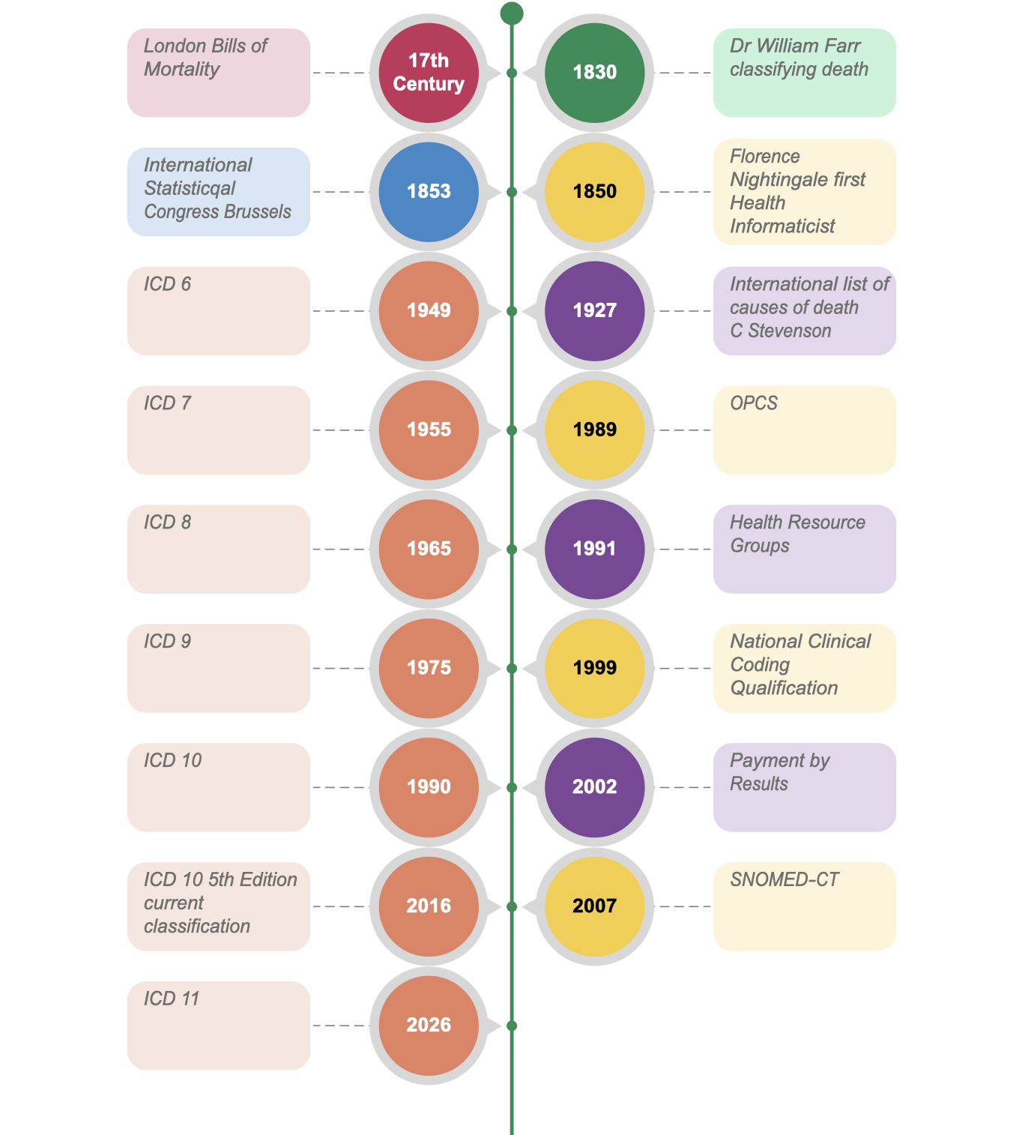
Figure 43 Timeline

Countries using ICD classification [38]

Country
Australia
Brazil
Canada
Czech Republic
Denmark
Estonia
France
Germany
Hungary
Korea
Netherlands
Russia
South Africa
Sweden
Thailand
United States
Table 6 Countries using ICD-10 classification

Local Policy
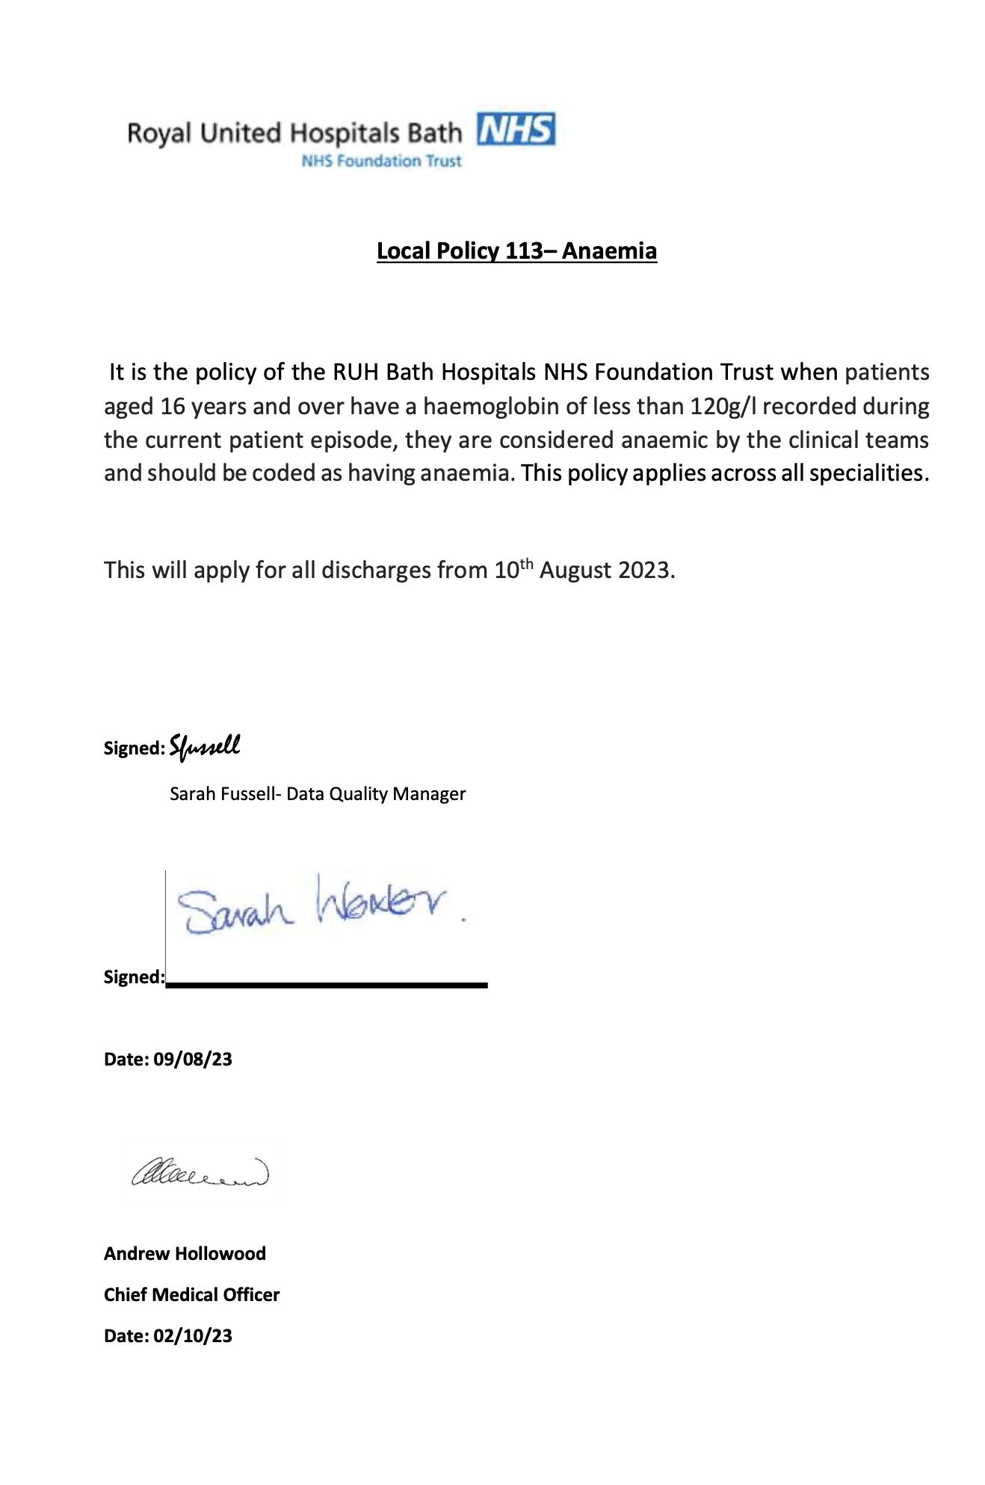
Figure 44 Local policy anaemia

Questionnaire

Questionnaire link

https://forms.office.com/e/dyy4QpH6xK
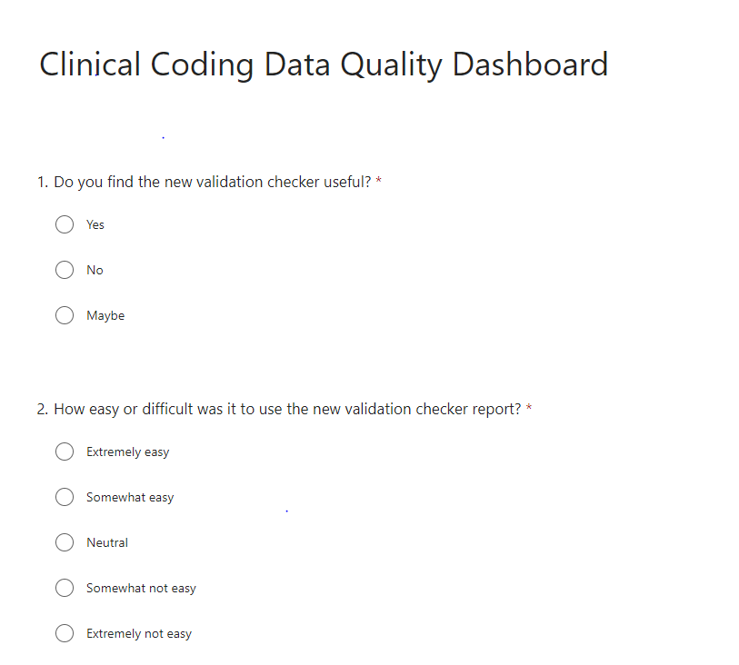

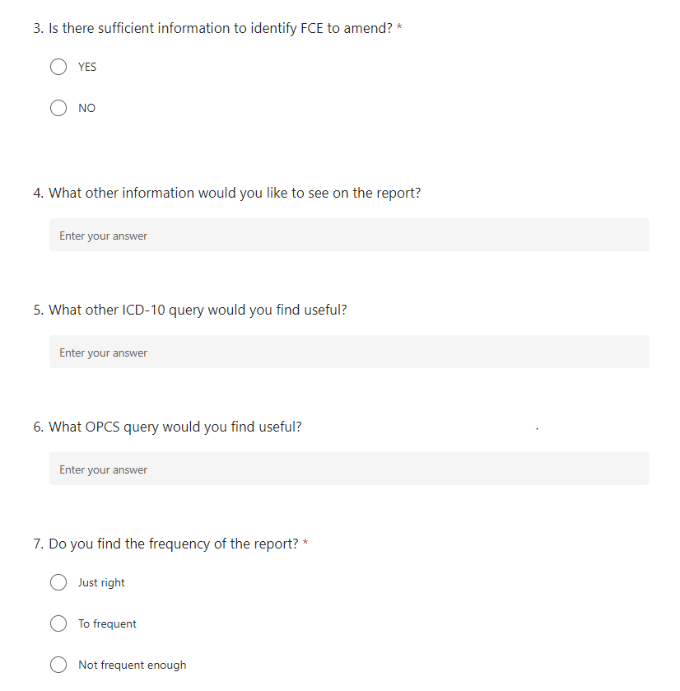


Questionnaire results
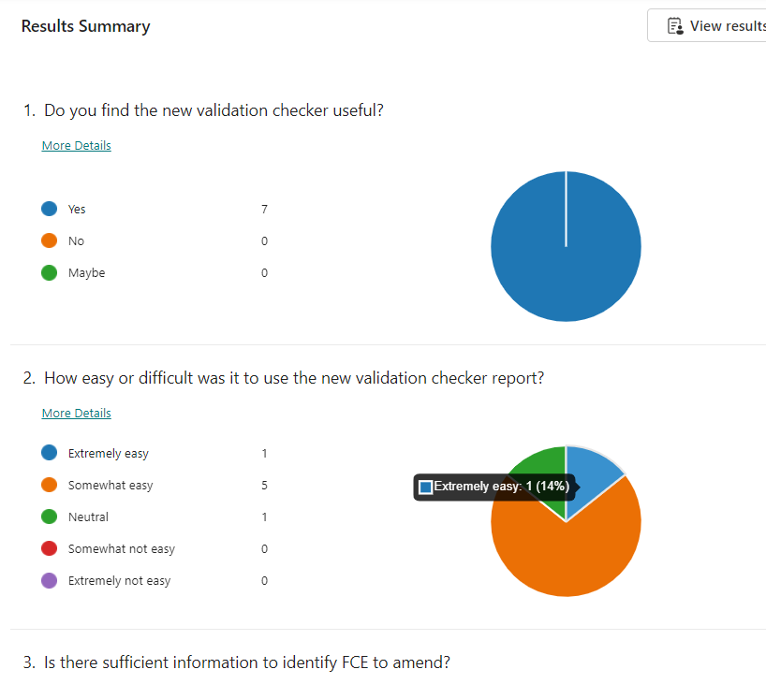
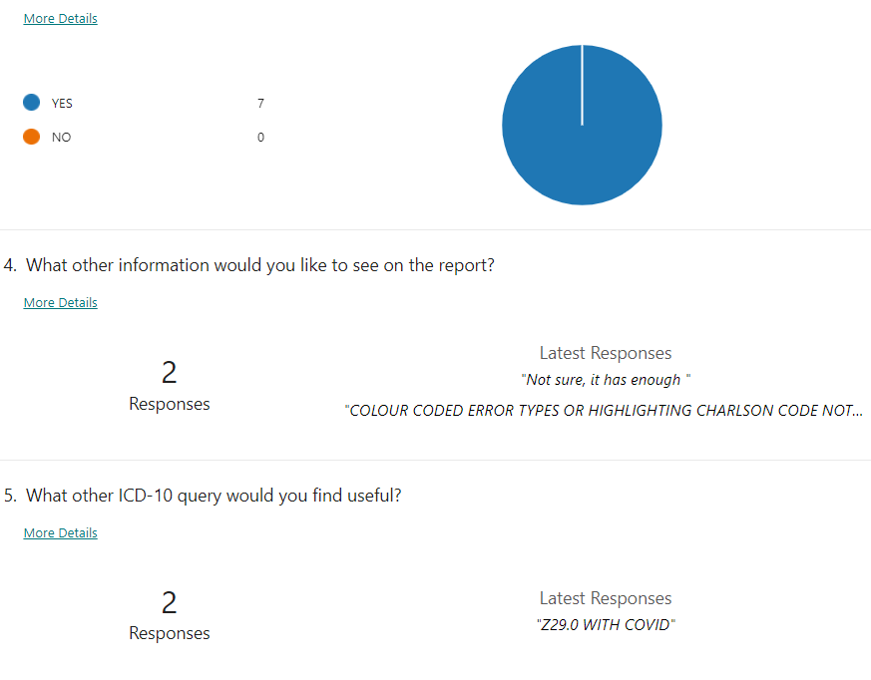
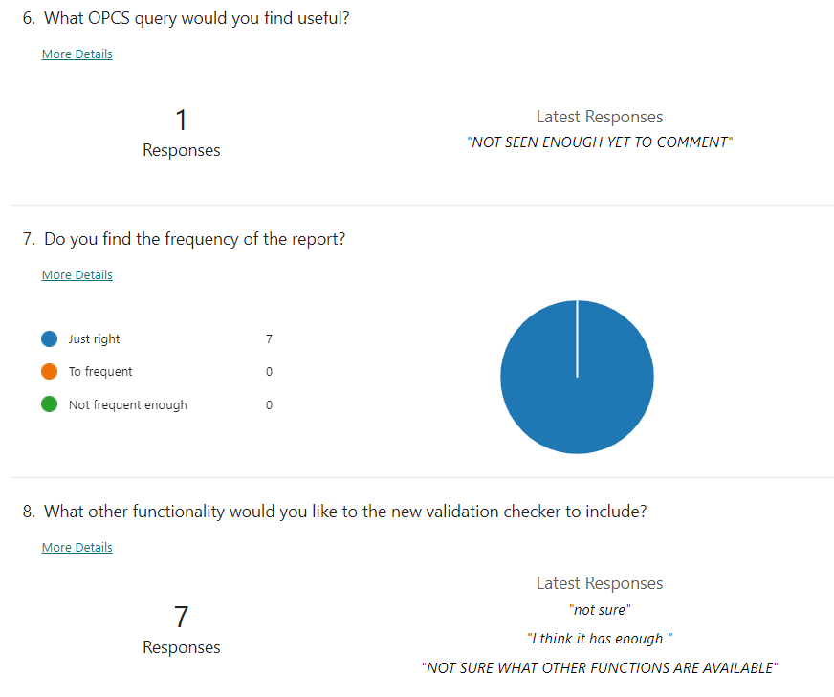
Figure 45 Questionnaire results

System usability scale form
https://forms.office.com/e/HXzNEk4dki
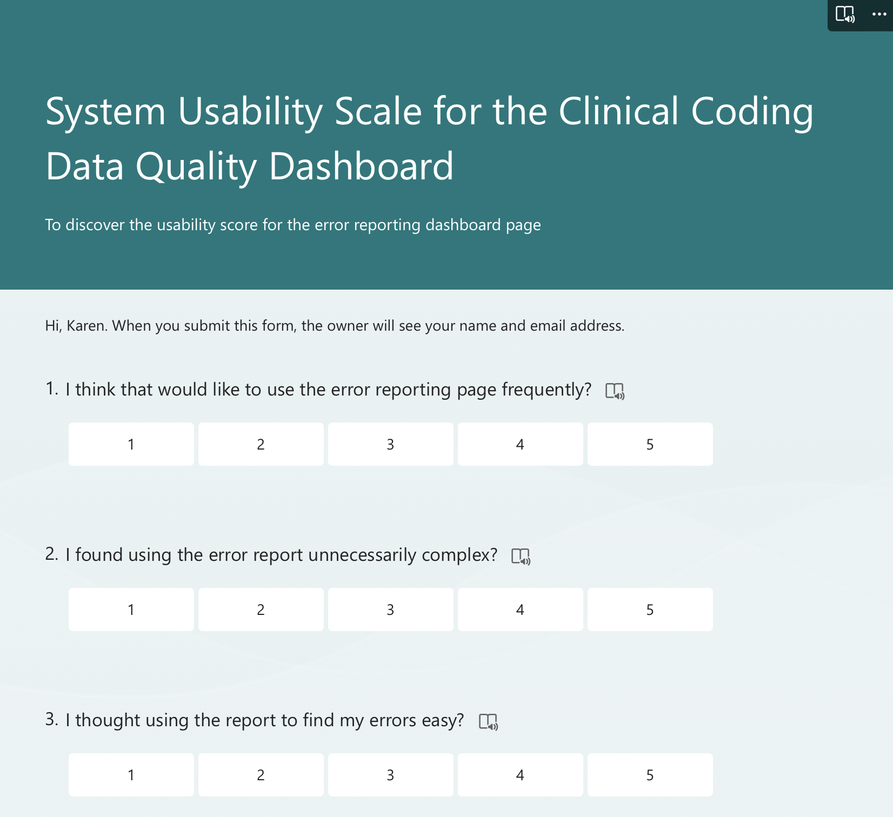

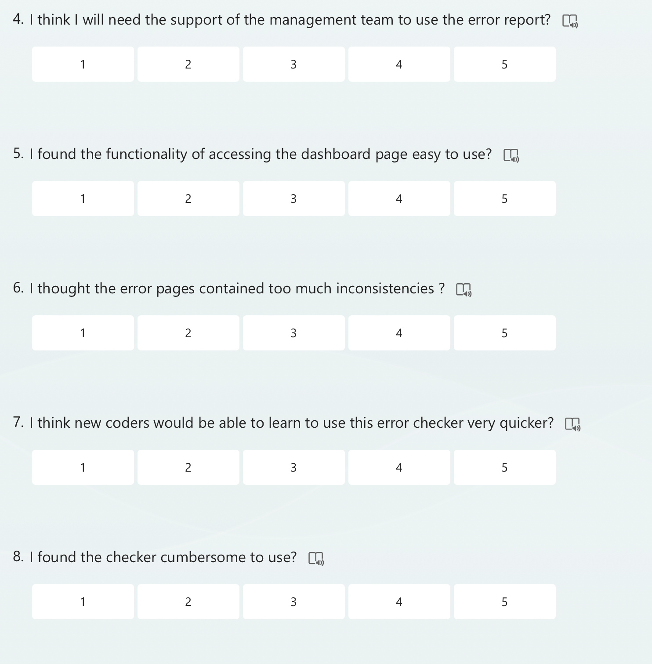
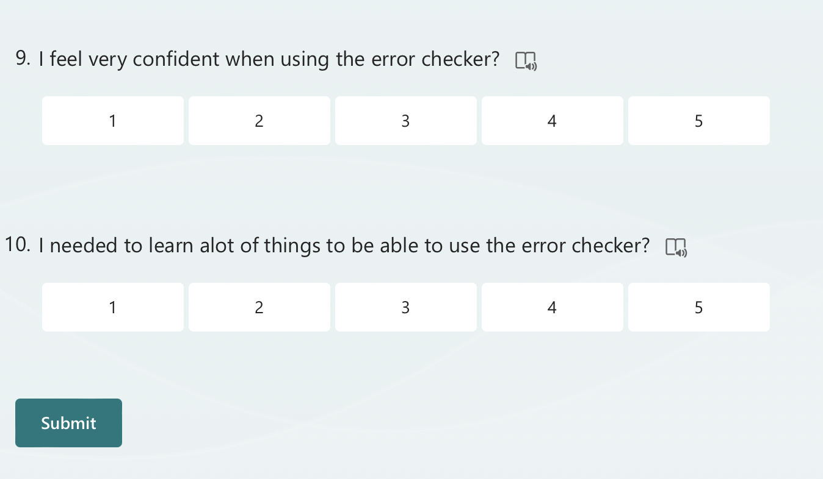
Figure 46 System usability scale form

Results of SUS
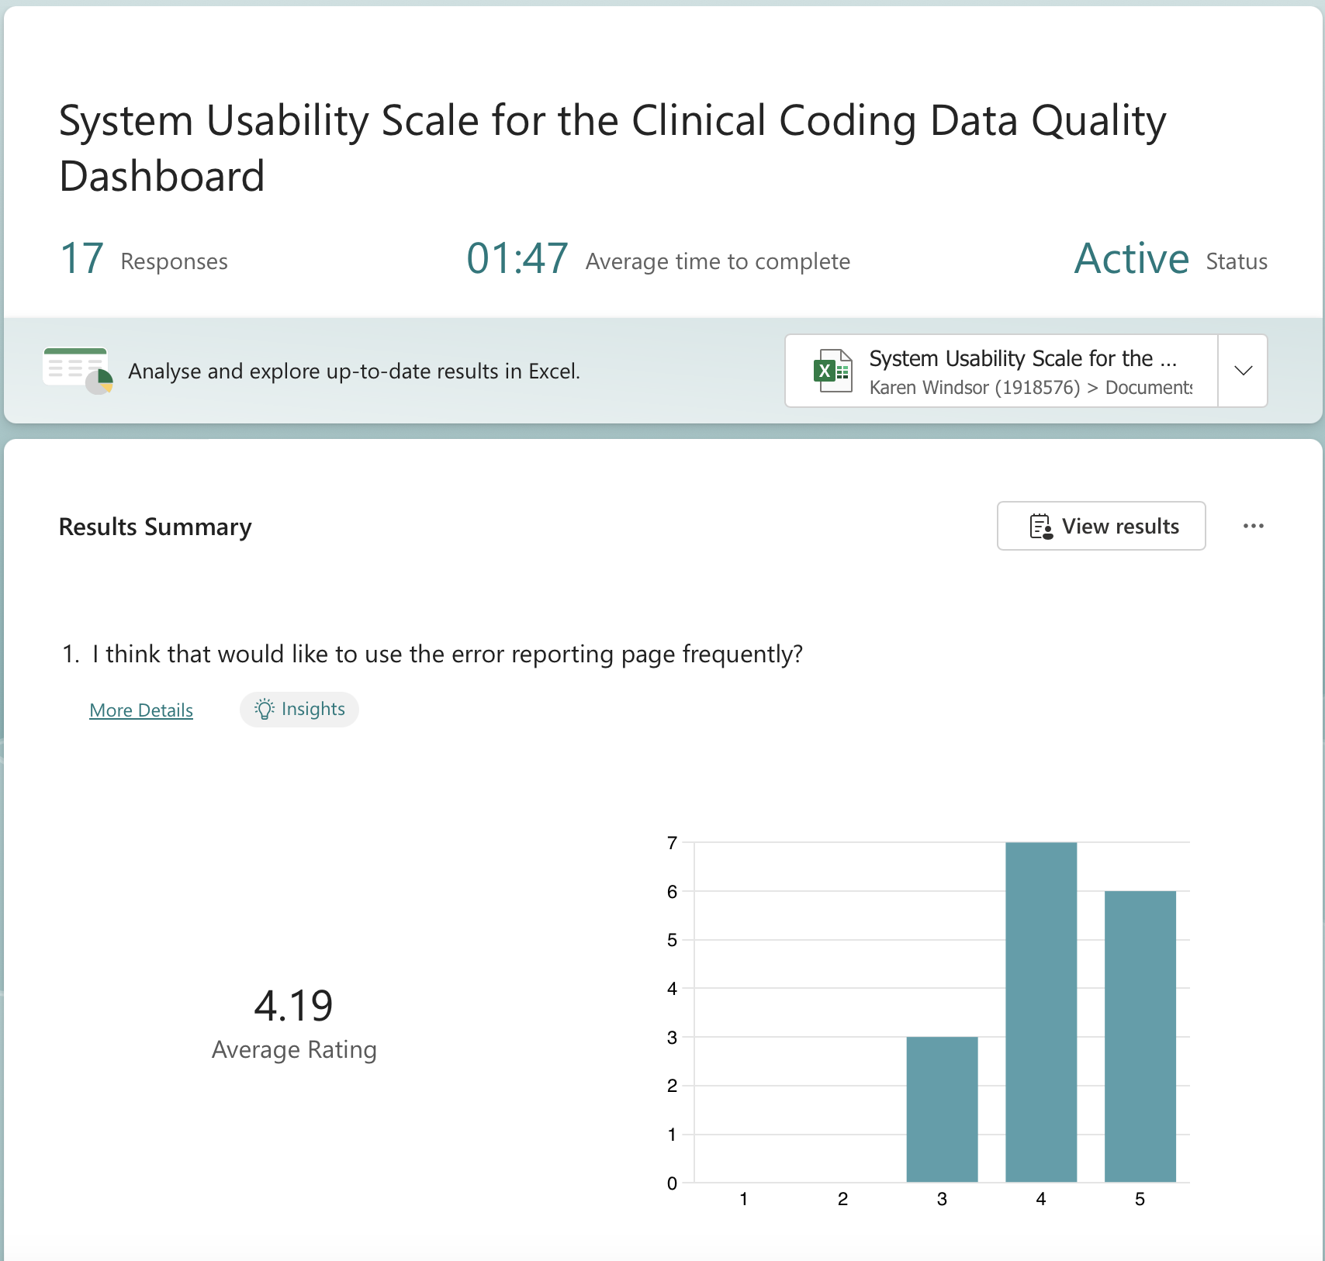

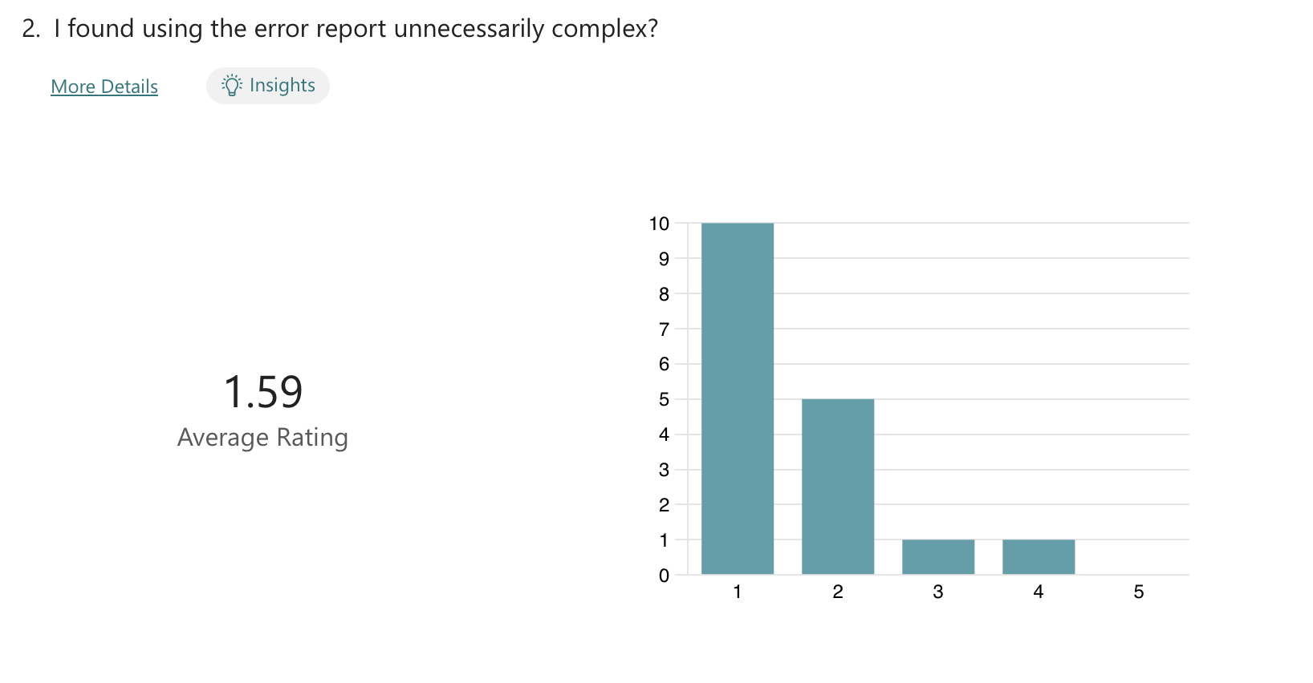
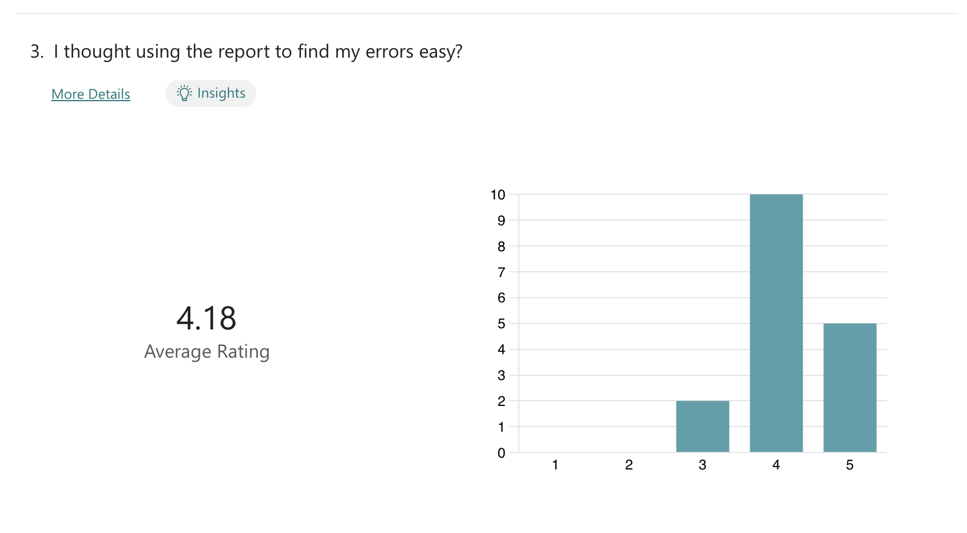

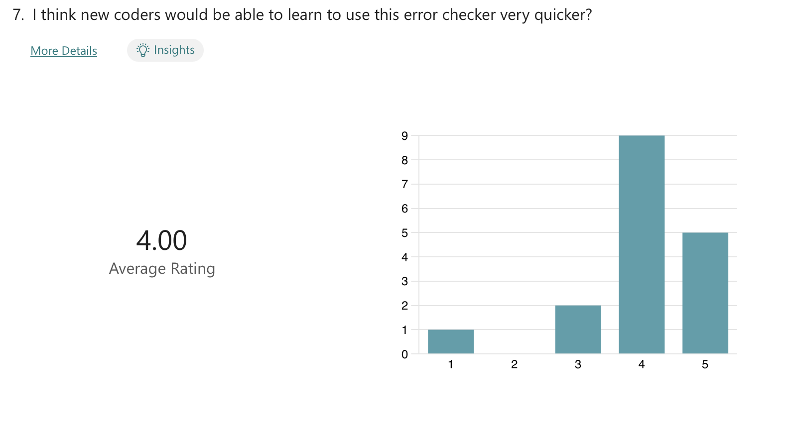
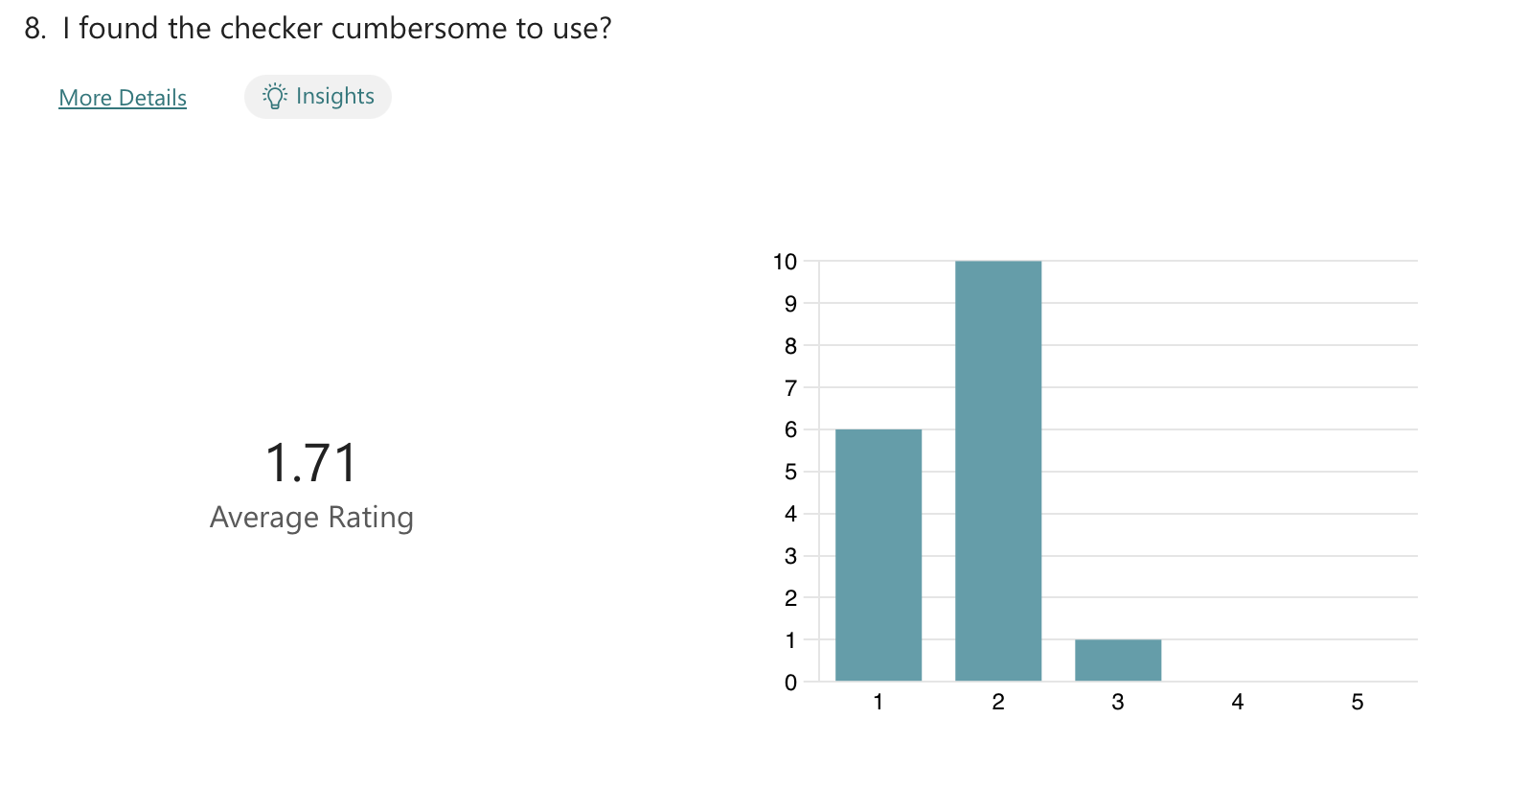

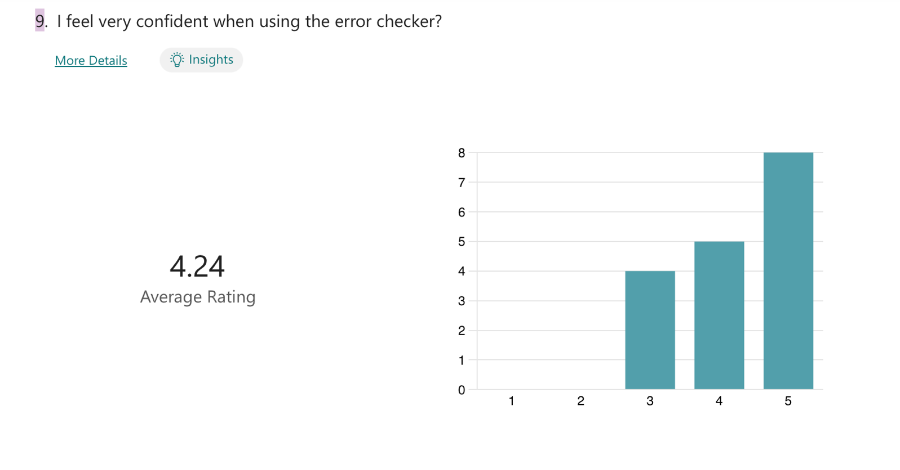
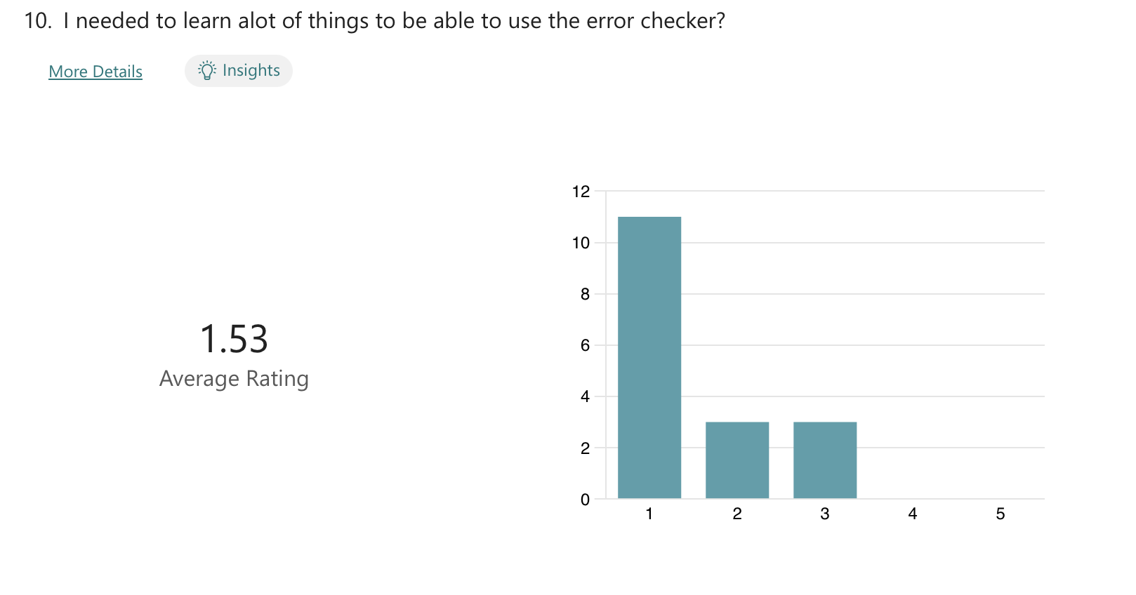
Figure 47 Results from SUS

Charlson Comorbidity Index
Condition No. | Condition Name | New Coding | New Weight | Old Weight
1 | Acute myocardial infarction | I21, I22, I23, I252, I258 | 5 | 1
2 | Cerebral vascular accident | G450, G451, G452, G454, G458, G459, G46, I60-I69 | 11 | 1
3 | Congestive heart failure | I50 | 13 | 1
4 | Connective tissue disorder | M05, M060, M063, M069, M32, M332, M34, M353 | 4 | 1
5 | Dementia | F00, F01, F02, F03, F051 | 14 | 1
6 | Diabetes | E101, E105, E106, E108, E109, E111, E115, E116, E118, E119, E131, E135, E136, E138, E139, E141, E145, E146, E148, E149 | 3 | 1
7 | Liver disease | K702, K703, K717, K73, K74 | 8 | 1
8 | Peptic ulcer | K25, K26, K27, K28 | 9 | 1
9 | Peripheral vascular disease | I71, I739, I790, R02, Z958, Z959 | 6 | 1
10 | Pulmonary disease | J40-J47, J60-J67 | 4 | 1
11 | Cancer | C00-C76, C80-C97 | 8 | 2
12 | Diabetes complications | E102, E103, E104, E107, E112, E113, E114, E117, E132, E133, E134, E137, E142, E143, E144, E147 | -1 | 2
13 | Paraplegia | G041, G81, G820, G821, G822 | 1 | 2
14 | Renal disease | I12, I13, N01, N03, N052-N056, N072-N074, N18, N19, N25 | 10 | 2
15 | Metastatic cancer | C77, C78, C79 | 14 | 3
16 | Severe liver disease | K721, K729, K766, K767 | 18 | 3
17 | HIV | B20, B21, B22, B23, B24 | 2 | 6
Table 7 Charlson Comorbidity Index

Elixhauser Co-morbidity Scores
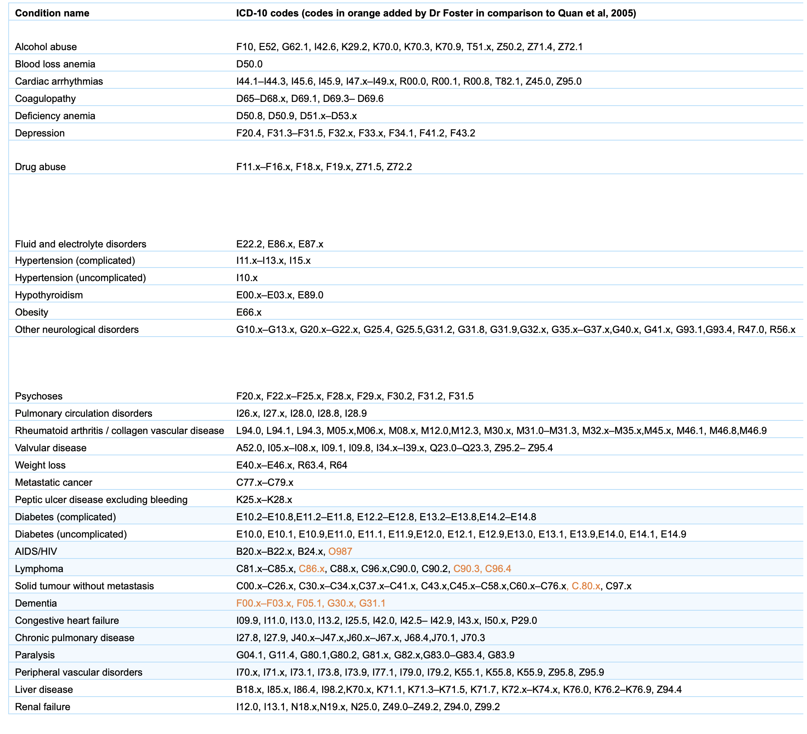
Table 8 Elixhauser Index

Example of TEMs
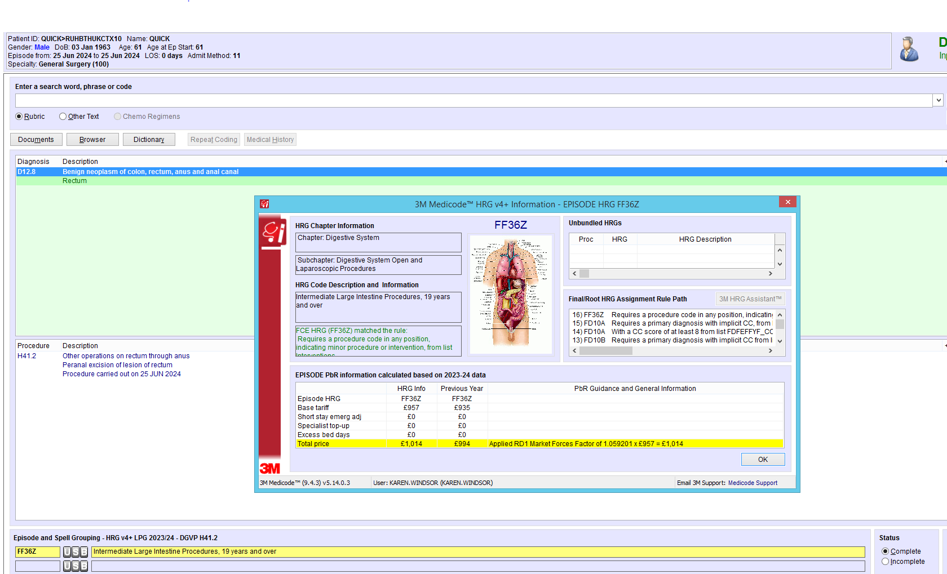
Figure 48 With Y76.3
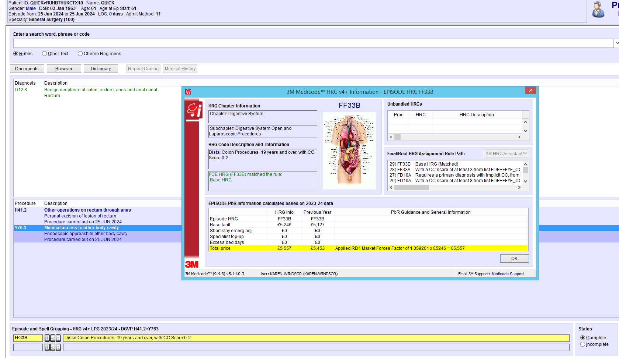
Figure 49 With Y76.3

List of original checks

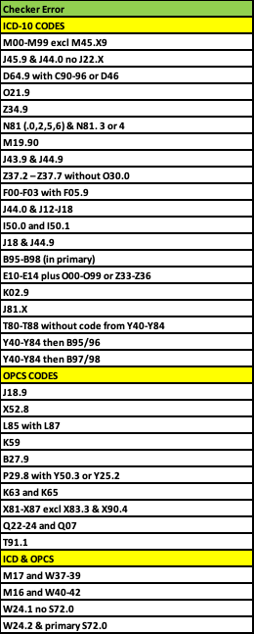
Figure 50 Original checks

Data set
Data Element | Description | Rationale
ProviderSpellNo | Unique system number for patient admission | FCE Identifier
MRN | Medical record number | FCE Identifier
Birthdate | Date of birth | To identify neonatal birth episodes
AdmissionDtTm | Date of admission | Month of FCE Identifier
Discharge DtTm | Date of discharge | Month of FCE Identifier
AgeonAdmission | Age of patient at the time of admission | Need for age-related local policies
EpisodeNo | The FCE number within the admission | To identify which FCE within an admission needs to be amended and some standards only apply to the first FCE within an admission
Specialty | Which specialty the patient has been admitted under | Some ICD/OPCS codes are specialty-specific
TreatmentFuntion | Treatment function codes | To identify sub-specialties
ConsultantCode | The NHS registration code for consultants | To ensure the FCE is under the correct consultant
EpisodeStartWard | Ward patient is first admitted to | To ensure elective/emergency admissions are admitted to the correct ward
DischargeWard | Ward where the patient is discharged | To check discharge ward is correct
DischargeDestinate | Where the patient has been discharged to | This code can identify RIP patients
EpisodeStartDtTm | Date of start of FCE | Month of FCE Identifier
EpisodeEndDtTm | Date of end of FCE | Month of FCE Identifier
DateCoded | When the primary diagnosis was coded | To analyse the time between discharge and code assignment
CodedBy | Each coder has a unique number | To identify who coded the episode
HRGCodeAcrossEpisode | HRG for FCE | To analyse the effect of amending the code on the HRG of the FCE
HRGCodeAcrossSpell | HRG for the admission | To analyse the effect of amending the code on the HRG over the entire admission
DiagnosisConCat | Concatenation of all the diagnosis codes assigned to the FCE | Useful for queries that look for 2 codes assigned together or not assigned together
Diagnosis1 to Diagnosis51 | All diagnoses that have been assigned in the FCE | To perform all the queries that are not possible just using the DiagnosisConCat data element
ProcedureConCat | Concatenation of all the procedure codes assigned to the FCE | Useful for queries that look for 2 codes assigned together or not assigned together
Procedure1 to Procedure51 | All procedures that have been assigned in the FCE | To perform all the queries that are not possible just using the ProcedureConCat data element
Table 9 Data set

Index trail for calculus of kidney and ureter
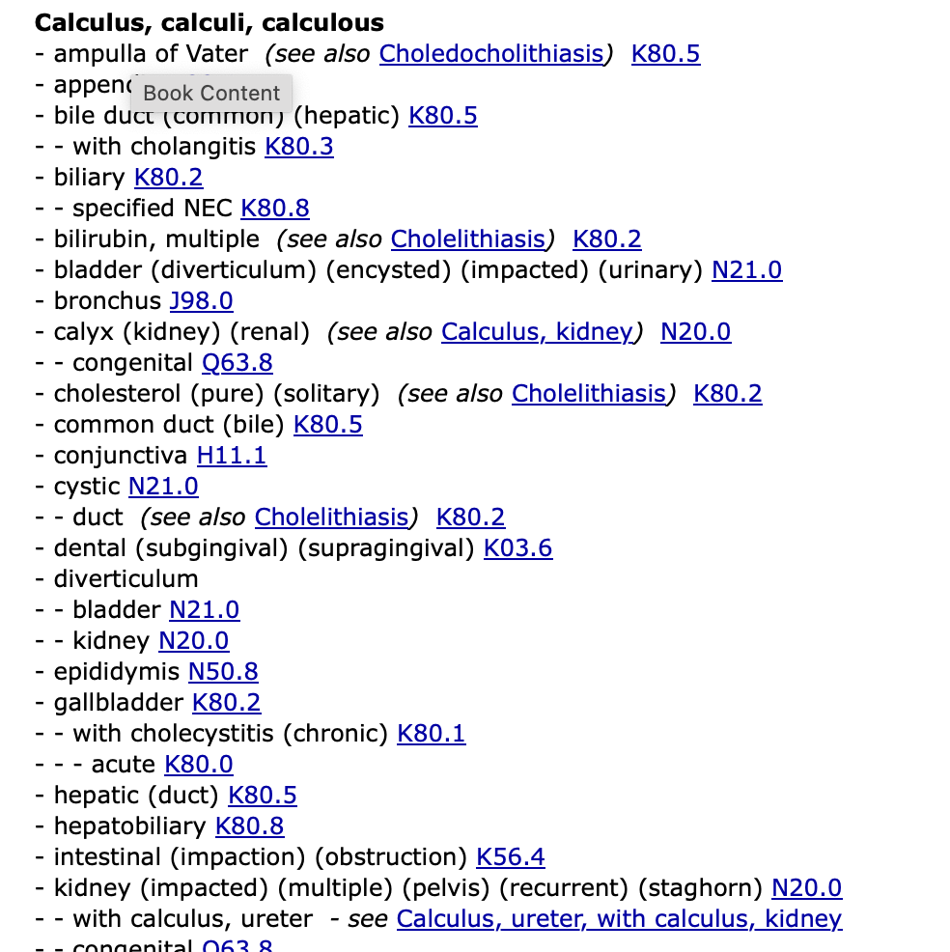

Figure 51 Calculus of kidney and ureter index trail [69]

Local Policy 27
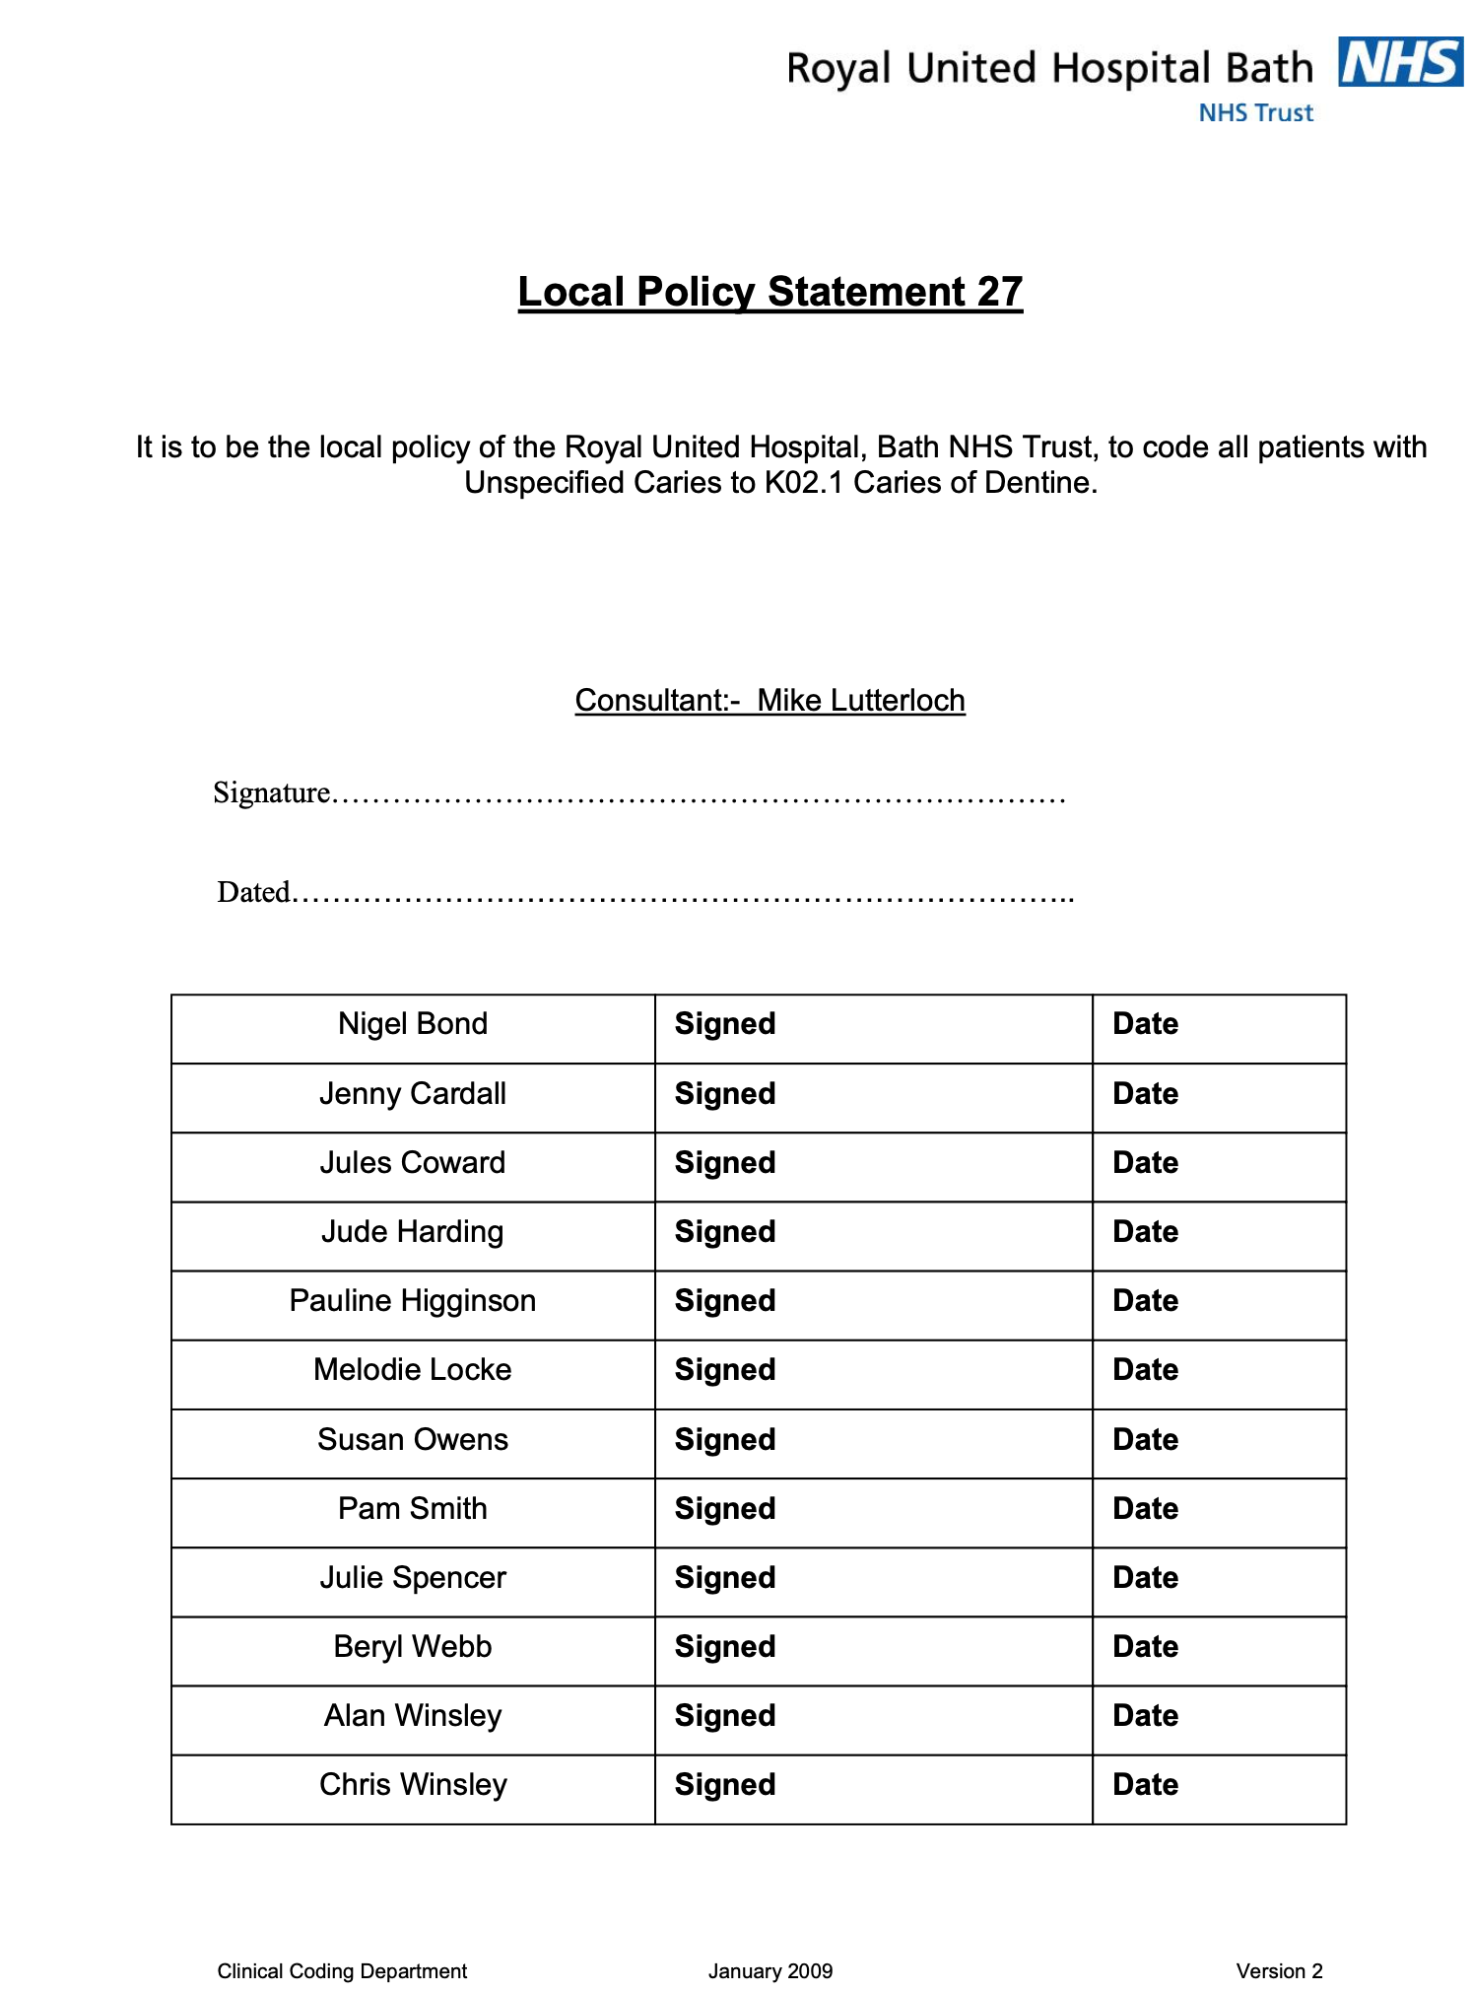
Figure 52 Local Policy 27

Queries

Error Number | Description | Specialty | Standard | Amendments
1 | I500 should not be coded with I501 | Cardiology | DCS.IX.10 Heart Failure
2 | J449 with respiratory infections, J22, J12-J18 and J69 | Respiratory | DCS.X.5 COAD/COPD
3 | N200 with N201 | Urology | Four-step coding process
4 | D64 (anaemia) assigned with a code from between C90 and C95 and D46 Myelodysplasia | Oncology | DchS.II.2 Anaemia in Neoplastic Disease
5 | J440 coded with J22X | Respiratory | DCS.X.5 COAD/COPD
6 | J449 with J439 | Respiratory | DCS.X.5 COAD/COPD
7 | J96 without 5th Character | Respiratory | Four-step coding process
8 | Elective without procedure and no Z53 - needs tweaking | ADHOC | DCS.XXI.11 Cancelled procedures and abandoned procedures
9 | Gastritis coded with Duodenitits | Digestive | Four-step coding process
10 | S06 with no 5th Character | Injury | Four-step coding process
11 | F050 or F059 coded with F01, F02, F03 | Mental Health | Four-step coding process
12 | F051 coded with F03X | Mental Health | Four-step coding process
13 | Blindness with Fugax | Neurology | DCS.VI.2: Amaurosis fugax (G45.3)
14 | Multiple codes in F10 to F16 and F18 | Mental Health | DCS.V.8: Mental and behavioural disorders due to multiple drug use and use of other psychoactive substances
15 | Mets without a primary | Oncology | DCS.II.1: Primary and secondary malignant neoplasms (C00-C97)
16 | C97X is in the primary position when Cancer, not the main condition treated | Oncology | DCS.II.4: Multiple independent primary malignant neoplasms (C97.X)
17 | E10 coded with either E11 or E14 | Endocrinology | Four-step coding process
18 | P599 coded with prematurity codes P072 and P073 | Neonatal | Four-step coding process
19 | R51X headache followed by Y40 - Y59 due adverse effects in theraputic use G444 | Neurology | Four-step coding process
20 | B95-B98 in primary | Infectious | DCS.I.4:Bacterial, viral and other infectious agents (B95-B98)
21 | K029 assigned | Digestive | Local Policy Caries
22 | E10-E14 coded in Obstetrics FCE | Obstetrics | DCS.XV.9: Diabetes mellitus in pregnancy (O24)
23 | T80-T88 without Y40-Y84 | Complications | DCS.XIX.7: Postprocedural complications and disorders
24 | M codes with 5th character 9 | Musculoskeletal | DchS.XIII.1: Fifth character in Chapter XIII
25 | O211 not coded with E86 E87 | Obstetrics | Four-step coding process
26 | Z349 and O219 coded | Obstetrics | Local Policy | after consultation agreed to drop O219 as now being coded correctly
27 | M1990 coded | Musculoskeletal | DCS.XIII.2: Arthrosis (M15-M19)
28 | N810 N812 N815 N816 coded with N813 N184 | Renal | Local policy
29 | Z372 - Z737 without O30 | Obstetrics | DCS.XV.14: Multiple gestation
30 | N993 without Y83 | Gynae | DCS.XIX.7: Postprocedural complications and disorders
31 | J81X with circulatory codes | Circulatory | DCS.IX.10 Heart Failure
32 | RIP with 2nd FCE as a symptom | RIP | HRG grouper
33 | F03 with F01 F02 F00 | Mental Health | Four-step coding process
34 | Atherosclerosis I70 without 5th character | Circulatory | DCS.IX.14 Atherosclerosis
35 | fifth character in chapter XIX | Musculoskeletal | DChS.XIX.2 Fifth characters in Chapter XIX
36 | K219 with K20 | Digestive | Four-step coding process
37 | Giant cell M136 with M353 should be M315 | Musculoskeletal | Four-step coding process
38 | Multiple haemorrhoid degree codes | Digestive | Four-step coding process
39 | Infected pressure ulcers | Infectious | DCS.XII.3 Pressure ulcers and leg ulcers with associated infections
40 | gestation age coded before gestation weight prems | Neonatal | DCS.XVI.2 Disorders related to the length of gestation and fetal growth
41 | Z515 and Z518 not in first 12th positions | Z codes | LP
42 | K70 or K74 coded with I85 | Digestive | LP
43 | Z34 patients above 40 | Obstetrics | LP
44 | Obesity in pregnancy | Obstetrics | LP
45 | Epilepsy in pregnancy | Obstetrics | LP
46 | P00 - P04 should not be coded in primary | Neonatal | DCS.XVI.1 Fetus and newborn affected by maternal factors and by complications of pregnancy labour and delivery
47 | O80 - O84 with other O chapter codes | Obstetrics | DCS.XV.28 Delivery O80 - O84
48 | J10 J11 with pneumonia | Respiratory | Four-step coding process
49 | Z33X in primary | Obstetrics | DCS.XV.33 Pregnancy state
50 | P95X coded | Neonatal | DSC.XVI.7 Stillbirths
51 | Sickle cell trait | Haematology | DCS.III.1 Sickle cell trait with thalassaemia or sickle cell anaemia
52 | M16 coded with M17 | Musculoskeletal | Four-step coding process
53 | O70 coded to the highest | Obstetrics | Four-step coding process
54 | Severe sepsis | Infectious | DChS.I.1 Sepsis septic shock severe sepsis and neutropenic sepsis
55 | Thrush in pregnancy | Obstetrics | Four-step coding process
56 | Y40-Y84 sequenced before B95-98 | Infectious | DChS.I.1 Sepsis septic shock severe sepsis and neutropenic sepsis
57 | J22X coded with J449 without J459 or J46X | Respiratory | DCS.X.5: COAD/COPD, chest infection and asthma with associated conditions
58 | J440 incorrectly sequenced with pneumonia J12 - J18 | Respiratory | DCS.X.5: COAD/COPD, chest infection and asthma with associated conditions
59 | E10 - E14 coded with any code from O10 - O99 | Obstetrics | Four-step coding process
60 | E10 - E14 with Z33 - Z36 | Obstetrics | Four-step coding process
61 | T821 without Z950 | Cardiology | Appendix 1: Co-morbidities list
62 | Z380 not in either 1st or 2nd diagnosis position | Neonatal | DChS.XVI.1: Liveborn infants according to place of birth (Z38)
63 | K521 without cause code | Digestive | Four-step coding process
64 | non-toxic diarrhoea with cause code | Digestive | Four-step coding process
65 | Endoscopic diagnostic exam of kidney M11 coded with therapeutic M07 M09 M10 | Urology | PGCS2: Diagnostic versus therapeutic procedures

Table 10 Current ICD-10 queries
Error Number | Description | Specialty | Standard
1 | H412 should be followed by Y763 TEMS | Digestive | Four-step coding process
2 | Z450 coded as primary for PPM exchange | Cardiac | DCS.XXI.5: Persons encountering health services in circumstances related to reproduction and for specific procedures and healthcare (Z30-Z54)
3 | Z452 coded as primary | Vascular | DCS.XXI.5: Persons encountering health services in circumstances related to reproduction and for specific procedures and healthcare (Z30-Z54)
4 | R158 instead of R152 | Obstetrics | Cooke balloon - LP
5 | K603 and K613 renewal | Cardiac | PCSK10:Renewal of pacemaker battery/generator K73 K74
6 | J382 without stent code | Digestive | Local Policy
7 | J189 | Digestive | Local Policy
8 | K73 and K74 without Y534 | Cardiac | Local Policy
9 | X528 | Respiratory | Local Policy
10 | L85 with L87 | Vascular | Four-step coding process
11 | B279 | Infectious | Local Policy
12 | P298 followed by Y503 or Y255 | Neonatal | Local Policy
13 | L882 should be followed by Y532 | Vascular | Local Policy
14 | All cardiac stents in RUH are DES | Cardiac | Local Policy
15 | All pulmonary angiograms were done under Y534 | Vascular | Local Policy
16 | CTPA without contrast | Scans | Local Policy
17 | bipolar tonsillectomy without Y102 | ENT | Local Policy
18 | transperineal biopsy of prostate M702 Y532 | Digestive | Local Policy
19 | Therapeutic kidney/ureteric calculus procedure without Y534 | Urology | Local Policy
20 | High-cost drugs | Misc Operations | PCSX24 High Cost Drugs
21 | T911 Biopsy sentinel node | Misc Operations | PCST3: Sampling, excision, biopsy or drainage of sentinel lymph node
22 | K63 with K65 | Cardiac | PCSK8: Angiocardiography (ventriculography) of the heart and coronary arteriography K63
23 | Q22-Q24 before Q07 | Gynae | Four-step coding process
24 | K512 and L726 | Vascular | PGCS2: Diagnostic versus therapeutic procedures
25 | B27/B28 directly followed by T85/T87 | Breast | Four-step coding process
26 | H23 H25 flexi sigmoidoscopy should not be coded as per guidance from endoscopy | Digestive
Table 11 OPCS-4 queries
Error Number | Description | Specialty | Standard
1 | Z53 diag procedure not performed with any procedure | Z code | Four-step coding process
2 | R33X retention without M479 catheterisation | Urology | PCSM6: Catheterisation of the bladder (M47)
3 | W37-W39 coded with M17 as the primary diag | Musculoskeletal | Four-step coding process
4 | W40 - W42 coded with M16 as primary diag | Musculoskeletal | Four-step coding process
5 | W241 without S720 | Musculoskeletal | Four-step coding process
6 | check for HRG HN97Z | HRG | Finance
7 | W242 with S720 | Musculoskeletal | Four-step coding process
8 | Renewal of pacemaker without Z950 | Cardiology | Appendix 1: Co-morbidities list
9 | ICD10 O349 maternal care for previous CS with OPCS R249 | Obstetrics | Four-step coding process
10 | OPCS drainage of breast lesion without either N61X or O911 | Breast | Four-step coding process
Table 12 Combined queries

Mind map
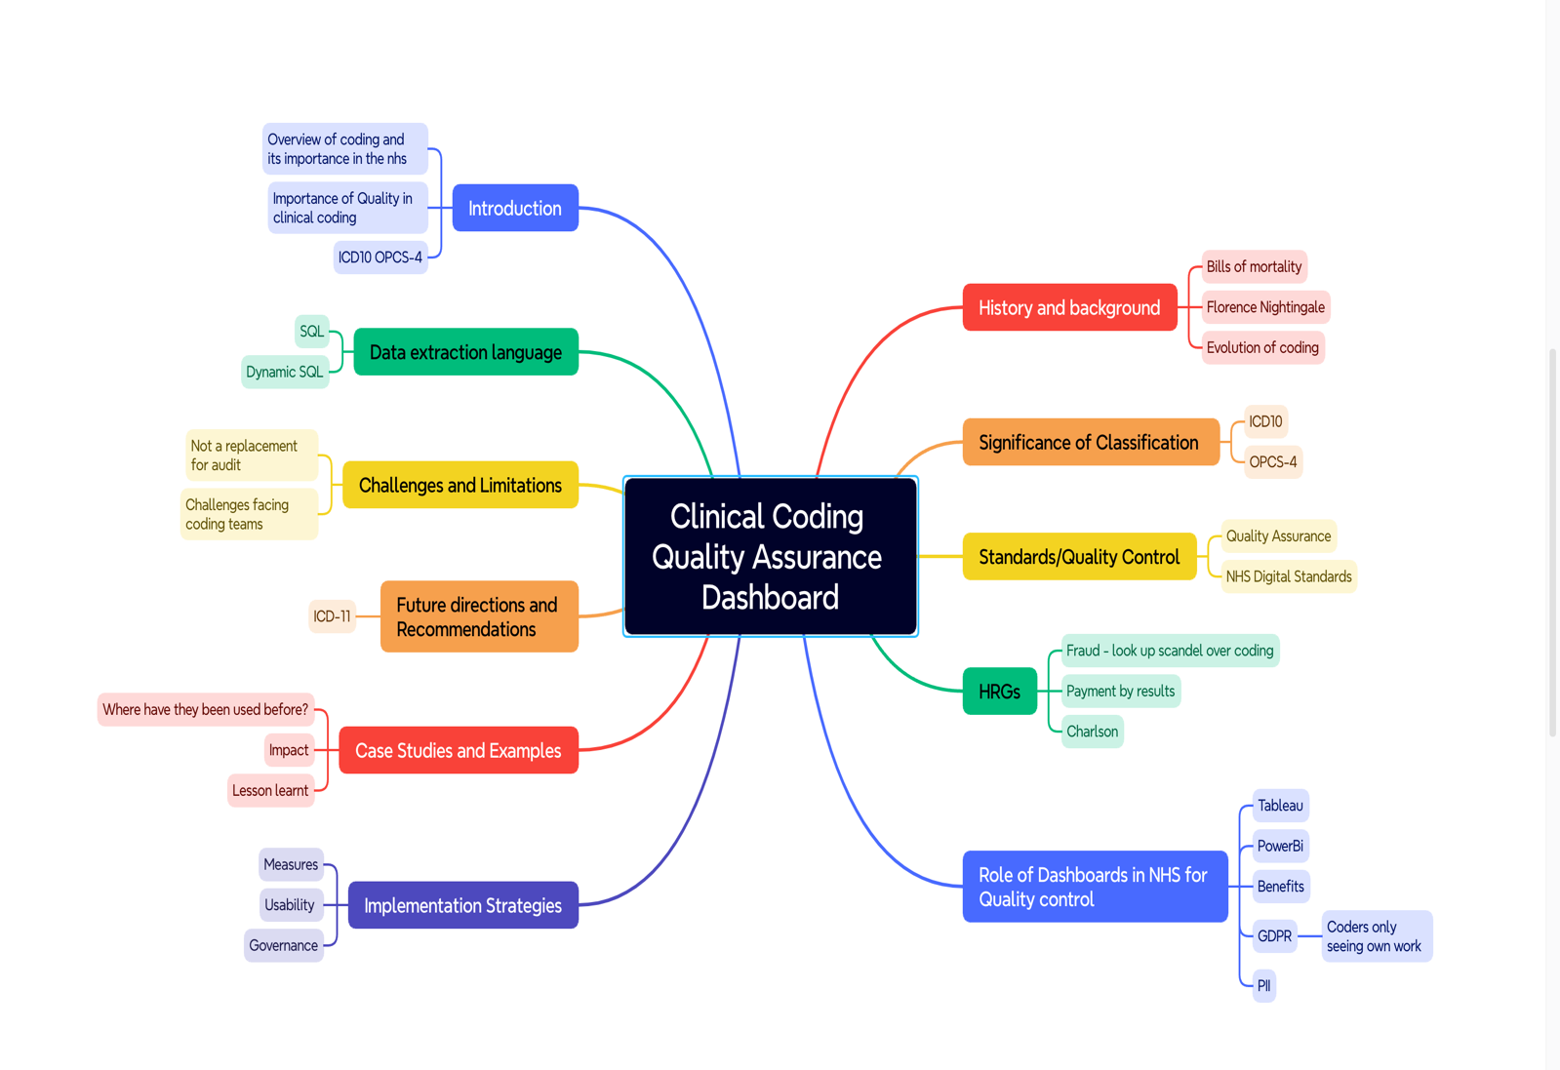
Figure 53 Mind map

