
Skills for the Workplace
Assessment-2
Date of Submission: 27/08/2018
Student Name: | Aktar Hussain
Student Number: | 1710628
Module No: | BMSK4003
Module Title: | Digital Skills and Research Methods

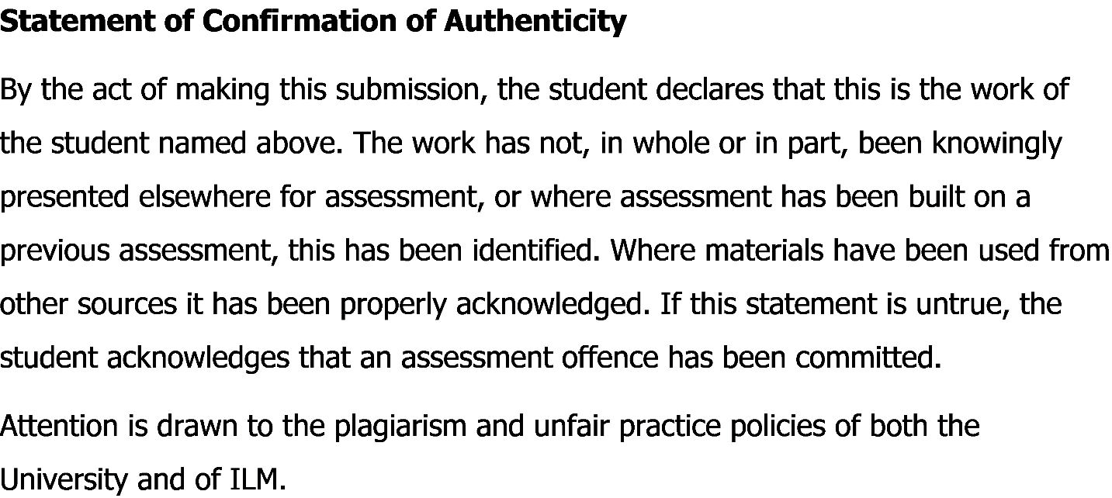

Abstract
Effectiveness and efficiency in the workplace are essential elements for any organizations. To measure effectiveness and efficiency in the organizational workplace, digitalization has already influenced and plays a vital role in terms of globalization, business expansion and various internal and external reasons now a days. Understanding and measuring the effectiveness and efficiency of digitalization in the workplace is dependent on skilled employees, digitalization and its practices in workplace etc. For measuring the effectiveness and efficiency of digitalization in the workplace, both primary and secondary data will be used for the accurate result and hypotheses. Various factors like internet, cloud storage system, social media influence, e-communication among employees in the management, web based email etc. are the driving forces for analyzing and measuring the effectiveness and efficiency of digital skills in the workplace among employees. Apart from this, some macro environmental factors will also be analyzed for findings and research methodology to get the best possible feedback about digitalization and its importance. So, a small research will be implemented among some respondents with a quantitative data analysis method, a questionnaire will be given about digital skills, its importance in the organizational workplace. Data and other findings will be analyzed by Microsoft Excel. In fine, the research will show the overall measurement and understanding the effectiveness and efficiency of digital skills in the workplace.

Contents
Abstract 2
Introduction: 4
Literature Review: 5
Research Methodology: 6
Introduction: 6
Data Structure: 6
Sample Size: 7
Research Questionnaire: 7
Demographic Part: 7
Question Part: 7
Data Collection: 8
Primary Data: 8
Secondary Data: 8
Findings: 8
Demographic Part: 9
Research Part: 10
Interpretation of Q1: 10
Interpretation of Q2: 11
Interpretation of Q3: 12
Interpretation of Q4: 13
Recommendation: 14
Limitations of the Study: 6
Conclusion: 15
References: 15

Introduction:
The aim and main purpose of this report is to analyze and measure the effectiveness and efficiency of digital skills among employee in the workplace environment. For globalization and extreme competitive situation, organizations are implementing various technological strategies and tactics which can give a positive result and organizational performance. In workplace, employees are being faced with various digital things like web based email, internet and cloud storage system for better and smooth communication with clients to make a better customer relationship. As communication is a key now a days, digitalization effects a lot organizations for smooth business operation. Employee need to have various digital skills like networking skills, communication through web, video conferencing etc. for completing their task in a shortest period of time and to achieve the organizational goals and objectives. Measuring effectiveness and efficiency through digitalization in the workplace is complicated and so a small research will help to get the real fact about digitalization and employee skills with their satisfaction and how those accumulate with organizational behavior and performance. The main problem is the effectiveness and efficiency of digitalization for organizations and employees as skilled employees are needed. So, the research topic will be “Measuring Effectiveness and Efficiency of Digital Skills in the Workplace”. The main objective of this research is to analyze the process of effective and efficient digitalization and digital skills in the workplace for both management and employees. For the research, a small questionnaire will be given to the respondents and it will be a casual study. For quantitative data analysis, respondents will be given a structured questionnaire to give their feedback about digitalization in the workplace and how digitalization effects the employee satisfaction with effectiveness and efficiency for achieving organizational goals. After that a findings will be analyzed and a recommendation will also be given to accumulate with the organizational performance with digitalization in organizations for present and future preference. This report will be based on a small size of respondents and feedback. So, further research will elaborate and demonstrate the measurement of digitalization and its effectiveness with efficiency in broad way for organizations and employees.

Literature Review:
Organizational effectiveness is interrelated with efficiency of the management, employees, groups, to fulfil organizational goals and objectives (What is Effectiveness?, 2017). According to Stephen P. Robbins, he stated that quality management, process control and various factors are directly dependent on the effectiveness of an organization to sustain the competitive advantage (Stephen P. Robbins, 2012). Efficiency actually refers to the maximum output of resources by given a minimum input (Effeciecny, 2018). According to Vojko Potokan, he stated that organizations need to achieve the effectiveness and efficiency and efficiency is dependent on the operational behavior of organizations and without efficiency, conflicts may arise (Vojko Potokan, 2001). According to Vohra, he stated that organizational performance and behavior is shaped by digitalization for better communication now a days to sustain in the extreme competition (Vohra, 2014). This statement actually reflects the fact about employability, effectiveness and efficiency in the workplace. For achieving organizational gals, management are now trying to be tech oriented and so, digital skills for needed for employees. According to Niina Rintala, stated that digital skills are the driving forces for management and employees to accumulate with the change of business environment (Niina Rintala, 2005). Due to the rapid globalization and competition, organizations are implementing various digitalization and technological strategies which may create a flexibility among employees. According to Keller, he stated that service organizations are mostly dependent on the employee satisfaction which increase effectiveness and efficiency of the service and organizations will achieve its goals and objectives in a strategic way (Keller, 2011). So, employees will be more satisfied and they will get less pressure on their work and working performance will be automatically increased. So, organizations are trying to set a digital workplace which is actually a holistic set and platforms for delivering work in a productive way (Understanding The Digital Workplace, 2017). There are various digital factors that are being found for organizational implementation and employee skilled required. According to John Mancini, he stated that web based email, intranet, extranet, cloud storage and many technical stuffs are important for organizations now a days for better communication and prompt service (John Mancini, 2014). According to Mancini, these are the factors of responsive services and communication with employees and clients to meet the organizational goals in a sustainable way. According to Taylor, he stated that business research and digital skills are interrelated because of the easy source of information, communication and better relationship both internally and externally (Taylor, 2011). According to Hershal, he stated that CRM software and Enterprise Resource planning (ERP) are the most used technological steps for organizations which increases the effectiveness and efficiency or work and employees have flexibility in their day to day activity (Hershal, 2012). So, our research question will be- “How effectiveness and efficiency can be ensured by implementing digital technology in the workplace and how employees can develop themselves with digital skills?” The limitations of the study are lack of time and a small data sample for questionnaire which effected the overall data and findings of the research. Further study and research will improve data and findings more correctly.

Limitations of the Research:
There are some limitations of the research. We have used only 20 sample size. But a big sample size will give the more accurate result. As our time was too short, so we have done on 20 respondents from different organizations for our research.

Research Methodology:

Introduction:
The research will measure the effectiveness and efficiency of digitalization’s and digital skills in the workplace. In the research, a small sample size of 20 will be given our questionnaire regarding effectiveness, efficiency, digital skills etc. This research will be a quantitative research and we will use a casual study here.

Data Structure:
For the research, both primary and secondary data will be used. As this research is based on the responses from respondents, we will do a quantitative data analysis to get hypotheses and outcome.

Sample Size:
Sample size means the population or the size of the respondents. Typical business analyst said that a sample size is some numbers of unit that represents the value and findings of the research (Sample Size, n.d.). In our research, we have used 20 respondents and our sample size is 20. Large sample size will give the accurate result but for the time limit, we have given our questionnaire to 20 employees from different organizations to submit their opinion about effectiveness and efficiency in the workplace.
We use five-likert scale for our research. Likert-scale is given below-
1  Strongly  Disagree | 2  Disagree | 3  Neutral | 4  Agree | 5  Strongly Agree

Research Questionnaire:
We have divided our questionnaire with two parts. One is demographic and another is the main question part. Demographic part consists of the information related to respondents.

Demographic Part:
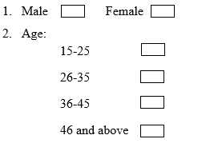

Question Part:
1. Efficiency and effectiveness is important in the workplace. | 1 | 2 | 3 | 4 | 5
2. Digitalization and technological implementation ensure an effective workplace with employee engagement and motivation. | 1 | 2 | 3 | 4 | 5
3. Employee skills and career development for professionals in digital skills are important. | 1 | 2 | 3 | 4 | 5
4. Employees should get a digital training on their initial stage in organizations to be effective and efficient. | 1 | 2 | 3 | 4 | 5

Data Collection:
Data collection is important for a research. We will use both primary and secondary data for our research.

Primary Data:
Primary data are the first-handed data those are new and unique. Primary data aren’t available on internet, social sites or in any other organizations. According to Chen, he stated that business research mostly evaluated by primary data (Chen, 2014). Primary data are mostly dependent on the sample size and the structured questionnaire. As we are going to do a quantitative research, we will do a casual study and our research data is primary data mostly.

Secondary Data:
Secondary data are like those data which sources are available on internet, newspapers and websites. Secondary data used in various research and documentary purposes both for academic and professional working activities. In this research, we will use secondary data base don our sample size and questionnaire. Secondary data are inexpensive and so, we are going to use it for data analysis.

Findings:
I have collected data from both primary and secondary sources. From the structured questionnaire, 20 respondents from various corporate sectors have participated. Employees were given and instructed to give the best possible answers according to the questionnaire. As our research is to measure and understand the effectiveness and efficiency of digital skills in workplace, we have analyzed our respondents based on various organizations and companies. After getting all the questionnaire forms, I put those data on MS Excel to find the quantitative data and interpret them.

Demographic Part:
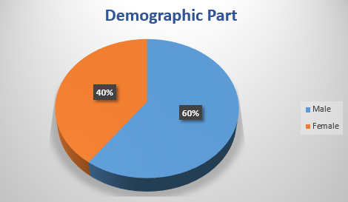
Figure: Demographic Part of the Questionnaire
We have surveyed our questionnaire among 20 respondents. Both male and female have participated in this area and our data is showing that 60% of the respondents were male and 40% were female.

Research Part:
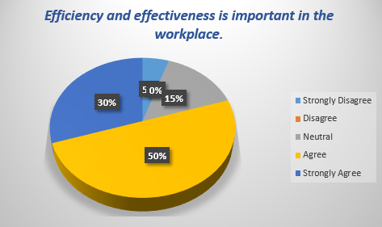
Figure: Pie Char figure of the Question 1 (Efficiency and effectiveness is important in the workplace.)

Interpretation of Q1:
From the given questionnaire, we have four questions. The first question was about the importance of effectiveness and efficiency in the workplace. From the 20 respondents, 50% of the respondents were agreed with the stated statements and they said, web based email, cloud storage system various digital technology have already made their working experience in a positive way and they are getting flexibility of doing work. They also demonstrated that more than 1,000 organizations in UK are operating green strategy where no employees are required to use paper rather than email, intranet and extranet for communication which actually reduces deforestation. Employees are more effective and efficient in the workplace for the flexibility and reduced load of work pressure. So, respondents are positive with the stated statement.
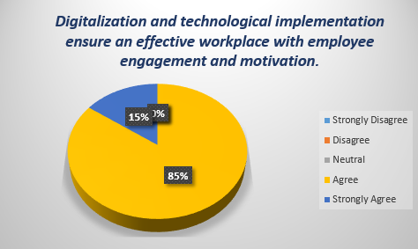
Figure: Pie Char figure of the Question 2 (Digitalization and technological implementation ensure an effective workplace with employee engagement and motivation.)

Interpretation of Q2:
Digitalization and technological implementation ensure the effective workplace with employee engagement and motivation. Respondents are agreed with that statement and from the survey we have found that 85% respondents are agreed and 15% are strongly agreed with the statement. Actually respondents are agreed that employees now a days have various technological skills and knowledge with a rapid use of mobile phone, internet, Tablets and so, they always want a suitable digitalize workplace for them. Digital skills are different and varies from many issue but most of the companies now a days implementing technology and skilled man force is needed. Digital skills and digitalization also has an influence on employee engagement and motivation as employees are now getting the opportunities of giving maximum output in a minimum input which makes them motivated and mutual relationship established. So, respondents are agreed with the statement.
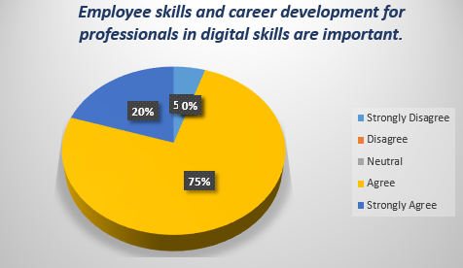
Figure: Pie Char figure of the Question 3 (Employee skills and career development for professionals in digital skills are important.)

Interpretation of Q3:
As above questions already showed us the importance and necessity of digital skills in workplace, so employees need to develop their digital skills for career development. In our survey, about 75% people are agreed with the statement. The most challenging part is, no respondents are disagreed with the statement. So, it showed that digital skills for employees are needed to compete and sustain in the organizational growth with performance now a days.

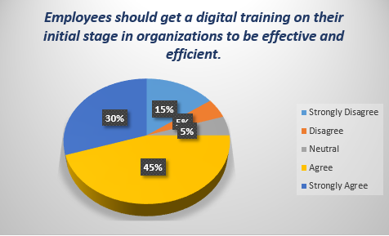
Figure: Pie Char figure of the Question 4 (Employees should get a training on their initial stage in organizations to be effective and efficient.)

Interpretation of Q4:
From the above pie chart, we have seen that 45% respondents of our survey are agreed to the statement that employees should adequate training on digital skills and various technological knowhow to accumulate with the flow of the management and organizational functions. Respondents are also agreed to the fact that training from the initial stage will enable the effectiveness and efficiency of the employees. So, the statement is true and respondents are positively agreed.

Recommendation:
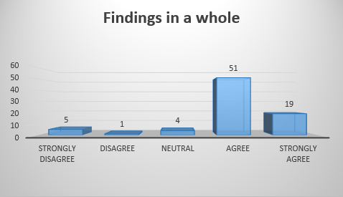
Figure: Findings Analysis
With the questionnaire and respondents, we are seeing from the chart that 51% people are agreed with the statement and they believe organizations will be more effective and efficient if management have skilled employee with digital skills. Respondents also suggested to adopt various training, skill development for employees in organizations. Employees need various soft skills along with hard skills like networking, email processing, data analysis with different tools and many more things. Respondents are also agreed that implementing digital technology will reduce the work burden and pressure among employees. Based on the findings and data interpretation, some recommendation are given below based on responses-
- Organizations should develop a data management center and train all employees about basic networking IT skills.
- Employees should develop themselves with some hard skills like web based email processing, cloud service processing, data analysis to accumulate with the every units and functions of the organizations. This will increase the effectiveness and efficiency of the organization.
- Effectiveness and efficiency should be practices every tier of the management to be digitalized and to achieve organizational goals.
These are some recommendations based on the research outcome and analysis from respondents.

Conclusion:
In fine, the research actually indicates the effectiveness and efficiency of digital skills in the organizations. Employees and management should practice digital methods and implement organizational digitalization for the betterment to achieve goals and objectives. This research reflects some external and internal analysis of digitalization, digital skills for employees in the workplace and the effectiveness with efficiency of digitalization in a broad way.

References:
Chen. (2014). Business Research Methods. An Empirical Study of Research and Evaluation, 45-48. Retrieved August 19, 2018
Effeciecny. (2018). Retrieved August 19, 2018, from Business Dictionary: http://www.businessdictionary.com/definition/efficiency.html
Hershal. (2012). Digitalization in Workplace. An Analysis of Effectiveness and Efficiency, 2, 67-69. Retrieved August 17, 2018
John Mancini. (2014). Factors for Creating an Information Strategy (Vol. 4). Aiim President. Retrieved August 17, 2018, from https://www.aiim.org/pdfdocuments/40480.pdf
Keller. (2011). Services Marketing (13 ed., Vol. 12). NY: Pearson.
Niina Rintala. (2005). Technological Change. An Empirical Study of Digitalization in the Workplace. Retrieved August 17, 2018, from https://pdfs.semanticscholar.org/2210/0eee0ab8e7c403bdd4d3bd32129de3a0b24e.pdf
Sample Size. (n.d.). Retrieved August 19, 2018, from Sage Research Methods: http://methods.sagepub.com/reference/encyclopedia-of-survey-research-methods/n507.xml
Stephen P. Robbins. (2012). Organizational Behavior (12 ed., Vol. 5). Pearson.
Taylor. (2011). Business Research in Organizations. An Analysis of Digital Skills and its Outcome, 5, 91-94.
Understanding The Digital Workplace. (2017, July). Retrieved August 17, 2018, from elcom: https://www.elcomcms.com/resources/blog/digital-workplace-framework
Vohra. (2014). Organizational Behavior (6 ed., Vol. 5). London: Pearson.
Vojko Potokan. (2001). Business Operation between Effectiveness and Effeciecny. An Analytical review of Digital Workplace, 2(4), 45-60.
What is Effectiveness? (2017, June 2). (Lean Six Sigma Training Certification) Retrieved August 19, 2018, from Six Sigma: https://www.6sigma.us/six-sigma-articles/what-is-organizational-effectiveness/

