Targets | How you have worked on this | An example can be found on
Proof-read your essay carefully before submission to avoid errors in grammar and punctuation. | I have proof-read my work to check my spelling, punctuation, and grammar. | Throughout the assignment.
Take every opportunity to support your points and decisions with literature. | I have used literature to support my points at every opportunity. | Throughout the assignment.

ECAD6009: Learners, Schools, and Communities: Where am I teaching?

Component 2:

How a school develops one aspect of its SDP: a report that critically reflects on the actions, impact, and evidence base.

Caitlin Llewelyn | Student Number: 1904121

Word Count: 2,699

This report aims to critically reflect on how a school develops one aspect of its School Development Plan (SDP). The SDP is a document which sets out the school’s strategic plan to raise standards and improve learner outcomes (Welsh Government, 2014a). All schools must ensure that this document meets the requirements of the SDP Regulations (Welsh Government, 2014b). The school that will be discussed will be anonymised throughout to ensure confidentiality is maintained in line with the BERA (2018) guidelines. The school is an English medium school situated in an affluent urban area in Swansea (Welsh Government, 2021a). It is a small school with approximately 221 pupils aged between three and eleven years old. 2.9% of the children are entitled to free school meals (FSM), which is below the national average of 21.3% (Welsh Government, 2021a; 2021b). The school population is predominantly white British with 9.4% of the pupils recorded as anything other than White-British which is lower than Wales’ national average of 16.7%. 1.8% of the pupils have English as an Additional Language (EAL). 16% of the pupils have additional learning needs, with 1% having a Statement of Additional Learning Needs (ALN). The aspect of the SDP that will be discussed is priority one ‘implementing a whole-school approach to emotional and mental well-being’ (Placement School, 2021, p. 2). Specifically focusing on the action of embedding the outdoors into teaching and learning.
The Curriculum for Wales (CfW) reform highlights the importance of schools continuously developing to provide an education which will support young people to develop the skills they need to be successful (Welsh Government, 2021c). It is important to recognise that the world is constantly changing; therefore, we must continue to develop teaching and learning to keep up to date with today’s society. Schools in Wales are developing as Learning Organisations (SLO) and follow the SLO model to support their continuous professional development (Welsh Government, 2022). Schools improve teaching and learning through external support such as the Welsh Government, Regional consortia and local authorities, Estyn inspections, school networks, parents, carers, governors, and local communities, as we as internal approaches such as self-evaluation and strategic planning.
The school will complete a cyclical planning process (Appendix 1), which involves four main stages starting with a vision of what the school wants to achieve (Welsh Government, 2014a). The school’s vision statement is ‘Let’s Work Together to be the Best That We Can Be!’ (Placement School, 2022). The school’s vision emphasises the importance of children’s well-being and positive mental health for successful learning. The school believes that learning should be a rewarding and enjoyable experience for everyone; it should be challenging but fun. Children should be provided with opportunities to gain the skills, knowledge and understanding necessary to make informed choices. This strongly links to the Four Purposes set out in the CfW, enabling pupils to become ‘Ambitious, Capable Learners; Enterprising, Creative Contributors; Ethical, Informed Citizens and Healthy, Confident Individuals’ (Welsh Government, 2020a). One of the twelve pedagogical principles recommended by Graham Donaldson (2015), is that good teaching and learning focuses on developing the four purposes. The priority discussed throughout this report focuses on developing ‘Healthy, Confident Individuals.’ One of Estyn’s (2021a) inspection areas is ‘well-being and attitudes to learning’, this highlights the importance of developing learner’s health and well-being to support their attitude towards learning and improve teaching and learning. The well-being of learners is a focus of Wales’ national mission to improve education (Welsh Government, 2020b). The school’s priority discussed throughout supports the development of the enabling objective three ‘equity, excellence and well-being’ (Welsh Government, 2020b, p. 24; Placement School, 2021).
The first stage of the cyclical process is self-evaluation, the school will reflect on their performance by identifying areas of strengths and improvement to be able to create actions to improve (Welsh Government, 2014a). Effective self-evaluation is essential for SLOs and supporting improvement (Welsh Government, 2021d). As part of the SLO process the relevant stakeholder will complete a survey which provides the school with a data analysis which helps them identify their strengths and areas for development (Welsh Government, 2022). Estyn (2017a) highlights the importance of using self-evaluation in schools to drive improvement. Self-evaluation provides an accurate assessment of how well the school is performing and what they need to do to move forward (Primary School, 2022). Self-evaluation ensures that the SDP is based on evidence which benefits learners. Estyn (2020a) emphasises the importance of schools completing an honest self-evaluation to successfully improve teaching and learning. Schools will use a range of qualitative and quantitative data to support the development of the SDP (Welsh Government, 2014a). Qualitative data may include inspection reports and information about learners’ well-being and quantitative data may include attainment results, tracking information on learners’ progress and PISA results. My placement school completed a self-evaluation and gathered information from parents and pupils through a questionnaire to gain their opinions about aspects of school life to help inform the SDP (Placement School, 2021). The pupils also completed an online well-being survey to identify the overall well-being of the school (Placement School, 2022). As a result of the questionnaires and surveys, they identified the need to implement a whole-school approach to emotional and mental well-being.
The second stage of the process is strategic planning, the governing body will meet with all stakeholders to effectively prepare the SDP (Welsh Government, 2014a). The stakeholders would usually involve all school staff, learners, parents/carers, the local authority, and the community (Welsh Government, 2014a). My placement school’s SDP was written after consultations with staff, governors, parents, and pupils (Placement School, 2021). These consultations were carried out through INSET days, questionnaires, and school council meetings. The SDP Regulations specify what must be included within the document (Welsh Government, 2014b). An SDP includes the school’s improvement priorities, targets, expected outcomes and strategies, professional development strategies, how they work with the community, school staff and resources, and previous targets (Welsh Government, 2014a). The stakeholders will work together to identify the schools’ priorities using the strengths and areas for improvement identified in the self-evaluation. Collaboration between relevant stakeholders provides an inclusive process which contributes to school improvement (Brighouse & Woods, 1999).
The third stage involves implementing the actions outlined in the SDP to make improvements (Welsh Government, 2014a). The SDP must include clear details of responsibilities, actions, and timescales to support effective implementation. The school staff must be aware of their responsibilities in implementing the actions to enable improvement. My placement school’s SDP clearly outlines the actions and members of staff that are responsible for implementing and monitoring the action within the school and the timescales for implementation and monitoring (Placement School, 2021). The action was implemented in September 2021 and was monitored in April 2022.
The fourth stage involves reviewing the impact of the actions on the development of the school (Welsh Government, 2014a). SDP should be regularly monitored by staff and officially reviewed annually by the governing body to ensure it is up to date. Monitoring should focus on efficiency and whether resources have been used appropriately (Chang, 2006). My placement school will be monitoring the action through planning scrutiny and by listening to learners, to identify whether outdoor learning has been implemented into their teaching and learning (Placement School, 2021). The school will review the learners emotional and mental well-being to address any issues and make further improvements. The school’s success criteria are for learners and staff to have improved resilience and well-being as a result of implementing the action. The school will measure the impact through questionnaires before and after implementing the action to identify the impact it has had on pupils. Involving pupils ensures that schools can develop teaching and learning to meet the needs of the learners (Pulis, 2016).
Support for emotional health and well-being has been significant in Wales to prevent future mental health problems (National Assembly for Wales, 2018). However, the coronavirus pandemic has had a massive impact on children’s mental health and well-being due to the exposure to school closures, isolation and worries about the virus; therefore, it is essential that teachers work together to improve their health and well-being (OECD, 2020; Children's Commissioner for Wales, 2020; French, et al., 2022). All children have the right to express their thoughts and feelings and to be supported to develop their mental health and well-being (UNICEF, 1989). Good emotional and mental well-being is essential to develop resilience and improve educational outcomes (Welsh Government, 2021d). It is also important to recognise that schools need to look after the health and well-being of their staff to be able to best support learners (Estyn, 2020b; Welsh Government, 2021c). When teachers work together to develop professionally, the well-being of teachers and pupils improve (NAHT, 2020). This suggests that an SDP is beneficial to support the well-being of the whole-school community.
Implementing a whole-school approach to emotional and mental wellbeing is important to build a resilient community (Young Minds, 2022). A whole-school approach involves everyone in the school collaborating and committed to making a change (Welsh Government, 2021d). A whole-school approach is identified as being essential to successful health and well-being. Young Minds (2022) suggest that wellbeing should be on the SDP and the school vision should reflect the wellbeing of pupils. Well-being is a major aspect of my placement school’s SDP (Placement School, 2021). Improving health and well-being will support the learner’s academic achievement and benefit the local community. One of the actions that my placement school has implemented to improve emotional health and well-being Is embedding the outdoors into teaching and learning. The CfW emphasises the importance of outdoor learning in the Health and Wellbeing Area of Learning and Experience (AoLE); therefore, highlighting the importance of implementing outdoor learning to support learner’s health and wellbeing (Welsh Government, 2020a). Estyn (2020b) highlights the importance of providing a broad and balanced curriculum that contains experiences and an environment that promotes good health and well-being; therefore, suggesting that embedding the outdoor environment into teaching and learning would be beneficial for the learner’s health and well-being. Dewey (1938) and Kolb (1984) highlight the importance of experiential learning for children, this could suggest that outdoor learning would improve teaching and learning by maximising a meaningful experience for learners (Ord & Leather, 2011).
The Wellbeing of Future Generations Act (Wales) 2015 highlights the importance of improving the wellbeing of children (Welsh Government, 2021e). Outdoor learning contributes to the seven wellbeing goals set out in this act (Appendix 2). Embedding the outdoors into teaching and learning can bring benefits for children’s mental health and well-being. Connecting through nature in the outdoor environment can reduce stress and positively effect mental health and well-being (HM Government, 2011). Estyn (2017b) recognises that outdoor learning leads to increased engagement from learners which leads to improved outcomes. Spending time in the outdoor environment promotes positive behaviour and attainment which further supports health and well-being (Higgins, et al., 2013). Outdoor learning can increase confidence and motivation for learning which encourages positive emotional health and well-being (OEAP, 2018). Contact with nature has immediate outcomes for learners which include enjoyment, relaxation, and lowered stress levels (RSPB, 2012).
After the school implemented the action, the questionnaires highlighted that children’s emotional and mental well-being had improved because of the increased outdoor teaching and learning (Placement School, 2022). Children appeared happier during outdoor learning and feedback from pupils, parents and staff was positive. After monitoring the action, the school will use the Red, Amber, Green (RAG) rating system within the SDP to identify whether they need to make improvements (Placement School, 2021). The school have identified that they are on track for implementing the action and meeting the priority. It is evident that research and the school’s evaluation highlight multiple benefits of incorporating the outdoors into teaching and learning that can benefit everyone at the school.

However, there are some barriers to embedding the outdoors into teaching and learning. Cost, time, and safety can be a problem which can prevent schools from improving outdoor learning provision (Higgins, et al., 2013). It was clear that during my time at the placement school, learners had outdoor learning for Physical Education sessions and forest school, which is when teachers had their planning, preparation, and assessment (PPA) time. Although this would have had many benefits for the learners, it would be even more beneficial for teachers to implement outdoor learning within and across the AoLEs (Welsh Government, 2020a). My placement school had ample outdoor grounds which they should take advantage of as well as this they have made use of the local beaches for outdoor learning. If schools have limited outdoor areas, they could use spaces within the local community such as beaches and forest areas. It may be beneficial for teachers to implement a timetable for outdoor learning to ensure it is implemented regularly. Sometimes it can be difficult to implement outdoor learning in the winter when the weather is particularly bad (Dijk-Wesselius, et al., 2020). Schools could develop a small undercover outdoor learning area which could be used during severe weather. Outdoor learning can be overlooked in Key Stage 2 (KS2); therefore, it is important for schools to recognise the benefits of outdoor learning for older children and implement it regularly within teaching and learning (Marchant, et al., 2019).

There are limited opportunities for Continuing Professional Development (CPD) to support teachers’ professional development (Higgins, et al., 2013). This could be problematic as teachers may not feel confident in embedding the outdoors into their teaching. To develop outdoor learning provision, teachers should gain training from someone who has expertise in the field, for example, during my first Professional Teaching Experience I had outdoor learning training from Nature Days (2022) during an INSET day which developed my knowledge and understanding of how to make the most of the school grounds and how to incorporate the outdoors into teaching and learning. CPD is important for teachers to positively impact their teaching and learning (Somantri & Iskandar, 2021). Estyn (2020b; 2020c) highlights the importance of continuing professional learning for staff to be able to support learners’ health and well-being and help teachers to feel supported.

To improve the action the school could create an outdoor area which specifically focuses on promoting health and well-being; for example, this could be a mindfulness area or a gardening area for learners to use. It may be beneficial for teachers to conduct outdoor learning as a whole school where learners can support each other across the year groups. Vygotsky’s (1978) would suggest that learners can act as More Knowledgeable Others (MKOs) to support each other’s development. Practical suggestions that could be used to support the development of emotional and mental health and well-being include mindfulness sessions, anti-bullying schemes and developing relationships between teachers and pupils (Banerjee, et al., 2016; Amundson, et al., 2020; Placement School, 2022).
In conclusion, I have critically reflected on how my placement school developed an aspect of the SDP. This assignment has highlighted the importance of schools continuously developing teaching and learning to improve outcomes. I have developed my knowledge and understanding of the SDP process. This will support my future practice as teachers have the responsibility of collaborating with pupils, parents, and other members of staff to develop the SDP and implementing the actions into their teaching to enable school development. In the future, I will engage with the schools SDP to ensure I understand my responsibilities to implement any actions within my teaching and learning and to ensure I support the whole-school approach to development.
The school implemented outdoor learning into their teaching and learning to improve the emotional and mental well-being within the school (Placement School, 2021). The importance of outdoor learning to improve health and well-being has been reinforced throughout this research. I will implement outdoor learning into teaching and learning to support pupil’s health and well-being. This will support the learner’s development as ‘Healthy, Confident Individuals’ (Welsh Government, 2020a). I will continue develop my own emotional and mental health using various strategies such as walking outdoors (Estyn, 2021b). This will ensure that my personal emotional and mental health positively impacts my practice and learners. This assignment has supported the development of the professional learning and leadership QTS professional standards (Welsh Government, 2021f).

References

Amundson, R. et al. (2020) Mindfulness in primary school children as a route to enhanced life satisfaction, positive outlook and effective emotion regulation. BMC Psychology, 8 (71).
Banerjee, R. et al. (2016) Promoting Emotional Health, Well-being and Resilience in Primary Schools.
Available at: http://ppiw.org.uk/files/2016/02/PPIW-Report-Promoting-Emotional-Health-Well-being-and-Resilience-in-Primary-Schools-Final.pdf
(Accessed: 4 May 2022).
BERA (2018) Ethical Guidelines for Educational Research, fourth edition.
Available at: https://www.bera.ac.uk/publication/ethical-guidelines-for-educational-research-2018-online
(Accessed: 15 October 2021).
Brighouse, T. & Woods, D. (1999) Chapter 5: Stakeholders and Partners. In: How to Improve Your School. London: Routledge, pp. 105-114.
Chang, G.-C. (2006) Strategic Planning in Education: Some Concepts and Steps, Paris: UNESCO.
Children's Commissioner for Wales (2020) Coronavirus and Me.
Available at: https://www.childcomwales.org.uk/wp-content/uploads/2020/06/FINAL_formattedCVRep_EN.pdf
(Accessed: 28 April 2022).
Dewey, J. (1938) Experience and education, New York: Touchstone.
Dijk-Wesselius, J. E., Van Den Berg, A., Maas, J. & Hovinga, D. (2020) Green Schoolyards as Outdoor Learning Environments: Barriers and Solutions as Experienced by Primary School Teachers. Frontiers in Psychology.
Donaldson, G. (2015) Successful Futures: Independent Review of Curriculum and Assessment Arrangements in Wales, Cardiff: Welsh Government.
Estyn (2017a) Using self-evaluation to drive improvement.
Available at: https://www.estyn.gov.wales/effective-practice/using-self-evaluation-drive-improvement
(Accessed: 25 April 2022).
Estyn (2017b) Active and Experiential Learning.
Available at: https://www.estyn.gov.wales/system/files/2020-07/Estyn%2520Active%2520and%2520experiential%2520learning_E_Accessible_1.pdf
(Accessed: 28 April 2022).
Estyn (2020a) Supporting schools to improve teaching and learning.
Available at: https://www.estyn.gov.wales/blog/supporting-schools-improve-teaching-and-learning
(Accessed: 26 April 2022).
Estyn (2020b) How can schools help pupils to be healthy and happy?.
Available at: https://www.estyn.gov.wales/blog/how-can-schools-help-pupils-be-healthy-and-happy
(Accessed: 2 May 2022).
Estyn (2020c) Improving staff and learner well-being.
Available at: https://www.estyn.gov.wales/effective-practice/improving-staff-and-learner-wellbeing
(Accessed: 29 April 2022).
Estyn (2021a) Our new inspection arrangements for schools and PRUs.
Available at: https://www.estyn.gov.wales/inspection-process/our-new-inspection-arrangements-schools-and-prus
(Accessed: 27 April 2022).
Estyn (2021b) Wellbeing must continue to be a priority says Chief Inspector as she recognises the resilience of educators.
Available at: https://www.estyn.gov.wales/news/wellbeing-must-continue-be-priority-says-chief-inspector-she-recognises-resilience-educators
(Accessed: 3 May 2022).
French, G. et al. (2022) The Impact of the COVID 19 Pandemic in Wales on the Health and Well-being of Learners and Practitioners and the Implications for Initial Teacher Education.
Available at: https://hwb.gov.wales/api/storage/91971af9-e1df-44d6-ba02-4c9ea487ef36/covid-rs6-final-en.pdf
(Accessed: 28 April 2022).
Higgins, P. et al. (2013) Submission given to the Education and Culture Committee on Outdoor Learning.
Available at: https://external.parliament.scot/S4_EducationandCultureCommittee/Inquiries/Prof_Higgins_submission.pdf
(Accessed: 28 April 2022).
HM Government (2011) The Natural Choice: securing the value of nature.
Available at: https://assets.publishing.service.gov.uk/government/uploads/system/uploads/attachment_data/file/228842/8082.pdf
(Accessed: 28 April 2022).
Kolb, D. (1984) Experiential learning, experience as the source of learning and development, Englewood Cliffs: NJ: Prentice Hall.
Marchant, E. et al. (2019) Curriculum-based outdoor learning for children aged 9-11: A qualitative analysis of pupils' and teachers' views. 14 (5).
NAHT (2020) Improving Schools.
Available at: https://www.naht.org.uk/Portals/0/PDF's/NAHT%20Improving%20schools%20final.pdf?ver=2021-05-31-090628-853/
(Accessed: 26 April 2022).
National Assembly for Wales (2018) Mind over matter: A report on the step change needed in emotional and mental health support for children and young people in Wales.
Available at: https://senedd.wales/laid%20documents/cr-ld11522/cr-ld11522-e.pdf
(Accessed: 29 April 2022).
Nature Days (2022) Nature Days.
Available at: https://naturedays.co.uk/field_trips/
(Accessed: 1 May 2022).
OEAP (2018) High Quality Outdoor Learning for Wales.
Available at: https://evolve.edufocus.co.uk/evco/assets/conwy/high_quality_outdoor_learning_welshenglish.pdf
(Accessed: 28 April 2022).
OECD (2020) Combatting COVID-19's effect on children.
Available at: https://read.oecd-ilibrary.org/view/?ref=132_132643-m91j2scsyh&title=Combatting-COVID-19-s-effect-on-children
(Accessed: 19 April 2022).
Ord, J. & Leather, M. (2011) The Substance Beneath the Labels of Experiential Learning: The Importance of John Dewey of Outdoor Educators. Austrailian Journal of Outdoor Education, 15 (2), pp. 13-23.
Placement School (2021) School Development Plan.
Available at: https://www.newtonprimaryschoolswansea.co.uk/information/school-development-plan
(Accessed: 24 April 2022).
Placement School (2021) Self Evaluation Report.
Available at: https://www.newtonprimaryschoolswansea.co.uk/community
(Accessed: 27 April 2022).
Placement School (2022) Conversation with Staff, Swansea.
Placement School (2022) KS2 Well-being Survey.
Available at: https://www.pupilwellbeing.uk/have-your-say/wellbeing-survey
(Accessed: 28 April 2022).
Placement School (2022) X Primary School.
Available at: https://www.newtonprimaryschoolswansea.co.uk/home
(Accessed: 24 April 2022).
Primary School (2022) School Improvement.
Available at: https://www.llanrhidian.swansea.sch.uk/school-improvement/
(Accessed: 1 May 2022).
Pulis, A. (2016) Pupil voice in quality assurance of schools.
Available at: https://www.bera.ac.uk/blog/pupil-voice-in-quality-assurance-of-schools
(Accessed: 28 April 2022).
RSPB (2012) Every Child Outdoors Wales.
Available at: https://www.rspb.org.uk/globalassets/downloads/documents/positions/education/every-child-outdoors---wales.pdf
(Accessed: 29 April 2022).
Somantri, C. & Iskandar, H. (2021) The Impact of CPD in Teaching, and the Role of Principal in Promoting CPD. 4th International Conference on Research of Educational Administration and Management (ICREAM 2020), Volume 526, pp. 336-343. Atlantis Press.
UNICEF (1989) The United Nations Convention on the Rights of the Child, London: Unicef.
Vygotsky, L. (1978) Mind in Society: The Development of Higher Psychological Processes. London: Havard University Press.
Welsh Government (2014a) School Development Plans.
Available at: https://gov.wales/sites/default/files/publications/2018-03/school-development-plans.pdf
(Accessed: 24 April 2022).
Welsh Government (2014b) The Education (School Development Plans) (Wales) Regulations 2014.
Available at: https://gov.wales/education-school-development-plans-wales-regulations-2014
(Accessed: 24 April 2022).
Welsh Government (2020a) Curriculum for Wales Guidance.
Available at: https://hwb.gov.wales/api/storage/afca43eb-5c50-4846-9c2d-0d56fbffba09/curriculum-for-wales-guidance-120320.pdf
(Accessed: 20 April 2022).
Welsh Government (2020b) Education in Wales: Our National Mission.
Available at: https://gov.wales/sites/default/files/publications/2020-10/education-in-Wales-our-national-mission-update-october-2020.pdf
(Accessed: 26 April 2022).
Welsh Government (2021a) My Local School.
Available at: https://mylocalschool.gov.wales/Schools/SchoolSearch?lang=en
(Accessed: 19 April 2022).
Welsh Government (2021b) StatsWales.
Available at: https://statswales.gov.wales/Catalogue/Education-and-Skills/Schools-and-Teachers/Schools-Census/Pupil-Level-Annual-School-Census/pupillevelannualschoolcensussummarydata-by-localauthority
(Accessed: 19 April 2022).
Welsh Government (2021c) Education is changing.
Available at: https://gov.wales/education-changing
(Accessed: 24 April 2022).
Welsh Government (2021d) Framework on embedding a whole-school approach to emotional and mental well-being.
Available at: https://gov.wales/sites/default/files/publications/2021-03/framework-on-embedding-a-whole-school-approach-to-emotional-and-mental-well-being.pdf
(Accessed: 20 April 2022).
Welsh Government (2021e) Well-being of Future Generations (Wales) Act 2015 Essentials Guide.
Available at: https://gov.wales/sites/default/files/publications/2021-10/well-being-future-generations-wales-act-2015-the-essentials-2021.pdf
(Accessed: 28 April 2022).
Welsh Government (2021f) Professional standards for teaching and leadership.
Available at: https://hwb.gov.wales/api/storage/19bc948b-8a3f-41e0-944a-7bf2cadf7d18/professional-standards-for-teaching-and-leadership-interactive-pdf-for-pc.pdf
(Accessed: 3 May 2022).
Welsh Government (2022) Schools as learning organisation.
Available at: https://hwb.gov.wales/professional-development/schools-as-learning-organisations
(Accessed: 24 April 2022).
Young Minds (2022) Why a Whole School Approach is Important.
Available at: https://www.youngminds.org.uk/media/1wbjxzku/why-a-whole-school-approach-is-important.pdf
(Accessed: 2 May 2022).

Appendices
Appendix 1: School Development Planning Cycle
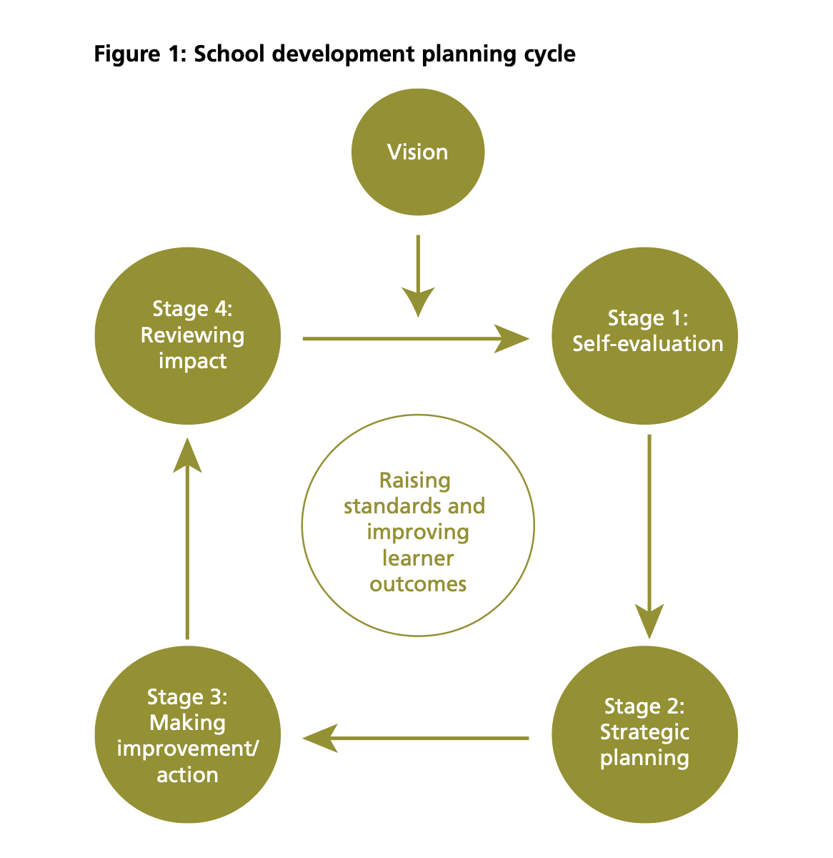
(Welsh Government, 2014a)

Appendix 2: Well-being of Future Generations (Wales) Act 2015 Goals
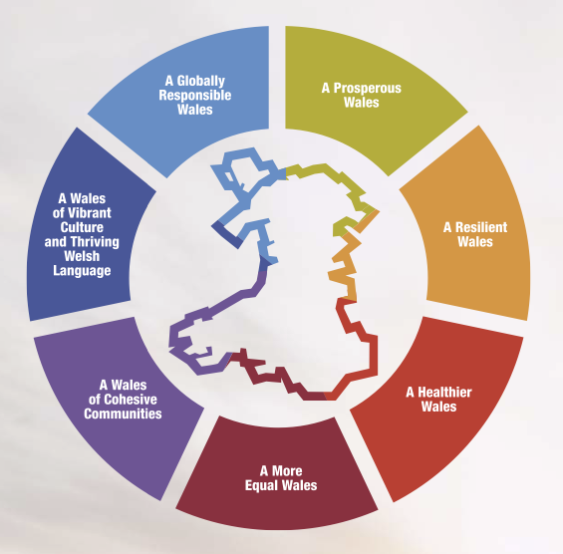
(Welsh Government, 2021e)

