University of Wales
Student:Maurilene Da Silva Boriosi (1809946)
Lecture: Dr A. Mazumbar
Date; 18-12-2019

Problem Solving and Decision Making

INTRODUCTION
Problem solving is a process of evaluating and putting forward a possible solution to situation at hand. Being complicated process, problem solving requires making judgment calls or decision making on the way (Lehoczky & Rusczk, 2006). Decision making is a choice one makes based on his/her judgments. It is an important skill needed to be acquired by leaders. Problem solving and decision making are the key aspects/skills of our life which is applicable whether at home or work. Usually, for a problem to be solved, it requires crucial decision making. So problem solving and decision making goes hand in hand but achieving one factor doesn’t lead to others. So, taking right decision to solve a problem can lead to successful achieving of objectives. But problem solving and decision making are used interchangeably, but they are not the same. The key difference that exists between problem solving and decision making is that problem solving is a step or process whereas decision making is a judgment made during the process (Nota & Soresi, 2004).
Problems can vary from major to minor. We face many small problems and react with a quick decision that we even do not notice. In day to day life especially in business sector countless problems arise and require decision to solve the problem. Tackling a problem varies from people to people. Some are used to decision making which seems natural for their personalities. But same problem and decision making can be burden for some people. This may cause obstacle in their activity as they are tangled in decision making to solve the problem.
If problems can be addressed with greater precision, creativeness, and believe, factors that otherwise might have a significant impact on the organisation will be mitigated or even completely prevented. Critical thinking is required for both decision making and problem solving. Critical evaluation of the problem, deciding to solve the problem is often important for an Organization success (Talanker, 2016). Critical thinking often leads to the use of a mix of study, interpretation, asking, and discovery of new ideas to obtain rich perspective into a scenario, becoming educated in a way that is not limited by peers ' subjective viewpoints. It’s not that no one faces problem or have to decide in their day to day activities. It is common to have problem within an organisation. It might be bullying of a fellow worker or discrimination within organization. In this study we will be discussing on different type of discrimination that is prevalent in an organisation, identifying the cause of the problem, some crucial decision that might lead to solving of the problem etc. In UK there has been report of discrimination based on age, racism, seniority has been repeated over several years which is still prevalent in many organisation across the country.
TOPIC: Discrimination
Experience in an organisation:
A lot of organisation has been established in UK over several periods; most common ones are sole trader, private company limited, public company limited etc. Discrimination varies from organisation to organisation. In case of sole trader there is only an individual investing for the trading purpose, so the chance of discrimination is very low. If we talk about school, there is also less chance of discrimination among the teachers. A large number of people are present in public companies were people ranging from different background like from commoners to some wealthy people work in different posts. A large number of employee means there is diversity in races, cultural difference, age, sex, religion among the workers. Though there has been claim of no discrimination in UK, there automatically exists discrimination. So there exist diversity and differences in a working organisation.
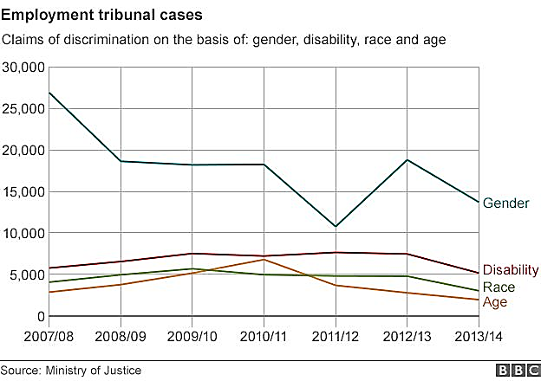
Fig: Claims of discrimination by different factors over several years in the UK
- Race differences: Though people of United Kingdom belongs to the white group, many people immigrating from different part of the world leads to change in racial spectrum. According to data from 2018, 14% of the total population of UK was occupied by people born outside UK. Among which most people belong came from non-EU whereas some people from EU (European Union). Most of the people from non-EU are involved in low skilled job like people from African countries. These people come from different races having different cultures. Due to difference among the UK people in an organisation there automatically exists discrimination (Wasserman, 2010).
- Age and generational difference: discrimination due to difference in Age among the workers in an organisation is common thing. Especially elders take advantage of their old age for discriminating younger people. For instance, juniors are required to respect the elders who don’t mean that seniors shouldn’t treat juniors as a fellow worker. They act and talk in rude manners, give orders to the juniors. Three-quarter of the workers in UK feel age discrimination (O’Loughlin et al., 2017).
- Language and communication differences: Diversity among the workers in an origination make it more difficult for embracing due to difference in language and communication (Brannen et al., 2014). Most commonly spoken language in the UK, but all the people in the big company are not familiar with the language due to which discrimination occurs.
- Sex discrimination: There has been a belief since past years that women won’t be able to carry out some task with full dedication. Women are not qualified for jobs. Especially in case of women with child there exists discrimination. Three-quarters of the mother in UK have experienced discrimination (Triana et al., 2019).
In case of myself, I worked in a chocolate factory ok United Kingdom for one year. I was junior supervisor of the company and had duty of supervising and directing people for their work. My specific department was of supervising the packing of manufactured chocolates, i.e. the chocolates are packed. The organisation had lots of worker coming from different countries and different races. Some group of people were from sub-Saharan African countries who find it difficult to converse in English language. Such people were discriminated based on their cultures beliefs, background etc. The workspace within the organisation was quite big, and it had different section for different purpose. Like, different section for packing, manufacturing, quality control etc. Having such employees in high density automatically calls for discrimination.
One common discrimination that I found was direct race discrimination. In such case, one employee treated unequally among workers from different race at same condition (Kennedy, 2015). There was an employee who emigrated from sub-Saharan Africa, and he was black. He couldn’t speak proper English; he had no fluency in English language. Due to such most of the people working in the company hesitated to talk with, have conversation with him. Some of them even didn’t want to shake hand as he was from different ethnic group. The organisation also showed indirect race discrimination. It had some rules and policy like first preferences to candidate with UK qualifications and had good command in English language. Then after such only preference was given to other people who did not meet the first criteria.
I also had to face discrimination in terms of age. I was younger to people working in the company, but I was well suited and hard worker. I had full dedication to my work, but I wasn’t given credit for my effort. This was because I was younger than most of the people. The credit always went to senior managers. Also younger people were deprived of salary increment until they reached certain age which was unlawful. Also seniors people than me always ordered for carrying out more task than I usually had to do. Seniors had the ego within them that led to age discrimination among the younger and older people. The voice of younger employee is less listened and heard in many companies. They didn’t want to consider the advice and suggestions from younger people working. So I couldn’t withstand such activities which led me to leave the job. Though the Equality Act 2010 preserves one from discrimination of age in a workplace, there are some flaws and exception in law which leads to age discrimination in workplace (Stypińska & Nikander, 2018). ACAS (The Advisory, Conciliation and Arbitration Service) has predicted that over a quarter of the population in the UK will involve people over 50 years of age by 2020. This might affect the perception of people throughout the workplace, can arise some concerns for those who are above the age of 50 and doing the job and people who are just starting to do the job. This might lead to discrimination (Katie, 2019).
These type of discrimination can be a major problem which might not only affect one’s career but also might harm or have an influence on the mentality of a worker. So it is crucial to implement a decision for solving such problem. Decision making requires critical thinking, brainstorming, analysing of the current situations, evaluating certain possibilities of solving the problem etc. Six steps in decision making process are
- Identifying and analysing the problem: Before a decision is made in solving a problem, it is analyzed beforehand. The identifying is based on observation, information and experiences. The root problem of discrimination is analyzed within an organisation. It is essential to think about the complexities of the dilemma beyond the ground (Narula, 1974). There is requirement to go deep into the problem, identify what might be causing the problem and what might be the possible solution to solving it.
- Gathering information related to problems: Information is gathered via reviewing documents to support our thoughts. Documents or information include the marketing metrics, satisfaction of the customers, different age group of people working in the company, different ethnic group of people etc. The claim towards the problem is backed up based on information collected (TBAE, 2016).
- Identification of alternatives: In most cases, searching for an alternative to the problem seems more reliable to address the problem. It is one of the obvious approaches to address a problem. For this it is important to brainstorm at first and look for alternatives. This might be done effectively in a group. The different idea can be generated in a group. This is also creative part of decision making process. List of ideas can be generated from discussion; even a silly idea shouldn’t have opted from the list (Desmond, 2007). Since sometimes such silly idea might have more weight as superb solution. In most of the cases people are obliged to take quick decision which is not good when considering the overall consequences.
- Weigh in the pros and cons of alternatives: The pros and cons of the alternative solution to the problem as derived from earlier step is analysed. Different tools can be used for identifying pros and sons such as SWOT Analysis. The ideas are analyzed to see the effectiveness in addressing a problem within an organisation. Pros and cons should be analyzed before implementing the solution (Simon, 2017). Visualising the pros and cons of the business or regarding the problem might be beneficial. Weighing of pros and cons can be done vi GIVING score during analysis.
- Deciding a solution: After analysing of all the possible alternatives, their pros and cons, it is crucial to decide onto a solution. The decision must be made quickly otherwise the problem might escalate further and reach out of hand for solving it. When trying to implement a decision it is important to consider few things like the risk solution poses when solving the existed problem. Possible outcomes along with negative side effects of implementing the solution should be considered for short and long term (Nezu & D’Zurilla, 1981). And most important part is analysing the likeliness of the success before deciding of a solution.
- Evaluation: After the implementation of the possible solution, it is crucial to evaluate whether the alternative has been able to address the issues or not. This might show us different direction to solving a problem, can broaden our range of analysis etc. If it hasn’t met required target the process is reviewed from beginning and analysed further. This helps in improving a situation next time an organisation faces.
The process in decision making step is supported by different tools like SWOT Analysis, PESTLE analysis, PORTERS analysis etc. With the help of these tools, the problem can be addressed, and possible solutions can be implemented systematically.
SWOT Analysis
SWOT stands for Strength, Weakness, Opportunities and Threats. A SWOT analysis is a qualitative information evaluation that is structured in a logical sequence by the SWOT model that helps to explain, view, analyse and make decisions (Fine, 2009). A SWOT model can be used for all types of decision making, and it allows strategic thought instead of relying on natural or reflexive reactions. The summary of SWOT analysis for decision making procedure for solving the discrimination problem is given in the diagram as shown below.
When viewing the strength of decision-making process, the organisation has good recognition among the companies in United Kingdom. It is one of the reputed established company. So such company might not want to spoil its reputation with internal affairs which might hamper the business (Sarsby, 2016). The workflow and work division is systematic thus there is no discrimination regarding the division of work. This can be a major strength. Apart from discrimination, the facility provided to the staff, no matter the races or culture they come from is equal. But some core problem exists which needs to be looked after before deciding to solve the problem. The native people are not willing to cooperate with people from different races esp. Africans. They have developed different peculiar perception of them. And there seem no policies regarding these matters. This solely affects the strength of the company. If there is no coordination among the workers, then the quality of the process is deteriorated. SO systems are to be improved for such conditions (Sammut-Bonnici & Galea, 2015). If not, this might cause problem for the stakeholders as well as the management. Some people from different race are skilled than that of the White races. If the discrimination continues then there might be chances of losing such skilled workforce. In my experience several such incidents have happened including me. This hampers the company. To improve such condition, different opportunities can be adapted as strictly applying or following the characteristics of Employment Act 2010. Based on which actions can be taken for any discrimination act. Also to motivate the equality in the organisation, the equal preference can be given to every race in case of job promotion, recruitment etc (Gurel & Tat, 2017). To understand the feelings of workers feedback can be taken. And based on which gap can be analysed and worked on that to see the improvement. To engage all the employees in an organisation, sometimes a small function or program can be organised which enhances the likelihood of cooperation among the workers (Fischer et al., 2012).

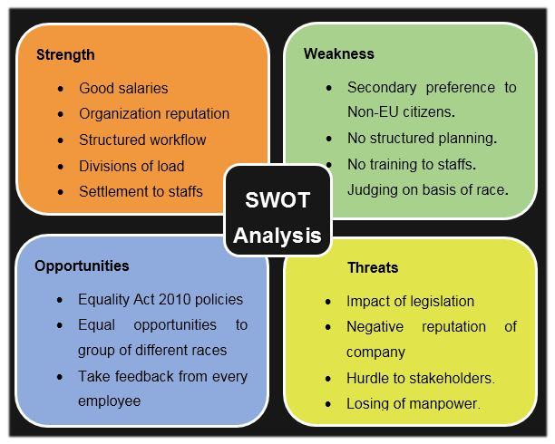
Fig: SWOT analysis for discrimination act in workplace

Fishbone Analysis
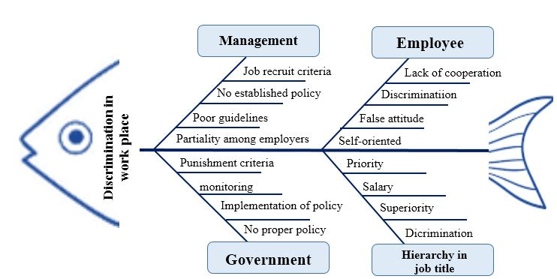
The cause of the discrimination prevailed in the working place and the different impact it has can be evaluated through fishbone diagram. The fishbone diagram also known as Ishikawa diagram helps to identify different causes to a problem and underlines a base for understanding a problem in deeper level such that a solution can be generated through it. Below is the fish bone diagram for the case study:

Fig: fishbone bone diagram identifying and analysing cause of discrimination in work place

The above diagram illustrates the different factors that resulted in discrimination in the workplace. Management of the organization, government, employess and hierarchy in job title plays key role to discrimination. Management lacks in implementing proper guidelines and policies against discrimination. The selection of new entrants is based on preference to native citizens which automatically results in discrimination. Along with management, government aslo lack in establishing proper rules against the discrimination. Though different policies has been set but there is no propler following or implementation of the rules. There is established punishement or trial for the one who is involved in discrimination act. Apart from these, employee within an organization play crucial role like their attituted towards people coming from different cultural background results in discrimination activity. The sequestering in the job title also hold prime root for discrimination. Seniority in workplace results in change in attitude of the people leading to discrimination.
An effective decision making should be implemented on an organisational level to successfully solve a deep-rooted problem. So we need to be confident in the decision made and should be able to persuade others to its advantages. But there might be some factors that hinder on to the effective implementation of decision. This creates or obstructs the process of problem solving. Some of the factors are
- There might not be sufficient information on the problem like discrimination in our case. Lack of information can lead to a weak foundation for decision making process. In such case decision is being made without any basis or considerations.
- Sometimes too much information can also lead to failure in implementing decision making. This causes process to be vague and conflicting making it impossible to see the light at the end of a tunnel.
- Also, if in an organisation, there are too many people involved leading to many conflicting ideas, too many views might also create a problem in decision making.
- Some people who are a victim of discrimination sometimes do not take stand for supporting a cause. This might create a problem. In an organisation, an individual effort doesn’t seem feasible, if a group is involved it strengthen the purpose. But some victims are afraid of the management and abstain the discrimination. Due to this the decision making becomes weak.
So for the effective decision making different step mentioned earlier should be followed.

After the decision-making strategies or option has been viewed, for further solving of the problem different strategies are applied. Some of the skills are essentials for solving a problem out of which one includes decision making which is already discussed. Apart from this, some of the skills are:
- Creativity: Sometimes, problems are solved with instincts. A rapid decision is made to approach such problem. Either a person has already faced the same problem or experiences in tacking such problems it doesn’t require quite a big effort. But in case of discrimination act, instinct doesn’t solely lead to a solution. It requires systematic procedure for solving it. A structured approached is essential in addressing such problem. As discrimination concerning age, race etc. has been prevailed since very past years. This is a kind of problem which requires a deep procedure and cannot be attained in short period. This requires a logical approach for which creative thinking plays crucial role. An innovative approach is required. So creative thinking is the ability to look at thing differently and coming up with new ideas for solving a problem (Fogler et al., 2013). This can have impact on a case for sustainable period.
- Researching skills: Research is required for knowing certain nature of the problem. It is usually best to understand a problem from core depth, for such research should be done. In a discrimination case, research on different policies that are set by the law, or different actions to tackle such problem can be researched. This helps in keeping knowledge or track on the ways to tackle the problem. The data from various sources can be collected for the purpose; either primary source of data or secondary source of data. It so has a researching skill can play an important role in solving a problem.
- Team Working: Teamwork is core or essence in carrying out any task, whether solving a problem, decision making or carrying out different task. A team includes more member. More members mean more ideas, more information, more workforce, more voice etc. This can be effective in pressuring the management of the organisation to look after the issues beforehand (Griffith & Dunham, 2014). Raising voice against some fault in an organisation will be easier and more effective if a team is involved. So many problems are better defined, evaluated and solved with the effort of many people.
- Emotional Intelligence: Before implementing a decision on solving a problem, it is important to understand the impact on the emotions of other people and to ourselves. The ability to keep track of the emotions of other people and our self can help to guide in reaching an appropriate solution. Understanding emotions of other people can help in maintaining cooperation with other employees within the organisation (Munir & Azam, 2017). This can build up confidence in approaching a decision making for solving a problem
- Risk Management: Every problem solving comes with a risk in the process. We should be prepared for tackling the risk that may arise. So proper management of risk is essential for solving a problem.
The discrimination problem in the organisation has two features in common that is goals and barriers. The goal, in this case, is to achieve similarity and equality among all the members or employee from different ethnic group. Different objectives are set to achieve the goal (Tannock, 2008). The thinking, perception of people in the organisation should be changed such that all the people in the company are in harmony. The goal is to have coordination of people belonging to different races. But achieving the goal is not an easy task, its tough nut to crack. There is going to be many barriers in the process. For instance, eradicating discrimination means changing the feelings of a person. Until and unless there is no feeling of discriminating in one’s heart, not even a law can eradicate the discrimination that is prevailed. It is very difficult, tends to impossible, kind of task to change the viewpoint of all the employee. Also to adapt the law against discrimination is not an easy task; there lies different and many barriers. All the hurdles should be crossed to reach the goal. Even applying the law against the person who discriminates, treats people from different races badly, there is only escalating the hatred in his/her heart.
Evaluation of the Proposed Solution
After the identification of the problem and analysing it in closer look, the decision making procedure widens the vision required for solving the problem. Solving a problem requires time and care. The task is tough nut to crack; there should always be reviewing the process. There might be necessary to going back to square one for solving the issues. Lots of priorities in the process needs to be changed based on the reaction from the situation. Many criteria set are improved during the process of implementation to further effectiveness of the decision making. The implementation of the act to discourage discrimination should begin from government side (Hammond et al., 2010). The government should recognise people of different races equally. This could be a major step in discouraging the ongoing discrimination in the organisation. The policy against discrimination should be not only present in the Act but also behavioral activity as well. Effectiveness of the solution can be visible if the government starts to act against the problem. The secondary level of implementation is through the organisation itself. If the discrimination has been set from organizational level then it is obvious among the employee. So changes are to be made from organizational level. The organisation should set policies that must be made compulsion in every level for the organisation. And finally main core for the change is required in every individual working in the organisation (Munk, 2013). They should establish feeling of togetherness in the organisation. If the problem is solved from individual level, then it will be automatically solved throughout the nation.
Within the organisation the effectiveness of the proposed decision making can be evaluated through the activity of the employee working together. If it were effective, people would start to change the perception towards people from different races like thinking positive of them, not taking them as an outsider within the company etc. Another way of evaluation can be feedback from the victim itself. The person from different races can be considered for obtaining the primary data for the evaluation (Ceschi et al., 2017). Based on the information the effectiveness of the proposed solution can be evaluated. This can be genuine information for further analysis. The reports from official state agencies can be obtained to see the progressing of problem solving. But as this is limited to organizational level, Management information plays crucial role. So until and unless management of the organisation set favorable environment discouraging the discrimination, the problem can’t be solved.
So in conclusion, problem solving and decision making can be considered as a part of same coin, but they are not the same. To achieve one, others need to be obtained. The decision making should be carried out creatively, considering every factor of the problem. Information should be precise, not too lengthy and relevant to the raised issues. The problem should be properly defined, causes of the problem should be accurately identified, alternative solution should be generated considering different factors, and after the implementation there should be proper evaluation of effectiveness of the solution. And for obtaining the goal of removing or discouraging the discrimination act within the organisation different hurdles should be crossed systematically, with proper risk management that might come in the way (Weekes, 2017).

Reference
Brannen, M.Y., Piekkari, R. & Tietze, S. (2014) The multifaceted role of language in international business: Unpacking the forms, functions and features of a critical challenge to MNC theory and performance. Journal of International Business Studies, 45 (5), pp.495–507.
Ceschi, A., Demerouti, E., Sartori, R. & Weller, J. (2017) Decision-Making Processes in the Workplace: How Exhaustion, Lack of Resources and Job Demands Impair Them and Affect Performance. Frontiers in Psychology, 8, p.313.
Desmond, M. (2007). Decision criteria for the identification of alternatives in strategic environmental assessment. Impact Assessment and Project Appraisal, 25 (4), pp.259–269.
Fine, L.G. (2009) The SWOT analysis : using your strength to overcome weaknesses, using opportunities to overcome threats. 1st ed. CreateSpace Independent Publishing Platform.
Fischer, A., Greiff, S. & Funke, J. (2012) The Process of Solving Complex Problems. The Journal of Problem Solving, 4 (1).
Fogler, H.S., LeBlanc, S.E. & Fogler, B.R. (2013) Strategies for creative problem solving. 3rd ed. Prentice Hall.
Griffith, B.A. & Dunham, E.B. (2014) Working in teams : moving from high potential to high performance. 1st ed. Sage Publications.
Gurel, E. & Tat, M. (2017) Swot Analysis: A Theoretical Review. The Journal of International Social Research, 10 (51).
Hammond, W.P., Gillen, M. & Yen, I.H. (2010) Workplace Discrimination and Depressive Symptoms: A Study of Multi-Ethnic Hospital Employees. Race and social problems, 2 (1), pp.19–30.
Katie (2019) UK Age Discrimination in the Workplace | ToughNickel [Internet]. Available from: <https://toughnickel.com/business/UK-Age-Discrimination-in-the-Workplace>.
Kennedy, R. (2015) For discrimination : race, affirmative action, and the law. Vintage.
Lehoczky, S. & Rusczk, R. (2006) The art of problem solving. 7th ed. AoPS Incorporated.
Munir, M. & Azam, R.I. (2017) Emotional Intelligence and Employee Performance: An Intervention Based Experimental Study [Journal of Business &amp; Economics (2075-6909)]. Journal of Business & Economics, 9 (2), pp.1–19.
Munk, J. (2013) Assessing the Benefits of a Proposed Solution - Six Sigma Daily [Internet]. Available from: <https://www.sixsigmadaily.com/assessing-the-benefits-of-a-proposed-solution/>.
Narula, S.C. (1974) Systematic Ways to Identify Research Problems in Statistics. International Statistical Review / Revue Internationale de Statistique, 42 (2), p.205.
Nezu, A. & D’Zurilla, T.J. (1981) Effects of problem definition and formulation on decision making in the social problem-solving process. Behaviour Therapy, 12 (1), pp.100–106.
Nota, L. & Soresi, S. (2004) Improving the Problem-Solving and Decision-Making Skills of a High Indecision Group of Young Adolescents: A Test of the ``Difficult: No Problem!’’ Training. International Journal for Educational and Vocational Guidance, 4 (1), pp.3–21.
O’Loughlin, K., Kendig, H., Hussain, R. & Cannon, L. (2017) Age discrimination in the workplace: The more things change …. Australasian Journal on Ageing, 36 (2), pp.98–101.
Sammut-Bonnici, T. & Galea, D. (2015) SWOT Analysis. In: Wiley Encyclopedia of Management. Chichester, UK, John Wiley & Sons, Ltd, pp.1–8.
Sarsby, A. (2016) Swot analysis : a guide to SWOT for students of business studies. Spectaris Ltd.
Simon, J. (2017) Public Pensions Should Weigh Pros and Cons of Alternative Investments | Plan sponsor [Internet]. Available from: <https://www.plansponsor.com/public-pensions-should-weigh-pros-and-cons-of-alternative-investments/>.
Stypińska, J. & Nikander, P. (2018) Ageism and Age Discrimination in the Labour Market: A Macrostructural Perspective. In: Springer, Cham, pp.91–108.
Talanker, S. (2016) Problem-solving is Decision-making [Internet]. Available from: <https://www.researchgate.net/publication/310844404_Problem-solving_is_Decision-making>.
Tannock, S. (2008) The problem of education‐based discrimination. British Journal of Sociology of Education, 29 (5), pp.439–449.
TBAE (2016) Information Gathering Stage of The Creative Problem Solving Process for Teams – TBAE Team Building Blog [Internet]. Available from: <https://www.tbae.co.za/blog/information-gathering-stage-of-the-creative-problem-solving-process-for-teams/>.
Triana, M. del C., Jayasinghe, M., Pieper, J.R., Delgado, D.M. & Li, M. (2019) Perceived Workplace Gender Discrimination and Employee Consequences: A Meta-Analysis and Complementary Studies Considering Country Context. Journal of Management, 45 (6), pp.2419–2447.
Wasserman, D. (2010) The justifiability of racial classification and generalisations in contemporary clinical and research practice. Law Probability and Risk, 9 (3–4), pp.215–226.
Weekes, J. (2017) 8 ways to prevent discrimination in your workplace [Internet]. Available from: <https://www.healthandsafetyhandbook.com.au/8-ways-to-prevent-discrimination-in-your-workplace/>.

