University of Wales Trinity Saint David

Wales Institute of Science & Art



Structural & Fluid Analysis
Designing a Kiteboard Hydrofoil Wing: Fluid Flow Assessment
ACMA6010

Garin Mann
2115399
Monday 29th June 2026

Contents
Task One 4
1.1 Introduction to Reynolds Number 4
1.2 Importance in Hydrofoil Application 4
1.3 Estimation of Reynolds Number 5
1.4 Discussion of Results 6
1.5 Conclusion 6
Task Two 7
2.1 Boundary Layer Development Around the Hydrofoil 7
2.2 Flow Separation and Its Impact 8
2.3 Turbulence and Flow Behaviour Around the Wing 8
2.4 Application to Hydrofoil Design 9
2.5 Why the Wing is Designed This Way (Critical Analysis) 9
2.6 Link to Real-World Performance 10
2.7 Conclusion 10
Task Three 11
3.1 Introduction 11
3.2 Physical Meaning of the 500N Force 11
3.3 Estimation of Realistic Forces 11
3.4 Critical Evaluation of the Assumption 12
3.4.6 Engineering Judgement 14
3.4.7 Link to Fluid Analysis 14
3.4.8 Conclusion 14
Task Four 15
4.1 Introduction 15
4.2 Mechanical Performance Advantages 15
4.2.1 High Strength-to-Weight Ratio 15
4.2.2 High Stiffness (Directional) 16
4.2.3 Fatigue Resistance 16
4.3 Hydrodynamic Performance Implications 17
4.3.1 Surface Finish 17
4.3.2 Shape Optimisation 17
4.3.3 Weight Reduction 17
4.4 Limitations and Challenges 17
4.5 Historical Development 18
4.6 Current Industry Applications 18
4.7 Future Developments 18
4.8 Industry Standards and Literature 19
4.9 Conclusion 19
Task Five 20
5.1 Introduction to Computational Fluid Dynamics 20
5.2 Governing Fluid Flow Equations 20
5.3 CFD Approaches for Hydrofoil Analysis 21
5.4 Turbulence Models 21
5.5 CFD Domain and Mesh Generation 22
5.6 Estimation of Hydrodynamic Forces 23
5.7 Advantages of CFD Analysis 23
5.8 Limitations of CFD Analysis 24
5.9 Engineering Assessment 24
5.10 Summary 24
Task Six 25
6.1 Introduction 25
6.2 Proposed Experimental Method 25
6.3 Measurement Systems 26
6.4 Flow Visualisation Techniques 26
6.5 Data Acquisition and Processing 27
6.6 Correlation with CFD Results 27
6.7 Sources of Error 28
6.8 Conclusion 29
References 30

Task One

1.1 Introduction to Reynolds Number
Reynolds number is a dimensionless parameter used to characterise fluid flow by comparing inertial forces to viscous forces within a fluid. It is widely used in fluid mechanics to determine whether flow is laminar, transitional, or turbulent, and therefore plays a critical role in predicting aerodynamic and hydrodynamic performance (White, 2016; Çengel and Cimbala, 2018).
It is defined as:
$$Re=\frac{ρVL}{μ}=\frac{VL}{ν}$$
Where:
ρ = fluid density (kg/m³)
V = flow velocity (m/s)
L = characteristic length, taken as hydrofoil chord length (m)
μ = dynamic viscosity (Pa·s)
ν = kinematic viscosity (m²/s)

1.2 Importance in Hydrofoil Application
For a kiteboard hydrofoil, Reynolds number is critically important because it determines how water flows over the wing surface and directly influences lift generation, drag, and overall performance (Anderson, 2017; Faltinsen, 2005).
At low Reynolds numbers, viscous forces dominate, leading to laminar flow that is prone to early separation. However, hydrofoils typically operate at higher Reynolds numbers where inertial forces dominate. In this regime, the flow is more likely to transition to turbulent behaviour, which increases momentum within the boundary layer and delays flow separation.
This is particularly important for a hydrofoil because:
- Lift generation depends on maintaining attached flow over the wing surface.
- Early separation reduces lift and increases drag.
- Stable flow behaviour improves rider control and efficiency.
Therefore, Reynolds number is fundamental in determining whether the hydrofoil will perform efficiently under operating conditions.

1.3 Estimation of Reynolds Number
To estimate the Reynolds number for the hydrofoil, assumptions must be made regarding fluid properties and operating conditions.
Assumptions:
- Fluid: water
Density: ρ = 1000 kg/m³
Dynamic viscosity: μ = 1.0 × 10⁻³ Pa·s
Kinematic viscosity: ν = 1.0 × 10⁻⁶ m²/s
Characteristic length (wing chord): L = 0.20 m
Velocity range: V = 5–10 m/s
Calculation:
At V = 5 m/s:
Re = (5 × 0.20) / (1.0 × 10⁻⁶) = 1.0 × 10⁶
At V = 7.5 m/s:
Re = (7.5 × 0.20) / (1.0 × 10⁻⁶) = 1.5 × 10⁶
At V = 10 m/s:
Re = (10 × 0.20) / (1.0 × 10⁻⁶) = 2.0 × 10⁶

Velocity, V (m/s) | Reynolds Number, Re
5.0 | 1.0 × 10⁶
7.5 | 1.5 × 10⁶
10.0 | 2.0 × 10⁶
Table 2.1

1.4 Discussion of Results
The calculated Reynolds number is in the order of 10⁶, indicating that the hydrofoil operates in a high Reynolds number regime. In this range:
- The boundary layer is likely to transition from laminar to turbulent.
- Turbulent flow improves resistance to separation.
- Lift is more stable, but skin friction drags increases
- Flow behaviour becomes sensitive to surface roughness and geometry
This explains why hydrofoil wings are designed with smooth, streamlined aerofoil profiles. The shape is optimised to maintain attached flow for as long as possible; minimising drag while maximising lift.

1.5 Conclusion
The Reynolds number for the hydrofoil is estimated to lie between 1.0 × 10⁶ and 2.0 × 10⁶, depending on operating speed. This places the flow firmly within a high Reynolds number regime where boundary layer behaviour and flow separation are critical to performance.
Understanding Reynolds number is therefore essential for predicting hydrodynamic performance, informing design decisions, and ensuring that the hydrofoil operates efficiently under real-world conditions.

Task Two

2.1 Boundary Layer Development Around the Hydrofoil
When fluid flows over the hydrofoil wing, a boundary layer forms along its surface due to the no-slip condition, where fluid velocity at the surface is zero. As the fluid moves along the chord of the wing, the boundary layer grows in thickness from the leading edge toward the trailing edge (Schlichting and Gersten, 2017; White, 2016).
Initially, the boundary layer is typically laminar, characterised by smooth, ordered flow with low momentum transfer. However, as the flow progresses downstream and Reynolds number increases (as established in Task 1, Re ≈ 1.0 × 10⁶ to 2.0 × 10⁶), the boundary layer transitions to a turbulent regime.
A turbulent boundary layer contains higher momentum fluid near the surface, allowing it to better resist adverse pressure gradients compared to laminar flow.

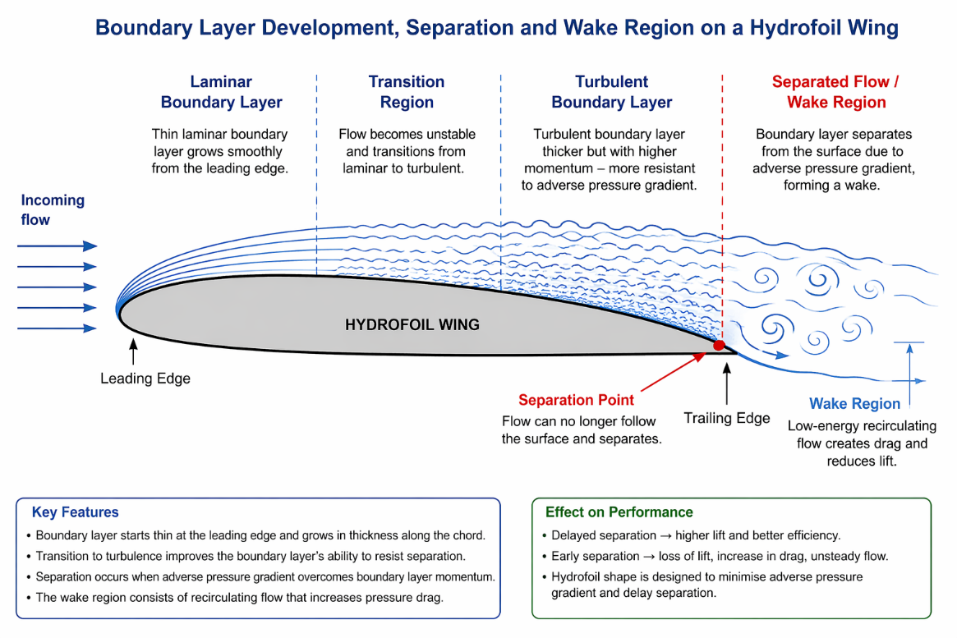

Figure 2.1: Boundary layer development, transition, flow separation and wake region around a hydrofoil wing (author’s own illustration, 2026; based on White, 2016; Anderson, 2017).
As shown in Figure 2.1, the boundary layer grows from the leading edge, transitions from laminar to turbulent flow, and eventually separates near the trailing edge to form a wake region.

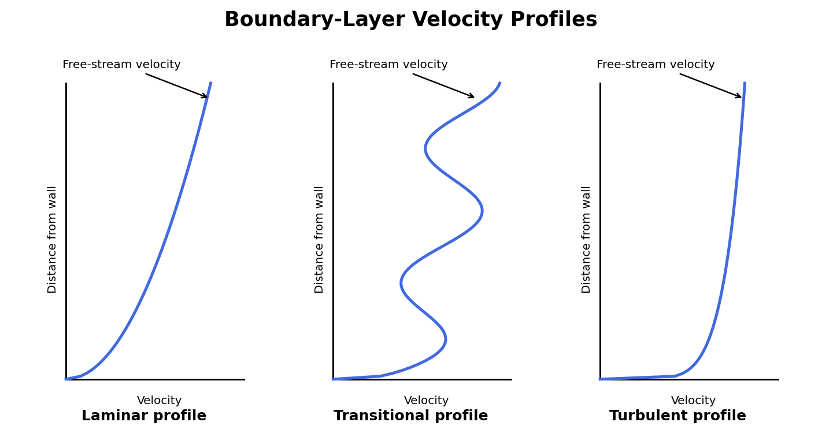
Figure 2.2: Typical laminar, transitional and turbulent boundary-layer velocity profiles (author’s own illustration, 2026; based on Schlichting and Gersten, 2017).
Figure 2.2 highlights that a turbulent boundary layer has a fuller velocity profile near the wall, improving its resistance to an adverse pressure gradient compared with a laminar boundary layer.

2.2 Flow Separation and Its Impact
Flow separation occurs when the boundary layer loses sufficient kinetic energy to overcome an adverse pressure gradient (i.e. increasing pressure in the flow direction). When this happens, the flow detaches from the surface, creating a wake region of recirculating, low-energy fluid (Anderson, 2017; Schlichting and Gersten, 2017).
For a hydrofoil, separation is critical because it leads to:
- Significant reduction in lift
- Increase in pressure drag
- Unsteady flow behaviour
- Reduced control and stability for the rider
At the Reynolds numbers calculated (~10⁶), separation behaviour is strongly influenced by whether the boundary layer is laminar or turbulent. A laminar boundary layer is more prone to early separation, whereas a turbulent boundary layer can remain attached for longer, delaying stall.

2.3 Turbulence and Flow Behaviour Around the Wing
Turbulence plays a dual role in hydrofoil performance. While turbulent flow increases skin friction drag, it enhances momentum transfer within the boundary layer, allowing the flow to remain attached over a greater portion of the wing surface (Pope, 2000; White, 2016).
This results in:
- Improved lift generation
- More gradual stall characteristics
- Increased operational stability
However, excessive turbulence in the wake region contributes to drag and energy loss, reducing overall hydrodynamic efficiency.

2.4 Application to Hydrofoil Design
The hydrofoil wing geometry shown in the assignment (Figure 2 in the brief) is designed to carefully manage boundary layer behaviour and minimise separation.
The key design features include:
Streamlined aerofoil shape
- A smooth, curved upper surface promotes gradual pressure changes
- Reduces adverse pressure gradients
- Helps maintain attached flow
Rounded leading edge
- Allows smooth flow acceleration
- Reduces risk of early separation
- Supports stable boundary layer development
Tapered trailing edge
- Minimises wake size
- Reduces pressure drag
Aspect ratio and spanwise flow control
- Reduces induced drag
- Improves lift efficiency

2.5 Why the Wing is Designed This Way (Critical Analysis)
The hydrofoil is designed to operate efficiently within the Reynolds number range identified (~10⁶), where:
- Flow is transitional to turbulent
- Separation must be delayed as much as possible
- Lift-to-drag ratio must be maximised
From an engineering perspective:
- A thin, smooth aerofoil ensures low drag and efficient lift
- A controlled pressure gradient prevents premature separation
- A turbulent boundary layer is beneficial in maintaining attachment
This design ensures that the hydrofoil can sustain lift at relatively low speeds while maintaining stability and efficiency at higher speeds.

2.6 Link to Real-World Performance
The interaction between boundary layer development, turbulence, and separation directly affects rider experience:
- Delayed separation → smoother ride and better control
- Reduced drag → higher speeds and efficiency
- Stable lift → improved balance and manoeuvrability
If separation occurs too early, the hydrofoil may stall suddenly, causing loss of lift and instability, which is undesirable in real-world operation.

2.7 Conclusion
The boundary layer behaviour around the hydrofoil is governed by its Reynolds number and geometry. As the flow transitions from laminar to turbulent, the ability of the boundary layer to resist separation improves, enhancing lift and stability.
The hydrofoil wing is therefore designed to promote controlled boundary layer development, delay separation, and manage turbulence effectively, ensuring optimal hydrodynamic performance.

Task Three

3.1 Introduction
In Assignment 1, a vertical load of 500 N applied at the centre of each side of the hydrofoil wing was assumed to represent hydrodynamic forces. While this provides a simplified loading condition for structural analysis, it is necessary to critically evaluate whether this assumption reflects realistic operating conditions.

3.2 Physical Meaning of the 500N Force
The applied 500 N force represents the lift force generated by the hydrofoil, which supports the rider and board above the water.
From a physical perspective, lift generated by a hydrofoil can be estimated using: (Anderson, 2017; Abbott and von Doenhoff, 1959).
$$L=\frac{1}{2}ρV^{2}C_{L}A$$
Where:
ρ = water density (kg/m³)
V = velocity (m/s)
C_L = lift coefficient
A = wing planform area (m²)

3.3 Estimation of Realistic Forces
Let’s estimate a realistic lift force.
Assumptions:
- $ρ=1000 {\text{kg/m}}^{3}$
- $V=7.5 \text{m/s}$
- $C_{L}≈0.5\text{–}1.0$(typical hydrofoil range)
- Wing area $A≈0.05 {\text{m}}^{2}$
Calculation:
$$L=\frac{1}{2}(1000)({7.5}^{2})(0.8)(0.05) \\ L≈1125 \text{N}$$
Interpretation
- Estimated lift ≈ 1000–1200 N total
As shown in Figure 3.1, lift increases with the square of velocity, so the assumed 500 N per side loading is only representative of a limited operating range.
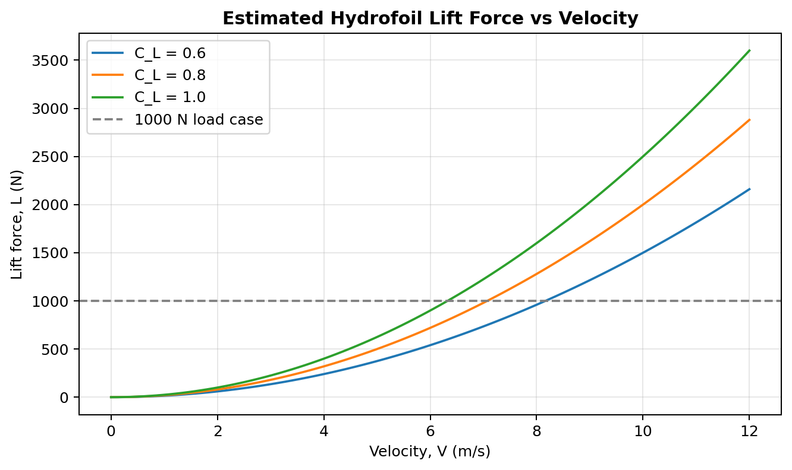
Figure 3.1: Estimated relationship between hydrofoil lift force and velocity for representative lift coefficients (author’s own calculation, 2026).
- Assignment assumption = 500 N per side → 1000 N total
So the assumed force is:
- Reasonable order of magnitude
- But very simplified

3.4 Critical Evaluation of the Assumption
Strengths of the 500N assumption:
- Provides a simple and consistent load case
- Suitable for initial design and comparison
- Matches approximate lift required to support rider weight (~100 kg ≈ 1000 N)
Limitations
Figure 3.2 shows that the 500 N load is a useful simplification, but it does not reproduce the distributed pressure field that generates lift on the hydrofoil.
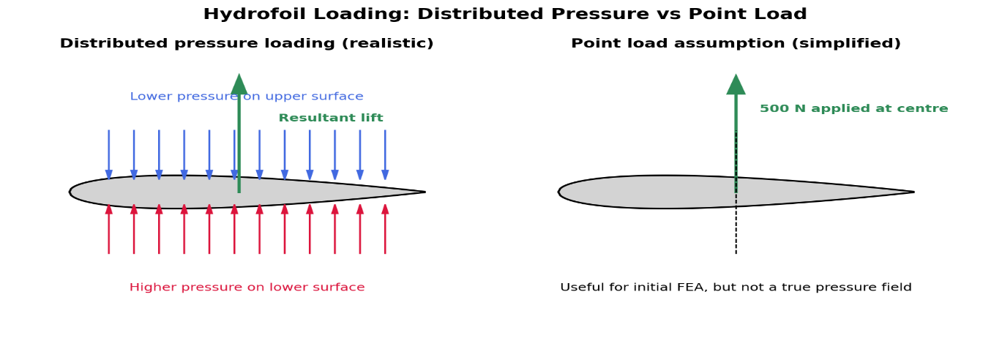

Figure 3.2: Comparison between realistic distributed pressure loading and a simplified point load assumption on a hydrofoil wing (author’s own illustration, 2026).
3.4.1 Load distribution is unrealistic
- Real lift is distributed across the entire wing, not concentrated at a point (Hoerner, 1965; Anderson, 2017).
- Point loading introduces artificial stress concentrations
3.4.2 Flow is unsteady
- Hydrofoil forces vary with:
  - Speed
  - Rider movement
  - Water conditions
The 500N assumption is static, whereas real loads are dynamic
3.4.3. Lift is not purely vertical
- In reality:
  - Lift acts perpendicular to flow direction
  - Drag also exists
The model ignores drag forces and moments
3.4.4 No consideration of pressure distribution
- Real forces arise from pressure differences across the wing surface
- CFD would show:
  - High pressure below
  - Low pressure above
3.4.5 Symmetry assumption
- Applying equal force on both sides assumes:
  - Perfect symmetry
- In reality:
  - Turning, waves → asymmetric loading

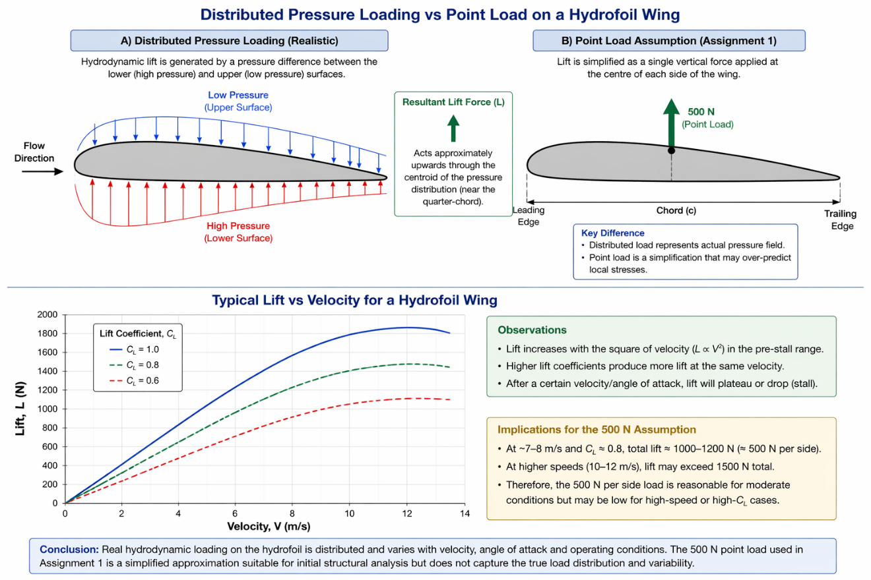

3.4.6 Engineering Judgement
From an engineering perspective:
The 500 N assumption is suitable for a baseline structural assessment, but it does not fully represent the complexity of hydrodynamic loading experienced by a hydrofoil in operation.
A more accurate model would:
- Use distributed pressure loads from CFD
- Include dynamic loading conditions
- Account for lift variation with speed and angle of attack

3.4.7 Link to Fluid Analysis
The limitations of the assumed loading highlight the importance of fluid flow analysis. By analysing Reynolds number, boundary layer behaviour, and CFD modelling techniques, a more realistic estimation of hydrodynamic forces can be achieved.

3.4.8 Conclusion
The assumed 500 N load provides a reasonable first approximation of the forces acting on the hydrofoil, particularly when compared to estimated lift values required to support rider weight. However, it oversimplifies the true nature of hydrodynamic loading, which is distributed, dynamic, and dependent on flow conditions.
Therefore, while suitable for initial structural design, more advanced modelling approaches are required for accurate prediction of real-world performance.

Task Four

4.1 Introduction
Carbon Fibre Reinforced Plastic (CFRP) is widely used in high-performance marine and aerospace applications due to its exceptional strength-to-weight ratio and stiffness. For a hydrofoil, where performance is highly dependent on both structural integrity and hydrodynamic efficiency, material selection is critical (Jones, 1999; Mallick, 2007).
This section critically evaluates the use of CFRP for the hydrofoil, considering its performance implications, and relating these to historical, current, and future developments in composite engineering.

4.2 Mechanical Performance Advantages

4.2.1 High Strength-to-Weight Ratio
CFRP offers significantly higher specific strength compared to traditional materials such as aluminium or steel (Hull and Clyne, 1996; Gibson, 2016).
As shown in Figure 4.1, CFRP can provide superior specific strength when the fibres are aligned with the principal load paths, although its performance is strongly dependent on lay-up quality and orientation.
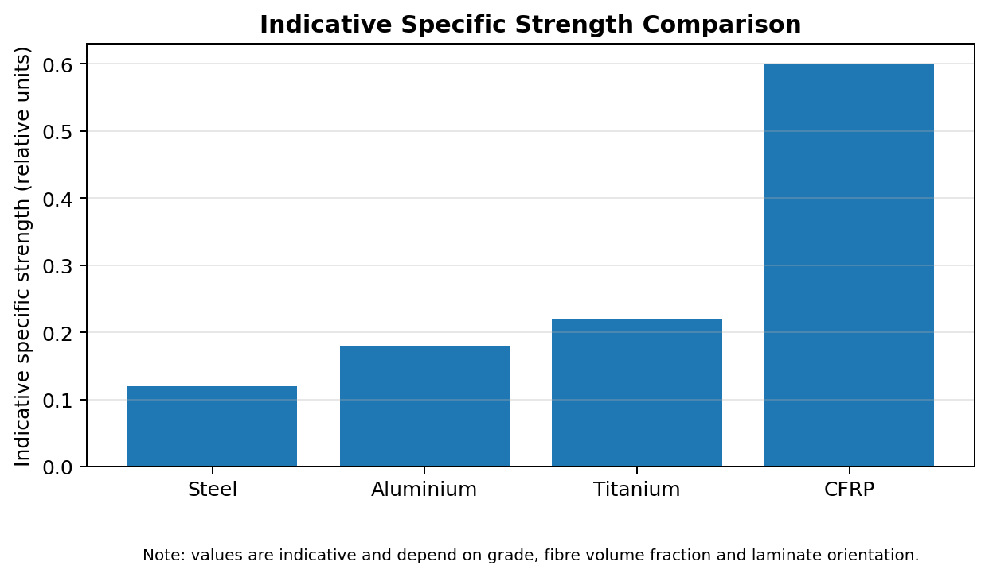
Figure 4.1: Indicative comparison of specific strength for common engineering materials and CFRP (author’s own chart, 2026; based on Hull and Clyne, 1996; Gibson, 2016).
Why this matters:
- Reduces overall hydrofoil weight
- Improves lift-to-weight ratio
- Enhances rider performance and responsiveness

4.2.2 High Stiffness (Directional)
CFRP can be tailored through fibre orientation, allowing stiffness to be aligned with load paths (Jones, 1999; Mallick, 2007).
Figure 4.2 illustrates how the direction of individual CFRP plies can be varied to resist bending, torsion and in-plane loading within the hydrofoil wing.
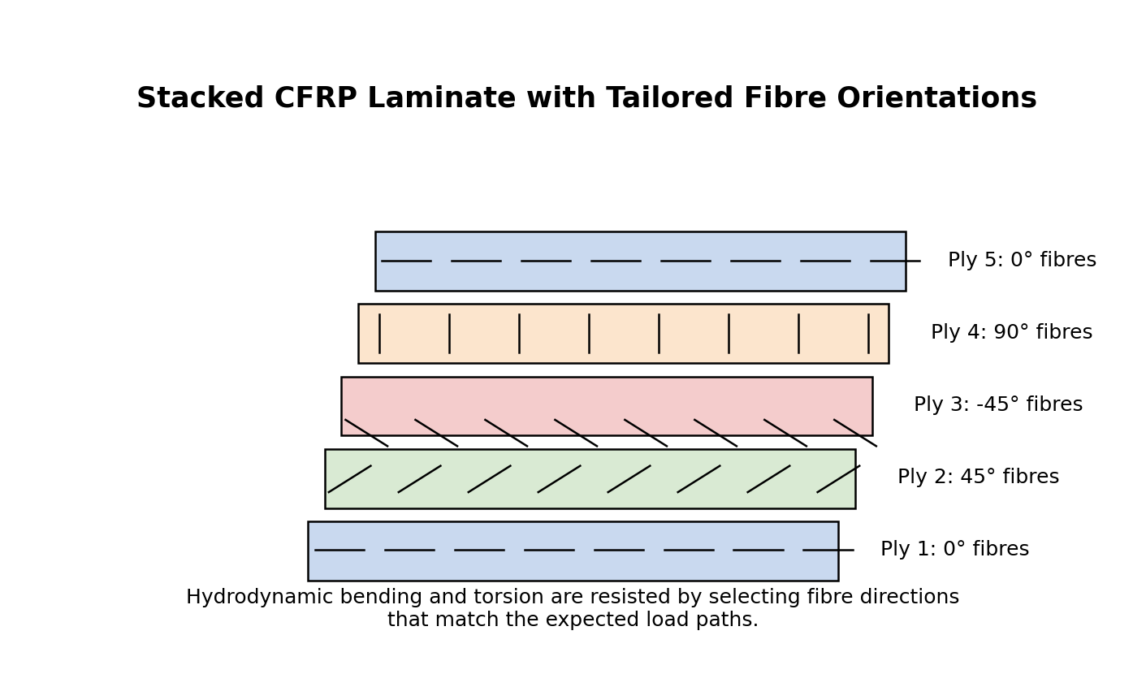
Figure 4.2: Example CFRP laminate with fibre orientations used to tailor stiffness and strength (author’s own illustration, 2026).
Application to hydrofoil:
- High bending stiffness prevents excessive deflection
- Maintains foil geometry under load
- Ensures consistent hydrodynamic performance

4.2.3 Fatigue Resistance
Unlike metals, CFRP exhibits superior resistance to cyclic loading (Gibson, 2016; Hull and Clyne, 1996).
Important because:
- Hydrofoils experience repeated wave and load cycles
- Reduces risk of long-term structural failure

4.3 Hydrodynamic Performance Implications
This is where you link to fluid analysis

4.3.1 Surface Finish
CFRP allows for a very smooth surface finish (Mallick, 2007; ISO, 2019).
Impact:
- Reduces skin friction drag
- Helps maintain attached boundary layer
Improves efficiency at high Reynolds numbers (~10⁶)

4.3.2 Shape Optimisation
CFRP enables complex aerofoil geometries.
Impact:
- Better control of pressure distribution
- Delayed separation
- Improved lift-to-drag ratio

4.3.3 Weight Reduction
Lower mass reduces inertia and improves dynamic response.
Real-world effect:
- Easier manoeuvrability
- Faster acceleration

4.4 Limitations and Challenges
High Cost
- CFRP is significantly more expensive than metals
- Manufacturing requires specialised processes

Manufacturing Complexity
- Layup, curing, and quality control are critical
- Defects (voids, delamination) can reduce strength

Anisotropic Behaviour
- Properties vary with fibre direction
- Poor design can lead to weak directions

Impact Sensitivity
- CFRP is more brittle than metals
- Can fail suddenly under impact (e.g., debris in water)

4.5 Historical Development
- Early hydrofoils used metals (aluminium, steel) (Faltinsen, 2005; Marchaj, 2003).
- Limited by weight and corrosion
- Introduction of composites improved performance
Key point:
- CFRP adoption driven by aerospace and marine industries

4.6 Current Industry Applications
CFRP is now standard in:
- Racing yachts (America’s Cup hydrofoils)
- High-performance kiteboards and surf foils
- Aerospace structures
Why:
- Lightweight
- High stiffness
- Corrosion resistance

4.7 Future Developments
Advanced Composites
- Hybrid composites (carbon + glass/Kevlar)
- Improved toughness

Manufacturing Techniques
- Automated fibre placement (Campbell, 2010; Gibson, 2016).
- 3D printing of composites
Smart Materials
- Embedded sensors for structural monitoring
Engineering implication:
- More efficient, safer, and optimised hydrofoil designs

4.8 Industry Standards and Literature
Relevant standards for composite hydrofoil design and validation include ISO 12215 for small craft hull construction and scantlings, ASTM D3039/D3039M for tensile testing of polymer matrix composites, and ASTM D7264/D7264M for flexural testing of composite materials (ISO, 2019; ASTM, 2017; ASTM, 2021).

4.9 Conclusion
CFRP offers significant advantages for hydrofoil construction due to its high strength-to-weight ratio, stiffness, and ability to produce smooth, optimised geometries. These properties directly enhance hydrodynamic performance by maintaining shape and reducing drag.
However, limitations such as cost, manufacturing complexity, and anisotropic behaviour must be carefully managed. With ongoing advancements in composite technology and manufacturing, CFRP is likely to remain the dominant material for high-performance hydrofoil applications.

Task Five

5.1 Introduction to Computational Fluid Dynamics
Computational Fluid Dynamics (CFD) is a numerical modelling technique used to predict fluid flow behaviour around engineering components. Within hydrofoil design, CFD provides a cost-effective method of assessing hydrodynamic performance prior to physical prototyping. Through the solution of governing fluid flow equations, CFD enables engineers to predict velocity fields, pressure distributions, lift generation, drag forces and flow separation characteristics. As hydrofoil performance is directly influenced by the interaction between water flow and wing geometry, CFD has become an essential design tool within the marine, aerospace and sporting industries (Versteeg and Malalasekera, 2007; Ferziger, Perić and Street, 2020).
The primary objective of CFD analysis in this study is to estimate the forces acting on the hydrofoil wing and evaluate the flow behaviour responsible for generating those loads.
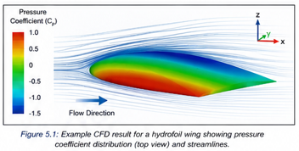

5.2 Governing Fluid Flow Equations
CFD simulations are based upon the conservation laws governing fluid motion. The continuity equation ensures conservation of mass, while the Navier-Stokes equations describe the conservation of momentum within the fluid domain. Together, these equations provide a mathematical representation of incompressible water flow around the hydrofoil (Versteeg and Malalasekera, 2007; White, 2016).
Due to the complexity of solving these equations directly for turbulent flow, turbulence modelling techniques are typically employed to reduce computational requirements whilst maintaining acceptable levels of accuracy.

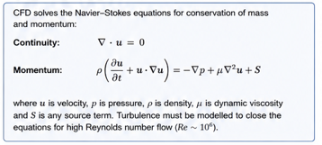

5.3 CFD Approaches for Hydrofoil Analysis
Several CFD methodologies can be applied when analysing hydrofoil performance. The most common approaches include Reynolds Averaged Navier-Stokes (RANS), Unsteady Reynolds Averaged Navier-Stokes (URANS), Large Eddy Simulation (LES) and Direct Numerical Simulation (DNS) (Launder and Spalding, 1974; Menter, 1994).
RANS methods are widely used within engineering practice because they provide reasonable accuracy with relatively low computational cost. The turbulent fluctuations are averaged, allowing efficient simulation of practical engineering problems. However, this simplification can reduce the accuracy of turbulence prediction in highly complex flow conditions.
URANS extends the RANS approach by incorporating transient behaviour, making it more suitable for applications involving fluctuating flow conditions and dynamic loading. Although more computationally expensive than standard RANS simulations, URANS can provide improved prediction of unsteady flow phenomena.
Large Eddy Simulation offers significantly greater accuracy by resolving larger turbulent structures directly while modelling only the smallest eddies. This approach provides excellent prediction of flow separation and wake development but requires substantial computational resources.
Direct Numerical Simulation represents the most accurate CFD technique because all turbulent scales are resolved directly. However, the computational demands associated with DNS make it impractical for most engineering applications and therefore unsuitable for routine hydrofoil design.
Considering the balance between accuracy and computational efficiency, a RANS-based approach is generally the most appropriate method for preliminary hydrofoil analysis.

5.4 Turbulence Models
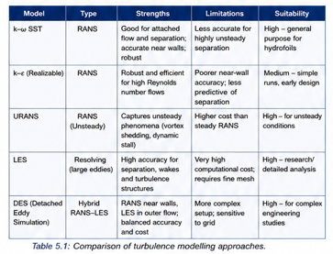
The selection of an appropriate turbulence model has a significant influence on CFD accuracy. Two commonly used models are the standard k-ε model and the k-ω SST model (Menter, 1994; Pope, 2000).
The k-ε model is widely recognised for its robustness and low computational cost. It performs well in free-stream flow regions and has been successfully applied across a broad range of engineering applications. However, the model is known to struggle when predicting adverse pressure gradients and flow separation, both of which are highly relevant to hydrofoil performance.
The k-ω SST model combines the advantages of the k-ε and k-ω approaches, providing improved near-wall behaviour and enhanced separation prediction. As hydrofoil performance is heavily influenced by boundary layer development and separation behaviour, the k-ω SST model is generally considered more suitable for this application.
Although the k-ω SST model requires greater computational effort, the increase in predictive capability justifies its use. Consequently, the k-ω SST model would be recommended for the CFD analysis of the hydrofoil wing.

5.5 CFD Domain and Mesh Generation
Figure 5.1 summarises the main modelling decisions required for hydrofoil CFD, including turbulence model selection, near-wall mesh refinement, boundary conditions and validation.
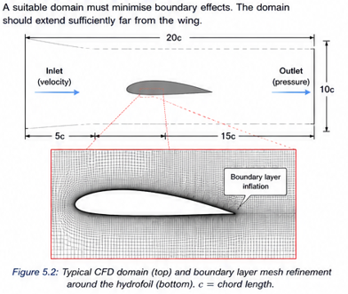

Accurate CFD simulations require careful definition of the computational domain and mesh. The computational domain should be sufficiently large to minimise boundary effects and allow realistic flow development around the hydrofoil (Ferziger, Perić and Street, 2020; ITTC, 2014).
Boundary conditions would typically include a velocity inlet, pressure outlet and no-slip wall condition at the hydrofoil surface. These conditions ensure that the simulation accurately represents the interaction between the water and the hydrofoil geometry.
Mesh generation is particularly important in regions where large pressure gradients and boundary layer effects occur. Refinement should therefore be concentrated around the leading edge, trailing edge and hydrofoil surface. Insufficient mesh density may lead to inaccurate prediction of lift forces, drag forces and flow separation.
As shown in Figure 5.2, refinement close to the hydrofoil surface is necessary to capture the near-wall velocity gradient and predict separation more reliably.
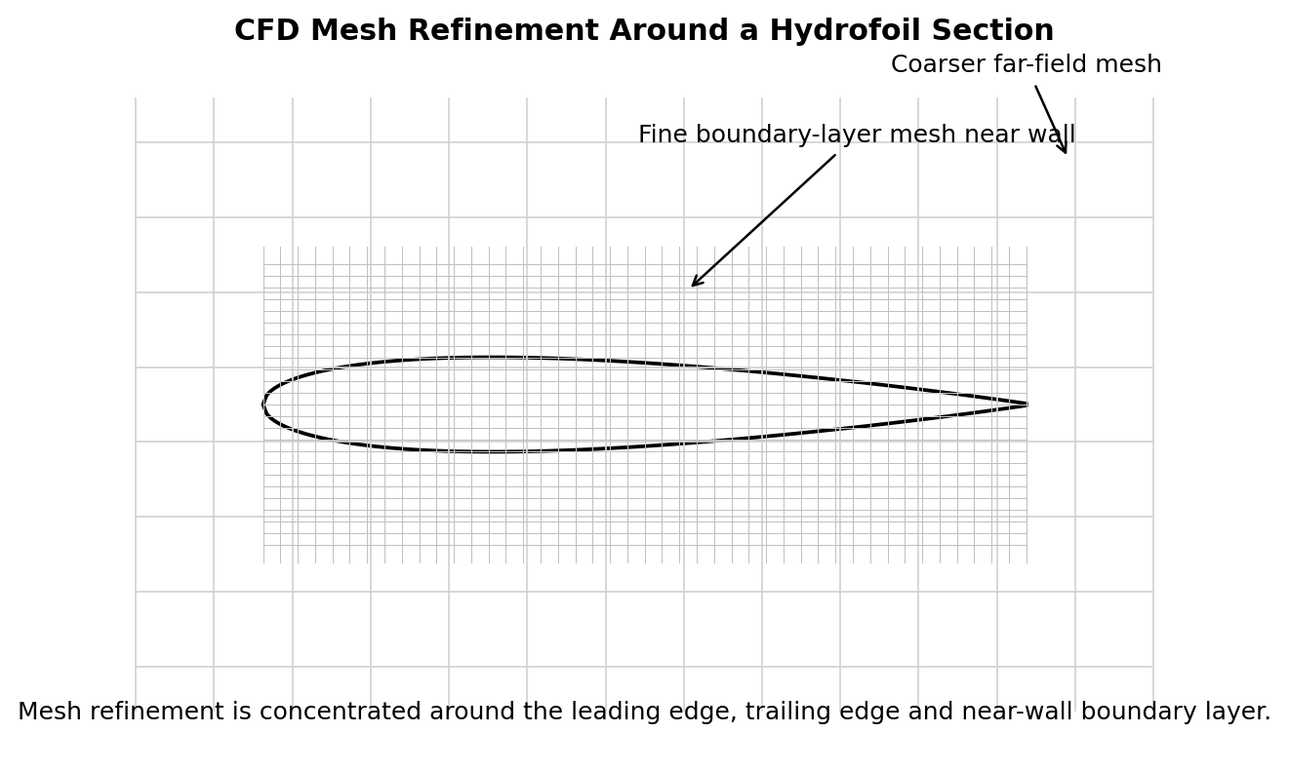
Figure 5.2: Mesh refinement concentrated around the hydrofoil surface and boundary-layer region (author’s own illustration, 2026).
A mesh independence study would normally be conducted to ensure that simulation results are not significantly influenced by mesh size. This improves confidence in the accuracy of the numerical predictions.

5.6 Estimation of Hydrodynamic Forces
The forces acting on the hydrofoil can be estimated using conventional lift and drag relationships. Assuming a water density of 1000 kg/m³, a hydrofoil velocity of 7.5 m/s, a lift coefficient of 0.8 and a projected wing area of 0.05 m², the estimated lift force is approximately 1125 N.
D = ½ρV²C_DA
This value compares favourably with the total 1000 N loading assumption adopted within Coursework 1, suggesting that the original loading condition was of a reasonable order of magnitude.
Assuming a drag coefficient of 0.05, the corresponding drag force is approximately 70 N. The relatively low drag force compared with lift indicates that the hydrofoil is capable of generating sufficient lift while maintaining hydrodynamic efficiency.
These force estimates provide an indication of the loading conditions that would be expected during operation and demonstrate the importance of accurately modelling fluid flow behaviour.

5.7 Advantages of CFD Analysis
CFD provides numerous advantages during the hydrofoil design process. Firstly, it significantly reduces the number of physical prototypes required, resulting in lower development costs. Secondly, CFD enables rapid evaluation of multiple design configurations, accelerating the optimisation process.
Another major advantage is the ability to visualise complex flow behaviour that would otherwise be difficult to measure experimentally. Pressure contours, velocity fields, streamlines and turbulence intensity distributions can all be examined in detail. This allows engineers to identify areas of flow separation and assess the effectiveness of design modifications before manufacturing takes place.
Figure 5.3 demonstrates the type of pressure information CFD can provide, which can then be converted into distributed structural loads for finite element analysis.
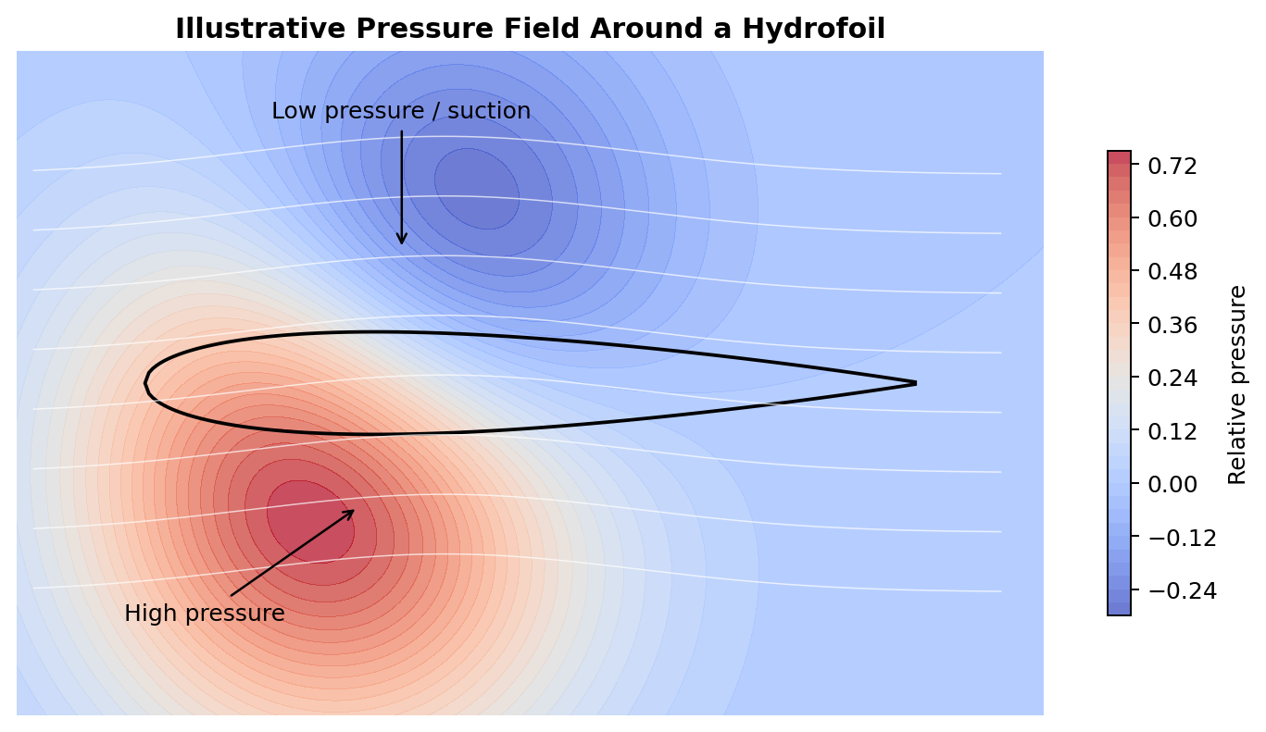

Figure 5.3: Illustrative pressure field around a hydrofoil showing high-pressure and suction regions (author’s own illustration, 2026).

5.8 Limitations of CFD Analysis
Despite its advantages, CFD possesses several limitations. The accuracy of results is highly dependent on the assumptions made regarding boundary conditions, turbulence modelling and mesh quality. Poor model selection can lead to significant inaccuracies in predicted flow behaviour.
CFD simulations can also require considerable computational resources, particularly when advanced turbulence models are employed. Furthermore, numerical results are only approximations of real-world behaviour and therefore cannot completely replace physical testing.
For these reasons, CFD results should always be validated against experimental measurements wherever possible.

5.9 Engineering Assessment
For the hydrofoil considered in this study, a RANS-based CFD approach incorporating the k-ω SST turbulence model would provide the most appropriate balance between computational efficiency and predictive accuracy. The model is capable of capturing the boundary layer development and separation behaviour that strongly influence hydrofoil performance, whilst maintaining practical simulation times.
Although higher-fidelity approaches such as LES may improve accuracy, the increased computational cost would be difficult to justify during the preliminary design stage. Consequently, the k-ω SST model represents the most suitable solution for engineering analysis of the hydrofoil.

5.10 Summary
CFD provides a powerful tool for assessing hydrofoil performance by predicting lift, drag and flow behaviour prior to physical manufacture. Several modelling approaches are available, each offering different balances between computational cost and accuracy. For this application, a RANS simulation using the k-ω SST turbulence model is considered the most appropriate option. The estimated lift force of approximately 1125 N and drag force of approximately 70 N demonstrate the ability of CFD to provide valuable insight into hydrofoil loading and performance. However, numerical predictions should always be validated experimentally to ensure confidence in the results.

Task Six

6.1 Introduction
Whilst Computational Fluid Dynamics (CFD) provides a powerful method of predicting fluid flow behaviour around a hydrofoil, numerical simulations are inherently dependent upon assumptions relating to turbulence modelling, mesh quality and boundary conditions. Consequently, experimental testing is required to validate CFD predictions and establish confidence in the accuracy of the calculated lift, drag and pressure distributions.
The primary objective of experimental validation is to compare measured hydrodynamic forces and flow characteristics with those predicted by CFD analysis. By correlating numerical and experimental data, the reliability of the simulation model can be assessed and any discrepancies identified.

6.2 Proposed Experimental Method
A suitable method for evaluating hydrofoil performance would be water tunnel testing. Water tunnels are widely used within marine and hydrodynamic research because they provide a controlled environment in which fluid flow conditions can be accurately reproduced (Faltinsen, 2005; ITTC, 2014).
The hydrofoil would be mounted within the test section of a recirculating water tunnel and subjected to a range of flow velocities representative of real operating conditions. Test velocities of 5 m/s, 7.5 m/s and 10 m/s would be selected to correspond with the Reynolds number calculations presented in Task 1.
The use of a water tunnel offers several advantages including repeatability, controlled flow conditions and the ability to collect high-quality experimental data. Compared with open-water testing, environmental variables such as wave conditions, currents and wind effects can be minimised, allowing more accurate comparison with CFD predictions.
Figure 6.1: Proposed water tunnel test arrangement.
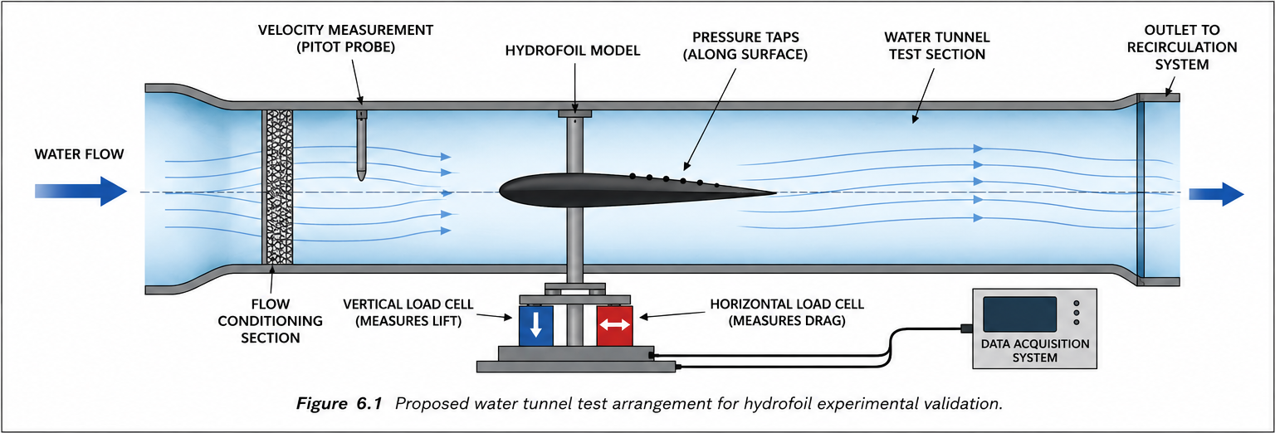
Figure 6.1: Proposed water tunnel test arrangement for hydrofoil experimental validation (author’s own illustration, 2026).
Proposed Water Tunnel Test Arrangement

6.3 Measurement Systems
To fully characterise hydrofoil performance, several key parameters must be measured during testing.
Lift Force Measurement
The lift force generated by the hydrofoil would be measured using a calibrated vertical load cell attached to the support structure. These measurements would allow direct comparison with the lift forces predicted by the CFD analysis and the estimated forces calculated in Task 5.
Drag Force Measurement
A horizontal load cell would be incorporated into the mounting arrangement to measure drag force. Drag measurements are essential when evaluating hydrodynamic efficiency, as excessive drag can reduce overall hydrofoil performance.
Velocity Measurement
Flow velocity within the water tunnel would be monitored using either a flow meter or a Pitot tube system. Maintaining accurate velocity measurements is critical because velocity directly influences Reynolds number, lift generation and drag forces.
Pressure Measurement
Pressure taps installed along the hydrofoil surface would be connected to pressure transducers. This would allow measurement of the pressure distribution across the wing and provide a means of validating CFD pressure contour predictions.

6.4 Flow Visualisation Techniques
In addition to force measurements, flow visualisation techniques can be used to investigate boundary layer behaviour and flow separation.
Dye Injection
A simple but effective technique involves injecting coloured dye upstream of the hydrofoil. As the dye passes over the wing surface, it provides a visual representation of flow behaviour and enables identification of boundary layer development, separation regions and wake formation.
Particle Image Velocimetry (PIV) (Raffel et al., 2018).
A more advanced technique is Particle Image Velocimetry (PIV). This method uses laser illumination and tracer particles suspended within the fluid to measure local flow velocities. High-speed cameras capture particle motion, allowing detailed velocity fields to be generated.
PIV provides significantly greater accuracy than dye visualisation and can be used to compare CFD velocity contours with experimental measurements. However, the technique requires specialist equipment and is therefore more costly to implement.
As shown in Figure 6.3, PIV can provide a two-dimensional velocity field that is directly comparable with CFD streamlines and velocity contours.
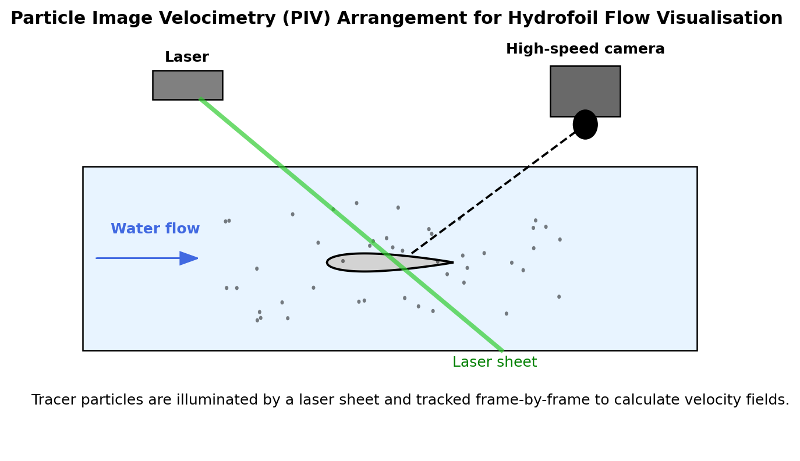
Figure 6.3: Particle Image Velocimetry arrangement for measuring flow velocity fields around the hydrofoil (author’s own illustration, 2026; based on Raffel et al., 2018).

6.5 Data Acquisition and Processing
All sensors would be connected to a central data acquisition (DAQ) system capable of recording force, pressure and velocity measurements simultaneously (Raffel et al., 2018; ITTC, 2014).
The data acquisition system would continuously record:
- Lift force
- Drag force
- Pressure distribution
- Water velocity
A sampling frequency between 100 Hz and 1000 Hz would be appropriate to capture transient fluctuations within the flow field. The recorded data would then be processed using suitable software to calculate average values, identify trends and compare experimental results with CFD predictions.

6.6 Correlation with CFD Results
The primary purpose of the experimental programme is to validate the CFD model developed during the numerical analysis stage.
Several key parameters would be compared:
Lift Coefficient Comparison
Experimental lift coefficients would be compared with those predicted by CFD simulations. Close agreement would indicate that the CFD model accurately captures the hydrodynamic loading experienced by the hydrofoil.
Drag Coefficient Comparison
Drag coefficients obtained experimentally would be compared with numerical predictions to evaluate the accuracy of the turbulence model and flow assumptions used within the CFD analysis.
Pressure Distribution Comparison
Pressure measurements obtained from pressure taps would be compared with CFD pressure contour plots. Similar pressure distributions would provide confidence that the CFD model accurately represents the flow field around the hydrofoil.
Separation Point Comparison
Flow visualisation results would be used to identify the location of flow separation. This separation point would then be compared with the location predicted by CFD simulations.
Agreement between experimental and numerical separation locations would indicate that the selected turbulence model is appropriate for hydrofoil analysis.
Figure 6.2: Example comparison between CFD and experimental lift coefficient.
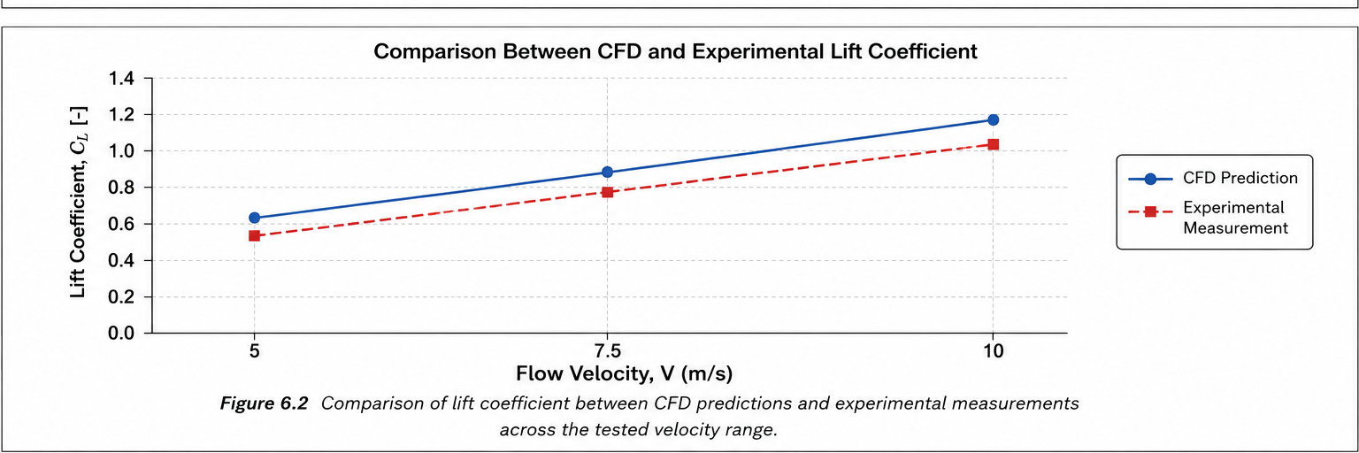
Figure 6.2: Example comparison between CFD-predicted and experimentally measured lift coefficient over the tested velocity range (author’s own illustrative graph, 2026).
Comparison Between CFD and Experimental Lift Coefficient

6.7 Sources of Error
Although experimental testing provides valuable validation data, several sources of uncertainty may influence the results.
Instrumentation Errors
Measurement errors can arise due to sensor calibration issues, electrical noise and load cell drift. Regular calibration procedures are therefore required to maintain accuracy.
Manufacturing Tolerances
Small deviations between the manufactured hydrofoil and the original CAD geometry may alter flow behaviour and affect force measurements.
Flow Quality Effects
Turbulence within the water tunnel and fluctuations in flow velocity may introduce uncertainty into the experimental results.
CFD Assumptions
Numerical simulations are influenced by turbulence model selection, mesh density and boundary condition assumptions. These factors may contribute to differences between CFD predictions and experimental observations.
It is therefore important to recognise that perfect agreement between CFD and experimental data is rarely achieved. Instead, the objective is to obtain sufficiently close correlation to demonstrate that the numerical model provides a realistic representation of hydrofoil performance (Versteeg and Malalasekera, 2007; ITTC, 2014).

6.8 Conclusion
Experimental validation is an essential component of hydrofoil development and provides confidence in the results obtained through CFD analysis. Water tunnel testing offers a practical and repeatable method for measuring lift, drag, pressure distribution and flow behaviour under controlled conditions.
By combining force measurements, flow visualisation techniques and pressure monitoring, a comprehensive understanding of hydrofoil performance can be achieved. Comparison of experimental data with CFD predictions allows verification of the numerical model and identification of any limitations within the simulation methodology.
Consequently, the integration of CFD analysis and experimental validation provides a robust engineering approach for the design and optimisation of high-performance hydrofoil structures.

References
Abbott, I.H. and von Doenhoff, A.E. (1959) Theory of Wing Sections. New York: Dover Publications.
Anderson, J.D. (2017) Fundamentals of Aerodynamics. 6th edn. New York: McGraw-Hill Education.
ASTM (2017) ASTM D3039/D3039M-17: Standard Test Method for Tensile Properties of Polymer Matrix Composite Materials. West Conshohocken, PA: ASTM International.
ASTM (2021) ASTM D7264/D7264M-21: Standard Test Method for Flexural Properties of Polymer Matrix Composite Materials. West Conshohocken, PA: ASTM International.
Bertin, J.J. and Cummings, R.M. (2014) Aerodynamics for Engineers. 6th edn. Boston: Pearson.
Campbell, F.C. (2010) Structural Composite Materials. Materials Park, OH: ASM International.
Çengel, Y.A. and Cimbala, J.M. (2018) Fluid Mechanics: Fundamentals and Applications. 4th edn. New York: McGraw-Hill Education.
Faltinsen, O.M. (2005) Hydrodynamics of High-Speed Marine Vehicles. Cambridge: Cambridge University Press.
Ferziger, J.H., Perić, M. and Street, R.L. (2020) Computational Methods for Fluid Dynamics. 4th edn. Cham: Springer.
Gibson, R.F. (2016) Principles of Composite Material Mechanics. 4th edn. Boca Raton: CRC Press.
Hoerner, S.F. (1965) Fluid-Dynamic Drag. Brick Town, NJ: Hoerner Fluid Dynamics.
Hull, D. and Clyne, T.W. (1996) An Introduction to Composite Materials. 2nd edn. Cambridge: Cambridge University Press.
ISO (2019) ISO 12215-5:2019 Small Craft – Hull Construction and Scantlings – Part 5: Design Pressures for Monohulls, Design Stresses, Scantlings Determination. Geneva: International Organization for Standardization.
ITTC (2014) Practical Guidelines for Ship CFD Applications. Recommended Procedures and Guidelines, 7.5-03-02-03. International Towing Tank Conference.
Jones, R.M. (1999) Mechanics of Composite Materials. 2nd edn. Philadelphia: Taylor & Francis.
Launder, B.E. and Spalding, D.B. (1974) ‘The numerical computation of turbulent flows’, Computer Methods in Applied Mechanics and Engineering, 3(2), pp. 269–289.
Mallick, P.K. (2007) Fiber-Reinforced Composites: Materials, Manufacturing, and Design. 3rd edn. Boca Raton: CRC Press.
Marchaj, C.A. (2003) Aero-Hydrodynamics of Sailing. 3rd edn. London: Adlard Coles Nautical.
Menter, F.R. (1994) ‘Two-equation eddy-viscosity turbulence models for engineering applications’, AIAA Journal, 32(8), pp. 1598–1605.
Munson, B.R., Okiishi, T.H., Huebsch, W.W. and Rothmayer, A.P. (2013) Fundamentals of Fluid Mechanics. 7th edn. Hoboken, NJ: John Wiley & Sons.
Pope, S.B. (2000) Turbulent Flows. Cambridge: Cambridge University Press.
Raffel, M., Willert, C.E., Scarano, F., Kähler, C.J., Wereley, S.T. and Kompenhans, J. (2018) Particle Image Velocimetry: A Practical Guide. 3rd edn. Cham: Springer.
Schlichting, H. and Gersten, K. (2017) Boundary-Layer Theory. 9th edn. Berlin: Springer.
Versteeg, H.K. and Malalasekera, W. (2007) An Introduction to Computational Fluid Dynamics: The Finite Volume Method. 2nd edn. Harlow: Pearson Education.
White, F.M. (2016) Fluid Mechanics. 8th edn. New York: McGraw-Hill Education.
Note: Figures labelled as author’s own illustration/chart were created for this report to explain the engineering principles discussed and are supported by the cited technical literature.

Table 2.1 shows that the hydrofoil operates at Reynolds numbers between 1.0 × 10⁶ and 2.0 × 10⁶, indicating a predominantly turbulent flow regime.

