Lab – Understanding Ethernet Cable Standards
Topology
Addressing Table
Device | Interface | IP Address | Subnet Mask | Default Gateway
PC-A | NIC | 192.168.10.1 | 255.255.255.0 | N/A
PC-B | NIC | 192.168.10.2 | 255.255.255.0 | N/A
Objectives
Part 1: Analyze Ethernet Cabling Standards and Pinouts
Part 2: Build an Ethernet Crossover Cable
Part 3: Test an Ethernet Crossover Cable
Background / Scenario
In this lab, you will build and terminate an Ethernet crossover cable and test it by connecting two PCs together and pinging between them. You will first analyze the Telecommunications Industry Association/Electronic Industries Association (TIA/EIA) 568-A and 568-B standards and how they apply to Ethernet cables. You will then construct an Ethernet crossover cable and test it. Finally, you will use the cable you just constructed to connect two PCs together and test it by pinging between them.
Note: With autosensing capabilities available on many devices, such as the Cisco 1941 Integrated Services Router (ISR) switch, you may see straight-through cables connecting like devices.
Required Resources
- One length of cable, either Category 5 or 5e. Cable length should be 0.6 to 0.9m (2 to 3 ft.)
- 2 RJ-45 connectors
- RJ-45 crimping tool
- Wire cutter
- Wire stripper
- Ethernet cable tester (optional)
- 2 PCs (Windows 7 or 8)
- Analyze Ethernet Cabling Standards and Pinouts
The TIA/EIA has specified unshielded twisted pair (UTP) cabling standards for use in LAN cabling environments. TIA/EIA 568-A and 568-B stipulates the commercial cabling standards for LAN installations; these are the standards most commonly used in LAN cabling for organizations and they determine which color wire is used on each pin.
With a crossover cable, the second and third pairs on the RJ-45 connector at one end of the cable are reversed at the other end, which reverses the send and receive pairs. The cable pinouts are the 568-A standard on one end and the 568-B standard on the other end. Crossover cables are normally used to connect hubs to hubs or switches to switches, but they can also be used to directly connect two hosts to create a simple network.
Reflection:
Write a research report (Max word count 600) on Cat 5e and 6 Ethernet cable standards.

Introduction
In this report I will be writing about Cat5e and Cat6 ethernet cables, and then comparing them with each other to see what is the better one to use for different scenarios.

Cat5e cables
Cat5e cables are an enhanced version of the Cat5 cable (Hence the E at the end of the name), and is mostly used in order to cable Ethernet, Fast Ethernet and Gigabit Ethernet networks. This type of cable can provide up to 100MHz performance, and can typically be used for a maximum length of up to 100 metres.
Cat 5e cables use four Unshielded Twisted Pairs (Or UTP for short) of copper wire, and use RJ45 connectors. The main difference between Cat 5 and Cat 5e is the performance requirements of the cables. Cat 5e has stricter specifications in a number of areas, such as attenuation (The reduction in signal loss) from the cable, as well as a reduction in crosstalk (Interference within the cable caused by energy from another cable).
The Cat 5e cabling standard was released in 1999, and is compatible with both the Cat 3 and Cat 5 cables. (Beal, n.d.)

Cat 6 cables
Cat 6 cables can be used as a cabling infrastructure for 10BASE-T Ethernet networks, 100BASE-TX Fast Ethernet, 1000BASE-T Gigabit Ethernet and 10GBASE-T 10-Gigabit Ethernet networks. Cat 6 cabling allows for performance of up to 250MHz, however the newer standard, Cat 6a can reach up to 500MHz. These cables, like Cat5e can be used for up to 100 metres, however, they can only be used for up to 55 metres for 10GBASE-T (10 Gigabit Ethernet) networks.
The Cat6 standard was released back in 2002, and is compatible with Cat 3, Cat 5 and Cat 5e cables. Just like Cat 5 and 5e cables, cat 6 uses unshielded twisted pairs of copper wire to build the cable, with the same RJ45 connectors at the end.
Cat 6 supports higher performance than cat 5 cabling, and it also has stricter specifications for things such as crosstalk, interference and system noise, and the connection should not be as affected by these factors. (Beal, n.d.)

So, which to use?
This can be determined in many different ways, such as the cost of the cable, the speed and the performance of the cable. In this section, I will be comparing and determining which is the better one to use.
The costs of the cables are very similar, the cost of cat6 cabling is around 20% more expensive than cat5 cabling, so it depends on whether a user would want to spend that little bit more. Cat5e only supports speeds of up to 100MHz, while Cat6 supports up to a maximum of 500MHz, so it all comes down to whether a user would want to spend a little more for a much faster cable.
One downside to cat6 cabling is it only supports Gigabit Ethernet with a cable length of around 55 metres, which is shorter than the 100 metres for Cat5e. So, for the user it depends how far they need the cable to go. If only Gigabit Ethernet is needed, then Cat5e would probably be a more sensible choice.
Cat5e may have more interference than a Cat6 cable, and a cat6 cable has a higher Signal to Noise Ratio (SNR), meaning that there is a much higher amount of information being carried than there is interference. (Merritt, 2010)
So, in conclusion, if the network is required to be fast, with minimal interference, then cat 6 cabling may be better, despite the cabling having to be shorter.
For a network such as a home network, Cat5e cabling should suffice as a fast connection is not usually required within a home network, and it would work out cheaper for the user.

References
Beal, V., n.d. What is Cat 5e?. [Online]
Available at: https://www.webopedia.com/TERM/C/Cat_5e.html#
[Accessed 5 12 2019].
Beal, V., n.d. What is Cat 6?. [Online]
Available at: https://www.webopedia.com/TERM/C/cat_6.html
[Accessed 5 12 2019].
Merritt, T., 2010. How to pick the right cables for your home network. [Online]
Available at: https://www.cnet.com/how-to/how-to-pick-the-right-cables-for-your-home-network/
[Accessed 5 12 2019].

  - Analyze diagrams and tables for the TIA/EIA 568-A standard Ethernet cable.
The following table and diagrams display the color scheme and pinouts, as well as the function of the four pairs of wires used for the 568-A standard.
Note: In LAN installations using 100Base-T (100 Mb/s), only two pairs out of the four are used.
568-A 10/100/1000Base-TX Ethernet
Pin Number | Pair Number | Wire Color | 10Base-T Signal  100Base-TX Signal | 1000Base-T Signal
1 | 2 | White/Green | Transmit | BI_DA+
2 | 2 | Green | Transmit | BI_DA-
3 | 3 | White/Orange | Receive | BI_DB+
4 | 1 | Blue | Not Used | BI_DC+
5 | 1 | White/Blue | Not Used | BI_DC-
6 | 3 | Orange | Receive | BI_DB-
7 | 4 | White/Brown | Not Used | BI_DD+
8 | 4 | Brown | Not Used | BI_DD-

The following diagrams display how the wire color and pinouts align with an RJ-45 jack for the 568-A standard.
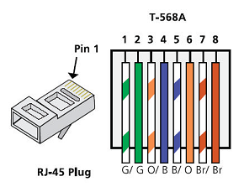
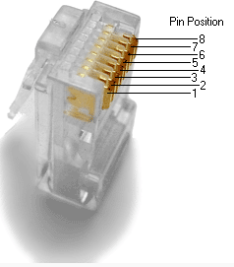
  - Analyze diagrams and tables for the TIA/EIA 568-B standard Ethernet cable.
The following table and diagram display the color scheme and pinouts for the 568-B standard.
568-B 10/100/1000-BaseTX Ethernet
Pin Number | Pair Number | Wire Color | 10Base-T Signal  100Base-TX Signal | 1000Base-T Signal
1 | 2 | White/Orange | Transmit | BI_DA+
2 | 2 | Orange | Transmit | BI_DA-
3 | 3 | White/Green | Receive | BI_DB+
4 | 1 | Blue | Not Used | BI_DC+
5 | 1 | White/Blue | Not Used | BI_DC-
6 | 3 | Green | Receive | BI_DB-
7 | 4 | White/Brown | Not Used | BI_DD+
8 | 4 | Brown | Not Used | BI_DD-
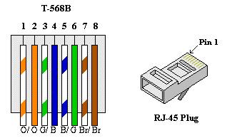

- Build an Ethernet Crossover Cable
A crossover cable has the second and third pairs on the RJ-45 connector at one end, reversed at the other end (refer to the table in Part 1, Step 2). The cable pinouts are the 568-A standard on one end and the 568-B standard on the other end. The two following diagrams illustrate this concept.
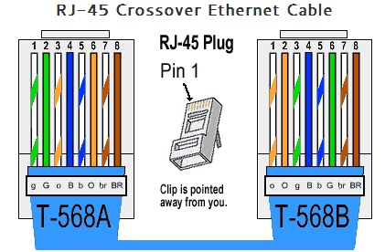
  - Build and terminate a TIA/EIA 568-A cable end.
    - Determine the cable length required. (Your instructor will let you know the cable length you should make.)
Note: If you were making a cable in a production environment, the general guideline is to add another 12 in. (30.48 cm) to the length.
    - Cut off a piece of cable to the desired length and using your wire stripper, remove 5.08 cm (2 in.) of the cable jacket from both ends.
    - Hold the four pairs of twisted cables tightly where the jacket was cut away. Reorganize the cable pairs into the order of the 568-A wiring standard. Refer to the diagrams, if necessary. Take as much care as possible to maintain the twists in the cable; this provides noise cancellation.
    - Flatten, straighten, and line up the wires using your thumb and forefinger.
    - Ensure that the cable wires are still in the correct order for the 568-A standard. Using your wire cutters, trim the four pairs in a straight line to within 1.25 to 1.9 cm (1/2 to 3/4 in.).
    - Place an RJ-45 connector on the end of your cable, with the prong on the underside pointing downward. Firmly insert the wires into the RJ-45 connector. All wires should be seen at the end of the connector in their proper positions. If the wires are not extending to the end of the connector, take the cable out, rearrange the wires as necessary, and reinsert the wires back into the RJ-45 connector.
    - If everything is correct, insert the RJ-45 connector with cable into the crimper. Crimp down hard enough to force the contacts on the RJ-45 connector through the insulation on the wires, thus completing the conducting path. See the following diagram for an example.
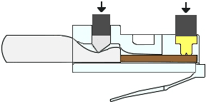
  - Build and terminate a TIA/EIA 568-B cable end.
Repeat steps 1a to 1g using the 568-B color wiring scheme for the other end.
- Test an Ethernet Crossover Cable
  - Test the cable.
Many cable testers will test for length and mapping of wires. If the cable tester has a wire map feature, it verifies which pins on one end of the cable are connected to which pins on the other end.
If your instructor has a cable tester, test the crossover cable for functionality. If it fails, check with your instructor first as to whether you should re-cable the ends and re-test.
  - Connect two PCs together via NICs using your Ethernet crossover cable.
    - Working with a lab partner, set your PC to one of the IP addresses shown in the Addressing Table (see page 1). For example, if your PC is PC-A, your IP address should be set to 192.168.10.1 with a 24-bit subnet mask. You partner’s IP address should be 192.168.10.2. The default gateway address can be left empty.
    - Using the crossover cable you made, connect the two PCs together via their NICs.
    - On the PC-A command prompt, ping the PC-B IP address.
Note: The Windows firewall may have to be temporarily disabled for pings to be successful. If the firewall is disabled, make sure you re-enable it at the conclusion of this lab.
    - Repeat the process and ping from PC-B to PC-A.
Assuming IP addressing and firewall are not issues, your pings should be successful if the cables were properly made.
Reflection
  - Which part of making cables did you find the most difficult?
  - For me, the most difficult part about making the cables was putting the connector onto the end of the cable, connecting the wires into their specific ports on the connector
  - Why do you have to learn how to make a cable if you can easily buy pre-made cables?
Because cables of different lengths may be needed, and cables may need to be cut. Learning how to make cables can allow the user to cut and put the connectors on correctly. This could also help when cables are not easily or readily available.

