‘Corporate Social Responsibility reporting in the UK supermarket industry, case study of Aldi’
Dissertation Proposal Matthew Rothwell – P150153

Contents Page

- Research Proposal Page 3
  - Topic Page 3
  - Title Page 3
  - Aims and Objectives Page 3
  - Rationale Page 3
  - Background Page 3-4
  - Literature Review Page 4-5
- Research Design and Methodology Page 6
  - Research Design Page 6
  - Methodology Page 6-7
  - Quantitative and Qualitative Page 7
  - Paradigm Page 7
  - Sample Page 7
- Data Analysis and Collection Page 8
  - Collection Method Page 8
  - Limitations Page 8
  - Risks and Ethical Issues Page 8
- Planning and Time Management Page 9
  - Time management and Resources Page 9
- Appendix and Figures Page 10
- Bibliography Page 11-12

Research Proposal

1.1 Topic
In this dissertation the author will report the topic of Corporate Social Responsibility (CSR) within the UK supermarket industry, conducting a case study on Aldi.

Title
The title of this thesis will be “Corporate Social Responsibility reporting in the UK supermarket industry, case study of Aldi”.

Aims and objectives
The aims and objectives of this dissertation will be:
1) Inspect the Corporate Social Responsibility significance within the supermarket sector in relation to consumer buying preferences.
2) Scrutinise the Corporate Social Responsibility practices, within Aldi.
3) Determine and critique the Corporate Social Responsibility issues within the supermarket industry, with an application to Aldi.

1.4 Rationale
The emergence of the German supermarket chain Aldi in the UK, with public CSR reports will allow the research of the principles within the business practices in relation to consumer preferences. Jonker (2005, pg.20) states the CR is ‘a ‘sensitising concept’: a term that draws attention to the complex range of issues and elements that are all related to the position and function of the business enterprise in contemporary society’. The developments and changes to the real value of the CSR to the consumers and customer buying preferences within the retail industry. Pomering (2009) states ‘studies indicate that consumer attitudes and purchase intentions are influenced by CSR initiatives – if consumers are aware of them.’ These statements appropriate the research presented as CSR is constantly developing.

Background
Aldi has risen from a small percentage of the supermarket market share, to becoming a main competitor to the likes of Tesco, Sainsbury’s and Asda, there was a notion of a ‘big 4/5’ but as documented by McKevitt, who headed the of retail and consumer insight at Kantar Worldpanel, said: “Just a decade ago Aldi was the UK’s 10th largest food retailer, accounting for less than 2% of the grocery market. Since then the grocer has grown rapidly, climbing the rankings by an impressive five places.” (Cahill, 2017) This rise within the industry, is due the business strategy and ethos of the company. It is well documented the CSR within the business, with constant updates online within the Corporate responsibility section of the website stating:
‘It is up to us to take responsibility and make a positive difference to the world. We love our environment, communities and people we work with, which is why we try to do amazing things every day. Our corporate responsibility plan is driven by 5 principles- community, people, customers, suppliers and environment. It’s about making sure that what you buy has been grown, caught or made with ultimate care for the environment and that workers are treated fairly. It’s also about our incredible suppliers, being fairer to farmers, raising money for great causes, inspiring kids to eat fresh, sourcing sustainable foods and reducing waste. Ultimately, it’s about making sure that together with our customers we feel Everyday Amazing.’ (Aldi, Corporate responsibility)
The supermarket industry within the UK consists of different types of strategies, approaches and array of different business models. In the past few years the emergence of ‘discount’ supermarkets, such as Aldi has taken the supermarket industry by ‘storm’ due to the approach of discounting and stocking mainly own branded products. The implementation of the strategies which allow the companies stated to become competitive within in a dense sector, which includes the price point and sourcing of products. ‘To prosper among the intense competition requires consumer savvy and excellent operations. Aldi have mastered both.’ (Loeb, 2013)
- The Aldi website has public content about the CSR and business objectives , within the about us section the following statements can be found ‘We’re one of the UK’s fastest-growing supermarket chains’ in addition to the previous statement there is signs of the CSR practices in place in the ensuing section ‘Our pay and benefits are the highest in the sector, and we’re renowned for our training programmes (for example, we’re No.3 in the Times Top 100 Graduate Employers). But it’s so much more than that. So many of our 30,000 people have fallen in love with our ethos, the way we do business, and everything that we stand for. We’re getting things right, and you could be part of it.’ (Aldi recruitment) The practice of CSR within Aldi has developed as the business in the UK has developed from the early stages then the introduction of fresh products from the UK, ‘In fact 100% of our fresh everyday meat and poultry in the UK is from British, Red Tractor approved farms. More than 40% of the fresh fruit and vegetables we sell in the UK are also British’ (Aldi Supply Chain) to now involving CSR practices across all stores daily.

Literature Review
‘While the role of business in society seems to have been changing for some time, there is no agreement among observers on what corporate social responsibility (CSR) stands for or where the boundaries of CSR lie.’ (Frynas 2009. Pg.3) yet there are highly remarked ‘definitions’ with the basis similar,
This dissertation will be using the directional tools, theories and definitions of Carroll’s due to the worldwide recognized research, academic literature within the understanding of CSR and its ever growing, changing state on businesses, Carroll (2015) states that there are ‘four components of CSR’ which are the following ‘economic, legal, ethical and philanthropic’
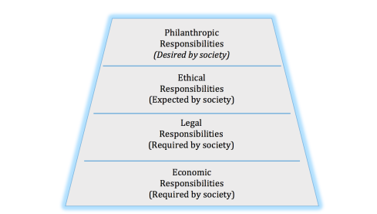

Figure 1.6.1 the four components Source: Adopted from Carrol, A.B. 1991.
The four components are to put into perspective in a theoretical way which is the pyramid of Corporate Social Responsibility, it enables ‘A CSR or stakeholder perspective would focus on the total pyramid as a unified whole and on how the firm might engage in decision, actions, policies, and practices that ‘simultaneously’ fulfil its four component parts’ (Carroll, 2015. Pg36)

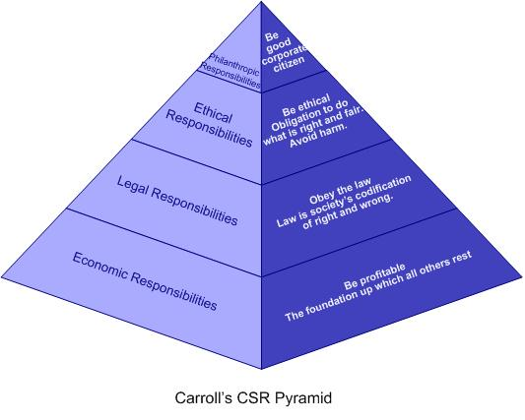

Figure 1.6.2, The pyramid of Corporate Social Responsibility. Source: (Carroll, 2015. Pg36)
The dissertation will use this pyramid concept as a basis for the CSR approach within this research. Implementing the theory against the CSR principles and practices within ALDI, with the use of the CR principles statement document which is available to the public (Aldi CR Report 2017)

‘Now retailing is the domain of corporate strategy, format strategy, marketing strategy, international strategy’ Reynolds and Cuthbertson (2004 pg.4) continuing on to state ‘In a strategic sense, retailers are concerned with growing larger and faster than their competitors, being different from the competitors’ this allows the understanding towards the different strategy in which Aldi has differenced itself from the other business concluding ‘gaining efficiencies in systems and procedures.’ These systems and procedures are related to the CSR Aldi due to the fact of the importance of the CSR based into the strategies, this is done by the full implementation of the ethos combined with CSR. ‘Our corporate plan is driven by 5 principles’ (Aldi, Corporate responsibility) as state previously, it highlights that the supply chain is key to the strategy this supply chain then contains links to a vast area of certifications and improvement which have happened internally. For example the ‘Sustainable improvement requires trust and cooperation between suppliers, production facility management and workers.’ (Aldi, safety in Bangladesh) ‘The Aldi Factory Advancement Project is a capacity building programme we introduced to improve the working conditions in the textile and garment industry in Bangladesh.’ This is one example of the CSR principles in place which benefits the business strategy, there are more which the researcher will investigate with this area, interlinking consumer buying preferences, to understand whether these CSR tools, are engaging with consumer choices of supermarkets.

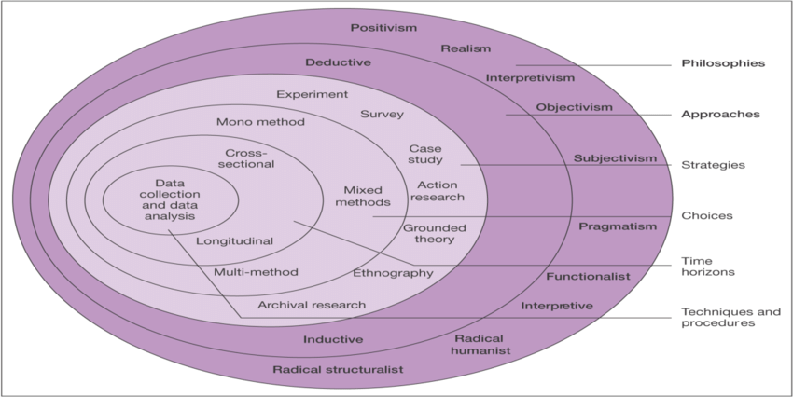

Research Design and Methodology

2.1 Research design

Research can be considered as ‘something that people undertake in order to find out things in a systematic way, thereby increasing their knowledge’ (Saunders, et al, 2009, pg.5) in addition ‘Research is based on logical relationships as opposed to beliefs, and purpose encompasses providing descriptions, explanations, understanding, criticisms and/or analysis’ (Ghauri & Gronhaug, 2005)

Figure 2.1, The Research Onion. Source: (Saunders, et al. 2009)
The core of the onion depicts data collection and analysis, and will be addressed by the researcher. The approach will be cross-sectional in nature as the research will be conducted at a specific point in time, using a mix method in the first form of an online questionnaire to gather quantitative data from a larger sample giving a wide scope of information allowing the philosophy of known as positivism. The researcher will also use a philosophical approach known as ‘Interpretivism’ by investigating the thought of individuals in-depth by conducting interviews.

Methodology
Deductive and inductive, these two are common methodology within research reports which enable different types of research. Trochim (2006) mentions the two ‘broad methods of reasoning as the inductive and deductive approaches. He defines induction as moving from ‘the specific to the general, while deduction begins with the general and ends with the specific; arguments based on experience or observation are best expressed inductively, while arguments based on laws, rules, or other widely accepted principles are best expressed deductively. ‘The researcher will be using these methods of research to analyse the data and to investigate different paths of the research topic, the methods allow a overall insight into the CSR within Aldi.
Anova research, is a ‘statistical technique that assesses potential differences in a scale-level dependent variable by a nominal-level variable having 2 or more categories.’ (Statistics Solutions. 2013) This approach to research allows the researcher to test results of different questionnaires within different situations against one another, to comparison the data efficiently.
Likert (1932) developed the principle of measuring attitudes by asking people to respond to a series of statements about a topic, in terms of the extent to which they agree with them, and so tapping into the cognitive and affective components of attitudes. Likert-type or frequency scales use fixed choice response formats and are designed to measure attitudes or opinions (Bowling, 1997; Burns, & Grove, 1997). These ordinal scales measure levels of agreement/disagreement. The researcher will use the Likert scale as a model for data collection as it is suitable for the data required by the researcher, such as attitudes towards CSR.

2.3 Quantitative and Qualitative Analysis
Qualitative research is ‘a uniquely useful method of find out about people, what they think, feel, hope, believe and understand’ Marks (2000, vii) ‘it enables us to explore beneath the surface and to consider why people do what they do.’ The observations made from interviews for examples allow and in-depth perception with a certain area, attaining precise knowledge from an individual deemed perhaps an ‘expert’ within the field who comprehends the content. Hence, qualitative research approach provides abundant data about real life people and situations (De Vaus, 2014, p6; Leedy and Ormrod, 2014).
Quantitative research often translates into the use of ‘statistical analysis to make the connection between what is known and what can be learned through research. Collecting and analysing data using quantitative strategies requires an understanding of the relationships among variables using either descriptive or inferential statistics. Descriptive statistics are used to draw inferences about populations and to estimate the parameters of those populations’ (Trochim, 2006).

2.4 Paradigm
Johnson and Clark (2006) highlight the significance of the philosophical obligations made by the selection of the research tactic, citing the substantial impact it has on the implementation and understanding of what is being inspected. This study adopts the ‘Interpretivism’ philosophy alongside an approach known as the ‘positivism’ philosophy, this is due to the researcher understanding the importance of both philosophy’s in relation to the research topic, as it permits an unspoilt observation, with the aspects of two approaches combined it will allow a greater understanding from two different philosophical approaches. The philosophies will be used to gather data differently, interpretivism for the interviews and positivism for the closed questions in the questionnaire.

Sample
The researcher will conduct statistical sampling, which is defined as ‘a process that allows inferences about properties of a large collection of things (commonly described as the population), to be made from observations made on a relatively small number of individuals belonging to the population (the sample).’ (F. W. Whicker et al, 2006 pg. 25) This will allow a large collection of data which the researcher can use in the most methodical way.

Data analysis and Collection

3.1 Collection method
‘In quantitative research, data can be collected from many participants at many research sites. Researchers rely on gathering information either by sending or administering testing instruments to participants. Data is usually collected through the use of numbers which can be statistically analysed. In qualitative research, the words and images of a few participants collected at their respective research sites, are recorded by the researcher’ (Creswell & Plano Clark, 2007).
The researcher of this thesis will focus on conducting qualitative data using the methods of an interview with a limited number of Aldi staff members, across different levels of job role/titles within store operations. This will able an understanding of the daily importance of CSR and the internal commitment to the principles Aldi base themselves on. This method will be conducted by the researcher with ethical issues in mind based on the content of the interviews, it is appropriate to the research to understand the individual employee perception of CSR.
This research will conduct a process of quantitative data collection method in a form of a questionnaire, online and paper approaches. The software used for the gathering of the online questionnaire will be ‘Surveyhero’ also the format for the paper questionnaire will be the exact same. It will distributed openly, on social media, this method of collection is appropriate to the research due, this is because it gives the advantage of a large amount of data in the best economical way. A focus group will also be undertaken by the researcher to gather quantitative data from a different area, with a hope of more precise information. Creswell (2005) recognises two categories of statistical analysis: descriptive and inferential. He states that researchers require “descriptive statistics that indicate central tendencies in the data (mean, mode, median), the spread of scores, or a comparison of how one score relates to others’. In addition, he says that ‘analysing the data might also identify the variables: independent, dependent, control, or mediating.’

3.2 Limitations
Within any research topic there are limitations and the key boundary in this study is the limited time-frame to conduct the primary research. As it such a vast range of research, the collection will be short therefore the process of analysation can commence. The sample used may not be an even balanced representation of the extensive population due to exposed access, without singling out one ‘cluster’ of the population, yet it is the most effective sample to implement within the time-frame. These limitations of time, will be moderated by the researcher by producing a Gantt chart to develop the time administration, see appendix 5.1 and using resources made accessible by the university to assist this research.
There could be limitations within the release of data of the CSR principles in the daily running of the supermarkets as Aldi have guidelines for employee’s knowledge and practices which are done internally.

Risks and Ethical issues
The researcher is aware of possible risks and ethical issue within this research paper, the following are the key issues:
Firstly, the collection of data under the Data protection act (2018) making sure the collection, storing and use of data is in line with the law and regulations.
Secondly, understanding that the methods of collection can put individuals involved under pressure, causing negative effects or views on for example: job roles within a business.

4.0 Planning and time management

4.1 Time management and Resources

The researcher will use a Gantt chart (see appendix 5.1) this will allow the researcher the ability to track progress and keep up to date with the research tasks.,
Recourses required by the researcher will not be a cost due to the fact that the Swansea Metropolitan University has a library sufficient in the literature required. The data collection tool ‘Surveyhero’ is free for use.

5.0 Appendix and Figures

Appendix 5.1 Gantt Chart,

Figures
1.6.1 the four components Source: Adopted from Carrol, A.B. 1991.
1.6.2, The pyramid of Corporate Social Responsibility. Source: (Carroll, 2015. Pg36) Business & Society, 2015, Cengage Learning.
2.1, The Research Onion. Source: (Saunders, et al. 2009)

6.0 Bibliography

Books/Journals

(Bowling, 1997; Burns, & Grove, 1997) - Bowling, A. (1997). Research Methods in Health. Buckingham: Open University Press.
(Carroll, 2015. Pg36)- Business & Society, 2015, Cengage Learning.
(Creswell & Plano Clark, 2007). - Creswell, J.W., & Plano Clark, V.L. (2007). Designing and conducting mixed methods research. Thousand Oaks, CA: Sage Publications
(De Vaus, 2014, p6; Leedy and Ormrod, 2014) - Surveys in Social Research. (6th ed). Australia: UCL Press.
(F. W. Whicker et al, 2006 pg. 25) – 3 General Sampling concepts and principles, Journal of the International Commission on Radiation Units and Measurements, Volume 6, Issue 1, 1 June 2006, Pages 25–34
(Frynas 2009. Pg.3) – Jedrzej G.Frynas, Beyond Corporate Social Responsibility, 2009. Pg.3. Cambridge University press.
(Ghauri & Gronhaug, 2005) – Ghauri, P & Gronhaug, K. 2005. Research Methods in business studies: A practical guide. 3rd ed. Harlow: Financial Times Prentice Halls.
(Saunders, et al, 2009, pg.5) – Saunders, M. & Philip, L. 2012. Doing research in business & management. 1st edition Harlow: Pearson Education Ltd.
(Trochim, 2006) - Inductive and Deductive Research Approaches 6 2006
Creswell (2005) – Educational Research: Planning, conducting, and evaluating quantitative and qualitative research. Merril
Johnson and Clark (2006) – Johnson, P. & Clark, M. 2006. Business and Management Research. 1st ed. London: Sage.
Jonkers, J. 2005 – CSR wonderland: navigating between movement, community and organisation, Journal of corporate citizenship, no 20. Winter, pg.19-22
Marks (2000, vii) – Laura Marks, Qualitative Research in context. Introduction vii. 2000, Admap Publications.
Reynolds and Cuthbertson (2004 pg.4) – Retail Strategy, the view from the bridge, 2004. Elsevier Butterworth-Heinemann
Online
(Aldi CR Report 2017) - https://cr.aldisouthgroup.com/en/cr-portal/simply-responsible/cr-principles (last accessed 16/11/18)
(Aldi Recruitment) - https://www.aldirecruitment.co.uk/about-us/ (last accessed 16/11/18)
(Aldi Supply Chain) - https://www.aldi.co.uk/about-aldi/corporate-responsibility/suppliers/british-sourcing
(Aldi, Corporate responsibility) - https://www.aldi.co.uk/corporate-responsibility (last accessed 16/11/18)
(Aldi, safety in Bangladesh) - https://www.aldi.co.uk/about-aldi/corporate-responsibility/suppliers/safety-in-bangladesh
(Cahill, 2017) – http://www.cityam.com/258562/aldi-just-became-uks-fifth-largest-grocer (last accessed 15/11/18)
(Loeb, 2013) - https://www.forbes.com/sites/walterloeb/2013/10/30/why-aldi-and-lidl-have-what-it-takes-to-beat-the-best-and-the-biggest/#7be7df5f5d23
(Statistics Solutions. 2013) ANOVA [WWW Document]. Retrieved from http://www.statisticssolutions.com/academic-solutions/resources/directory-of-statistical-analyses/anova/ (last accessed 16/11/18)
Data protection act (2018) - http://www.legislation.gov.uk/ukpga/2018/12/contents/enacted
Pomering, A. & Dolnicar, S. J Bus Ethics (2009) 85(Suppl 2): 285. https://doi.org/10.1007/s10551-008-9729-9
Trochim, W.M.K. (2006) - https://www.socialresearchmethods.net/ (last accessed 16/11/18)

