Kaleb Bartholomew
University of wales trinity saint david Swansea
Fundamentals of Construction technology (Acba4001)
Site Investigation Case Study
Contents
No table of contents entries found.

The site to be investigated is located in Swansea (SA1) near the docks. The area highlighted blue and labelled E9 illustrates the area that is to be analysed.

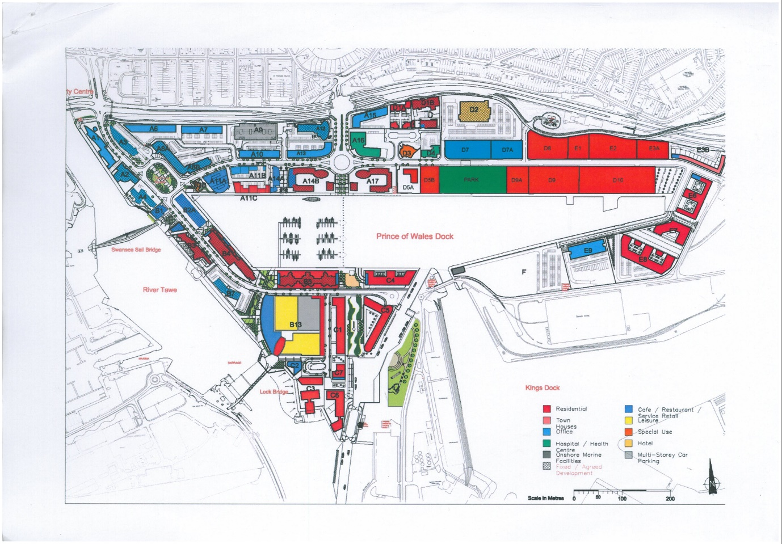
Image 0.1

I apologise for this assignment, at the start of the Christmas break I received a call from my aunt in London and was told that there was a family emergency. Since then I have been in London helping my aunt with the situation and have been on the go with hardly any rest since I got there. I got back to Swansea today and only had time to leave my luggage before heading to class this afternoon. As a result of the situation, I was unable to make any progress in my assignment and I am sorry for that. This is not to look for any pity as I know it is my decision to help my family. I just wanted to let you know the reason there is no work done on the assignment so that you know it isn’t because I don’t care. Thank you and I would do my best to make up for it in the assignment this semester. I apologise again.

