
Skills for the Workplace
Module Assignment Submission
Student Name: | Alhaj Moqaddas
Student Number: | 1807602
Module No: | BMSK6001
Module Title: | EMERGENT LEADERSHIP SKILLS FOR THE WORKPLACE

Statement of Confirmation of Authenticity
By the act of making this submission, the student declares that this is the work of the student named above. The work has not, in whole or in part, been knowingly presented elsewhere for assessment, or where assessment has been built on a previous assessment, this has been identified. Where materials have been used from other sources it has been properly acknowledged. If this statement is untrue, the student acknowledges that an assessment offence has been committed.
Attention is drawn to the plagiarism and unfair practice policies of both the University and of ILM.

Table of Contents
Introduction 3
The ability to use a range of leadership styles 3
Importance of leadership model to impact on the performance of individual 7
Assessing own ability of setting direction, motivation, and delegation 11
Conclusion 14
References 16

Introduction
Leadership is an important part of management and it is helpful in maximising efficiency with respect to an organisation. An effective leader is very important for setting a clear vision. It is the duty of the leader to provide a clear idea about the vision of the company to the employees because it is significant for the employees as well. A leader must have different kinds of skills because a leader has to deal with different kinds of people. Motivation is one of the most important skills which is essential for the team member to boost their activities. Decisiveness, integrity as well as problem-solving skills are some of the most important leadership skills. All these skills are very important for team development.
Considering present times it can be said that most of the organisations prefer a team working. Apart from that, self-development is another skill which needs to be mentioned in this context. Communication is a skill that needs to be addressed in this regard. Proper communication skill is important in a workplace so that the team member cannot be afraid to let their problem known to the leader. Considering all these factors, the study will discuss my ability with respect to using different types of leadership styles. A Leadership model will be discussed in this context to understand the impact of this model on the performance of the individuals. Furthermore, I will assess my ability for setting direction and providing motivation. It is also important for delegating and empowering others for bringing change in the workplace.

The ability to use a range of leadership styles
Authoritarian leadership
Authoritarian Leadership is a style of leadership in which the total procedure is controlled by only one person (Hoch and Dulebohn, 2017, p.680). In other words, I want to say that under this leadership style, the leader is responsible for decision-making. In order to assess me in this particular leadership style, I took the help of a self-assessment process. From that, I can say that my score of mine in this leadership skill is high. Therefore I can say that I have the skill to follow this leadership in a proper way. I think decision-making skill is one of the most important skills that one needs to have for this particular leadership style. The skill related to policymaking is also required and I have this skill and I can say it from my previous experiences in the workplace. While performing as an authoritarian leader, I had to take responsibility for making every kind of decision, and in this way, the pressure was also created. From that context, I want to mention the importance of self-management skills.
In my opinion, self-management skills are very important for the reduction of stress. It is very important for dealing with various kinds of situations as well as people. Time management is also an important skill which has an association with this leadership skill. However, I think that I need to bring improvement in this particular skill. Being an authoritarian leader, I was responsible for taking any kind of decision. Many times I had to make decisions in more than one and this is within a short span of time. In that case, I found it quite problematic and therefore I have already started to give enough attention. The process which should be followed by the team members needs to be decided by an authoritarian Leader (Cherkowski and Schnellert, 2017, p.18). I think I am efficient to decide on a short process for a short-term project. However, I cannot say the right procedure when it comes to a long project. Considering all these factors, I can say that I am not very good under an authoritarian leader. This is the reason for which I was not able to get a high score under authoritarian leadership.
Under this particular leadership style, group members are always directly supervised by the leader. Therefore I think I need to bring improvement in some of the skills. The aspect of self-confidence is also an important fact that I want to mention. The aspect of empathy also cannot be ignored. More specifically, it can be said that the aspect of empathy helps in understanding the emotional factor of employees (Gerpott et al. 2018, p.525). When I started working as an authoritarian leader, I could not understand this fact in a proper way. However, with time I was able to develop myself and it helped me to deal with all sorts of people in the workplace. I was able to build a good relationship with the team members.
Democratic Leadership
Democratic and authoritarian Leadership styles are two different kinds of leadership styles. However, I had to perform as a democratic leader as well as per the situation.
- Under a democratic leadership style, decisions are not taken by only the leader (Carnabuci et al. 2018, p.120). However, I want to mention that a leader should have the ability to understand which opinions of the team members should be taken and which are not. From that context, I want to mention the importance of conceptual skills. Considering this particular skill, I want to mention that I am efficient in this particular skill and the high score on this particular skill can be considered as proof.
- I want to mention the significance of interpersonal skills. I have the ability to predict the response of the people about my idea. I can understand the emotional factors of the team members and I can identify it as my strength. This is one of the most significant reasons which helped me to conduct democratic leadership in a proper way (Western, 2018, p.50). The members of my team started to engage from the very first day and it is a great success for me. In that context, I want to mention that in order to develop interpersonal skills, I used a communication model. Within a very short period of time, I was able to overcome the problem related to communication. Communication is a very important factor in democratic leadership.
- Encouragement of creativity and provision of reward are some of the most important features of democratic leadership (Laleka, 2019, p.230). Considering that aspect I want to mention that I could not encourage creativity all the time. This is due to the fact that I did not use emotional energy to motivate employees all the time. However, I want to mention that I did not discourage them. However, encouragement might help in increasing productivity to a great extent. I think I should give proper focus on this particular factor.
- Though under democratic leadership style, it is not required to take all the actions and decisions by the leaders only, the importance of administrative skill cannot be ignored (Lindner and O’Brien, 2019, p.82). I observed that when I gave a chance to make any decision about any particular topic, some of the employees took a long time to make a decision. I was able to solve the problem with the help of administrative skills. The score related to this particular skill is very high and it can be said from the self-assessment process.
- While working I found sometimes that I was unable to solve some of the intricate problems coming from team members. I also faced a problem when lots of ideas came from the team members. I think this should not be continued for a long time. This is due to the fact that it reduces the quality of a democratic leader (Rubinstein, 2017, p.160). I am efficient in conflict resolution ability but I think with the improvement of this particular problem, I can develop myself in the skill of conflict resolution in a more appropriate way.
Laissez-Faire Leadership
Laissez-Faire Leadership is also an important leadership and I had to perform as a Laissez-Faire Leader in another organization. The feature of this leadership can be properly understood from the following figure.
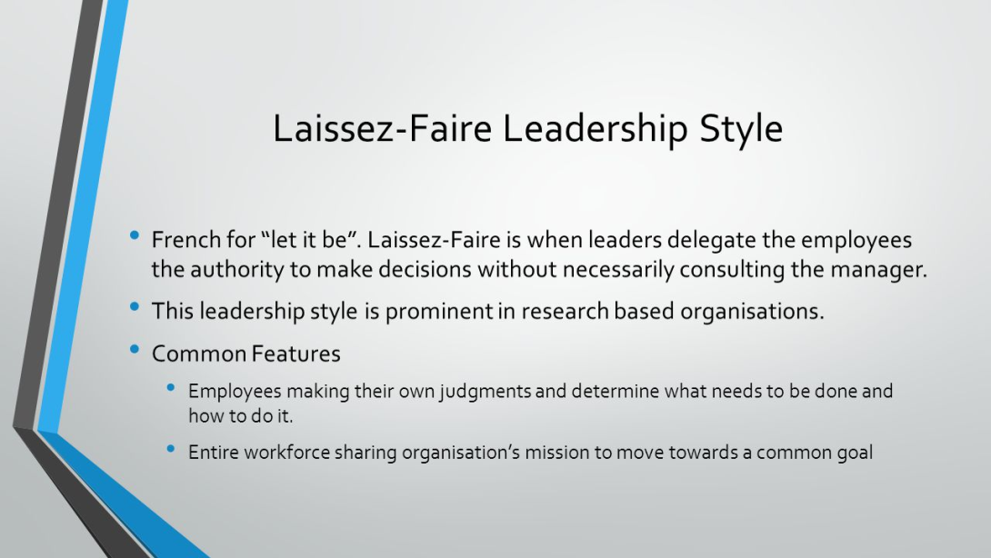
Figure 1: Features of Laissez-Faire Leadership
(Source: Shields, 2021)
Considering the above figure, it can be said that the role of the leader is very less under this kind of leadership. However, for that, it is very important to have confidence about the ability of the employees. However, I was not able to build trust in employees. Under this leadership style, employees are responsible for making decisions (Baptista et al. 2020). However, I sometimes interrupted and tried to convey my decision. This is due to the fact that I thought that I could better make decisions related to the situations. I can say it based on the score on different kinds of skills from the self-assessment process. In order to deal with situations, it is important to take decisions whenever necessary.
As I could not do it, I was unable to conduct this leadership style in a proper way. This is the reason for which I had to face conflict many times. I observed that the performance of the employees with respect to this particular organization was significantly low. However, I could not do anything as I was told not to change my leadership style. In my opinion, in order to be a laisse-fair leader, very few skills are required. However, a leader who has a different kind of skill, found it difficult to adopt this leadership skill (Acton et al. 2019, p.147). Considering the above points, I want to mention that I have many skills and abilities to incorporate various types of leadership styles. However, I cannot say that I am an expert in all kinds of leadership styles. From that respect, it can be said that I am not very expert in handling different kinds of situations.
Based on the self-assessment process, I can say that all the required skills related to leadership such as administrative skills, interpersonal skill as well as conceptual skills are already incorporated within me. However, these skills are not very high. I want to make myself in such a way so that I can adopt any kind of leadership style in the near future. It is important to change the leadership style according to the situation and people (Kilduff et al. 2017, p.223). In that context. I want to mention transformational leadership as well. Therefore I think it is very important to upgrade those skills. When a problem arises, I cannot address those problems within a very short span of time. However, I think it should be incorporated as a quality of a leader. Apart from that, I also want to mention that I should develop the skill of seeing the big picture. This is because a leader places a high position with respect to an organization. The ability of conflict resolution is another important factor that I also do not want to ignore because it is the fundamental quality of an effective leader.

Importance of leadership model to impact on the performance of individual
There are different kinds of leadership models that can be adopted. However, I think the adoption of Deloitte inclusive leadership is very effective to impact on workplace performance. In other words, I can say that this model is helpful to boost the productivity of the employees. The main factors of this model can be properly understood from the following figure.
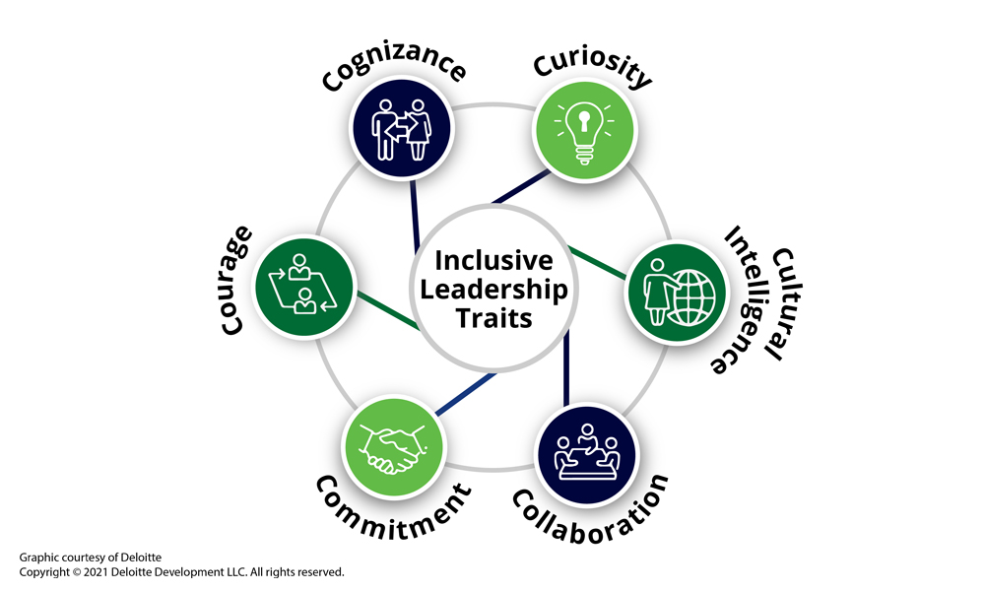
Figure 2: Deloitte inclusive leadership model
(Source: taprootfoundation.org, 2021)
Based on the above figure, I can say that a leader should have six traits. These are curiosity, cultural intelligence, collaboration, commitment, courage as well as cognizance. There is another trust as well. However, these traits are very important for becoming an effective leader (Davies et al. 2019, p.213). In other words, I can say that these are very basic and essential traits which are required to become an effective leader with respect to a company.
- According to the model, cognizance is very important to guide different kinds of people. From that aspect, I want to say that it is better to make someone a leader who has the experience of dealing with people. Inclusive leaders understand that personal and organizational biases narrow their field of vision and preclude them from making objective decisions. With the help of this trait, a leader can implement various types of processes as well as policies (Gabriel et al. 2020). The importance of it cannot be ignored on the grounds of making proper structure. I think maintaining structure helps in successfully completing any task within the deadline.
- I want to adopt this leadership style because I think a leader should have curiosity all the time. Considering the present case scenario, I can say that the taste and preference are changing fast. Therefore the business process is also changing fast. Therefore it will be required to acquire more knowledge. However, there are very few leadership models which are focused on curiosity (Rathore et al. 2017, p.167). I think curiosity must be an important and integral part of leadership quality. I want to say that Courtesy helps a leader to be open-minded. The judgment process can be developed with the help of these particular traits.
- I think a leader must be focused on cultural intelligence. This is due to the fact that all the people do not see the world under the same cultural frame. The second company was an international company. Therefore there were different cultural people as they belong to different countries. I think this particular model is very significant to deal with such a situation. This model helps in understanding different kinds of cultures and act accordingly (Seaman et al. 2018). When I was in charge of the leadership, I could not handle all the situations under different cultural backgrounds. However, I can say that I can handle the situation in a better way after adopting this leadership model.
- The fourth trait is collaboration. I think it is also an important factor because a diverse thinking team is greater than the sum of parts. The thinking process of all the individuals is not the same and I think it is a great advantage when work is done in a team. However, there are several disadvantages of this particular factor as well (Nicholson and Kurucz, 2017). Collaboration helps in mixing all the right thoughts. According to my, it is the duty of a leader to make the process of collaboration smooth. I think the importance of it cannot be ignored on the grounds of making a good relationship among team members. It is also important for completing a work successfully.
- Based on the above figure I can say that the fifth trait is commitment. There are many leaders who are not committed to their work. In other words, it can be said that they are not properly committed. Deloitte inclusive leadership helps in finding out ways through which a leader can maintain its commitment. Diversity, as well as inclusion, are some of the important factors under team management of international teams (Karia and Asaari, 2019). In that case, a leader should be committed to both the factors. It is very important for the mitigation of conflict in the workplace as well. There are many models of leadership which do not include this factor at all.
- The last trait according to the model is courage. I have practical experience in which I had to make such a decision on which the loss and profit of the company were decided. There are leaders who do not want to take this kind of decision and this is due to a lack of courage. This particular model helps in understanding the way courage should be increased and incorporated within a leader (Crowley et al. 2019, p. 1167). I think this is very effective for being an effective leader. Based on my self-assessment process, I can say that I obey organizational values very much. In order to render value towards the company, it is extremely important to take calculated risks many times.
Apart from these six traits, there are several pillars associated with this model and therefore I want to use this model. These are the treatment of groups and people fairly, personalizing individuals as well as leveraging the thinking of diverse groups. Based on the model, I want to say that adoption of unique characteristics is very much required for the treatment of employees. There are many leaders of various types of organizations who think that the stereotype mentality is essential for treating people (Sousa and Rocha, 2019, p.363). However, this is not true for most of the time. Personalizing individuals is valuing the uniqueness of other people. It works as a motivation factor for the employees. This is one of the most important reasons for which it lies under my preference. There is sufficient evidence that shows that the employees can boost their productivity to a great extent when they feel that they are valued. Leveraging the thinking of diverse groups is important with respect to smarter ideation along with decision making. I think it is very much helpful to deal with various kinds of risk in a business enterprise.
Considering all the aspects I want to mention that Deloitte's inclusive leadership helps in providing a proper work environment and this is very much essential for impacting on work performance. When a leader is committed to the work, the team members also become committed to the work (Daley and Baruah, 2020, p.28). I think commitment is very essential to complete the task within the deadline. The sense of empowerment is an important factor which I want to mention in this regard. I think it can be considered as a motivation factor. Therefore I can say that the Deloitte inclusive leadership model helps me to improve my motivation skills and I think it is one of the most common fundamental factors with respect to any kind of leadership style. In order to understand the way this particular model can have an impact on work performance, I want to include the following figure.
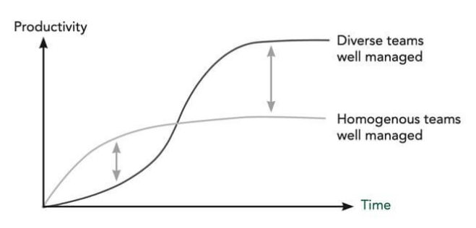
Figure 3: Change of performance level under Deloitte inclusive leadership
(Source: kornferry, 2021)
Considering the above figure, it can be said that the chosen model can increase the performance of a diverse team rather than a homogeneous team. In that context, I want to mention that dealing with a diverse team is much better than dealing with a homogeneous team. This is due to the fact that dealing with a homogeneous team cannot improve the skill of the leader. With the help of the collaboration aspect, everyone can understand their strengths and weaknesses (Grady et al. 2019, p.90). Apart from that, I want to mention that with collaboration, employees can learn some new skills and in this way, they can contribute towards creativity and innovation. It is possible and I experienced this matter in the workplace. Deloitte's inclusive leadership model is also effective to find out the inner potential of the employees as well.

Assessing own ability of setting direction, motivation, and delegation
- A leader plays a very important part in the organization. I think a leader needs to play a different kind of role and responsibility so that the team members are able to increase their productivity level. I have already mentioned that there are various kinds of skills required for that. However, most of the time it is seen that a leader does not have all the skills (Iordanoglou, 2018). I can say it based on my experience in the workplace as well. Therefore assessing one's own ability is very important.
- I think while assessing ability, I should take four important factors and these are strength, weakness, threat as well as opportunity. In other words, I can say that the assessment process should be followed based on these four important factors. In this way, I can understand the area in which I should give maximum focus to be an effective leader. Assessing owns ability is significant to transform weakness into strength (Jambunathan et al. 2019, p.400).
- After assessing my ability, I want to take help from a personal development plan. This is due to the fact that this process will help me in providing proper guidance through which I can set my goals related to the improvement of skills under leadership. The working environment needs to be changed according to the situation. However, most of the time leaders cannot do that because of not having the assessment about them (Carpenter et al. 2019, p.651). I also felt this problem at the time of inception of my working as a leader in a company.
- The aspect of self-management is another important aspect that I do not want to ignore. In the following, I will discuss an assessment of my ability on the ground of motivation, direction, delegation as well empowerment for bringing change in the workplace.

Figure 4: Factors need to bring change in workplace
(Source: Created by self)
Direction
Considering direction, I want to say that I can direct people in a proper way. It should be a fundamental quality of a leader. From the self-assessment procedure, I can say that I can manage people in a proper way and it helps to direct people in an appropriate way. I think before directing team members, a leader should have a clear understanding of the direction. From that aspect, I can say that I can predict the direction within a very short span of time. I can manage both physical resources as well as capital resources and I think this is an important thing to set proper direction. However, in this context, I want to mention that with the help of direction I was able to bring little to moderate change in the organization and workplace environment. However, I could not take any large initiative toward setting a direction that would lead to a massive change in the context of the workplace as well as the organization (Moldoveanu and Narayandas, 2019, p.47).
Actually, I did get this opportunity but I am sure that if I will get this kind of opportunity, I will be surely successful in burning a massive change. The ability to have a long-term perspective is very important and I want to mention it under this particular point. Under the consideration of this particular factor, I want to say that I need to bring some level of arity in terms of bringing a long-term perspective. In order to set direction, I follow several steps. It involves listening and learning, defining the mission of the team, laying out key initiatives, and defining various kinds of matrices (Kairys, 2018). I think I set direction considering both short-run as well a long-run perspective. I am able to make the employees understand the importance of it and in this way, I can bring change in the workplace with less amount of friction.
Motivation
The skill of motivation is very important for a leader (Laleka, 2019, p.230). I think I can motivate other people and this is very important for bringing change in the workplace. I always try to be self-motivated and I think it is the fundamental factor to motivate other people. At first, this particular skill was not incorporated within me. However, I could understand the factors associated with motivation. I could also understand the importance of incorporating various kinds of theories and models related to motivation. I always recognize the talent of employees because I think recognition helps an employee to be self-satisfied which leads to encouragement of working better. There are many times when I provide various types of prices for performing well. In this respect, I want to mention that the price was non-monetary and I was solely responsible for it. In other words, I can say that it was not provided from the company's perspective.
I observed that by adopting very small initiatives I was able to change the mentality of the employees and in this way, I was successful in bringing a change in the workplace. With the help of adopting Herzberg's Motivation Theory model, I could understand as a leader, in which factor I should provide maximum focus. Under hygiene factors, company policy, supervision, salary as well as security among others are considered. On the other hand, achievement, recognition, advancement, growth and responsibility are important factors under motivators of this motivation model (Lindner and O’Brien, 2019, p.82). I wanted to focus on many factors but I cannot take any kind of initiative which is beyond my control. I am focused enough on changing the workplace environment. According to me, a peaceful environment is very important for work. It is also important for unleashing the inner potential of an employee (Rathore et al. 2017, p.167). However, in that context, I want to mention that I did not use emotional aspects in respect of motivation.
Delegation
Based on the above discussion, I can say that I am able in the three important factors to bring change in the workplace. However, I can consider this aspect as my weakness. Under delegation, it may require to tolerate risk as well as mistakes. In that context, I want to mention that I can tolerate mistakes for the first time. I never entertain blunders because it has a serious negative impact on productivity and organization. However, a delegate leader can tolerate those (Cherkowski and Schnellert, 2017, p.18). Considering the motivational aspect, I can consider myself to delegate to a certain extent. However, in order to be a delegate, many more factors are required to be considered. Describing the desired result in detail is another important aspect which is also important for bringing change in the workplace. However, I could not follow it all the time. I think this particular factor has a connection with team development and therefore I should give proper focus on this particular matter.
There are various kinds of resources like articles, journals, and online videos which can help me to improve this matter to a great extent. I plan to use all these resources. This is due to the fact that I think I should be delegated in some situations. The business scenario and the demand for employees have changed much. From that context also I cannot ignore this fact. Dividing the total work and allocating work properly also lied under delegation. I am moderate in this factor and therefore I need to take proper initiative for burning improvement (Baptista et al. 2020). Delegation is also important for learning new skills. The significance of it cannot be ignored on the grounds of improving efficiency, productivity as well as time management. I want to say that I will incorporate this quality within a short span of time.
Empowering other people
Assessing my ability I want to mention that I have the moderate capability in empowering others. In that context, I want to mention that all the employees do not deserve to get empowerment. Therefore selection is very important (Acton et al. 2019, p.147). I observed that there are many times when a leader has to face the problem of giving empowerment to the wrong people. I know that empowering other people can bring a massive change and therefore as a leader I should allow it. However, before that, I should have proper clarity about this particular fact. Considering recent times, I want to say that I have developed these particular factors. In the present times, I check the performance of the team members for a long time before giving them empowerment.
I am flexible enough to bring a change in the organization but that change must be positive with respect to the organization. Therefore I cannot provide empowerment to just any kind of person. I could not understand the exact expectation from the team members and that created a large issue in the process of giving empowerment. However, in recent times I was able to develop this fact. It came within me from the practical experiences and I am hopeful that the future experiences will be helpful to deal with this. I think communication is an important factor that has an association with empowering others. Communication is strength and I want to mention that I have proficiency in both verbal and oral communication. Recognition of employees for hard work should not be the ultimate factor to be considered (Davies et al. 2019, p.213). I think an employee must be given empowerment that can complete the task within a specific time period. My ability toward it needs much more improvement for proving empowerment to the right people.

Conclusion
From the above discussion, I can conclude that I am moderate in leadership skills. Based on the discussion I can say about various kinds of skills. Among all of those, I am an expert in most of the skills but for some, I need to bring improvement. Considering these factors, I want to say that I am not an expert in adopting any kinds of leadership skills. The self-assessment process indicates that the score related to interpersonal skills, administration and conceptual skills is high. However, in order to be highly effective, I needed to get a large score. Therefore these are the factors on which I must not ignore my focus.
I have mentioned the importance of the Deloitte inclusive leadership model. This is because the model holds six main important traits. These are very important for managing an international team. The way I can use those traits and be benefited is discussed in the above section. I want to mention that following these traits in a proper way is helpful for the team members as well. The importance of assessing one's own ability is also elaborated. From this elaboration, I can say that the skill of motivation, as well as setting direction, are some of my strengths and I can use those in a proper way to bring changes in the workplace in the organization. However, I need to focus on the skills to provide empowerment to the right people. Delegation is another factor which also requires having sufficient focus.

References
Acton, B. P., Foti, R. J., Lord, R. G., and Gladfelter, J. A. (2019). Putting emergence back in leadership emergence: A dynamic, multilevel, process-oriented framework. The Leadership Quarterly, 30(1), 145-164.
Baptista, J., Stein, M. K., Klein, S., Watson-Manheim, M. B., and Lee, J. (2020). Digital work and organisational transformation: Emergent digital/human work configurations in modern organisations.
Carnabuci, G., Emery, C., and Brinberg, D. (2018). Emergent leadership structures in informal groups: A dynamic, cognitively informed network model. Organization Science, 29(1), 118-133.
Carpenter, C. R., Hurria, A., Lundebjerg, N. E., Walter, L. C., and Mody, L. (2019). Leadership lessons: developing mentoring infrastructure for GEMSSTAR scholars. Journal of the American Geriatrics Society, 67(4), 650-656.
Cherkowski, S., and Schnellert, L. (2017). Exploring Teacher Leadership in a Rural, Secondary School: Reciprocal Learning Teams as a Catalyst for Emergent Leadership. International Journal of Teacher Leadership, 8(1), 6-25.
Crowley, S. L., Homan, K. J., Rogers, K. S., Cornell, K. K., Olavessen, L. J., Charles, E. M., and Shaw, D. H. (2019). Measurement of leadership skills development among veterinary students and veterinary professionals participating in an experiential leadership program (the Veterinary Leadership Experience). Journal of the American Veterinary Medical Association, 255(10), 1167-1173.
Daley, J., and Baruah, B. (2020). Leadership skills development among engineering students in Higher Education–an analysis of the Russell Group universities in the UK. European Journal of Engineering Education, 1-29.
Davies, R., Potter, T. G., and Gray, T. (2019). Diverse perspectives: gender and leadership in the outdoor education workplace. Journal of outdoor and environmental education, 22(3), 217-235.
Gabriel, A. G., Alcantara, G. M., and Alvarez, J. D. (2020). How do millennial managers lead older employees? The Philippine workplace experience. SAGE Open, 10(1), 2158244020914651.
Gerpott, F. H., Lehmann-Willenbrock, N., Silvis, J. D., and Van Vugt, M. (2018). In the eye of the beholder? An eye-tracking experiment on emergent leadership in team interactions. The Leadership Quarterly, 29(4), 523-532.
Grady, C., Schultz, K., Wolfrom, B., and Knarr, N. (2019, March). Establishing learning objectives for a leadership skills development curriculum in family medicine. In Healthcare management forum (Vol. 32, No. 2, pp. 88-91). Sage CA: Los Angeles, CA: SAGE Publications.
Hoch, J. E., and Dulebohn, J. H. (2017). Team personality composition, emergent leadership and shared leadership in virtual teams: A theoretical framework. Human Resource Management Review, 27(4), 678-693.
Iordanoglou, D. (2018). Future Trends in Leadership Development Practices and the Crucial Leadership Skills. Journal of Leadership, Accountability and Ethics, 15(2).
Jambunathan, S., Jayaraman, J. D., Jayaraman, K., and Jayaraman, A. (2019). Effect of peer-led leadership workshops on leadership skills among middle school students in India. Journal of Research in Childhood Education, 33(3), 399-413.
Kairys, M. R. (2018). The influence of gender on leadership in education management. International Journal of Educational Management.
Karia, N., and Asaari, M. H. A. H. (2019). Leadership attributes and their impact on work-related attitudes. International Journal of Productivity and Performance Management.
Kilduff, M., Mehra, A., Gioia, D. A. D., and Borgatti, S. (2017). Brokering trust to enhance leadership: A self-monitoring approach to leadership emergence. In Knowledge and networks (pp. 221-240). Springer, Cham.
kornferry, 2021. [online] Available at: <https://www.kornferry.com/insights/featured-topics/diversity-equity-inclusion/the-benefits-of-inclusive-leadership> [Accessed 29 June 2021].
Laleka, S. (2019). Developing multilevel school leadership for instructional improvement in elementary schools of post-colonial Pakistan. International Journal of Leadership in Education, 22(2), 222-236.
Lindner, R., and O’Brien, D. (2019). The global virtual teams project: Learning to manage team dynamics in virtual exchange. Telecollaboration and virtual exchange across disciplines: In service of social inclusion and global citizenship, 81-89.
Moldoveanu, M., and Narayandas, D. (2019). The future of leadership development. Harvard Business Review, 97(2), 40-48.
Nicholson, J., and Kurucz, E. C. (2017). Fostering an emergent mindset in leaders: The role of caring in leadership development. In Developing Leaders for Positive Organizing. Emerald Publishing Limited.
Rathore, D., Chadha, N. K., and Rana, S. (2017). Emotional intelligence in the workplace. Indian Journal of Positive Psychology, 8(2), 162-165.
Rubinstein, G. (2017). Narcissistic Leadership in Organizations: A Two-Edged Sword. In Redefining Management (pp. 155-178). Springer, Cham.
Seaman, C., LaPerla, J. T., Schwartz, E., and Bienstock, J. E. (2018). COMMON LEADERSHIP CHARACTERISTICS, PERSONALITY TRAITS, AND BEHAVIORS THAT GENERATIONS X, Y, AND Z LEADERS FIND EFFECTIVE FOR SHARED LEADERSHIP: A FORMAL, INFORMAL, AND RATIONAL APPROACH. Journal of International Management Studies, 18(3).
Shields, G., 2021. Leadership Styles Autocratic, Democratic and Laissez-Faire - ppt video online download. [online] Slideplayer.com. Available at: <https://slideplayer.com/slide/4702783/> [Accessed 29 June 2021].
Sousa, M. J., and Rocha, Á. (2019). Leadership styles and skills developed through game-based learning. Journal of Business Research, 94, 360-366.
taprootfoundation.org, 2021. Deloitte: A Case Study in Inclusive Leadership and Pro Bono. [online] Taproot Foundation. Available at: <https://taprootfoundation.org/case-study/deloitte-a-case-study-in-inclusive-leadership-and-pro-bono/> [Accessed 29 June 2021].
Western, S. (2018). The eco-leadership paradox. In Innovation in Environmental Leadership (pp. 48-60). Routledge.

