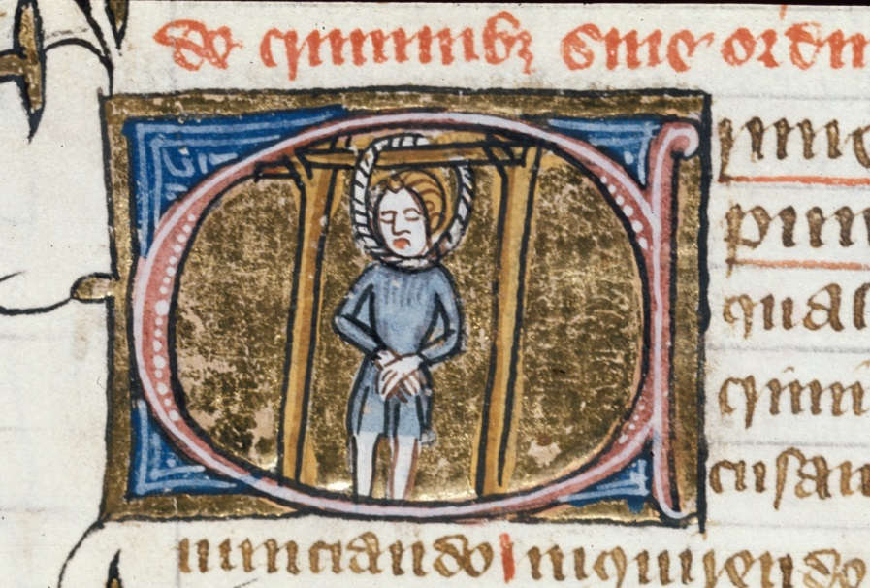

HPHI4007
The Medieval World
Claire Mann
1602593
28th September 2018

The hanging of William Cragh in 1287 ‘Medieval Swansea’

For this assessment we will be using the ‘City Witness’ website which examines the story of the twice hanged William Cragh (also known as William ap Rhys) at Swansea castle in 1287.

William Cragh ‘the Scabby’ was a ‘poor but free man’ from Swansea. He and a nobleman by the name of Trahaearn ap Hywel were sentenced to death following their involvement in the attack on Oystermouth castle. The Oystermouth castle at Swansea belonged to the de Briouze family, the lords of the Gower. On the 5th of July 1287 the castle at Oystermouth was seized and burnt, resulting in the death of thirteen of the lords men.

Lord William de Briouze Snr sentenced Trahaearn and Cragh to be hanged for their involvement in the attack. Later that year, possibly November, the prisoners were taken from the dungeons at Swansea Castle, where the de Briouze family lived, and led to the gallows by Lord de Briouze’s men. Here Cragh was hanged first, followed by Trahaearn. Trahaearn ap Hywel was said to be ‘big and heavy’ and we are told as he was hauled up, the crossbeam on the gallows broke and both men fell to the ground.
The hanging took place for a second time, one man on either side of the upright of the remaining gallows and they were checked to make sure they were ‘definitely dead’.

The events that followed were later reported as miraculous with accreditation for the miracle linked to Thomas Cantilupe a bishop of Hereford. It is said that when the twice hanged Cragh although in a revolting physical condition with ‘a blackened visage, swollen tongue and protuberant eyes’ was examined prior to his burial he was found to be still alive. In 1307, 20 years after this supposed miracle Cragh himself and eight other individuals gave witness statements on his double hanging. These statements later contributed to the canonisation process for St Thomas de Cantilupe.

From the nine witness statements documented the one I am going to write about is that of Lady Mary de Briouze. It is likely that Lady Mary came from a ‘wealthy baronial family’, she was the third wife of Lord William de Briouze and was said to be a woman of independent means prior to their marriage. They both lived at Swansea castle at the time of Cragh’s hanging. Lady Mary asked her husband, Lord William de Briouze, to pardon William Cragh’s hanging though her request was rejected. The lady was said to have a ’mysterious interest’ in William Cragh’s fate though there is no evidence as to why. Following on from his execution Lady Mary arranged the measuring of his body, a handmaiden of hers was sent though it is uncertain which one as there are three conflicting testimonies. What is interesting though is that the string used to measure the body of Cragh was in fact string taken from Lady Mary’s daughter, Margaret’s purse.

From the document it would seem Lady Mary de Briouze was rather heavily involved with events surrounding the miracle. From begging her husband to spare Cragh’s life, praying to St Thomas to intercede on Cragh’s behalf, the measuring of Cragh’s body and also the after care of the miracle. It is believed Lady Mary de Briouze sent Matilda de la Chapel another of her handmaidens to assist in Cragh’s care during his recovery. Later she travelled to Hereford to visit the tomb of St Thomas de Cantilupe accompanied by her husband Lord William de Briouze and Cragh.

It is uncertain how reliable Lady Mary de Briouze’s testimony is as her statement describes the hanging of Cragh, the removal of his body from the gallows. Lady Mary goes on to describe the way Cragh’s body was transported on a certain wooden wheel ’head hanging down from one part and the feet from another, and the middle of him as it were lying across the said wood’. Lady Mary goes on to describe the manner in which Cragh’s body was carried, on the wheel was so painful, even a healthy person carried in that way would be ‘almost dead’. The testimony goes on to say the evidence she gave was what she had heard from people present and she had not witnessed any of the said events herself.

The miracle of the resuscitation of the twice-hanged William Cragh () <http://www.medievalswansea.ac.uk/en/person/william-cragh> [accessed 28 September 2018].
The miracle of the resuscitation of the twice-hanged William Cragh () <http://www.medievalswansea.ac.uk/en/the-story/the-twice-hanged-william-cragh/#story> [accessed 28 September 2018].
The miracle of the resuscitation of the twice-hanged William Cragh () <http://www.medievalswansea.ac.uk/en/the-story/the-twice-hanged-william-cragh/#story> [accessed 28 September 2018].
The miracle of the resuscitation of the twice-hanged William Cragh () <http://www.medievalswansea.ac.uk/en/the-story/the-twice-hanged-william-cragh/#story> [accessed 28 September 2018].
The miracle of the resuscitation of the twice-hanged William Cragh () <http://www.medievalswansea.ac.uk/en/person/mary-de-briouze> [accessed 28 September 2018].
The miracle of the resuscitation of the twice-hanged William Cragh () <http://www.medievalswansea.ac.uk/en/the-story/the-twice-hanged-william-cragh/> [accessed 28 September 2018].
The miracle of the resuscitation of the twice-hanged William Cragh () <http://www.medievalswansea.ac.uk/en/statement/2> [accessed 28 September 2018].
The miracle of the resuscitation of the twice-hanged William Cragh () <http://www.medievalswansea.ac.uk/en/statement/2> [accessed 28 September 2018].

