

Assessment Component 1
Case study - Written Report

Student name: Dewan Ashrafi
Student ID: 1916230

Module name: Children, Young People and Families
Module code: (BMHP5004_LON)
Lecturer name: Bianca Sanfilippo
Word count: 2000

Table of Contents
Introduction: 3
Presentation of case study 2

Introduction
According to the Office of the Children's Commissioner, about 2.3 million children in England are growing up in vulnerable circumstances. (England, 2019) Child vulnerability is the result of the dynamic interplay of a variety of human and environmental variables throughout time. Child vulnerability comes in a variety of forms and degrees as these variables alter and develop. (OECD, 2019) "Vulnerable children" are defined as children who are unlikely to achieve or maintain, or who have the potential to reach or maintain, an appropriate standard of health or development in the absence of social care services, children whose health or development is probably considerably impaired, or further impaired, in the absence of social care services, and children who have a physical disability. (Parliament, 2008) This study investigates and analyses a case of a family with vulnerable children who is struggling to operate effectively. This family is subjected to emotional abuse and neglect, domestic violence, and drug addiction, parent’s mental health, making them very vulnerable.

Presentation of case study
The family
This case is about a family based in Norfolk, with Holly (37), a single mother of three children: Sarah (13), Mark (9) and Kylie (2).
The risk factors of vulnerability
Because of emotional abuse and neglect, the family was sent to the unit by the local authority, and the children were subject to a child protection plan (in which the local government specifies what measures a family must take to improve how their children are cared for). The family has a long history of suffering and witnessing domestic abuse. Holly struggled with alcoholism and suffered from panic attacks and anxiety. She lacked problem-solving abilities and struggled to establish proper limits for the children. The family was both the offender and the victim of anti-social behaviour on the estate, and the children's school attendance was low. There are significant issues with this family which are very much related to children’s vulnerability.
The Children Act of 1989 guaranteed every child the right to be protected from abuse and exploitation, as well as the right to investigations to ensure their well-being. Its fundamental premise was that children are generally best cared for within the context of their family. The legislation went into effect in England and Wales in 1991, and in Northern Ireland in 1996, with certain exceptions. (UK, 1989) Therefore, it can be said, this family is not ideally a functioning and children are vulnerable.
Emotional Abuse and Neglect: In this case, the children of this family are living with a single mother who is failing to cope with parental duties. Consequently, her children are being neglected and emotionally abused.
Child abuse-related illness accounts for a substantial part of the worldwide disease burden. (WHO, 2002)
- Aside from physical injuries such as bruises and welts, burns and scalds, lacerations and fractures, child maltreatment is linked to a variety of additional outcomes, including:
- Abuse of alcohol and drugs
- Delays in development and cognitive impairment
- delinquent, violent, and other high-risk behaviour
- Sleep and eating problems
- low academic achievement bad interpersonal connections
- Problems with reproductive health
- PTSD stands for post-traumatic stress disorder.
- Anxiety and depression
- Suicidal ideation and self-harm
- Many of these issues, in turn, raise the risk of many major adult illnesses and diseases.
Risk Factors
- Certain traits of the child and caregiver, as well as aspects of the family environment, have been related to child abuse and neglect in studies.
- The vulnerability of a kid to abuse — whether physical, sexual, or via neglect – is determined in part by the child's age and gender. Young children are more vulnerable to physical abuse, while children who have entered puberty or adolescents have the greatest incidence of sexual assault.
- Boys are more likely than girls to be the victims of beatings and physical punishment in most areas, whereas females are more likely to be the victims of infanticide, sexual abuse, forced prostitution, and educational and nutritional deprivation. More than 130 million children between the ages of 6 and 11 are not enrolled in school worldwide, with females accounting for 60% of the total.
- Other characteristics that make a child more vulnerable to maltreatment include:
- being raised by a single parent or very young parents without the support of extended family overpopulation a lack of income to fulfil the family's requirements the existence of other violent relationships in the home
- Parents who abuse their children are more likely to have low self-esteem, poor impulse control, mental health issues, and antisocial behaviour. They are also often ill-informed and have unreasonable expectations for their children's growth.
- Child maltreatment is also more frequent in areas with high rates of poverty and less of the social networks and neighbourhood support systems that have been proven to protect children, according to research.
Domestic Violence
This family has a long history of domestic violence. Witnessing domestic violence may have both immediate and long-term cognitive, behavioural, and emotional consequences for children.
Children's reactions to the trauma of witnessing domestic violence may vary depending on a variety of variables, including, but not limited to, age, ethnicity, sex, and developmental stage. It's also essential to note that these reactions may be triggered by anything other than witnessing domestic violence.
Children are individuals who may react differently when they see abuse. Some of the consequences mentioned in a briefing by the Royal College of Psychiatrists (2004) are as follows (Aid, 2021):
- They may experience anxiety or depression.
- They may have trouble sleeping; they may have nightmares or flashbacks; they may be easily frightened; they may complain of bodily symptoms such as stomach pains; and they may begin to pee their bed.
- They may have temper outbursts and academic difficulties.
- They may act much younger than they are. They may become violent, or they may internalise their pain and withdraw from others.
- They may have a poor sense of self-worth.
- Older children may begin to skip school, use alcohol or drugs, self-harm by overdosing or cutting themselves, or develop an eating problem.

Children may also feel furious, guilty, insecure, alone, terrified, helpless, or perplexed. They may feel conflicted about both the abuser and the non-abusing parent.
Parent’s Alcohol and Drug addiction
The mother of this family, Holy, a single mother who is suffering from alcohol addiction. The use of alcohol and drugs by parents may have a detrimental effect on their children's physical and emotional well-being, development, and safety. Among the consequences for children are (England, 2018):
Physical abuse and neglect
Development of health-harming behaviours later in life, which predicts more entrenched future usage.
Inadequate school attendance as a result of unsuitable caregiving duties
participation in anti-social or criminal behaviour due to a lack of knowledge
Provide specific reasons why the child, young person and/ or family were in a position of vulnerability: what factors meant that there were specific issues in this case which might not be seen in the average family?
This family is different by other average families as these factors make the children vulnerable and in Need. Vulnerable means more likely to be exposed to harm, health and safety risk abuse, neglect…. Being a child in Need according to the Children Act 1989, occurs when the child without the intervention of the social services would not been able to have a good quality life….

Case Study: the impact of these factors on the child/children health and wellbeing
Drawing on research on websites NSPCC, or books, articles.. , here you need to consider all the impact of these factors on the children, such as parents with mental health, parents misusing alcohol/drugs, sexual abuse poverty….child with disability, parents with disability….parents/carers or child involved within criminal justice system (are in prison or had been in prison or commit criminal offences)….
You can draw on any evidence you feel is relevant but it may be that the child, young person or family were living in specific circumstances which might have indicated a higher level of vulnerability. What do you feel were the risk factors? What is the Impact of these factors on child’s health and wellbeing? Why these factors represent a problem….

In writing this you have to Demonstrate your knowledge of the specific issues of the case, including theoretical, policy and professional perspectives.
Theoretical perspectives are all the studies that have been made on the topic, for example, domestic abuse and impact on children).
The child/the children within this family facing adversity would be classified as a child in need, According to the Children Act 1989 a child in need is when ‘…….’
In this case as seen above the mother is involved in parental substance misuse. What is parental substance misuse (drugs misuse).
What is domestic abuse? Speak the consequences of this/ the impact

This case study presents a multiple risk factors, as seen above, such as domestic abuse…..parental substance misuse
Always link this to your case study.
Parental substance misuse and the impact on children’s health and wellbeing.
Define what is parental substance misuses
Provide information about percentage of parental substance misuse in the UK
The impact of parental substance misuse in children
Parental substance misuse is related to a quarter of referrals..

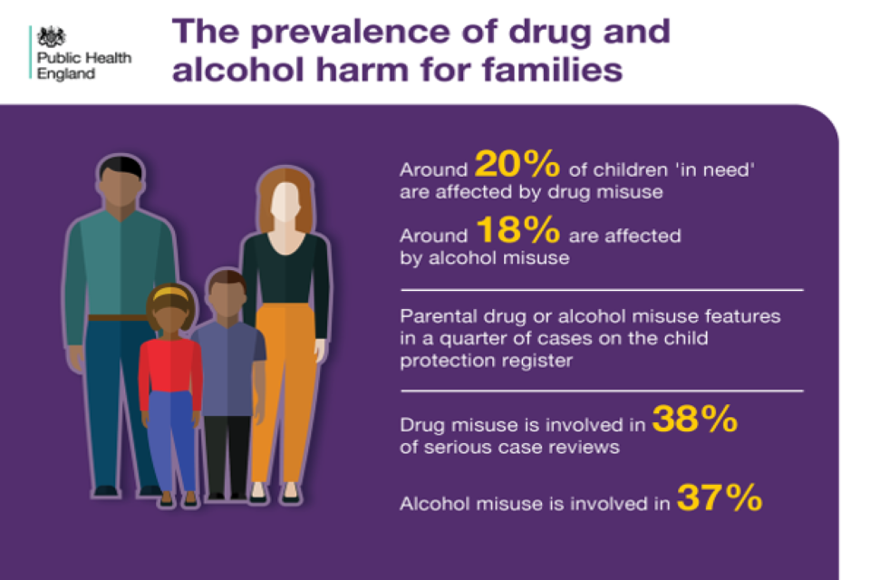

Image 1: Source:

The impact of parental substance misuses leads to neglect (NSPCC, 2019)…parental misuse = what is the impact on the child?
According to the NSPCC (2019) parental substance misuses can lead to other risks for the child/children, such as neglect (describe neglect)

Sexual abuse and the impact on children’s health and wellbeing

In this case study one of the factors of vulnerability was sexual abuse. In the UK this factor is increasing in recent years as shown in the table below…..
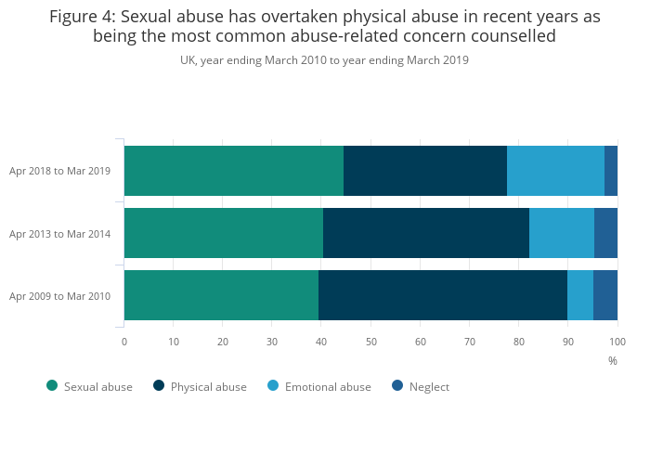
Image 2: Source: number of child sexual abuse case uk - Bing images

The impact of sexual abuse in children according to the NSPCC (2019) includes…..

Parents/carers involved within the criminal justice system and the impact on children’s health and wellbeing.
Children with parents involved within the criminal justice system are more likely to suffer from legal, mental issues as shown in the graph below……
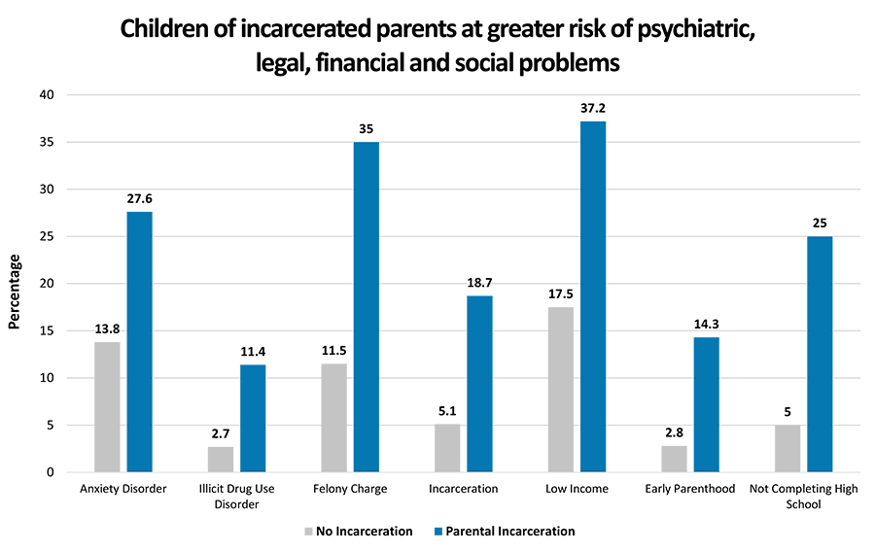

Parents with mental health issues and and the impact on children’s health and wellbeing.

Parents with disability and the impact on children’s health and wellbeing.

Poverty and and the impact on children’s health and wellbeing.

Domestic abuse

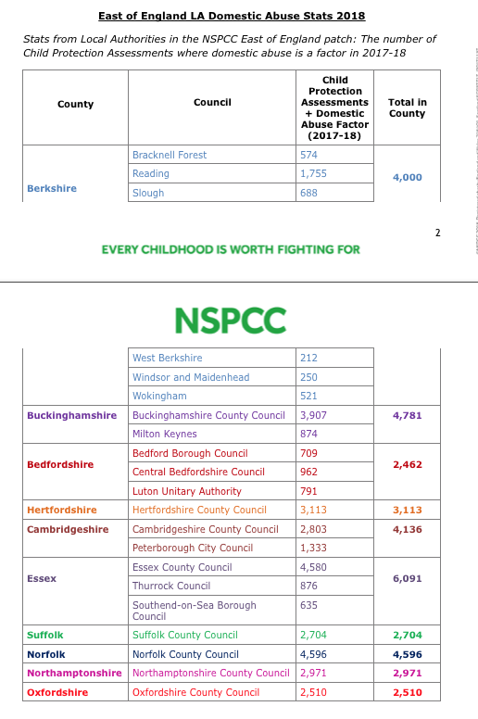

Source:
Analysis:
The assessment, intervention of multi-agency and results.

Identify the point at which the child, young person or family became the subject of assessment by health and social care agencies, and what action the agencies or a specific agency decided to take.

Explain the process of intervention by relevant health and social care agencies and current relevant policy.

Here you will have to explain the interventions that have been made, justifying it by policy. CHILDREN ACT 2004, CHILDREN ACT 1989, EQUALITY ACT, DATA PROTECTION ACT 2018, UNCRC 1991, STATUTORY GUIDANCE WORKING TO Working Together to Safeguard Children A guide to inter-agency working to safeguard and promote the welfare of children (2018). (see power point week 7)

- The child became the subject of assessment as it was considered a child in need according the Children Act 1989 that says that a child in need is when without the intervention of the local authority would not been able to have a high quality life. .
The assessment was based on the Children Act 1989 as it says that when considering a child at risk, practitioners should focus on the following questions:
- ‘Is this a Child in Need?’ (Section 17 Children Act 1989);

- ‘Is there reasonable cause to suspect that this child is suffering, or is likely to suffer, Significant Harm?’ (Section 47 Children Act 1989);

- ‘Is this a child in need of accommodation?’ (Section 20 or Section 31A Children Act 1989).
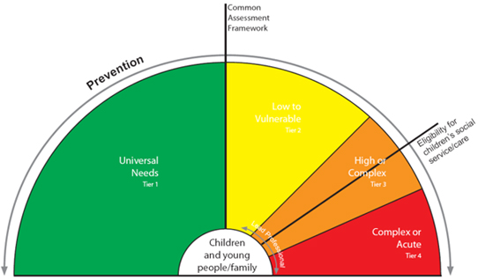
The practitioners implemented a specific intervention as in this case study the child/family was at risk and specific assessment was required.

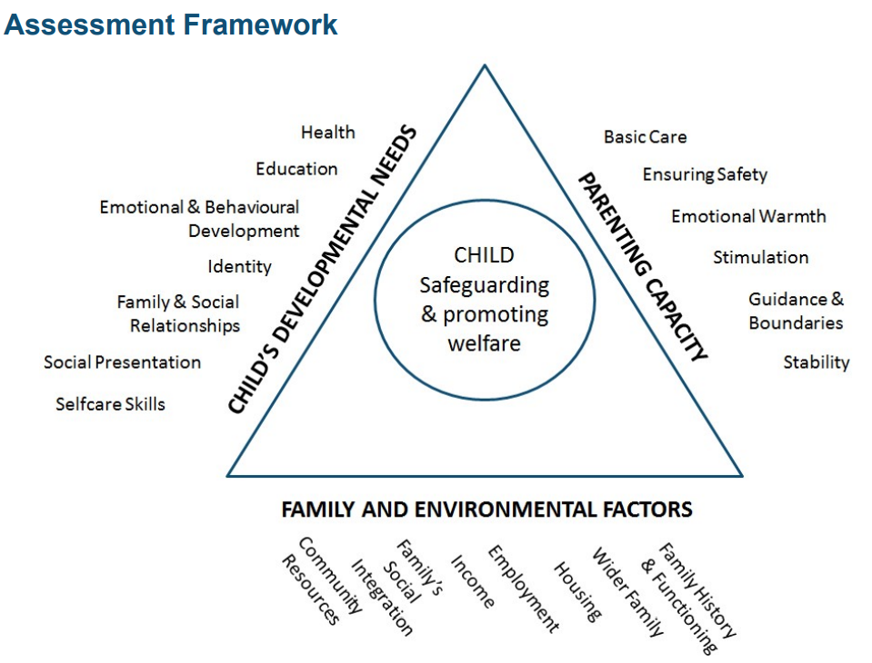
Image: Source: Working Together to Safeguard Children A guide to inter-agency working to safeguard and promote the welfare of children' (2018).

The intervention in the case study was based on the assessment framework ‘Working Together to Safeguard Children A guide to inter-agency working to safeguard and promote the welfare of children' (2018).
Case study

In this case study the assessment framework was based on parental capacity , children developmental needs and family environmental factors.
parental capacity in this case was poor because

Based on this assessment, the practitioners start the plan to support the family. The family was kept together according the Children Act 1989.
OUTCOMES/RESULTS
Referral

PLAN/ACTION
The family

ASSESSMENT

The intervention was made as the Children Act 2004 place a duty on local authorities and other agencies working with children and young people under the age of 18 to protect them from abuse, harm , neglect….they have a safeguarding responsibility.
Practitioners according to the Children act 2004 and the statutory guidance ‘Working Together to Safeguard Children A guide to inter-agency working to safeguard and promote the welfare of children’ (2018), they have the duty to work in multi-agency. The organisation involved are all children’s service (private and public), NHS and private healthcare providers, Police officers and other agencies such as youth offending team, rehabilitation offices. For example, in this case study, there was multi-agency work as different professional were involved. For example, July was sent to parenting programme, rehabilitation programme, she was supported in finding a new accommodation,
In this case study the Practitioners’ intervention was based on the United Nations Convention on the Rights of the Child (UNCRC, 1991), article 24, 26, 27, 28. Article 24 places a duty on UK Government to support children health and wellbeing…
The article 28 protects the right to education. In this case study the intervention ensured the improvement of children’s school attendance…in this case study the children had low school attendance. The social service intervention ensured the improvement of the children’s school attendance. This is related to the article 28 of the UNCRC (1991) which promotes the right to education. The articles states that ‘Every child has the right to an education’ (UNCRC, 1991).
In this case study the intervention in multi-agency of the professionals involved can be related to the Article 24 of UNCRC as it ensured that the children involved received the best possible health. (1991) This article is related to the health and health care services and states that ‘every child has the right to the best possible health’.
Article 26 (social security) Every child has the right to benefit from
social security. Governments must provide social security, including financial support and other benefits, to families in need of assistance.
Article 27 (adequate standard of living) Every child has the right to a standard of living that is good enough to meet their physical and social needs and support their development.
Equality Act 2010 and say how the intervention was in line with this it…This Act applies to this case study as the professional intervention was carried out fairly. The family and the children involved were assessed fairly and objectively without discrimination. This Act ensures that every child has EQUAL access to the health and social care services and support. According to this Act, the professionals should remove any barrier to equal access.
The Data Protection 2018 (confidentiality of information).

3. Discuss and evaluate current policy and the roles of multi-disciplinary services within the case study and the potential impact of their actions on the children, young people and family.
Here is when you provide the results of the intervention
For example, the results of the intervention include children’s school attendance improved to 99%. Full-time employment.
You need to say if the intervention was effective and led to positive outcomes/good results.
Also evaluate the effectiveness of the policy.
Evaluation of current policy:

For example, the policy ‘Working Together to Safeguard Children A guide to inter-agency working to safeguard and promote the welfare of children' (2018) is effective in protecting the rights and the health and safety of the children as it is based on main legislation, such as the Children Act 1989, Children Act 2004, UNCRC 1991, The Equality Act. Following this legislation, this policy document promotes a child-centred approach. This means that the interest of the child is the most important thing to be considered. According to this policy, the assessment should be personalised to the individual needs of the child/children involved. This policy ensures that housing needs are met under the Homelessness Duty. This places a duty on local authorities to provide a suitable accommodation for children in need. This policy following the Children Act 1989 states that family should be kept together when possible. This is very important as children when are removed form their family can suffer form trauma (reference)…This policy provides good guidance in terms of multi-agency. Multi agency is essential as it ensures that different professionals, such from NHS, housing officers, education officers, social workers, teachers, police, youth officer work together following an integrated and a holistic approach. In this way the child/family is put at the centre of the care/services. The impact of multi-agency on the children ensures their holistic health and wellbeing. Holistic needs are related to the PHYSICAL (body, water, food, hygiene, good air), INTELLECTUAL (brain, memory, problem solving), EMOTIONAL (Feeling and behaviour, self-esteem) AND SOCIAL (Social relationships and social skills). This is known as PIES (p=physical – I =intellectual – E=emotional – S= Social development).

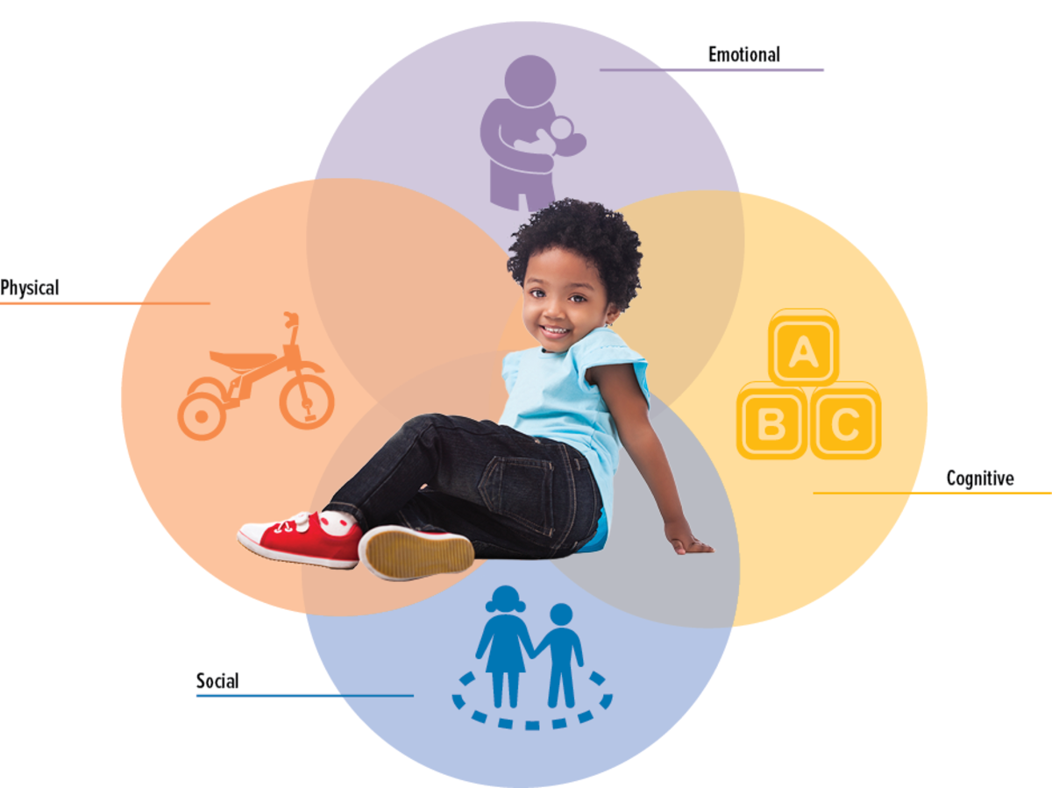

Evaluation:

- Provide a critical analysis of the responses of the relevant agencies.

- Having considered the specific details of the case as well as current policy and the actions taken by health and social care agencies, provide a critical evaluation based on your perspective of what could have been done differently. Provide recommendations for improvements required, which are appropriate to meet the needs of the children/young people and family involved in the case study. Provide valid reasons for your suggestions and support these with literature and references.

You can link the intervention of the social workers to Maslow’s hierarchy of needs theory which is based on the idea that human beings in order to achieve their full potential need to meet specific needs first in hierarchical order. Firstly, physiological needs, such as food, water….
Secondly, safety needs, such as house, health and safety measures….
Thirdly, love and belonging which include the needs to form positive relationships with others, friends, family members, peers…
Fourthly, Esteem needs which include self-esteem, elf-confidence and respect for themselves and others.
Finally, self-actualisation: this means that when all the previous needs are met, it is possible to achieve their full potentials.
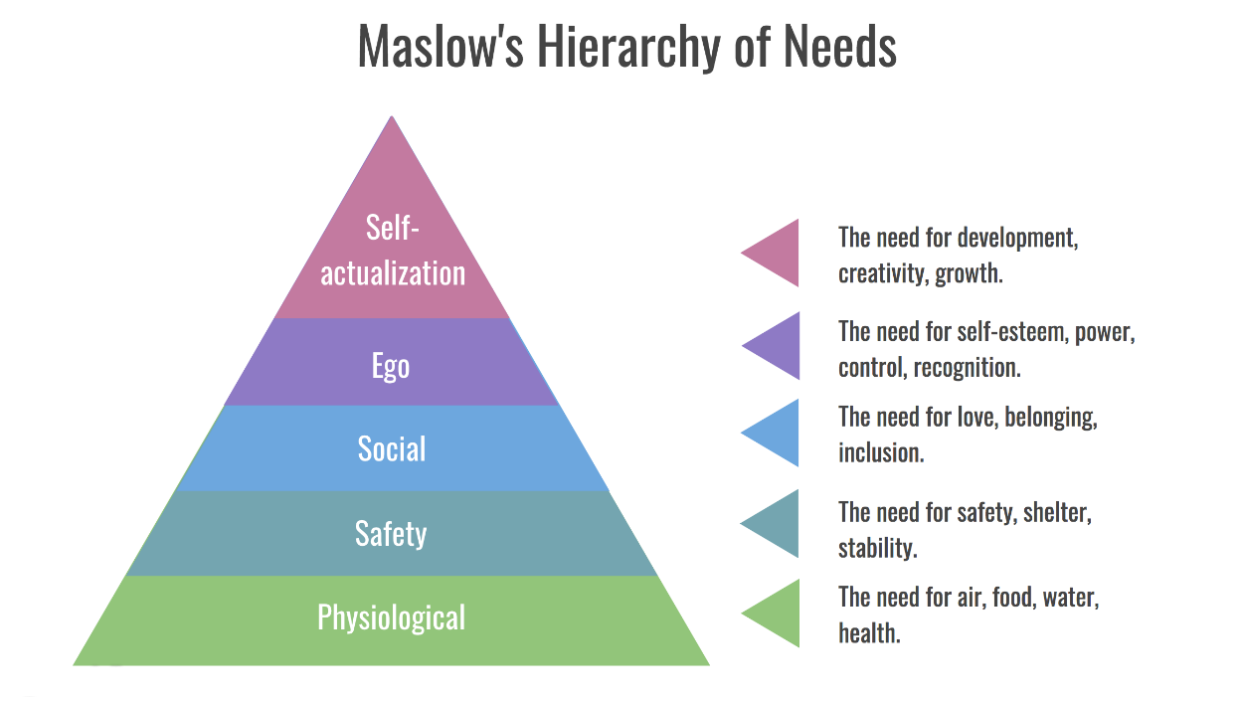
Image 1: Source: maslow theory of hierarchy - Bing images

In conclusion we need to provide better universal services for children, including more services to prevent difficulties and support families facing adversity. It is important as well that children in need receive appropriate support. This can be linked to Bronfenbrenner’s ecological systems theory to explain how everything in a child and the child's environment affects how a child grows and develop. According to Bronfenbrenner it is not only the family that influence a child but also the healthcare provision, social services, welfare systems available….

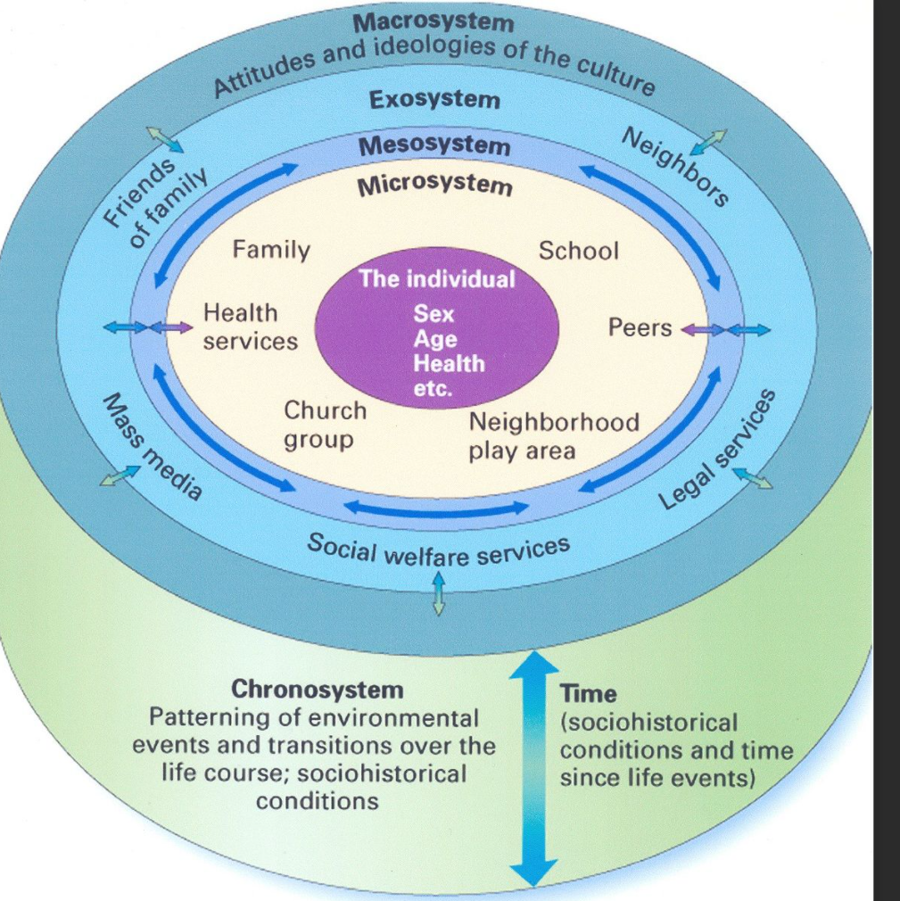
Image 2: Source: bronfenbrenner theory - Bing images
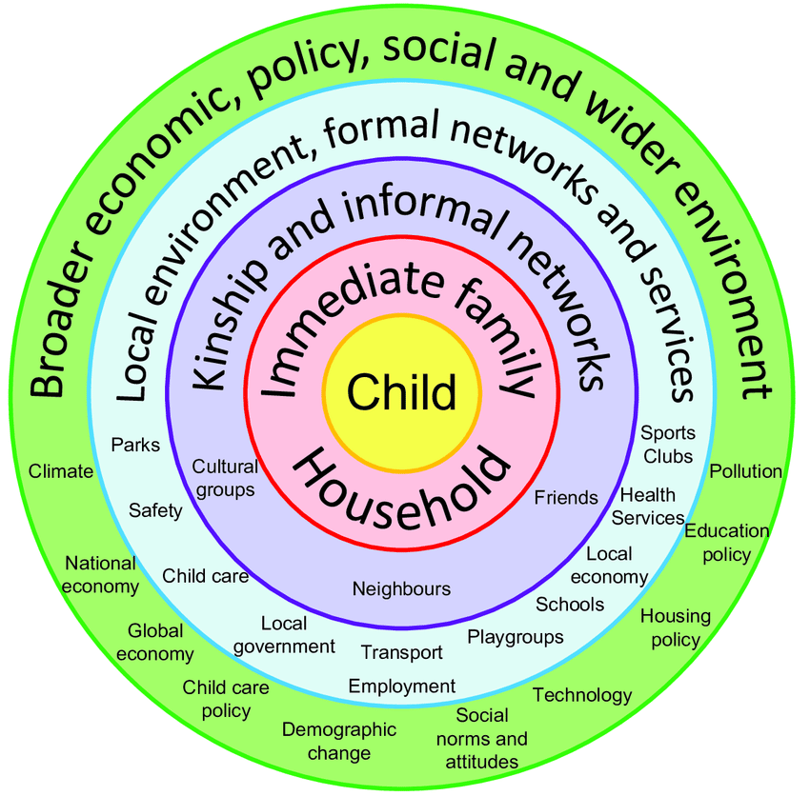

Image 3: Source: Bronfenbrenner theory - Bing images

References

