Impact of virtual learning environment
Student name:Violeta Zisu
Student ID:2130492

Executive summary

The research project focuses on the need for virtual learning in the present times. The importance of the virtual learning on the students is also explained from a wider perspective. Additionally, the consequences on the experience of the students are also explained in a detailed and explanatory manner. Consequently, the research methodology is used to explain the topic of virtual learning.

Table of Contents

1. Introduction 4
2. Objectives 4
3. Literature review 4
3.1: Introduction 4
3.2: Consequences of Virtual learning on the student’s experience 4
3.3: Importance of virtual learning for a student 5
3.4: Analysing the impact of VLE on student’s academic learning in influencing academic and employability skill 6
3.5: Literature Gap 6
3.6 Summary 7
4. Research methods 7
5. Data collection and analysis 7
5.1 Quantitative survey 7
5.2 Qualitative (Secondary thematic analysis) 11
6. Conclusion 12
References 13

1. Introduction
As mentioned by Ryan, and Poole, (2019, 408), personal characteristics, attributes, habits, and attitudes constantly influence an individual's interaction ability with others. Academic and employability skills can control these personal traits and help the students to grow by developing competencies and gaining experiences in any mode of learning. The current report structure is focused on the virtual learning environment and analyses its impact on student learning in the University Wales Trinity Saint David London campus. A virtual learning environment (VLE) is a type of learning and teaching tool developed to increase students' learning experience, capability, and evaluation power by incorporating computers and the IoT in the learning procedure. The current report is focused on a primary research survey with 20 students participating who are learning in the Virtual learning environment Moodle in the university. The survey was conducted with a set of three questions regarding moodle and a detailed literature review and methodology used for the report have been elaborated effectively in this report.

2. Objectives
- To evaluate the effectiveness of a Virtual learning environment on student's experience
- To identify its importance for a student learning in the University Wales Trinity Saint David London Campus
- To analyze VLE's impact on students' academic learning that influences their academic and employability skills effectively.

3. Literature review

3.1: Introduction
As cited by Henritius, et al., (2019, p. 90), Virtual Learning Environment is defined as the set of teaching and learning methods that are developed to empower and enhance student's learning experience by involving computers and the internet in the learning procedures. The examples of a few virtual learning environments are distance learning degree programs, instructional videos, podcasts, and webinars. There are certain advantages of the virtual learning environment such as an increased level of inclusivity, improved level of accessibility, and saving in cost. In this context, the influence of virtual learning on the student of University Wales Trinity Saint David London Campus, its importance, and the way they influence the academic, as well as employability skills of the scholars, is illustrated from a broader perspective.

3.2: Consequences of Virtual learning on the student’s experience
Virtual Learning has played an important role in changing the view of students regarding learning and teaching procedures. It has both positively and negatively affected the quality of learning among the students (Odrekhivskyy, et al., 2019, p. 361). The positive effects on the students have increased efficiency in learning, flexible accessibility, improved level of interaction, and also student attendance. It has proved to be more effective for the students helping them to find textbooks and learning materials easily. It has helped the students to save their costs and achieve learning from any part of the world. As a result, Virtual Learning has proved to be affordable as well as easily accessible to students. There has been an improvement in the attendance of the scholars because they can easily attend class from any place managing their time. At the same time, this has better their experience because they can create their studying schedules in a more efficient manner. According to Dumford, and Miller, (2018, p. 461), the scholar's understanding level has been increased because they can dynamically interact with the teachers and clear their doubts. Similarly, they can also send emails to clarify the keywords which they have missed during online learning. The scholar's experience is sometimes negative as it creates a sense of isolation because different students have different approaches to acquiring knowledge. Hence, they can become bored and lose interest in the subject. It can also cause eye problems in students because they are staying for long hours to attend class and take notes. The students may face technical difficulties while downloading the audio and video. The connection problem may arise but the virtual learning experience can also prove negative to the less privileged student who does not have money to buy electronic gadgets like a laptop. They are deprived of acquiring knowledge and hence Virtual Learning Environment is good and bad reflecting on their experience.
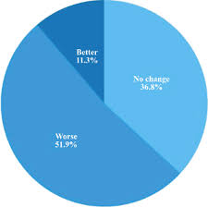
Figure 1: Impact of Virtual Learning
Source: emerald.com

3.3: Importance of virtual learning for a student
The virtual learning experience is important for students of the University Wales Trinity Saint David London Campus because it plays an essential role in encouraging a wide range of educational opportunities to reach as many scholars as possible in the university (Muir, et al., 2019, p. 271). Similarly, it can help the shy scholars of the respective university to be more participative and hence reduce the level of anxiety. It can assist the oversee students attending the lessons from any part of the world having a stable computer and internet connection. It will help them to build a better relationship with the teachers as they can easily clear their doubts as and when required. It can assist the students to build team building skills and develop knowledge of various cultures as well as background. Consequently, the immediate feedback can assist the scholars of the respective university to clear their basic base of learning.
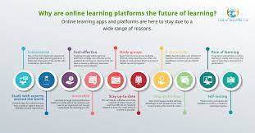
Figure 2: Importance of Virtual Learning
Source: learnteachworld.com

3.4: Analysing the impact of VLE on student’s academic learning in influencing academic and employability skill
The virtual learning experiment also plays an important role in building organization quality, time management potentiality, and technical skills. The organization quality is built on the students when the teacher virtually teaches in a systematic manner. As cited by Racheva, (2018), it also grows when the scholars carefully note the keywords of the subject matter in a structured manner. Apart from it, the ways of tracking and measuring valuable information on the subject also assists in growing the organizational quality. The time management potentiality is built in the student as they can schedule their academic tasks and also manage their other activities. They become technical savvy and adapt quickly to the knowledge of operating devices like laptops and computers. Hence, the Virtual Learning Experience is proven to be flexible and self-paced learning (Estriegana, et al., 2021, p. 55).

3.5: Literature Gap
The literature gap identified is the ways used to acquire virtual learning and the disadvantages of the virtual learning experience for the students. The ways such as hybrid courses and fostering collaboration must need to be mentioned to bring out the importance in a clearer manner (Murillo-Zamorano, et al., 2019, p. 103608). Additionally, the disadvantages need to be added to mitigate them and bring out the flexibility from it.

3.6 Summary
In this context, the importance of the virtual learning experiment is discussed from a wider perspective. Additionally, the impact is also illustrated from a wider perspective, and the way it influences their academic and professional potentiality is also mentioned.

4. Research methods
The Research Philosophy that has been used is interpretivism because the researcher will analyze the impact of virtual learning experiments on the students and bring out the importance in society. Additionally, positivism has been used because the researcher will discuss the probable skills developed through virtual learning in students. The Research Approach that has been used by researchers is deductive because constructivist learning theory will be used to explain the topic of virtual learning. Consequently, the inductive research approach has been utilized because the researcher will collect information on virtual learning importance and its consequences from scholarly articles. The Research Design that has to be used is explanatory because limited information such as the consequences and the benefits are present keeping in doubt the origin and the ways of virtual learning. Consequently, Exploratory because the researcher has b kept a space for future research as the ways and causes of the topic are not mentioned clearly. The data collection has been quantitative because the researcher has analyzed the numerical data by taking an interview with 20 students. Consequently, the qualitative method has been used because the research topic focuses on the impact and benefits of virtual learning. The data analysis that has been used is descriptive for the primary data because interviews with 20 students are taken to identify the need of the research topic. The researcher has used thematic analysis for secondary data because the information could also be taken from scholarly articles, journals, and research papers.

5. Data collection and analysis

5.1 Quantitative survey

1) Where did you find this module?
Options | Number of total Participants | Number of total respondents | Percentage %
Official Website | 20 | 5 | 25
University | 20 | 8 | 40
Friends | 20 | 3 | 15
Family | 20 | 4 | 20
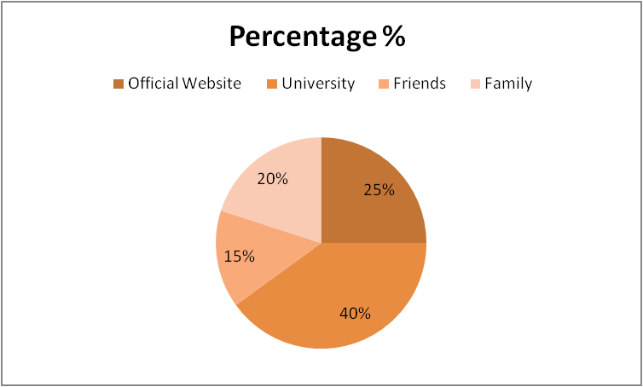
Figure 1: Graphical representation of the survey question 1 regarding the source where students find about the discussed module in the university
(Source: Developed by the author)
Analysis: As per the above graph it can be evident that students find this module from four significant sources, the university, the official website, friends, and family. Moreover, it can be evident that almost 40% of the students find the virtual learning environment or VLE moodle of the University of Wales from their campus. On the other hand, almost 25% of students learn about this moodle from the official website of Trinity Saint David London campus official website. In addition, some students like 15% and 20% of the participant students find about this moodle from their friends and family respectively.
2) Is this module helpful for you?
Options | Number of total Participants | Number of total respondents | Percentage %
Strongly Agree | 20 | 10 | 50
Agree | 20 | 6 | 30
Neutral | 20 | 2 | 10
Disagree | 20 | 1 | 5
Strongly Disagree | 20 | 1 | 5
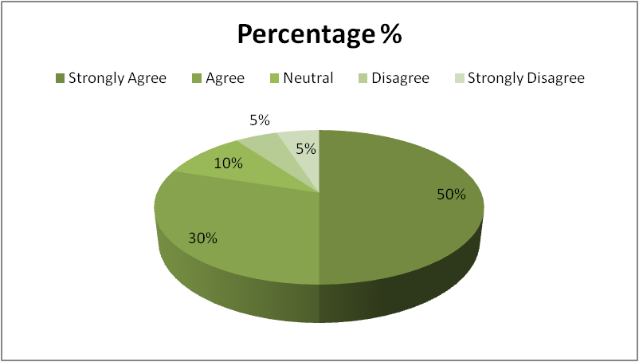
Figure 2: Graphical representation of survey question 2 regarding the helpfulness of the significant module for the students
(Source: Developed by the author)
Analysis: The above graph represents that almost 50% of the respondents find out that the VLE module of the university is highly helpful for them. On the other hand, almost 5% of the respondents believe the process is not accurate for their learning. However, it can be evident that students like the VLE module of the university, and they are quite satisfied with the results as well.
3) Did you find the Module is easy to access?
Options | Number of total Participants | Number of total respondents | Percentage %
Strongly Agree | 20 | 12 | 60
Agree | 20 | 4 | 20
Neutral | 20 | 2 | 10
Disagree | 20 | 1 | 5
Strongly Disagree | 20 | 1 | 5
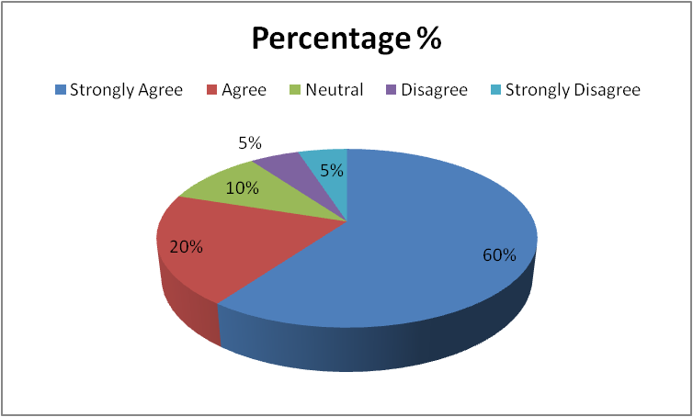

Figure 3: Graphical representation of the survey question 3 regarding the module’s effectiveness and its easy access for the students

(Source: Developed by the author)
Analysis: As per the above graph it can be evident that almost 60% and 20% of participants strongly believe that the VLE module is very easy to access and it is quick responding as well. In addition, almost 5% of people disagree with the statement. However, it can be evident that this module is easily accessible and it is highly effective as well.
Discussion
As stated by Ryan, and Poole, (2019, p.410), students get to benefit from virtual learning expertise by improving their common interests which can assist them to improve their team working, team building ability. It can be evident throughout the survey that a maximum of participants are agreeing that the virtual learning environment moodle is highly effective and influential for them to develop their academic and employability skills. In addition, the first question denotes the most adopted source by the students where they find out this moodle and engage with this. According to the student's statements, they find out about the existence of this VLE module at the University of Wales through the official website, friends, family, and the university. The second question is about the helpfulness of VLE for the students. As per the student's perspective, they are highly satisfied with this module and they find out virtual learning is more effective for them. As mentioned by Awoyemi, and Awoyemi, (2021, p.10), Virtual learning environments help students to enhance their communication and team working capabilities through online easy access and constant conversation with teachers. However, the third question of the survey is about the easy access of the module for the students, as per survey results maximum of participants find out the module is easy to access through the computers and the internet.

5.2 Qualitative (Secondary thematic analysis)
Theme 1: Covid-19 situation influences the Virtual learning environments in the universities
As stated by Caprara, and Caprara, (2021, p.38), the Covid-19 situation has become one of the precursors of the increasing popularity of online and distance learning. Virtual learning environments have become a critical learning tool for students while learning from remote conditions. Virtual learning environments through the internet and online learning platforms of the universities help the students continue their studies without interruption and comfort of their home environment. In 2020, March after the sudden outbreak of Covid-19 in the global health system, the nations started to shut down universities and other educational institutes to avoid mass gatherings. Students were affected the most in this period because without accurate learning they were not able to increase their employability skills for furniture careers. In this situation, virtual learning environments have become the saviour for the students and they started their learning through the internet. For example, the VLE module of the University of Wales helps several students to continue their degree learning and increase their academic productivity.
Theme 2 Virtual learning environment influences students' academic performance
Due to Covid-19 maximum number of students became irregular and the universities were not able to reconnect their students. In this meantime, virtual learning aspects help the universities to reconnect with their students and serve them accurate course studies through using the internet. On the other hand, students also connect with their professors and universities for completing their studies and increasing their knowledge accurately. The virtual learning environment offers the opportunity to their students to schedule a range of learning activities and develop tools available instead of just managing the core content (Annansingh, 2019, p.3669). Users of VLEs at the University of Wales are capable of exploring social conditions, health implications, current university courses, and other features in the online portal of the university and trying out a variety of behaviors and responses to improve their employability knowledge.

6. Conclusion

Henceforth, it can be concluded that virtual learning has become a very well-known concept in recent times. It has benefitted the students in ways like lowering the total costs and building a more comfortable learning experience. Similarly, it has helped scholars to build their organizational, time management, and technical abilities. It can be assessed that in the research methodology both primary and secondary data will be used to complete the topic.

References
Annansingh, F., 2019. Mind the gap: Cognitive active learning in virtual learning environment perception of instructors and students. Education and Information Technologies, 24(6), pp.3669-3688. https://link.springer.com/article/10.1007/s10639-019-09949-5
Awoyemi, R.A. and Awoyemi, R.O., 2021. A mediated approach to the virtual learning environment (VLE): Implications for academic libraries in the 21st century. International Journal of Library and Information Services (IJLIS), 10(2), pp.1-10. https://www.igi-global.com/article/a-mediated-approach-to-the-virtual-learning-environment-vle/279672
Caprara, L. and Caprara, C., 2021. Effects of virtual learning environments: A scoping review of the literature. Education and information technologies, pp.1-40. https://link.springer.com/article/10.1007/s10639-021-10768-w
Dumford, A.D. and Miller, A.L., 2018. Online learning in higher education: exploring advantages and disadvantages for engagement. Journal of Computing in Higher Education, 30(3), pp.452-465. https://link.springer.com/article/10.1007/s12528-018-9179-z
Estriegana, R., Medina, J., Robina, R. and Barchino, R., 2021, June. Virtual Learning Environment to Encourage Students' Relationships and Cooperative Competence Acquisition. In Proceedings of the 26th ACM Conference on Innovation and Technology in Computer Science Education V. 1 (pp. 53-59). https://dl.acm.org/doi/abs/10.1145/3430665.3456363
Henritius, E., Löfström, E. and Hannula, M.S., 2019. University students’ emotions in virtual learning: A review of empirical research in the 21st century. British Journal of Educational Technology, 50(1), pp.80-100. https://bera-journals.onlinelibrary.wiley.com/doi/abs/10.1111/bjet.12699
Muir, T., Milthorpe, N., Stone, C., Dyment, J., Freeman, E. and Hopwood, B., 2019. Chronicling engagement: Students’ experience of online learning over time. Distance Education, 40(2), pp.262-277. https://www.tandfonline.com/doi/abs/10.1080/01587919.2019.1600367
Murillo-Zamorano, L.R., Sánchez, J.Á.L. and Godoy-Caballero, A.L., 2019. How the flipped classroom affects knowledge, skills, and engagement in higher education: Effects on students' satisfaction. Computers & Education, 141, p.103608. https://www.sciencedirect.com/science/article/pii/S0360131519301617
Odrekhivskyy, M., Pasichnyk, V., Rzheuskyi, A., Andrunyk, V., Nazaruk, M., Kunanets, O. and Tabachyshyn, D., 2019. Problems of the Intelligent Virtual Learning Environment Development. In MoMLeT (pp. 359-369). http://ceur-ws.org/Vol-2386/paper27.pdf
Peng, H.H., Lin, Y.T. and Wu, T.L., 2019, December. The effects of virtual learning environment on high school students’ English learning performance and attitude. In International Conference on Innovative Technologies and Learning (pp. 815-824). Springer, Cham. https://link.springer.com/chapter/10.1007/978-3-030-35343-8_85
Racheva, V., 2018, December. Social aspects of synchronous virtual learning environments. In AIP Conference Proceedings (Vol. 2048, No. 1, p. 020032). AIP Publishing LLC. https://aip.scitation.org/doi/abs/10.1063/1.5082050
Ryan, E. and Poole, C., 2019. Impact of virtual learning environment on students’ satisfaction, engagement, recall, and retention. Journal of medical imaging and radiation sciences, 50(3), pp.408-415. https://www.sciencedirect.com/science/article/pii/S1939865418304636
Ryan, E. and Poole, C., 2019. Impact of virtual learning environment on students’ satisfaction, engagement, recall, and retention. Journal of medical imaging and radiation sciences, 50(3), pp.408-415. https://www.sciencedirect.com/science/article/pii/S1939865418304636

