
University of Wales TSD

Effective Team working and Communication Module

Reflective Analysis on Teamwork and Communication

BMSW4009
December 2024
Name: Asmina Izabella Covaci
Student number: 2122494

Contents
1. Introduction 3
2. Main findings 3
3. Conclusion 6
References 7

1. Introduction
Teamwork has always played a significant role in my personal and professional growth (Wenny Desty Febrian et al., 2023). It is not just about working with others to achieve shared goals but also about understanding individual roles, building trust, and communicating effectively (Turyadi et al., 2023). Reflecting on my team experiences has helped me understand my strengths and weaknesses, which I aim to improve upon to become a better team member.
In this report I will reflect on my experiences in a workplace team, relating them to concepts that were discussed in the module, including Tuckman’s stages of team development, Belbin’s team roles, and the Thomas-Kilmann conflict solving model. By reflecting in this way, I want to learn about my influence on team processes and to define what needs to be done in the next teamwork to improve results.

2. Main findings
2.1 Defining Teamwork and My Natural Role within Teams
To me, teamwork means combining individual strengths to achieve shared objectives while supporting each other through challenges. My natural role in teams, as I have discovered through self-reflection and the module activities, aligns with being both an implementer and a coordinator. I enjoy organizing tasks, setting goals, and motivating others to complete them effectively.
For instance when working in a workplace project one time where we had been required to redesign a customer service protocol I automatically assumed the role of structuring the workflow (Calçado, Ávila and Rosa, 2024). I worked with timelines, checklists, and responsibilities, all in a goal to maintain focus from the team. But at the same time, I came to understand that as a manager I am too controlling and that contradicts the ability to delegate work properly. What became apparent from this was that this tendency from time to time put pressure and organisational confusion within the team work area, which I now appreciate is a weakness that needs improvement.
2.2 Reflections on Team Development and Dynamics (Tuckman’s Theory)
Bruce Tuckman’s (1965) stages of team development—forming, storming, norming, performing, and adjourning—provided a helpful framework for analyzing my team’s dynamics during the project (Zirar et al., 2023).
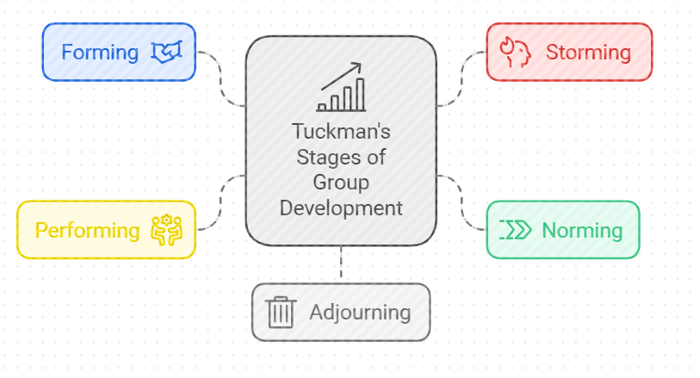
Figure 1: Tuckman's tages of group development
- Forming: At the start, our team members were polite but hesitant to share ideas or take initiative. As a coordinator, I initiated conversations about our goals and responsibilities, which helped set a positive tone for collaboration.
- Storming: This stage was exhibiting conflicts that arose from issues to do with delegating activities as well as the time frame slated for each activity. At first, I struggled with handling these cases, avoiding direct confrontations, and as a result, I experienced delays. Out of the conflicts that arose in regards to task ownership, there was one specific conflict that made me consider the significance of bringing up issues as soon as possible.
- Norming: Over time, trust began to build, and our communication improved. We started collaborating more effectively after a team-building exercise, which allowed us to clarify our shared goals and expectations.
- Performing: By the performing stage, we operated as a cohesive unit, completing tasks efficiently and supporting each other’s efforts (He, Krajcik and Schneider, 2023). My strength in organizing tasks was particularly helpful here, as I ensured we stayed focused on the end goal.
- Adjourning: At the project’s conclusion, we reflected on our achievements and challenges. This reflection allowed me to see how I could grow as a team member by improving my delegation skills and conflict resolution approach.

2.3 Belbin’s Team Roles and My Contributions
Through Belbin’s (1981) team roles (Monsalves, Cornide-Reyes and Riquelme, 2023), I identified myself primarily as an implementer and coordinator. I am naturally drawn to creating structure and ensuring that tasks are completed on time. For example, in the workplace project, I translated abstract ideas from brainstorming sessions into actionable plans and timelines.
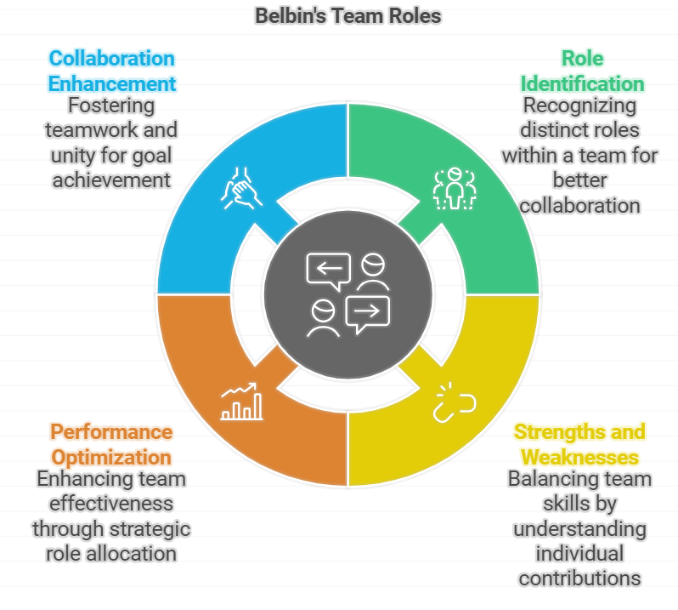
Figure 2: Belbin's team role
However, when I think of this experience, I see that there was a problem of underestimating the creative input from the team members who assumed positions like ‘plant.’ For example, I once overlooked one of my peers because his input was not coherent with the framework I developed. This experience made me realize more the significance of accepting all roles that are assigned to a team for one to create.
2.4 Managing Conflict (Thomas-Kilmann Model)
Conflict is inevitable in teamwork, as the module highlighted, and my experiences align with this reality (Vinokur et al., 2024). The Thomas-Kilmann Conflict Mode Instrument identifies five conflict management styles: competing, collaborating, compromising, avoiding, and accommodating (Rudnák et al., 2024).
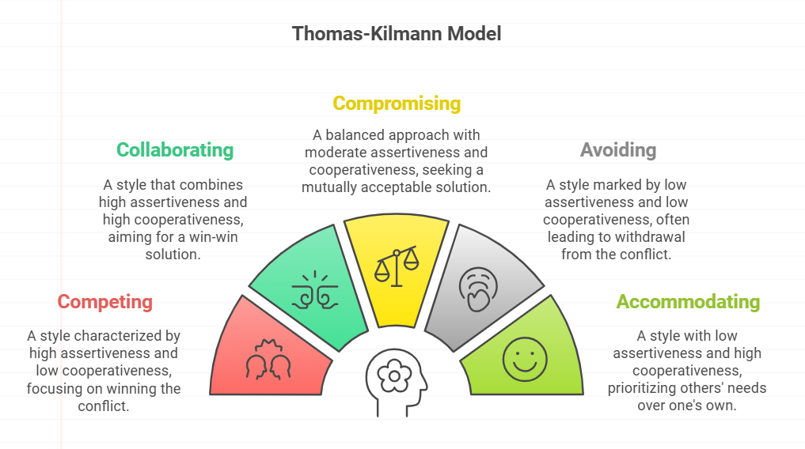
Figure 3: Thomas-Kilmann model
In situations when my team was in the storming stage, I used avoiding style for conflicts. For instance, when two employees were arguing over which work was more important, I refused to interfere expecting them to sort it out on their own. This strategy only/postponed developments and generated more conflict within the team.
Looking at this situation, I decided that the best approach was to adopt a collaborating style. I started mediating meetings where one can speak their mind and try to find a common ground for the team. I also invited people to air out their grievances and learn to deal with conflicts in a more appropriate manner. I have learned that in order to solve conflicts one must be willing to listen, and understand the other person’s view on a matter.

3. Conclusion
Reflecting on my experiences has shown me the value of understanding teamworking theories and applying them to real-world scenarios. Tuckman’s stages of team development helped me analyze the dynamics within my team, while Belbin’s team roles highlighted my strengths and areas for growth. Additionally, the Thomas-Kilmann model provided insights into how I can better manage conflict in the future.
I will work to vary my conflict management style and seek to accept multiple viewpoints as well as learning how to work on delegation tactics. This shall assist me in achieving the overall goals of a better team player and contributor to excellent teams.

References
Belbin, R.M. (1981). Management Teams: Why They Succeed or Fail. Heinemann.
Calçado, R., Ávila, L. and Rosa, M.J. (2024). Combining business process management and lean manufacturing to improve information and documentation flows: a case study. Business process management journal. doi:https://doi.org/10.1108/bpmj-10-2023-0773.
He, P., Krajcik, J. and Schneider, B. (2023). Transforming standards into classrooms for knowledge-in-use: an effective and coherent project-based learning system. Disciplinary and Interdisciplinary Science Education Research, 5(1). doi:https://doi.org/10.1186/s43031-023-00088-z.
Monsalves, D., Cornide-Reyes, H. and Riquelme, F. (2023). Relationships Between Social Interactions and Belbin Role Types in Collaborative Agile Teams. IEEE Access, 11, pp.17002–17020. doi:https://doi.org/10.1109/access.2023.3245325.
Rudnák, I., Barczi, A., Bajkai-Tóth, K. and Garamvölgyi, J. (2024). Exploring the conflict management of international students at a Hungarian University based on the Thomas-Kilmann model. Journal of Infrastructure, Policy and Development, 8(13), p.9046. doi:https://doi.org/10.24294/jipd9046.
Thomas, K.W., and Kilmann, R.H. (1974). Thomas-Kilmann Conflict Mode Instrument.
Tuckman, B.W. (1965). "Developmental Sequence in Small Groups." Psychological Bulletin, 63(6), pp. 384-399.
Turyadi, I., Zulkifli, Z., Tawil, M.R., Ali, H. and Sadikin, A. (2023). THE ROLE OF DIGITAL LEADERSHIP IN ORGANIZATIONS TO IMPROVE EMPLOYEE PERFORMANCE AND BUSINESS SUCCESS. Jurnal Ekonomi, [online] 12(02), pp.1671–1677. Available at: https://www.ejournal.seaninstitute.or.id/index.php/Ekonomi/article/view/2001.
Vinokur, E., Avinoam Yomtovian, Marva Shalev Marom, Itzchakov, G. and Baron, L. (2024). Social-based learning and leadership in school: conflict management training for holistic, relational conflict resolution. Frontiers in Social Psychology, 2. doi:https://doi.org/10.3389/frsps.2024.1412968.
Wenny Desty Febrian, None Nuraeni, None Didin Sjarifudin, Bekti Setiadi and None Supardi (2023). Strategy Increasing Performance Employee: Analysis Implementation Knowledge Management, Career Development, Team Work & Employee Engagement. Indonesian Journal of Business Analytics, 3(3), pp.885–898. doi:https://doi.org/10.55927/ijba.v3i3.3969.
Zirar, A., Muhammad, N., Upadhyay, A., Kumar, A. and Garza‐Reyes, J.A. (2023). Exploring lean team development from the Tuckman’s model perspective. Production Planning & Control, pp.1–22. doi:https://doi.org/10.1080/09537287.2023.2275693.

