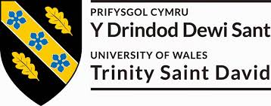

ANA DZHIPOVA

Student Number: 2013882

MBA MARKETING MANAGEMENT
LCMB7001
Assignment 1

Module Lecturer:
Tushara Balendran

Table of content

1.Introduction………………………………………………………………………..……………….……..3

2.Communication -definition, communication models, marketing communication………………………………………………………………………………………….……3
2.1. Communication – definition and importance …………………………………………………3
2.2. Integrated marketing communication -definition, importance…………………………5
2.3. Current promotion that are utilised by Zara………………………………….………………….6
2.4. New Promotional Strategies that Zara can Adopt……………………………………………11
3 . Branding and brand equity………………………….………………………….………….…..12
3.1. Brand, branding, brand equity models - definitions and purposes……….…………..12
3.2 Keller’s Brand Equity model and its application to Zara……………………….……………..12

4. Customer journey and customer touchpoints of Zara………………………………14
4.1. Customers journey…………………………………………………………………………………….……..14
4.2. Customers touchpoint………………………………………………………………………………….…….15
4.3. Customers journey map…………………………………………………………………………………….16
4.4. Total Engagement model and its relation to Zara……………………………………………….18

5. Conclusion…………………………………………………………..…………….………………..…….19

Referencing

1.Introduction
Consumers are flooded with information reaching them through numerous channels. Business environment and consumer requirements are constantly changing, and this makes marketing communication very complicated process. Creating customer engagement is more difficult than ever and require modern designed marketing strategy including variety of tools and methods. The effective marketing strategy goes beyond reaching the existing and potential consumers today, it aims to ensure their future loyalty through development of the relationship with them.
The focus of this report is an overview and critical appraising of Zara marketing strategy and what innovative marketing strategies can help for raising awareness of the brand. Also, it will include a critical overview of the customer journey across all the communication channels in relation of fulfilling the future stakeholder’s expectation.

2.Communication – definition, communication models, marketing communication

2.1 Communication
Communication can be defined as act of transferring information/meaning from one person or group to another person, or groups. It is two-way moving of information flow and its purpose is to send message to the person/place/group and to ensure this message is well understood.
In the context of marketing, communication are all the means aimed to increase the awareness of the brand and sales of the products. There are three main components of the marketing communication – to inform, to persuade and to remind the existing and potential customers.
There are some models of communication known and their purpose is to explain the communication process. One of the major and most popular communication models is the Shannon and Weaver Model of Communication which is a mathematical model of communication which identifies six key components: sender, encoder, channel, noise, decoder, and receiver.

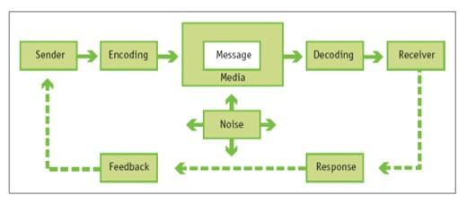
Figure 1, Source: Marketing Management, by Philip Kotler and Kevin Lane Keller, 15th Edition (Global Edition), Pearson, Chapter 19, page 585
Businesstopia, “Shannon and Weaver Model of Communication (2018), states that:
Sender (Information source) – Sender is the person which compose the message and sends it using the method and channel chosen by himself.
Encoder (Transmitter) –It is the person which sends the message using machine converting this message into signals or binary data.
Channel is the medium used to pass the message (it can be media, Television, radio, social networks).
Decoder or receiver is the person/place/group who gets the message and gives a feedback.
Noise is physical disturbance like environment, people, etc. which are not letting the message to get to the receiver as what exactly is sent.
How it works?
The sender (the company) encodes and sends the message to the receiver (consumers) using a medium (channels like Radio, Television, web, and social networks). The receiver needs to decode the message. The channel can have noise and it might cause problems in the communication process.

The effective communication is an approach for increasing of the awareness of the brand through combination of activities which reinforce each other.
Communication can be interpersonal, sales and impersonal.
Interpersonal communication has four basic categories: verbal, non-verbal, visual and written. This method for communication with the consumers gives a direct feedback.
Sales communication is oriented to keep the sales team well informed, high engaged, and productive in relation of the encouraging their feedback.
Impersonal communication is mostly used in a business and refers to indirect methods such as emails and social networks. This type of communication is advertising and main characteristic of this type of communication is the indirect feedback.

2.2 Integrated Marketing Communication
Brands implement their marketing communication with the target market via their communication mix / all the tools used for communicating with the consumers/ and it can include: Advertisement (TV, radio, press), direct marketing and digital marketing (email, social media), public relations, personal selling, sales promotions, social media, sponsorship, product packaging, new variables/innovations. The combination of all marketing tools for communication, is called integrated marketing communications. These tools must be well harmonised and to reinforce each other.
According Varey (2002): “Integrated marketing actions, when applied to meeting the needs of consumers or buyers, can generate profits and other corporate results through customer satisfaction. This matching of corporate and customer interests requires the parties to communicate”. This is exactly what defines the role of communication in the marketing.

According to Kotler, Keller, Bradly, Goodman, and Hansen, (2009):
“An ideal ad campaign:
The right consumer is exposed to the message at the right time and place,
The ad causes consumer to pay attention.
The ad reflects consumer’s level of understanding and behaviors with product.
The ad correctly positions brand in terms of points-of-difference and points-of-parity.
The ad motivates consumers to consider purchase of the brand.
The ad creates strong brand associations”.
Messages used in “IMC campaign must be tailor made for fit a specific target audience’s needs, wants, and lifestyle. The goal is to reach one individual within the target with specially designed message that will create lasting relationship and develop a brand-loyal consumer who will continue to purchase that brand without the need for continuing advertising efforts”. (Blakeman, 2018)

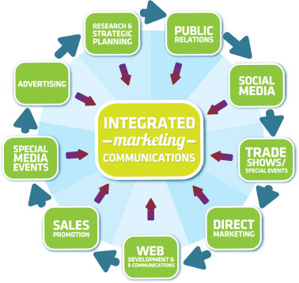
Figure 2 , Source: https://globalmarketingprofessor.com/integrated-marketing-communications/

There are five stages in an IMC Campaign: to identify their target group, to specify the objectives of marketing communication, to consider the budget, to compose the promotional mix and critically to evaluate the results.

2.3 Current promotions of Zara
Zara utilities multichannel approach to customer engagement via various channels like brand webpage, posters and magazines, social media, including five most popular platforms – Facebook, Instagram, Twitter, Pinterest, and YouTube, smartphone application.
Zara differs with its unique marketing communication strategy. The distinctive component in the strategy of the brand is “Be fast, not first”. Following this strategy Zara creates two new collection every week and the products way from the designers to the retail counter takes 3-5 weeks which is much faster comparing with the competitors. Zara waits for appearing of the new fashion trends and adapt its new collection designs with them. The politic of the company is if in the first few days a particular product has not successful sales, it gets replaced by new designed.
Zara’s business model is symbiosis of vertical integration, effective supply chain management, and unique marketing politic Main Zara’s marketing techniques are as follows:
Product – quick reply to new fashion trends
Price – affordable prices of the products
Store location – typical for Zara is the impression of the stores on the high streets.
Promotins like:
sales promotions,
store vision and design.
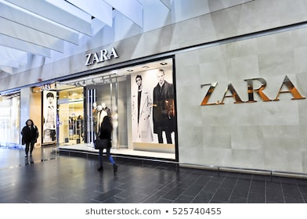
assortment display;
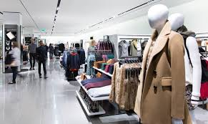

customer service – Zara provides excellent in-store and online customer service and continue improving it.

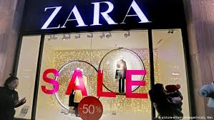
https://www.dw.com/en/zaras-fast-fashion-problem-in-focus/a-52161858
Zara communicates with its target market via well considered combination of various methods and channels but the integration of them is built on a customer-centered focus. “We consider the relationship with our customers to be something unique, regardless of the channel they choose at any time” (Annual report 2019). That is what determinates the communication methods of Zara and the distinctive element in its relationship with consumers. Zara’s marketing communication strategy differs with minimised image advertising and promotions compared with its competitors.
Advertisement which is a long-term permanent strategy oriented to maintaining of the brand image, is one of the ways Zara reaches its consumers. An example for this there is some posters and advertisement in the print press.

Source: Pinterest
Zara’s image and positioning is global but adapted to each country. According Riezebos (2003) there is a dualethic brand-name strategy, unique names used for the same product group – Zara Women, Zara Basic, Zara Trafaluc and this reinforces Zara’s global but local perception. The company solely relies on the establishment of public stores and word-of-mouth to increase its publicity.
Sales promotion are used by marketers as a short time lasting campaign aimed to promote a new product or to increase the sales. Zara has very impressive presence at the online platforms and excellent customer service in the stores. Website of the brand offers easy access and keeps updated the customers about the new product and current promotions. Same information the consumer receives via social media platforms and by regular emailing of newsletters. There is application for smartphones available which is the best suitable way to contact the loyal customers – the fasters and easiest way to reach the loyal customers and gives them an opportunity to find new arrivals, seasonal collections, and catalogues, to create Wishlist for later and all this anywhere and at any time. Most sales promotion Zara use are seasonal sales, promocodes, free shipping options, etc. One of the biggest last sales promotions was Black Friday 2020 
https://www.blackerfriday.com/zara

Christmas sales started on 24th December 2020 and includes up to 60 % discount.



Pull and push strategy – Basically push strategy refers to pushing a product to the customers and pull strategy is a strategy that pulls the customer to the product. Pull marketing creates deeply relationship with the customers. Zara is oriented to pulling strategy and in fact, this causes its success. “Creating customer curiosity is a most powerful pull marketing strategy. Every human being is innately programmed to satisfy it. With this new AR application and in so many other ways, Zara excels by pulling customers into the brand, unlike its closest competitor H&M, which remains fixed on pushing its brand and product out to the customer”. (Forbes, 2018)
Public relations are very important component of the communication because reflects to the reputation of the brand and it determinates the role of the public relations in the marketing mix. It includes all the contacts the company has until operating (Customers, employees, investors, suppliers, press, social media platforms, partners, other organisations, and institutions, and etc). Zara is a brand that has reputation of good retailer and good employer. Zara is a partner of Greenpeace in its Detox Campaign and turned to non-toxic producing. It is eco-friendly brand.
Zara uses direct marketing as well. An example in this point is the regular emailing of the newsletter.
As it was mentioned already, Zara has serious presence on internet. Discussing Zara’s marketing strategy cannot be missed to highlight the fact that Zara is one of the pioneers in the Influencer marketing – one of the main types of digital marketing which refers to endorsement by influencers.

2.4 New Promotional Strategies that Zara can Adopt.
Current changes in the external environment such a Covid-19 pandemic, development of new technologies and the results of these changes like upcoming period of economy recovery, social and lifestyle changes, income levels of the consumers, etc. have already caused some changes in the marketing strategies of the companies. Zara is vertically integrated, and it is a good opportunity for designing of flexible strategy and quick adapting to the changes. It is one of the brands that started last to close their shops because of Covid-19 pandemic. In June 2020, the parent retailer Inditex has announced that it is planning to close more than 1000 shops over the next two years and to divers its resources into online sales strategies. Pablo Isla, the chairman of Inditex, confirmed that the retailer will “increase the online customer service teams and the dedicated packaging both from the specific online stockrooms and from the stores," as well as offer customers "uninterrupted service no matter where they find themselves, on any device and at any time of the day." In the current situation online sales got raised by 50% comparing with previous year and the company has composed an investment plan for developing its website and online social platforms and in up-to date technology solutions/Inditex annual report/.
One of the most consumer-driven sectors in the economy is exactly the fashion retail. The main consumer group are women aged between 18 and 45 but not only – the brand offers clothes, accessories and perfumes for men and kids as well. This fact requires the marketing strategy of Zara in the future to be kept focused on the consumer in the centre and to keep following pulling strategy. Brand should continue investing in the online presence and in-store improving of the customer service. In my opinion, Zara should move its forces in influencer marketing because it is the new trend of the digital marketing, extremely powerful for attracting young consumers. It is one of the fasters and effective ways to reach maximum protentional number of people in parallel withs will increasing the engagement of the existing ones. Profitable influencing marketing can be implemented by selected influencers. These influencers can also promote more than one product – clothes and assessors for example, and to get direct feedback from the consumers immediately.
Zara proved its online presence and in accordance with the expectations for the changes in the consumer behaviour, prioritises the online advertising and promotions. Nevertheless, the brand should invest in advertisement and keep presence on the main streets which will keep the high reputation of the brand.
One more innovation is the concept store (opened in London) where customers can touch and fit the products but to do online purchasing. This can be very successful practice as it will allow the buyers to get physically at the stores and to choose the product and to have it by home delivery. Also, it will reduce some costs (for example from return from online sales) and it will increase the profit of the business.

3. Branding and brand equity
3.1 Brand, branding, brand equity models - definitions and purposes
According to American Marketing Association “A brand is a name, term, design, symbol or any other feature that identifies one seller's good or service as distinct from those of other sellers” (cited by Muniz, 2015). Respectively, branding is marketing process aimed to create a name, symbol, design that will achieve easy recognition of the brand by strong impression in the customer’s minds and as a result of it to create a value to the benefit of the brand's customers, its owners and stakeholders.
Zara has successful branding strategy. Example for its easy recognition is the logo of the brand which was changed 2 years ago. Firstly, there were many critics of the idea but now, business results of the firm are evidence it was appropriate step.
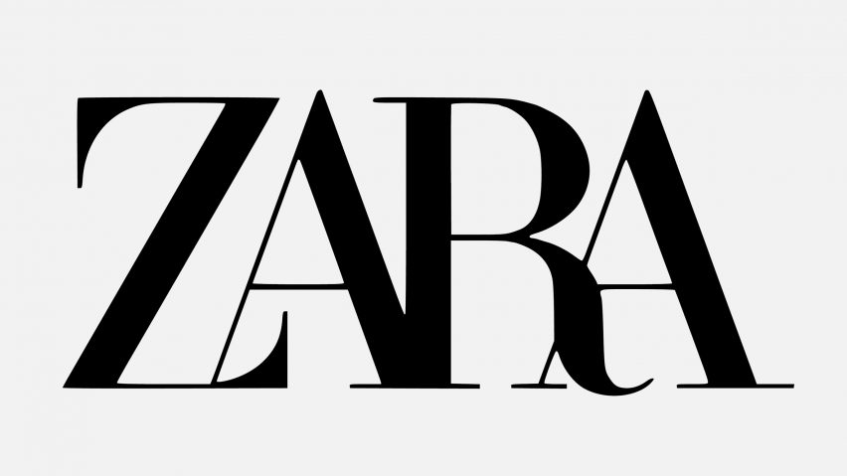

3.2. Keller’s Brand equity Model and its application to Zara
“The power of the brand lies in what resides in the minds of customers” (Keller, 2008). Keller defines the customer -based brand equity as “differential effect that brand knowledge has on consumer response to the marketing of that brand”. His brand equity model has four levels pyramid structure. These levels are as follows: brand Identity, brand Meaning, Response and Relationships.
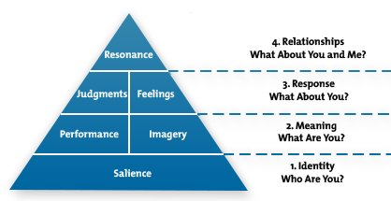
Figure 3, Source: https://www.mindtools.com/pages/article/keller-brand-equity-model.htm
These four levels refer to four fundamental points that consumers should know about the brand.
How it works? Building of strong brand can be explained by building of the pyramid covering four steps using six building blocks until getting to the top of the pyramid.
How this applies to Zara:
Brand identity – who are you? To cover this means to achieve silence with the consumers. Zara is popular with its fast fashion strategy with distinctive elements such as high quality, excellent customer service, affordable prices. Easy recognition is caused by black-and-white logo, vivid and brave brand images. Stores are located at the main streets and luxurious shopping canters.
Brand meaning - What are You? This step refers to the performance and imagery of the brand. Zara’s strategy is oriented to meeting more functional needs of the consumers through production meeting the fashion trends using good quality materials at affordable prices.
Brand response - What about you? On this level model is focused on the response of the customers – their judgement and feelings. Feedback is a fundamental point on this level.
On this level Zara’s customers enjoy good styling, cool clothing and accessories, new look every season.
Resonance or Relationships - What about you and me?
Top level of the pyramid is related to the relationship with the consumers achieved, what level of loyalty and customer’s engagement has the brand.
Zara is fast fashion brand, presents new designs much faster than its competitors and does not replenish the production. Customers have easy access to the information about the new arrivals and all of this makes their decision to buy very easy. As mentioned above, the brand is popular with its high performed customer service. This is exactly what makes Zara so attractive and causes the high level of customer’s loyalty reached.

Advantages and disadvantages
Building brand equity is extremely complicated because it is very difficult to capture influence of all components of the branding, so it is an abstract evaluation of this influence. This is what makes building brand equity real challenge for the businesses but at the same is a real opportunity to reach strong presence at the market. To build brand equity is a way for the companies to achieve higher level of the brand potential. Strong brand leads to increasing of the sales, customer’s loyalty and respectively, increases profit of the business. The most serious disadvantage is its cost but reputation and position on the market is always paid.

4.Customer journey and customer touchpoints of Zara

4.1 Customer journey
Customer journey is concerned with customer’s path leading them to the decision to buy a particular product or service via touchpoints. It includes all the interactions moving the consumer from its total unawareness to the decision to buy and to recommend the product.
These interactions present five stages of the customer journey and they are:
- Awareness – on this stage the potential customer is aware of need and is in process of
searching option to solve this. On this stage consumer gets first impression of the product.
- Consideration – on this stage the potential customer has already collected some information needed about some products available on the market but still needs extra information for making final decision which product to buy. Customer evaluates the alternatives and the main factors considered are different depending on type of product or service needed but for clothing they are usually price, size, quality. Zara attracts consumers by offering high styling at moderate prices.
- Decision – on this stage customer makes final decision. The researching process is already
completed. Often customers make their choice in according to the lowest risk. It is important criteria the communication options after purchasing.
- Retention – on this stage customer creates deep relationship with the company and
becomes loyal client. All the traders are interested in retaining customers.
- Advocacy – this is the desired stage of the customer journey for every business. At the end of the path, customer starts to recommend the product sharing experience through spreading positive opinion word-of-mouth, so he is acting as a brand advocate.

4.2. Customers touchpoint

“Integrated marketing communications calls for recognising all touch points where the customer may encounter content about the company and its brands.” (Kotler & Armstrong, 2016). Following the purpose to improve customer satisfaction, marketers analyse in details customer experience. (www.surveymonkey.co.uk). It means they “need to look at the customer journey from start to finish, taking into account each interaction they have with your company”. Customer touchpoints are where appearing points of interaction of the brand and the customer. ( Pahwa, 2020). It can be at different places at any time (before, during or after purchase) and some of them are out of control of the brand but many of them are opportunity to hear from the customers. With other words, everything that creates mind about the brand and works for engaging customers and influencing their behaviour is customer touchpoints. They can be Integrated marketing communication, all the terms and conditions of the purchase – packaging, delivery options, return policy, etc. Businesses must control these customer touchpoints as much as possible because they give feedback and based on this feedback, companies can improve the relationship with their existing and potential customers.

According to the purchase there are customer touchpoints at 3 different stages but some of them can be at more than one stage.
Zara’s customer touchpoints are as follows:
Social media – customer touchpoints at pre-, and post-purchase customer touchpoints of the brand. Before the purchase consumers can get much information and to compare the products of Zara and its customer service via Zara’s website, social platforms like Facebook, Twitter, Instagram, Pinterest, and the most popular video sharing platform You tube, leading to the website of the brand. Social media is main marketing channel and provides most of the customer touchpoints for Zara. Main advantages of social media are low cost and that it is the most suitable way to reach main group of existing customer and potential consumers– increase the engagement and reach larger target market. At the post – purchase stage it gives direct feedback and again helps for building good relationship with clients using the option to reply to the feedback published. In the current situation of Covid-19 pandemic it replaces some in-store touchpoints.

There are some more pre-purchase customer touchpoints like:
- Word of mouth
Study about “Why Word of Mouth Marketing Is the Most Important Social Media” says that ”64% of marketing executives indicated that they believe word of mounts is the most effective form of marketing and according to Nielsen, 92% of consumers believe recommendations from friends and family over all forms of advertising”. (Whittler, 2020).
- Public relations – it is including relationship with consumer, partners, media, and all the communities. Good relationships are essential for the success of every business and that is why marketers must maintain their public relationships very carefully.

Some of the main customers touchpoints during purchase used by Zara are:
- communication with sales team members – online and offline ( in-store and via phone conversations),
- website,
- packaging,
- catalogues,
- delivery options
- shop design and products presence in the shops.

Zara’s website is professionally designed and gives many options to the consumers like many languages available, accessibility options, product catalogues, terms, and conditions of purchase process- payment, delivery, exchanging and return policy, gift options, creating Wishlist. Same are the opportunities for the customers using the smartphone application. In this point it is very important for the company to perform high quality of sales process and customer service. Sales team culture and professionalism have an extremely important role in keeping customer’s engagement and increasing of their loyalty.
After purchase – Billing, thank you emails, online and phone help centre. All these interactions with the customers are related to the loyalty of the consumers. Marketing purpose at this stage is to ensure ongoing purchases of the customers – by themself and by other people they recommended the products of the brand.

4.3. Customers journey map

It is “a visual representation of the customer journey” (Ross, 2020). Zara is focused on the customer – “The customer is the starting point for all that we do in Inditex”. (Inditex Annual report 2019). Following the steps leading customers from end -to-end journey helps the marketers to see where customers interact with their business, to find out the customer needs and to design products meeting these needs, also to develop the customer service at all stages in the buying process in relation to increase the effectiveness.
Zara does not use any sub-contractors, so at all the stages is very close to the customers and gets feedback straight away but at social media, people share their opinions and experience and usually this is related to after – purchase stage – Figure 5 shows the customer touchpoint at return process.
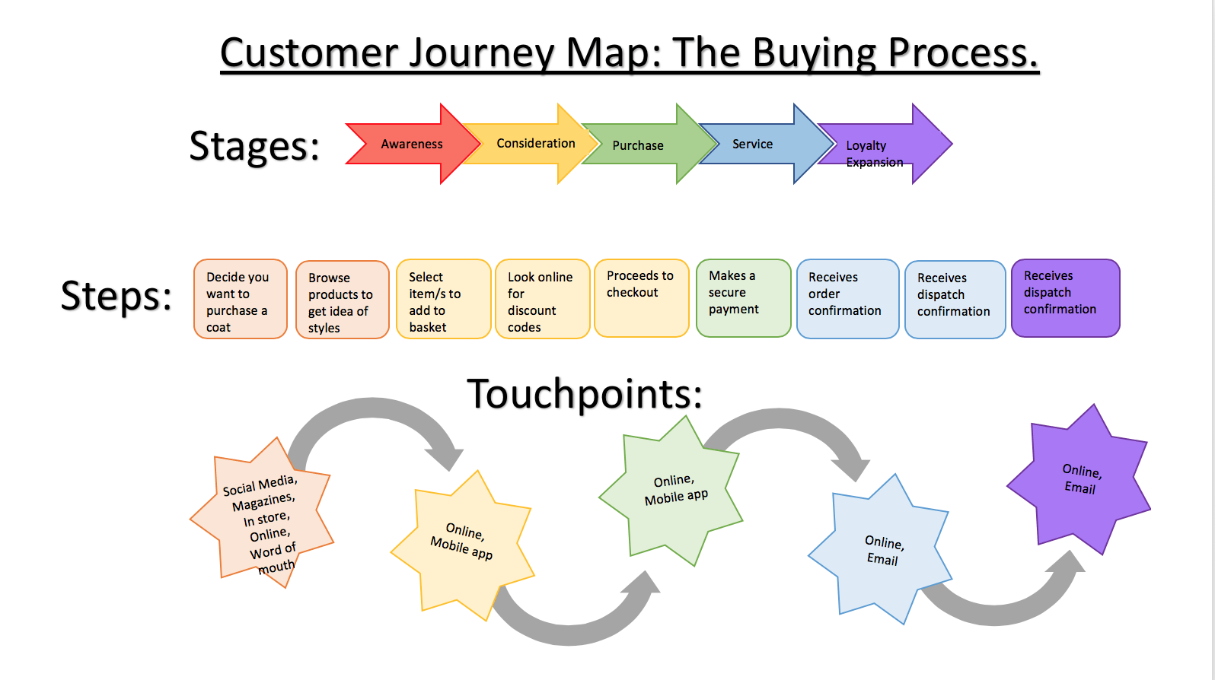
Figure 4, Source: http://blogs.brighton.ac.uk/agrey/2018/12/06/assessed-blog-post-1-audit-of-a-company-website-zara-uk/

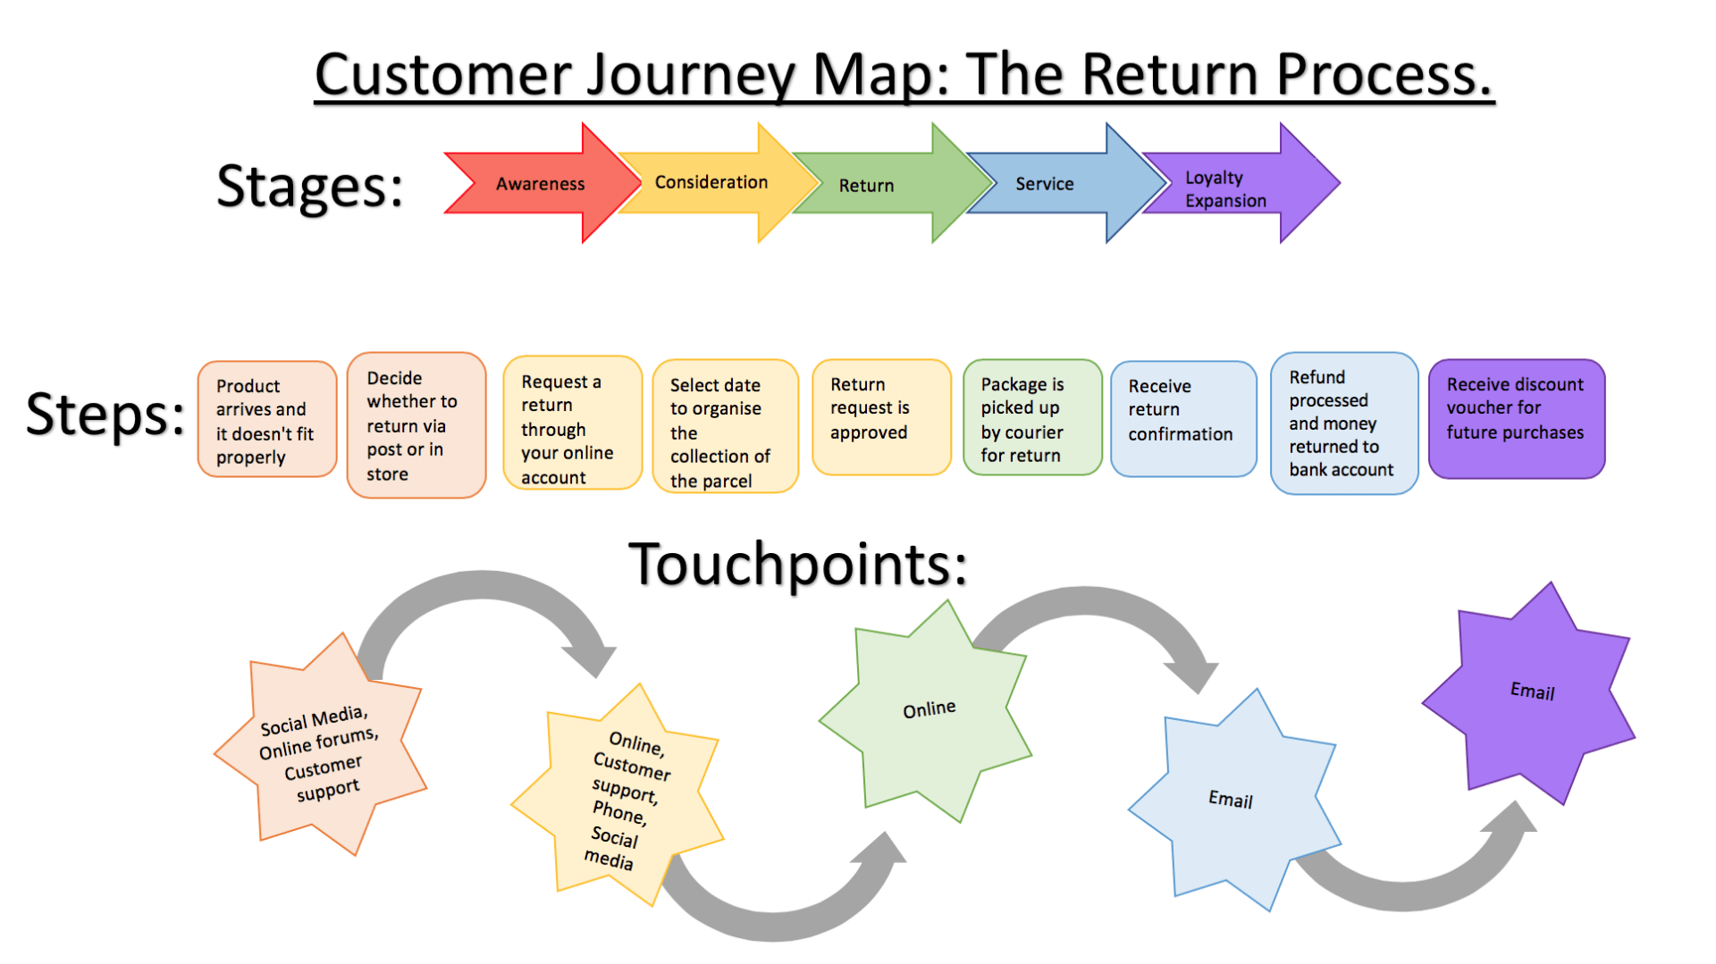
Figure 5, Source: http://blogs.brighton.ac.uk/agrey/2018/12/06/assessed-blog-post-1-audit-of-a-company-website-zara-uk/
Both customer’s journey maps show clearly that majority of the Zara’s touchpoints are online. Wong (2020) points as a crucial “Moments of Truth” which are “instances wherein a customer's opinion about your brand is formed based on their experiences”. Online touchpoints are very useful for earning trust because they give the brand opportunities in many aspects (presentation of new products, maintaining of blogs, feedbacks, etc.) for small costs and in very short time.
Relationship with the customers, are strongly dependent on all the customer touchpoints but key role in this process has post-purchase stage, especially clothes online, return process tilts the scales and people buy. “92% of consumers will buy something again if returns are easy whereas”, (Saleh, 2020).

4.4. Total Engagement model and its relation to Zara

A customer engagement model is the process used for approaching ongoing relationship with customers. ( Reyn, 2020). The conception here is not only one-off purchases but going further via building customer engagement which will increase the sales and respectively, the business performance. Process of engaging customers includes some key elements as follows:
- Customer value proposition- “reason for buying a particular product or service in relation to the value that it offers” (DictionaryCambridge)
- Branding
- Internal culture elements
- Customer experience
It is fundamental to collaborate engaged employees with engaged clients. “People are at the heart of Inditex. We strongly believe that they are the driving force for the growth and transformation of our Group.” (Inditex Annual report 2019). Exactly the internal culture is one of the keys to company’s performance.
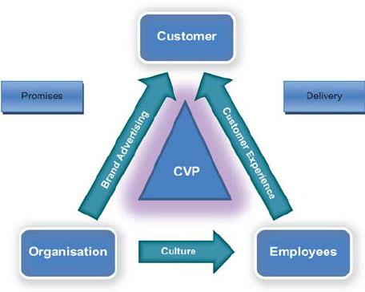
Figure 6, Source: https://www.researchgate.net/figure/The-total-engagement-model_fig2_49513186

The figure 6 shows the relation of the four key steps for achieving an engaged customer: brand advertising, culture, customer experience and customer value propositions.

5. Conclusion
Zara is a giant in one of the most competitive sectors of the economy and the financial results combined in one with the increasing awareness of the brand and customer loyalty proves that the company is on right direction. Of course, this carries advantages and strong reputation of the brand. Notwithstanding, the marketing communication is continuing process happening in dynamic and fast changeable external environment. It means that the brand must keep innovating the marketing strategies in. The report explained Zara’s customer touchpoints and customers journey from end-to-end. There was also critical appraising s of possible innovating marketing strategies aimed to raise awareness of the brand to enable the company to meet stakeholders’ expectations not only now but in the future as well. Company is strongly oriented to increase online sales and, in this order, Zara must ensure excellent post-purchase customer experience and excellent customer service at all the stages. Keeping delivering styling for inexpensive price in combination with customer satisfaction is a key for sustainability of the company and better business results.

Referencing

Blakeman, R., (2018), Integrated marketing communication - creative strategy from idea to implementation, 3rd edition, New York, London, University of Tennessee, Knoxville, Lanham, Boulder,
Keller, K., (2008), 3rd Edition, Strategic Brand Management, Building, Measuring, and Managing Brand Equity, London, Pearson Education Limited
Kotler and Armstrong, (2016), Principles of Marketing, 16th Edition, Harlow, Pearson Education Limited
Kotler, P. and Keller, K. Marketing Management, Marketing Management, 15th Edition (Global Edition), London, Pearson Education Limited
Kotler, Keller. Bradly, Goodman and Hansen, (2009) Marketing management, 1st edition, Pearson Education LTD
Muniz(2015), Brands and Branding, (online), available at: https://onlinelibrary.wiley.com/doi/abs/10.1002/9781405165518.wbeosb047#:~:text=According%20to%20the%20American%20Marketing,which%20can%20be%20defined%20as, accessed: 21/12/2020
Zara website – www.zara.com
Inditex Annual Report 2019
Riezebos, R. (2003), Brand Management: A Theoretical and Practical Approach, London, Pearson Education Limited
Roberts, C. , Frank, A. and Carissa Roberts (2016), “Strategic Drivers of Customer Engagement: Practical Applications” chapter in the book Contemporary Issues in Customer Engagement, edited by Professor Roderick Brodie, Dr Linda Hollebeek, and Dr Jodie Condui, New York, Routledge
Varey, R J (2002), Marketing communication: principles and practice, (online), available: www.books.google.com, accessed 18/12/2020
Pahwa(2020), What Are Customer Touchpoints? Importance & Examples, (online), available at: https://www.feedough.com/customer-touch-points/, accessed 23/12/2020
Reyn, (2020), 7 Proven Models to Increase Customer Engagement in 2020 , (online), available at: https://www.parlor.io/blog/customer-engagement-model/#:~:text=A%20customer%20engagement%20model%20is,interaction%20with%20a%20potential%20customer, accessed 24/12/2020
http://blogs.brighton.ac.uk/agrey/2018/12/06/assessed-blog-post-1-audit-of-a-company-website-zara-uk/
https://www.businesstopia.net/communication/shannon-and-weaver-model-communication, accessed on 21/12/2020.

Ross, (2020), Are Customer Journey Maps More Than A Pretty Diagram? Are They Worth The Investment?online, available at: https://www.invespcro.com/blog/are-customer-journey-maps-more-than-a-pretty-diagram-are-they-worth-the-investment/, accessed 24/12/2020
Saleh, (2020), E-commerce Product Return Rate – Statistics and Trends [Infographic], online, available at: https://www.invespcro.com/blog/ecommerce-product-return-rate-statistics/, Accessed 22/12/2020.
Wong, A. (2020), How To Make A Customer Journey Map In 7 Steps, online, available at: https://marketingcraft.getcraft.com/en-articles/how-to-make-a-customer-journey-map-in-7-steps, accessed 24/12/2020
www.forbes.com Why Zara Succeeds: It Focuses on Pulling People In, Not Pushing Product Out, Apr 23, 2018, accessed 24/12/2020.
https://www.blackerfriday.com/zara
https://conceptdraw.com/a2422c4/preview
https://en.ryte.com/wiki/Customer_Journey
https://globalmarketingprofessor.com/integrated-marketing-communications/
https://www.investopedia.com/terms/b/brandequity.asp
https://dictionary.cambridge.org/dictionary/english/
https://www.forbes.com/sites/kimberlywhitler/2014/07/17/why-word-of-mouth-marketing-is-the-most-important-social-media/?sh=5bc1766854a8
https://www.mindtools.com/pages/article/keller-brand-equity-model.htm
https://www.professionalacademy.com/blogs-and-advice/marketing-theories---the-communications-mix
https://www.researchgate.net/figure/The-total-engagement-model_fig2_49513186
www.surveymonkey.co.uk/mp/identify-customer-touchpoints/
https://transformation.ai/customer-journey-definition

