

Is Domestic Violence still a reoccurring crime in 2021 and is there enough being done about it?

Name: Emily Slade
Student ID: 1900690
School: UWTSD Swansea
Degree: Policing and criminology
Due Date: 6th May 2022
Word Count: 8514

University of Wales Trinity Saint Davids
In fulfilment of the requirements for the Degree of
Policing And Criminology

May 2022

Table of contents

List of figures: 3
Acknowledgements 3
Abstract 3
Chapter one: Introduction 4
1.1 introduction 4
1.2 Why I chose Domestic Violence 5
1.3 RESEARCH OBJECTIVES: 5
1.4 THEORETICAL CONTEXT: 6
1.5 RESEARCH METHOD: 6
1.6 FRAMEWORK: 6
Chapter two: Literature review 7
2.1 Introduction 7
2.2 Plan of my literature review 7
2.3 Domestic Abuse in Wales 8
2.4 South Wales police approach to domestic abuse 9
2.5 Stereotype within Domestic Abuse 10
3.0 Chapter three- Methodology 12
3.1 Introduction 12
3.2 Advantage of questionnaire 13
3.3 Research 14
3.4 Online questionnaire 14
3.5 Qualitative data 15
3.6 Quantitative data 16
3.7 Strategy 16
3.8 Time Horizon 17
3.9 Limitations 17
Chapter four: Research findings 18
Chapter Five: Conclusion 23
5.1 Introduction 23
5.2 conclusion 23

List of figures:
- Figure 3.1: The Research Onion (Saunders et al., 2016)
- Figure 2.1: crimes reported (HMIC,2014)
- Figure 4.1
- Figure 4.2
- Figure 4.3
- Figure 4.4
- Figure 4.5
- Figure 4.6
- Figure 4.7
- Figure 4.7
- Figure 4.9
- Figure 4.10

Acknowledgements

I would like to thank my supervisor, Rhiannon Lloydd, not just for her continued support and availability throughout the process of my dissertation, but also for the extent she has gone to. Ensuring myself and my other classmates were all doing well. With any questions that we had, she was always available to help us with anything.
As well as Rhiannon, I would like to thank Jane Thomas and Mike Durke with all the help that was provided, even to the extent of helping us find great sources to use for our research proposal.
I would also like to thank my friends and family for the support they provided during my dissertation and for pushing me to strive and do my best throughout this major project and throughout my three years at Trinity Saint Davids.

Abstract

Many people can agree that domestic violence is a crime that may never go away. Statistics are on the rise daily as it is a hard crime to try and prevent. This is because of the amount of people who suffer in silence and do not seek help during their extreme time of need.
Domestic violence is a serious crime that is very popular in 2021. On a daily basis, decisions are being made and carried out by the government and the police, as well as organisations, analysing what they can do further to help victims of domestic abuse. The case of this research proposal is to determine whether or not there is enough being done to help victims of domestic abuse. Whether or not they are male or female. Speaking on the topic discussion of gender, it is proposed to the community and to researchers that males are less likely to seek out help than women. This goes without saying that there is research and methods being done to help males and females when they are experiencing domestic abuse. Although, the question that this dissertation is looking into is whether or not ‘enough’ is being done by the government, police and organisations.
After concluding and giving recommendations on what can help encourage domestic abuse victims to speak out, it is my only hope that victims get the help that they deserve and that my recommendations throughout could be helpful to decreasing crime rates of domestic abuse.

Chapter one: Introduction

1.1 introduction
The aim of this introductory chapter is to provide both the overview and background on this study. The goals and objectives, as well as a description and organisation of the research project, will be discussed.
The research aims to examine the opinions of the public regarding if they believe that victims of domestic abuse are being helped as much as possible and to explore whether more or less needs to be done for the needs of the victims. Through thorough research, it has been acknowledged that there is more that can be done and my research project's goal will be to fulfil this gap in current and previous research.

1.2 Why I chose Domestic Violence

I chose this topic as for myself, I find it the most interesting to research about. There is a lot of data and research that has gone into domestic violence/abuse over many years. I would like to compare how the times have changed in the last ten years and what is being done now about domestic violence. I believe that this topic is worthy of consideration for an undergraduate dissertation because there is much secondary research on domestic violence. There are lots of journals, articles and books all on domestic violence as a whole which are very credible sources. Also, as well as researching and writing a dissertation, I will also be learning new things on domestic violence from my research, helping myself develop a better understanding and knowledge of the topic which could help me further in my choice of career path a few years down the line. It is also worthy as it is something that is sadly quite popular for rates and statistics no matter what the date is. There will always be research and theories on domestic violence.

1.3 RESEARCH OBJECTIVES:
My first key objective will be to look at the police methods ten years ago to see what they have done to try and decrease the amount of domestic violence/ abuse in general.
My second objective will then be to see if the police methods ten years ago worked and if so what worked best and what did not work so well.
Somewhere between this I would like to research the different stereotypes within domestic violence and mention statistics that might have changed lately. For example, a statistic could be that there has been an increase in women abusing men because a lot more males have come forward and reported the crime. I will lead from this statistic into “what has made men come forward now than before?”.
My third objective will then be to see what the police do in today’s society to try and tackle domestic violence.
Using surveys and questionnaires, I can find out if people have the same opinion on domestic violence and to see if they agree or disagree that there has been a lot of help from the police surrounding domestic violence.
My fourth objective will then be to contrast my research and suggest why methods worked better than others. I will then bring in the answers of people from my own research and evaluate why they have these “opinions” and what could be done by the police to support people that have been through domestic violence. For example, “is there enough being done after someone reports a crime of being involved in domestic violence?”, “Are people getting the help that they need once the perpetrator has been dealt with?”.
My final objective will be to relate back to the question and evaluate whether or not there could be better methods from the police and suggesting whether the police can work with other organisations in order to tackle domestic violence.

1.4 THEORETICAL CONTEXT:
I will be using google books online as part of my research and also I will be using google scholar, looking for different articles, journals and books on domestic violence/abuse. I will also be discussing the UK policy on domestic violence, the Welsh government on domestic violence (what are they doing differently from each other? What is Cardiff doing different from Swansea?). So I will be using sites such as government reports and journals providing me with statistics and facts.
The questions I will be asking myself in my dissertation is: what is domestic violence/abuse? Why do we have this problem in society? Where is the issue being caused? When did domestic violence/abuse start coming to a rise? Has domestic violence/abuse gradually gotten worse over the years? How do we tackle the problem?

1.5 RESEARCH METHOD:
My research is going to be secondary research which is finding information on my topic online. I have decided to look at google scholar, google books and online university library.
I think that these will be the best for me because they tend to have a lot of credible sources.
My own independent research that I will be carrying out will be to find answers from the community surrounding my topic of domestic violence. I will be conducting a survey/questionnaire with ten questions, open and closed, to collect quantitative and qualitative data. This will allow me to have more of a range of different answers in which I can compare and contrast them to each other.

1.6 FRAMEWORK:
Using my questionnaire/survey, I would like to ask people to participate from the general public. This way I will have a variety of different answers from people who all have completely different opinions. I know people on a personal level who have been involved in a domestic violent relationship so with their consent I will be asking them the same questions and looking at if they agree with the general public opinions.
I will also be emailing my questionnaire/survey to a group called ‘Womens Aid’, in hope that I can get answers and opinions from people at an expertise level in helping with domestic violence.

Chapter two: Literature review

2.1 Introduction

The purpose of this section is to obtain a better grasp of the topics and subjects that will be discussed throughout this dissertation by reviewing previous literature on the topic.
This chapter will aim to achieve the first objective which is to critically analyse if there has been enough rehabilitation for victims of domestic abuse and to see whether it has reduced the amount of crime rates in Wales.
Sources used below were acquired using the UWTSD online library and from Google Scholar. The sources include a mixture of academic journals, articles, and government reports.

2.2 Plan of my literature review
In 2022, in my opinion I believe that there is not enough being done to help people who are victims of domestic abuse. In the hope that my research will propose an unresolved problem in society, I created a survey. The survey is based on people’s opinions on domestic abuse and whether or not there is enough being done to help victims. I am hoping for results that will allow me to compare my work to others, and simply analyse where more work and help needs to be done on the topic of domestic abuse. Other than my survey, I have researched domestic violence and discovered reports, articles and books where there is lots of information and research looking into the similar type of research that I am proposing. I will be looking into what is already being done in Swansea for domestic victims and what is being done in Cardiff, comparing both of their strategies and analysing what is good and what could be better. As well as, looking into the interventions that are presented into society to help victims and what interventions that I think would bring more help.
As of 2021, there is a new definition for the term ‘domestic abuse’. According to the ‘Domestic abuse legislation act’ of 2021, domestic abuse consists of the following:
- Physical or sexual abuse.
- Violent or threatening behaviour .
- Controlling or coercive behaviour.
- Economic abuse.
- Psychological ,emotional or other abuse. (Gov.UK, 2021).

2.3 Domestic Abuse in Wales
Domestic abuse is more common than people think. It is just not reported enough as not everyone who experiences domestic abuse will open up and discuss it. According to women’s aid (2022), domestic abuse is specified as an event or pattern of events of dominating, manipulative, intimidating, demeaning, or violent behaviour, involving sexual assault, perpetrated mostly by a partner or ex-partner, but also by a family member or caregiver. It is extremely frequent and it is experienced by women and committed by men with a great majority of incidents, although there are still many cases in which a woman can be a perpetrator of domestic abuse.
Smith, K (2010) states that, domestic abuse has the highest percentage of repeat victimisation of just about any offence, contributing for 76 percent of all instances.
This fact alone presents to us that domestic abuse is more common than people know or think about it. Repeat victimisation is where someone who has been a victim of a crime such as burglary, but it happens to them quite often where they may have been a victim of the same crime two or three times, even more in some cases (Farrell, G. and Pease, K. 2001).
Looking into the facts and figures of domestic abuse in Wales, statistics have increased in the past few years.
Firstly, I will be looking at the statistics of domestic abuse in Wales during the year 2020. According to the Office for National Statistics (2020), the number of domestic abuse reports had increased and they recorded 259,324 offences from March to June. Looking at the report specifically, there was a monthly time table where the reports had risen from March to June 2020 which was during the Pandemic when COVID-19 had struck. Overall, it represents a 7 percent increase from 242,413 in the same period in 2019 and an 18 percent increase from 218,968 in 2018.
Analysing these figures, it is presented to us that domestic abuse in Wales has risen in the last 3 years from 2018. The aim of this dissertation is to find out why.
More cases are being reported in today’s society as more men are reaching out and seeking help which are adding to the list of figures being reported. AS well as other reasons, CoronaVirus had a major impact on the increase of domestic abuse (Taub, A., 2020). This will be discussed further in the dissertation.
Reports of domestic abuse had risen by an extra 23,445 more compared to reports in 2018. With the continued rise of domestic abuse in Wales, this has helped me come to the conclusion that there is not enough being done to help victims of domestic violence or how to prevent it.

2.4 South Wales police approach to domestic abuse
Previously looking into the statistics in Wales as a whole on Domestic Abuse crime rates, it was shown that the rates were high. To look more into Wales effectively, focus points will be looked into South Wales police, and what they do/ are doing to tackle domestic abuse.
The police are unable to do much help for domestic abuse victims if they do not come forward and report a crime that they have been a victim/ witness in. On the South Wales Police website, they have provided links in one of their sections that are helplines from other organisations that people can ring or text if they need help if they did not want to speak to the police directly.
The suggested organisations are:
- Cardiff Women's Aid - Helping women in the capital who are victims of abuse.
- Safer Merthyr - Includes help for domestic abuse victims.
- Pontypridd Safety Unit - Includes The Freedom Project, which helps women gain freedom from control and abuse.
According to HMIC (2014), in South Wales 6 percent of calls that are made to the police for advice on domestic abuse, 24 percent of these people were repeat victims of domestic abuse. The police are trying to tackle domestic abuse crimes but are also trying their best to reduce the amount of repeat victimisation. Both of these are their main priorities and is to ensure victims are getting the best help possible.
When it comes to knowing how to handle a domestic abuse report, staff are trained to ask questions to people who call, to understand the likely risk to the victim or anyone else who may be present. Once they know the risk of the person calling, They can use force intelligence systems to dispatch the appropriate level of police response and inform the visiting officer of the situation they are likely to encounter (HMIC, 2014).
Looking deeper into whether or not the police are doing much to help victims of domestic abuse, figures were looked at to see if they are tackling the crimes effectively.
The figure below shows that the police must be working effectively due to the high amount of arrests they make with every domestic abuse report.
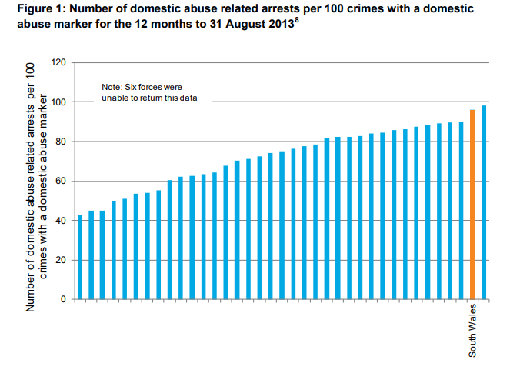Figure 2.1 crimes reported (HMIC,2014)
“For every 100 domestic abuse crimes recorded there were 96 arrests in South Wales”.
Due to there being so many arrests being made by police when domestic abuse incidents are reported, it presents to us as an audience that the police are doing something correct and effective to have made so many arrests in South Wales alone. They have many strategies where a lot of people are trained callers to answer and provide advice for the victims.
Although there are a high amount of arrests made per 100 reports being taken into the system, it does not mean that all domestic abuse victims are safe.
When reports are being made by the victim, there are not always enough risk assessors to help with the incidents.
The risk assessors do not work on the weekend. This can create more pressure on the police and other assessors to try and help the amount of victims calling in. Other domestic abuse staff can take over the people that are not in on the weekend but the downside to this is that they do not have the same amount of training or education as the risk assessors. Following this, as there is a delayed time in helping the victims of domestic abuse, this can result in a negative time setting for the victim as they are not getting the best help that they need at the specific time (HMIC, 2014).
A recommendation that can be made for the police to ensure that this does not happen, is either to recruit more staff that are willing to work on the weekends and have the full potential training to risk assess the victims call or, to train the other specialist staff to the same standard as the risk assessors. This will be more efficient as the specialist staff that take over the risk assessors that are off on the weekend, will know how to carry out the risk assessment properly and to a high standard.

2.5 Stereotype within Domestic Abuse
Whilst researching domestic abuse, it is evident that there is a stereotype within the sector of domestic abuse that victims tend to be women being abused by their male partners. Women are more likely than males to recognise domestic abuse as a crime and report it, whereas men prefer to minimise the abuse they have experienced and are more hesitant to tell others about it. (Dempsey, 2013).
Statistics show in the year ending March 2020, domestic abuse was more common among women than it was among men throughout the year (GOV.UK, 2020).
This statistic creates the stereotype for men being targeted as always being the perpetrator of domestic violence. However, this may not always be the case. It may come across to society and the media that women are abused more, although it could be that men do not report it as a crime to the police as much as women do. I believe that if more men reached out for support and reported being a victim of domestic abuse, then there will be a similar correlation in reports between men and women experiencing domestic abuse (UN Women, 2020).

Whilst conducting my research on gender in domestic abuse, I noticed that there was a large and drastic difference between the amount of research I could find between men and women.
When researching domestic abuse, there was no trouble looking at reliable statistics based on women being victims of domestic abuse. The opposite however, it was quite difficult to find information and figures on men being the victim.
There are many charities across the United Kingdom that allow both male and female victims to seek help. Because female victims are stereotyped, there isn't a lot of scholarly research focusing on male victims. This created a limitation for me within my research which was a struggle.
There are really only a handful of organisations in England and Wales that expressly assist male victims of domestic abuse. Although there is some research on males being victims of domestic abuse, we are not to say if these are reliable or not.
These are helplines such as:
- ManKind
- ADAM Project
- NCDV

In a latest report, male victims indicated that their abuse encounters were regarded as vulnerability, that they were doubted, and that they were preserved as perpetrators themselves, or that they struggled to establish themselves as victims (Hester M, Ferrari G, Jones SK, et al 2015).
The Office of National Statistics (2020), stated that of the reports of domestic abuse being recorded, 26 percent of these crimes were against males.
This is a low percentage of males reporting domestic abuse if we compared the statistic to women reporting domestic abuse. Following up on that statistic, 61 percent of men who called the Mankind helpline have never spoken to anyone about it before. As well as 64 percent of men suffering never would have called if it was not anonymous (Mankind 2020).
A recommendation that could be made for the police to help domestic abuse victims is to spread the word more on helplines for men. Also by spreading the word via social media and posters throughout communities to start encouraging men to speak up. Encouraging men that it does not affect your masculinity for opening up and seeking help. Police should also be trained where to recognise if a man is experiencing abuse. An example would be seeing a man with a black eye. Most people would assume straight away that the man had gotten into a fight and would not think twice to ask how they got it. By always reaching out to men who might be a victim of abuse will allow more men to feel comfortable opening up to others and reporting the abuser.
To decrease the amount of domestic abuse incidents, police and the government should try harder to ensure that word is spread across the communities that there is help available for anyone struggling. One example is that the Welsh Government has a free helpline that a victim can ring if they are experiencing domestic abuse. You can email, text or call a number which is open 24 hours a day, 7 days a week. They provide you with someone to talk to, give you advice on how to leave the abuser and advice on how to stay safe.
However, although there are a lot of helplines for victims of domestic abuse, it is not spread widely enough for people to reach out about their situation.
A new survey has been found that 2 in 5 people are not sure or do not know how to get help after being sexually assulted. Along with 72% unaware there are NHS specialist sexual assault services who can offer confidential support. In addition, more than half of those who have been sexually assaulted report they did not seek treatment afterward (NHS, 2022).

3.0 Chapter three- Methodology

3.1 Introduction

Having already established the basis of my theoretical context of this dissertation, which is looking into whether there is enough being carried out on domestic violence by the police and government, this chapter will discuss the research methods available for this dissertation and what is applicable for it to use in the response to my literature research.
This chapter will present the strategy that I had used to carry out my own research in preparation to compare and contrast the research that has already been conducted on domestic abuse. Whilst also explaining why I chose the method that I did.

3.2 Advantage of questionnaire

For my research, I decided it would be best to carry out a questionnaire. The questionnaire I created was aimed at the public to answer questions on whether there is enough being done for domestic violence victims. I choose to carry out an online questionnaire as part of my research because according to Mertler (2002), it is the most easiest and efficient option to go for. A lot of people were able to access my questionnaire online and submit their answers via the website link. Anyone who answered my questionnaire remained anonymous for security and privacy reasons.
When people who participated are aware that their answers are anonymous, they are more likely to be honest and speak up ( P. Mildred, 2016).
Numerous advantages have now been found for conducting online data, despite the fact that online data gathering is still fairly recent within educators, there are advantages. One advantage of online questionnaires is that they ensure a relatively good time to complete the questionnaire and gather data (Wright, K.B., 2005). These are both time saving which is another advantage on top. Jones, S (1998) says that the Internet also provides academics direct access to a broad, varied, and globalised population, which allows a more diverse amount of responses. As well as, massive volumes of data as the questionnaire can be shared more effectively. Experts also pointed out that collecting data online safeguards from loss of answers and enables the data collected to be put into a database for analysis easily (Carbonaro & Bainbridge, 2002).
I was able to conduct the best research method for me by following the guide called the ‘research onion’.
According to Saunders et.al. (2007), they developed the research onion to assist anyone wishing to undertake research by providing numerous judgement phases which would assist a person in determining whether research method was suitable for themselves. The following is an onion diagram:
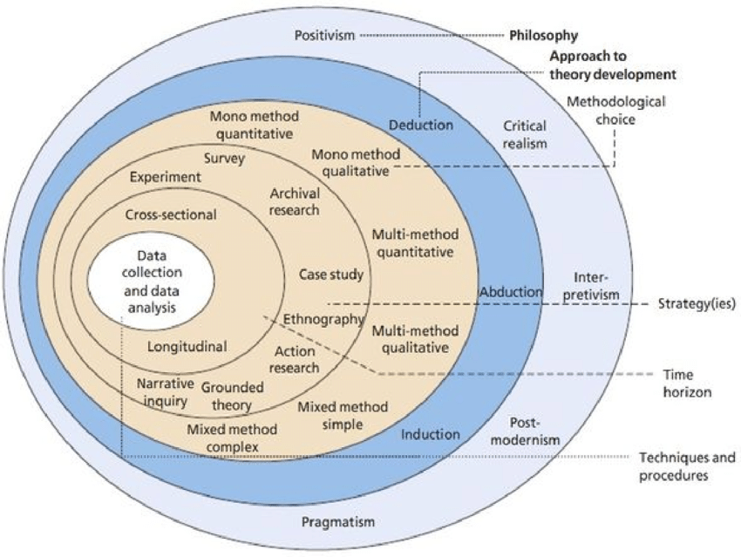Figure 3.1: The Research Onion (Saunders et al., 2016)

3.3 Research

There are many ways in which I could have conducted my research through primary or secondary research. Secondary research is conducting my own survey/ questionnaire that is unique and made by myself which is different from other people’s research (Driscoll, D.L., 2011).
I had chosen to carry out my dissertation under secondary research to allow me to collect data that I have not been able to see in other authors' academic research. This will in future allow me to analyse more in depth with my own results and evaluate what needs to be done to help victims of domestic abuse according to the participants who answered my online questionnaire.
Primary research is very useful as Jaime Walker (2021) said that
Primary research is an important study feature that allows academics and researchers to increase the quality of the research of their findings.
Primary research is an excellent resource of in-depth knowledge on a particular study topic. The data collected using primary research is gathered first hand and also very accurate as it is your own knowledge and information. The information gathered by the researcher will be directly relevant to your own primary research such as a questionnaire, as the primary research is unique. This allows researchers such as myself to gather information on what I believe to be a gap in studies and research today.

3.4 Online questionnaire
According to Lydeard (1991), online questionnaires are much better when comparing it to face to face surveys/ questionnaires. When creating an online questionnaire it is easier for people to access and can gain a lot more participants faster and more efficiently as well as being easier for people as they are able to do it in the comfort of their own home and time. Whereas a face to face questionnaire can take longer and acquire to go out to the public in order to get participants using more time and effort. Also people completing the questionnaire in person can feel pressured into completing it well and efficiently, thus being uncomfortable to do the questionnaire in the first place. Online surveys encourage people to participate as well if they remain anonymous, face to face is not.
Due to the internet being extremely fast in 2022, we have the ability to reach people across the world as well as close to home. Gaining participants online is as easy as sending an email with the link of your questionnaire to people. As well as posting your questionnaire link to a social media platform, more people can answer online (Duffy B, 2005).

3.5 Qualitative data
The research that I have carried out for my dissertation is qualitative and quantitative research.
There is quite a difference to both of these data’s and they both have their own advantages and disadvantages.
Starting with qualitative data, when the researcher collects the responses, it is based on the participants answering open questions on the questionnaire. Qualitative data is basically a participants’ opinion on the question that is being asked, their answer is explained in more detail (Miles & Huberman, 1994).
This type of data collecting allows a wider range of research techniques to be used and allows a variety of different answers to compare to one another.
Even though the data collected will have a variety of different answers and lots of opinions, it will be hard to analyse the data and compare everyone’s opinions against each other. This could be even more difficult as there might not be an opinion that's exactly the same on qualitative research questions.
Instead, most researchers prefer to work with quantitative data (Gibbs, G.R., 2018.).
In qualitative research, analysing the data and interpretation is a much more difficult process to contain. It is lengthy, contains difficult data to understand and has prerequisites for a really complex analysis (Pope, C et.al 2000)
Furthermore, generating a research question in this manner is difficult work because the open questions are typically hard to compare and contrast them to one another.

3.6 Quantitative data
In view of the fact that quantitative research incorporates larger sample sizes that are selected for the study by researchers, its results can be extended to the entire population (Blaikie, N. 2003).
Furthermore, the methodologies that are taken into account are for the use of statistical software in answering the questions (Cramer, D. 2003).
As a result, the approach reinforces efficient time and is effective for solving complicated research topics. Quantitative research ensures the reliability and correctness of the questionnaire's data findings. This method is very well made to provide key knowledge that helps in the generalisation of a topic under study. It includes a few factors and a large number of responses to ensure the validity and the reliability of the research findings.
When carrying out my research, I chose to use mainly quantitative type questions and only a few qualitative. I had chosen to do it this way, as when evaluating my gathered data, I can compare and contrast more with the ‘yes or no’ questions and find out the differences and similarities between them, thus, creating my analysis of my findings much easier. However, I also used qualitative type questions to allow people to have an opinion based answer. This allowed me to view the different opinions to which these can help me answer my dissertation title under opinion based not factual knowledge.
Using both qualitative and quantitative data in my questionnaire is called ‘Pragmatism’. Pragmatism embraces the use of both qualitative and quantitative data, that means that when it gets to gathering the necessary data, and analysing it, there will be a much more of a variety group of outcomes, all of which can lead to a more fulfilling strategic conclusion (Morgan, D.L. 2013).

3.7 Strategy
The research methods that could have been chosen are listed as:
- Interview
- In person survey/questionnaire
- Online survey/questionnaire
(Östlund U, 2011).
For this dissertation, a questionnaire was undertaken to gather the primary data. Conducting a questionnaire is the most arguably the best choice of method when looking to gain very quick results and comparing the data gained from the questionnaire efficiently. (Fricker, R.D. 2002).
The questionnaire in this dissertation will be created using a survey monkey. Once the questionnaire is all set up and ready to be answered, a link will be sent out via people's emails and on social media platforms to gain the attention it needs in order to be able to collect data from it. The survey will be anonymous and confidential as it protects the people who answer the questionnaire. Having people’s names put on the questionnaire creates things to be a lot more complicated in the long run. It is easier to leave the questionnaire anonymous for those who answer it.

3.8 Time Horizon
The ‘Time Horizon’ is the time within which the dissertation is intended for completion (Saunders et al., 2007).
Two types of time horizons are specified within the research onion: the cross sectional and the longitudinal (Sahay, A, 2016).
There seem to be two sorts of frames to consider in the research onion: longitudinal and cross-sectional. A longitudinal research would be completed over a lengthy period of time, even though a cross sectional research would be conducted over a single period of time. (Melnikovas, A., 2010).
Throughout this dissertation a cross sectional time horizon is chosen to be the most suitable as it would carry out more sufficiently than the longitudinal. The research I'm conducting seeks contemporary viewpoints so the cross resection time horizon fits well with this research.

3.9 Limitations
Carrying out my research, there were limitations that prevented certain things from being carried out a certain way.
Corona Virus was a major effect in carrying out my questionnaire. There were times where I could have taken my research further and had produced my questionnaire to people outside in the public areas and to do my questionnaire in person. However, due to the Coronavirus, lots of people were uncomfortable taking face to face art.
On the other hand, even though this limited me from gaining results, posting my link online for people to take part in my questionnaire got me results a lot quicker than what it would have been in person. As well as, the participants that filled out my questionnaire were able to feel more comfortable as they could fill it out in their own time and place. Furthermore, with the questionnaire being online, it allows people to be more honest and truthful as they remain anonymous.
Even though the limitation of Corona Virus prevented me from carrying my questionnaire out in person, the online questionnaire was the easiest approach overall. It was very sufficient in saving time due to it being online and people could access the questionnaire when they had the free time to do so.

Chapter four: Research findings

Question one and question two:
Figure 4.1 Figure 4.2

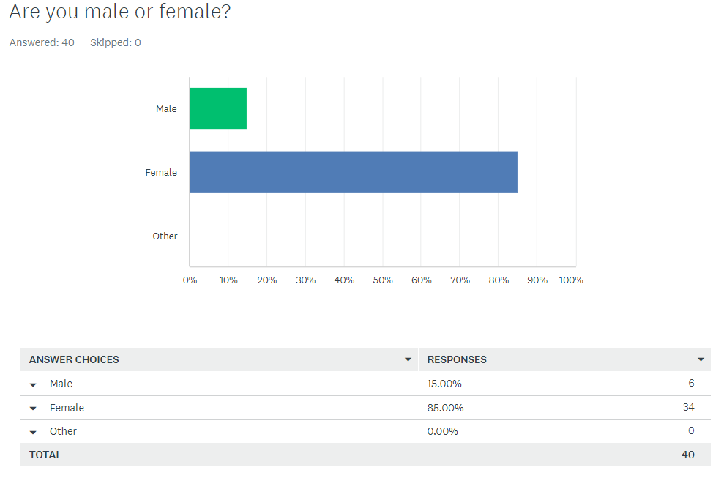
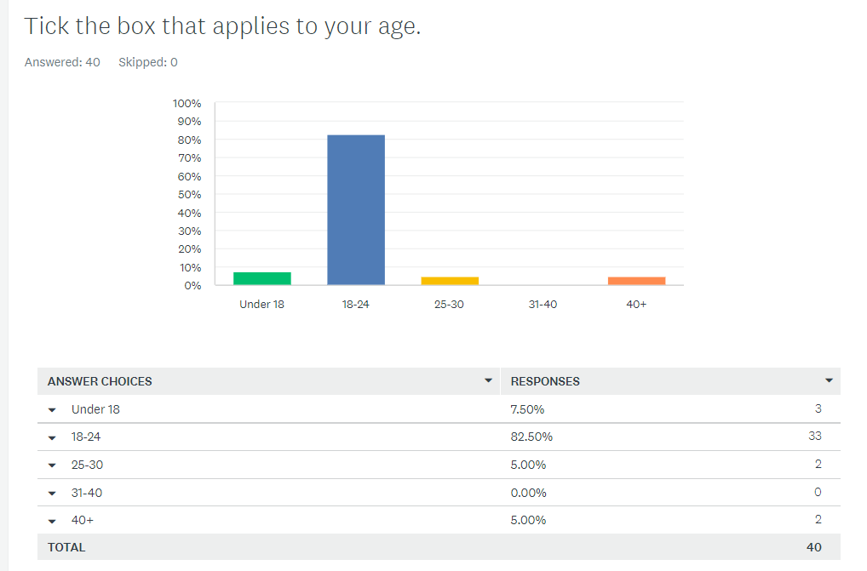

A total of 40 responses were collected. The questionnaire has 10 questions including the open questions. The data was collected using surveymonkey and analysed using survey monkey.
In total there were 6 (15%) male respondents and 34 (85%) females. Options were given for “other” however none were checked by any respondents.
Regarding age, 33 (82.5%) respondents ticked that they were between the 18 - 24 age mark, 3 (7.5%) people ticked under 18, 2 people (5%) ticked 25-30 and lastly 2 people (5%) ticked 40+.

The following questions are based on yes or no answers and open questions.
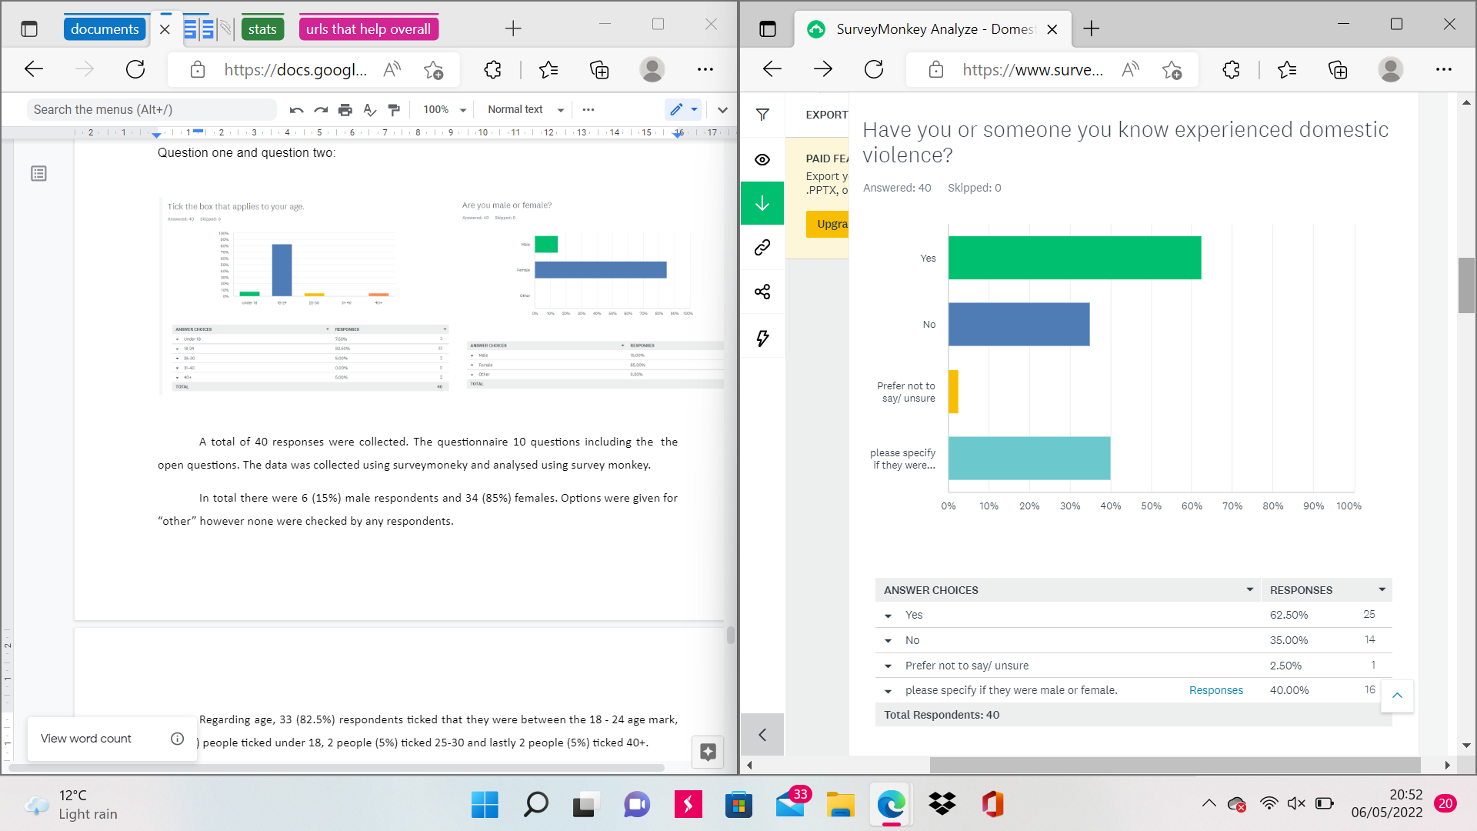
Q3. -

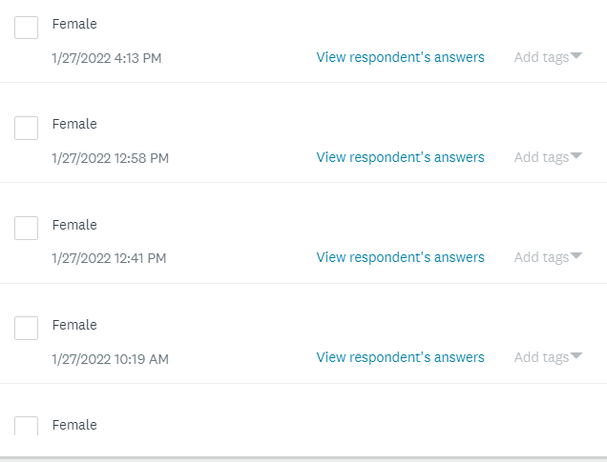

Figure 4.3 Figure 4.3.1

An overwhelming number of participants responded to this question. 25 people had responded yes to the question and 14 people responded with no along with 1 person who was unsure or preferred not to say. Of the 25 people who responded yes, 16 wrote in the slide down box that the person they knew was female and 1 person wrote male.
Straight away, we can see a correlation from the answers that domestic abuse is quite common amongst people and that the responses were all female except from one answer which said male. This supports back to my literature review where there is not enough help for males to reach out and report being a victim of domestic abuse.
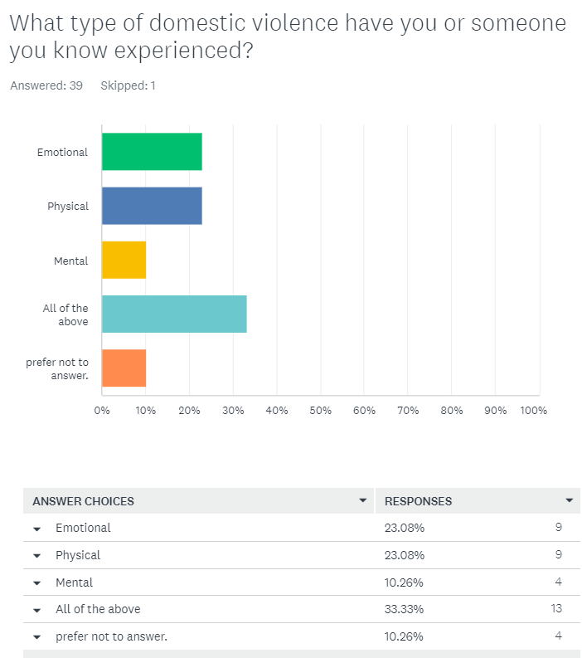
Q.4

Figure 4.4
This question was asking what type of domestic violence have they or someone else experienced. These answers were not surprising.
9 people (23.08%) responded with emotional abuse, 9 people (23.08%) responded with physical abuse, 4 people (10.26%) responded with mental abuse and 13 people (33.33%) responded with all of the above. One person had skipped and four people preferred not to answer.
These responses varied with numbers.
All of the above being the most popular and emotional and physical tying with the same amount of votes.
The most common type of abuse is physical abuse (Kavinoky D, 2012).
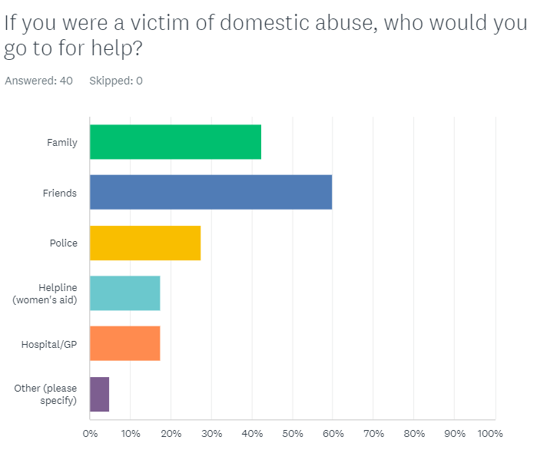
Q.5
Figure 4.5

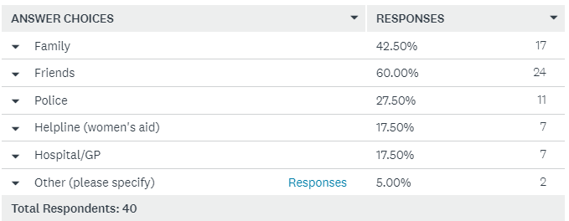
This question, I wanted to find out who
People would go to for help if they were
A victim of domestic abuse.
17 (42.5%) people voted for a family.
24 (60%) of people voted for friends, 11 (27.5%) of people voted for the police, 7 (17.5%) people voted for a helpline and 7 (17.5%) of people voted for the hospital/GP.
2 (5%) of people voted for others and their specified answers were: their partner.
A lot of people voted for friends and family first before voting for the police. This could suggest that the victims may be too scared to go to the police in case it could make things worse for them between the victim and the abuser. If the police assure people that they will give all the help needed and that the victim can remain anonymous and stay off the database then this might encourage people to report to the police.
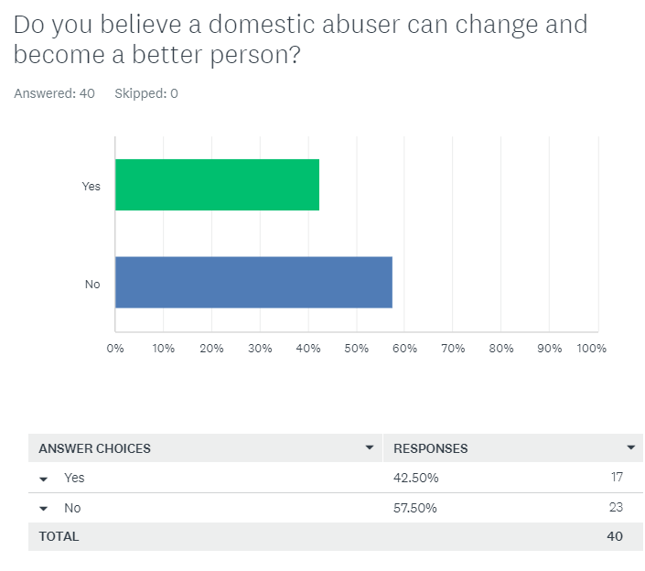
Q6.
Figure 4.6
This question is asking the participants whether or not an abuser can change for the better. 17 (42.5%) of people said yes and the other 23 (57.5%) of people said no.
What can support these answers is the amount of people that are repeat victims of domestic abuse. Like mentioned in the literature review 24% of people are repeat victims of domestic abuse. This is suggesting to us that maybe there is not enough being done for the victims or the pwr portraits in this case. The repeat victims are most likely not getting the help that they need to never have to go through being abused again. Whereas the perpetrator may not be getting enough rehabilitation for them to learn and become a better person. According to Blaser Mills Law (2018), defendants are most likely to receive a sentence of 26 weeks or up to 5 years in prison. The question asked here is whether or not the defendants are getting the help they need during this time to turn over a new leaf and change for the better, or are they going to complete their sentence and come out as the same person.

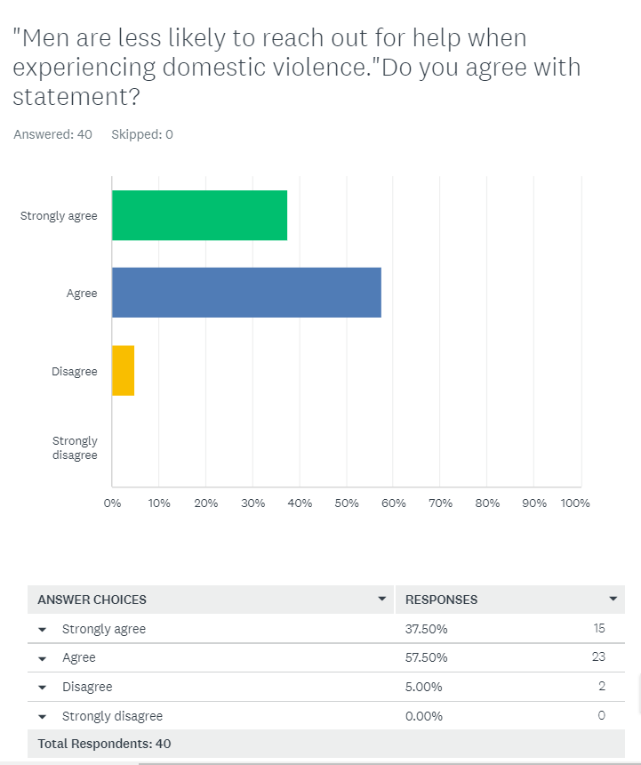
Q.7

Figure 4.7
This question is asking participants if they agree or disagree that men are less likely to reach out for help when experiencing domestic abuse.
Most participants have agreed or strongly agreed that men are less likely to reach out for help when experiencing domestic violence.
The figures show that 16 people (37.5%) strongly agree with the statement. 23 (57.5%) of people agree with the statement and lastly 2 (5%) people disagree with the statement.
Relating back to my literature review chapter 2, heading ‘ 2.6 stereotypes’,
Mankind stated that 61 percent of men who called the Mankind helpline have never spoken to anyone about it before. As well as 64 percent of men suffering never would have called if it was not anonymous (Mankind 2020). This particular question in my questionnaire is supporting the reasoning that not enough is being done to help male victims of domestic abuse. The participants agree with the stated fact that they believe that men are less likely to report the crime.

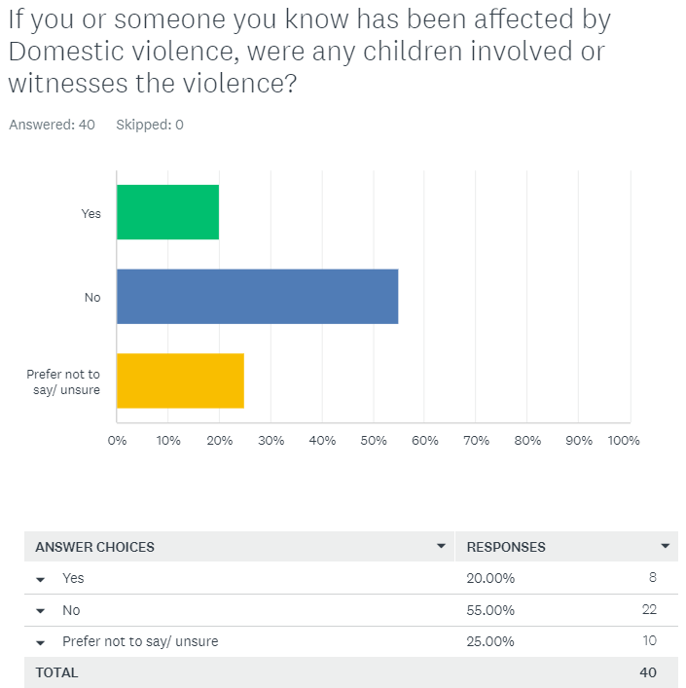
Q.8
Figure 4.8
For this question, 8 people voted ‘yes’ that children were involved/ witnessed the domestic violence and 22 people voted no. The other 10 people had voted unsure or they preferred not to say.
This question was aimed to reach out whether or not children were being affected by domestic abuse. It is a stereotype that when people think of the term 'domestic abuse’, people think of a male and female relationship. Whereas, domestic abuse can involve a partner, family, carer or someone you are living with. This means that children can be a victim of domestic abuse.

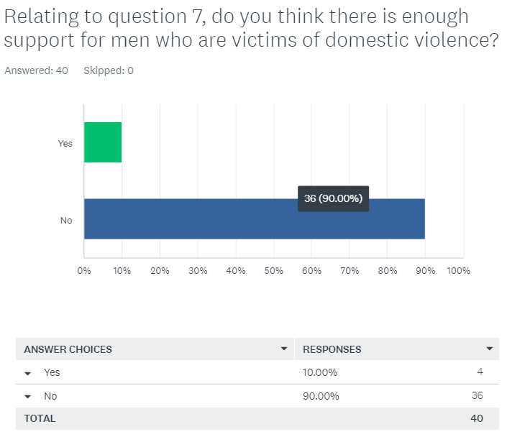
Q.9
Figure 4.9
This question again relates to the fact whether or not men are getting enough help as much as women. As you can see on the chart, the vast majority of people voted that men are not getting enough help that is needed for them. 4 people voted that men do get the help that they need and the other 36 participants voted that men do not get enough help. Relating back to chapter 2 heading 2.6 about stereotypes,
It was mentioned that men do not get the help that they need showing from real statistics. If the community are agreeing with a statement then it shows that there is not enough being done to help male victims.

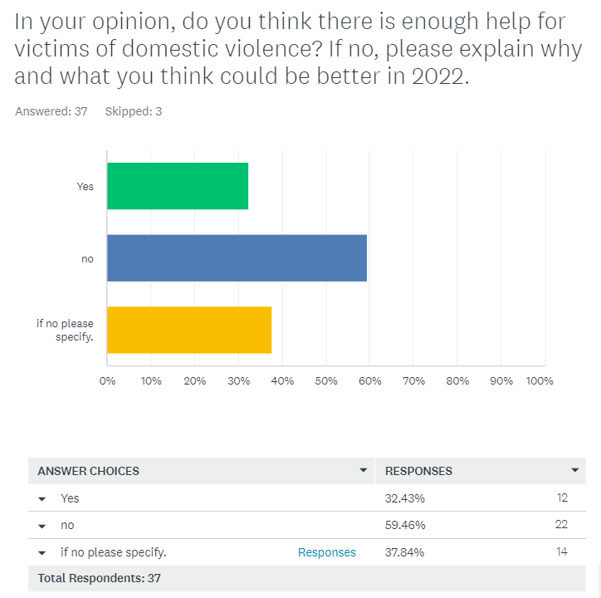
Q.10
Figure 4.10
Overall, the last question was an open question. This was an overall statement whether there is enough help for domestic abuse victims as a whole, male or female.
12 people voted yes and 35 people voted no.
The most common answer to this question was no.
Their explanations to why are below:

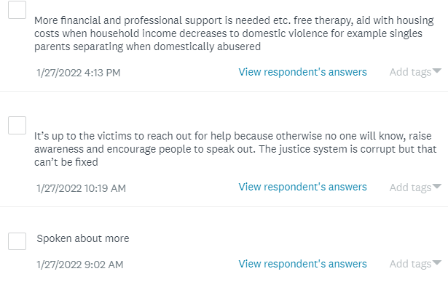
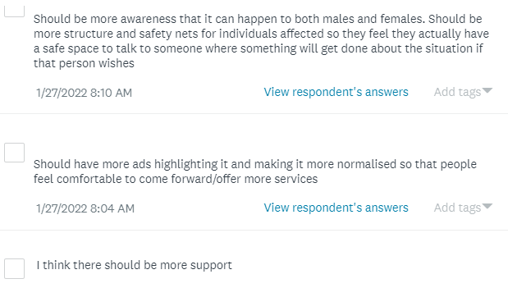

All these answers were very similar. Most of them all agree that it should be talked about more in places such as schools and events and also there should be more awareness spread of the help that the victims of domestic abuse can receive.
One answer had mentioned that the government should aid with housing costs so that the victim can be helped. The example that was given is that if someone had to move somewhere else and live on their own due to domestic violence then the government should create a scheme to help with housing bills etc.
Hyperlink to questionnaire: https://www.surveymonkey.com/r/YWBY6WF

Chapter Five: Conclusion

5.1 Introduction
This is the final chapter of this dissertation and it will present the main findings of the research that has been carried out.

5.2 conclusion
To sum up everything that has been stated throughout this dissertation is whether or not the title of this dissertation has been answered.
The title being “Is Domestic Violence still a reoccurring crime in 2021 and is there enough being done about it?”.
With the research that has been carried out and the methods used to conduct my own primary research, I believe that I can answer this question with confidence that there is not enough being done for domestic abuse victims. As well as that domestic abuse is still a very common occurring crime in 2021.
One of the main findings this research presented was that the participants of my questionnaire all mainly agreed that not enough is being done for victims of such crime (mainly for males). Generally speaking, with the secondary research presented in chapter two of the literature review, there were many scholarly articles and work based on the amount of abuse there has been within males and females in the past 5 years.
This dissertation has shown the extent and nature of domestic abuse in the United Kingdom and the efforts made to provide support for victims.
Domestic abuse is no longer being treated lightly however, there is still a lot more that can be done to help victims. Spreading the word about domestic abuse plays a huge part in trying to reduce the amount of rising crime rates through this. Education and public awareness play a massive role in this as the more people that know about the help that's out there for victims of domestic abuse, the more people are likely to report it to the police.
There are strengths of some of the research. Journals and articles were researched into and lots of them came back with positive outcomes that are helping victims. On the other hand, there are many weaknesses where the government and police are slacking. Comparing this with the victims, as much help that the government and police can provide, it is still at the end of the day down to the victim to open up and speak about what they are going through and also report it as a crime.

Bibliography:

- Dempsey, B. (2013) Men’s experiences of domestic abuse in Scotland. What we know and how we can know more. Abused men in Scotland. (AMIS). www.amis.org.uk.
- Gov. UK (2021), “Domestic abuse, main facts and figures.”
Domestic abuse - GOV.UK Ethnicity facts and figures (ethnicity-facts-figures.service.gov.uk)
- UN Women 2020, ‘Stereotypes’, Stereotypes (endvawnow.org)
- Office for National Statistics (2020). Domestic abuse during the coronavirus (COVID-19) pandemic, England and Wales: November 2020. Domestic abuse during the coronavirus (COVID-19) pandemic, England and Wales - Office for National Statistics (ons.gov.uk)
- NHS (2022), “NHS pledges more support for victims and survivors of sexual assault and abuse alongside powerful awareness campaign”.
NHS England » NHS pledges more support for victims and survivors of sexual assault and abuse alongside powerful awareness campaign
- Walker, J. (2021) “Advantages of Primary Research”.
Advantages of Primary Research - A Definitive Guide - Research Prospect
- Kavinoky D, (2012). PHYSICAL ABUSE: THE MOST COMMON TYPE OF DOMESTIC VIOLENCE
Physical Abuse: The Most Common Type of Domestic Violence - NoCuffs.com

- LYDEARD, S., 1991. The questionnaire as a research tool. Family practice, 8(1), pp.84-91.Questionnaire as a Research Tool | Family Practice | Oxford Academic (oup.com)
- Driscoll, D.L., 2011. Introduction to primary research: Observations, surveys, and interviews. Writing spaces: Readings on writing, 2(2011), pp.153-174. Writing Spaces 2: Readings on Writing - Google Books
- Mertler, C. (2002). Demonstrating the potential for web-based survey methodology with a case study. American Secondary Education, 30, 2, 49–62.
https://www.jstor.org/stable/41064450?casa_token=hRAK04yWvNgAAAAA:h2Y_9wuY1DWb-79GDT8Q7T58VM8HVVIaLdCO2aeDUxq-SEf0Rtz5SU1cHnVvGzhMfxzES4mzqdiS_aM4TMzvEBnCHOzN1prYlKCZVjX0C7S9UjwToA
- Patten, Mildred. Questionnaire research: A practical guide. Routledge, 2016.
https://api.taylorfrancis.com/content/books/mono/download?identifierName=doi&identifierValue=10.4324/9781315265858&type=googlepdf
- Wright, K.B., 2005. Researching Internet-based populations: Advantages and disadvantages of online survey research, online questionnaire authoring software packages, and web survey services. Journal of computer-mediated communication, 10(3), p.JCMC1034.
https://academic.oup.com/jcmc/article-abstract/10/3/JCMC1034/4614509
- Jones, S. ed., 1998. Doing Internet research: Critical issues and methods for examining the Net. Sage Publications. https://books.google.com/books?hl=en&lr=&id=tQhzAwAAQBAJ&oi=fnd&pg=PP1&ots=R44a1CnAPe&sig=hSJNxxV7CG4gEjiyViV-Uix76tk
- Carbonaro, M. & Bainbridge, J. (2000). Design and development of a process for web-based survey research .The Alberta Journal of Educational Research, 46, 4, 392–394. https://www.researchgate.net/publication/289958930_Design_and_development_of_a_process_for_Web-based_survey_research
- Duffy, B., Smith, K., Terhanian, G. and Bremer, J., 2005. Comparing data from online and face-to-face surveys. International journal of market research, 47(6), pp.615-639.
Comparing Data from Online and Face-to-face Surveys (sagepub.com)
- Miles, M., & Huberman, A. (1994). Qualitative data analysis (2nd Ed.). Beverly Hills: Sage. Qualitative Data Analysis - Matthew B. Miles, A. Michael Huberman, Johnny Saldana - Google Books
- Rahman, M. (2016). The Advantages and Disadvantages of Using Qualitative and Quantitative Approaches and Methods in Language “Testing and Assessment” Research: A Literature Review. Journal of Education and Learning, 6(1), 102.The Advantages and Disadvantages ... preview & related info | Mendeley

- Pope, C., Ziebland, S. and Mays, N., 2000. Analysing qualitative data. Bmj, 320(7227), pp.114-116.
https://www.bmj.com/content/320/7227/114.short
- Gibbs, G.R., 2018. Analysing qualitative data (Vol. 6). Sage.http://politicalscience.ceu.edu/sites/politicalscience.ceu.hu/files/attachment/course/733/sgierqualitativedataanalysis_40.pdf

- Morgan, D.L., 2013. Integrating qualitative and quantitative methods: A pragmatic approach. Sage publications.
Integrating Qualitative and Quantitative Methods: A Pragmatic Approach - David L. Morgan - Google Books
- Saunders, M., Lewis, P., & Thornhill, A. (2007). Research Methods for Business Students, (6th ed.) London: Pearson. Research Methods for Business Students - Mark Saunders, Philip Lewis, Adrian Thornhill - Google Books
- Östlund, U., Kidd, L., Wengström, Y. and Rowa-Dewar, N., 2011. Combining qualitative and quantitative research within mixed method research designs: a methodological review. International journal of nursing studies, 48(3), pp.369-383.
Combining qualitative and quantitative research within mixed method research designs: A methodological review - ScienceDirect
- Fricker, R.D. and Schonlau, M., 2002. Advantages and disadvantages of Internet research surveys: Evidence from the literature. Field methods, 14(4), pp.347-367.
Advantages and Disadvantages of Internet Research Surveys: Evidence from the Literature - Ronald D. Fricker, Matthias Schonlau, 2002 (sagepub.com)
- Sahay, A., 2016. Peeling saunder's research onion. Research Gate, Art, pp.1-5.
https://www.researchgate.net/profile/Arunaditya-Sahay/publication/309488459_Peeling_Saunder's_Research_Onion/links/5813283508aedc7d89609ea8/Peeling-Saunders-Research-Onion.pdf
- Melnikovas, A., 2018. Towards an explicit research methodology: Adapting research onion model for future studies. Journal of Futures Studies, 23(2), pp.29-44.
03-Melnikovas-Onion-Research-Model.pdf (jfsdigital.org)
- Womens Aid, (2022). ‘What is Domestic Abuse?. What is domestic abuse? - Womens Aid
- Smith, K., Flatley, J., Coleman, K., Osborne, S., Kaiza, P. and Roe, S., 2010. Homicides, firearm offences and intimate violence 2008/09. London: Home Office.Homicides, Firearm Offences and Intimate Violence 2007/08 Supplementary Volume 2 to Crime in England and Wales 2007/08 (equation.org.uk)
- Farrell, G. and Pease, K. eds., 2001. Repeat victimisation (Vol. 12). Criminal Justice Press. Farrell_and_Pease_Eds_2001_Repeat_Victimization-with-cover-page-v2.pdf (d1wqtxts1xzle7.cloudfront.net)
- Taub, A., 2020. A new Covid-19 crisis: Domestic abuse rises worldwide. The New York Times, 6. Domestic-Abuse-Rises-Worldwide-New-York-Times.pdf (chesco.org)#
- HMIC 2014 I am the title (justice inspectorates.gov.uk)
- Hester M, Ferrari G, Jones SK, (2015). “Occurrence and impact of negative behaviour, including domestic violence and abuse, in men attending UK primary care health clinics: a cross-sectional survey”. bmjopen-2014-007141 1..10
- Mankind (2020), Statistics on Male Victims of Domestic Abuse. Statistics on Male Victims of Domestic Abuse - (mankind.org.uk)
- Office For National Statistics (2020), Domestic Abuse in England and Wales overview: November 2020. Domestic abuse in England and Wales overview - Office for National Statistics (ons.gov.uk)
- Mills B (2018), “New sentencing guidelines could lead to harsher punishments for domestic abuse crimes”. New guidelines could lead to harsher sentences on domestic abuse cases (blasermills.co.uk)

