

Programme: Master of Business Administration
Module: International Business Concepts
Module code: LCMB7034
Lecturer: Dr Robert Ejike Udeogu
Student name: MD Abdul Kadir Chowdhury
Student ID: 2435894

Table of Contents
SECTION 1: International Industry/Business Report 1
1.0 Introduction 1
2.0 Industry and Country Overview: Aerospace Industry in France 2
2.1 Introduction to the Industry 2
2.2 Size, Scope, and Economic Importance 3
2.3 Key Firms in the Industry 4
3.0 Application of Michael Porter’s Diamond Model of National Advantage 6
3.1 Porter’s Diamond Model Overview 6
3.2 Using Porter’s Diamond 6
4.0 Evaluation of a Major Foreign MNC/TNC in the Aerospace Industry in France: Airbus 10
4.1 Company Profile and France Strategy 10
4.2 Entry Mode and Operating Model 11
4.3 Market Attractiveness (PESTLE) 12
4.4 Industry Structure (Porter’s Five Forces) 17
4.5 Success Factors and Risks for Airbus in France 19
4.6 Recommendations 20
5.0 Conclusion 21
Section 2: Reflective Account 22
1.0 Introduction 22
2.0 Reflective Analysis of the Research Process 23
2.1 Description of the Process 23
2.2 Feelings 23
2.3 Evaluation 23
2.4 Analysis 24
2.5 Conclusion 24
2.6 Action Plan 25
3.0 Conclusion of the Reflective Account 25
References 27

Table of Figures
Figure 1: Airplane maker market Share (Spray, 2025) 1
Figure 2: COMMERCIAL AEROSPACE MARKET SIZE AND FUTURE OUTLOOK (Fortune Business Insights, 2025) 2
Figure 3: France Exports of aircraft, spacecraft (Trading Economics, 2025) 3
Figure 1: Porter Diamond Model (Porter, 2014) 6
Figure 2: Porter’s Diamond Model: France's aerospace industry competitiveness (Author) 7
Figure 3: The Airbus A380 vs A350 (Bailey and Garbuno, 2023) 10
Figure 4: Airbus’s operating model in the French market (Author) 12
Figure 5: Political and economic factors influencing Airbus in France (Author) 13
Figure 6: Social and technological factors shaping Airbus’s innovation (Author) 15
Figure 7: Legal and environmental factors influencing Airbus’s operations (Author) 16
Figure 8: Porter’s Five Forces analysis of the aerospace industry (Author) 17
Figure 9: Understanding Gibbs' Reflective Cycle (Williams et al., 2012) 22
Table of Tables
Table 1: Key Players in the French Aerospace Industry and Their Specializations (Author) 3
Table 2: Key recommendations for Airbus to enhance its market presence and competitiveness in France (Author) 17

SECTION 1: International Industry/Business Report

1.0 Introduction
The report evaluates the competitiveness of the French aerospace industry in the international context with regard to technological capability, positioning, and the dynamics in the industry. The global commercial aerospace market is estimated to be approximately USD 960 billion in 2025, and it is expected to rise significantly within the upcoming decade due to the increased demand in air travel and expansion in the fleet (Fortune Business Insights, 2025). Airbus and Boeing are the two industry giants in the aircraft market across the world. Whereas Boeing has dominated the wide-body segment, Airbus has demonstrated high growth in the narrow-body segment, and the two companies have been trading positions as leaders in the total deliveries, depending on a segment. Over the past years, Airbus has dominated in the overall number of commercial aircraft deliveries with a market share of 56% compared to 40% (Spray, 2025).. The leading companies in France, such as Airbus, Dassault Aviation, and Safran, have a considerable amount of influence in domestic and global markets.
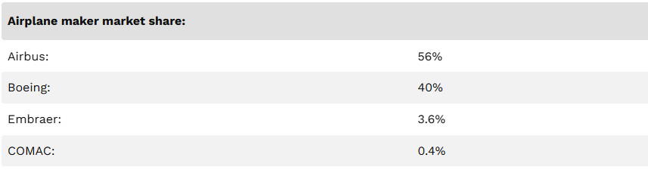
Figure 1: Airplane maker market Share (Spray, 2025)
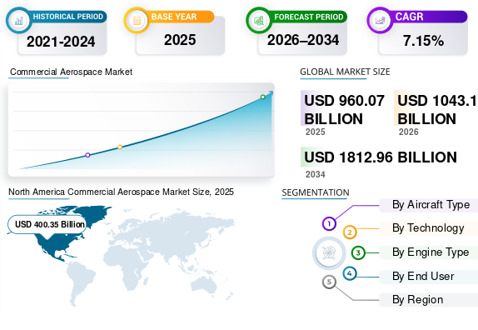
Figure 2: COMMERCIAL AEROSPACE MARKET SIZE AND FUTURE OUTLOOK (Fortune Business Insights, 2025)

2.0 Industry and Country Overview: Aerospace Industry in France

2.1 Introduction to the Industry
The aerospace industry in France is one of the pillars of the local and international economies, which is supported by the presence of superior production, innovation, and export. The French aerospace sector is estimated to bring in revenues of about 70.2 billion euros in 2023, and it directly employs more than 210,000 people, thus enlisting it among the most critical industrial sectors in the country. In addition, it happens to be the primary source of the French trade balance and exports €31.60 billion of the total (GIFAS, 2025).
The ancient aviation heritage of France has produced world-renowned companies like Airbus, Dassault Aviation, and Safran, which altogether predetermine the civil aviation, defense technologies, and high-end aerospace equipment. The flexibility of the industry to the globalization trends such as electrification, autonomous systems and sustainability of aviation highlights the strength of the industry and its ability to be technologically innovative (Atout France, 2025)

2.2 Size, Scope, and Economic Importance
The aerospace industry holds a strategic location in the French economy. More recently, in 2023, the industry recorded revenues of €70.2 billion; the same year, civil aeronautics represented the equivalent of 57.4 billion, whereas defence was 20.3 billion, supported the same year by strong export deliveries (GIFAS, 2025).
France is one of the leading aerospace countries in the world, and it is estimated that there are about 1,000 organizations in terms of aircraft design, building, engines, electronics, and systems. The major markets of exports include Europe, North America, and Asia; France has an excellent export potential because in the year 2024, the country exported aircraft and aerospace supplies, which were worth approximately US $1 billion (Trading Economics, 2025).
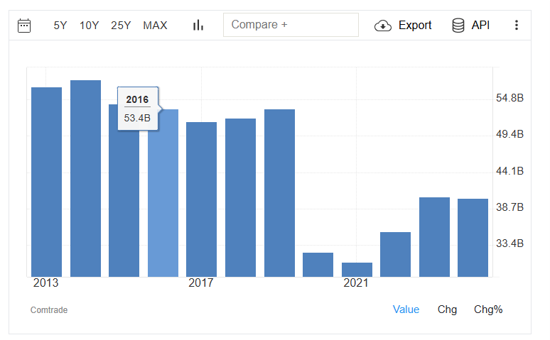
Figure 3: France Exports of aircraft, spacecraft (Trading Economics, 2025)
The sector produces far-reaching supply-chain impacts on top of its direct revenues and stimulates its activities in engineering, manufacturing, testing, and service sectors. The aerospace production also contributes to the strengthening of regional clusters due to its multiplier effect, most notably in southwestern France with Toulouse, a global aerospace center with Airbus and other participants (Aerospace Industries Association, 2022).
The role of the industry in research and development (R&D) was remarkable, since French aerospace companies invest a lot in the technologies that will be developed next, including green propulsion engines, composite materials, and avionics, thus preventing a decrease in competitiveness in the international arena.

2.3 Key Firms in the Industry
Airbus, Dassault Aviation, and Safran are the main players in the French aerospace industry, which is one of the most powerful industries in the world.
- Airbus: Airbus is a European multinational aerospace manufacturer, which is based in Toulouse, France. Even though the company maintains a high presence in France, its operations are spread throughout the world with several production facilities and operations in various countries in Europe, North America, and Asia (Airbus, 2025). The leader of the A320 is Airbus, which is known to have the A350 XWB, which is believed to be one of the most fuel-efficient aircraft in the world among the long-haul aircraft. Their strong suits contribute to Airbus staying at the top of the heap in Europe and having an increasing presence in Asia and Latin America (Globe News Wire, 2025).
- Dassault Aviation: Dassault Aviation, a leading French aerospace company that deals in military aircraft, business jets, and advanced systems, was recognized to have strong sales growth in 2024, posting net revenues above 6 billion and a large back-order base, thus illustrating its dominance in the defense and high-end aircraft market (Dassault Aviation, 2026). The company is very active in the defense business, and its business jets are very competitive in the highly competitive luxury business.
- Safran: Regular aircraft engine, landing system, and aerospace electronics manufacturer Safran is an international investment in the field of propulsion and fuel-efficient technologies. As of 2025, the company registered revenues of about 31.3 billion euros, and it has a workforce of more than 110,000 individuals working across the world (Safran, 2025). The innovation and green aviation technologies that Safran has been committed to have strengthened its competitive edge in the commercial aviation and defense contracts.
Table 1: Key Players in the French Aerospace Industry and Their Specializations (Author)
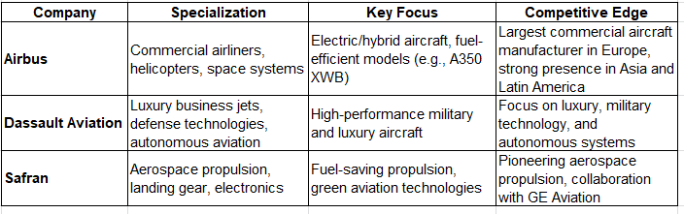
Despite Airbus having the highest market share in the commercial aircraft production industry, Dassault and Safran has a more specialized niche, hence winning an eminent position in military and luxury aircraft. Airbus has a solid presence in the marketplace at the local level and internationally; on the contrary, Dassault and Safran target niche markets in which performance is combined with technological superiority. The Airbus-Boeing airline competition continues to be stiff, especially in the Asian market, where the two companies continue to grapple over sales of airliners.

3.0 Application of Michael Porter’s Diamond Model of National Advantage

3.1 Porter’s Diamond Model Overview
The Diamond Model, developed by Michael Porter, explains competitiveness at the national level, featuring four components (factor conditions, demand conditions, related and supporting industries, and the firm's strategy, structure, and rivalry) that are interrelated. Factor condition is characterized by productive resources of the nation, such as skilled labor, infrastructure, capital, and technological capability. Domestic market needs and consumer tastes are included in the list of demand conditions, and they fuel both innovation and performance of the industry. The related industries are complementary partners in the value chain, where they are the source of the inputs, technologies, and intangible assets to strengthen the core industry. Firm strategy, structure, and rivalry dwell on competition, organizational structure, and strategic decisions that determine global competitiveness (Porter, 2014).
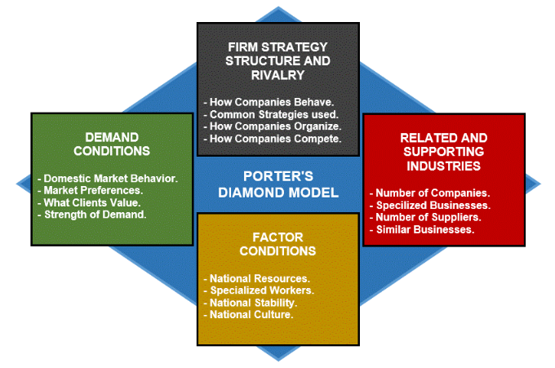
Figure 1: Porter Diamond Model (Porter, 2014)

Using Porter’s Diamond
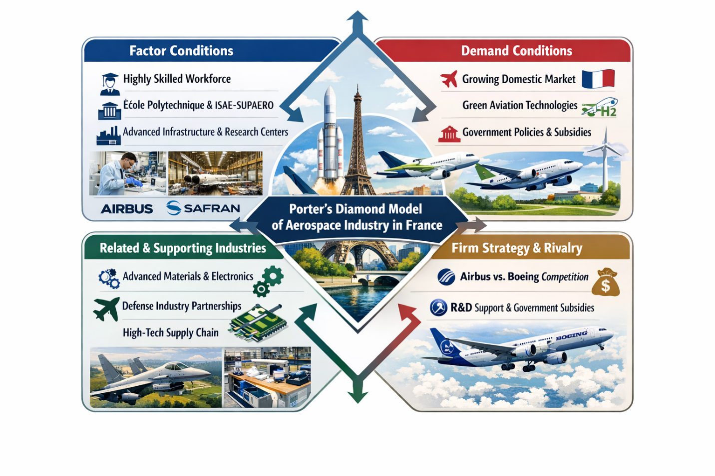
Figure 2: Porter’s Diamond Model: France's aerospace industry competitiveness (Author)

3.2.1 Factor Conditions
The aerospace sector in France has been able to capitalize on its strength of an experienced workforce and the developed infrastructure that is able to support the complex technological demands of the sector. The long history of aviation innovation in the country, as well as the existence of the most prestigious educational colleges and universities such as the École Polytechnique and the ISAE-SUPAERO, guarantees a high level of innovation and provision of technologically competent talent (Globe News Wire, 2025). Furthermore, the airports, manufacturing, and research facilities in France are rated as global best, thus allowing companies like Airbus and Safran to manufacture products of the super state, like commercial planes and sophisticated propulsion systems, among others (UNCTAD, 2025). The large number of these resources also immensely endows France with a competitive advantage in the engineering and production of aerospace, making it a global leader in the sector.

3.2.2 Demand Conditions
The domestic market of France is very critical in influencing the demand terms because it is very stable in terms of technological advancement and product development. Another example of such international partnerships that have led to the rapid speed of next-generation aircraft development is that of the Airbus consortium in which the nation is part of (PWC, 2025). Moreover, France is one of the biggest consumers of aviation services throughout the European continent, and the increasing need for environmentally friendly aviation technologies and autonomous flight systems arouses local innovation (Defence Industry and Space, 2021). This healthy domestic market makes aerospace companies invest in green technologies, including hydrogen-power propulsion, which increases their ability to meet the needs of the domestic and international markets (Airbus, 2025).

3.2.3 Related and Supporting Industries
The aerospace industry in France enjoys the advantage of having a strong, supportive network of industries. However, as an example, Safran not only develops aircraft engines, but it also produces critical aerospace electronics and landing gear and is enabled by electronics, material sciences, and automated manufacturing technology suppliers ((Safran, 2025). In addition, the sector of defense in France (especially such companies as Dassault Aviation) stimulates the military aerospace technologies to be innovated, which also contributes to the commercial sphere (Dassault Aviation, 2026). These interconnections form a well-developed value chain that confirms the presence of France in the aerospace market.

3.2.4 Firm Strategy, Structure, and Rivalry
The French aerospace companies are in a competitive sector that promotes excellence and innovation. Such competitors as Airbus, in its turn, are in active competition with Boeing, the U.S.-based conglomerate (IATA, 2026). This rivalry prompts active innovation and long-term investment in new-generation airplanes and new sustainable aviation solutions (Statista, 2025). The role of the French firms is strengthened through governmental assistance such as subsidies and research and development financing, which ensures that they can invest in the development of innovations without compromising their competitiveness in the world market (International Trade Administration, 2025). The shift of Airbus to the electrifying and hybrid investments is an example of how the strategy of the company can be greatly shaped by the domestic policy and international competition, making it a prominent figure in the future of the aviation industry (Airbus, 2025). Having a healthy domestic competition means that these firms are dynamic and they keep on changing with the times in order to match the globalized aerospace market.
The Diamond Model is an effective Porterian model, as it highlights the interdependent components that make the aerospace industry of France competitive in the world. With a highly skilled labor force and advanced technological infrastructure on one hand and internal demand and high intensity of firm competition on the other hand, every aspect of the diamond model plays a central role in cementing French supremacy in the aerospace sector. The ability to be creative, flexible, and strategically use its powerful supporting industries provides the country with a sustainable competitive edge in the worldwide aerospace market.

4.0 Evaluation of a Major Foreign MNC/TNC in the Aerospace Industry in France: Airbus

4.1 Company Profile and France Strategy
Airbus, based in Toulouse, France, comprises a leading company worldwide in the aerospace sector, which is dedicated to aircraft, helicopters, defense, and space technologies' conception, manufacturing, and selling. With a global workforce of more than 130,000 employees, Airbus operates in a competitive environment that is characterized by its major competitor, Boeing, and has contributed critically to the development of innovation in the entire aerospace sector (Airbus, 2020). The company offers a wide range of products, including the A320, A350, and A380, operating in the specific desired market segment in the commercial aviation industry.
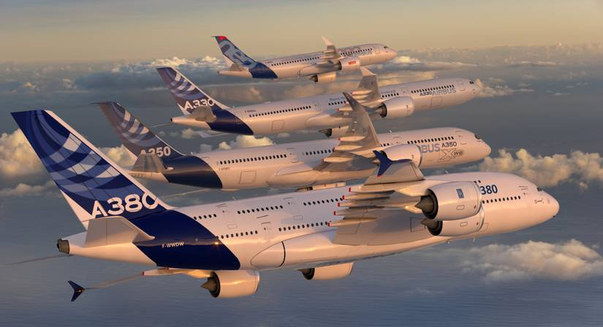
Figure 3: The Airbus A380 vs A350 (Bailey and Garbuno, 2023)
The strength of France in the aerospace industry is further boosted by well-established governmental support, well-established technological infrastructure, and a central location in the European Union (EU). This merger brings about a fiscal and policy benefit to Airbus. Being a key participant in the French economy, Airbus enjoys the advantages of EU financing, research efforts, and regulatory environments that help it to improve its competitiveness at a global level (Spreen, 2019). The production capacities of Airbus, as well as the innovation, are supported by the endorsement of the French government, with subsidies and tax allowances (Airbus, 2020.). Through the hardships such as lengthy trade negotiations with Boeing, Airbus can maintain its competitive advantage in the domestic and international markets due to its strategic focus on sustainability and technological prowess (EEAS, 2025).

4.2 Entry Mode and Operating Model
International market entry strategies that Airbus has been using to dominate the market have been mainly strategic alliances and joint ventures, thus enhancing global presence and reducing entry risks associated with market entry strategies. Its association and cooperation with others, including the state-owned companies in China and with the group of its tier one suppliers, like Safran, have given Airbus intimate knowledge of the local market, availability of cheap labor, and improved production (Airbus, 2024). Such practice is particularly crucial in those markets, like China, where joint ventures are often a legal condition of a foreign company that wants to enter the aerospace market (EEAS, 2025).
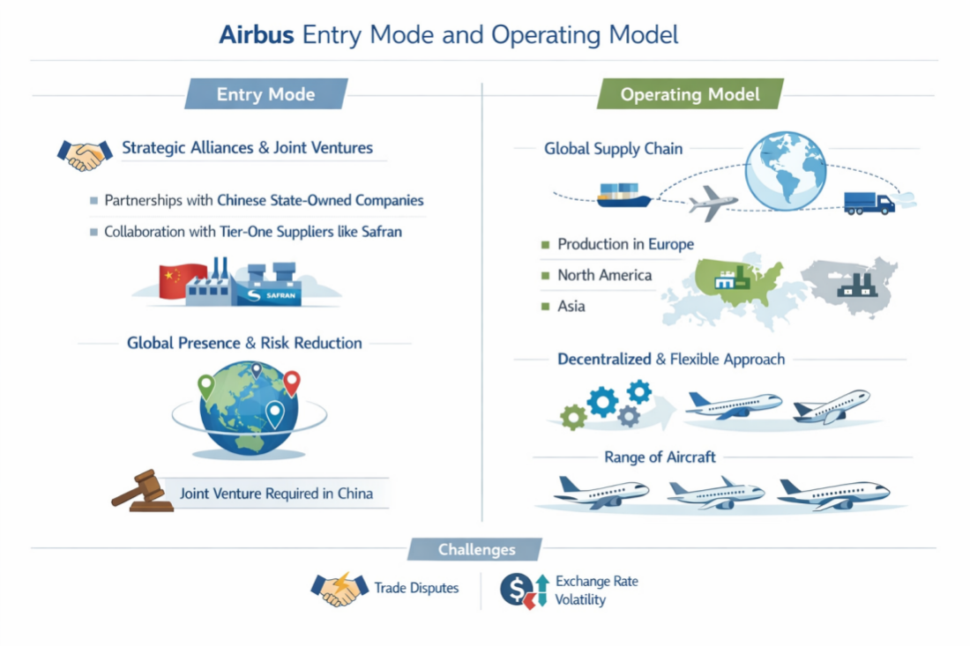
Figure 4: Airbus’s operating model in the French market (Author)
In regard to its model of operation, Airbus has been using a globally integrated supply chain, whereby it has set up production plants in well-located areas throughout Europe, North America, and Asia. Such a decentralized system operates as a way of reducing the threat posed by geopolitical tensions and supply-chain disruptions, which increases flexibility and cost-effectiveness (GlobalData, 2025). At the same time, the company applies a differentiated approach by manufacturing a wide range of aircraft, including the various regional jets and larger intercontinental airplanes, to have a wider market presence and, through this, consolidate its global competitiveness (Frost and Sullivan, 2025).
Although the operating model by Airbus is highly successful, it is vulnerable to external shocks, which include trade controversies and unstable exchange rates that could significantly influence the level of profitability as well as market share.

4.3 Market Attractiveness (PESTLE)
The attractiveness of Airbus in the French market was tested using a PESTLE analysis, which analyzed the political, economic, social, technological, legal, and environmental factors that affect the operation and competitiveness of the corporation.

4.3.1 Political Factors
The political stability of France, combined with the long-term government support, creates the favorable strategic environment of Airbus. Bpifrance is an agency of the French state, which provides direct finance and RandD grants, where Airbus has to invest in next-generation technologies and grant long-term innovation projects (GIFAS, 2025). The regulatory framework of the European Union also fosters common safety measures and funding tools like Horizon Europe that Airbus uses to become a co-financier of sustainability projects. However, the continuing trade disputes with the United States and related tariffs on aerospace products can affect the choice of pricing tactics, either forcing Airbus to pay the expenses in the aeroplane and compensate buyers or passing the inflation to the final customer, and this may damage the competitiveness in the price-sensitive markets (The European Aerospace Cluster, 2020). These are the politics that influence how Airbus decides to enter the market and lobby, as well as plan to abide by regulations.
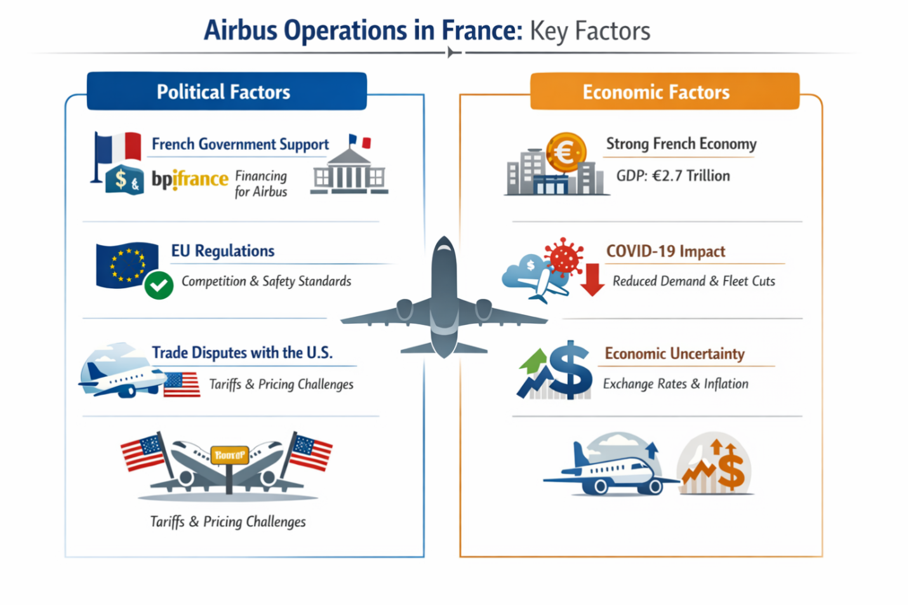
Figure 5: Political and economic factors influencing Airbus in France (Author)

4.3.2 Economic Factors
France has a strong economy, which in 2025 will have a GDP of about 2.9 trillion US dollars, giving it a stable demand market and a cost-effective production market (World Bank, 2025). Nevertheless, macroeconomic shocks like the COVID-19 pandemic have shown that aerospace is prone to changes in demand. The airline clients of the whole world significantly cut down on ordering in 2020-21, which made Airbus respond to the impact by adjusting the production levels, prices, and supply agreements in a bid to maintain the cash flow (IATA, 2026; FAA, 2025). Fluctuation of exchange rates also has an effect on the cost structure of Airbus since most of its components are imported, thereby making its cost more expensive, and in that case, Airbus would use a currency hedging approach and a diversified procurement strategy to protect its margins (Airbus, 2025). Therefore, the strategic choices of Airbus are dynamic pricing policies and adaptable agreement conditions with clients to manage the economic uncertainty.

4.3.3 Social Factors
Airbus is influenced by the changing demands of consumers and the workforce. Environmentally friendly travel is also increasing in demand, and such airlines are looking for fuel-efficient aircraft. Airbus has reacted by increasing the speed of delivery of the A320neo and the A350 families, which have a 1525% lower fuel burn than previous versions (Airbus, 2025). The availability of local talent – Airbus has thousands of aerospace engineers every year – France is the source of this talent. However, the change in demographics, like the older population in Europe, can limit the development in passenger numbers in the future, and as a result, long-term fleet demand and Airbus will be forced to develop other segments, including regional aircraft and defence (OECD, 2025).

4.3.4 Technological Factors
Technological leadership is a strategic requirement in the modern aerospace sector. A strong research and development foundation in France, including cooperation with research centers, gives Airbus the opportunity to invest in electric, hybrid-electric, and autonomous system development to a considerable extent. The company is invested in hydrogen propulsion, with the ZEROe project being a clear example of a transition to decarburization, and it may redefine its competitive advantage (Airbus, 2025). However, maintaining an advantage in technology would be able to create an ongoing force of cost on investment, and this demands partnerships between organizations to spread the risk and cost.
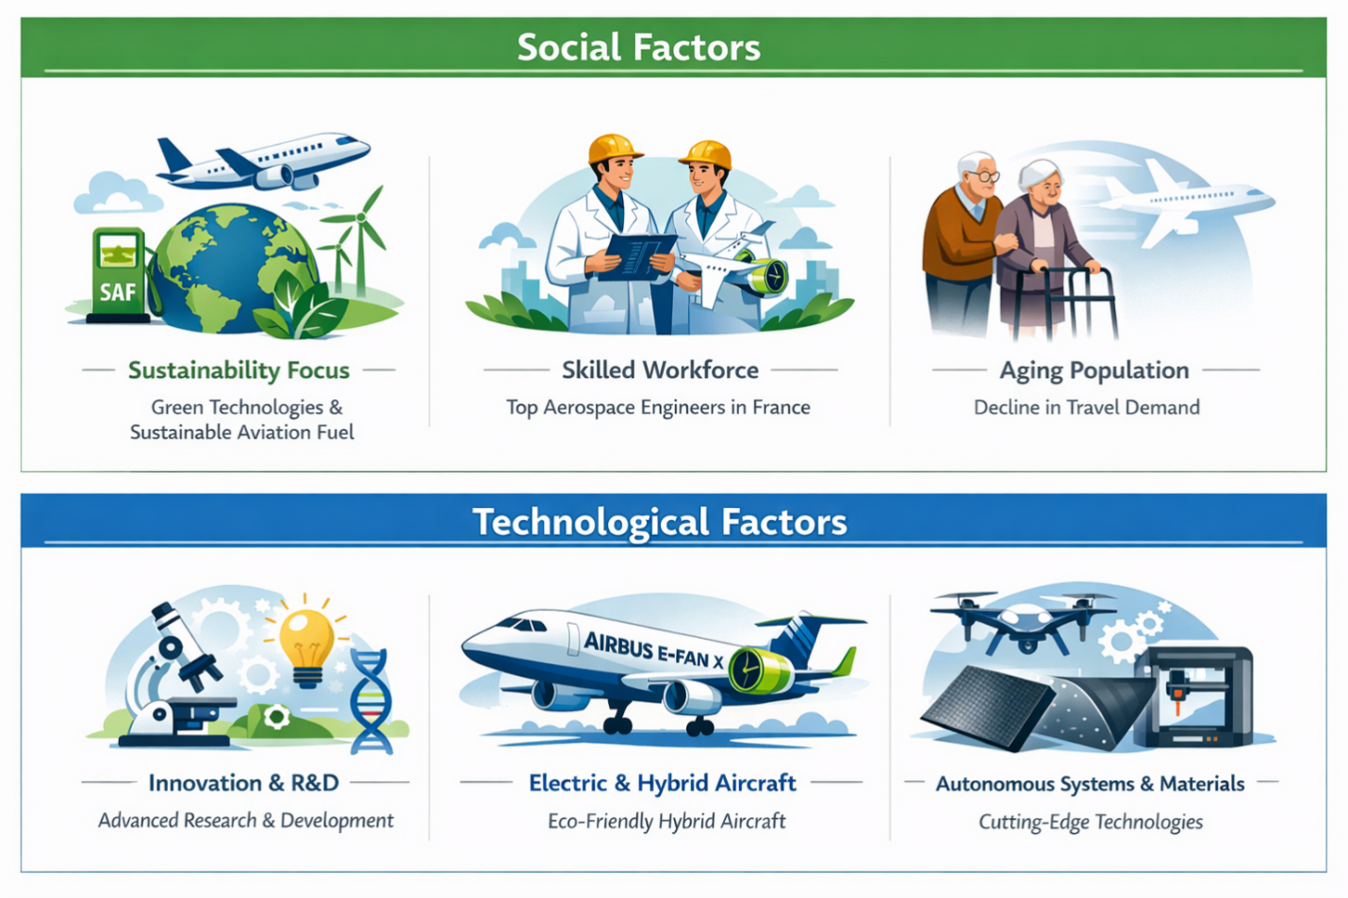
Figure 6: Social and technological factors shaping Airbus’s innovation (Author)

4.3.5 Legal Factors
Airbus conducts its activities on strict safety and certification standards established by regulatory agencies like the European Union Aviation Safety Agency (EASA) and the International Civil Aviation Organization (ICAO). Such regimes increase the cost of compliance, and at the same time, their acceptance in the global market improves. The use of intellectual protection of property also helps Airbus to obtain returns on its innovative efforts. Nevertheless, complex international trade laws and unresolved tariff issues, especially with the United States, present legal uncertainties that affect negotiations on contracts and strategies to get access to the markets (EASA, 2025).
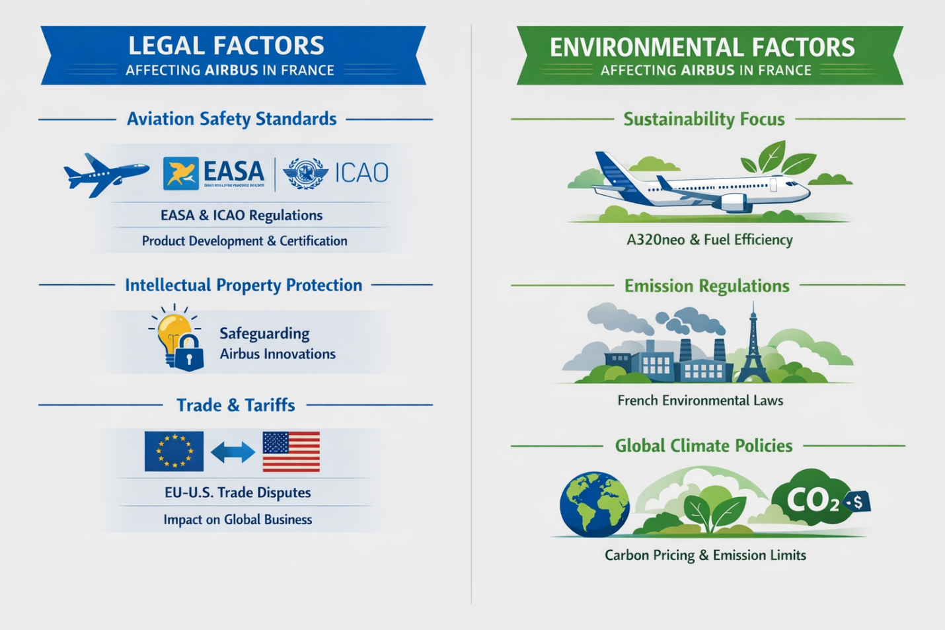
Figure 7: Legal and environmental factors influencing Airbus’s operations (Author)

4.3.6 Environmental Factors
The issue of environmental concerns is becoming more and more important in the strategic orientation of Airbus. Sustainability is one of the most crucial priorities, and the company has focused on reducing its carbon footprint and making aircraft more environmentally friendly. The A320neo aircraft group, which was designed to be fuel-efficient, reflects the attempts of the firm to meet the progressively stricter environmental regulations (Airbus, 2025). French environmental laws, in particular, the laws on emissions, encourage Airbus to continue innovating in areas that touch on green technology. Nevertheless, the increasing regulatory pressures in the international arena, including carbon pricing policies and emission restrictions, can definitely increase the operational expenses of Airbus unless the organization remains creative and compliant with environmental policy (Spreen, 2019).
Airbus has a very favorable market environment in France, which can be attributed to the favorable political and economic climate, technological progress, and the need to be sustainable. Nevertheless, the company is facing severe problems, such as international trade tensions, economic instability due to crises occurring on a global scale, such as the COVID-19 pandemic, and the necessity to constantly innovate to be able to maintain its leading position. As a PESTLE analysis shows, although Airbus has a strong presence in France, it needs to be agile to endure the rogue environment in the global arena, especially with the environmental and technological changes transforming the aerospace sector.

4.4 Industry Structure (Porter’s Five Forces)
The framework of five forces by Porter presents a sophisticated analyzer scope to look at the competition within the aerospace industry and particularly Airbus. The analysis below critically analyzes each of the five forces in the context of how they are relevant to the position of Airbus in the market.
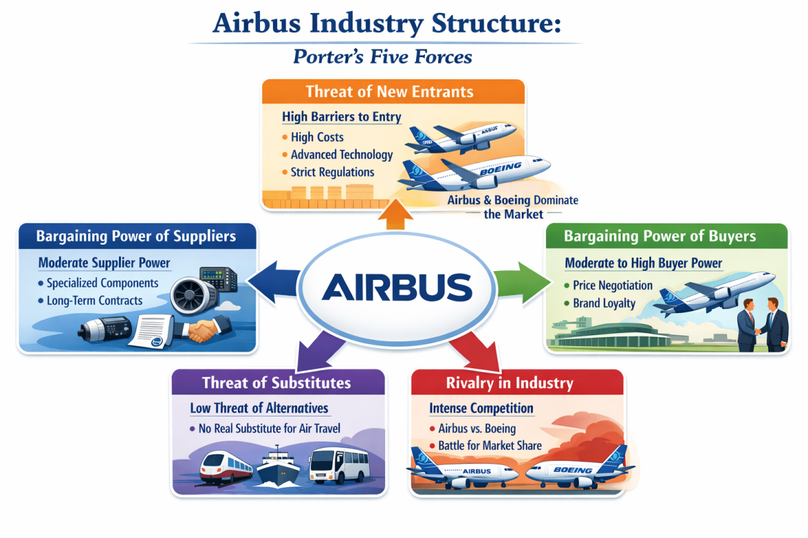
Figure 8: Porter’s Five Forces analysis of the aerospace industry (Author)

4.4.1Threat of New Entrants – Low
The threat of new entries would be viewed as low. The barriers to entry in the aerospace industry are very high based on capital requirements and regulatory and certification fees. It can take a decade-long period with RandD investment exceeding ten billion dollars even before the commercial sale of a new aircraft platform, and companies should have their platforms certified by such agencies as the European Aviation Safety Agency (EASA) and the Federal Aviation Administration (FAA), which may involve significant spending (McMillan, 2010). Such were the prohibitive prices, a history of established relationships with customers, and economies of scale enjoyed by existing airlines, Airbus, and Boeing, which compel potential entries. This means that there is a low probability of new entrants entering the market (IATA, 2026).

4.4.2 Bargaining Power of Suppliers – Moderate to High
The Airbus Company relies on the relatively narrow system of specialised suppliers of the main components that it uses, such as engines, avionics, and composite materials (Spreen, 2019). As an example, suppliers of engines, like CFM International and Rolls-Royce, have great power because they have no alternatives, and the lead time is long. Although long-term contracts may help reduce the effect of price volatility, suppliers remain powerful as a result of high switching costs and scarcity of substitute sources. This complication poses more threats of supply interruptions and cost rises.

4.4.3 Bargaining Power of Buyers – Moderate
Customers of the major airlines have growing bargaining power, fuelled by their price sensitivity as well as their negotiating power based on volumes, especially when they place large orders. However, the buyer power is mitigated by the differentiated product features by Airbus: the efficiency of fuel, the performance based on the range, and the lifecycle support (NASA, 2023). It is in the interest of airlines to struggle with the idea of replacing similar options that are not part of the duopoly of Airbus and Boeing, hence constraining buyer power (CAPA, 2026).

4.4.4 Threat of Substitutes – Low to Moderate
Although there are traditional alternatives like high-speed rail that are applicable in short routes (e.g., the TGV network in Europe), they are inapplicable to long routes. The digital communication tools (virtual meetings) are offering a minor alternative to business travel, but do not substantially cover passenger or cargo demand (OECD, 2025).

4.4.5 Industry Rivalry – Very High
The aircraft market is characterized by competition between Airbus and Boeing. Airbus has also performed increasingly well in 2024, with an average of 790 finished commercial aircraft over Boeing's 610, which has demonstrated high competition in the narrow-body and wide-body categories. Competition leads to constant competition, price competition, and situational product development (Airbus, 2020; Child, 2007).
Altogether, aerospace is an industry of high entry and high investment with a small number of global players, and suppliers and buyers have a strategic influence. The main contributor to competitiveness must be continuous innovation and effective management through efficient supply-chain systems.

4.5 Success Factors and Risks for Airbus in France
Some of the key reasons that have enabled Airbus to succeed in France include the support of the government and technological innovation. The direct investments, government subsidies, and tax incentives by the French government have given Airbus a strong competitive advantage, especially in RandD and manufacturing (Spreen, 2019). Moreover, France has an excellent aerospace system and a highly talented workforce that can help Airbus to sustain its innovativeness, particularly when it comes to the production of fuel-efficient and friendly aircraft. The technological innovations of the company, including hybrid-electric propulsion systems, are in line with the global environmental objectives, which makes it even more appealing to the market.
Nevertheless, there are a number of threats to the future of Airbus in France. Boeing International is a threat to the profitability of Airbus, as global trade conflicts, especially with the United States and Boeing, impact its freedom of operations in the global market (Global one groups, 2025).. Also, the financial instability of other externalities, including the COVID-19 pandemic, adversely affects the demand for new aircraft, interfering with Airbus' revenue streams (Airbus, 2024). Finally, the stiff competition of Boeing and the entrance of a new force in the market of electric aircraft are an increasing challenge to the domination of Airbus in the market.

4.6 Recommendations
Table 2: Key recommendations for Airbus to enhance its market presence and competitiveness in France (Author)
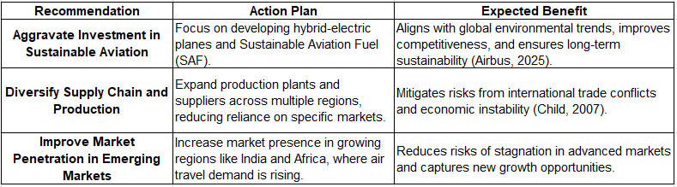
- Aggravate Investment in Sustainable Aviation: Airbus ought to focus on the further development of sustainable aviation technologies, including hybrid-electric planes and sustainable aviation fuel (SAF), to remain a leader in the competitive aerospace sector. This is in line with the global environmental trends and enhances the competitive advantage of Airbus compared to the upstart competitors (Airbus, 2025).
- Diversify Supply Chain and Production: Due to the dangers of international trade conflicts, as well as economic instabilities, Airbus must diversify its supply chain and manufacturing plants in additional areas, not relying on any particular market (Child, 2007).
- Improve market penetration in the emerging markets: Airbus must pay attention to the influx of its presence into the emerging economies such as India and Africa, where there is a growing demand in the use of air transportation. This would reduce the risks of stagnation in the advanced markets.

5.0 Conclusion
The strategic location of Airbus in the French aviation industry is supported by strong governmental assistance, a well-trained workforce, and continued advancement in technology. Its efforts to maintain sustainability, which is a priority issue and business procedure, combined with global supply chain control tactics make the company competitive in both the domestic and international markets. However, the company faces the possibility of vulnerability on the trade front, macroeconomic instability, and competition by Boeing and market entrants in the electric aircraft sector, which are some possible weaknesses that undermine its market dominance. In order to maintain its hegemonic position, Airbus needs to continue investing in sustainable aviation technologies, diversify its operations portfolio, and increase its presence in emerging markets.

Section 2: Reflective Account

1.0 Introduction
The following reflective report critically analyzes how Section 1 of the Airbus operation in the French aerospace industry has been completed with references to the Diamond Model proposed by Porter and the PESTLE analysis. The report discusses the competitiveness of France and external dynamics, which affect the strategic positioning of Airbus, based on the information provided by the government, business reports, and market research, to shed light on the very specific challenges encountered by foreign multinationals within highly regulated markets. The reflective part follows the Gibbs Reflective Cycle, which is structured in a logical way to explain the challenges in using analytical frameworks and the intricacies of EU regulatory demands that have an impact on the actual operations at Airbus (Williams et al., 2012).
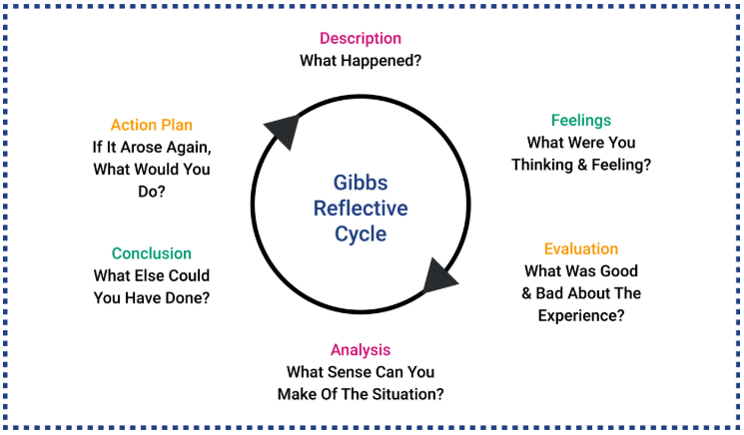
Figure 9: Understanding Gibbs' Reflective Cycle (Williams et al., 2012)

2.0 Reflective Analysis of the Research Process

2.1 Description of the Process
In order to fill in the first part of the report, I initially chose a country and an industry (aerospace) in France due to the high degree of competitiveness of the country in the selected industry. The information was pooled based on various publicly available sources, such as government publications, corporate reports of Airbus and Safran, and market-analytic documents (Statista, 2025). I used the PESTLE model to analyze external factors that affect the activities of Airbus in France and Porter's Diamond Model to analyze the policies of competitive advantage that France is in the realm of aerospace (Porter, 2014). The synthesis of the qualitative data in this research phase was realized through the usage of quantitative metrics to create the complete picture of the dynamics in the industry.

2.2 Feelings
During the process, I had a feeling of frustration and confidence mixed. The first phase of gathering information was stimulating, as the aerospace industry is a complex and dynamic field. I was confident in the use of such a framework as the Diamond of Porter and PESTLE because it provided systematic approaches to the analysis of the competitive environment and external factors. However, the issue also became frustrating with the realization of solving the technical complexity that would be required of such frameworks with the data available, particularly in cases where one faced challenges in finding detailed economic and legal insights that would be relevant to Airbus operations in France. Furthermore, the regulations surrounding the aerospace industry in the EU needed a delicate understanding that posed a certain pressure, as I had to infiltrate the legal writings and the industry-oriented reports.

2.3 Evaluation
It was a victory that facilitated effective primary source acquisition, such as annual reports of Airbus and disclosures of Airbus on top of governmental issues (PWC, 2025). The study was structured and took advantage of various authoritative materials, hence supporting the development of a balanced perception of the aerospace sector and the issues Airbus faces in France. However, the challenges were present when implementing the complex models like Porter's Diamond and PESTLE. I initially had difficulties in associating particular data with the aspects of these models, such as how to measure the role of the EU subsidies on the Airbus strategy, or clarify how the cultural aspects contribute to the Airbus market strategies in France (International Trade Administration, 2025). It, therefore, ensured that I returned to my sources many times to be sure that the analysis was detailed enough and was geared towards the structure of different models.

2.4 Analysis
This experience shows that international business analysis is a progressive process whose assessments and adaptation have to be assessed repeatedly. The Porter model of the diamond helped in explaining the competitive advantages of France in the region of aerospace, hence how local forces like access to skilled labor and government assistance can make the industry successful (Porter, 2014). The PESTLE analysis also improved the cognition of the broader political, economic, and cultural forces that will influence the operations of Airbus in France (IATA, 2026). As an example, sustainability and trade policies established by the EU were found to affect the market strategy and products offered by Airbus. One of the most important lessons was related to the multi-faceted nature of trade relations, in particular, considering the US-EU tension regarding the issue of subsidies to Airbus, which influences business choices in France. This discussion provided a greater understanding of the strategic issues experienced by multinational corporations when working under a high-regulation situation.

2.5 Conclusion
These results demonstrate the importance of using various analytical paradigms to reflect the complexity of the international business dynamic. Although the diamond of Porter's Five Forces and PESTLE gave useful macro-level information, the exercise revealed the lack of granularity of data in terms of legal and political details. To improve the following analyses, a more stringent sourcing plan that will focus on specialized legal sources and industry commentators on the subsidy conflict between Boeing and Airbus deserves a more serious approach (Deloitte, 2025). Also, a systematic analysis of the strategic alignment of the French aerospace industry, involving policy-driven scenario planning, would more accurately indicate the level of interaction between political and economic variables. As a result, such methodological improvements would be expected to provide a more detailed version of regulatory intricacies that define the functioning of multinational activities.

2.6 Action Plan
The next version of the research will put a greater focus on data collection methodology, but more specifically on the sourcing of authoritative legal materials, government publications, and trade laws that support the political landscape that influences Airbus operations in France. The empirical foundation on the basis of strategic evaluation will be enhanced by the further extension of the available body of primary information, including more industry reports and corporate disclosures. At the same time, the increasing analytical skills of the regulatory systems, in particular, of the regulations of subsidies and sustainability principles, will increase the ability to assess their effect on international business strategies. The inclusion of more case studies will make the theoretical constructs and practical exemplars consistent with one another, and this will enhance the connection between theoretical models and the theory of practice. Lastly, a strict writing strategy that seeks clarity, brevity, and a strict adherence to assignment requirements will assist in sustaining a more serious and vigorous approach to the applied frameworks.

3.0 Conclusion of the Reflective Account
Areas where I would have done better in the process are the collection of data, which would be more specific to particular areas, especially on the legal and political matters that affect multinational companies in France. Besides, further sharpening my knowledge of regulatory frameworks and using additional case studies in real-life applications will complement my future work and improve my skills as an analyst.

References
Aerospace Industries Association (2022) 2021 facts and figures, Aerospace Industries Association. Available at: https://www.aia-aerospace.org/publications/2021-facts-figures/ (Accessed: 07 March 2026).
Airbus (2020) Annual activity report 2020, Airbus. Available at: https://www.airbus.com/sites/g/files/jlcbta136/files/2021-08/Airbus-Foundation-Annual-Report-2020.pdf (Accessed: 15 March 2026).
Airbus (2024) Sustainability, Airbus. Available at: https://www.airbus.com/en/sustainability (Accessed: 16 March 2026).
Airbus (2025) Investors: Financial results, Airbus. Available at: https://www.airbus.com/en/investors/financial-results (Accessed: 07 March 2026).
Atout France (2025) France in command of Global Aviation, Accueil - Atout France. Available at: https://www.atout-france.fr/en/mice/us/aeronotics? (Accessed: 16 March 2026).
Bailey, J. and Garbuno, D.M. (2023) The Airbus A380 vs A350 - what plane is best?, Simple Flying. Available at: https://simpleflying.com/airbus-a380-vs-a350/ (Accessed: 16 March 2026).
CAPA (2026) Southwest Airlines enters Interline partnership with Ana, CAPA - Centre for Aviation. Available at: https://centreforaviation.com/ (Accessed: 16 March 2026).
Child, J. (2007) ‘Performance in international joint ventures in China: Critical factors’, Business Networks and Strategic Alliances in China, pp. 290–316. doi:10.4337/9781781959954.00022.
Dassault Aviation (2026) All annual reports - Dassault Aviation, Dassault Aviation, a major player to aeronautics. Available at: https://www.dassault-aviation.com/en/group/finance/annual-report-archives/ (Accessed: 07 March 2026).
Defence Industry and Space (2021) EU Aeronautics Industry, Defence Industry and Space. Available at: https://defence-industry-space.ec.europa.eu/eu-aeronautics-industry_en (Accessed: 07 March 2026).
Deloitte (2025) 2020 Global Aerospace and Defense Industry Outlook, Deloitte. Available at: https://www2.deloitte.com/content/dam/Deloitte/us/Documents/energy-resources/us-2020-global-aerospace-defence-outlook.pdf (Accessed: 06 March 2026).
EASA (2025) European Union Aviation Safety Agency, EASA. Available at: https://www.easa.europa.eu/en (Accessed: 16 March 2026).
EEAS (2025) Boeing subsidy case: World Trade Organization confirms EU right to retaliate against $4 billion of U.S. imports, EEAS. Available at: https://www.eeas.europa.eu/delegations/united-states-america/boeing-subsidy-case-world-trade-organization-confirms-eu-right-retaliate-against-4-billion-us_und_en (Accessed: 16 March 2026).
FAA (2025) Aviation economic impact report, Aviation Economic Impact Report | Federal Aviation Administration. Available at: https://www.faa.gov/economic-impact (Accessed: 07 March 2026).
Fortune Business Insights (2025) Commercial Aerospace Market Size, share: Growth report 2034, Commercial Aerospace Market Size, Share | Growth Report 2034. Available at: https://www.fortunebusinessinsights.com/commercial-aerospace-market-115473 (Accessed: 16 March 2026).
Frost and Sullivan (2025) Aerospace and Defense Industry | Aerospace Market | Defense Market, Frost and Sullivan. Available at: https://store.frost.com/industries/aerospace-defence-and-security.html (Accessed: 06 March 2026).
GIFAS (2025) Launch of the ‘Team France Aerospace’ sector, GIFAS. Available at: https://www.gifas.fr/en/news/launch-of-the-team-france-aerospace-sector? (Accessed: 16 March 2026).
Global one groups (2025) Commercial market outlook, 2021 – 2040 – Boeing, Meeting the recruitment needs of the Airline Industry. Available at: https://globalonegroups.com/https-www-boeing-com-commercial-market-commercial-market-outlook/ (Accessed: 07 March 2026).
GlobalData (2025) Report store, Industry Aerospace. Available at: https://www.globaldata.com/store/industry/aerospace-market/ (Accessed: 07 March 2026).
Globe News Wire (2025) France Aviation Industry Research and Competitive Analysis Report 2025-2033, Airbus, Bombardier, Dassault Aviation, Embraer, Leonardo, Pilatus Aircraft, Robinson Helicopter Co, Textron, Boeing, GlobeNewswire News Room. Available at: https://www.globenewswire.com/news-release/2025/09/24/3155304/28124/en/France-Aviation-Industry-Research-and-Competitive-Analysis-Report-2025-2033-Airbus-Bombardier-Dassault-Aviation-Embraer-Leonardo-Pilatus-Aircraft-Robinson-Helicopter-Co-Textron-Boe.html (Accessed: 07 March 2026).
IATA (2026) Airline profitability stabilizes with 3.9% net margin expected in 2026, IATA. Available at: https://www.iata.org/en/pressroom/2025-releases/2025-12-09-01/ (Accessed: 07 March 2026).
International Trade Administration (2025) Aerospace defense market resource guide - france, International Trade Administration | Trade.gov. Available at: https://www.trade.gov/aerospace-defense-market-resource-guide-france (Accessed: 07 March 2026).
McMillan, C. (2010) ‘Five competitive forces of effective leadership and Innovation’, Journal of Business Strategy, 31(1), pp. 11–22. doi:10.1108/02756661011012741.
NASA (2023) Advancing Technology for Aeronautics, NASA. Available at: https://www.nasa.gov/general/advancing-technology-for-aeronautics/ (Accessed: 07 March 2026).
OECD (2025) OECD Economic Outlook, volume 2025 issue 2 | OECD, OECD. Available at: https://www.oecd.org/en/publications/oecd-economic-outlook-volume-2025-issue-2_9f653ca1-en.html (Accessed: 15 March 2026).
Porter, M.E. (2014) Competitive advantage of nations: Creating and sustaining superior performance. Free Press.
PWC (2025) Aerospace and Defense (AandD) industry performance and outlook, PWC. Available at: https://www.pwc.com/us/en/industries/industrial-products/library/aerospace-defense-review-and-forecast.html (Accessed: 06 March 2026).
Safran (2025) Publications and results | safran, Safran. Available at: https://www.safran-group.com/finance/publications-results (Accessed: 06 March 2026).
Spray, A. (2025) How Airbus and Boeing Aircraft Production has changed over the past decade, Simple Flying. Available at: https://simpleflying.com/how-airbus-boeing-production-changed-over-past-decade/ (Accessed: 16 March 2026).
Spreen, W. (2019) ‘Government economic support of the Aerospace Industry’, The Aerospace Business, pp. 101–114. doi:10.4324/9780429299452-5.
Statista (2025) Topic: European Aerospace Industry, Statista. Available at: https://www.statista.com/topics/4130/european-aerospace-industry/ (Accessed: 07 March 2026).
The European Aerospace Cluster (2020) Aerospace Valley | european cluster collaboration platform. Available at: https://clustercollaboration.eu/cluster-organisations/aerospace-valley (Accessed: 06 March 2026).
Trading Economics (2025) France exports of aircraft, SPACECRAFT2026 data 2027 forecast 1994-2024 historical, France Exports of aircraft, spacecraft - 2026 Data 2027 Forecast 1994-2024 Historical. Available at: https://tradingeconomics.com/france/exports/aircraft-spacecraft (Accessed: 16 March 2026).
UNCTAD (2025) World investment report, UN Trade and Development (UNCTAD). Available at: https://unctad.org/topic/investment/world-investment-report (Accessed: 07 March 2026).
Williams, K., Woolliams, M. and Spiro, J. (2012) ‘Using a framework for Reflection: Gibbs’ reflective cycle’, Reflective Writing, pp. 90–102. doi:10.1007/978-0-230-37724-0_16.
World Bank (2025) GDP (current US$) - France, World Bank Open Data. Available at: https://data.worldbank.org/indicator/NY.GDP.MKTP.CD?locations=FR (Accessed: 16 March 2026).

