Reflective Report
Psychology in Health and Social Care
Module code: LCHS4006
Lecturer: Bianca Sanfilippo
Student name: Julia Catia Gomes Dias da Silva
Student ID:2130195
Submission Date: 5th May 2023

Table of Contents

Introduction
Jean Piaget's psychosocial theory, which I used in my group presentation, is the psychological life span theory that I describe in this report. Then I go into detail about the social learning theory and how it has impacted my life. Finally, I address how the psychological insights I learned in this module will benefit me in my present and future professional endeavours.

Reflect on the psychological life span theory (An in-depth discussion of the theory you focussed on in your group presentation.

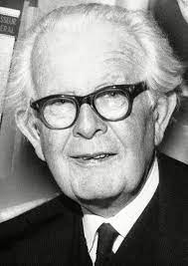
Jean Piaget was a Swiss psychologist, biologist, and thinker who lived from 1896 until 1980. His theories and ideas advanced knowledge of young children's growth and learning. The so-called Piaget Method is still used in academic research in the fields of psychology and education.
The idea of learning in early childhood education according to Piaget. Developmental theory refers to Piaget's theory, often known as the Piagetian theory, which focuses on child development. He said this: “The most creative years of a person's life are those of childhood”.
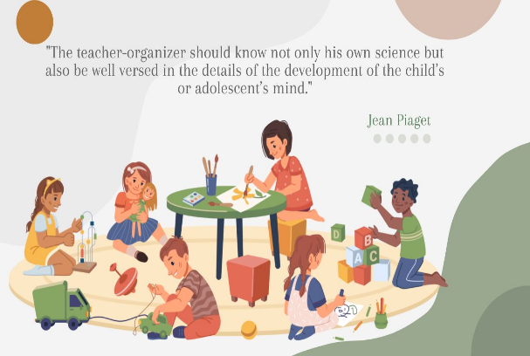
Piaget's so-called cognitive theory, which was based on research on cognitive and human development, was referred to by him as "genetic epistemology." He contributed greatly to the development of the constructivist current with his theories. According to Piaget, a child goes through four stages of development before entering puberty. These stages relate to a person's capacity for thought or the way they store information in their psyche. the following
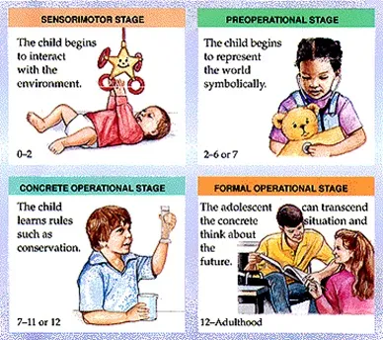
Sensorimotor (ages 0 to 2 years) stage, it is implied by the name alone that the child's senses and motor coordination are at this stage of development. At that stage, despite his limited cognitive abilities, he begins to explore his environment and recognise objects.
Pre-operational stage (from 2 to 7 years) As speech develops, the child begins to name the objects in his environment at the same time that he begins to be able to recall them in his mind (mental representation). Though still developing, reasoning is also beginning to take shape.
Stage of concrete operations (from 7 to 11 years old) The next phase has to do with the brain's capacity to think through and solve specific problems. In it, the child starts to develop a stronger capacity for interpretation and, as a result, can already work out some simple issues. For instance, knowledge of numbers and mathematical procedures is internalised.
Stage of formal operations (from 11 years to 14 years) Adolescence marks the beginning of the development of logical reasoning and the beginning of an individual's capacity for independent thought, as well as his capacity to formulate theories and consider the possibilities of the universe. Thus, it is an autonomous phase.
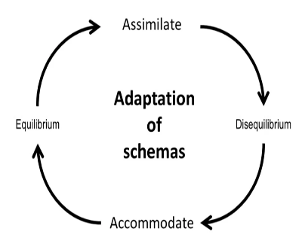
According to Piaget's thesis, the child's cognitive development happens as a result of assimilation and accommodation. The person creates mental absorption systems to deal with reality. What Piaget refers to as "accommodation" takes place when anything is modified. The formation of new assimilation schemes is facilitated by accommodations, which are the means by which cognitive progress occurs. When there aren't any issues or challenges in the environment, the mind only assimilates; nevertheless, when there are, it restructures (accommodates) and grows. Assimilation is necessary for the configuration of accommodation since it is a reorganisation of assimilation. The middle ground between assimilation and accommodation is situational adaptation.
A person's "cognitive structure" is a collection of assimilation strategies that, in accordance with Piaget, are frequently arranged in accordance with the mathematical models of group and network. Piaget viewed all aspects of behaviour—including the physical, verbal, and mental—as a component of the action. Even perception is a process for him, and the mental image is an internal duplicate of the thing being perceived.
There are three types of action: verbal, mental, and sensorimotor. Thought is merely the internalisation of action, which is typically accompanied with residual motor activity like gestures and eye movements.
The theories of Piaget can be used in a variety of real-world contexts in the field of pedagogy, whether as a guide for organising classroom activities according to developmental stages or even for parents to use when buying games and stimulating activities.
Although I still think it's a useful approach to the topic, the Piagetian model has received significant criticism for its ambiguity and the potential for cognitive gaps. The concept that a child may be developing in some ways relative to his stage and delayed in others, or that his development is not uniform but scale-based, has not been considered in Piagetian investigations. Other significant criticisms centre on the Piagetian model's alleged undervaluing of religious tradition and the social setting, which are key determinants in the development of not only intelligence but also of all personality types and individual differences. He still holds the title of psychologies’ founding figure.

A comprehensive discussion on a psychological phenomenon/framework taught under this module and its impact on your lives.
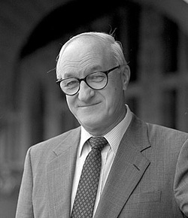
How much does it affect you if you walk into a classroom, pick a seat, and as soon as the training begins you notice that all your classmates are concentrating on their phones rather than the teacher? The theory of social learning, which examines how much people have an impact on one another in terms of learning, both negatively and favourably, was established along these lines by Canadian psychologist and Stanford University professor Albert Bandura.
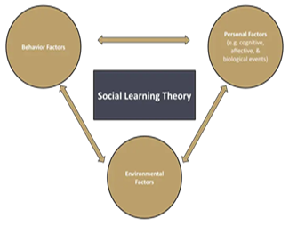
The theory emphasises education gained through observation. According to Bandura, a major factor in the process of knowledge absorption is the learner's internal mental state. Thus, social learning results from the interaction of the learner's mind and his immediate environment. In other words, this philosophy emphasises something that everyone should consider: it is educated by example and acts. Naturally, all of this had an impact on how someone felt mentally. People pick up new skills by watching how others behave.
Children with parents, students with teachers, or other daily interactions can all lead to this insight. However, it can also happen thanks to the internet, modern technology, and social media. But the impact goes further than that; it is also incorporated into the context of education. This approach promotes each student to learn at their own time and speed, therefore it naturally works for the distance learning that occupies an increasing amount of the market.
The "bridge" between classical learning theory (i.e., behaviourism) and the cognitive approach is frequently referred to as social learning theory. Bandura has consistently valued the role of mental (cognitive) aspects in learning, characterising "learners" as active individuals when processing information and appreciating the connection between their actions and potential outcomes.
The expert makes the point that we shouldn't assume that people replicate what they see and that all kids will act aggressively just because they watch violent films or television shows at home. "Thoughts come before imitation, and some mediators favour imitation or a different course of action."

Environment: Rather from being equitable or homogeneous, our society is made up of the most diverse surroundings and situations. Some are more favourable, more uplifting, while others are more repressive. Let's examine a case in point. I've been learning how to play the piano since I was ten years old, up to this school year. I used to be fascinated by this instrument and yearned to learn more about it. My father, who lived in a difficult home, swiftly convinced me otherwise when I got there. I've stopped playing the piano ever since.
Attention: In order for a behaviour to be mimicked, it must capture our attention, pique our interest, and activate our mirror neurons in some way. Many behaviours are present in our daily lives, but not all of them are beneficial to us.
Motivation is the force behind the will to carry out the behaviours we observe in other individuals. However, at this point, we need to discuss vicarious learning, in which Albert Bandura claimed that it is not enough to merely "observe" what people do, but also to see what benefits or consequences come as a result of their actions.

Reflection (Application of learnt perspectives in your current or future career settings)

For the work of health professionals, technical expertise is crucial. The need to comprehend the patient's posture and assist him in overcoming the challenges, on the other hand, is crucial. This is one of the things that demonstrates how important psychology is to nursing. A bandage cannot be applied mechanically, nor can an injection be administered or a medication taken. After all, a person's emotional state greatly influences his or her quality of life, particularly when that person requires medical attention.
Empathy is a virtue that can help you care for someone in the proper manner. It entails the capacity for one individual to assume the role of another. In other words, it offers insight into the motivations behind a person's actions. The nurse technician can come up with strategies for approaching patients that will assist them acquire their trust by observing their mental condition. To build a stronger bond between the two, this initiative is essential.
Additionally, it makes the medical professional more patient when dealing with patients who are undergoing treatment. To maintain the environment's harmony, which is crucial for rehabilitation, one must act with calm and goodwill.
The right to be heard is a key component of psychology in nursing and is necessary for everyone to feel appreciated. If the nursing technician listens intently to the patient, it is a positive first step towards developing a successful working relationship All healthcare providers should be able to listen well. It is still important to pay attention to what is being said, even if it is not pertinent.
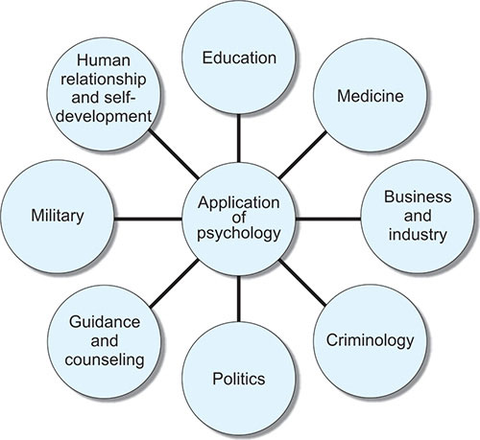
Just being available to talk to the patient demonstrates how much the medical practitioner cares for them. Any assistance is appreciated during trying times. Under no circumstances can this be disregarded.
For nursing technicians to get along with the patient, listening skills development is essential. Additionally, it enables a positive conversational opening. Discussion topics that will keep the conversation going longer can be addressed based on what the other person is saying. The delivery of care with openness and respect for others depends on effective communication. People undergoing medical treatment benefit greatly from words of encouragement or optimism in their daily lives. Even if the talk is about something inconsequential, showing the patient affection is beneficial for their self-esteem. It also suggests that he is in a setting where humanised care is prioritised.
All professionals are constantly looking for ways to improve. This is not any different for nursing technologists. As a result, it is advised that participants in training acquire the technical know-how and communication abilities necessary to effectively interact with the target audience. The expert is more eager to aid the patient in having a higher quality of life when he incorporates psychology into nursing. After all, our emotional state greatly affects our physical state.

Conclusion
A crucial inquiry for individuals who are unaware of the facts behind what promotes our happiness and wellbeing. In its broadest sense, psychology is a discipline that investigates how people behave and think, with the overarching goal of helping people feel good about themselves, the people they relate to, and their surroundings. Each of our decisions, fears, successes, and failures are all influenced by psychology. I'll try to contextualise right away because it's difficult and far from universal to define psychology. The term "psychology" comes from the Greek phrase "study of the mind." A science, psychology has a specific subject of study as is true of all sciences. Generally speaking, human behaviour and mental processes are the subject of research in psychology, and general principles that can explain them are sought after.

References

