Introduction
The processing_anomalies dataframe includes Day, Zone, Category, and UnitsProcessed, along with empty columns for DailyZoneAverage and Anomaly. When the dataframe contains only specific flights, it computes an average for matching records across days and zones. A second loop calculates the average for each row and checks if values exceed 115% or fall below 85%. Rows violating these limits are marked as TRUE, then filtered to display the first 10 matching rows alongside a total count (Gries, 2021).
2 Explanation of Code and Logic
2.1 Warehouse Data Generation Using Nested Loops
The code uses a random seed of 123 to ensure reproducible results each time it runs. The warehouse_data dataframe is pre-allocated with 840 rows and 5 columns to avoid expanding it during the loops. Three nested for-loops iterate through each day, zone, and category combination. The number of units processed is calculated as 100 + (Zone × 8) + (Category × 5) + random adjustment (R). ProcessingTime is then calculated by multiplying UnitsProcessed by 0.85. Finally, a row_index counter increases after each iteration to store the results in the correct row of the dataframe.
2.2 Total Units Processed per Zone
Zone and TotalUnits are contained in the zone_totals dataframe. An outer loop goes through zone 1 to 5. An inner loop looks at all 840 rows, and an if statement increments the running total value of UnitsProcessed if the row's Zone value occurs. Once the inner loop is complete the total is set and the next zone resets the total.
2.3 Average Processing Time per Category
The category_average_time dataframe updates by adding ProcessingTime to total_time and incrementing record_count for matching rows in the inner loop. After scanning, total_time is divided by record_count to calculate AverageProcessingTime, allowing the count to be utilized even if a record of 140 was not made.
2.4 Processing Anomaly Detection
The processing_anomalies dataframe includes columns for Day, Zone, Category, and UnitsProcessed, with empty columns for DailyZoneAverage and Anomaly. When it contains only certain flights, it sums records daily by zone to calculate averages of matches across six records. A second loop calculates each row's average and checks it against the 115% and 85% thresholds; if these limits are breached, the Anomaly value is set to TRUE. Rows marked TRUE are filtered, displaying the first 10 matching rows along with a total count (Gries, 2021).
2.5 Identification of Peak Productive Days
The peak_zone_days dataframe contains the variables: Zone, Day and TotalUnits. There are three loops for each zone, with one passing through the 28 days and another adding up the units for that day. If a total sum is higher than best_total (which is initially set to −1), then the best_day and best_total are updated. The Ready values are saved for the zone.
2.6 Program Flowchart
The sequence of the program is outlined in Figure 1, starting from the generation of the program's data, to the five tasks of the analysis, and finally up to the end product.
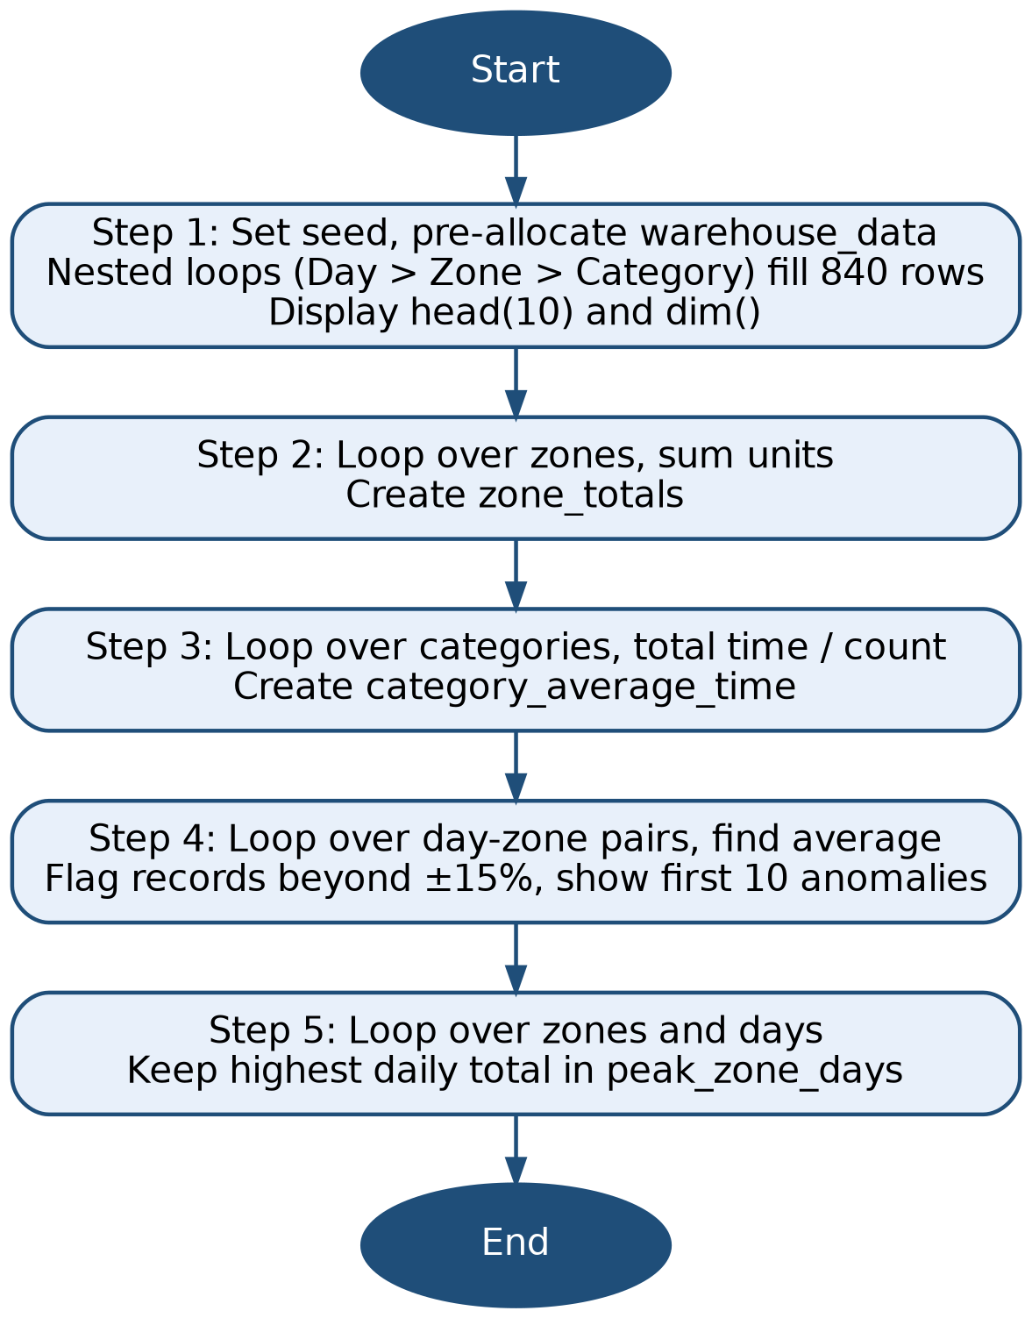
Figure 1: Program flowchart for warehouse_manipulation.r
3 Justification of Programming Choices
3.1 Data Structures and Loop Selection
Each row in the dataframe represents a record with accessible header names and attributes, allowing for simple future usage of additional columns. Nested for loops were utilized to create a fixed grid based on days, zones, and categories. If-condition statements were used in the summaries due to restrictions on apply-family functions and the aggregate() function.
3.2 Assumptions and Calculation Methods
The examines unique combinations of day, zone, and category, resulting in six records for each daily zone average. It defines R as a random uniform integer between −12 and 12, with a processing time of 0.85 minutes per unit. Additionally, it sets strict bounds for anomaly limits, classifying values above 115% or below 85% as non-anomalies.
3.3 Alternative Approaches and Trade-offs
Functions like aggregate() and tapply() could make the code shorter and faster, but they may make the calculations harder to follow. Using loops to calculate averages makes each step easier to understand and check. Since the dataset contains only 840 rows, keeping the code simple and clear is more important than making it run faster.
4 Testing and Validation
4.1 Dataset Dimensions and Structure Checks
The out(Array dim(warehouse_data), warehouse_data) returned the following: 840 and 5, representing 28 × 5 × 6 rows and five columns. The result of the head() operation verifies the order of the loop as Day 1 with the corresponding Categories 1–6 listed in order. There were no missing data. UnitsProcessed ranged from 101 to 182, exactly the theoretical minimum (100 + 8 + 5 − 12) and maximum (100 + 40 + 30 + 12).
4.2 Manual Verification of Calculations
Row 1 (Day 1, Zone 1, Category 1) has a base value of 100 + 8 + 5 = 113. The displayed 115 implies R = +2, within range, and 115 × 0.85 = 97.75 matches ProcessingTime. For Day 1, Zone 1 the six units sum to 754, giving an average of 125.67 and limits of 106.82 and 144.52. No Daily Record is outside of these ranges; corresponding overall no Day 1 no Zone 1 rows in the anomaly list.
4.3 Validation of Summary Results and Anomalies
The sum of all the five zone totals equals 119,051, which is also equal to the sum of all the UnitsProcessed values and corresponds to the Zone × 8 term, increasing from 21,059 in Zone 1 to 26,463 in Zone 5. The mean scores for the categories each increase by about 10 points (e.g., +109.36 to +131.65 minutes), evidence of the term Category × 5. The first anomaly (Day 1, Zone 4, Category 6) has 168 units rather than an average of 145.83 and its upper limit of 167.71 so is flagged well. In total, 41 anomalies were found.
Table 1: Zone totals and peak productive days from the R output
Zone | Total Units | Peak Day | Peak Day Units
1 | 21,059 | 16 | 786
2 | 22,547 | 6 | 838
3 | 23,715 | 8 | 895
4 | 25,267 | 3 | 948
5 | 26,463 | 19 | 972

4.4 Errors Encountered and Corrections
There were no run-time errors, and the output of the str() command generated a list of UnitsProcessed stored as a numeric data type. Careful consideration was given to incrementing row_index to avoid overwriting the first line, and the behavior was confirmed with dim() and head() functions (Ramachandran and Tsokos, 2020).
5 Efficiency and Scalability Reflection
The program processes 840 rows multiple times, leading to about 4,200 checks for Steps 2 and 3, 117,600 for Step 5, and 235,200 for Step 4. Although the execution is fast at this scale, increasing the number of groups hampers performance due to the costs associated with R loop interpretation and data writing. For large datasets, it's more efficient to store totals in a vector and preallocate a dataframe to reduce memory operations (James et al., 2021).
6 Reflection on Learning and Use of Generative AI
I gained a better understanding of using nested loops, running totals and conditional logic in this task, including the need for accumulators to be reset for each group. The primary difficulty was not knowing which loop was controlling each calculation, especially for the anomaly step, as without knowing the average, no record can be judged. Learned dataframe coding and how to clearly explain and validate code.
7 References
Gries, S.T., (2021). Statistics for linguistics with R: A practical introduction. Walter de Gruyter GmbH & Co KG.
James, G., Witten, D., Hastie, T. and Tibshirani, R., (2021). An introduction to statistical learning: with applications in R (Vol. 2). New York: springer.
Mount, J. and Zumel, N., (2019). Practical data science with R. simon and schuster.
Ramachandran, K.M. and Tsokos, C.P., (2020). Mathematical statistics with applications in R. Academic Press.

