
Skills for the Workplace
Module Assignment Submission
Student Name: | Daniela Ventrice
Student Number: | 1910840
Module No: | BMSK5006
Module Title: | Information and kno

Statement of Confirmation of Authenticity
By the act of making this submission, the student declares that this is the work of the student named above. The work has not, in whole or in part, been knowingly presented elsewhere for assessment, or where assessment has been built on a previous assessment, this has been identified. Where materials have been used from other sources it has been properly acknowledged. If this statement is untrue, the student acknowledges that an assessment offence has been committed.
Attention is drawn to the plagiarism and unfair practice policies of both the University and of ILM.
Permission for ILM to use this script
ILM uses learners’ submissions – on an anonymous basis – for assessment standardisation. By submitting, both the centre and the learner agree that ILM may use this script on condition that identifying information is removed. However, if you are unwilling to allow ILM use this script, please refuse by ticking the box: □

Table of Contents
INTRODUCTION 3
DATA AND INFORMATION HANDLING HOUSEKEEPING.AND ITS KNOWLEDGE MANAGEMENT. 4
DIKW 5
UNDERSTANDING KNOWLEDGE MANAGEMENT FROM A WORKPLACE CONTEXT 9
METHODS OF ANALYSIS 11
KNOWLEDGE ASSESTS 13
Communication is key 15
Factors to be aware of when managing a housekeeping team 16
Conclusion 17
Appendix 2 20
References 21

KNOWLEDGE AND INFORMATION MANAGEMENT

SKILLS FOR THE WORKPLACE

INTRODUCTION
This written report discusses knowledge and information management that relate to the housekeeping department in hotel organisations. To understand what is required to actively manage data and information within a department that is the largest out of all departments within the organisation, but the one that’s perceived as a lower level and rarely gains any recognition.
The choice of context in discussion relates to hotel organisations and the management of knowledge between hotel and the housekeeping department.
The purpose is to identify processes used by a middle manager to enable easy, management relating to housekeeping and all work tasks including data and information. How knowledge is created, stored, used and shared from hotel to housekeeping.,

The writer has previous background experience in housekeeping, however much further research was needed simply because of the time of which the writer was employed.
Because of this, reflection over experience as a housekeeping employee, was needed. Information was gathered using online resources consisting of articles, blogs, extracts from books that are relevant and credited. With effort made to gather and collate information obtained from different perspectives mainly looking for people diversity in cultural background and professional positions to gain an overall better understanding because of the global scale of the hotel industry its diversity in sectors and overall and asset value. (Gilbert, N .2021). Providing enough evidence to support this report, that consisted of case studies, blogs, business articles, credited books, statistic reports All references can be found at the end.

DATA AND INFORMATION HANDLING HOUSEKEEPING.AND ITS KNOWLEDGE MANAGEMENT.

The housekeeping department are said to be the backbone to any hotel organisation because the hotel must be clean and aesthetically pleasing, to meet the requirements of its guests and the public. If it is not it will be the first thing guests will notice when entering the hotel itself.
The department of housekeeping provide a service and deal with all areas of managing a clean, comfortable, hygienic friendly environment. (Stephens, M. (2021). Hotel chains want their guests experience to be a non-complacent one so that they receive good feedback and positive reviews to stay in the public eye (for the good reasons) and remain successful. Hotel intention is to be known for providing service to the public with satisfaction and cannot afford to lose business sales due to lack of cleanliness and hygiene as this could lessen the hotel standard and give the hotel a bad name and reputation, which could prove difficult to come back from.

Because of the service hotel industries provide and cater for, there are plenty of platforms where knowledge is needed to be stored and be readily accessible for future use. A fully integrated knowledge management system would be expected from all hotel chains considering the service that is provided to the public day in and day out. (Voegeli, C, (2021).

DIKW

Because there is so much data floating around hotel organisations, its important this data is stored in the right way, with the right information and in the right place, and has it accessible for when it is needed
Knowledge is the overall understanding gathered from both data and information. The established facts that can be seen after analysing all relatives
Knowledge can be gained through the receiving and sharing of data and information. Knowledge is established evidence that proves realistic, logical and makes sense.
Data cannot work without information and information cannot work without data. Knowledge cannot be gained without either data or information. Only by applying the latter can knowledge be obtained. Knowledge provides an organisation a platform of direction and a context to initiate some form of action or approach to a solution.

Russell Ackoff states in his book titled ‘From data to wisdom’ that data consists of raw singular facts displayed as figures and symbols. These figures and symbols represent properties of objects and events. (Ackoff, R. L. (1999). Little interpretation can be made other than establishing an increase or decrease in the number value itself and no further understanding can be gained from this alone. data is meaningless if you don’t know what it is referring to because you can’t do anything with it.
Other Information is used alongside data, Information consists of words that explain or instruct, with information the data now has meaning and can begin to be understood conceptually, both theoretically and practically. (KnowledgeMT,2017). More questions can begin to be asked enabling further analyse to build a rationale. (KnowledgeMT,2017).

The DIKW pyramid is a widely known recognised method that visually structures the process of turning data to wisdom, each level of the pyramid adds value to the initial data that it began with.

The principle of its construction at the time?
To capture store and retrieve documents. (Sharma, N, (2008).
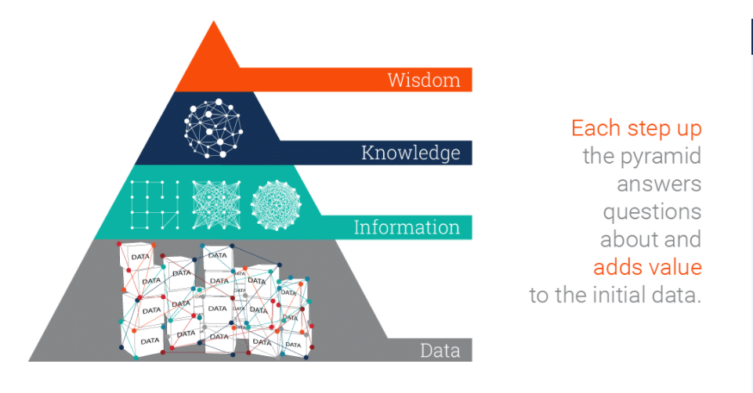

Image source: (Ontotext.com, (2021).

Each segmented level of the pyramid adds more context to the data to form a greater understanding, the more understanding that can be gained the more knowledge is attained.

ORGANISATIONAL KNOWLEDGE
Organizational knowledge is knowledge that is used in an organization with the organization. It is the skills possessed by people who work for the organisation

Knowledge:
‘understanding of or information about a subject that you get by experience or study, either known by one person or by people generally’.

(https://dictionary.cambridge.org/dictionary/english/knowledge .
(Cambridge university press. 2021).

Following below is a diagram showing work roles in the housekeeping department, taken from hotel housekeeping tutorial, it identifies each role that generally is active in housekeeping today. (Tutorials point, (2016).

Diagram to show work roles in housekeeping
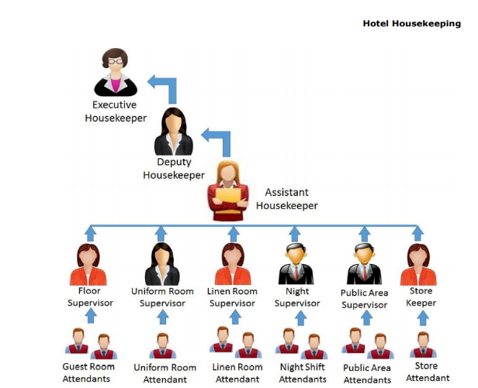
Image source: (tutorials point. (2016).

Office / front desk – all the main administrative work is carried out here. – Only managers of housekeeping, including supervisors if no manager is on the floor have direct communication with front office, Executive housekeeper and head office. if there are any issues the general manager receives the communication from head office to relay to the staff within the housekeeping department.
The housekeeping staff report to the manager at the start and end of the shift. They do not approach front desk.

ROLE OF A HOUSEKEEPING MANAGER
the general housekeeping manager is responsible for scheduling staff work rotas, daily room allocation count, assigning rooms to the housekeeping staff along with key cards which operate all rooms on each floor.

They would access the systems database for a printout of room allocations count and assign the staff to rooms before they start work.

Shadowing as a training method holds more purpose once understood. Because some rooms will need more cleaning some may not need as much.
business to grow. There needs to be some form of system structure in place to manage all handling of data and information that comes with being manager of a housekeeping teasm, Tacit knowledge is used in hotel environments. For example, room service and housekeeping staff will train a new employee by showing them how to do the job. New housekeeping staff will shadow a supervisor watching how the room is made up. depending on whether the guest is stay or departing depends how the room is cleaned. The disadvantage is that this process doesn’t necessarily mean it is the easiest way for the employee. but as the employee familiarizes themselves with the role they will adapt and work in a way that is best for them.

There are various methods and charts used to manage knowledge within the housekeeping department. Methods and charts give structure and organisation but also cover the department and the hotel. in case of any health and safety breaches or discriminatory issues. Everything needs to be accounted for.

UNDERSTANDING KNOWLEDGE MANAGEMENT FROM A WORKPLACE CONTEXT

IN THE EVENT ON GUEST COMPLAINTS REGARDING ROOM STANDARDS
In this section the writer has tried to establish how data along with information turns to knowledge for a manager to begin to implement decision making and take the right action so there are no risk factors. If these reports weren’t filed staff could place discriminatory claims against the manager and with no evidence nothing can be proven. These charts protect the hotels assets.

Daily room audit report
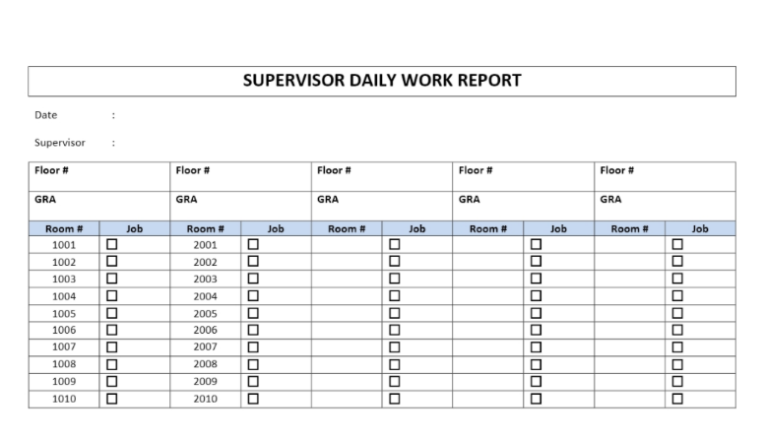
At the end of each day a supervisor is required to fill out a report on all employees that were assigned to clean rooms that day. (Steve, (2016). Data would be written along with information Once recorded they need to transfer all information into a database. (see sample diagram below).

Image source: Hotel Housekeeping supervisor report. (Steve, 2016).
In the event of guest complaining of room standards, there is already knowledge in the system of who cleaned the room prior establishing who was accountable for the room fault.

See below an adapted version of the DIKW Pyramid.

What is a housekeeping department chart?
The organization chart of housekeeping department should provide a clear picture of the lines of authority and the channels of communication with the department. Housekeeping department chart not only provides for a systematic direction of orders, but also protects employees form being over directed.
Housekeeping systems provide software to that organize all tasks

METHODS OF ANALYSIS

A pestle analysis (Humphries, A, (1960) was conducted in the form of a fishbone diagram to establish causes and effects (see appendix 1). These external factors are factors outside of the organisations control and could prevent business sustainability and manageability. Which could affect the way housekeeping is operated. It’s important for managers to be aware of any problem potentials outside of the organisation that may be hidden. for example, new legislations enforced by the government may affect any activity in the organisation and the way in which it operates. health and safety Laws need to be followed or the risk factor can prove catastrophic to the entire organisation. (PESTLEanalysis contributor, (2015), So health and safety policies need to be visually shown to alert staff to hazards they may miss.

Upon completing the diagram, the pestle analysis has identified
government have a large influence on the running of a hotel and all its inner activities. From the people they employ to the products they purchase.
Attention toward customers and providing good service is essential. Customers’ needs differ staff need to be polite and professional when on the hotel floor.
A swot analysis (See appendix 2) was applied to identify the strength and weaknesses within the housekeeping department.

Established from the swot analysis was the following factors

Strengths

- Eye to detail
- Organization
- creative

Weaknesses

- capabilities of staff meeting time management policies that they are instructed to do when first employed, not all rooms will be left at the same standard so won’t take the same time to clean.
- Housekeeping staff are paid by room and a set limit is allocated, if an employee goes over the designated time, they do not get paid any more. however, if an employee finishes before the designated time required, they still get paid, wage is not reduced.
- Recognition in housekeeping goes unnoticed
- Employment role perceived as lower level that the other departments.
- Diversity in people and culture differs employee capability

Threats

- Enforced government rules such as travel bans
- Job role is perceived as lower level
- Guests may not be as polite because of this
- Recognition failure

Opportunities

- Experience and adaptability can lead to a general housekeeper to train as a supervisor and operate from that role. This will benefit the housekeeping department if another supervisor is sick, has taken holidays or for any unforeseen circumstance.
- Also gives staff incentive to work well and using initiative to work more efficiently.

KNOWLEDGE ASSESTS

Knowledge assets are accumulated over time. See mind map below devised by the writer that helped to establish knowledge assets within housekeeping.

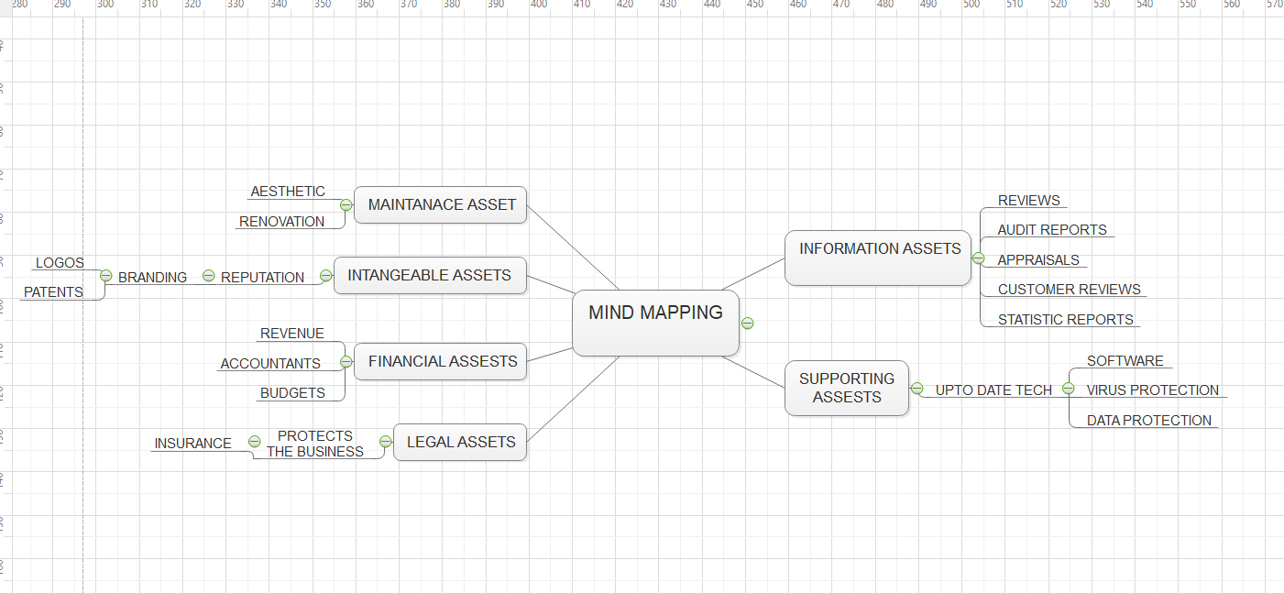
Information taken from URM.Consultancy.com (URM ,2019).
and interpreted into the above diagram.

Routines implemented through individually sharing information and knowledge (individual knowledge turns to organizational knowledge) A personal knowledge of the organisation itself and all its employees from bottom to top. Finding a balance to perform with great synergy. (Tuckman, B. (1965). once synergy is reached you have an established wise workforce. That has gain skills and technique. Once knows how to work adapt share and relearn with the demanding needs of social culture and their ideals. All an organisation’s success is built on its capability to manage work efficiency in the result of profitable turnovers. This knowledge is categorized and referred to as assets. (Priestley, D. (2015).
As Every business strives for success. Always scoping out news ideas and looking for ways to improve to promote better work efficiency.

The main principle of knowledge management is to enable:
- Better decision making
- Maintain effective time management
- Lessen the risk of mistakes
- Strengthen the workforce
- Helps innovation and creativity
- Helps an organization to be proactive

Knowledge management is the safety net to sustain what an organization has built on. Without it, valuable information can be lost which can prove costly to an organisation and its assets.

Knowledge management involves good collaboration
Successful management of knowledge requires individuals to connect through different channels and communicate clearly transferring and receiving information and working in cohesion as a committed team. Including holding a certain level of trust and reliance on one another.

Communication is key
Clear forms of communication are needed between all housekeeping staff, kitchen staff and front desk administration staff to be able to successfully manage knowledge. For example, room ready for allocation need to be communicated to front desk so that the database can be updated. Any maintenance or repairs are to be logged in the maintained book and the in-house maintenance engineer is to be notified to carry out necessary work. Not all employees report to the same person. There is a process of who reports to who, depending on the information that needs to be communicated, this is less likely to cause confusion and mixed messages, and lessen the risk of losing information as its being created sent received or shared.

Housekeeping - contribution and recognition
Housekeepers contribute massively to hotels in respect to its knowledge assets. Solely because employees come from multi-cultural backgrounds, a lot of different personalities will have to adapt to new people will come together for the initial purpose to earn a living getting paid to clean rooms. dealing with diversity in people an approaching in a way to and their contribution to the hotel and its assets hold more importance than the public actually give them credit for. (Tutorials point, (2016).

Factors to be aware of when managing a housekeeping team


Cultural diversity – attitudes and behaviours will differ.

Cultural differences as of 2021 has never created such a division. if problem areas are surfacing know how to notice issues between staff that may affect the standard of the work.,


Motivation and having the ability to influence this in others. Leaders need to initiate an urge for staff to want to want to engage and share in order to build a collaborative organisational based culture working environment.

The only way to determine successful KM is seeing financial gains or financial losses via the company’s annual turnover , to know whether an organisation is doing something right or see problem areas in the department divisions that would be identified through staff shortages , sick days , poor performance and any maintenance and aesthetic issues , for example. (Voegeli, C, (2021). Poor management would show in staff performance. Awareness of each other as individuals will help strengthen bonds as a team.
With such diversity in people and culture, managing a team of associates is another challenging factor that needs to be considered if you want a well-functioning cohesive team.

Conclusion
Knowledge is the cement that sets the business, an organization cannot achieve its intended goal effectively or successfully if there is no knowledge in that field, no information to refer to or no data to progress forwards. Personal and private information is transferred every day, information needs to be stored correctly ensuring customer privacy and security from any data protection policies are not broken
From this assignment an understanding of how creating and managing a sustainable team of employees creates a stronger workforce. cultural differences will prove beneficial as people hold different skills and have different techniques with how they make up a room. although there are standards expected so certain procedures and policies are in place, Tacit knowledge is also required to do the job in the designated time.

Trust is earned over time so the longer the employment the more trust between the managers and the employees and this ls what will enable to gain competitive advantages against other leading hoteliers (Dr. Subramaniam, U, K. (2015).
Knowledge is built up of massive amounts of data and information. The more information accumulated over time the more knowledge is attained, this enables an individual to hold more skillsets, more experience and become more comfortable settling into the job role itself.

Appendix 1
PESTLE DIAGRAM

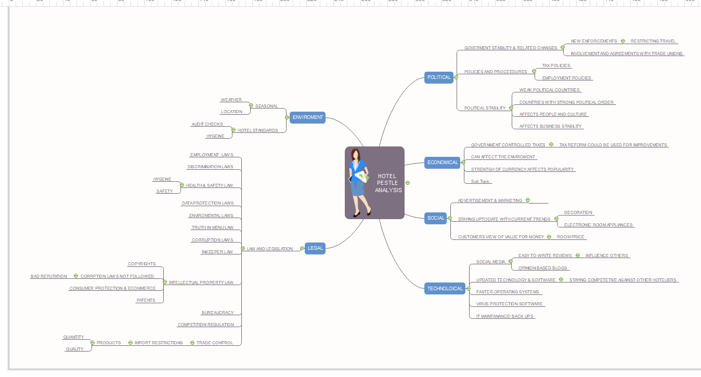

Appendix 2

Swot analysis

References

Gilbert , N .2021) , 109 Hospitality Statistics You Must Know: 2021/2022 Data Analysis & Market Share , URL : https://financesonline.com/hospitality-statistics/ (UNDATED ) , Accessed 20th may 2021.

Humphries ,A.(1960) , Title : Marketing theories swot analysis URL : Marketing Theories - SWOT Analysis (professionalacademy.com) , Blog by professional academy . accessed 22 May 2021.

Ackoff, R. L. (1999), Russell Ackoff, From data to wisdom , Ackoff Best. New York: John Wiley & Sons, pp 170 – 172. URL ; Microsoft Word - Ackoff (softwarezen.me) , accessed may 13th 2021.

Tutorials point, (2016). Title: Hotel housekeeping - Housekeeping, page 5. URL : www.tutorialspoint.com/hotel_housekeeping/hotel_housekeeping_tutorial.pdf , Accessed 20th may 2021.

Ontotext.com (2021), title: What is the Data, Information, Knowledge, Wisdom (DIKW) Pyramid?
URL : www.ontotext.com/knowledgehub/fundamentals/dikw-pyramid/ , 20221 , ACCESSED 21ST MAY 2021.

Knowledge, MT,2017). Video link : https://www.youtube.com/watch?v=sIjSY05JE9Q , Title : Data-Information-knowledge in less than 3 minutes , , Published : 5th February 2017. Accessed April 27th, 2021.

Cambridge university press, 2021) , URL : https://dictionary.cambridge.org/dictionary/english/knowledge , Knowledge , Accessed 20 April ,2021 .

Kempe , S , (2013) , Dataversity , the data information knowledge cycle , URL : The Data – Information – Knowledge Cycle - DATAVERSITY , published : November 14 2013 . Accessed May 13th, 2021.

Voegeli, C, (2021). eHotelier, 2021. Title: Why knowledge management matters in the hotel industry. Author: Christoph Voegeli, Regional General Manager, Archipelago International Jakarta, Indonesia, Weblink : Why Knowledge Management matters to the hotel industry - Insights (ehotelier.com) , Accessed 04th May 2021.

WICS_ADMIN. (2019), TITLE: what is organisational knowledge and why is it so important?
URL : www.wics.co/quality-management/knowledge/what-is-organisational-knowledge-and-why-is-it-important/ , posted : 27th June 2019 , Accessed 16th may 2021.

Ackoff, R. (1989). DIKW pyramid - Wikipedia . Data, Information, knowledge wisdom, DIKW pyramid, Wikipedia, 2021, accessed 16th May 2021.

Sheikh , A , ( 2016) , Recruitment specialist , Duties and responsibilities of housekeeping staff published: July 19 2017 , URL :https://www.linkedin.com/pulse/duties-responsibilities-housekeeping-staff-ashraf-kamel . Accessed 17th May 2021.

Hotel tech report, (2020), Hotel housekeeping duties: A day in the life. Published 20th August 2020 URL: Hotel Housekeeping Duties: A Day in the Life (hoteltechreport.com) , accessed 17th may 2021.

Stephens , M.(2021) , eHotelier 2021, Author Mathew Stephens , title : housekeeping is the core of the hotel , URL: Housekeeping is the core of the hotel - Insights (ehotelier.com) . Accessed 17th May 2021.

Dr. Subramaniam, U, K. (2015), Author : Dr. U. K. SUBRAMANIAM HOD, Commerce, Sidho-Kanho Birsa University , Title: KEY AREAS OF KNOWLEDGE MANAGEMENT IN HOTEL INDUSTRY.

Ihmnotes ,( 2021 ) , PDF file link - Ch-2,ORGANISATION CHART OF THE HOUSEKEEPING DEPARTMENT.pdf (ihmnotes.in) , Organisation chart of the housework department, undated , Accessed 18th may 2021.

Tuckman, B. (1968), Performing, Tuckman’s stages of group development , : WIKPEDIA URL LINK : Tuckman's stages of group development - Wikipedia ACCESSED 19 MAY 2021.

Priestley, D, (2015). Venture team building, Title: Forming, Storming, Norming and Performing: The Stages of Team Formation , published : August 11TH 2015 , author : David Priestley , .URL Forming, Storming, Norming, Performing: The Stages of Team Formation (ventureteambuilding.co.uk) Accessed 19 may 2021.

PESTLEanalysis contributor, (2015). Title: Political Factors Affecting Business URL : https://pestleanalysis.com/political-factors-affecting-business/ . published: 24th February 2015. Accessed: 20 may 2021.

Steve, (2016) , title : Hotel Housekeeping Supervisor Report ,URL :Hotel Housekeeping Supervisor Report (freewordtemplates.net) , published : September 1st 2016 , accessed 22 may 2021.

URM ,2019) URM Consultancy , URL : Understanding Information Assets | Understanding Each Step (urmconsulting.com) published July 22nd 2019. Accessed may 23 2021.

