Richard Jones - 1809132
rojones@gmail.com & 1809132@student.uwtsd.ac.uk
Network Operating Systems and Services
ACCA5023 – Nitheesh Murugan Kaliyamurthy

Abstract

Table of Contents
Abstract 1
Table of Contents 2
Introduction 1
1. Part 1 – Practical Work 1
1.1 Worksheet 1 Task 1 – VM Creation and Operation System Installations. 1
1.1.1 Virtualbox Installation 1
1.1.2 Virtual Machine(s) Setup 2
1.1.3 Virtual Machine(s) – Operating System Install and Configure. 5
1.1.4 Virtual Machine(s) – Demonstration of Additional Device Setups. 8
1.2 Worksheet 1 Task 2 – Virtual Network Configurations. 12
1.2.1 Virtual Box Network Configuration Setup of VMs 12
1.2.2 Virtual Box Server and Client Extended Configuration (Firewalls) 15
2 Part 2 – Observational Tasks/Work. 18
2.1 Differences between Type 1 and Type 2 Hypervisors 18
2.1.1 Type 1 Hypervisor Examples & Vendors 19
2.1.2 Type 2 Hypervisor Examples & Vendors 20
2.1.3 Advantages and Disadvantages of Type 1 Hypervisor 21
2.1.4 Advantages and Disadvantages of Type 2 Hypervisor 22
2.2 IPv4 Subnet mask significance 22
2.3 Cloud Computing Uses – Benefits and Drawbacks 24
2.3.1 Benefits of Cloud Computing. 24
2.3.2 Drawbacks of Cloud Computing. 25
2.3.4 Cloud based Vendors. 25
2.4 Task 1 and 2 Technologies and purposes 26
2.4.1 Firewall 26
2.4.2 Desktop Experience 27
2.4.3 OOBE (Out Of Box Experience) 28
2.4.4 Server Manager 29
2 References 30

Introduction

Part 1 – Practical Work
In Part 1, the practical work set out in worksheet one has been undertaken and documented by the author. The author was tasked with completing and documenting two specific defined tasks within the worksheet. These two tasks were.
1). Virtual Machine creation and Operating System Installations
2). Virtual Network configurations.
In task one, the author will have completed a setup of four Virtual machines, two of which will be utilising Windows Server 2019 and the remaining two will be utilising Windows 10. The task dictates a number of configuration aspects such as Processor settings, Memory and disk space requirement and additional configurations.
These configurations will all have been screenshot captured in the following document to confirm and demonstrate the authors understanding and completion of task one.
In task two, the author will build upon the completion of the Virtual machines but completing the Virtual Network configuration requirements. This configuration will allow for the created Virtual Machines to be able to interact with each other on their own internal networks separate to the hosting device.

Worksheet 1 Task 1 – VM Creation and Operation System Installations.

Virtualbox Installation

The Author already had an install of Virtualbox version 6.1.14 installed on their hosting device. To confirm the steps that would ordinarily be required to install Virtualbox the below screenshots demonstrate the short “next” “next” setup that would have been carried out.
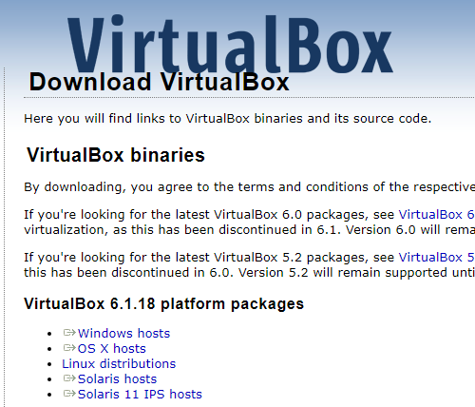
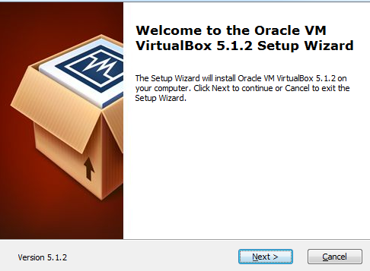
Figure 1. Virtualbox Downloads Page Figure 2. Virtualbox Installation GUI process
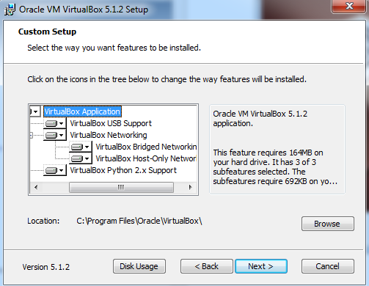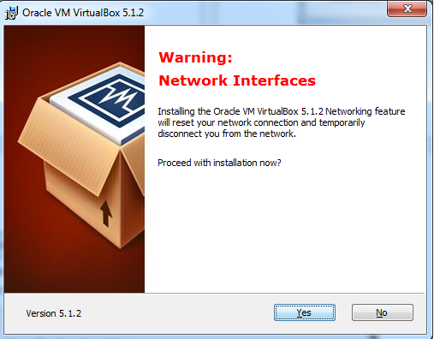
Figure 3. Virtualbox Custom Setup screen Figure 4. Virtualbox Network Warning Screen.
As the author worked through the GUI interface for the Virtualbox install the wizard as shown in figures 1 & 2 for the most part is a “Next” and “Finish” button process. But there are two screen captures as shown above that are of interest.
In figure 3 the custom setup presented the author with a number of options which could be selected or deselected accordingly. By default these options are selected and provide a brief description as to what they refer to. In short these options allow the author installing the software to enable or disable addition such as but not limited to USB support within the product, as well as Virtual networking features such as Bridged and Host-Only Networking.
As shown in figure 4 if enabling the Virtual network options, during this phase the networking on the hosting device may be affected and temporarily interrupted.

1.1.2 Virtual Machine(s) Setup

Once the author had installed the Virtualbox product the author was then tasked with setting up first of 4 Virtual machines. The first Virtual machine will be a Windows 2019 server OS (operating system).
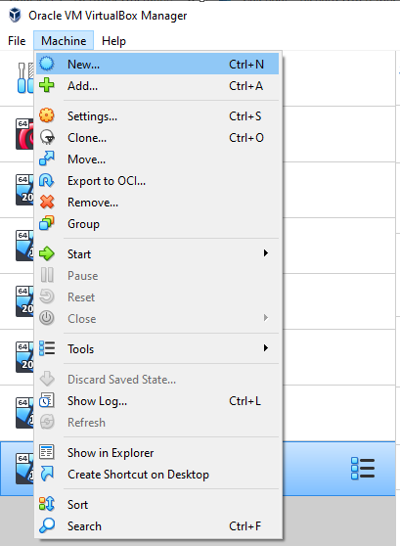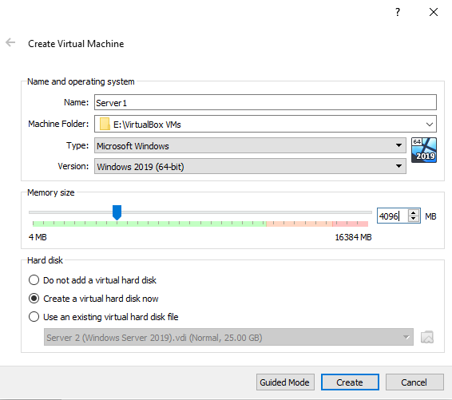
Figure 5. Virtual Box Machine Menu Figure 6. Create Virtual Machine GUI.
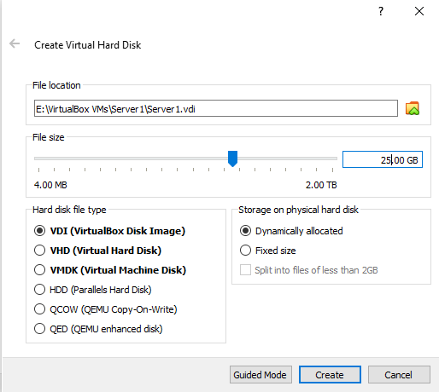
Figure 7. Create Virtual Disk Menu
When opening the Virtualbox software post install the author was presented with a number of options when selecting the Machine tab. In this case the author will look to create a “new” virtual machine from scratch. So the author selected the “new” option as shown in figure 5.
Once this option was selected the author was then presented with a series of GUI (Graphical User Interface) setup menus. As shown in figure 6 the author selected the storage location for the Files that would represent the virtual machine entities and completed some initial setup option such as but not limited to the Name of the device, Operating System Type (Windows in this instance), Version of the Operating System type (Windows Server 2019 64bit in this instance), how much memory would be allocated to this device (4GB or 4096MB in this instance).
Finally what type of Hard Disk would be desired, the author was presented with 3 options carrying from no disk, create a new disk and use existing disk. In this instance the author would be creating a new disk and installing an OS from scratch.
As shown in figure 7 when selecting a new disk creating the author was then presented with a separate window to configure the options desired for the new disk. At the stage the author was presented with confirmation of the file storage location which could be amended if desired, along with a number of additional configuration options for the new disk. These included the desired size of the disk, the hard disk file type (these can be utilised for compatibility with other systems) and the desired storage type of the disk.
The two options are dynamically allocated or fixed. A “fixed disk” selection would mean that whatever option was selected in terms of size of disk would then instantly create a disk file of that size on the host device. The author did not chose this option as it is preferred for file size optimisation on the host device to utilise the “dynamically allocated” option. This option means that the size of disk chosen is what will be presented within the virtual device. But only the actually used space will be taken up as the drive is used and the file will grow accordingly. One area to be concerned of at this point, is that when utilising many virtual machines not to over allocate disk space on the host device as the usage grows on the virtual devices.

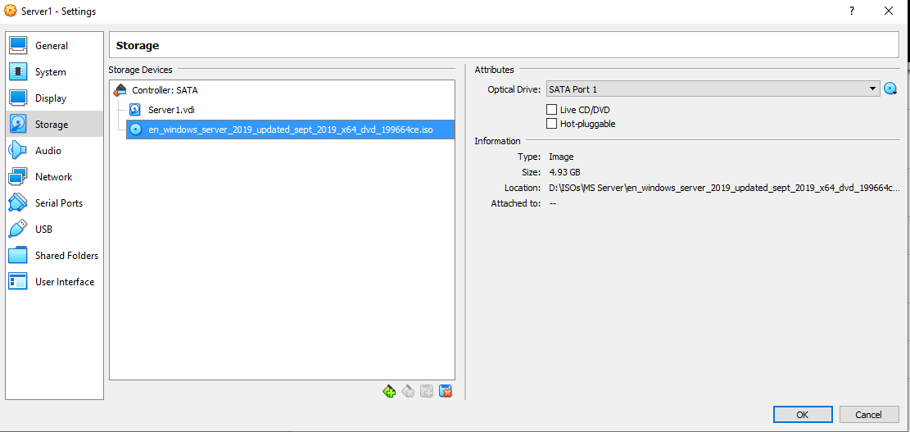
Figure 8. Virtualbox, Virtual machine Server 1 Settings Menu.
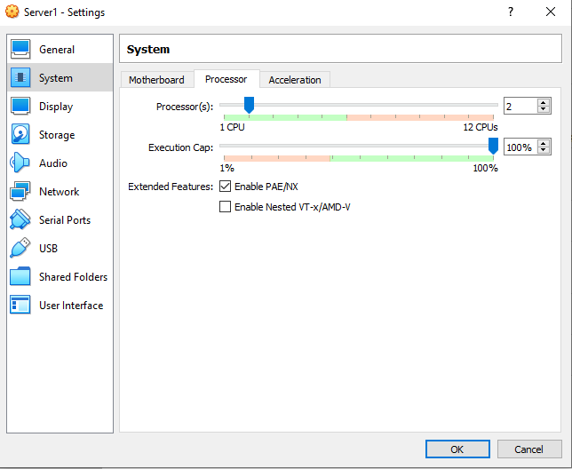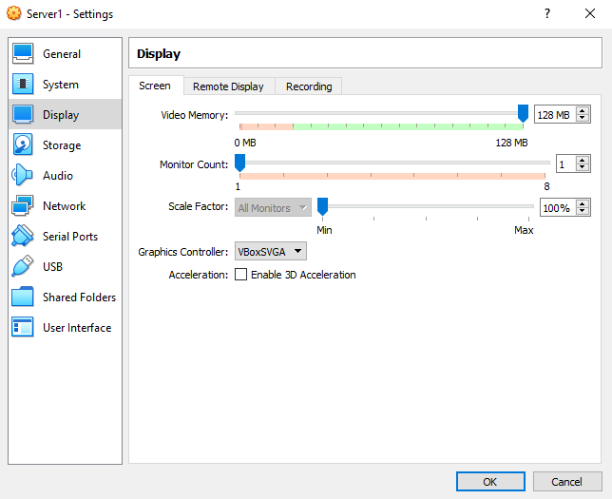
Figure 9. System Settings, Processor Tab. Figure 10. Virtualbox VM Display Setting Menu.

Virtual Machine(s) – Operating System Install and Configure.

Now that the author has created the virtual machine, the configuration amendments to the VM are fine tuned. The author selected the settings from the Virtual Box menu of the created VM which will then bring up a number of options as detailed in Figure 8.
As shown in Figure 8 the author amended the storage options to add a virtual CD/DVD drive, an ISO file type of a downloaded Operating system was downloaded (Windows Server 2019 in this example) and added to the drive to emulate the bootable operating system media. In
Figure 9 the author has amended the default CPU count to 2. When left at 1 you will often find that the CPU will bottleneck at 100% often giving a performance decrease and slow response times within the Virtual machine. If you have enough CPU’s/cores on the host machine it is recommended allowing as many as possible. In the authors setup the host machine has 12 cores available and therefore 2 will be shared with each VM created. Also the author has enabled the PAE/NX option within this settings area. This has been done to allow for greater memory use and also as best practise to improve security issues around executable code in memory prevention[1].
Lastly in Figure 10 the author has amended the display settings. Here the display settings have been modified to increase the memory supplied for the display interface. This is done to allow for an increase the in the resolution[2] that can be used and the higher colour settings within the virtual machine also.

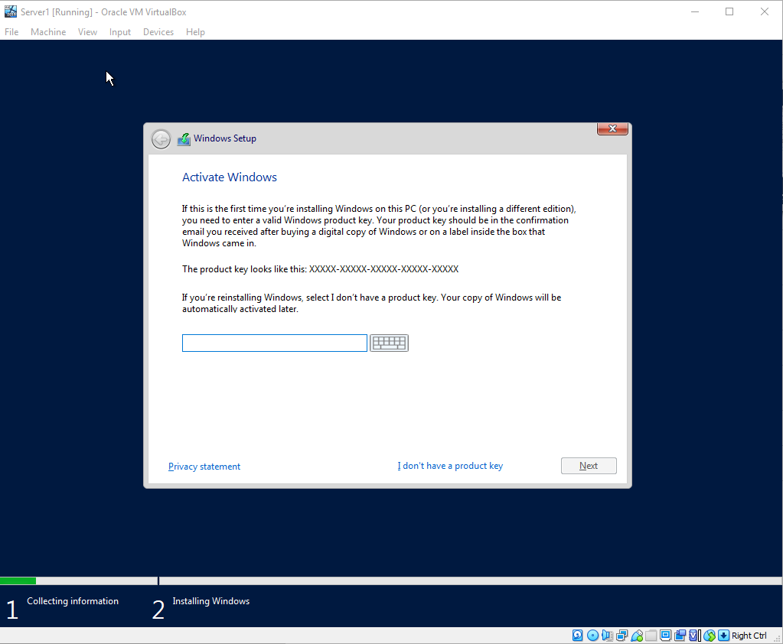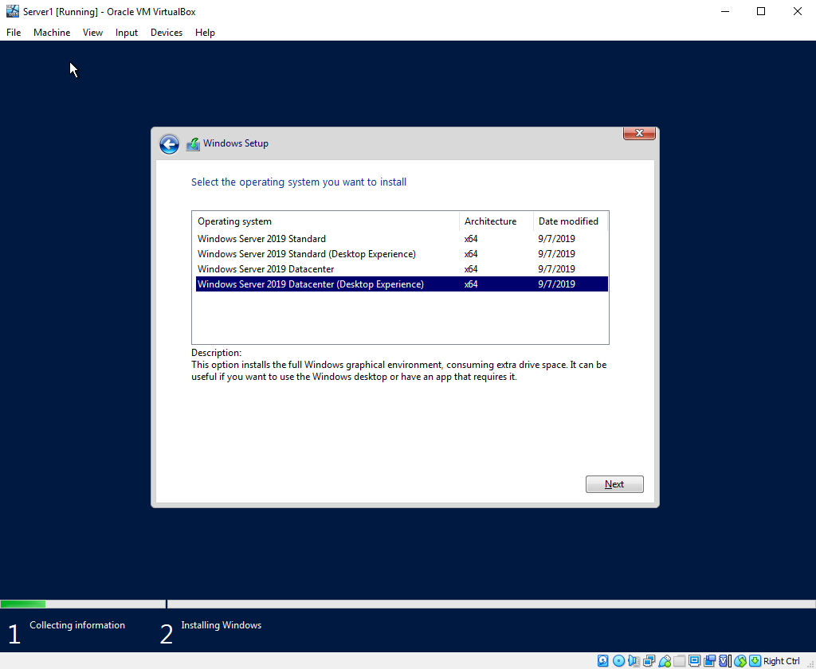
Figure 11. Server 2019 Licence Prompt Figure 12. Server 2019 Editions Selection
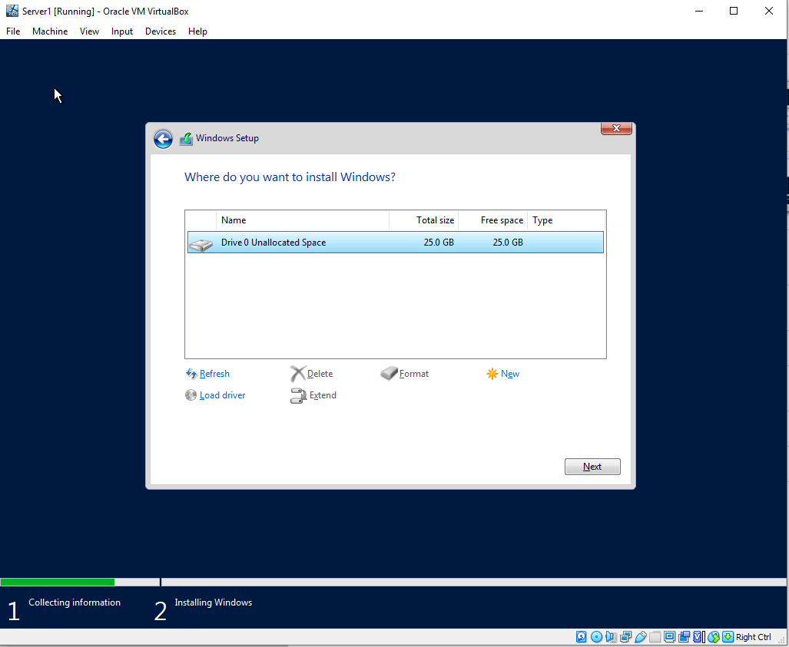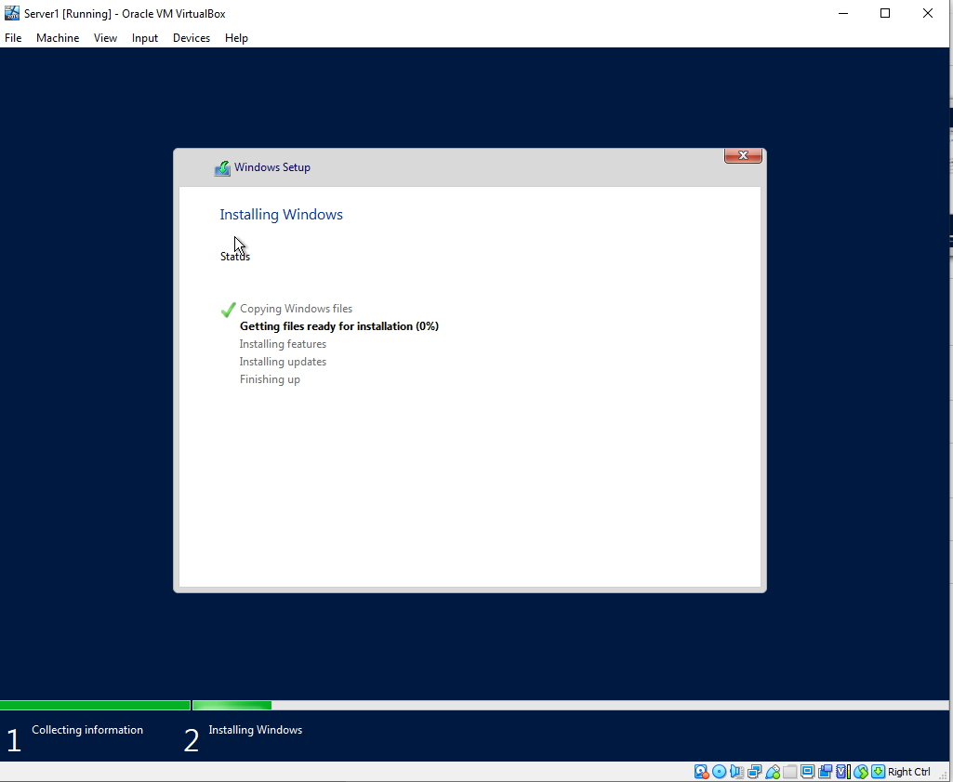
Figure 13. Server 2019 Drive Selection Figure 14. Server 2019 Install Notifications.
Now that the settings of the virtual machine have been fine-tuned and applied, the author then starts the virtual machine. At this point with the configurations the author has put in place the VM will boot and look for a bootable OS. As the hard drive is formatted and not containing an OS the VM will then look to the removable media (in our case the emulated CD/DVD drive), and then boot to the Windows Server 2019 install GUI.
The initial screens will then follow and lead you to a licence screen as shown in Figure 11. At this point in a traditional setup the author would have entered in valid licence keys that were either purchased for the device separately, or in larger business enterprises volume licence keys or MAK keys would be provided for pre purchased licence numbers. In this instance the virtual devices are only for testing purposes and the grace time provided within the licencing is sufficient to allow the author to have selected the “I do not have a product key, which will allow for a grace period of operating the software.
In Figure 12 the author was presented with a screen to select the edition of Windows Server 2019 in this case. With this version of OS the author has the ability to select Standard or Datacentre. There are a number of difference between the two version which are detailed here[3], but an example and not limited to is the ability to host limited number of VM’s within Hyper-V platform vs. unlimited in the datacentre edition. There is also an option to have either of these editions in a (Desktop Experience or non-Desktop Experience) the main difference but not limited to these version is that the non-desktop experience is a slimmed down version and is administered through command line rather than the traditional Windows GUI desktop experience[4].
In Figure 13 post editions selection the author is presented with a screen prompting for the drive installation selection. Here the OS install will scan the drives available on the device and prompt the user to select a drive to install the Operating system on.
In this example the author was only prompted with the 25GB drive that was provisioned in the VM create phase and this was selected. It is possible at this point to create separate volumes/partitions on the single drive to present the Operating system with what appears to be multiple drives in software but are actually one physical drive in hardware. The reasons for this can be but not limited to Organisational reasoning, running multiple Operating Systems on a single device and potentially separating out valuable files in case of a volume corruption[5]. Lastly in Figure 14 the author has completed the installation GUI steps and the operating system is now installing and providing the author with an update progress screen.

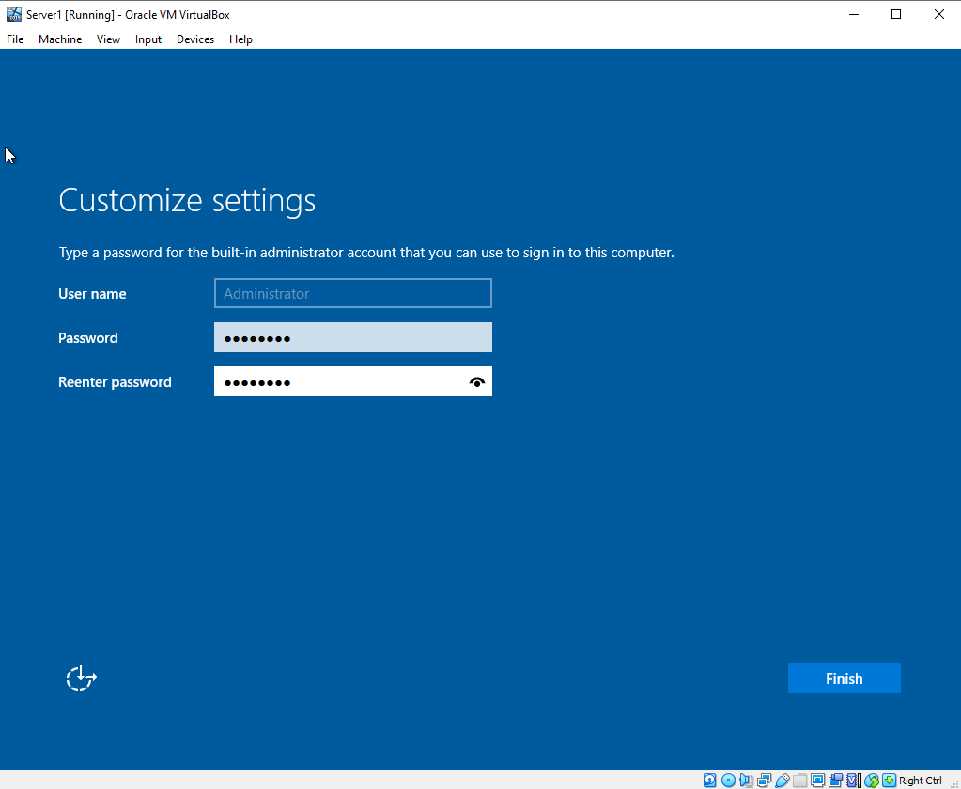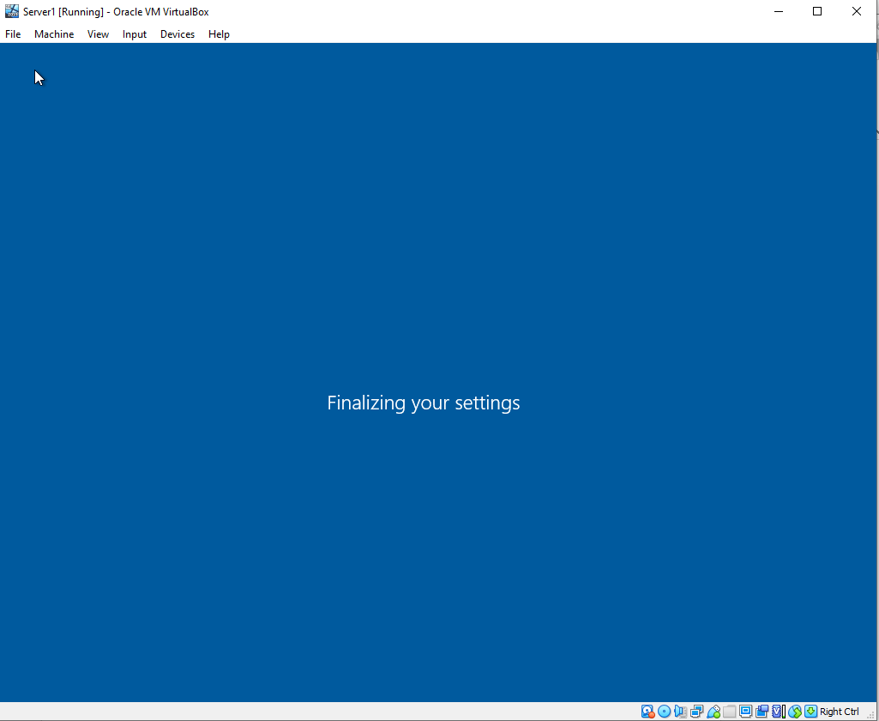
Figure 15. Windows Server 2019 post install setup/customization screens.
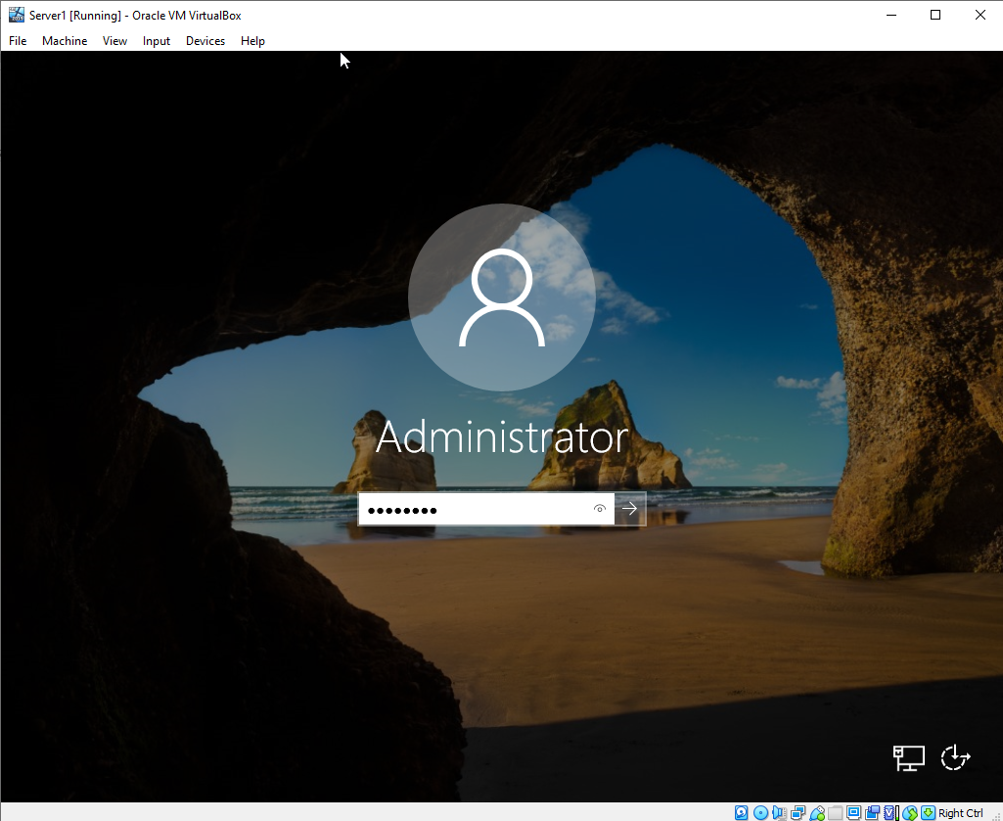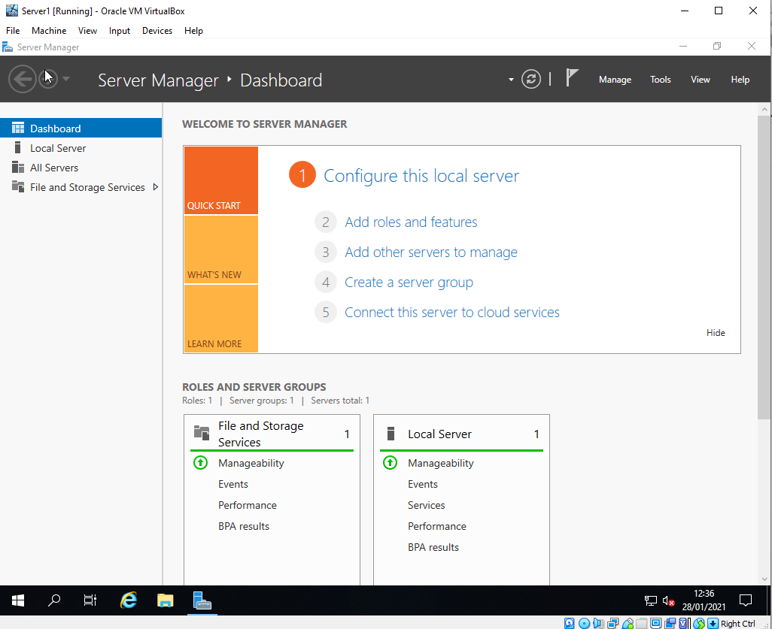
Figure 16. Windows Server 2019 Login and Post login Server Management Screen.
Once the installation has been completed the VM rebooted and arrived at Windows setup/customization screen(s) as demonstrated in Figure 15. The author completes the setup by providing a password to be used for the local administration account of the device and confirming the customization options.
Once Complete the author is then presented with a login screen for the created administrator account. Once the author had entered the created credentials he was then presented with a desktop of the OS and shortly after then Server Manager Dashboard was presented. The server manager dashboard allows for the user to enable and configure the Windows Server 2019 install in regards to features and roles for the servers use case scenario. For example the server could be utilised but not limited to as a DHCP server or a File Share server[4], a single server can be used for multiple roles but this is not always recommended depending on the environment the server will be used in.

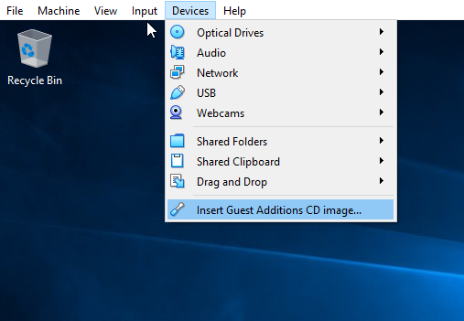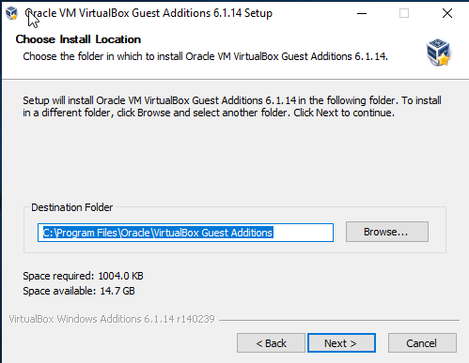
Figure 17. Mounting VM Additions Install. Figure 18. VM Additions Installation GUI.
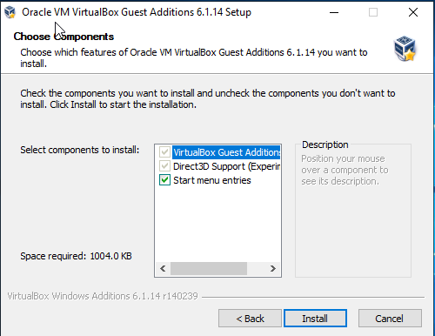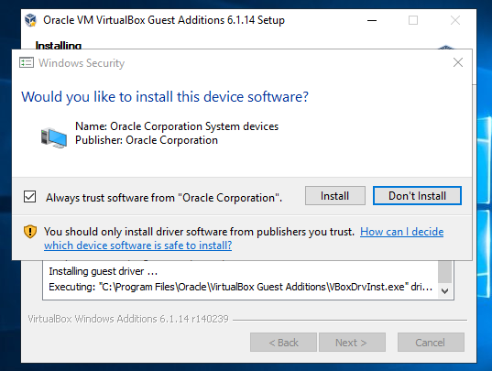
Figure 19. VM additions Components Figure 20. Device Software Prompt.
The author had decided to install the optional Virtualbox Additions media. This is an optional install which provides the created VM with many benefits. These benefits include but not limited to Shared Clipboard between host and guest, better video support, shared folder ability between the host and guest device and also general performance improvements around the mouse and window resize and interface[6].

Virtual Machine(s) – Demonstration of Additional Device Setups.

As detailed in Worksheet 1. The Author once completing the setup of server 1 was tasked with completing the process to setup another Windows Server 2019 VM along with two Windows 10 VMs. The screenshots that follow and the brief text demonstrate the work being carried out to show the difference between the Windows Server 2019 setup and the Windows 10 setup.
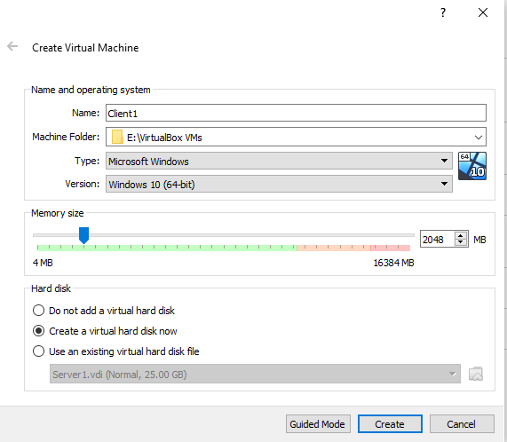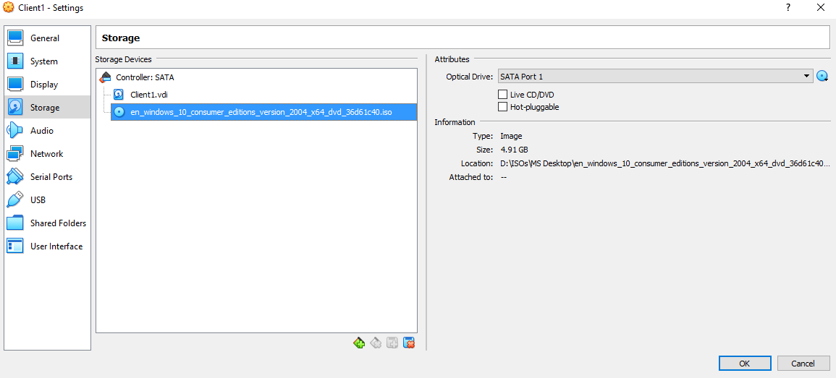
Figure 21. VM Windows 10 Setup options Figure 22. Windows 10 Install Media Selection.
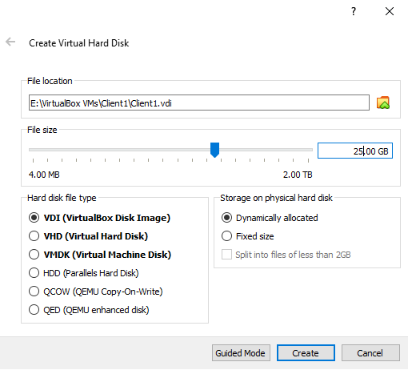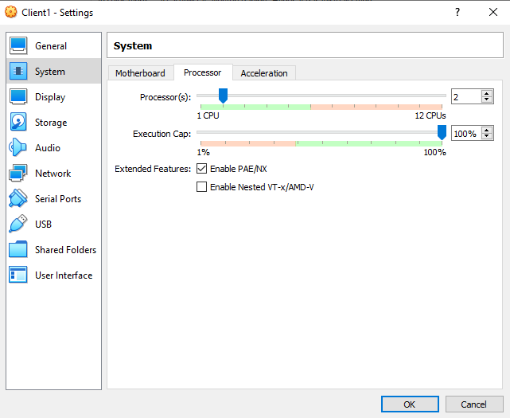
Figure 23. W10 Virtual Disk Config. Figure 24. W10 Guest Setting Demonstration

As with the Setup of the Windows Server 2019 the setup of the Windows 10 VMs are the same with a few exceptions. As noted in Figure 21 the OS type and Version are altered to reflect the Windows 10 install rather than the Server 2019. In Figures 22 the Windows 10 mounted ISO is specified rather than the Windows Server 2019. In Figures 23 and 24 the Virtual disk, CPU and Graphics setup were all setup in the same method as the Windows Server 2019 config by the author.
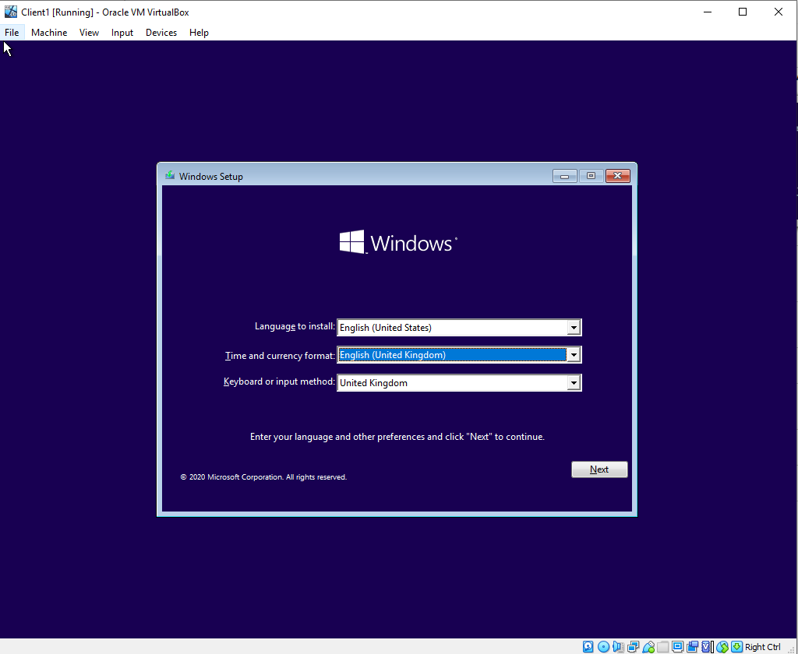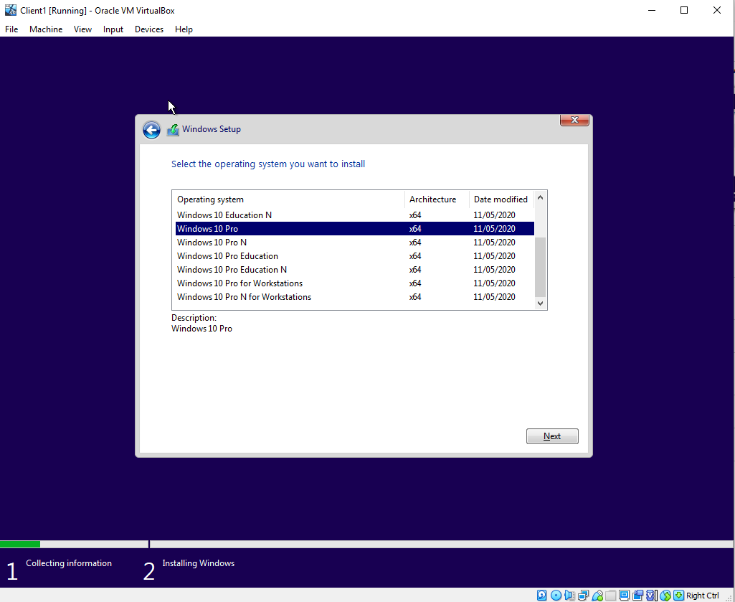
Figure 25. Windows 10 Install GUI Figure 26. Windows 10 Editions Selection.
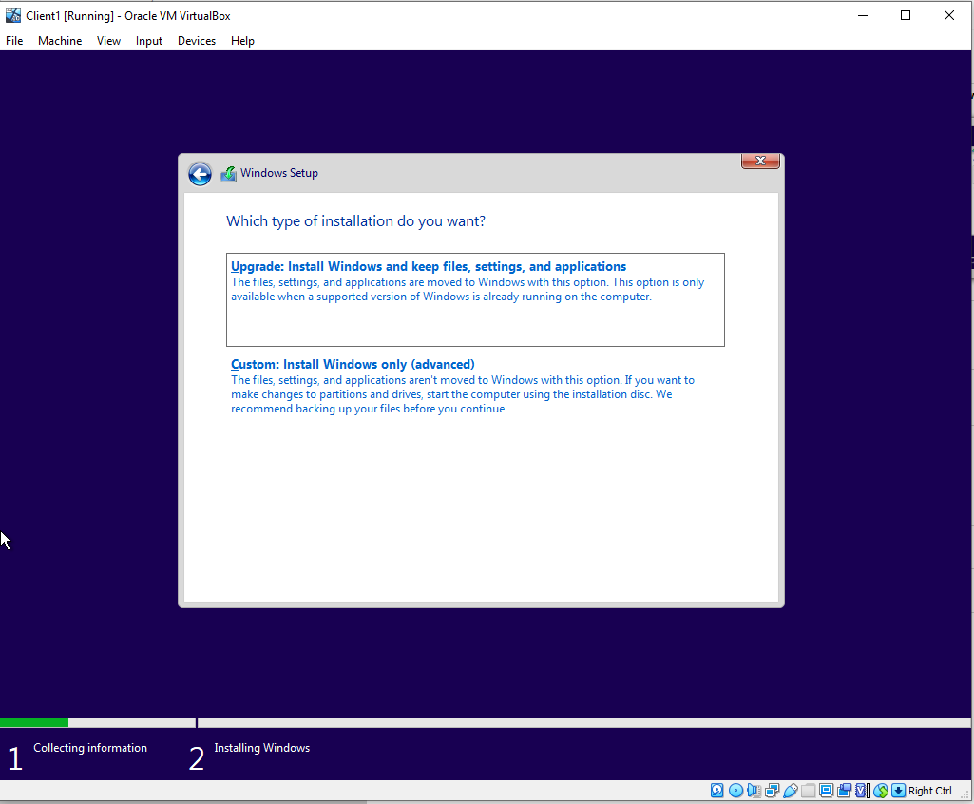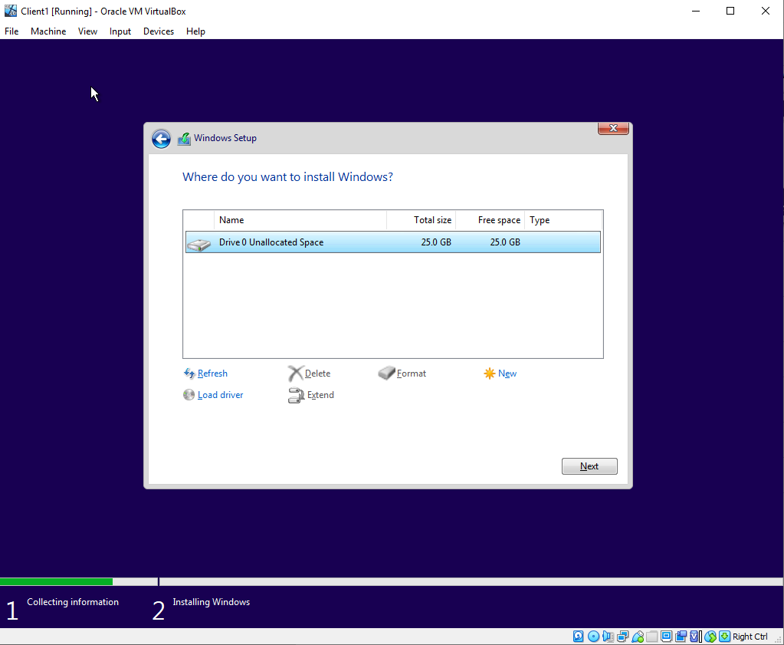
Figure 27. Windows 10 Install Method. Figure 28. Windows 10 Drive Install Selection.
Once the Virtual Machine was setup the author then started the VM and ran through the Windows 10 Setup GUI. Much like the work already carried out in the Windows Server 2019 the GUI is very similar as demonstrated in Figure 25. The difference between Windows Server 2019 and Windows 10 are shown in figures 26 and 27.
In these screen you are presented with the Editions available for Windows 10, the difference between these versions are discussed [7], some examples but are not limited to are ability to utilise features such as bitlocker drive encryption, ReFS file system, Endpoint Detection and Response (enhanced security measures) and ability to join corporate domains.
Once the edition was selected the author then progressed in the same manner as with the Windows 2019 install and selected the drive to format and partition as required as demonstrated in Figure 28.
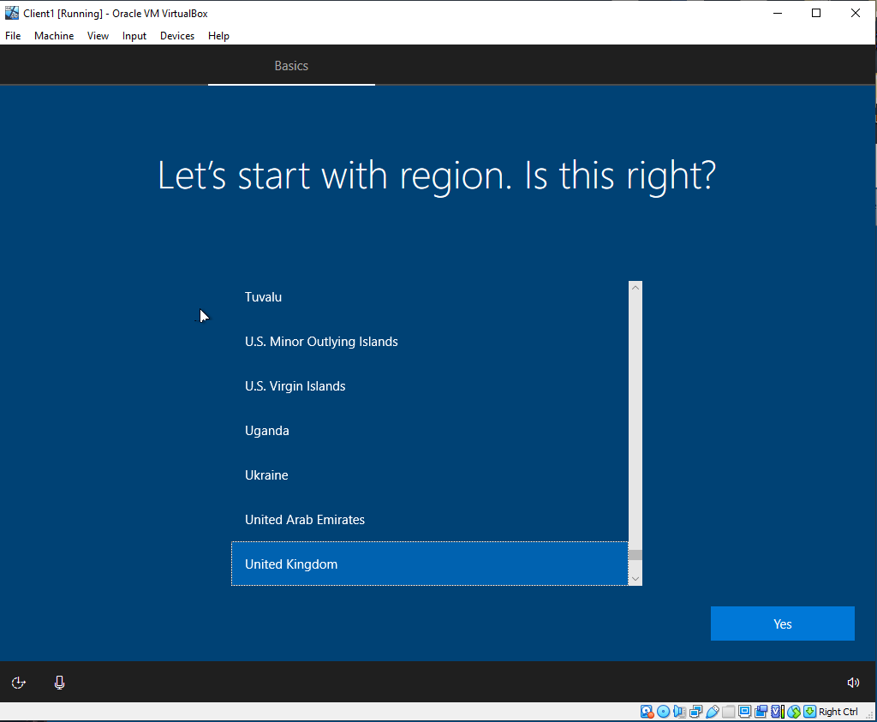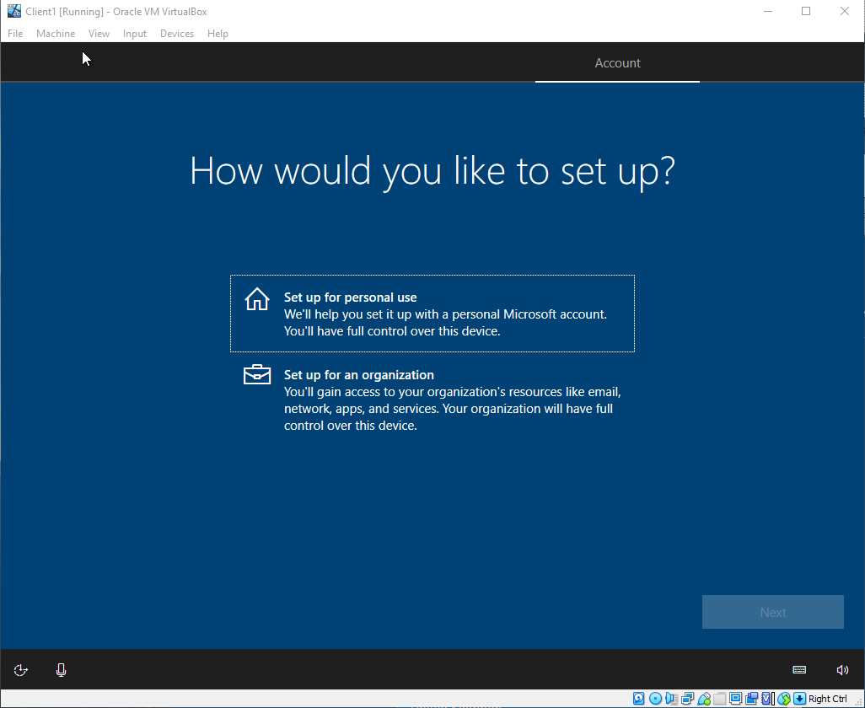
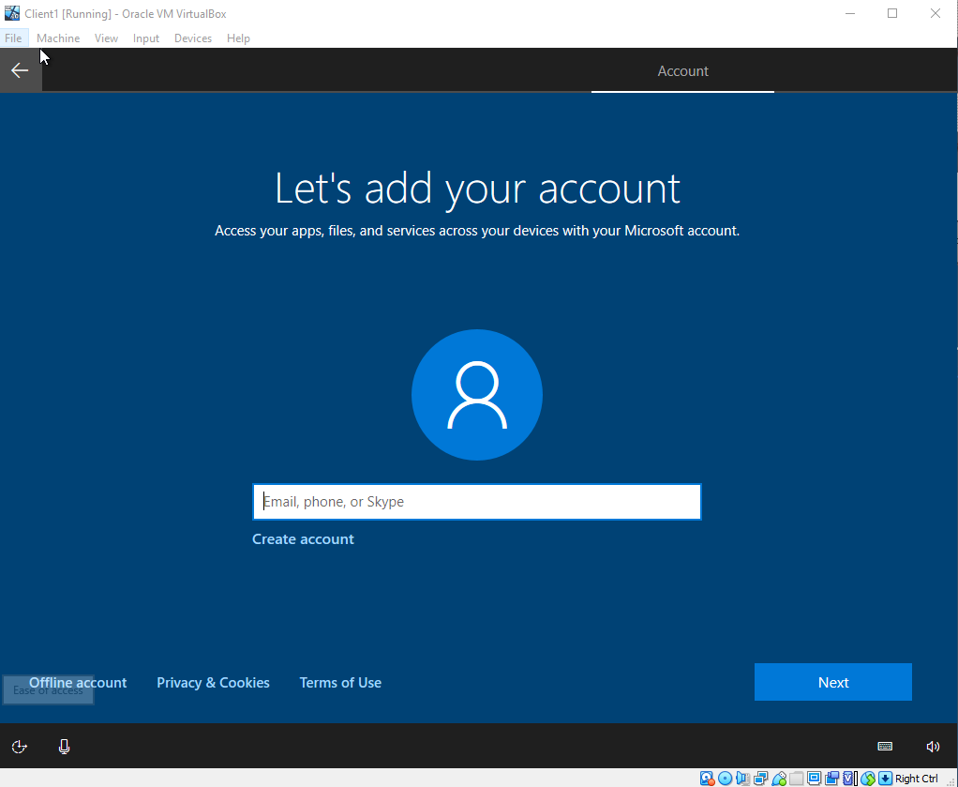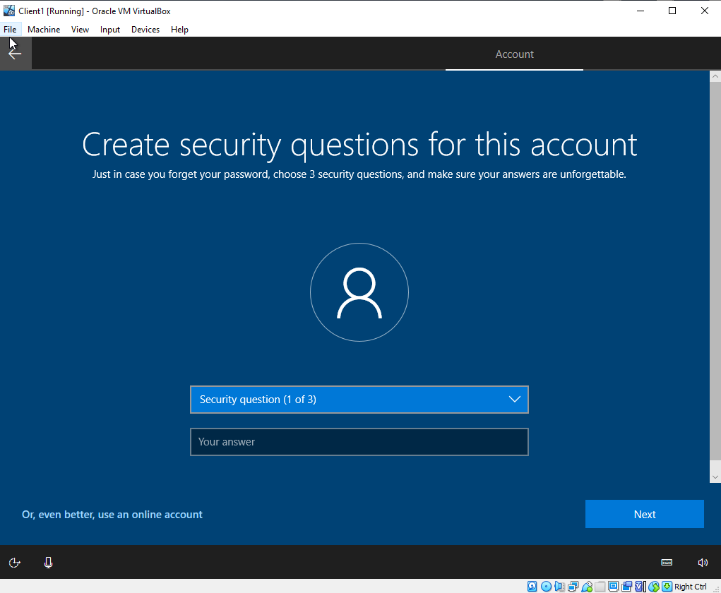
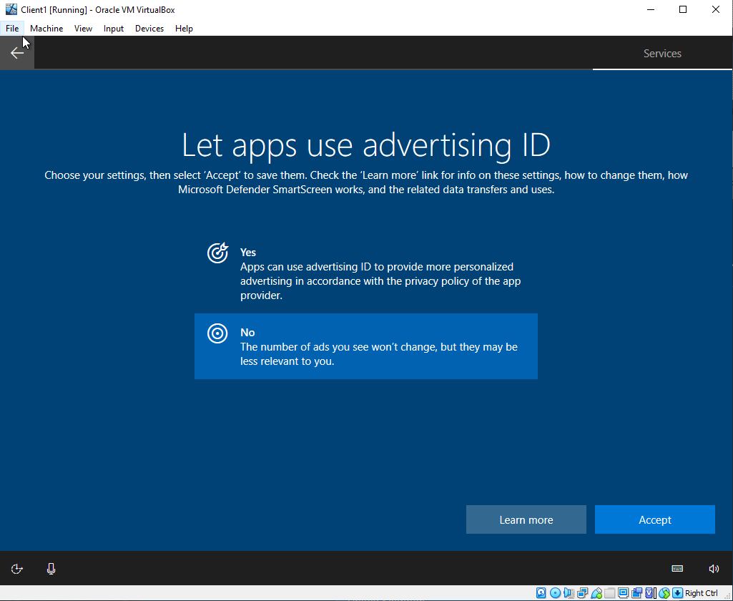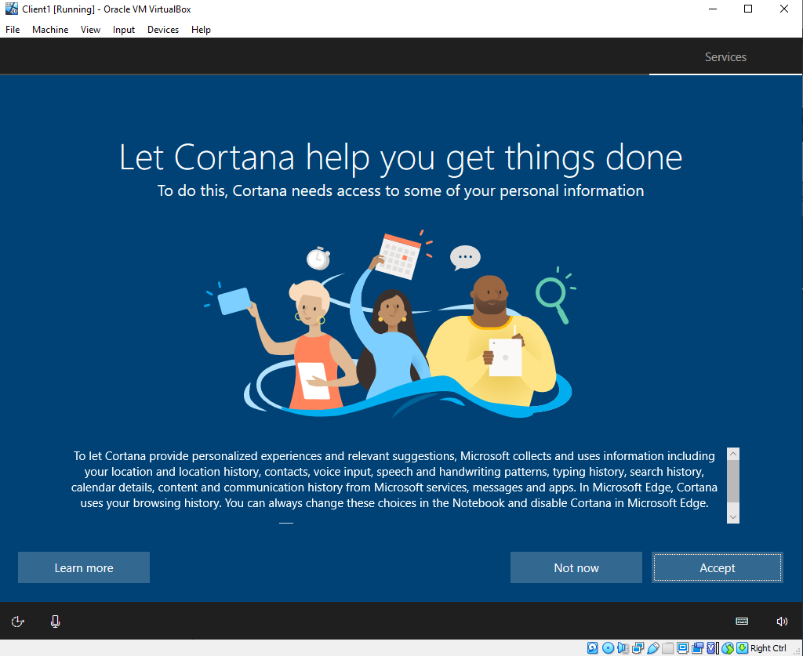

Figure 29. W10 Initial Setup Screens
Once the initial setup GUI is complete the VM will then much like it did with the Windows 2019 server setup send the author to the Configuration/Setup Screen. This is one of the main differences between Server install and Windows 10 install. As shown in Figure 29 there are a number of additional screens which presented the author with options to not only create either an online/offline account but also to set the configuration of user customisations such as but not limited to Advertising ID preference and Enablement of features such as Cortana.
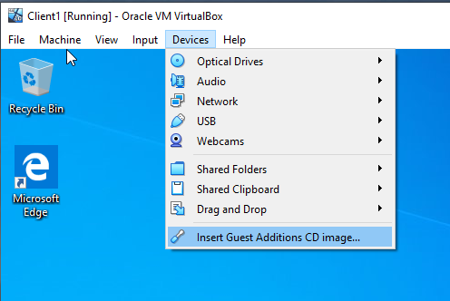
Figure 30. Virtualbox additions install for Windows 10 Clients.
Once the initial customization and account setup processes have been completed and the author logged in with the local offline created account. The author as with the Windows Server 2019 install carried out the Virtualbox Additions install as shown in figure 30 for the same reasons carried out the Virtualbox Additions install for the same reasons in relation to feature additions and performance and user interface improvements.

Worksheet 1 Task 2 – Virtual Network Configurations.

1.2.1 Virtual Box Network Configuration Setup of VMs
Once the author had completed the setup of the two Windows Server 2019 VMs and the two Windows 10 Client VMs, the author was then tasked with creating and configuring the Network settings on the VM settings side and then following up with configuring the hosts Operating systems with the correct configuration once this was completed.

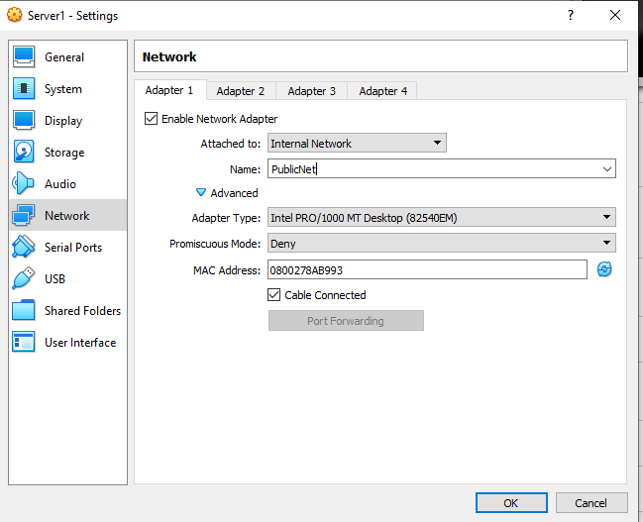
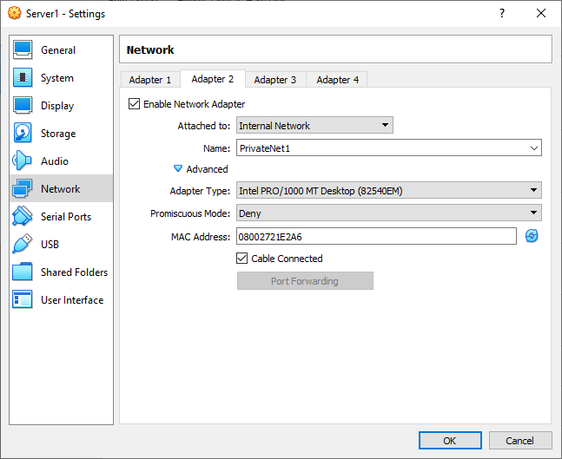
Figure 31. VM Server 1 Public Network. Figure 32. VM Server 1 Private Network.
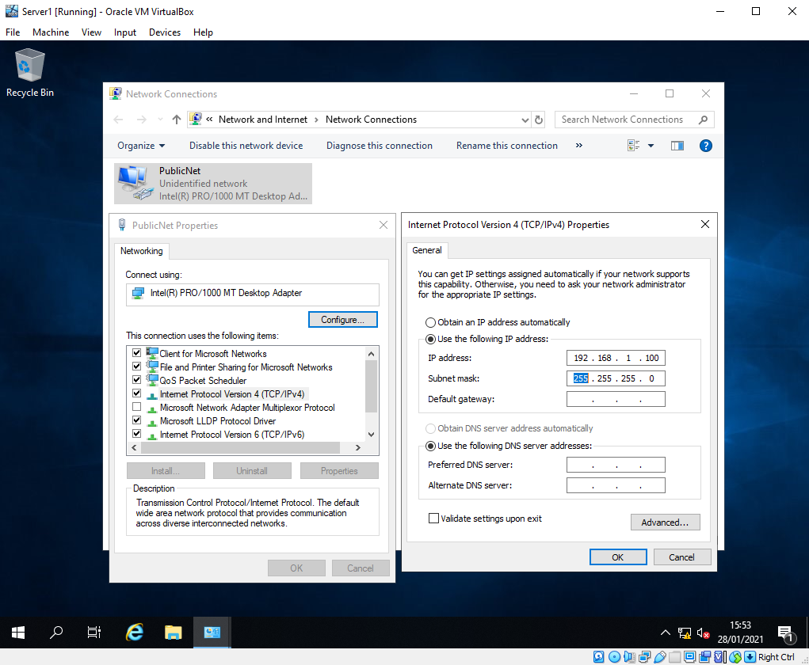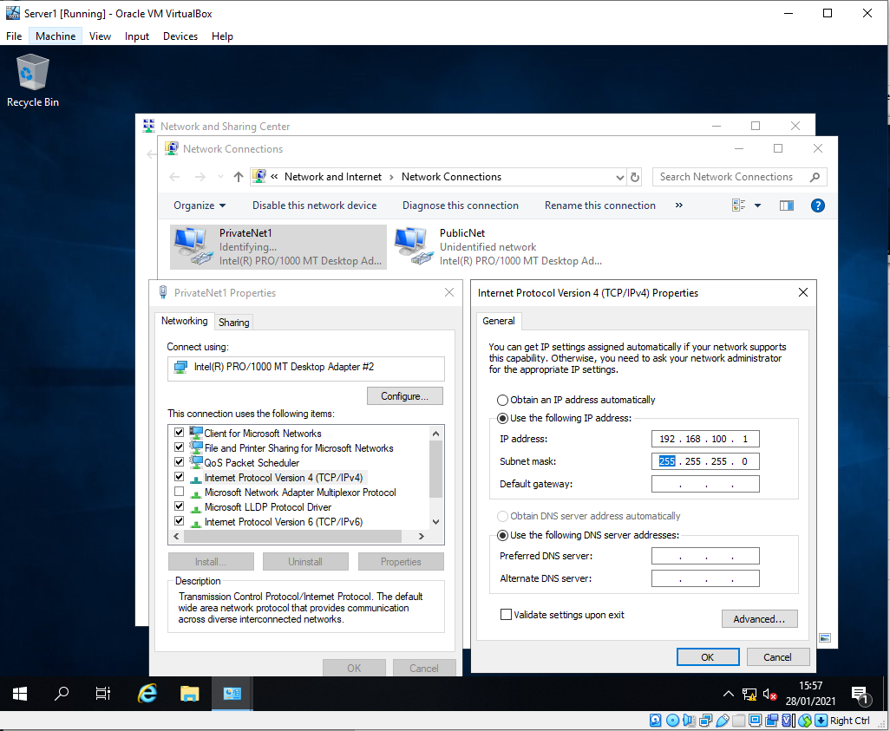
Figure 33. Server 1 Public Network Config. Figure 34. Server 1 Private Network config
The author was tasked with setting up 2 networks to be presented within the Server VMs. As shown in Figure 31 under the Network settings tab the author has created an internal network [8](which meant that the network is configured for use within the Virtual box environment and not the host environment) which was labelled the “Publicnet” once enabled this will present a Network Interface Card (NIC) within the OS. The same process was repeated in Figure 32 to create a second NIC and labelled as “privatenet1”.
Once the author had completed the setup of the network cards within the Virtualbox settings, the author then started the Windows Server VM and moved to configure the presented NICs within the OS. As shown in Figure 33 the author navigated to the properties of the Public presented NIC and renamed it accordingly, once renamed the author then specified the IP address information required. The same process was carried out in Figure 34 to label and configure the Private NIC and its associated IP address information.
These two NICs were now available within the OS and this meant the OS had two network paths it could utilise to communicate with other device, if setup in the same manner in relation to the internal network config of Virtualbox.
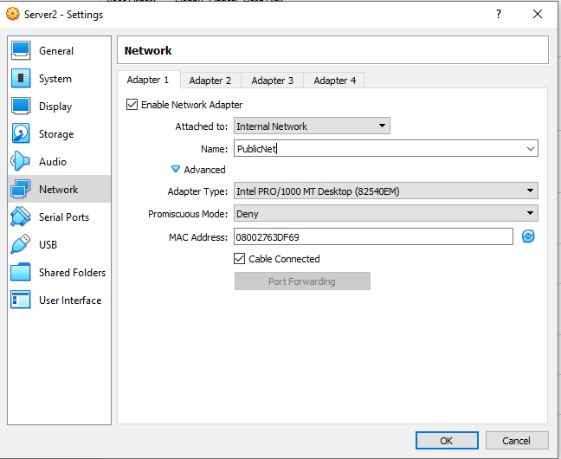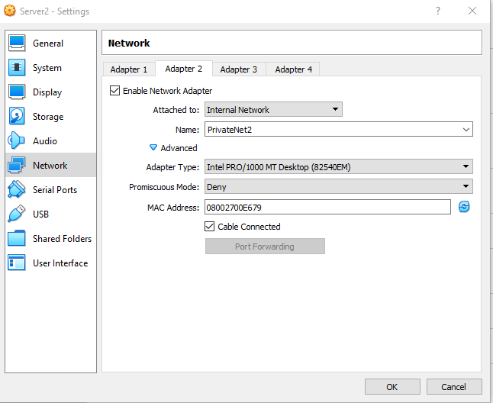
Figure 35. VM Server 2 Public Network. Figure 36. VM Server 2 Private Network.
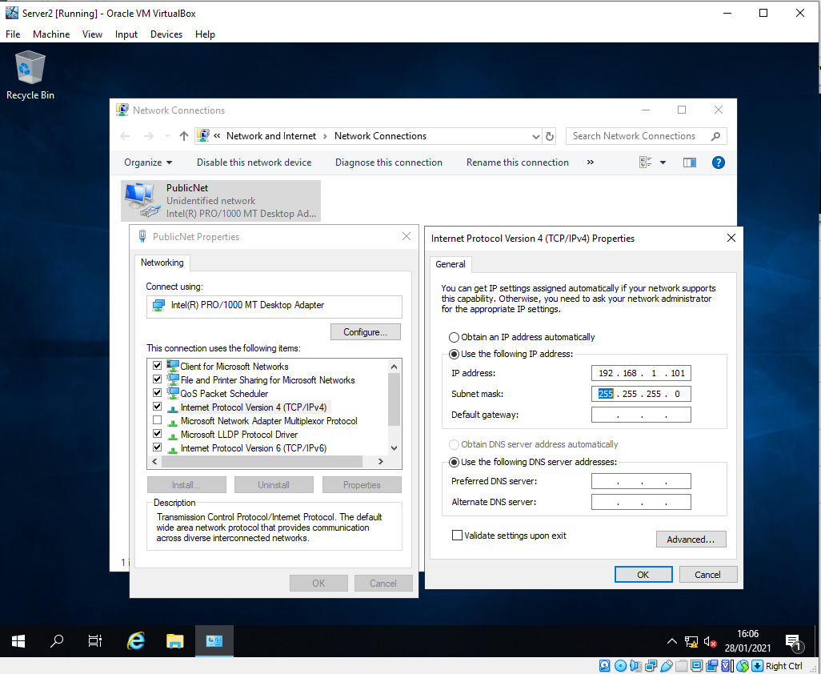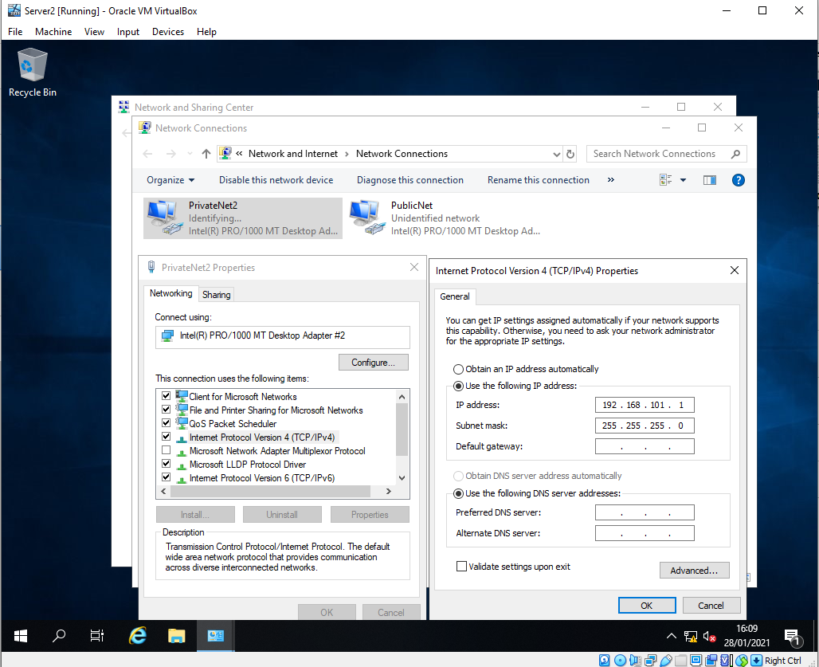
Figure 37. Server 2 Public Network Config. Figure 38. Server 2 Private Network config.
The author then carried out the same process of NIC setup within Virtualbox and config within the Windows operating system for Server 2 as shown in Figures 35, 36, 37 and 38. The only difference being the assigned IP address being allocated for Server 2 along with the fact that the PrivateNet2 is separate to private Net1. The Publicnet is continued to be utilised to allow for communication between the two Server VMs.

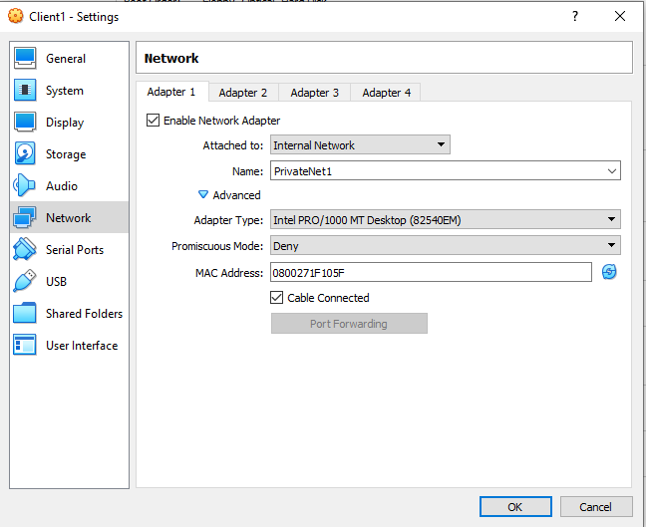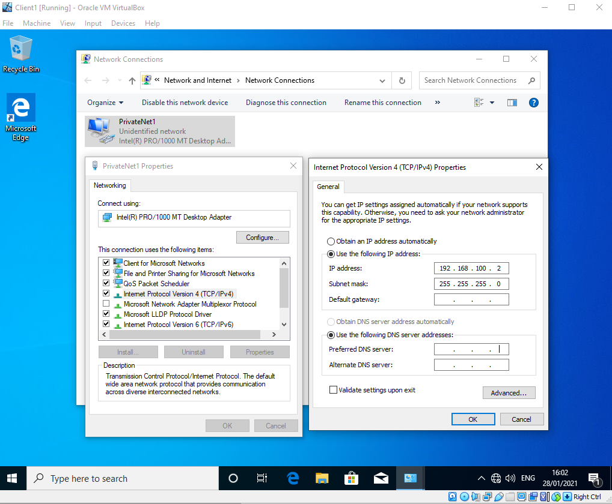
Figure 39. VM Client 1 Windows 10 Private Network Setup.
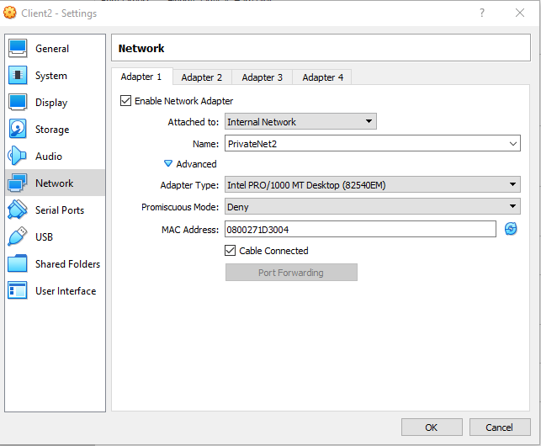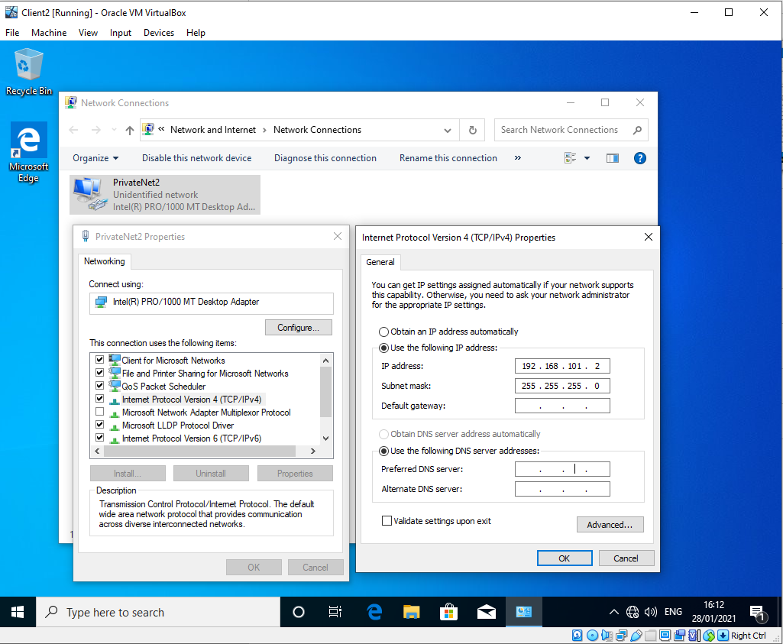
Figure 40. VM Client 2 Windows 10 Private Network Setup.
Now that the Server Networking both in Virtualbox and OS config has been completed, the same process is then carried out on the Windows 10 client VMs. The difference in this instance was the for the Windows 10 client VMs there was only a requirement for a Private Network to be setup.
As shown in Figure 39 the PrivateNet1 has been configure and assigned an IP address on Client VM1 so that it is able to communicate with the PrivateNet1 of Server VM1. And then on Client VM2 the PrivateNet2 was configured to allow for the client to communicate with the PrivateNet2 of Server VM2.

1.2.2 Virtual Box Server and Client Extended Configuration (Firewalls)
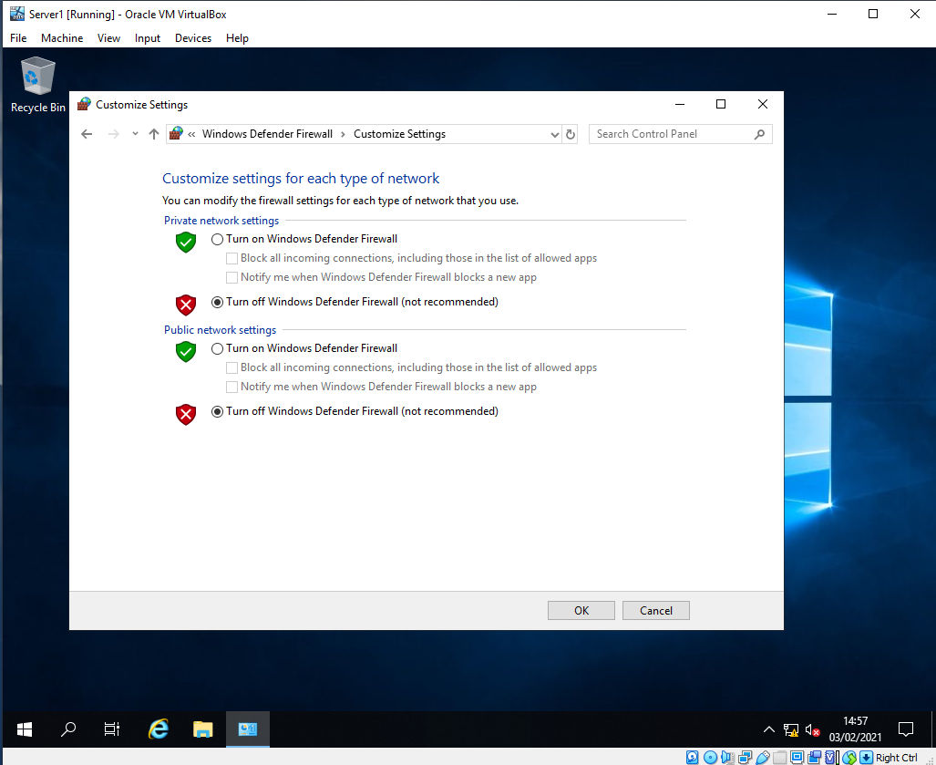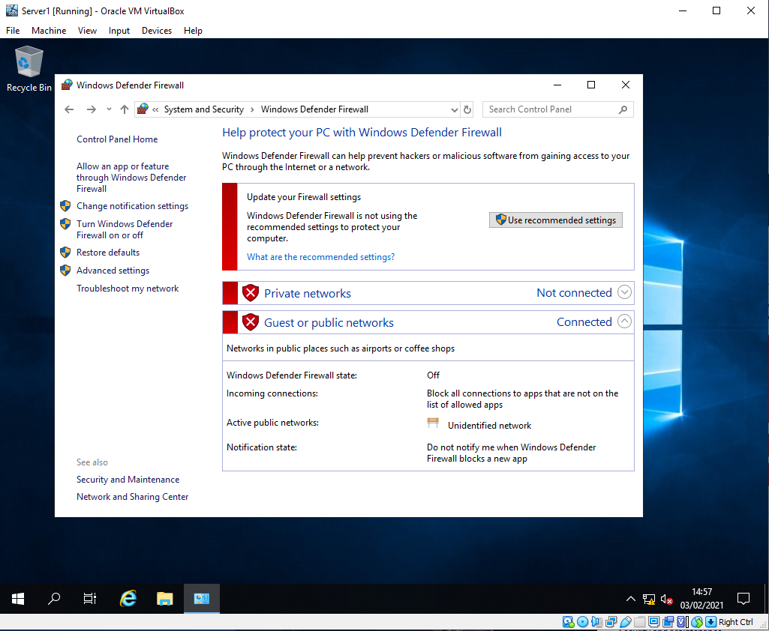
Figure 41. Server 1 VM Firewall Config and confirmation of settings.
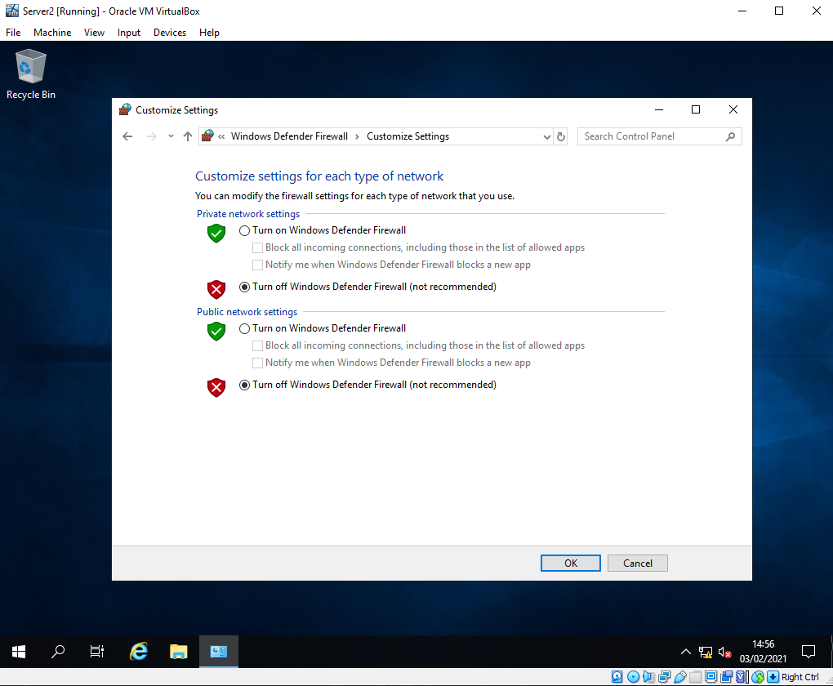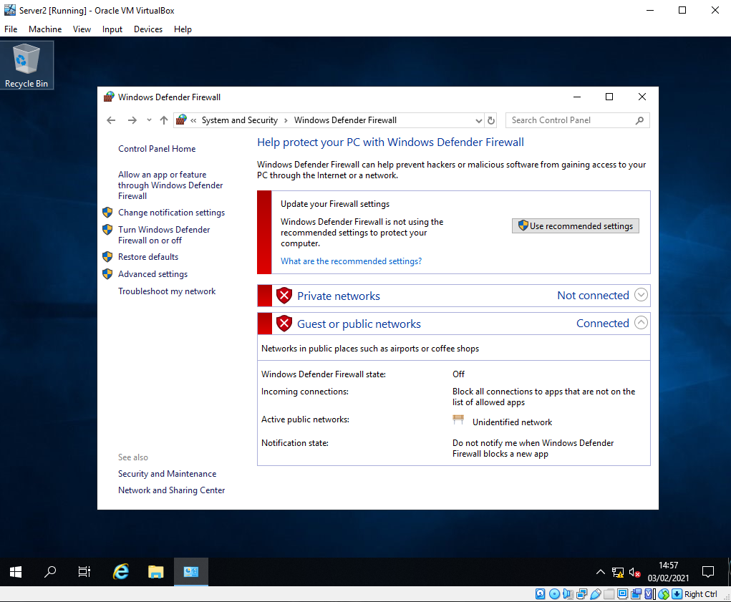
Figure 42. Server 2 VM Firewall Config and confirmation of settings.
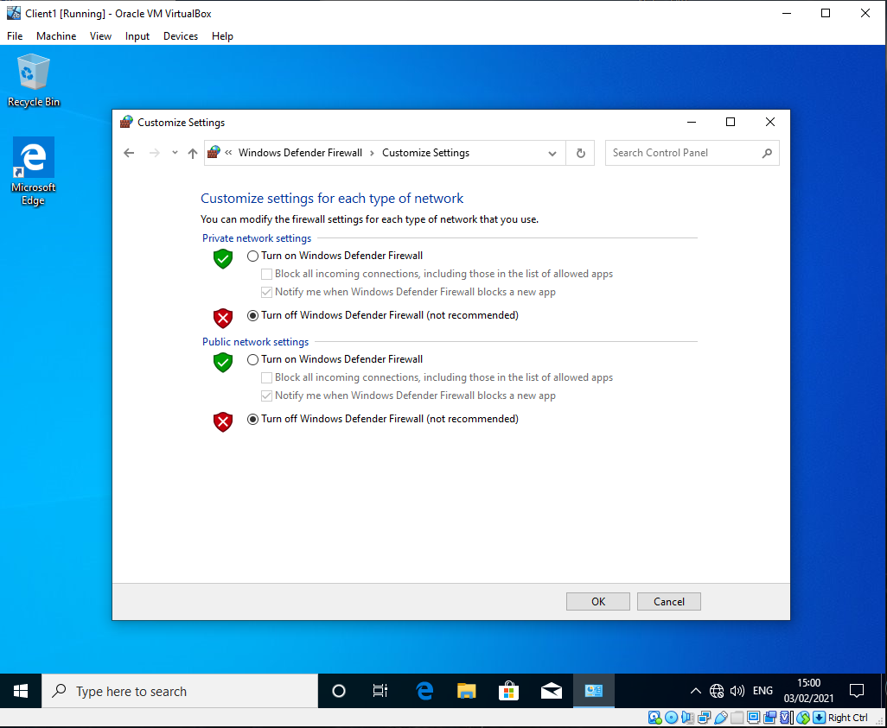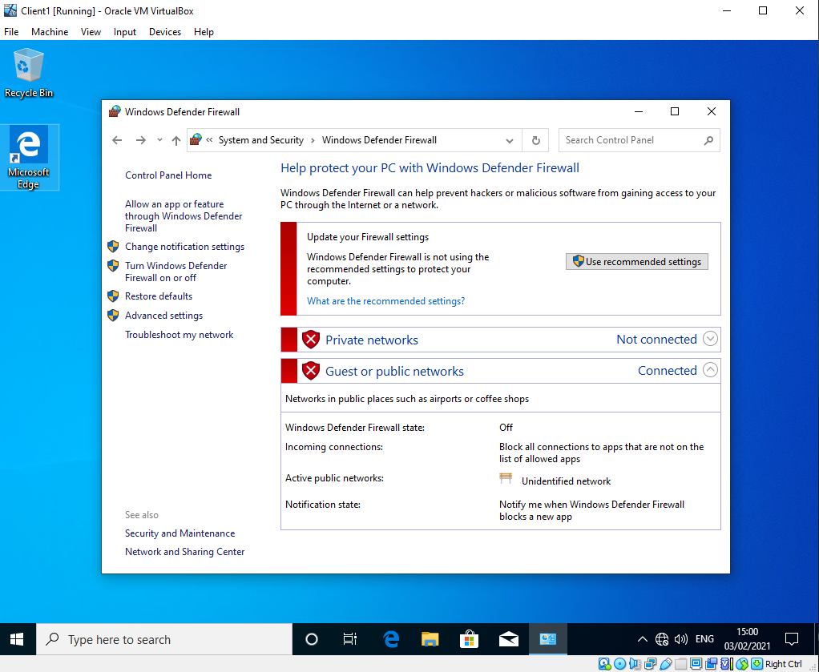
Figure 43. Client VM 1 Firewall Config and confirmation of settings.
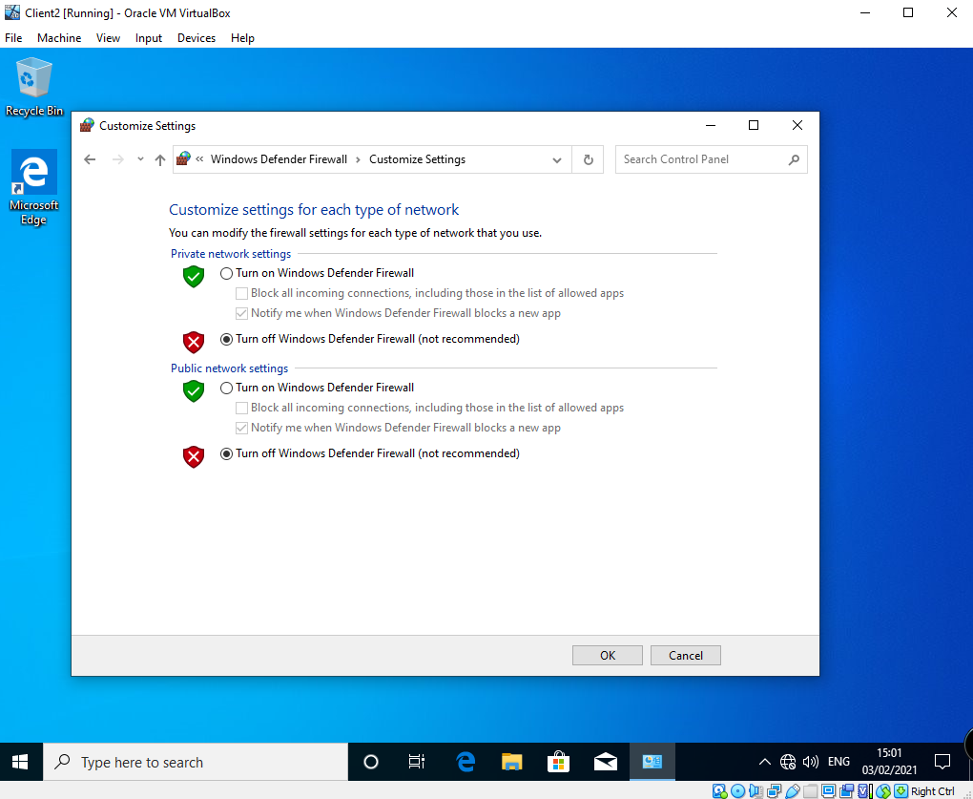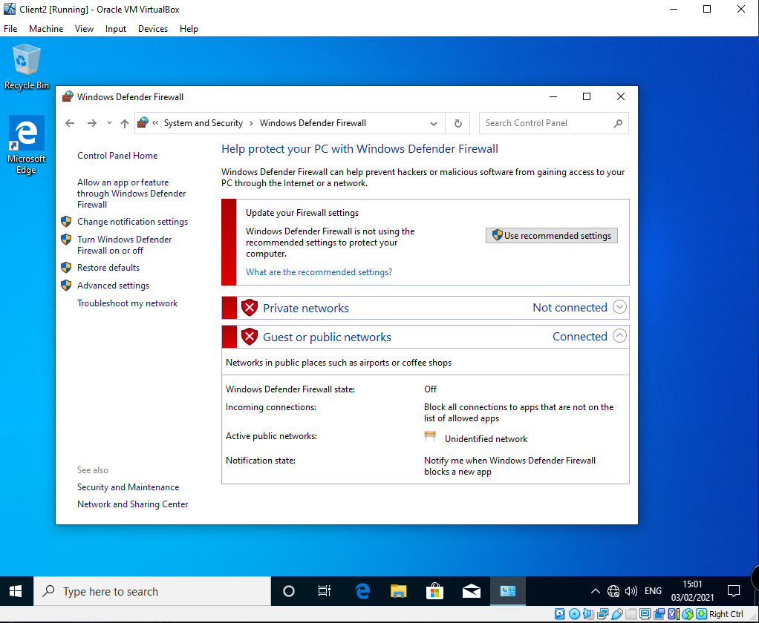
Figure 44. Client VM 2 Firewall Config and confirmation of settings.
To enable the ability to ICMP ping between the various Server VMs and Clients VMs to confirm the network connectivity has been setup and configured correctly. The Firewalls on the Windows Server 2019 servers VMs Figure 41 and 42 have been disabled and turned off for both private and public network profiles. As demonstrated in Figures 43 and 44 the author also disabled the same Firewall settings for the Windows 10 Client VMs.
Alternatively rather than disabling the entire firewall profiles for the devices listed above. It is possible to simply amend the port rules within the firewall control panel of both Windows Server 2019 and Window 10 Client to allow the specific ICMP protocol[9]. But for the purposes of the test to follow the author disabled the Firewalls as demonstrated.
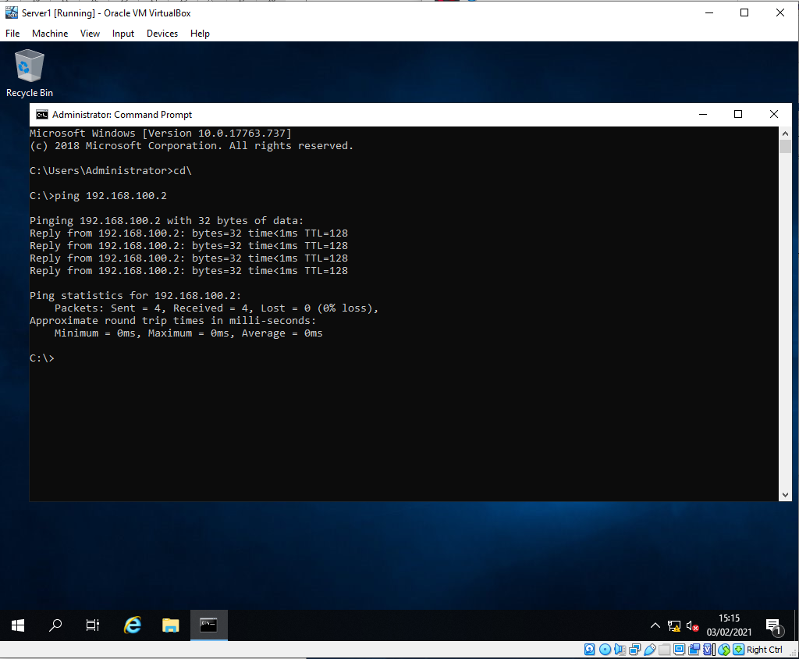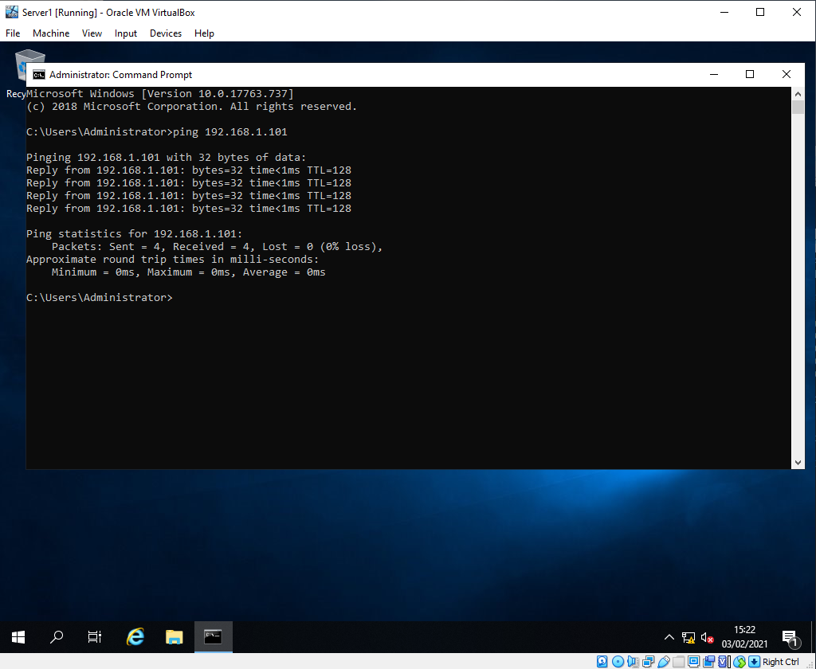
Figure 45. Successful ping commands from Windows Server 2019 Server 1.
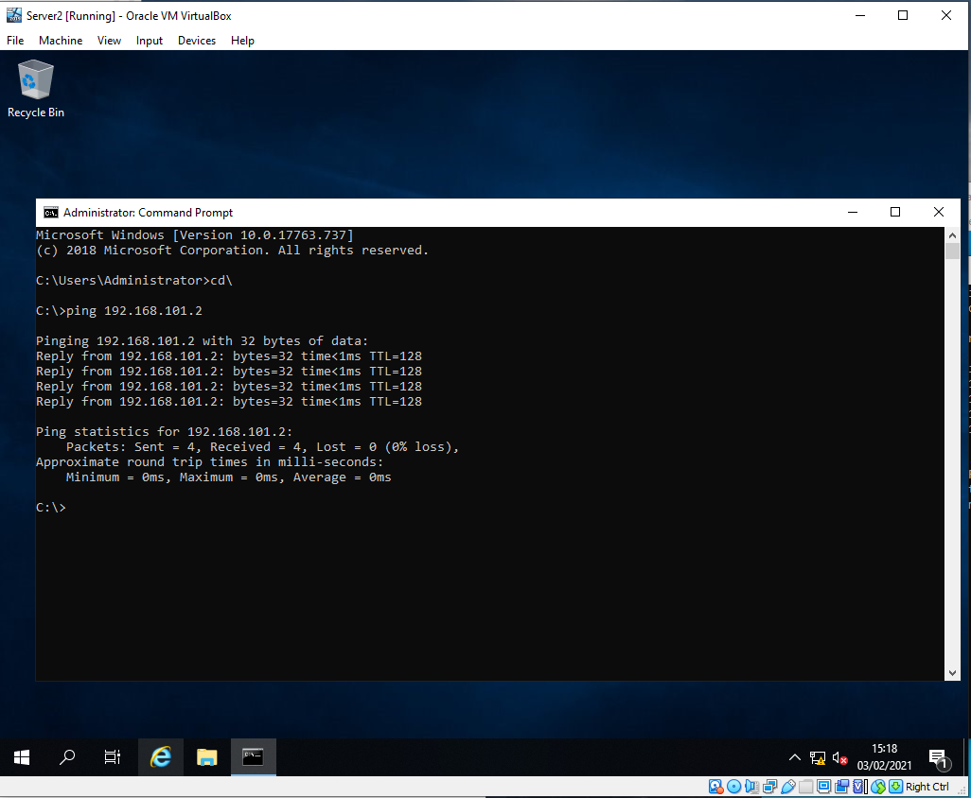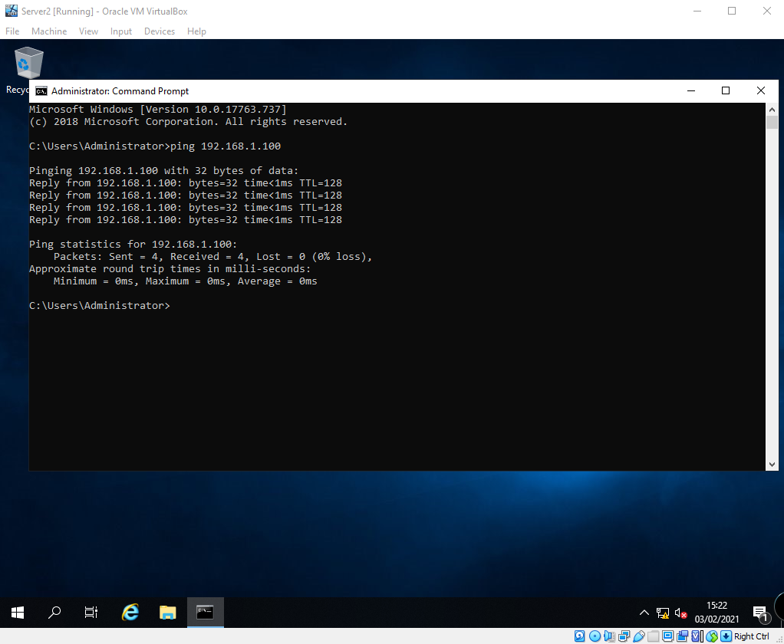
Figure 46. Successful ping commands from Windows Server 2019 Server 2.
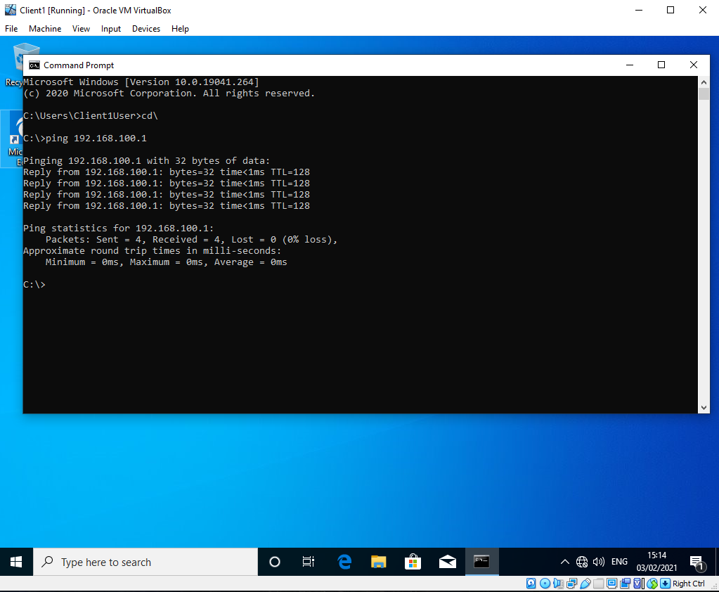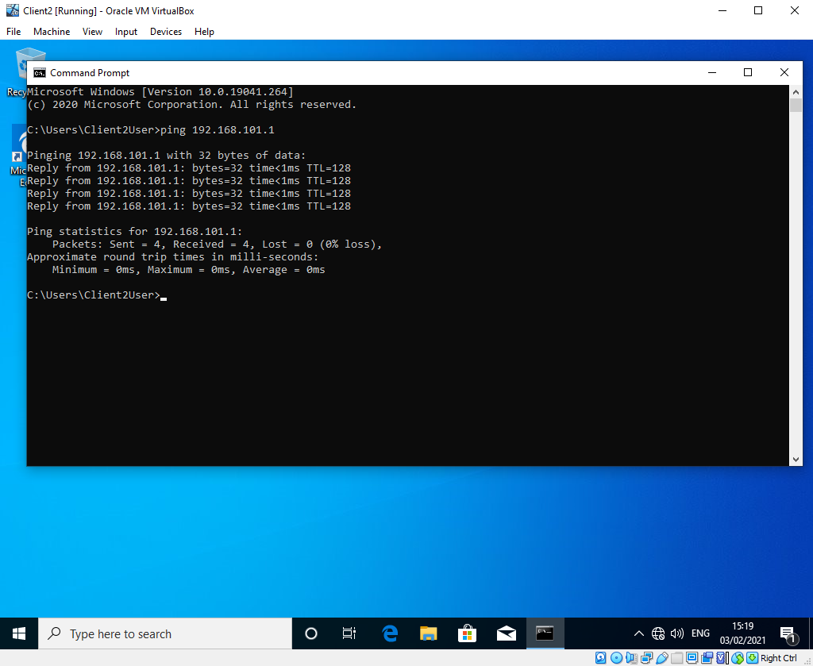
Figure 47. Successful Ping from Client 1. Figure 48. Successful Ping from Client 2.
The author then carried out a series of ping command between the Servers and Clients as demonstrated in Figures 45, 46, 47 and 48 to demonstrate successful config and network connectivity as a results of the worksheet completion.

Part 2 – Observational Tasks/Work.

Differences between Type 1 and Type 2 Hypervisors
The definition of a Type 1 hypervisor and a Type 2 hypervisor can be broken down in to multiple categories.
Firstly main difference between a Type 1 and Type 2 hypervisor is that a Type 1 is often referred to as a “bare metal” hypervisor. The term bare metal simply refers to the fact that the hypervisor software is directly ran on top of the host’s physical hardware[10] Figure 49.
A Type 2 hypervisor in contrast is often referred to as a “hosted hypervisor”. The term hosted hypervisor in this instance simply means the software unlike Type 1 is not hosted directly on the host’s physical hardware, but instead hosted by another software operation system[10] Figure 49.
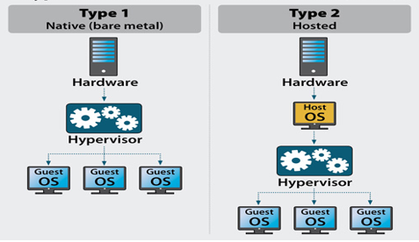
Figure 49. Comparison of high level overview of Type 1 vs. Type 2 Hypervisor Configuration.
As shown in Figure 49. It is clear to see that the Type 1 hypervisor software is embedded in to the host computer and manages and assigns resources as needed to the guest VMs. Alternatively the Type 2 Hypervisor software runs on top of an Operating system like Windows for example and interacts between the Host OS layer and the Guest OS layer upon its Hypervisor Software.
Due to the nature of the deployments Type 1 Hypervisors rely on Hardware acceleration technologies to function, and without these technologies the Hypervisor would not function as they have no ability typically to fall back to a software emulation as the hypervisor as previously disgust link directly to the host’s hardware. Type 2 However is also able to utilise hardware acceleration where possibly, sometimes but no always requires additional configuration and install media to take advantage of any such hardware acceleration available and presented through the Host OS. But typically Type 2 Hypervisors fall back and rely on software emulation if hardware support is not available.

2.1.1 Type 1 Hypervisor Examples & Vendors

The author has listed below some but not limited to examples of large Type 1 Hypervisor vendors in the current marketplace.

- VMWare ESX/ESXi:
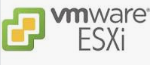
One of the main players in the hypervisor market. Aiming their core products at large business environments and are often regarded as a high level enterprise solution[11]. Their platform often comes at a high level of expense in relation to licencing cost, usually but not limited to the level of scalability and advanced feature sets provided by the solution along with the support aspect

- Microsoft Hyper-V Server:
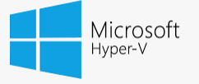
Microsoft Hyper-V has progressed a lot since its inception in 2008 as an add-on feature to the then Windows Server 2008 platform. Hyper-V has been available in two variations the OS layered Hyper-V as an add-on component or Server Role in more modern additions of Windows Server along with the Hyper-V server Edition which is aimed at carrying out the singular role of Hyper-V Hypervisor[12]. It has gained greater ground in recent years as the product has matured and gained greater feature sets, along with the fact that most large organisations are paying for Microsoft licencing and gain the Hyper-V product as a “Free” additional offering.

- KVM Hypervisor:

The KVM also known as the Kernel-based Virtual machine by its name implies is a variation on the Linux Kernel to convert Linux in to a Type 1 Hypervisor[13]. As will all hypervisors they are essentially a bespoke OS which require but not limited to key items such as memory managers, device drivers and network stacks for example. And in KVMs instance the utilisation of the Linux Kernel which has these components in place is utilised. Features such as live migration of hosted VMs, scheduling of events and resource control are all available in KVM but the open source aspect leaves a gap in the traditional support frameworks.

- Citrix Xen Server Hypervisor:
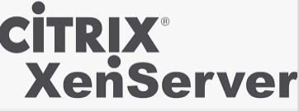
Citrix Xen Server is one of many hypervisors that has its origins in the open source Xen hypervisor. Citrix began to develop and build upon the open source Xen Hypervisor and branded the Citrix XenServer as their own hypervisor primarily aimed at providing a low cost specific use case scenario in hosting their other software platforms, such as their Virtual Desktop and Virtual machine offerings ranging from XenDesktop and XenApp through to current day Virtual apps offering. It is limited in its scope for these very reasons, but the free “standard edition” and even with low cost licenced support driven version “Enterprise” made it popular in various environments[14].

2.1.2 Type 2 Hypervisor Examples & Vendors

The author has listed below some but not limited to examples of well-known Type 2 Hypervisor vendors in the current marketplace.
- VMWare Workstation, Fusion, Player
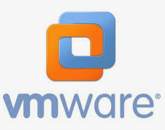
VMWare as well as offering their enterprise orientated Type 1 hypervisors, offer a Type 2 Hypervisor in their VMWare Workstation, Fusion and Player stack. Depending on which version you use, they all provide varying degrees of operability features[15]. For example VMWare Player only allows the running of a single VM and not the creation either with cut down features, in comparison to Workstation and Fusion both of which are aimed at the Windows and Apple market respectively and provide the ability to run multiple OS versions on top of the native OS along with sandboxed environments for but not limited to networking along with Snapshot backup and restore abilities.

- Oracle VM VirtualBox
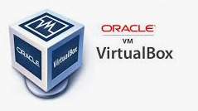
Oracle Virtualbox is very similar to paid for versions of VMware Workstation for example. It allows for the creation and running of multiple VMs on a single host along with advanced feature stacks including but not limited to the sandbox of networking and the ability to snapshot and restore VMs at any point. It is a very capable platform considering it is a free product and also comes with a small footprint in relation to system resources.

- Parallels Desktop

Parallels Desktop is a Type 2 hypervisor aimed at Apple OS platforms. It has a similar future sets in relation to other hypervisors such as VMWare Fusion which is the VMware Offering for Apple OS platforms. One of its biggest limitation is that it is purely Apple orientated and therefor unable to share and run the images on non-Apple devices[16]. But it is very popular for allowing Apple OS users to run Windows Apps on their Apple devices.

- QEMU

QEMU is a Type 2 Hypervisor offering aimed purely at Linux platforms. This is a limited factor in the same was Parallels is aimed purely at Apple OS’s. But for its intended purposes it provides a free and easy to use product (for those experienced with Linux). One of the benefits but not limited to are the fact that guest VMs on the software run with very little overhead and have performance levels very similar to installs on the host hardware. It is able to run a wide array of guest Operating systems and it even has the ability to act as a machine emulator, for example QEMU can emulate a number of architectures and not limited to Power PC and ARM environments[17].

2.1.3 Advantages and Disadvantages of Type 1 Hypervisor

- Advantages of Type 1 Hypervisors including but not limited to[18]:
  - The ability to have large scalability options not only on single Hosts but across multiple hosts
  - Reduced conflict between host OS and Hypervisor OS in Type 2 Examples as the Type 1 OS is linked directly to the hardware layer.
  - Improved Security as the hypervisor isn’t relying on underlying Host OS layer
  - Greater Resource Allocation and management. As the underlying hypervisor OS is lightweight and directly in control of host hardware.
  - Overall better performance and reliability as there is no second layer of Operating system to interact with that could cause issues.
  - Backup and restore options of a much higher calibre with the ability to live migrate devices across multiple hosts.

- Disadvantages of Type 1 Hypervisors.
  - Often come with higher costs than a type 2 hypervisor. As the product is aimed at enterprise environments.
  - More complex in its admin and setup than Type 2 Hypervisors and often require specialist training and resources to administer
  - High end hardware is often required leading to increase costs and support
  - Hardware support between varying Hypervisors can be different and specific hardware types may not be supported or compatible by all vendors.
  - Separate Management systems and Consoles often have to be in place and setup.

2.1.4 Advantages and Disadvantages of Type 2 Hypervisor

- Advantages of Type 2 Hypervisors including but not limited to[19]:
  - Often low cost and many free versions available
  - Available on multiple OS platforms and in many differing levels of features and complexity
  - Easy to setup and get running as the interface often mimics the host OS they platform is ran on.
  - Easier management of the guest VMs as there is no requirement or need for separate management consoles
  - As the Hypervisor is running on an OS there are very few compatibility issues. An example but not limited to is if the vendor support hardware acceleration features and these are not compatible the product often falls back to a software acceleration offering.

- Disadvantages of Type 2 Hypervisors including but not limited to[19]:
  - Often more points of failure due to the inherent reliance on underlying Host Operating system which can affect the hypervisor
  - Only able to run the VMs without offline migration on a single device.
  - Downtime of the Host OS will result in downtime of the Guest VMs

IPv4 Subnet mask significance
The term Subnetting IP Address is a term used to describe the breaking up and splitting up entire IP Addressing scheme in to smaller scopes[20]. The Subnet mask when assigning it to the configuration of a computer or network for example defines what part of the IP address scheme is assigned to the network, and what part of the ip address scheme is assigned to the hosts.
There are a number of classes of networks that are defined by subnet masks and these are shown in Figure 50.
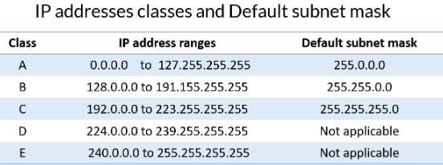
Figure 50. IP address table showing the Default subnet mask Classes.
Depending on the Class of network used will define the number of networks and hosts that can be hosted within that class of network. For example as shown in Figure 51 the default subnet masks of a Class A Network can support large number of hosts but in a small number of networks. Whereas a Class C network can support a larger number of networks with a smaller number of hosts in each of those networks.
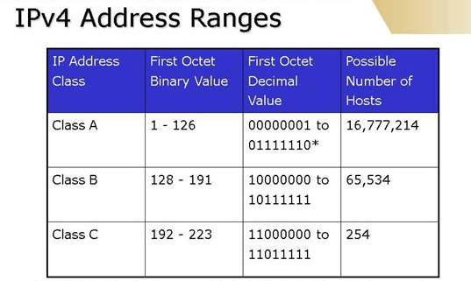
Figure51. IPv4 Subnet Class Table example.
So the significance of a subnet mask in IPv4 Addressing is that it allows for the network to be split up in to smaller sub networks of varying number of hosts supports, this can also be modified further with Variable Length Subnet Masking[21] which in its simplest form simple allows for the classed of network to be split more granularly and less rigidly to avoid waste of host addresses within the larger IP scheme.
By having the subnet mask in place on a network it allows for the guests to be able to communicate specifically within their own split networks if needed[22], this allows for greater improvement in performance of the packet communication within a network, and well as but not limited to security improvements for example as it can be configured to prevent certain traffic of data from leaving predefined subnets[23], to avoid sensitive data from being vulnerable in less secure areas of the network.

Cloud Computing Uses – Benefits and Drawbacks
Cloud computing is essentially the provision of traditional infrastructure services, along with modern infrastructure/desktop service hosted in a datacentre accessible over the internet. Services typically defined as:
- Infrastructure as a Service (IaaS)[24]: IaaS is where the traditional infrastructure services such as Physical Facility Housing, Server Hardware and Storage along with Networking and Security are all leverage and made available via a Cloud provider.

- Platform as a Service (PaaS)[25]: PaaS is where leveraging IaaS provisions along with adding additional OS and Development tools such as database management or Analytics models to provider the consumer with a development and deployment platform.

- Software as a Service (SaaS)[26]: SaaS includes IaaS and PaaS and provides additional hosted Applications and/or Apps to the customer. All of which relies and is built upon the cloud infrastructure and Platform services.

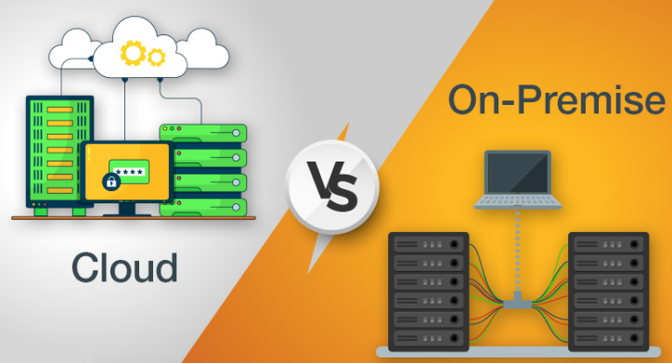
Figure 52. Visual Graphics comparing Cloud vs. On-Premise Infrastructure [27]

Benefits of Cloud Computing.
- Low Upfront Costs: in most cases, as most of the primary cost in Cloud services are often centred on a subscription service that is paid for over the term of the service contract.
- Flexibility: Cloud based services are often able to expand the infrastructure requirements instantly, their services are devised around scalability[28] and do not require complex and expensive Infrastructure projects to modernise and improve services to meet the growing demands
- Mobility: Cloud computing but its very nature means that the services that are hosted and made available to the end user are accessible over the internet. This means that gaining access to service outside of traditional corporate offices etc. is already built in to the design.
- Collaboration: As services are based in the cloud it is easy to allow for greater collaboration as there are often already available features tailored to allow for cross platform and organisational sharing of data and services.
- Security: Cloud based services have dedicated staff that are expert is specific areas such as security, as its core to their business. Unlike traditional infrastructure on-premise staff who often have many other roles alongside security for example[29]. Cloud based services also have dedicated monitoring teams that are able to flag any issues to the specialised teams to address.
- Disaster Recovery: Cloud based services are hosted by large cloud based provider such as but not limited to Microsoft, IBM and AWS (Amazon Web Services). These providers often have large datacentres that are not only dedicated to account for hardware failures with large clusters of mirrored backups, but also large industrial solutions in place to account for natural disasters and power failures[30]. As the cost of all of this coverage is essentially spread to all of the Cloud Service users.

Drawbacks of Cloud Computing.
- Network: Cloud based services are entirely reliant on network connection quality. Now that all of the data and services are accessed via a datacentre over WAN links. The Network connection has to be very resilient and to a high enough spec to account for the increased traffic.
- Vendor Ties: Moving from on-premise to cloud is often easy and vendors will encourage and incentivise the process. But once the data and services are in the cloud it is often very difficult to go back to on-premise if needed[31], or to move to another provider. The Costs alone are often prohibitive
- Ongoing Licence/Service Costs: While it’s true the initial outlay of cloud service is a lot lower than traditional large scale on premise infrastructure. The cost if often much larger over a longer period of time as the ongoing subscription model[32] continues to cost over the lifetime of the service.
- Control: The lack of true end to end control is a drawback to cloud service. If and when issues occur the cause of the issue will often be out of the control of the business and local IT staff. This means sometimes the true visibility and understanding of when services are made available after an outage can be a grey area.

Cloud based Vendors.
There are many large and well known Cloud based Vendors. By the nature of the scale of resources that are required to setup and maintain a reliable and functional cloud based service, they are often hosted by large successful technology companies[33]. Some of which are listed but not limited to the following:
- Amazon Web Services (AWS): Service provided include but not limited to Compute Power, Database Storage and content delivery[34]. Upfront costs are minimal and services are based on a Pay for what you use model.
- Microsoft Azure: Services provided by Azure include but are not limited to replicating and taking traditional IT services based on Microsoft such as Office Applications and their backend infrastructure (Email Server), and services such as Active directory. While also providing hypervisor based solutions for many other IaaS services for other vendors as well as themselves[35].
- IBM Cloud Services: Service provided include but not limited to platform as a service models allowing for customers to develop and built upon IBM cloud computing services[36], as well as traditional IaaS Services.
- Google Cloud Platform: Service provided include but not limited to services such as Data analytics, machine learning and Data storage[37]. Many of the uses are well known to even the average home user as many of Google’s own in-house software such as Mail, Media service such as YouTube and their own Google search are housed on the same platform.
- Adobe: Service provided include but not limited to services such as SaaS & PaaS which utilise their existing traditional software packages and platforms[38], but made available in the cloud and allow for the scalability and compute power of the cloud to garner greater productivity and storage.

Task 1 and 2 Technologies and purposes
The author will list a number of terminologies and technologies that were implemented and/or referred to in the Task 1 and Task 2 of the worksheets. As well as describing their use cases and functionality, the author will reflect on similar implementations in other network operating systems.

2.4.1 Firewall
Firewall at its most basic level is often a software driven application which permits or denies communication between devices and or between devices and networks. In Task 1 the author was using the Microsoft Windows Firewall client, and configured it to be off and allow all traffic to enter and leave devices network interfaces both on Servers and Clients. In reality this is not good practise and by default Windows Firewalls should be turned on and then adjusted within the advanced settings as shown in figure 53.
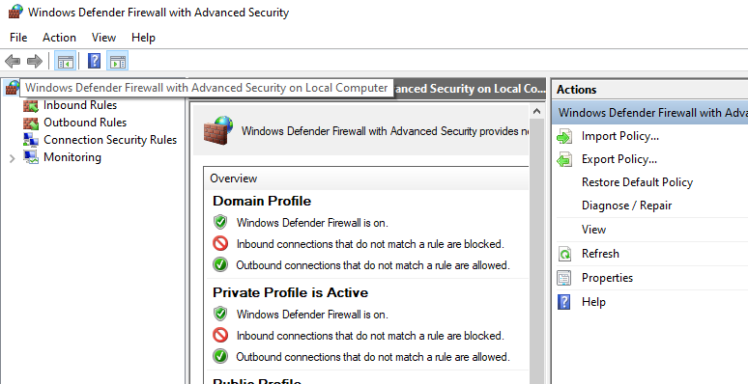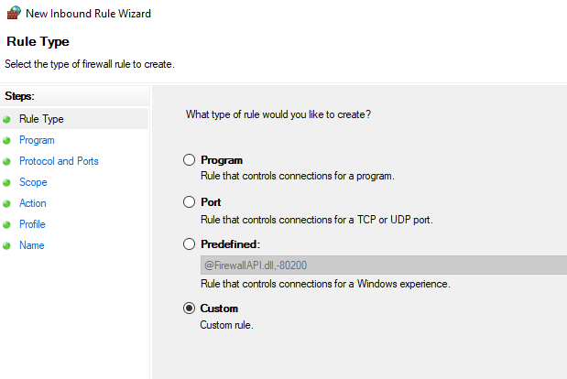
Figure 53. Windows Firewall Settings. Figure 54. Windows Firewall Rule Creation.
Within the advanced feature the author is able to amend either/or both inbound and outbound rules. As show in figure 54. The author is author is able to follow a GUI driven menu to fine tune rule creations including but not limited to example such as rules based on programs, Ports and custom rules. By utilising this functionality users are able to fine tune and restrict and allow access that is required and therefore leaving the attack surface of the device as narrow as possible.
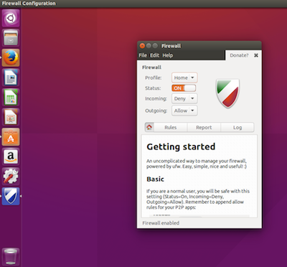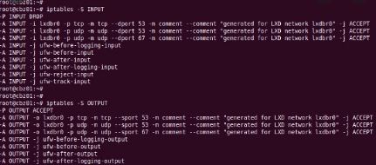
Figure 55. UFW Firewall Linux. Figure 56. IPTables Linux Command Line.
There are many types of firewall packages that can either be found in other operations systems based on Linux platforms. Simple to use examples such as Uncomplicated Firewall (UFW)[39] figure 55 emulate to a simple level the GUI driven firewall interface as is familiar with Windows users. It has many of the same features and similarly allows users to toggle on/off firewall profiles and create GUI driven rules to enable disable access to various ports and programs.
More traditional Linux Firewall implementations such as IPTables[40] utilise a more traditional command line structure familiar with many experienced Linux users. This relies on command line structure to configure and edit packet filtering rules for the hosted system(s)
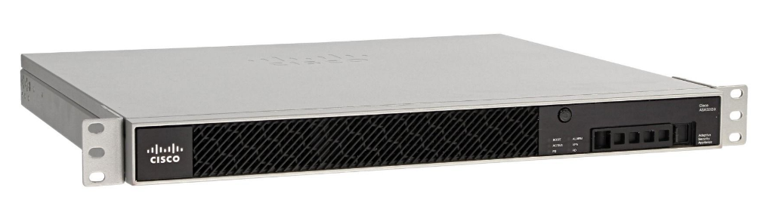
Figure 57. Cisco integrated Firewall Appliance.
Other examples outside of traditional Microsoft and Linux offerings would include offerings including but not limited to Network vendors like Cisco or Forcepoint who provide specific packages hardware/software solutions that are classed as appliances as shown in figure 57, with the sole task of carrying out and administering the functional of firewall within an enterprise/business network primarily.

Desktop Experience
Desktop Experience or specifically Windows Desktop Experience is an option within primarily Windows Server installs that allows the user to select and install a traditional Windows Graphical User Interface as an option. This was named as such upon the release of an install option known originally as Core[41] as shown in figure 58.
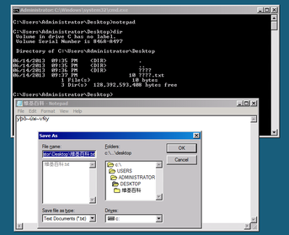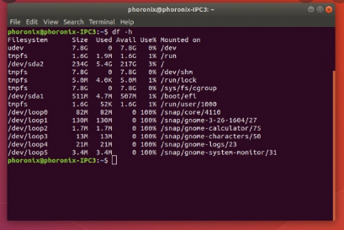
Figure 58. Windows Server Core Interface Figure 59. Ubuntu minimal command line.
The purpose of the core option was to reduce a number of areas of the windows install but providing the user with a command line driven interface. The reduced areas include but are not limited to reduced servicing and management requirement, reduced resource requirements such as disk space and memory along with what was noted at the time of release a reduced attack surface due to the lack of a windows explorer shell interface install.
Windows Core mimics in many ways the traditional Linux installs and more modern minimal installs of Linux which are command line driven and hence reduce the attack surfaces for attacker, example such as Ubuntu minimal[42] Figure 59 or turnkey.

OOBE (Out Of Box Experience)
OOBE also known as Out Of Box Experience is a terminology primarily associated with Microsoft Windows Operating systems. It is at its core a GUI driven interface with a scripted install and configuration flow underneath[43]. It allows for devices to be handed to the end user(s) and allow from a customizable final setup flow process to include but not limited to items such as network setups, language selections and user preferences such as keyboards as shown in figure 60.
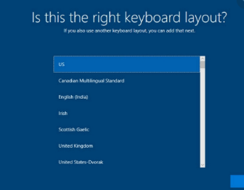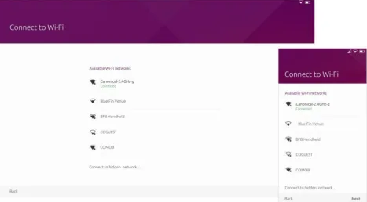
Figure 60. Windows OOBE example. Figure 61. Ubuntu OOBE example.
Other operating systems have also made available OOBE solutions. Once such Linux example including but not limited to Ubuntu OOBE[44] as shown in figure 61 demonstrates the Network selection phase of the same kind of scripted configuration flow that is provided by the Windows OOBE solution.

Server Manager
Server manager is a management console that was provided in Windows Server versions starting in Windows Serve 2012 onwards. It pulled together many traditional configuration and administration functionalities of Microsoft Servers, and provided them to be installed in what are known as Roles and/or features[45]. An example of this is when utilising the DHCP functionality within Windows Server, administrators are now able to select the DHCP roles from within the server manager as shown in figure 62. And they require features that may or may not be needed to enable this are then automatically enabled as part of the GUI driven wizard.
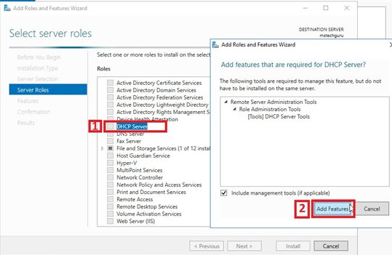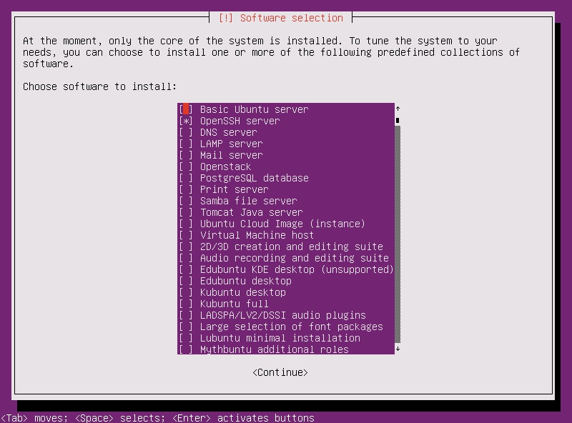
Figure 62. Windows Roles DHCP Addition. Figure 63. Ubuntu Roles Collections.
A Linux equivalent of Windows Server role manager include but not limited to the Ubuntu Server Linux platform and the predefined collections. From within the collections selection the user is able to select roles for the Ubuntu Server which will install the required software for those purposes.

References
[1] “virtualbox - When do I have to use PAE/NX? - Super User.” https://superuser.com/questions/1118712/when-do-i-have-to-use-pae-nx (accessed Mar. 04, 2021).
[2] “Power up VirtualBox with these performance boosting tips.” http://www.rawinfopages.com/tips/2017/07/speed-up-virtualbox-in-windows/ (accessed Mar. 04, 2021).
[3] “Comparison of Standard and Datacenter editions of Windows Server 2019 | Microsoft Docs.” https://docs.microsoft.com/en-us/windows-server/get-started-19/editions-comparison-19 (accessed Mar. 04, 2021).
[4] “Server Core and Server with Desktop: Which one is best for you - Windows Server Blog.” https://cloudblogs.microsoft.com/windowsserver/2018/07/05/server-core-and-server-with-desktop-which-one-is-best-for-you/ (accessed Mar. 04, 2021).
[5] “Disk Partitioning: The Good, The Bad, and The Techy | Baseline Data.” https://baseline-data.com/blog/disaster-recovery-news/disk-partitioning-good-bad-techy/ (accessed Mar. 04, 2021).
[6] “Chapter 4. Guest Additions.” https://www.virtualbox.org/manual/ch04.html (accessed Mar. 04, 2021).
[7] “Compare Windows 10 Editions: Pro vs. Enterprise – Microsoft.” https://www.microsoft.com/en-us/windowsforbusiness/compare (accessed Mar. 04, 2021).
[8] “Chapter 6. Virtual Networking.” https://www.virtualbox.org/manual/ch06.html (accessed Mar. 04, 2021).
[9] “Create an Inbound ICMP Rule (Windows 10) - Windows security | Microsoft Docs.” https://docs.microsoft.com/en-us/windows/security/threat-protection/windows-firewall/create-an-inbound-icmp-rule (accessed Mar. 04, 2021).
[10] “Hypervisor Server Review | What is a Hypervisor?” https://www.serverwatch.com/virtualization/hypervisor-server/ (accessed Mar. 04, 2021).
[11] “What’s the difference between Type 1 vs. Type 2 hypervisor?” https://searchservervirtualization.techtarget.com/feature/Whats-the-difference-between-Type-1-and-Type-2-hypervisors (accessed Mar. 04, 2021).
[12] “What Is Hyper-V & How Do You Use It? A Beginner’s Guide.” https://www.cloudwards.net/hyper-v/ (accessed Mar. 04, 2021).
[13] “What is KVM?” https://www.redhat.com/en/topics/virtualization/what-is-KVM (accessed Mar. 04, 2021).
[14] “What is Citrix XenServer? - Definition from WhatIs.com.” https://searchservervirtualization.techtarget.com/definition/Citrix-XenServer (accessed Mar. 04, 2021).
[15] “Desktop Hypervisor Solutions | VMware | UK.” https://www.vmware.com/uk/products/desktop-hypervisor.html (accessed Mar. 04, 2021).
[16] “Parallels Desktop 16 For Mac Review - Macworld UK.” https://www.macworld.co.uk/review/parallels-desktop-16-for-mac-review-3794693/ (accessed Mar. 04, 2021).
[17] “Best virtual machine software of 2021: virtualization for different OS | TechRadar.” https://www.techradar.com/uk/best/best-virtual-machine-software (accessed Mar. 04, 2021).
[18] “Hypervisors | IBM.” https://www.ibm.com/cloud/learn/hypervisors (accessed Mar. 04, 2021).
[19] “Types of Virtualization Technology-Advantages vs. Disadvantages | securitywing.” https://securitywing.com/types-virtualization-technology/ (accessed Mar. 04, 2021).
[20] “Subnetting and Masks: Separating IPv4 Addresses for Security and Routing.” https://www.thesslstore.com/blog/subnetting-and-masks/ (accessed Mar. 04, 2021).
[21] “Variable-Length Subnet Masks > Foundation Topics | Cisco Press.” https://www.ciscopress.com/articles/article.asp?p=2731924 (accessed Mar. 04, 2021).
[22] “Subnet Mask - an overview | ScienceDirect Topics.” https://www.sciencedirect.com/topics/computer-science/subnet-mask (accessed Mar. 04, 2021).
[23] “The importance of the subnet mask.” https://searchnetworking.techtarget.com/tip/The-importance-of-the-subnet-mask (accessed Mar. 04, 2021).
[24] “What is IaaS? Infrastructure as a Service | Microsoft Azure.” https://azure.microsoft.com/en-gb/overview/what-is-iaas/ (accessed Mar. 05, 2021).
[25] “What is PaaS? Platform as a Service | Microsoft Azure.” https://azure.microsoft.com/en-gb/overview/what-is-paas/ (accessed Mar. 05, 2021).
[26] “What is SaaS? Software as a Service | Microsoft Azure.” https://azure.microsoft.com/en-gb/overview/what-is-saas/ (accessed Mar. 05, 2021).
[27] “Cloud Vs On-Premise: IT Infrastructure Model of Your Choice?” https://www.veritis.com/blog/cloud-vs-on-premise-it-infrastructure-model-of-your-choice/ (accessed Mar. 05, 2021).
[28] “Cloud Computing vs. Traditional IT Infrastructure | Leading Edge.” https://www.leadingedgetech.co.uk/it-services/it-consultancy-services/cloud-computing/how-is-cloud-computing-different-from-traditional-it-infrastructure/ (accessed Mar. 05, 2021).
[29] “12 Benefits of Cloud Computing and Its Advantages - Salesforce.com.” https://www.salesforce.com/products/platform/best-practices/benefits-of-cloud-computing/ (accessed Mar. 05, 2021).
[30] “5 Cloud Computing Disadvantages.” https://blog.centretechnologies.com/5-cloud-computing-disadvantages (accessed Mar. 05, 2021).
[31] “What are the Pros & Cons of Cloud Computing? | Morefield.” https://www.morefield.com/blog/pros-and-cons-of-cloud-computing/ (accessed Mar. 05, 2021).
[32] “Video Hosting Costs in Cloud vs. On-Premises Infrastructure.” https://blog.vidizmo.com/cloud-vs.-on-premises-video-hosting-costs (accessed Mar. 05, 2021).
[33] “5 Top Cloud Service Providers Companies in the World - DataFlair.” https://data-flair.training/blogs/cloud-service-providers-companies/ (accessed Mar. 05, 2021).
[34] “Amazon Web Services (AWS) - Cloud Computing Services.” https://aws.amazon.com/ (accessed Mar. 05, 2021).
[35] “What is Microsoft Azure and How Does It Work?” https://searchcloudcomputing.techtarget.com/definition/Windows-Azure (accessed Mar. 05, 2021).
[36] “IBM Cloud Infrastructure and Platform Services.” https://www.gartner.com/reviews/market/public-cloud-iaas/vendor/ibm (accessed Mar. 05, 2021).
[37] “Google Cloud Platform: What it is, how to use it, and how it compares.” https://www.acronis.com/en-gb/articles/google-cloud-platform/ (accessed Mar. 05, 2021).
[38] “Cloud Service | Adobe Experience Manager .” https://www.adobe.com/uk/marketing/experience-manager/cloud-service.html (accessed Mar. 05, 2021).
[39] “An Introduction to Uncomplicated Firewall (UFW) - Linux.com.” https://www.linux.com/training-tutorials/introduction-uncomplicated-firewall-ufw/ (accessed Mar. 06, 2021).
[40] “netfilter/iptables project homepage - The netfilter.org ‘iptables’ project.” https://www.netfilter.org/projects/iptables/ (accessed Mar. 06, 2021).
[41] “Install Server with Desktop Experience | Microsoft Docs.” https://docs.microsoft.com/en-us/windows-server/get-started/getting-started-with-server-with-desktop-experience (accessed Mar. 06, 2021).
[42] “Ubuntu Minimal Install.” http://www.linuxandubuntu.com/home/ubuntu-minimal-install (accessed Mar. 06, 2021).
[43] “In Windows 10, what is Out Of Box Experience (OOBE)? - Super User.” https://superuser.com/questions/964010/in-windows-10-what-is-out-of-box-experience-oobe (accessed Mar. 06, 2021).
[44] “Why the first impression matters | Ubuntu.” https://ubuntu.com/blog/why-the-first-impression-matters (accessed Mar. 06, 2021).
[45] “Server Manager | Microsoft Docs.” https://docs.microsoft.com/en-us/windows-server/administration/server-manager/server-manager (accessed Mar. 06, 2021).

