Wilko Innovative Service Plan

Julia Mansell
2110746
20/10/2023

Developing Innovation and Creativity for Business Advantage
BMSW 6102
ABDI RAHMAN



Contents

Introduction 3
The product offering of Wilko 5
Innovation and its influence on Wilko 6
How should Wilko respond to address the market’s challenges through innovation? 8
Conclusion 10
Reference list 11

Introduction

History of Wilko
Wilko began as a single hardware store in 1930, expanding their presence across the United Kingdom, with physical stores and a website with more than 2 million weekly visits. This store has been a trusted destination for determined individuals seeking assistance with their home and garden projects. The commitment of Wilko has always been to continuously observe the requirements of the customer and strive to fulfil them.
Whether it involved satisfying the demand for DIY products in the 1950s, introducing original Wilko brand offerings in the 1970s, or venturing into online shopping during the 2000s, the primary idea has remained coherent: helping customers in the realisation of their tasks and enhancing the beauty of their homes and gardens (Wilko, 2018-2023).

Wilko in numbers
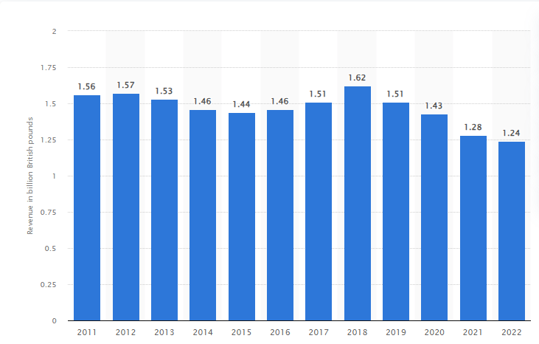
Fig. 1 Revenue of Wilko in the UK from financial year 2011 to 2022 (in billion British pounds). Source :(Statista, 2023)

According to the data in Fig.1, Wilko’s revenue was at its peak in 2018 reaching 1.62 million British pounds.
During the fiscal year 2022, the yearly income of Wilko Retail Limited in the United Kingdom equalled to 1.24 billion British pounds, marking a decrease from the 1.43 billion reported two years prior.
For the period concluding on January 29, 2022, Wilko Retail incurred a loss of nearly 32 million British pounds (Statista, 2023).

Wilko’s fall

In February 2023, to manage expenses, Wilko tried to tackle its losses by reducing its workforce by more than 400 positions from call centre workers to head office managers, regardless of the job role. This move comes in response to a decline in sales. The proposed adjustments are aimed at ensuring the business's stability and growth. Earlier this year, the company secured £40 million in funding from prominent high-street investor Hilco UK (Wood, 2023). This, unfortunately, was just the beginning of Wilko’s fall. In August 2023, the homeware high street retailer entered the administration, jeopardising the employment of 12,000 individuals (Marketline, 2023). What was the reason behind Wilko’s administration and what could they do differently? This report will further evaluate this organisation by looking at its product offering and service, comparing it to its more successful competitors and using academic models, such as SCAMPER.

The product offering of Wilko

There are several advantages of multiple departments in one store. Wilko is a network of "variety stores" offering a wide range of products, including items like mops, shower gel, dog food, and paint, among many others. The brand offers over 50 thousand products and over 1000 products are Wilko’s own brand in its 200 stores, millions of customers per week and 2 million visits per week online, on wilko.com.
Convenience is the idea of being able to buy everything the consumer needs in one store has been one of the most significant factors for its stores to gain popularity.
Serving a broad spectrum of customers, rather than offering products only for one customer segment, Wilko can welcome a variety of them, such as pet owners, decorators, children, and garden enthusiasts among others.
Ability to compete with different markets. By having various departments, Wilko can compete in several markets.
Festive and seasonal store adaptation is one of the attractive trends in mixed goods stores. This ensures the customer meets their demands and the store offers products relevant to the season or occasion.
Due to the above factors, multiple departments are contributing to the maximised revenue of the store (Wilko, 2018-2023).

Main Competitors
Wilko's continuous collapse is attributed to the competitive challenges posed by other major players like B&M, The Range or Home Bargains, who have lured away their customer base with more affordable pricing. Despite Wilko's positioning as a budget-conscious retailer that focuses on product quality, the market has become saturated. In an environment overflowing with budget stores, there's limited space for a brand promoting itself as a higher-end option. Additionally, the emergence of budget supermarket chains like Aldi and Lidl, well known for their tempting bargain offerings in the middle aisles, has further worsened Wilko's difficulties. More to be discussed in the application of the SCAMPER model (Strudwick, M. and Duell, M., 2023).

Wilko’s product offering
Wilko has divided its products into sections, such as Garden & Outdoor, and Decorating & DIY for our DIY enthusiasts. Customers can find an automotive section, as well as sealants and adhesives. Home and Furniture provides a diverse selection of home-related products. The technology department includes computing and its accompanying accessories. Cleaning and Household offers a wide range of cleaning products and other items for your home. Pets and wildlife cover a wide range of pet needs. Stationery and Office, whether it's for your residence or workplace, from desk organisation and filing solutions, stationery, to packaging and mailing products. Kids and Toys, dedicated to children, contains a wide assortment of items designed for babies, toddlers, and older children. This department also includes options for kids' furniture and wheeled toys. Health and Beauty is the final category composed of vital products such as dental care items, toiletries, foot care products, skincare solutions, health and wellness supplements, hair care and styling products, including makeup and eye care options.

Wilko’s products are available in-store and online (Wilko, 2018-2023).
The next section will uncover how Wilko’s innovations affected the business in a positive or negative way.

Innovation and its influence on Wilko

The concept of innovation as a significant disruptive factor has consistently retained its centrality in Schumpeter's theory. Innovation has an influence on contemporary analyses of business growth. The introduction of contemporary products and procedures serves as a pivotal driver in redefining competitive dynamics in both local and global markets. Its impacts extend to consumers, businesses, and nations, resulting in both short-term and enduring effects by generating and redistributing economic well-being within a progressively expanding economic domain (Hagedoorm, 1996).
Innovation has had positive, but also negative impacts on Wilko, the high-street homeware and DIY retailer.

Positive Influences:

Product Diversification
Innovation has allowed Wilko to enrich its product range, offering a wider selection of items in various departments, from home goods to technology and pet care. This has attracted a broader customer base and increased sales opportunities. In addition to the product range, the organisation introduced the complete selection of wipes free from plastic, plastic packaging has been eliminated from bedding, and bags for life are now crafted from 100% recycled plastic (Wilko,2018-2023).

Efficiency and Cost Savings
In 2017, Wilko Retail commenced discussions with approximately 4,000 employees as part of a restructuring effort aimed at optimizing its operations. The company initiated this process following an 80% profit decline to £5.1 million for the fiscal year ending in January (Marketline, 2023). Restructuring involves more effective reallocation of tasks, potentially negating the necessity for layoffs. This signifies a constructive approach to addressing the profit decline. As evidenced in Figure 1, the subsequent year yielded the highest revenue in Wilko's history, reaching 1.62 million British pounds.

Online Presence
Wilko’s presence in e-commerce enables the company to reach a broader audience and compete effectively in the e-commerce space, especially during the COVID-19 pandemic when online shopping surged.

Negative Influences

Market Competition: The enormous acceleration of innovation in the retail sector has made the competition vigilant. A decade ago, Wilko's sales exceeded those of B&M, but in recent years, its sales have dipped below those of its competitors, including Poundland, Home Bargains, and The Range. These competitors seem to provide comparable products at more competitive prices, making Wilko's business less attractive to potential buyers (BBC, 2023).

Economic Impact
Physical retail has faced challenges due to changing consumer habits. Innovation in e-commerce, while positive in one sense, has contributed to the decline in foot traffic in stores. The deterioration of poor or outdated store locations contributed to Wilko's decline. B&M and Home Bargains have made significant investments in enhancing their stores, and post-lockdown, UK customers are increasingly seeking an enriched shopping experience. Wilko also faced difficulties in integrating its online and in-store operations effectively. Trimming down the store count to 250 outlets would have been a wise decision by the business owners, but this was not actioned. In the post-COVID era, as the market grew more competitive and shoppers permanently altered their buying habits, Wilko failed to adapt, ultimately leading to the challenging situation they find themselves in today (BBC, 2023).

Supply Chain Challenges
Empty spaces on store shelves were observed because of Wilko's challenges in settling payments with suppliers. At least one credit insurer withdrew trade coverage, causing certain firms to halt their deliveries and therefore substantial investment was inevitable to revitalise the retailer and rebuild supplier trust (BBC, 2023).

In summary, the organisation has taken some positive steps towards product diversification and sustainability as well as cost-saving and effectiveness, however, they were unable to tackle competitors and failed to respond to the change in consumer habits after the COVID-19 which resulted in administration. In the following part of the report, the innovative solutions of Wilko overcoming these, and other challenges will be uncovered.

How should Wilko respond to address the market’s challenges through innovation?

Every problem presents an opportunity for a solution, and naturally, there are various problem-solving methods available. One such approach is the SCAMPER technique, which uses a series of targeted, idea-generating questions to propose additions or amendments to existing concepts. This technique has gained significant interest as an educational tool that nurtures awareness, motivation, creativity, adaptability, and inventiveness. Its effectiveness lies in the fact that it encourages individuals to address questions they might not typically consider (Serat, 2017). The changes which could be applied by the SCAMPER model are listed in the Fig. 2.

Each of the strategies will be applied and analysed to respond to Wilko’s organizational challenges.
Substitute
When considering substitute, it is an aspect of the business process or product that could be substituted with an alternative to enhance it. While Wilko was previously a standout player in the market, offering competitive prices across an extensive range of household products, retailers like The Range and B&M actively compete for Wilko's customers by presenting similar product offerings and creating an engaging shopping experience, employing this strategy to encourage frequent store visits. New and unusual products are frequently featured, often near the store entrance to attract customers. Whether you're looking for a fluffy bat or a pumpkin-themed mug, you'll find these items at The Range, along with practical products in any department of the store. This approach enhances the profitability of these retailers, as customers come for their regular purchases and end up adding higher-margin items to their shopping carts (Montano,2023). Wilko, therefore, ‘missed the trick’ and could attract its customers to the store by displaying new and original products at the front of the store.

Combine
By combining various concepts, business operations, products, or services, a business can enhance its efficiency and profitability. Since 2020, we've witnessed the closure of over 9,000 retail establishments, with department stores experiencing a significant decline of 13.4%. These stores are being replaced, primarily by food and beverage outlets (with takeaways increasing by 7.2% and cafes by 5.7%) and hair and beauty services (up by 5.9%). Not all consumers have transitioned to online shopping entirely. Online sales have reduced from their pandemic peak of 37.8% of all retail sales in January 2021 to 26.1% in July 2023. Weekend shopping has made a comeback for many (Montano, 2023). Primark is one of the retailers, who took this as an opportunity to combine their shopping experience with offering a hair salon and café on their premises. This is proof of their market awareness and unconventional strategy of combining multiple products and services in one store to become more competitive and profitable. Wilko could address the competition between B&M and The Range by combining the shopping experience with a service not provided by their competition.

Adapt
As previously advised in the "Innovation and Its Impact on Wilko" section, one of the adverse effects has been Wilko's difficulty in adapting to the changing landscape brought about by the pandemic and the increasing prevalence of e-commerce and online shopping. To prevent losses, the management should take prompt action and consider the possibility of closing some of the stores.

Modify
This could be an alteration of an element of the situation or issue to assess which one adds or holds significant value. If Wilko closed some of its stores as previously advised and invested in its supply chain to ensure its shelves are not empty (BBC, 2023), this would have a positive impact on customer experience and satisfaction. In other words, Wilko should modify their interests from the number of stores to a stable supply chain.

Put to other uses
How could the product or process be repurposed? Are there possibilities of reusing elements from another source? Tesco has successfully reclaimed more than 80% of the soft plastic returned by its customers. The company is currently collaborating with recycling partners to explore options for the remaining 20%, which is presently directed towards energy recovery (Tesco PLC, 2021). Sustainability is an increasing priority for businesses due to the growing urgency of environmental preservation. While Wilko has taken steps to make a minority of its products plastic-free, there could be certainly more involvement.

Eliminate
Contemplate the potential outcomes if certain components of the product or process were removed, and then explore the actions you would take in such a scenario. Due to the surge in e-commerce spurred by the COVID-19 pandemic, B&M initiated a trial to make changes. Historically, the B&M website has not been used for transactions but has served to drive foot traffic to their physical stores and engage with an online customer community, however, B&M has launched an online home delivery limited to a specific range of products. The sales came through, but they constituted a marginal disruption that wasn't financially viable. And so, the management has decided to continue being a physical business (Lauchlan, 2023). This is an important learning curve for Wilko, as the organisation could first launch the trial and assess the value, rather than continue with the process not financially viable for the business.

Rearrange & Reverse
Considering the actions taken if components of the product or process operated in reverse or were arranged in different sequences. Wilko always focused on targeting a broader audience, therefore with the launch of new products, they may try to focus on niche markets and offer products or services not provided by other competitors.

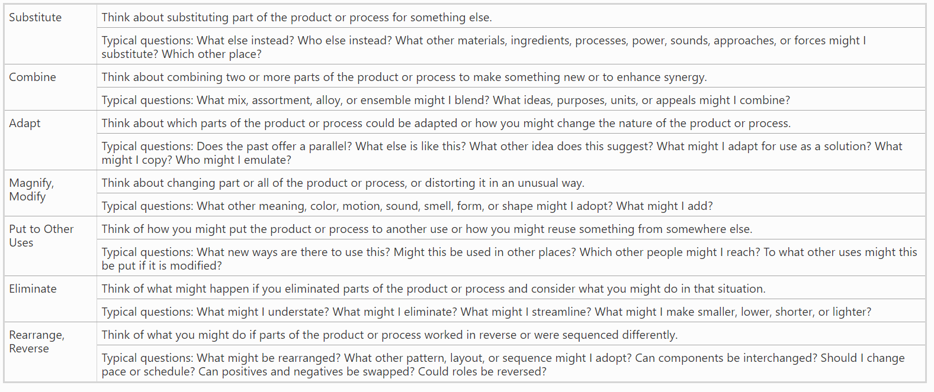
Fig. 2 Help Guide to the SCAMPER technique. Source: (Serat, 2017)

Conclusion

In conclusion, Wilko should address the market challenges through innovation and employment of the SCAMPER technique, a problem-solving approach that encourages creativity and adaptability. Specifically, Wilko could consider:
Substitute: Introduce unique and original products at the front of stores to attract customers.
Combine: Offer complementary services in stores to enhance the shopping experience
Adapt: Promptly respond to changing market conditions, which may involve closing underperforming stores.
Modify: Shift the focus from store count to ensuring a stable supply chain, addressing the issue of empty shelves.
Put to Other Uses: Increase sustainability efforts, including reducing plastic use and waste.
Eliminate: Launch trials of new initiatives before committing to them fully to avoid unprofitability and loss
Rearrange & Reverse: Consider targeting niche markets with unique products or services that differentiate Wilko from competitors.

In conclusion, Wilko's journey to recovery and long-term success would require strategic innovation, including adaptability to changing market dynamics, an enhanced product offering, and a more sustainable approach. By thoughtfully implementing the SCAMPER technique and considering these innovative strategies, Wilko could find a path towards a brighter future in a competitive retail landscape.

Reference list

BBC (2023) What went wrong at Wilko? Available at: https://www.bbc.co.uk/news/business-66394238
(Accessed: 12 October 2023).

Hagedoorn, J. (1996) 'Innovation and Entrepreneurship: Schumpeter Revisited', Industrial and Corporate Change, 5(3), pp. 883-896. Available at: https://doi.org/10.1093/icc/5.3.883

Lauchlan, S. (2023) E-commerce isn't a bargain insists B&M, even as Poundland steps up its online game. Available at: https://diginomica.com/e-commerce-isnt-bargain-insists-bm-even-poundland-steps-its-online-game (Accessed: 18 October 2023).

Marketline (2023) Wilko enters administration, ‘outflanked’ by competitors. Available at: https://advantage-marketline-com.ezproxy.uwtsd.ac.uk/News/wilko-enters-administration-outflanked-by-competitors_69423 (Accessed: 12 October 2023).

Marketline (2023) Wilko Retail begins restructuring consultation process with around 4,000 staff. Available at: https://advantage-marketline-com.ezproxy.uwtsd.ac.uk/News/wilko-retail-begins-restructuring-consultation-process-with-around-4000-staff (Accessed: 12 October 2023).

Montano, S. (2023) Wilko – What went wrong? Available at: https://blog.bham.ac.uk/business-school/2023/09/14/wilko-what-went-wrong/ (Accessed: 17 October 2023)

Serrat, O (2017) Knowledge Solutions. Available at: DOI: 10.1007/978-981-10-0983-9_33 (Accessed: 17 October 2023).

Statista (2023) Revenue of Wilko Retail Limited in the United Kingdom (UK) from financial year 2011 to 2022.
Available at: https://www.statista.com/statistics/1009407/wilko-retail-limited-turnover-united-kingdom-uk/ (Accessed: 12 October 2023).

Statista (2023) Wilko: UK profit/loss after tax 2015-2022.Available at: https://www.statista.com/statistics/1009439/wilko-retail-limited-profit-and-loss-united-kingdom-uk/ (Accessed: 12 October 2023).

Strudwick, M. and Duell M. (2023) The downfall of another High Street giant: How Wilko was pushed out by competitors such as Lidl, Home Bargains and B&M offering cut-price deals. Available at: https://www.dailymail.co.uk/news/article-12372527/Wilko-closing-downfall-High-Street-giant-competitors-Lidl-Home-Bargains-B-M-offering-cut-price-deals.html (Accessed: 16 October 2023).

Tesco PLC (2021) Shoppers can now return all their soft plastic packaging to recycling points at every large Tesco store in the UK. Available at: https://www.tescoplc.com/news/2021/shoppers-can-now-return-all-their-soft-plastic-packaging-to-recycling-points-at-every-large-tesco-store-in-the-uk/ (Accessed: 18 2023).

Wilko (2018-2023) Corporate - Our History. Available at: https://www.wilko.com/en-uk/corporate/our-history (Accessed: 11 October 2023).

Wilko (2018-2023) Corporate – Corporate Social Responsibility. Available at: https://www.wilko.com/en-uk/corporate/corporate-social-responsibility (Accessed: 12 October 2023).

Wood, S. (2023) Wilko to cut 400 jobs. Available at: https://www.punchline-gloucester.com/articles/aanews/wilko-to-cut-400-jobs-has-stores-in-gloucester-cheltenham-stroud (Accessed: 12 October 2023).

