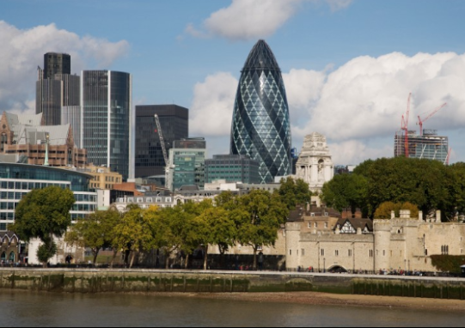  A report focussing on:  Construction Materials | Prepared for:  Allen Nantel  Created by:  Lloyd wilson  2211509  Date completed:  6th December 2022  Word count: 2,037

Table of Contents
Page Number
1.0 Executive Summary 1
2.0 Terms of reference 2
3.0 Procedure 3
4.0 Findings 3
5.0 Conclusion 8
6.0 References 9
7.0 Appendices 10

- Executive Summary

This report contains my research on “The Gherkin” in London and shows why steel was used as its main frame. It was designed by the modernist architect Norman Foster, the real name of the skyscraper is 30 St. Mary axe, London, but due to its unusual, elongated egg ovular shape it resembles a gherkin. My study will analyse the framing material of the building in these specific areas What is the materials production processes and the impacts of this production to the social and ecological environment. Ease of assembly and the frames properties and how this has affected the overall design. I will back up with my research with refences and illustrations from reputable sources.
The original design for the building was to build a skyscraper called the millennium Tower that was 92-stories high, but due to it being near London Heathrow flight paths it was scaled down and redesigned into a 41-story structure as stated in the article by (Jones, Sackley and Watson, (2017), p 277). The new design was innovative and a more sustainable aspect for the build was adopted before starting construction in 2001 with completion in 2003. However, this wasn’t the first major structure on the site as there was the headquarters for the Baltic exchange, but in 1992 the IRA bombed the building damaging it beyond repair. This then set the pathway of the new structure to be built in its place and through several years of planning and designs the final decision to build the Gherkin was made.

- Terms of Reference

  - The principal focus is to find why:
    - Why steel was used for the mainframe.
    - Material process production.
    - How it was assembled.
    - Design of the building.
    - The report is due for submission on the 31st of October.

- Procedure

This section identifies the research sources used.
  - The research included sources from internet, articles, and books
  - Notes taken in class also provided background to the research.
  - Photographs/illustrations of the Gherkin building

- Findings

  - The Gherkin building is situated in London England and isn’t set in a harsh or extreme weather part of the world. It isn’t expected to be affected by earthquakes or extreme wind events like tornados. The Gherkins exterior is mostly glass and is the main material wrapping the building, it’s a super water resistance material and durable against UK weather. The exterior skin is made from steel and glass in a lattice shape that wraps the structure. This unique design in my mind is not just suitable to withstand climatic pressures but also looks aesthetically pleasing to the eye which is hard to get the balance between the architect’s design ideas and practicality for the building. The building can self-regulate temperatures as it has circular floors with vents and a gap in the floor on each level so naturally promotes air ventilation from the exterior windows (Appendix 4). The building boasts that it uses half the energy to run compared to other buildings of its size, due to the window acting as a natural light source but also adding cool external air reducing the interior and exterior temperatures affecting the structure warmed. This makes the Gherkin designed perfectly for years to come, resisting environmental conditions as they change to a hotter more tropical type of weather being the norm in the UK as global warming effects temperatures externally and internally to buildings.

  - Manufacturing process for the materials of this building is quite harmful to the environment as a lot of CO2s is released into the atmosphere in its production of steel, glass, and the concrete foundations. The Gherkin is made up from mostly recyclable materials, so if in the future it was dismantled a lot of the materials could be broken down ready to be reused in other products of production. Manufacturing Steel is a lengthy process but first from extraction of natural minerals such as Iron ore must be extracted from the ground in large open cast mines. This process of just getting the raw iron is immense, I worked at setting up a mine, port, and rail line in Sierra Leone for the extraction of this process. It was a great source of income to the country and its people, by providing jobs and income to businesses across the country as the mine site to the port was vast (Mining Frontier). This however being positive socially did have massive ecological impacts to the environment locally and globally as the amount of effort in exportation of the mineral impacted the landscapes. The next part of the process is to grind the rock (taconite) and separate the foreign bodies by using strong magnets to pick up the iron. The iron is then heated and are formed into iron pellets, the pellets are then combined with solid carbon fuel which is coal/coke crushed and sealed and baked in airtight ovens. The fuel and iron are then placed in a furnace with an addition of limestone (removes impurities) The furnace then combusts the coke which adds extra heats that smelts the iron. The iron is then transferred into the basic oxygen furnace where heat, recycled steel scraps and pure oxygen is blasted with the molten iron to create molten steel. The molten steel is then customised into the required type, then the next step in the process is to pour the molten steel into a vacuum degasser. Its then formed into the workable shapes so it then can be transformed into its required shape/purpose with the desired finish process next. I used a YouTube video (Menghrajani, 2011) as a reference to learn about the creation of steel. However, concrete is cheaper in comparison due to being relatively easy to make and less energy is required to make it compared to making steel as the process explains above.

  - The main frame was constructed by bolting steel members/beams together with the external skin being a diagrid interlocking system. By prefabricating the steel off site and labelling the steel members it makes it easier to work off plans for the engineers to assemble the parts together on site. Storage space on site is then minimal as the lorries would deliver to site where they could be offloaded straight from the lorry into place via cranes. The steels were lifted by cranes and installed by fabricators on site, as the building went higher it was more difficult as wind effects the stability of the lifted beams (Appendix 1). High winds would have delayed the build, but time was saved compared to if it was a concrete type of structure, especially being built in London. Where if it was concrete, lorries would have been delayed by traffic and the sheer demand needed to complete a build of this stature would have been a logistical nightmare. With the steel beams it would be easier to calculate the vertical load at design stage but with concrete discrepancies in the quality can affect the overall performance of the build. Concrete would be tested to calculate its strength, but this method delays the process if the concrete fails to meet the right load properties. The other advantage is that with concrete you would need a lot more different types of trades from carpenters, steel fixers and concrete finishers. There would be a lot of waste with the shuttering of the concrete form work and with a site as previously mentioned being in London there isn’t a lot of spare space for storage of shutters and steel rebars. Maintenance of the structure can be maintenance by periodically having maintenance works in place e.g., painting the exposed steel periodically which would prolong the building life span. The plans would dictate the stages in which the build was at, this would be monitored by the architects and engineers that would have assisted the main building trades in the build. By having a well organised work force the build was completed within two years of the start of construction.
The unique curved shape in London’s skyline makes it a desirable place to work, live or eat and others office space that has had several businesses use. This makes it adaptable for different uses throughout its lifecycle and has proved since the start that it has been multifunctional. The use of steel is great for baring weight across big spans, so partition walls within the building are made from timber and plasterboard. These walls can be easily removed, and floor layouts can be altered for different layouts of what the new requirements would be. If this was made from concrete more consideration would be needed before any adaptations as firstly, are the walls weight baring, the time/waste removal it would take to adapt the floor space and services. This is advantageous in a forever evolving society and what companies/people need to work and live. Since covid and technology advancements a lot more office-based workers can work from home or on the go. The need for office space has dwindled so re-evaluating the building purpose of what it can be used for could change in the future, so it being made from steel instead of a traditional concrete type has been rewarding in the fact its ease to modernise and adapt to current/future needs. With less office space needed these spaces could be utilised for more accommodation or entertainment purposes, this makes it truly sustainable for any eventuality.

  - The Gherkin being a skyscraper at 41 stories tall it is still suspectable to high winds (wind loading), this is one reason to why the structure is curved giving it a more aerodynamic shape so wind can pass across/around the curved façade with ease from any direction. The calculations for this can be found in a case study by Bengani (2015) in (appendix 2) The cylindrical shape then reduces the wind loads as its not a solid flat surface therefore has less buffering and less vibrations because the shape decreases the effect of wind loading. Steel structures can flex in these conditions whilst a concrete structure is more rigid. To give more strength to the building it has steel and glass diagrid façade as stated in an article by Masterclass “The frame of the Gherkin is constructed from a series of diagonally interlocking steel beams that make a series of triangular prisms on the building’s facade. This structure makes the building resistant to the wind without the need for added reinforcements like columns” Steel has been used as the main frame for the building as it is high in tensile strength and has elastic properties, so in extreme conditions where it can bend/flex with cross wind force it returns to its manufactured shape. The Gherkin has an outer skin layer which is designed in a diagrid shape, this formation of steel and glass protects the main inner frame from the elements by deflecting wind around the curvature of the building. This minimises the effects of wind loading/sheer strains dramatically especially when compared to a traditional concrete skyscraper (appendix 3), as the façades are flat in shape which creates a wind block and the wind loading pressures would be immense in comparison. The shape of the building stands out in the City of London’s skyline as its unique in comparison to the more traditional square type mega structures.

5.0 Conclusion

5.1 The findings I’ve made when investigating The Gherkin has been extremely insightful, not just a skyscraper but a truly unique picturesque building. It was used in the bid for the London Olympics when an athlete was superimposed vaulting over the building, showcasing the city of London. It was also used in other promotional campaigns and has been seen in many TV and film pieces. This building wouldn’t have been made possible without the super product that is steel, its multi-functional properties of strength, longevity and ease of use make it a leading choice in modern construction. Like the Gherkins feet of architectural providence making it, adaptable for any type of use, with the ability to construct building of great imaginations. The ability to segregate steel in demolishment to then reclaim and recycle it by forging into new steel products give it longevity and not just made for one purpose makes it more environmentally friendly long term than some other materials used in construction.

6.0 References

Adam T. Jones, William H. Sackley & Ethan D. Watson (2017) Teaching exchange rate risk using London's Gherkin building: How investors were in (and out of) a pickle, The Journal of Economic Education, 48:4, 276-287, DOI: 10.1080/00220485.2017.1353457 To link to this article: https://doi.org/10.1080/00220485.2017.1353457

- The Gherkin: An Architectural Guide to 30 St. Mary Axe
Written by Masterclass Last updated: Sep 23, 2021. https://www.masterclass.com/articles/the-gherkin-architectural-guide

Mamik Menghrajani, (2011) Steel from start to finish available from: https://www.youtube.com/watch?v=-ZCaFE97hkM (Accessed 10/11/2022)

Tonkolili Iron Ore Mine, Sierra Leone Article on Mining frontier Available at: https://www.miningfrontier.com/projects/tonkolili-iron-ore-mine-sierra-leone/#:~:text=UK-based%20African%20Minerals%20%28AML%29%20through%20its%20subsidiary%20Tonkolili,is%20planned%20to%20be%20developed%20in%20three%20phases. (Accessed 23/10/2022)

7.0 Appendices

  - Appendix 1

The picture below shows a picture of the construction of the Gherkin, it shows the steel lattice frame.
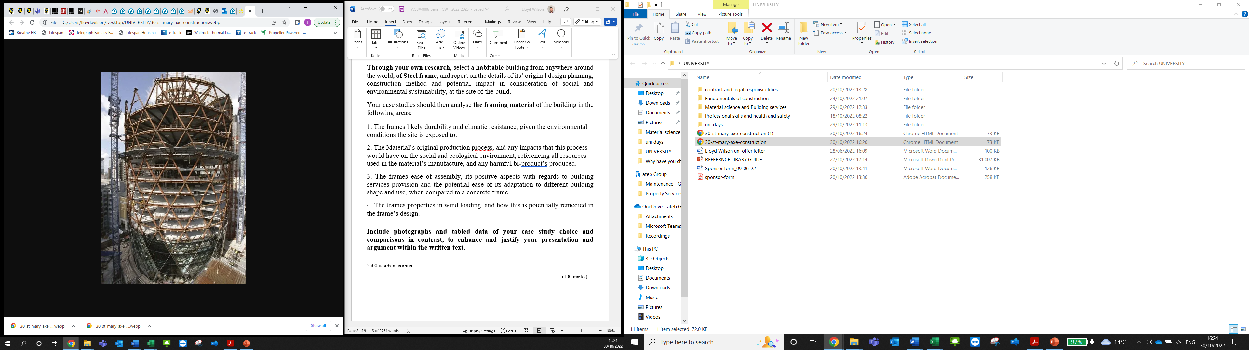

Source: https://architectboy.com/the-gherkin-building-london/ The Gherkin Building, 30 St Mary Axe, London | Architecture | Design
International Architecture / By Masud Rana (30/10/2022)

  - Appendix 2

The following picture is of wind loading calculations

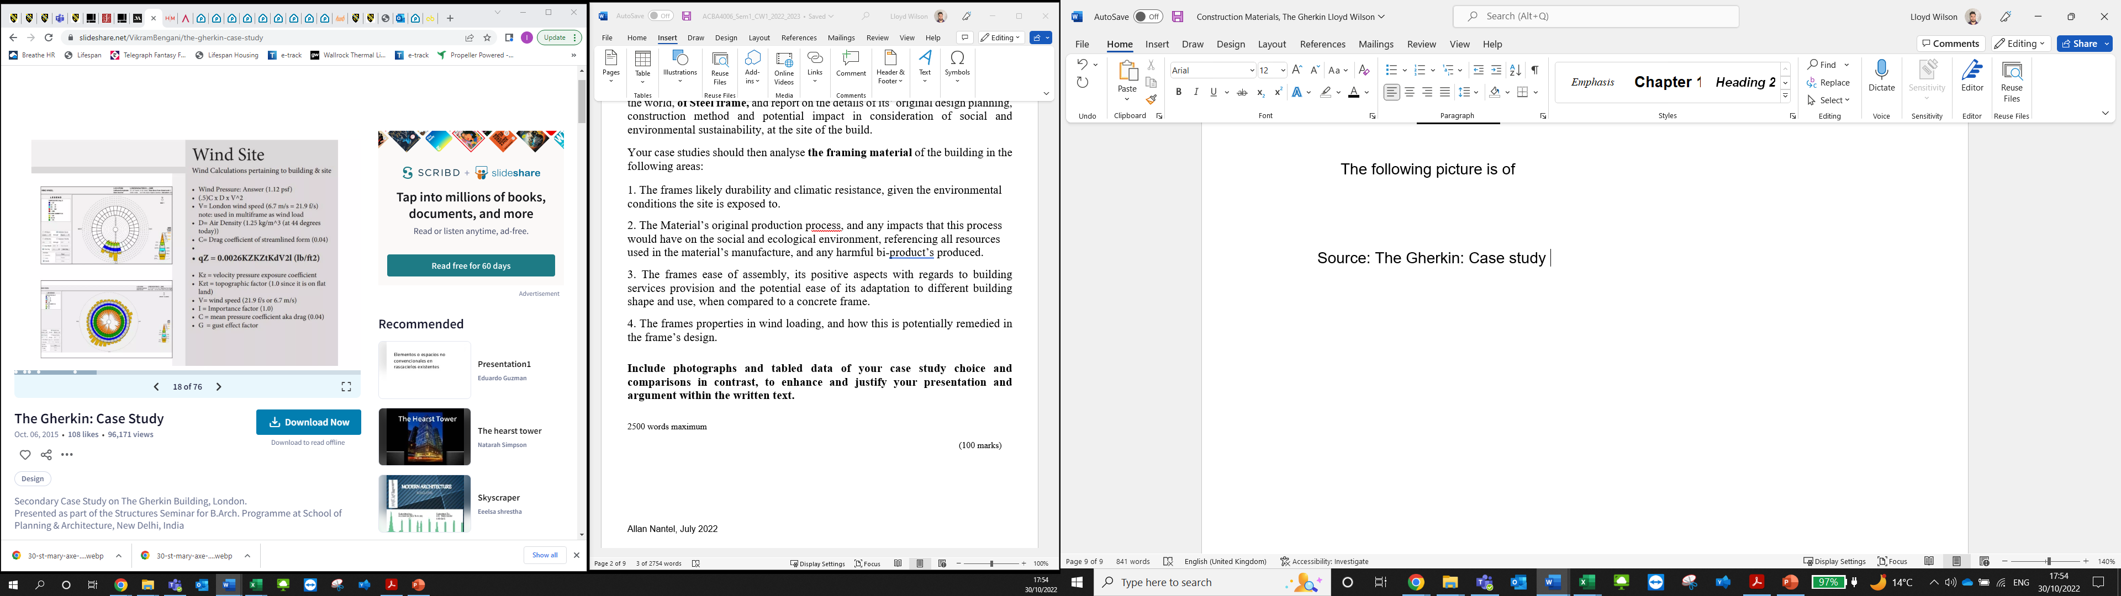

Source: The Gherkin: Case study Vikram Bengani 2015 https://www.slideshare.net/VikramBengani/the-gherkin-case-study (found on 30/10/2022)

  - Appendix 3

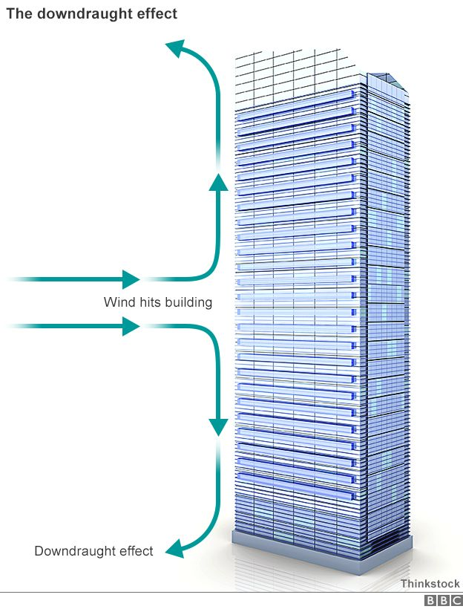

Source: Justin Parkinson BBC News Magazine
The problem with Skyscraper wind effect
https://www.bbc.co.uk/news/magazine-33426889 (10/11/2022)

  - Appendix 4

The below picture is of how air is ventilated naturally around the building

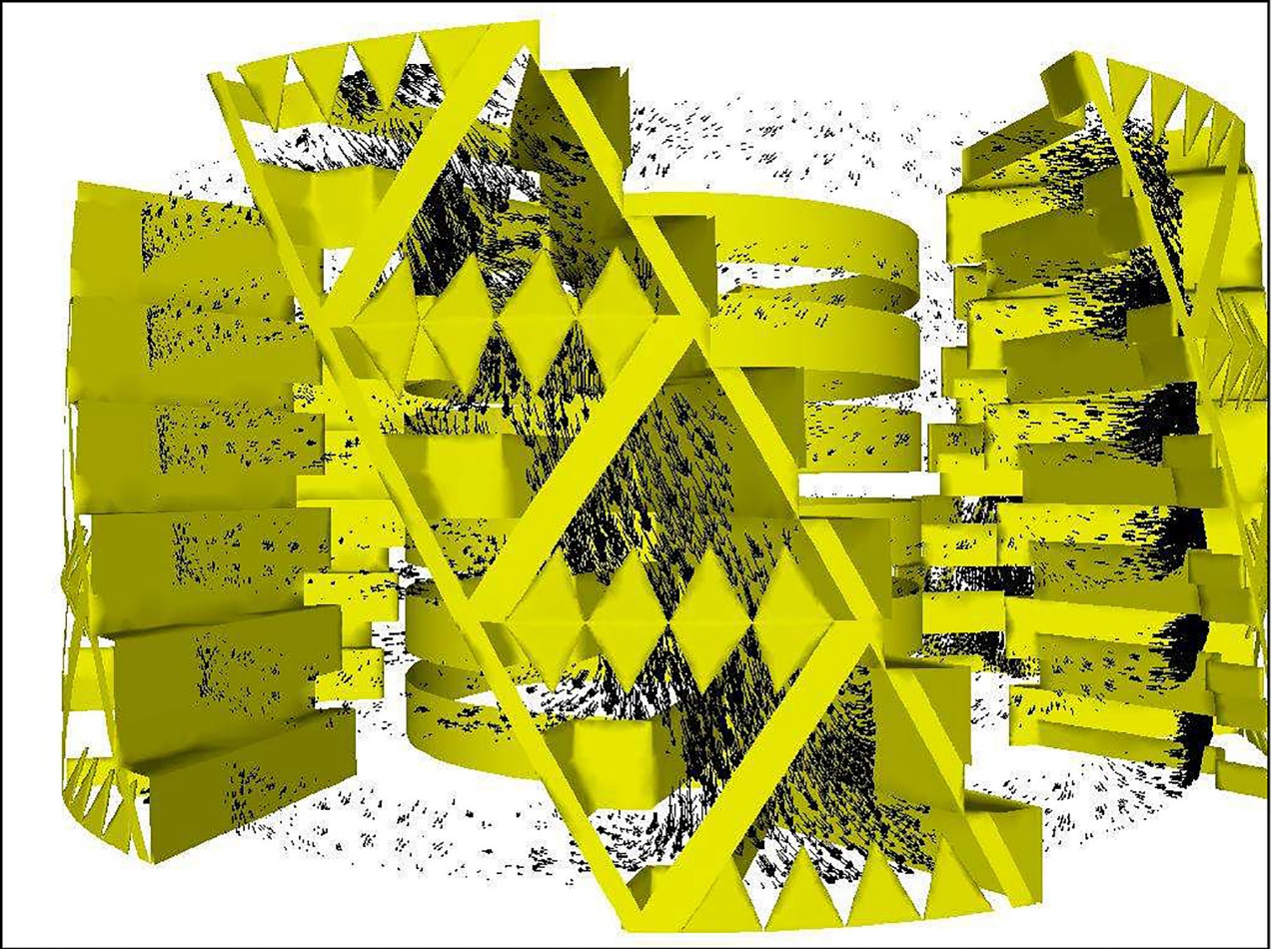

Source: John Massey, Arch daily (2013) The Gherkin: How Londons famous tower leveraged risk and became an icon (part 2)
https://www.archdaily.com/447205/the-gherkin-how-london-s-famous-tower-leveraged-risk-and-became-an-icon-part-2
source date:13/11/2022

